MASTER OF BUSINESS ADMINISTRATION

NAME: Mohit Bhatt

STUDENT ID -2132840

MODULE: LCMB7001

LECTURER: Tushara Balendran

SUBMISSION DATE: 8/09/2022

Table of Contents
Introduction 3
About Heinz 3
Communication 3
Integrated marketing communication 4
Promotional strategies 5
Branding and brand equity 6
Customer journey mapping 8
Total engagement model 11
Conclusion 12
References 14

Introduction

Pre- and post-sale interactions with customers are all part of an organization's customer experience strategy (Batat, 2019). The Indian market and its targeted segment have been investigated for designing Heinz baked beans’ customer experience strategy. The report has been analysing the new marketing tactics that Heinz may develop to increase brand awareness and manage and evaluate the customer journey across a range of communication channels to meet the expectations of both present and future stakeholders. The customer centric data of the organisation would be utilised in this report for discussing Integrated Marketing Communication, Strategies for marketing promotion, brand equity and branding purposes, customer journey map development and exploring total engagement model. In this process the focus will be on developing customer persona, mapping of customer journey, OmniChannel Marketing for understanding brand awareness and customer retention related value creation for Heinz baked beans in the Indian market. About Heinz

H. J. HeinzIs an American company that has been operating for more than 150 years. More than 200 country based business operations of Heinz are globally managed through the Pennsylvania headquarter of the organisation. The organisation has a large product portfolio of food products which are processed and manufactured in six different continents of the world. The largest manufacturer of pickles, vinegar, and ketchup in the US is Heinz Company. The business had 25 factories and more than 6,000 workers by 1919. The H. J. Heinz Company manufactures and markets Heinz Baked Beans under that name in the UK and other nations. Since 2008, they have been offered as Heinz Beanz. Heinz began using the catchphrase "BeanzMeanz Heinz" in their advertising in 1967. This catchphrase was made highly popular in the UK by Maurice Drake, an Advertising executive. Heinz Baked Beans was chosen as one of the 12 trademarks that British consumers believed best exemplified the last ten years of the millennium in 1998. The company changed the name of "Heinz Baked Beans" to "Heinz Beanz" in 2008 since it was "a bit of a mouthful to say" before. The Commercial Standards Authority (ASA) banned Heinz's advertising campaign in 2016 that featured people playing empty bean cans as instruments.

Communication
In the business communication process the goal is to share the appropriate information with the important business internal and external stakeholders. It has been observed that in the process of achieving the organisational goals and objectives, the internal stakeholders of the organisation use the business communication process as an important method. On the other hand in the process of marketing communication, it becomes much more specific where the marketers use appropriate media and messages for communicating with the target audience (Iftikhar et al., 2019).. In general the business communication process reduces the chances of error as well as improves practices within the organisation.
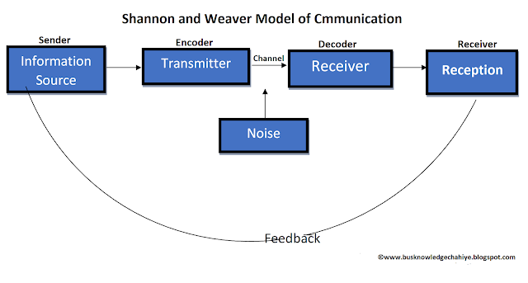
Source: (McColl-Kennedy et al., 2019)
In the well known communication model called ‘Shannon and Weaver model”, there are different concepts. The concepts like the sender or the sources of information, channel or the medium of message delivery, encoder or the transmitter, the decoder or the process or machine based message decoding, receiver or the end destination of the message, and noise or the disturbance in the system (McColl-Kennedy et al., 2019). Using these important concepts the above model diagram can be explained. In general the encoded form of message is delivered by sender using channels of communication, to the receiver. After this process the receiver receives the message for the interpretation and understanding of it. The noise or disturbance present in the channel prohibits the receiver to properly decode the message and results in communication problems. Therefore in any system it would be important to reduce the elements of noise for better communication.

Integrated marketing communication
An effective integrated marketing communication strategy have helped to both firm and individuals to offers an effective and better customer satisfaction for products and services and also helps to improve better brand awareness, value and reputation which gain higher level of improvement in performance. In context to integrated marketing communication strategies firm needs to implement practices better advisement elements including digital media, social media marketing and promoting through brand identity which is same across different media channel refers to the IMC (Integrated marketing communication)(Iftikhar et al., 2019). People with better experience in IMC may hunt for work during the communication as well as marketing sectors in professional involves market consulting, media, government and associated sectors.
Every organisation needs to thoroughly analyse changes in consumer purchasing behaviour in the ever-changing economy and global market place in order to prioritise the customer experience journey (Motta-Filho, 2021). Heinz is undergoing a continuing change in the present market environment and needs to pay closer attention to the shifting needs of its customers. In order to compete against its rivals, the corporation must strengthen its digital skills and improve the customer experience by valuing its clients. Additionally, the business must accelerate its innovation agenda in order to comprehend consumer expectations and buying patterns as well as eating trends (Hawkins, 2021). As a result, developing a customer experience culture is crucial for the company to increase its competitiveness.

Promotional strategies
Heinz can develop better promotional strategies for their baked beans in new markets.
Marketing content in social media
By piqueing their interest and gaining their trust, relevant and engaging content for Heinz target audience can assist in generating new leads. By establishing Heinz brand, responding to consumer inquiries, and outlining the benefits of working, it can also help raise the percentage of sales. By including it on Heinz website, one can raise domain authority because great material frequently receives features and backlinks (Abbu et al., 2021).
social media
Building a community around the brand, business, and product is made possible by having own social media channels, which also provide complete control over message and allow to freely publish updates. A social media helps to the firm and organization to develop users generated content, gather effective feedback and also aids to overcome the problem associated with the customers as it is free medium to utilize (Hossain et al., 2020).. Implementation of the social media by the firm has helped to improve better conservation rate as may customer utilizes these platform in order to determine whether the feedback about the products and also whether they can trust an organization or business and also uses review before making any decision regarding purchasing of products and services.

Affiliate initiatives
The use of affiliates can increase sales without incurring significant fixed marketing expenses like advertising. Affiliates are appropriately motivated to market goods or services since they have a stake in the outcome and are only compensated if they are successful because of this. Heinz can design the partnerships with these affiliates to pay out depending on clicks, leads, or sales (Cui et al., 2021).
Referral marketing
One of the quickest, simplest, and most affordable methods to develop is to capitalise on the goodwill of satisfied, current consumers. Encouraging consumers to tell others about Heinz goods or services by encouraging them to refer new clients and reminding them to share their experiences (Berman and Thelen, 2018). The company have a wide range of possibilities to develop a strong marketing strategy, even on a limited budget. The marketing can strategically attract clients and generate income and invest into the marketing and accelerate growth by using a variety of different affordable strategies that address the entire marketing funnel,(Gallino and Rooderkerk, 2020).

Branding and brand equity
With the help of the implementation of an effective branding components including better logo design, use firm mission statement in their marketing and communication strategies firm able to attract customer towards products and services and create positive impression in front of customers about its goods and products.
According to Gallino and Rooderkerk, (2020), stated that brand equity is refers to the marketing term which can explain the organization brand value and helps to determine the value of consumer perception as well as experience with brand. The CBBE (Customer based brand equity) also refers to the Keller’s brand equity model is implemented by the firm to improve performance. It is straight forwards model therefore it helps to build robust brand and helps to improve performance.

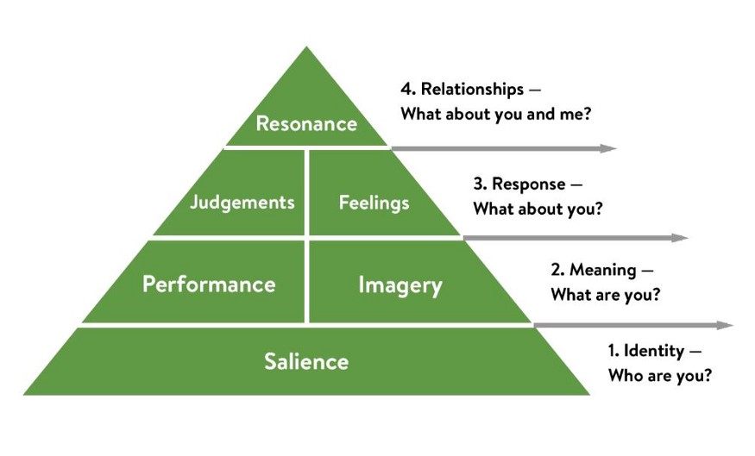
Source:(Yan et al., 2017)
Identity- The Identity of baked beans comes from the idea that it can be prepared directly through preservatives and can be served on a toast or baked potato. The Identity of baked beans was introduced by heinz in Pittsburgh and the baked beans found their way to the British breakfast tables as a luxury items due to Limited availability and high pricing. However the company started reducing the cost of production and increased their importance as health benefit and convenience mail for individuals (Yan et al., 2017). The company has positioned themselves as a comfort food provider and the baked beans are promoted as means of advertising as healthy choice of nutrition in English breakfast providing high calories protein and fibre for breakfast. As per the brand equity model heinz has created a Unique Identity for the baked beans and has established their brand identity as a comfort food having nutritional value and zero preparation time.
Meaning- The performance and imagery of the brand has been developed from their primary characteristic features product reliability service effectiveness style and pricing. The image and position created by the brand is high and is viewed as the comfort food for most Americans. Heinz has created a low preservative baked beans having high nutritional value and coming in good packaged cans which increases durability of the packaging and also improves service effectiveness (Aguirre et al., 2019). The product always has a nutritional information printed on them as well as visibility of them expiry and manufacturing date which enables the customers to make their choices. The beans are served in a thick tomato gravy which also enhances the taste of the food product thereby improving the overall product reliability. All the prices of the baked beans was higher before heinz started marketing it afterwards, the price is reduced by reducing the overall cost of production.
Responses- Most of the individuals who have had the baked beans say that the sauce was runny and very prominent in tomato flavour which says that the baked beans can be served directly over noodles spaghetti baked potato or even in a loaf of bread. The baked beans do not need to be remade with new types of recipe or sauces and comes directly packaged in a tin (Hunke et al., 2021). The beans have high fibre protein nutrients and plant compounds improving cholesterol and gut health. The beans are also convenient because it has added salt sugar additives which reduces the make time for newly prepared items. The product is a comforting convenience food and after scrutinizing the flavour most of the individuals are actually habit weighted to the baked beans because of sentimentality emotional connection habit and also incredible taste.
Relationship- The customer engagement via the baked beans can is high because the product provides a convenience and also an emotional connection with the Americans since childhood. The company provides not just good tasting baked beans but nutritious baked beans which can be used by different types of branch personal having high affiliation towards body building and maintaining healthy life side (Yan et al., 2017).

Customer journey mapping
Molenaar (2017) mentions the buyer or consumer persona. A persona is a fictitious depiction of a certain core consumer that is based on factual facts and market research. Building archetypes of the ideal baked bean purchasers in the Indian market is the main reason for developing a consumer persona: doing so will engage and inspire potential consumers to make purchases (An et al., 2018).
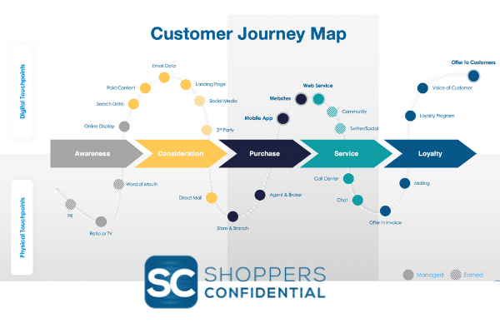
Source: (Rosenbaum et al., 2017)
An individual's various interactions and pathways with the product or service provided by a brand are depicted on a customer journey map. The customer journey includes both direct encounters (involving direct face to face interaction) and indirect encounters (involving communication on telephone on telemarketing calls). The marketing team at Heinz can easily determine the various key factors and elements that will affect a customer's buying behaviour by outlining the whole customer journey. The marketing team may develop suitable communication platforms for enhancing the customer experience by properly comprehending the complete customer journey map touchpoints and interactions (Micheaux and Bosio, 2019).
Awareness: Gaining knowledge about Heinz baked beans through social media websites, television, and internet commercials, and contrasting Heinz baked beans with those of other brands. To help customers make better decisions and give more thought to their options, the business can develop nutritional value charts and promote the content on social media and online channels.
Consideration: Think about contrasting Heinz baked beans with those of rival brands on the market. To help customers make better decisions and give more thought to their options, the business can develop nutritional value charts and promote the content on social media and online channels.
Purchase Decision: The organisation develops paid campaigns to increase sales and builds individualised relationships and rapport with customers based on their preferences and lifestyles.
Retention: Customer interaction and ongoing marketing are key to retaining clients, as is the creation of a customer lifetime value.
Advocacy: This involves creating meaningful customer experiences that would be remembered by the customers for a long time. This is a key component that helps in fostering long term brand loyalty which eventually helps companies to ensure long term customer retention. Advocacy can be created by providing the right products and services to the customers that thoroughly fulfils their needs and expectations.
In order to create a consistent brand experience and image, omni channel marketing integrates the various platforms and channels that businesses use to communicate with customers. The other Omni Channel Marketing platforms may consist of both digital and physical channels, such as websites and e-commerce platforms (Berman and Thelen, 2018). The organization's main goal in creating an omnichannel marketing strategy is to provide users with a seamless experience that is conveniently affordable and gives a range of chances for achieving customer satisfaction. Additionally, omni channel marketing techniques integrate possibilities for online and in-store pickup (Abbu et al., 2021). Omni Channel Marketing leverages data-driven marketing to improve customization and personalization while also enhancing the customer experience with the business. Additionally, omni channel marketing offers a multi-channel sales strategy that is carefully curated to give customers a smooth shopping experience based on the interplay between changing consumer purchasing behaviour and growing brand experiences. By increasing the customer's lifetime value, it aids in the development of a long-term customer connection (Hossain et al., 2020). As a result, in the current business environment, omni-channel strategy would play a key role in increasing Heinz’s business competitiveness. In the long term, it also results in Agile marketing operations in the current global environment because it increases higher value for an organization's growth.
For the purpose of boosting sales and improving the customer experience, Heinz uses three efficient marketing channels. These include e-commerce platforms and conventional retail food wholesalers. The business sells its goods offline and online through a variety of channels, including wholesalers, independent brokers, grocers, retail chains, and outlets required by governmental organisations (Cui et al., 2021). Currently, the corporation in India uses carry forward agents to go directly from the manufacturing facility to stockists throughout the urban regions via wholesalers and retailers. However, the company's multi-marketing strategy makes it difficult for them to successfully enter other Indian towns and cities, and as a result, their presence is lessened all over the nation (Gallino and Rooderkerk, 2020). The proper distribution of these suppliers' products has been a problem for the other outlets as well, mainly during and after the pandemic. Due to nationwide supply chain delays, baked beans were not available in stores or online (Iftikhar et al., 2019). The business needs to increase its omnichannel visibility across the nation, develop multiple omni-channel strategies to regularly monitor their raw material suppliers and develop a fully computerised inventory management system.
Heinz has been making use of modern day business intelligence tools and technologies to improve the customer interaction points and this has helped the company to increase the overall effectiveness of their customer journey map. The company has continuously focused on the growing needs and expectations of their customers in a bid to bring forth the much need change in their business and marketing strategies. By undertaking a data and market insight driven research through the use of Artificial Intelligence and Big Data Analytics, Heinz has succeeded in significantly enhancing their omni-channel presence in the global markets (Pennbizreport.com, 2022).

Total engagement model
Make a stimulating learning environment
The first step in creating a meaningful customer experience is the creation of a learning centre where customers can easily visit if they intend to find more about an organisation and their product offerings. This really plays a vital role in shaping up the initial brand perception of an organisation in their customer’s mind. Start by inquiring about the clients' pain points with the customer service staff (Kim and Chung, 2018). For each issue, evaluate the volume of queries and its effect on shaping up the brand perception among the customers. Provide the marketing team with complete access to the recordings of support or sales calls will help them make the most of this CX approach.
Post material with an instructional focus.
High levels of product confidence are the foundation of a positive customer experience. Whether they like to acknowledge it or not, Google searches are the first place people go when they need assistance. Profit from the existing organic traffic rather than fighting it(Jain et al., 2017). A well-kept support website has helped Nextiva achieve a double ranking in search results, for instance. Both present and potential clients will find the information regarding jitter useful. Customers want to do more with a product than just learn how to use it for simple tasks. surpass client expectations by demonstrating to them how to live and work better. Additionally, do not let account setup webinars lapse. To welcome new clients, take into account cultivating them (Naz et al., 2018).
Boost client loyalty with social media
Social media has become a powerful platform for brand exposure and brand awareness. More and more people have an active presence on the social media platforms which make them an appropriate tool for Heinz to maximise their brand exposure and brand awareness among the global customers (Fisher and Kordupleski, 2019). Heinz needs to capitalise on the wide reach and popularity of the social media platforms to create positive brand perception regarding their products. This can be achieved by providing positive brand testimonies from their existing customers. This would really help Heinz in attracting new potential customers and by imparting customer satisfaction the company would be able to retain them for the long haul (Hill et al., 2017).

Conclusion
The study leads to the conclusion that Heinz must enhance their customer experience strategy in order to create a strong market foundation in India. Heinz now has a poor customer experience overall due to poor supply chain management and disruptions caused by the epidemic. Heinz is working with Google technologies to establish its omnichannel presence. Heinz is taking these actions because they recognise the urgent need for ongoing transformation and have sharpened their focus on understanding the needs of their customers. To establish the presence of the baked beans category in India, Heinz needs to expand their brand exposure by capitalising on social media marketing, as well as its Omni-channel presence through E-Commerce websites and local stores. Various models have been used to understand the customer IMC of Heinz, and this will enable the company to develop promotions and product awareness more. This in turn will also impact the CX strategy of the brand. In order to promote and distribute goods like baked beans, the company will be able to improve the customer experience and establish a culture that puts the needs of the consumer first. Additionally, it's crucial to comprehend the requirements of the target market, and the many strategies for effectively engaging with clients in order to boost retention and loyalty.

References
Abbu, H., Fleischmann, D. and Gopalakrishna, P., 2021, June. The Case of Digital Transformation in Grocery Business: A Conceptual Model of Digital Grocery Ecosystem. In 2021 IEEE International Conference on Engineering, Technology and Innovation (ICE/ITMC) (pp. 1-9). IEEE.
Aguirre, A.F., Villareal-Freire, A., Diaz, J., Gil, R. and Collazos, C.A., 2019, July. Extending the Concept of User Satisfaction from Customer Experience. In International Conference on Human-Computer Interaction (pp. 397-407). Springer, Cham.
An, J., Kwak, H., Jung, S.G., Salminen, J. and Jansen, B.J., 2018. Customer segmentation using online platforms: isolating behavioral and demographic segments for persona creation via aggregated user data. Social Network Analysis and Mining, 8(1), pp.1-19.
Batat, W., 2019. Experiential marketing: Consumer behavior, customer experience and the 7Es. Routledge.
Berman, B. and Thelen, S., 2018. Planning and implementing an effective omnichannel marketing program. International Journal of Retail & Distribution Management, 46(7), pp.598-614.
Cui, T.H., Ghose, A., Halaburda, H., Iyengar, R., Pauwels, K., Sriram, S., Tucker, C. and Venkataraman, S., 2021. Informational challenges in omnichannel marketing: remedies and future research. Journal of Marketing, 85(1), pp.103-120.
Fisher, N.I. and Kordupleski, R.E., 2019. Good and bad market research: A critical review of Net Promoter Score. Applied Stochastic Models in Business and Industry, 35(1), pp.138-151.
Gallino, S. and Rooderkerk, R., 2020. New product development in an omnichannel world. California Management Review, 63(1), pp.81-98.
Hawkins, R., 2021, June. BeanzMeanz Heinz. In Proceedings of the Conference on Historical Analysis and Research in Marketing (Vol. 20, pp. 81-83).
Hill, N., Brierley, J. and MacDougall, R., 2017. How to measure customer satisfaction. Routledge.
Hossain, T.M.T., Akter, S., Kattiyapornpong, U. and Dwivedi, Y., 2020. Reconceptualizing integration quality dynamics for omnichannel marketing. Industrial Marketing Management, 87, pp.225-241.
Hunke, F., Heinz, D. and Satzger, G., 2021. Creating customer value from data: foundations and archetypes of analytics-based services. Electronic markets, pp.1-19.
Iftikhar, R., Pourzolfaghar, Z. and Helfert, M., 2019, August. Omnichannel value chain: mapping digital technologies for channel integration activities. In International Conference on Information Systems Development (pp. 74-92). Springer, Cham.
Jain, R., Aagja, J. and Bagdare, S., 2017. Customer experience–a review and research agenda. Journal of Service Theory and Practice.
Kim, J.R. and Chung, B.G., 2018. Comparative Analysis of Customer Feedback Metrics for Improving Predictability of Customer Loyalty. Journal of Venture Innovation, 1(2), pp.61-73.
McColl-Kennedy, J.R., Zaki, M., Lemon, K.N., Urmetzer, F. and Neely, A., 2019. Gaining customer experience insights that matter. Journal of service research, 22(1), pp.8-26.
Micheaux, A. and Bosio, B., 2019. Customer journey mapping as a new way to teach data-driven marketing as a service. Journal of Marketing Education, 41(2), pp.127-140.
Molenaar, L., 2017. Data-driven personas: Generating consumer insights with the use of clustering analysis from big data.
Motta-Filho, M.A., 2021. Brand experience manual: bridging the gap between brand strategy and customer experience. Review of managerial science, 15(5), pp.1173-1204.
Naz, N.A., Shoaib, U. and Shahzad Sarfraz, M., 2018. A review on customer churn prediction data mining modeling techniques. Indian Journal of Science and Technology, 11(27), pp.1-27.
Pennbizreport.com. 2022. Kraft Heinz, Google partner to enhance customer experience - Pennsylvania Business Report. [online] Available at: <https://pennbizreport.com/news/22495-kraft-heinz-google-partner-to-enhance-customer-experience/> [Accessed 11 August 2022].
Rahimian, S., ShamiZanjani, M., Manian, A. and Esfiddani, M.R., 2020. Developing a Customer Experience Management Framework in Hoteling Industry: A Systematic Review of Theoretical Foundations. Journal of Business Management, 12(3), pp.523-547.
Rosenbaum, M.S., Otalora, M.L. and Ramírez, G.C., 2017. How to create a realistic customer journey map. Business horizons, 60(1), pp.143-150.
Yan, J., Tian, K., Heravi, S. and Morgan, P., 2017. The vices and virtues of consumption choices: price promotion and consumer decision making. Marketing Letters, 28(3), pp.461-475.

