

AS 1 – Vandana

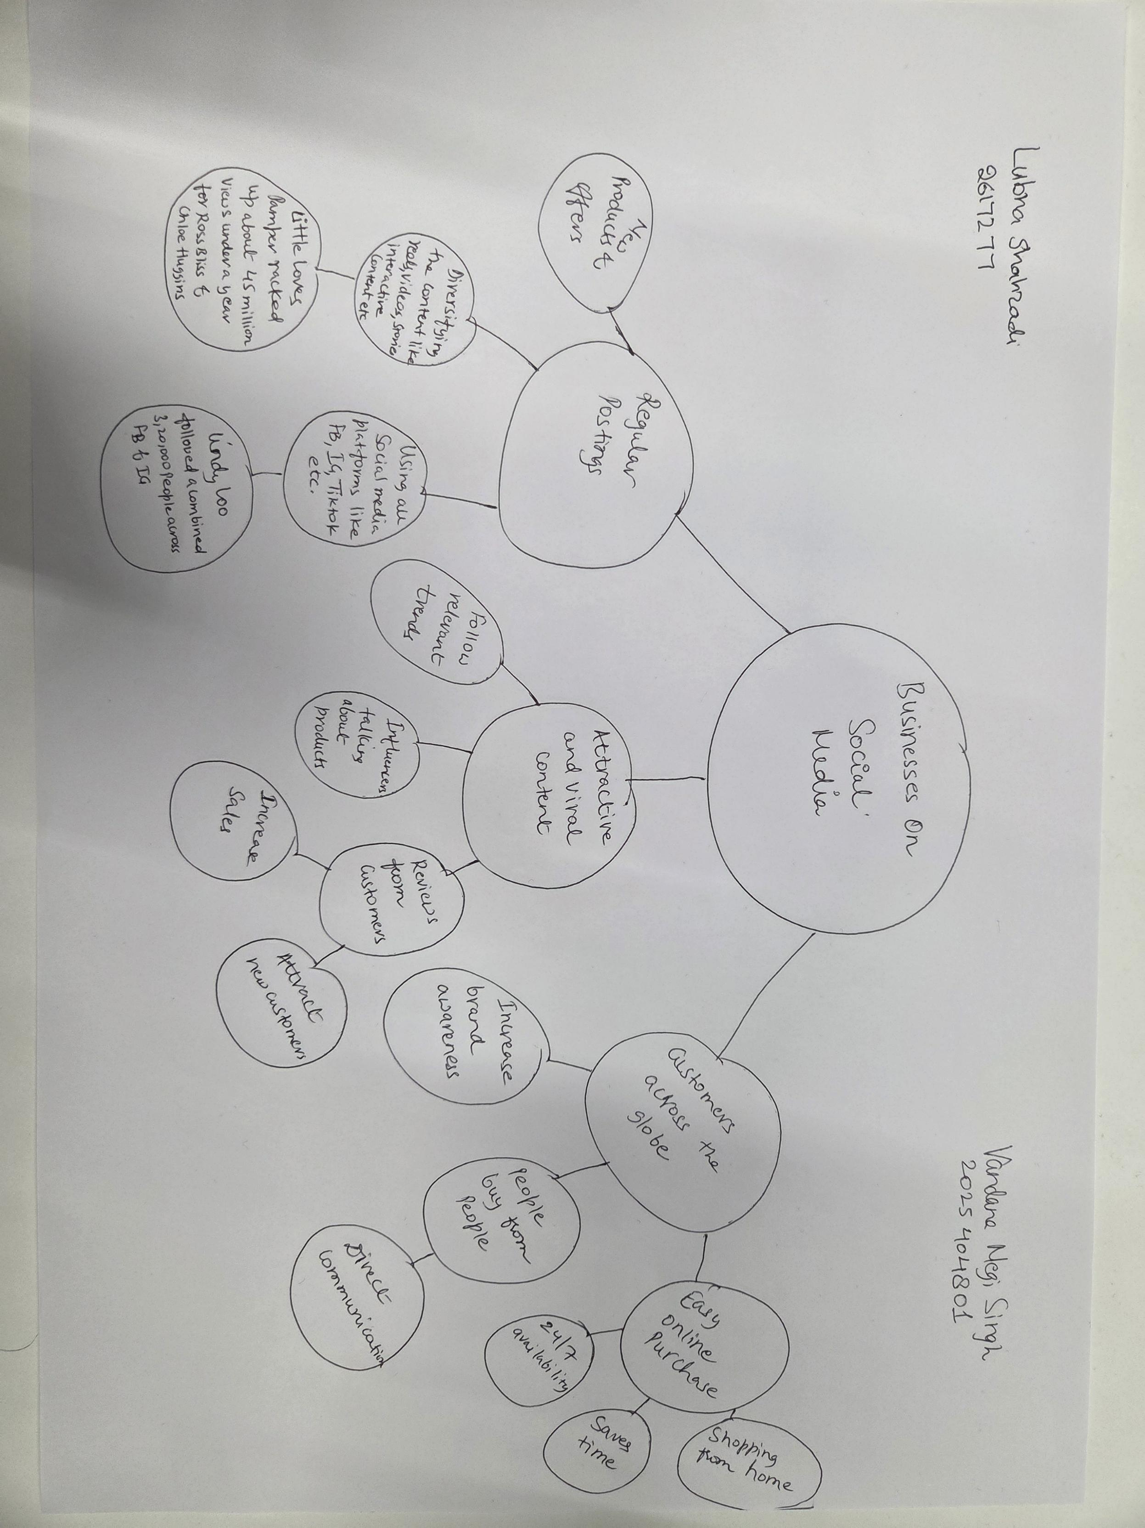

- What is the main idea of the whole text?
Ans – To promote business on social media like Facebook, Instagram, Tiktok etc. The power of social media in spreading the word and going viral when using it daily and getting more and more customers from all across the globe because a business could be online and offline and if the customers are getting the products worth the price and quality then they will travel or even happily pay the postage for the shipping.

- What is one key point that supports the main idea, and which specific example from the text shows this?
Answer - It shows the power of social media and how when using it everyday consistently promoting business increases the sales and the business becomes profitable. For e.g using Facebook, Tiktok, Instagram etc to reach wider crowd

- What is a different key point that supports the main idea, and which specific example from the text shows this?
Answer - With the help of online shopping/social media people can buy products across the globe from the comfort of their space and that too anytime they want. It made such a huge difference in people’s life.

- Which part of the text do you think is most important, and why?
Answer - It is using social media like Facebook, Instagram, Tik Tok etc to promote business online which helps in getting more customers from all across the globe. It’s a win- win situation for both buyers and sellers.
Reflection:
- What did you find difficult in this task (including in-class components), and why was it difficult?
Answer - It will be branching out the information and making them small and crisp to understand, update the figures and names of the business/owners.
- What helped you with this difficulty, and how did it help you?
Answer - Note taking helps jotting down important points so we can remember them. It saves time and helps us understand the bigger picture. Active listening plays an important role and helps us compare the information easily.

