Harvard Referencing Activity 1

On the pages that follow there are 20 reputable sources from either books, journals, or websites.

Using your new knowledge of referencing, along with the UWTSD Harvard Referencing Guide (from our Moodle page), please provide the citation for each source, and the full correctly formatted reference for each source in the spaces provided.
The images of the webpages all contain hyperlinks – this means you can click on the link and look around the webpage to search for the information you need.
When referencing journal articles, keep in mind that not all journals will have an issue number.
When you are finished, ensure you save your document and upload it to the correct submission link for Activity 1.

Good luck!

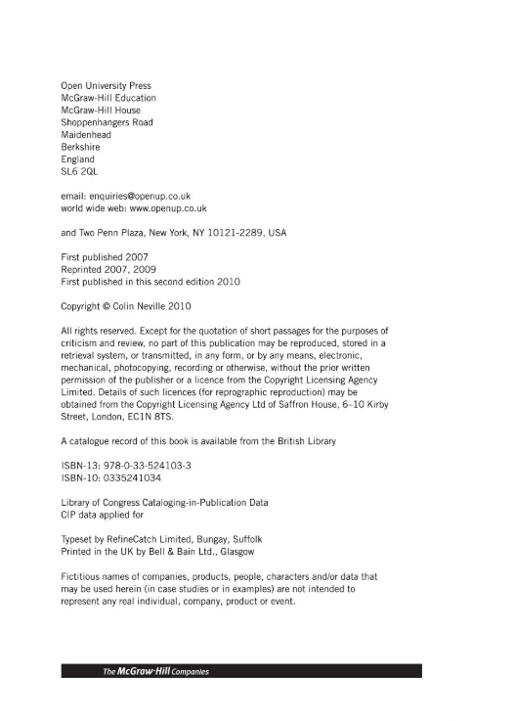

Citation : (Neville, 2010)
Reference : Neville, C. (2010) The Complete Guide to Referencing and Avoiding Plagiarism. 2nd edn. Maidenhead: Open University Press.
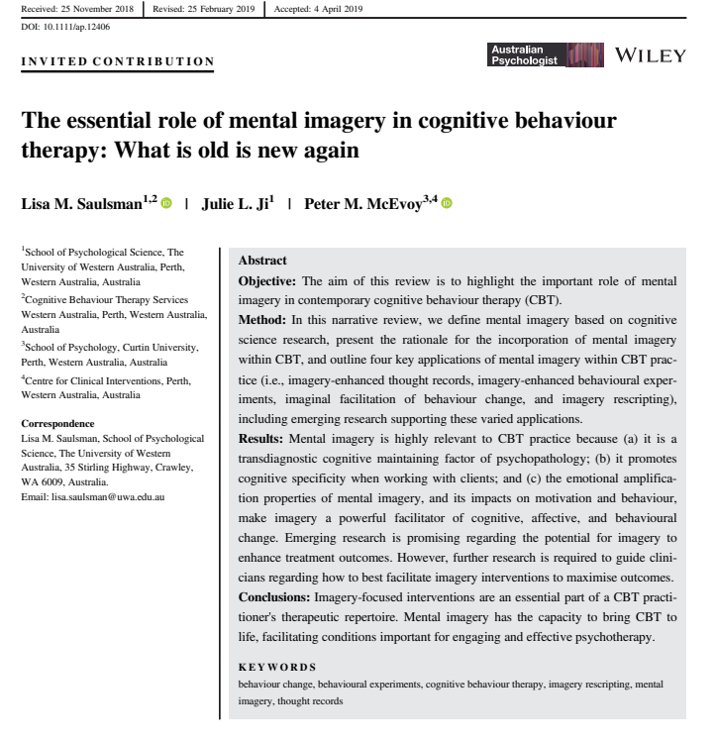
Citation : (Saulsman, Ji and McEvoy, 2019)
Reference : Saulsman, L. M., Ji, J. L. and Mcevoy, P. M. (2019) The essential role of mental imagery in cognitive behaviour therapy: What is old is new again. Available at: https://doi.org/10.1111/ap.12406 (Accessed: 05.02.2021).
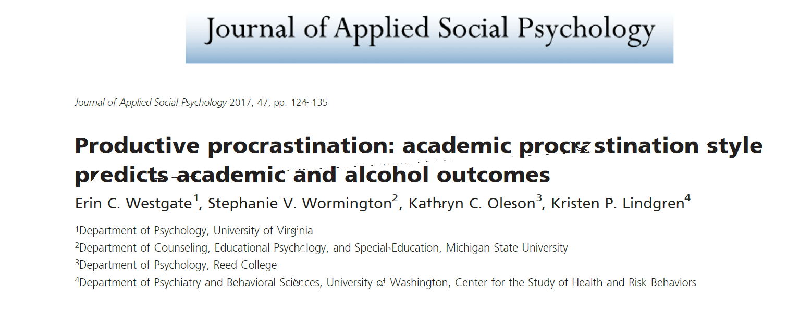
Citation : (Westgate, et al, 2016)
Reference : Westgate, E. C. et al. (2016) ‘Productive procrastination: academic procrastination style predicts academic and alcohol outcomes’, Journal of Applied Social Psychology, 47 (3), pp. 124-135.

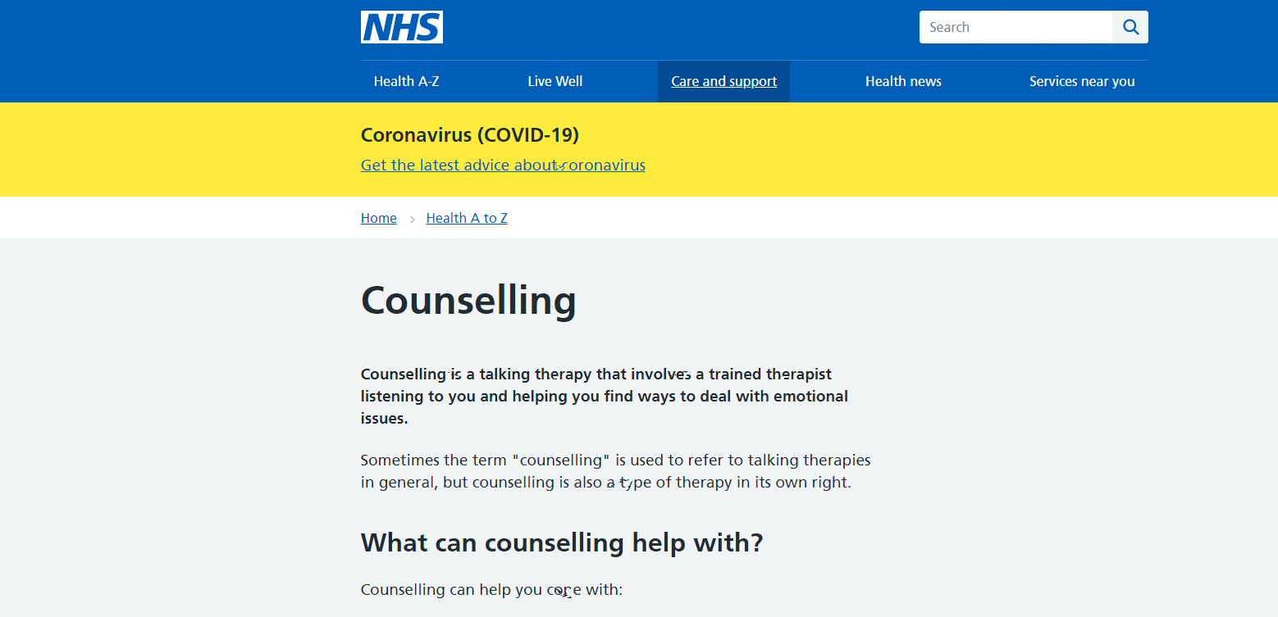

Citation : (National Health Service, (2020)
Reference : National Health Service. (2020) Counselling. Available at: https://www.nhs.uk/conditions/counselling/ (Accessed: 3rd February 2021)
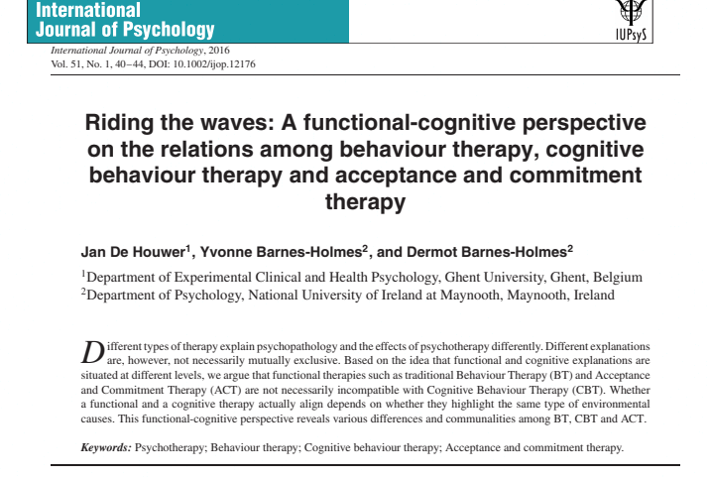

Citation : (Houwer, Barnes-Holmes and Barnes Holmes,2016)
Reference : Houwer, J., Barnes- Holmes, Y. and Barnes- Holmes, D. (2016) ‘Riding the waves: A functional-cognitive perspective on the relations among behaviour therapy, cognitive behaviour therapy and acceptance and commitment therapy’, International Journal of Psychology, 51 (1), pp. 40-44.
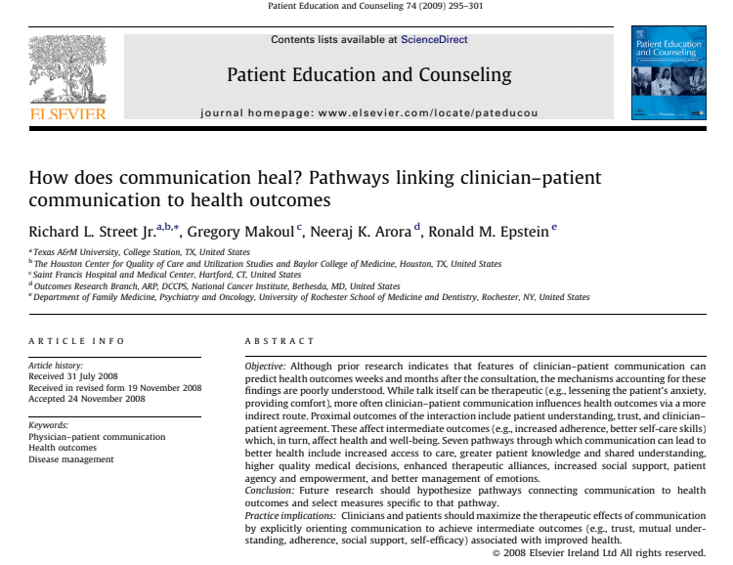

Citation (Street Jr, et al, 2008)

Reference : Street Jr, R. L., et al. (2008) ‘How does communication heal? Pathways linking clinician-patient communication to health outcomes’, Patient Education and Counselling, 74 (3), pp.295-301

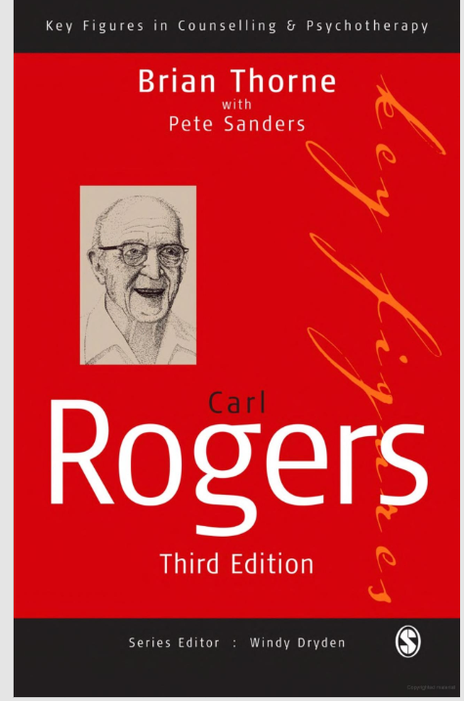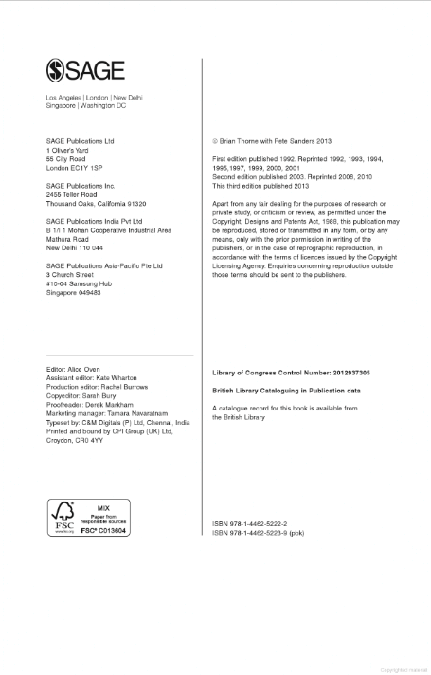

Citation : (Thorn and Sanders 2013)
Reference : Thorne, B. and Sanders, P. 2013 Carl Rogers. 3rd edn. London: SAGE Publications Ltd.

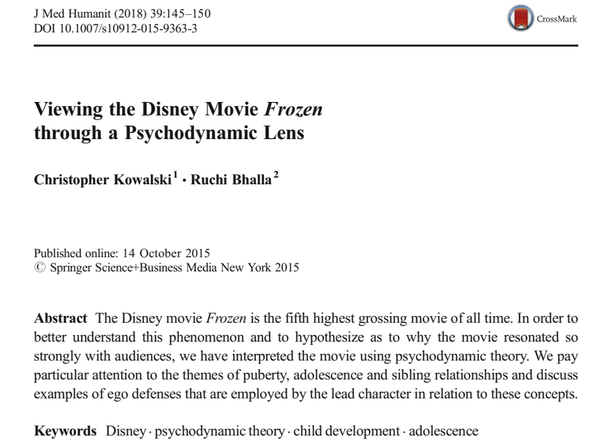

Citation : (Kowalski and Bhalla 2015)
Reference : Kowalski, C. and Bhalla, R. (2015) ‘ Viewing Disney Frozen Movies through a Psychodynamic Lens’, 39 (2), pp. 145-150.
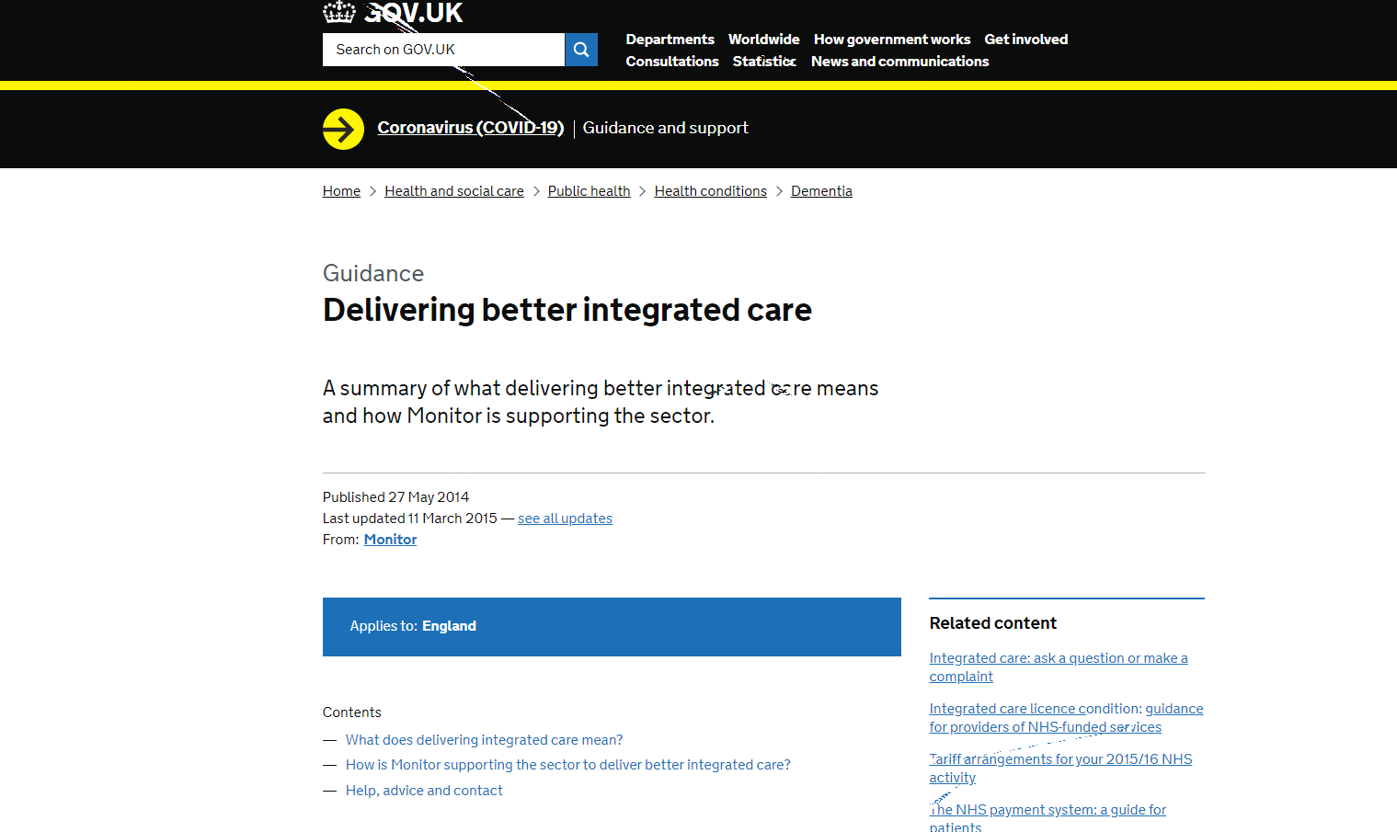
Citation : (gov.uk, 2015)
Reference : Gov.uk. (2015) Delivering better integrated care. Available at: https://www.gov.uk/guidance/enablig-intergrated-care-in-the-nhs (Accessed: 5th February 2021)
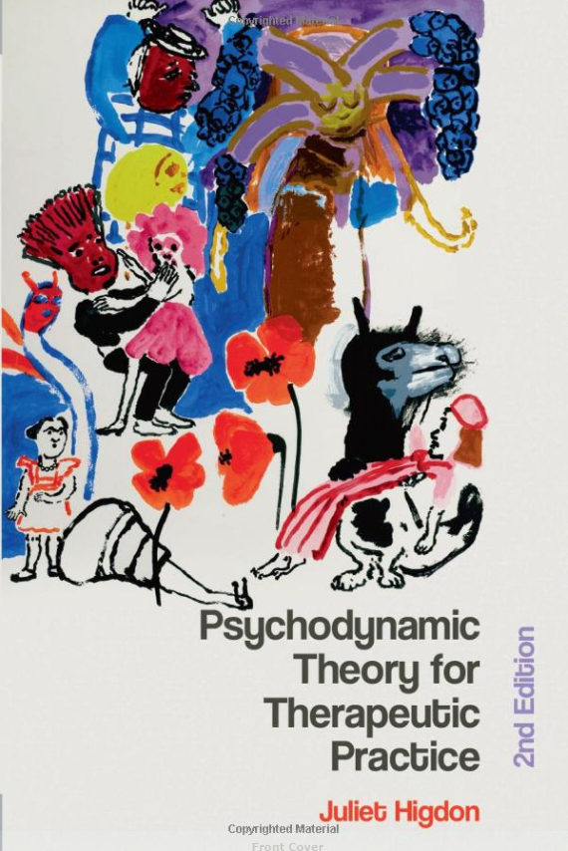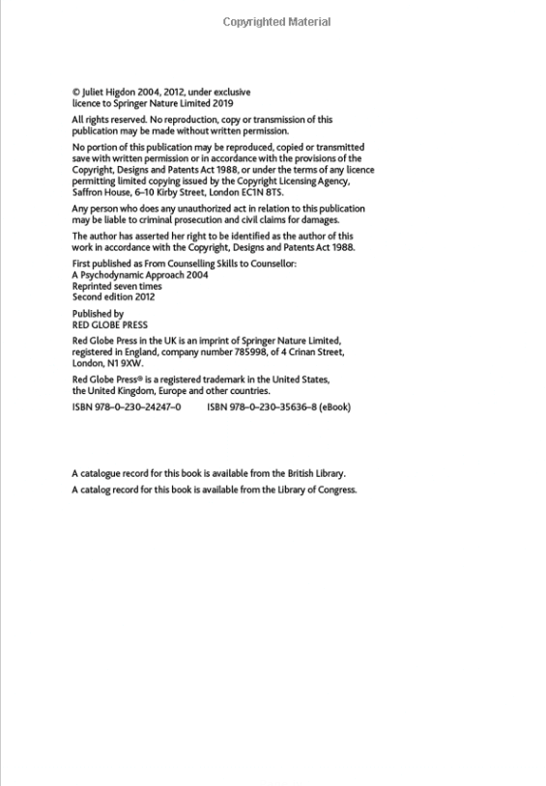

Citation : (Higdon, 2012)
Reference : Higdon, J. (2012) Psychodynamic Theory for Therapeutic Practice. 2nd edn. London: Red Global Press.
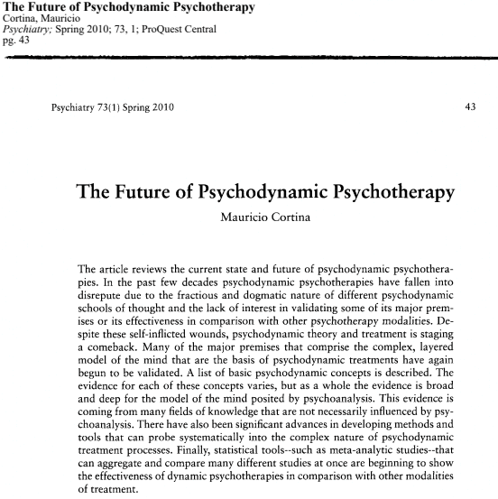
Citation : (Cortina, 2010, Pg 43)

Reference : Cortina, M. (2010) ‘The Future of Psychodynamic Psychotherapy’, Psychiatry Interpersonal and Biological Processes, 73(1), pp.43-56.

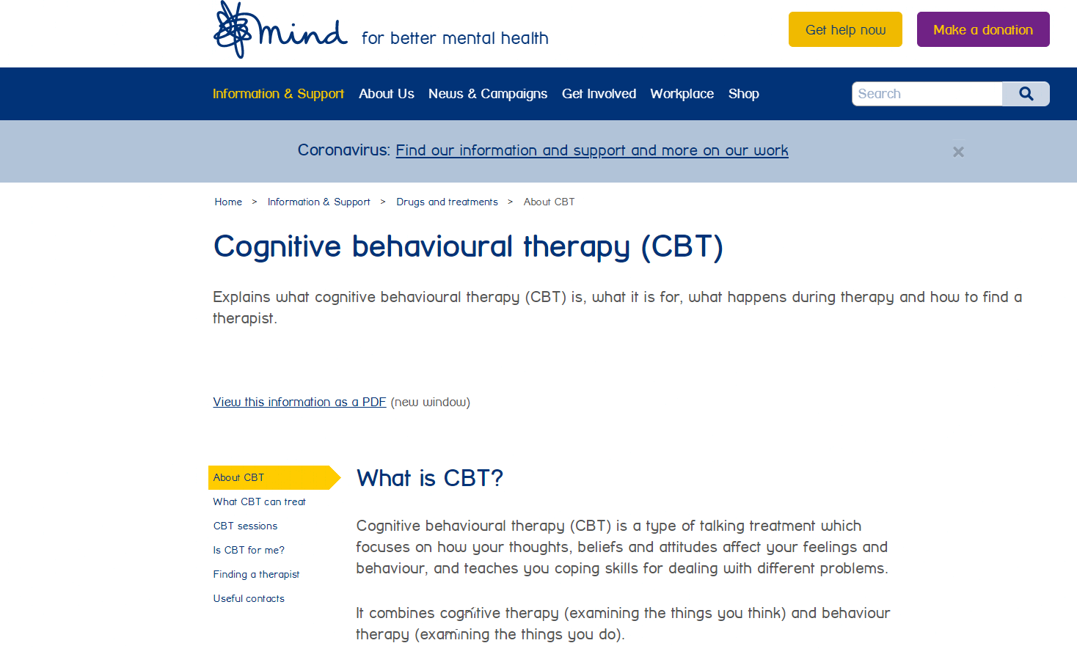
Citation : (Mind, 2017)
Reference :Mind. (2017) Cognitive behavioural therapy (CBT). Available at: https://www.mind.org.uk/information-support/drugs-and-treatments/cognitive-behavioural-therapy-cbt/about-cbt/ (Accessed:05.02.2021)
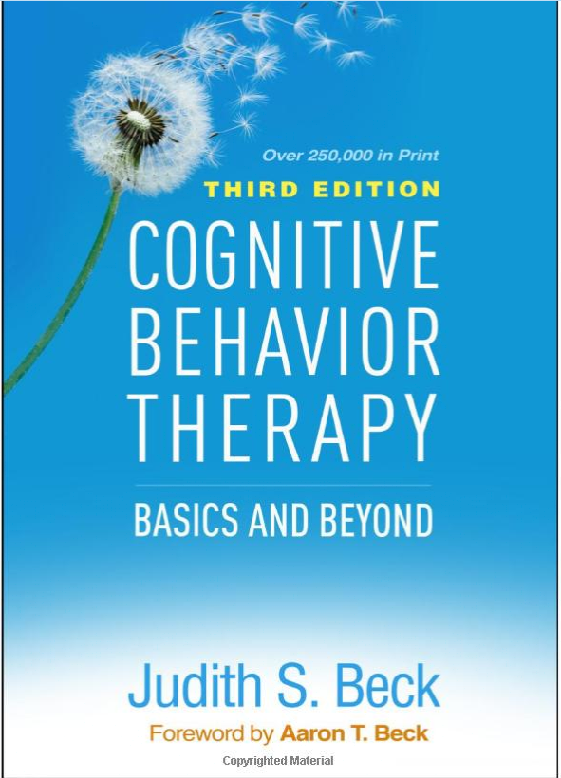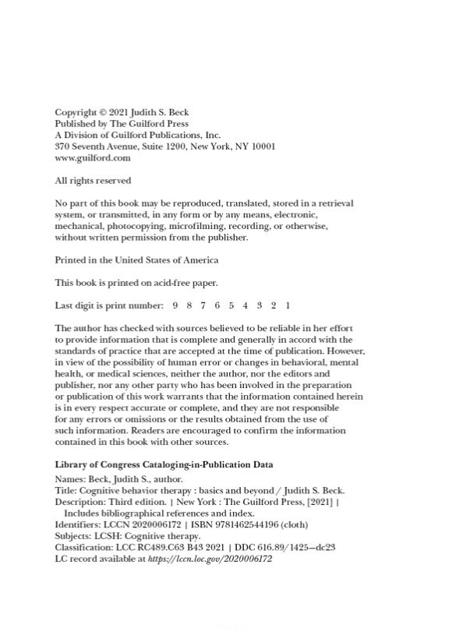
Citation : (Beck, 2021)
Reference :Beck, J. S. (2021) COGNITIVE BEHAVIOUR THERAPY BASICS AND BEYOND. 3rd EDN. New York: The Guilford Press.
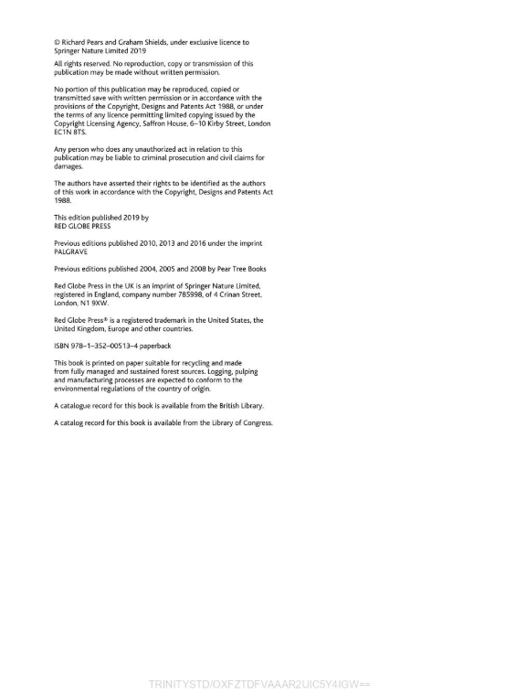
Citation : (Pears and Shields, 2019)
Reference : Pears, R. and Shields, (2019) CITE THEM RIGHT the essential referencing guide. 11th edn. London: Red Global Press.

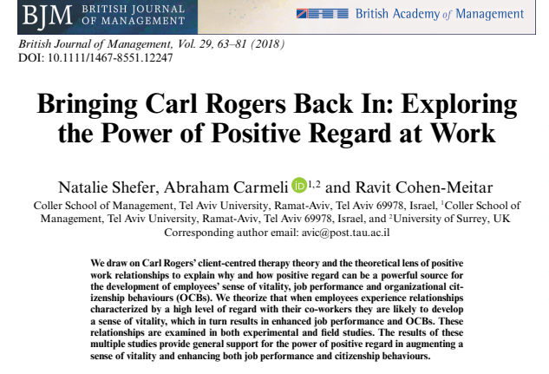

Citation : (Shefer, Carmeli and Cohen-Meitar,2018)
Reference : Shefer, N; Carmeli, A. and Cohen-Meitar, R. (2018) ‘Bringing Carl Rogers Back In: Exploring the Power of Positive Regard at Work’, British Journal of Management, 29(1), pp. 63-81.
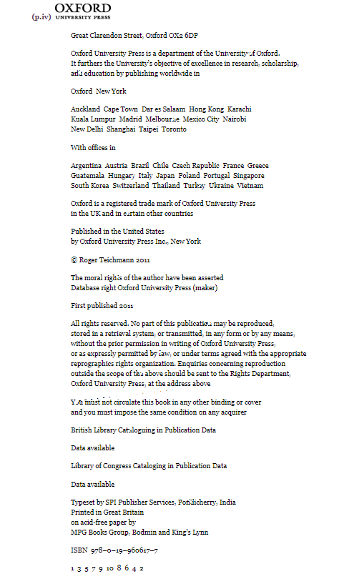
Citation : (Teichmann, 2011)
Reference : Teichmann, R. (2011) Nature, Reason and the Good Life. New York: Oxford University Press.

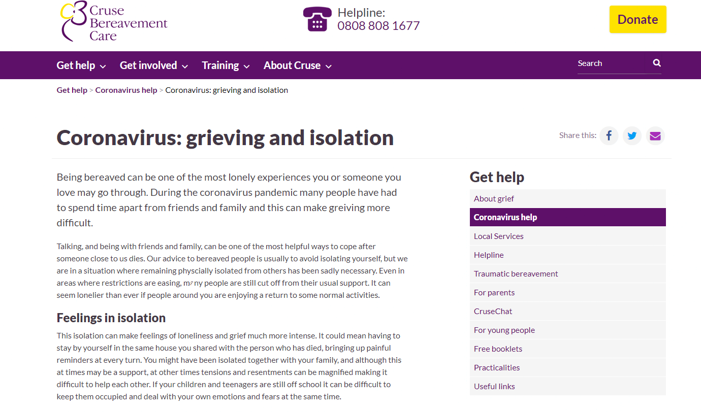

Citation : (Cruse Bereavement Care, no date on website)
Reference : Cruse Bereavement Care. Coronavirus: grieving and isolation. Available at: https://www.cruse.org.uk/coronavirus/grieving-and-isolation (Accessed 05.02.2021).
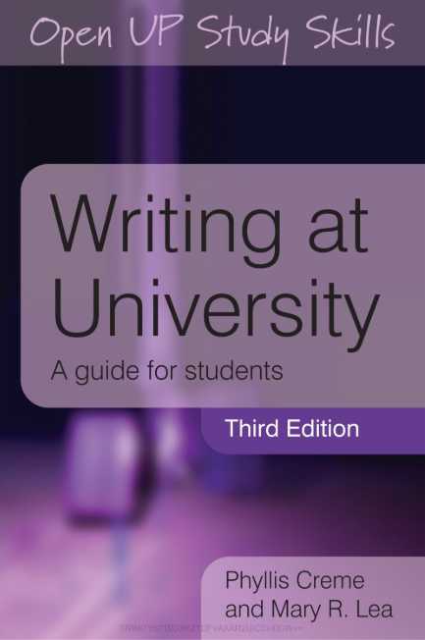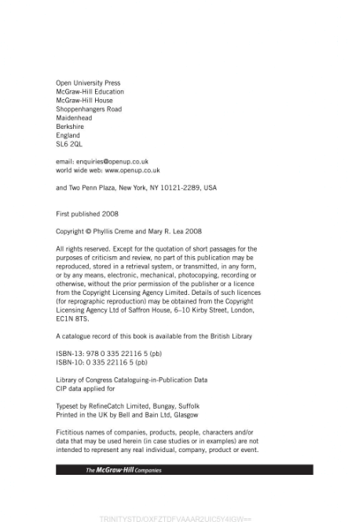
Citation: (Crème and Lea 2008)
Reference: Crème, P. and Lea, M. R. (2008) Writing at University A guide for students. 3rd edn. Maiden Head: Open University Press.

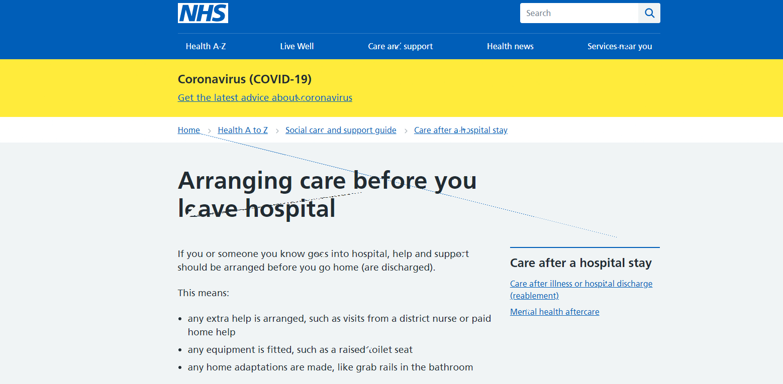

Citation : (National Health Service, 2018)
Reference : National Health Service. (2018) Arranging care before you leave hospital. Available at: https://www.nhs.uk/conditions/social-care-and-support-guide/care-after-a-hospital-stay/arranging-care-before-you-leave-hospital/ (Accessed: 05.02.2021).
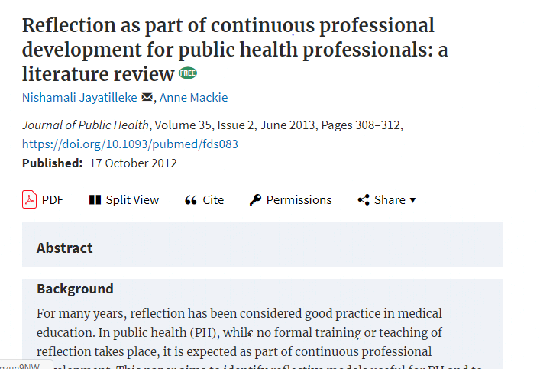

Citation: (Jayatilleke and Mackie, 2012)
Reference : Jayatilleke, N. and Mackie, A. ‘Reflection as part of continuous professional development for public health professionals: a literature review, Journal of Public Health, 35(2), pp. 308-312.

