Malayha Cazley
2325483
BSc Health and Social Care
Building your Personal Brand for
Sustainable Employment
Module: BMHP5015
Lecturer: Olufemi Oluranti
Component 1 – Portfolio
Task 1 – Personal Brand

My Personal Brand
Personal branding is about how people showcase their abilities, principles and career persona to others especially in a professional setting. Creating a personal brand enables individuals to articulate their strengths and establish professional connections that foster career advancement. In health and social care professional identity holds significant importance as professionals are required to exhibit values like empathy, compassion and ethical conduct when engaging with vulnerable individuals.

I would describe myself as a compassionate and understanding individual, especially when engaging with those in vulnerable situations. My life experiences and past roles in care and support have given me a solid grasp of vulnerability and the difficulties certain individuals encounter. These experiences have made me more empathetic and considerate of others.

Another trait I think I have developed is resilience in spite of personal difficulties I have persisted in advancing my education and striving towards my objectives. I think this strength has enabled me to cultivate patience and emotional insight when engaging with others.

I understand that there are aspects where I must improve, especially in communication and networking abilities. Enhancing these skills will assist me in establishing more robust professional connections and broadening my professional network in the health and social care.

Task 2 – Network Map and Rationale
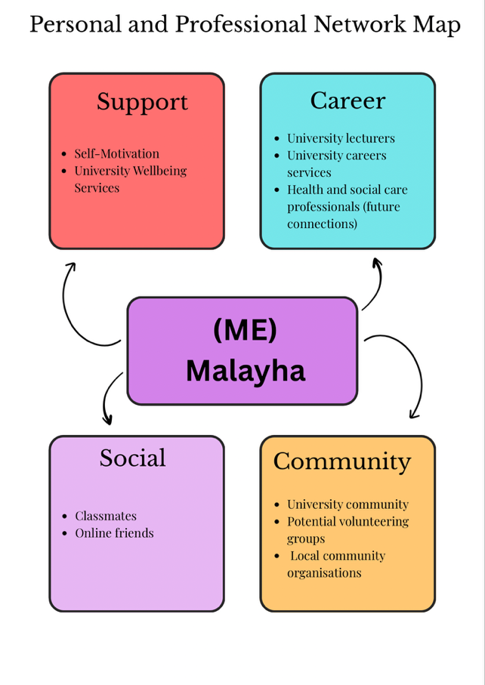
My network can be described as small network as it consists of a relatively small number of connections mainly linked to my university environment. Although my network is not very large it still provides access to some important sources of support and information.

One strength of my network is my connection to the university. This includes lecturers, classmates and university services. Classmates can be helpful because they often share information about coursework or missed lessons through group chats or messages. This helps me stay up to date with my studies University services such as wellbeing or mental health support are also part of my network as they provide professional support when students need guidance or assistance.

According to Putnam’s social capital theory, social networks can provide different types of support including bonding, bridging and linking connections. In my network bonding connections include online friends and classmates who provide social interaction. Bridging connections include lecturers and university staff who help with academic development. Linking connections include university services that provide professional support.

my network does have weaknesses. It is quite small and I currently have limited professional connections within the health and social care sector. In the future I would like to improve my network by attending university events, volunteering and building connections with professionals in my chosen career.

Task 3 – Blog

Why Supporting Children in the Care

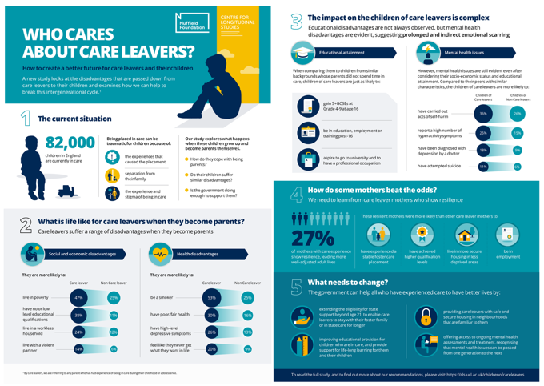
System Matters

Introduction
Kids growing up in the care system often face complex challenges that can affect their mental health, development and sense of stability. Many young people in care systems have experienced trauma like neglect or family breakdown or even difficult life circumstances at an early age Because of this professional working in health and social care play an very important role in supporting vulnerable children and helping them feel safe and heard.

Supporting vulnerable children in the care system matters.

_____________________________________________________________________
Why this matters

Social workers are one of the key professionals responsible for protecting children and ensuring their needs are understood Their role involves working with family's schools and other services to make decisions that priorities the safety and wellbeing of the child Still social work is not only about following procedures or policies. It also requires empathy, patience and strong communication skills when working with young people who may feel unheard or misunderstood.

From my personal experience this topic is really important because understanding vulnerability can help professionals provide better support. Children in care may feel like they do not always have a voice in decisions about their lives. This makes it essential for social workers and care professionals to listen carefully, advocate for them and ensure their wellbeing is prioritized.

_____________________________________________________________________

Conclusion
For students entering the health and social care sector learning about the experiences of children in care highlights the importance of empathy, safeguarding knowledge and professional responsibility. Developing these skills can help future professionals support vulnerable individuals more effectively. providing the right support can make a positive difference.

Task 4 – Equality and Diversity Quiz

1. What is the primary goal of the NHS Equality, Diversity and Inclusion Improvement Plan?

The main goal of the NHS Equality Diversity and Inclusion (EDI) Improvement Plan is to create a fair and inclusive workplace where all staff are treated equally and have the same opportunities. It aims to reduce discrimination and improve the experiences of both staff and patients (NHS England, 2023)

2. How does the NHS EDI Improvement Plan propose to tackle the gender pay gap?

The NHS EDI Improvement Plan aims to reduce the gender pay gap by promoting equal career progression opportunities and ensuring fair pay across different roles. Organizations are also encouraged to review workforce data to identify and address inequalities.

3. What is meant by the term ‘intersectionality’ as used in the NHS EDI Improvement Plan?

Intersectionality refers to how different aspects of a person’s identity such as race gender, disability or social background can overlap and influence their experiences of discrimination or disadvantage.

4. Why is it important for the NHS to create a psychologically safe work environment?

A psychologically safe workplace allows staff to speak openly share ideas and raise concerns without fear of punishment or discrimination. This helps improve staff wellbeing and contributes to better patient care.

5. How does the NHS EDI Improvement Plan suggest improving the experience of internationally recruited staff?

The NHS aims to improve the experience of internationally recruited staff by providing better support, fair treatment, and opportunities for career development. It also promotes inclusive workplace cultures and mentoring opportunities.

6. What role does leadership play in advancing EDI objectives according to the NHS Improvement Plan?

Leadership plays an important role in promoting equality and inclusion by setting clear expectations and ensuring EDI policies are implemented effectively. Strong leadership helps create respectful and supportive workplace environments.

7. Identify one way the NHS EDI Improvement Plan aims to reduce health inequalities within the workforce.

One way the NHS aims to reduce inequalities is by collecting and analyzing workforce data to identify differences in experiences and opportunities among staff from different backgrounds.

8. Why does the NHS EDI Improvement Plan emphasize the importance of collecting and analyzing data on protected characteristics?

Collecting data on protected characteristics helps organizations understand where inequalities exist within the workforce. This information can then be used to develop strategies that improve equality and inclusion.

9. Explain how flexible working policies can contribute to equality and inclusion in the NHS workforce.

Flexible working policies allow staff to balance work with personal responsibilities such as caring duties health needs or family commitments. This can make the workplace more inclusive and supportive.

10. What is one strategy mentioned in the NHS EDI Improvement Plan to combat bullying and harassment in the workplace?

One strategy is creating clear reporting systems so staff can safely report bullying or harassment. Organizations are also encouraged to promote respectful workplace cultures and take action against inappropriate behavior.

Task 5 – A Letter to Yourself

Dear younger me

Looking back at a difficult period in my life I now recognize how challenging it was for my wellbeing and mental stability. At the time I was dealing with a lot of uncertainty and constant change and I did not always understand how to manage my emotions or respond to difficult situations. This sometimes made it harder to cope with stress and the challenges around me.

After studying this module, I have learned more about social awareness and Adaptability I can now see how these skills could have helped during that time. Emotional awareness or being self aware involves recognizing and understanding emotions both in ourselves and in others. If I had understood this earlier, I may have been able to reflect on my feelings more clearly and respond to situations in a calmer and more constructive way.

Resilience is another important concept that I have learned about during this module. Resilience does not mean avoiding difficulties but instead developing the ability to adapt and continue moving forward despite challenges. Looking back, I realize that many of the experiences I went through required resilience even if I did not recognize it at the time.

If I could give advice to my younger self I would encourage myself to be more aware of my emotional responses and to seek support when needed. Developing emotional awareness and resilience earlier could have helped me manage difficult situations more effectively and maintain better wellbeing.

Reflecting on this experience has helped me understand the importance of these skills particularly for anyone working in health and social care where emotional awareness and resilience are essential.

Task 6 – Gantt Chart
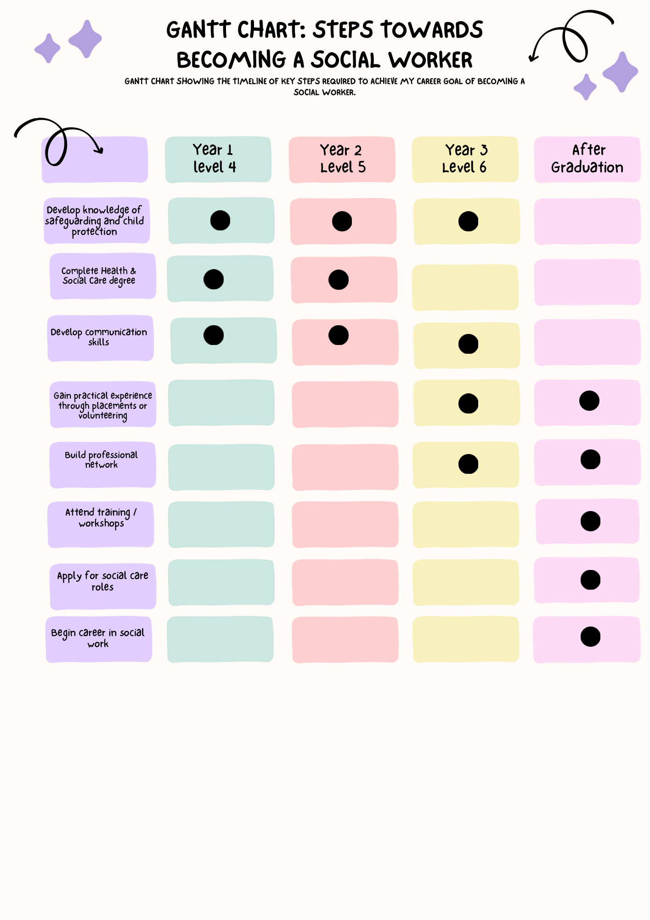

Task 7 – Making Changes Report

Introduction

I will be looking at introducing a digital note taking system in a care home setting. From my experience working in support work documentation was often completed on paper which could be time consuming and difficult when staff were busy supporting residents.

Planning the Change

In many care settings staff are required to record notes regularly throughout the day such as documenting interactions meals and activities. During my experience in support work staff often had to remember information and write notes later due to time pressures. Introducing a digital system potentially including voice to text technology could allow staff to record notes quickly by speaking into a device improving accuracy and efficiency while ensuring that important information is recorded in real time. as digital technologies have been shown to improve the efficiency of healthcare delivery (National Library of Medicine, 2023)

Skills Required

Implementing this change would require leadership communication and simple digital literacy skills Managers would need to guide staff through the transition provide training and ensure that staff feel confident using the technology within their daily care routines.

Barriers and Solutions

A possible barrier could be staff resistance to using new technology particularly for those who may be unfamiliar with digital systems. To overcome this training and support should be provided to ensure staff feel comfortable using the system Another barrier could be financial costs associated with purchasing devices or software however digital documentation could improve efficiency and reduce the risk of errors which may benefit care quality in the long term. improving efficiency and service delivery is a key focus within healthcare systems (Crown Commercial Service, n.d)

Task 8 – Self Reflection Gibbs Reflective Cycle

Description

During this module I explored several topics related to health and social care including leadership innovation and organizational change Much of my learning came from reviewing the module materials available on the learning portal and completing independent research. These topics helped me develop a better understanding of how services such as the NHS and social care organizations operate and how improvements can be made within these systems.

Feelings

At first I felt unsure about some of the concepts discussed within the module particularly around leadership and change management in health and social care organizations. However as I continued reviewing the learning materials and conducting my own research I began to feel more confident in understanding how these theories apply to real world care settings.

Evaluation

One positive aspect of this module was learning how theoretical concepts can be applied to real practice in health and social care. The topics helped me understand the importance of leadership, communication and equality within care services I recognize that I could have engaged more consistently with the module throughout the term.

Analysis

Through this learning experience I realized that leadership and innovation play a significant role in improving the quality of care services. As someone who has personal experience with the care system these insights helped me reflect on how services could better support vulnerable individuals.

Conclusion

Overall, the module helped me gain a broader understanding of the health and social care and the challenges faced by care services hat support vulnerable populations.

Action Plan

In the future I plan to continue developing my understanding of health and social care policy and leadership as I progress through my studies. I will also aim to engage more consistently with module materials to strengthen my learning.

Reference list
Academy of Medical Royal Colleges (2020) Developing professional identity in multi-professional teams.
https://www.aomrc.org.uk/wp-content/uploads/2020/05/Developing_professional_identity_in_multi-professional_teams_0520.pdf

Cote, C. (2024) Personal branding: What it is and why it matters. Harvard Business School Online.
https://online.hbs.edu/blog/post/personal-branding-at-work

Putnam, R. (2000) Bowling Alone: The Collapse and Revival of American Community. New York: Simon & Schuster.

Thompson, K. (2025) Social capital theory: Robert Putnam, bonds, bridges, and civic engagement. ReviseSociology.
https://revisesociology.com/2025/08/14/social-capital-theory-robert-putnam-bonds-bridges-and-civic-engagement/

NSPCC (2025) Children in care (looked after children).
https://learning.nspcc.org.uk/children-and-families-at-risk/children-in-care#article-top

Cheraghi, R., Ebrahimi, H., Kheibar, N. and Sahebihagh, M.H. (2023) Reasons for resistance to change in nursing: An integrative review. BMC Nursing, 22(1), pp. 1–9.
https://doi.org/10.1186/s12912-023-01460-0

Crown Commercial Service (2023) Health | NHS procurement.
https://www.crowncommercial.gov.uk/sectors/health
Gibbs, G. (1988) Learning by Doing: A Guide to Teaching and Learning Methods. Oxford: Oxford Polytechnic.

