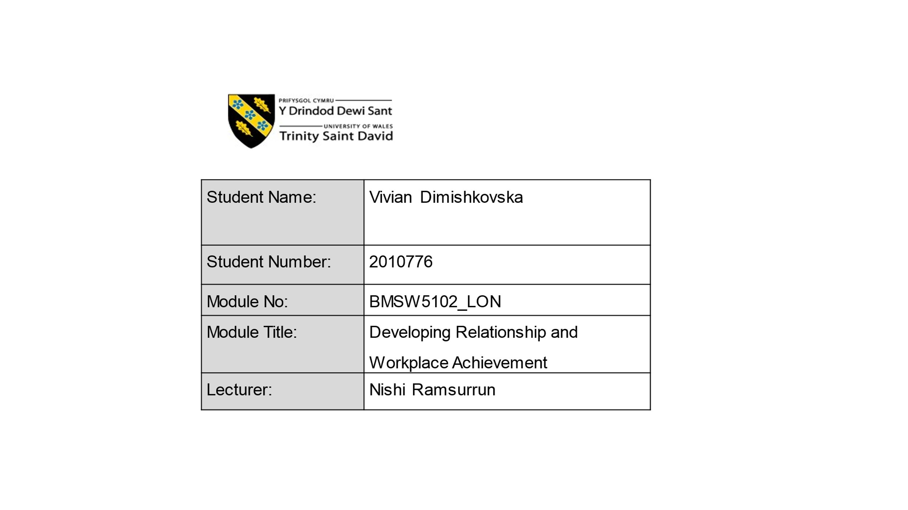

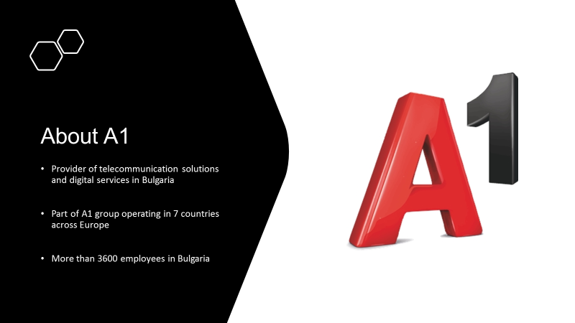

A1 Bulgaria is a market leader in providing communications, financial, entertainment, and integrated business solutions. Offering mobile and fixed-line services, high-speed broadband internet, satellite television, its own interactive television platform, four sports channels under the MAX Sport brand, financial services, information technology and cloud computing.
Almost 3,600 personnel and cutting-edge internet infrastructure support digital business and lifestyles, enabling individuals and businesses to connect anywhere, at any time.
The company is a subsidiary of A1 Group, a market leader in Central and Eastern Europe for digital services and communications solutions, as well as integrated business solutions, with approximately 25 million customers in seven countries: Austria, Bulgaria, Croatia, Belarus, Slovenia, North Macedonia, and Serbia.
A1 places a premium on trust and loyalty, viewing them as the bedrock of all relationships with clients, partners, investors, and workers. As a member of the A1 Group, A1 Bulgaria abides by all applicable laws and moral values.
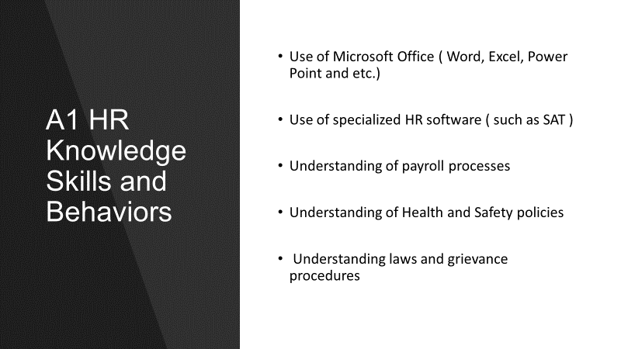
To determine the necessary knowledge, abilities, and behaviours, I will need to study the primary tasks of a human resources officer, which are listed in Appendix. A
It is critical to comprehend employment legislation and to execute various procedures such as grievance and disciplinary procedures, as well as to counsel employees on compensation, benefits and promotions. Consistent updating and study is also important to keep abreast of any modifications or additions to the legislation. IT skills necessary for everyday use of Microsoft Office, Microsoft Excel, and PowerPoint are must,as well as daily use of the HR software.
Understanding the health and safety laws that apply to each job role is critical for everyone working in the human resources department.

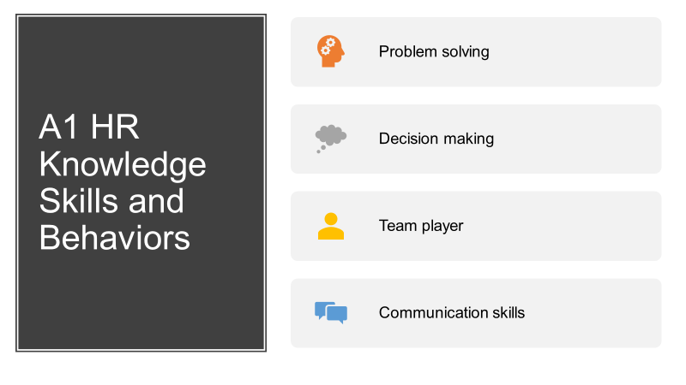
As part of my daily responsibilities, I'll be collaborating with department managers and employees, which means I'll require strong communication skills. Excellent English abilities (writing and reading) are necessary, as is a working knowledge of the terminology used in generating any relevant documents.
Decision-making ability is a vital component of the recruiting process. Additionally, this procedure requires the ability to plan and conduct interviews, as well as the production of job descriptions, job advertisements, and application forms.
I must be an excellent team player in order to effectively communicate, cooperate, and work closely with a variety of different departments and personnel.
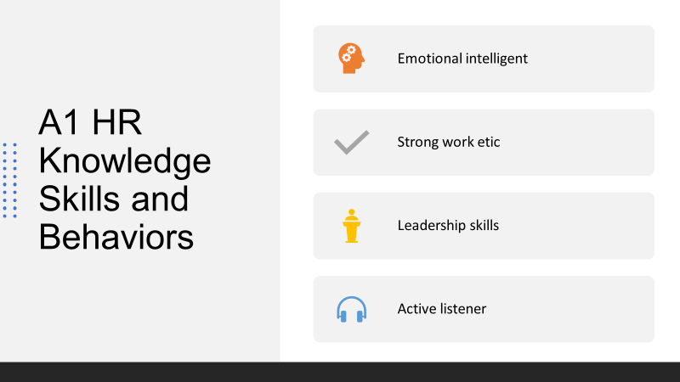
Being emotional intelligent, means having the capacity to recognise, utilize, and control one's own emotions constructively to alleviate stress, communicate effectively, empathize with others, overcome obstacles, and defuse conflict
A good work ethic demonstrates employee’s dedication to seeing a job through, regardless of how challenging it becomes. Developing resolve and tenacity will enable to accomplish tasks more effectively, work for extended periods of time, and remain focused on the subject at hand without feeling disappointed or disheartened.
Working as an HR officer determines the need of leadership skills which are in the bases of influencing individuals or group of people.
The active listening skills is essential part of the job duties of an HR officer, because it is the ability to engage a conversation with the colleagues on positive way, without judgment.
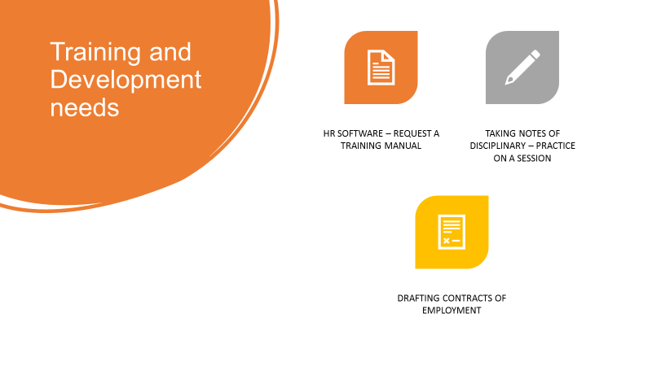
By completing the personal skills audit form (see attachment B), I was able to ascertain my knowledge and skill gaps and identify necessary training for my role as an HR officer. In general, my problem-solving abilities are rather good. In terms of technology, I have no prior experience dealing with the company HR software, I will request that the organisation supply a manual/description guide for the application. Concerning communication skills, I lack information regarding how to prepare contracts and also take disciplinary notes, which may be practiced during a training session with an experienced employee from the company.
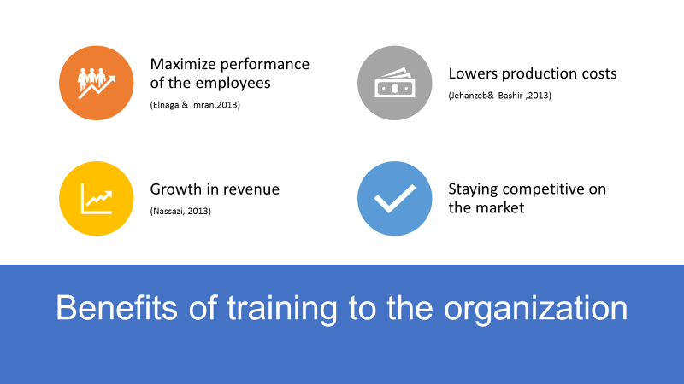
To determine the benefits of training employees to the organisation I have reviewed some studies and journals. According to the researchers, there are many benefits for the organization, however I have stated a few, which in my opinion are the most significant ones. On first place the appropriate training can maximize the performance of the employees. Achieving that performance boost, the organisation can benefit of lower production costs and there after increase the overall revenue. Last, but not least the organisation will be more competitive on the market.
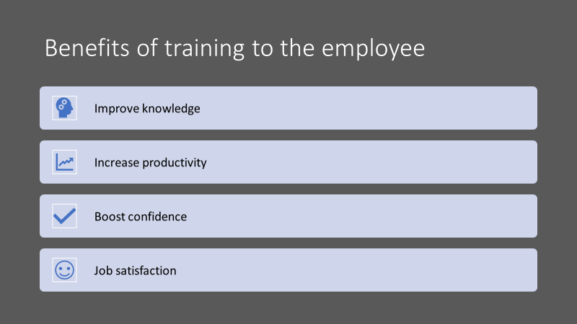
As a trainee HR officer, acquiring the proper training from the company I will profit from strengthening my knowledge gaps. Developing specialized knowledge and abilities I will be able to be more productive and more confident when dealing with everyday operations. Finally, I will be able to enjoy the work process and feel content of my advancement in the organisation.


Appointed as a trainee HR Officer in A1 Bulgaria, my task was to develop understanding of my role in the organization. To do that I have determined what are the knowledge, skills and behaviours required by the HR professionals. By conducting personal skills audit I have found my knowledge and skill gaps and recommended appropriate training needs. By reviewing some studies and journals, I managed to determine some of the benefits of training for the organization. Finally, I evaluated my own benefits from receiving an appropriate training from the company.
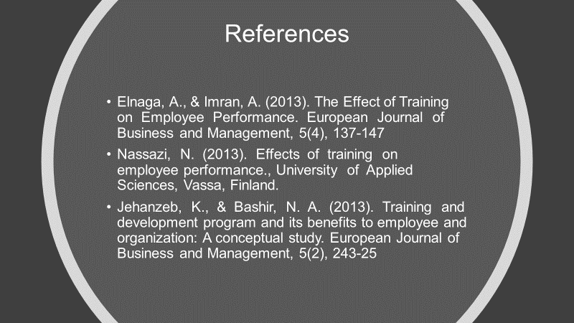

Appendix A

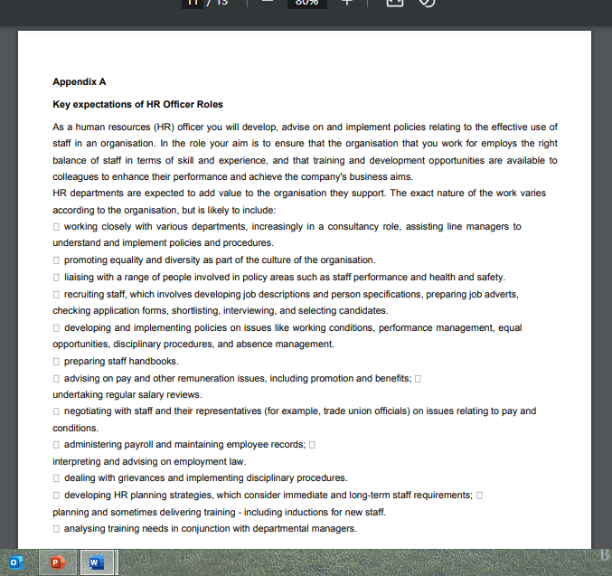

Appedix B


