

University of Wales Trinity Saint David

School of Engineering

Design for X Projects

Kyle Edward Evans

2029909

Mechanical and Manufacturing Engineering

03/07/2023

ACMA5002 – Manufacturing Design & Technology

Table of Contents
List of Figures 2
General Introduction 3
Task One: DFAM Case Study 4
Introduction 4
Background 4
Design for Additive Manufacturing Application 6
Generative Design Process 6
Optimising for Direct Metal Laser Sintering 8
Analysis 10
Design Failure Mode and Effects Analysis 10
Limitations of Additive Manufacturing 11
Final Rendering of the Vice Jaws 11
Conclusion 12
Task Two: Portable Wind Turbine Redesign (2,500) 13
Introduction 13
Concept Design Appraisal 13
Quality Functional Deployment 13
Design Specification 14
Manufacturing Process Proposal 15
Cost Drivers 15
Design and Development Work Undertaken 16
Draft and Undercut Analysis 18
Conclusion 19
Bibliography 20
Appendices 24
Appendix A 24
Appendix B 24

List of Figures
Figure 1 Original Vice Jaw Components. Source: Self-created in Solidworks (Evans, 2023) 4
Figure 2 Removing Undercuts vs Adapting Them. Source: Self-created in Solidworks (Evans, 2023) 7
Figure 3 Allocating Geometric Constraints and Specifying Loads. Source: Self-created in Fusion 360 (Evans, 2023) 7
Figure 4 Generative Outcomes. Source: Self-created in Fusion 360 (Evans, 2023) 8
Figure 5 Section Analysis to Demonstrate Shelling Operation. Source: Self-created in Fusion 360 (Evans, 2023) 9
Figure 6 Testing Build Volume for Printing. Source: Self-created in Solidworks (Evans, 2023) 9
Figure 7 Final Rendering of the Vice Jaws. Source: Self-created in Solidworks (Evans, 2023) 11
Figure 8 Quality Functional Deployment of the Windturner. Source: Self-created in Visio (Evans, 2023) 13
Figure 9 Component Consolidation with Snap Hooks. Source: Self-created in Solidworks (Evans, 2023) 16
Figure 10 Three Crush Ribs for a Press Fit Bearing. Source: Self-created in Solidworks (Evans, 2023) 17
Figure 11 Exploded View of the Subassembly Redesign. Source: Self-created in Solidworks (Evans, 2023) 17
Figure 12 Results of the Draft Analysis. Source: Self-created in Solidworks (Evans, 2023) 18
Figure 13 Designing the Snap Hook with a Shut-Off. Source: Self-created in Solidworks (Evans, 2023) 18
Figure 14 Stainless Steel Outcome. Source: Self-created in Fusion 360 (Evans, 2023) 24
Figure 15 FSWizard Calculation Report. Source: Self-created in FSWizard (Evans, 2023) 24

General Introduction
The following report explores how modern manufacturing methods enable the design of complex components and the necessary steps to prepare a product for mass production—starting with a case study that applies the design for additive manufacturing principles to an existing component and concluding with a review of the manufacturability of a prototype assembly. Both tasks will utilise various analytical tools to justify design changes and capitalise on their manufacturing processes. Meanwhile, the digital design work leverages the strengths of SolidWorks and Fusion 360. The former will handle most of the workload. The latter will be helpful as it can use machine learning to generate designs within user-defined constraints (Autodesk, 2023); while this is well suited for additive processes, it can also generate parts for subtractive methods.

Task One will detail the steps to redesign a component using the Design for Additive Manufacturing (DFAM) principles. Furthermore, background research into the product and the manufacturing process's strengths, weaknesses, and constraints is necessary to understand the requirements better. Similar research is necessary for Task Two. However, the emphasis is on adapting the current design to facilitate the production of approximately 1000 to 2000 units a week. This report aims to achieve these goals by conducting research and utilising the appropriate methods to analyse and evaluate the design and development work, considering the design for excellence principles specified in each task.

Task One: DFAM Case Study

Introduction
Soft jaws are one of the most common fixturing techniques in machining and are often necessary when making complex components. Typically, subtractive methods like milling and grinding are necessary to manufacture vice jaws (Tormach, 2017; NYC CNC, 2021). However, additive technologies are also becoming a reliable and cost-effective solution for prototyping and low-volume parts for manufacturing enterprises (TCT Magazine and Altair, 2020; Bromberger, Ilg, and Miranda, 2022). This task will explore how applicable the DFAM principles are by applying them to a set of jaws that have seen significant use in a production machine shop. Figure 1 looks at the original jaw assembly and the two in use. An existing set of steel jaws was modified by drilling and tapping M10 holes into the face to affix the blocks. The company chose this route to save on material costs and speed up the production of the prototype components. Each vice jaw has three components: the body, clamping blocks, and an M10 socket head cap screw.

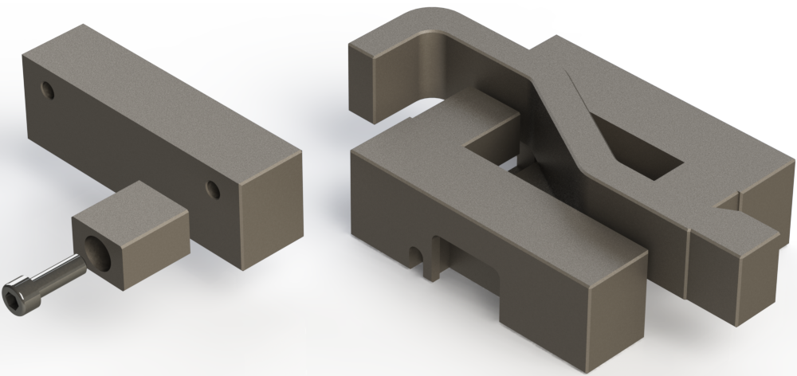
Figure 1 Original Vice Jaw Components. Source: Self-created in Solidworks (Evans, 2023)

Background
Since the initial prototypes, the company has received repeat orders for these components and may benefit from the introduction of dedicated jaws. While they have been capable of serving their purpose, their assembly often leads to longer setup times, with the work-holding accuracy needing to improve. The current situation also calls for using a riser block to lift the component high enough to reach the final machining depth due to a change in procedures and machining operations. One of the most significant drawbacks of the current design, along with those above, is the complexity of the setup. The additional component introduces points of failure for the setters and operators. For example, if the blocks are not bolted correctly to the jaw faces, the component will shift or potentially lack rigidity. Similarly, if the operator were to trap waste material between the riser and the vice top between cycles, the parallelism of machined features would suffer.

These problems are solvable through the introduction of new jaws that consolidate the individual components of the assembly into one and can firmly grip the part along its entire profile. While these are manufacturable through subtractive means, some manufacturers adopt additive technologies to produce them concurrently, allowing the machines to fulfil other orders (Stratasys, 2023; Behrens-Thomsen, 2023). Not only does this reduce production downtime, but three-dimensional printing is especially suitable for lights-out production, only requiring the operator to conduct finishing tasks the following day. Depending on the precision and use case, these components are typically steel or a continuous fibre material like carbon fibre (Trimech, 2023; Markforged, 2023). Despite these advantages of additive manufacturing, some features of the existing design may prove difficult to replicate using the current technology.

The vice the company uses as a standard across all machines features a quick-change mechanism for the jaws to facilitate speedy changeovers and reduce production downtime (Chick Workholding, 2009; Penn Tool Co., 2011). As a part of this mechanism, the jaws require an undercut to accept a moving clamp and prevent the jaw from pushing away from the mating surface. Undercuts, or overhangs, are inadvisable on components manufactured using three-dimensional printers (Bintara et al. 2019). These are especially detrimental to equipment that utilises fusion deposition modelling technology and will require support or clever reorientation of components on the print bed if necessary (Kondo, 2022; O'Neill, 2023). Depending on the analysis undertaken on the vice jaw, an alternative fixturing method is available using two M10 bolts on the mating surface of the vice, assuming clearance for the clamping mechanism is maintainable in the design.

Design for Additive Manufacturing Application
Before initiating the design work, a clear understanding of the practical applications of the technology is necessary. To start with, some have experimented with the uses of non-planer three-dimensional printing with both three and five-axis machines (Ahlers, 2018; TAMS UHAM, 2019; Hong et al., 2023), as it can reduce the effects that gravity may have on certain overhanging features and improve stress performance by printing in multiple orientations to reduce the risk of delamination as is present in planer printing solutions (Eckhoff, 2022). Despite these advantages, this report will instead approach the project with the intention of producing a manufacturable component through the latter means since the benefits gained do not outweigh the complexity of non-planer solutions. Also, since most commercial and industrial machines are only capable of movement along three-axis, with fused deposition modelling and selection absorption fusion among the most popular methods for industry (Grand View Research, 2023), using a five-axis printing approach is beyond most companies.

One of the most significant benefits of additive manufacturing is its effects on the environment compared to subtractive manufacturing methods. Javaid et al. (2021), Agnusdei and Pretei (2022), and Sandvik (2023) agree that the process is more environmentally friendly due to the ability to produce components using less material with less waste. One study by AMPOWER GmbH & Co. KG (2022) concludes that while the process itself may not exhibit a substantial change in CO2 emissions, the efficient use of materials and weight reduction in parts will strongly reduce CO2 emissions due to the embodied carbon in raw materials. Machine shops specialise in subtractive methods, often using numerically controlled lathes, mills, and grinders to shape and refine stock material into components while producing significant waste. Using additive technologies to produce work holding and tooling for internal use can assist in a more considerable sustainability effort by reducing waste while also improving productivity and minimising downtime.

Generative Design Process
While there are many principles to the design for additive manufacturing philosophy, the ones most appropriate to this component are component consolidation, internal structures, and mass customisation. Preparing the following component is reproducible and applicable to creating similar work-holding solutions. Generative design is a standard tool in designing components using this philosophy, which uses machine learning algorithms to generate parts within user-defined constraints (Autodesk, 2023). The tool requires the user to define preservable and obstacle geometries, structural loads and constraints, manufacturing methods, and desirable materials for the generative study. By understanding the functional requirements of the final product, these boundary conditions can result in a product that utilises very little material while maintaining maximum stiffness. Alternatively, a tool known as topology optimisation can produce similar results; however, it requires an initial design to simulate and subtract material to achieve the desired weight. Hargude and Patil (2014) reduced the weight of a rear vice jaw for a horizontal band saw by twenty-four per cent by applying these techniques.

Before moving the solid bodies from Solidworks to Fusion 360, a reassessment of the jaws' clamping features is necessary. As previously mentioned, the initial design calls for an undercut; however, this is optional. As seen in Figure 2, setting the cut-extrusion to through all instead of blind results in a component without any undercuts, assuming the print orientation matches. The issue with this design choice is that this will create a pocket for waste material to fill during machine operation, potentially interfering with and damaging the clamping mechanism. Rather than risking operational failure, an alternative is to make the overhang printable. According to Kondo (2022) and O'Neill (2023), the most reliable method of producing overhangs using additive technologies without supporting structures is to avoid angles exceeding 45 degrees. In this instance, neither the clamp nor the locating pin is in contact with the roof of the overhang.

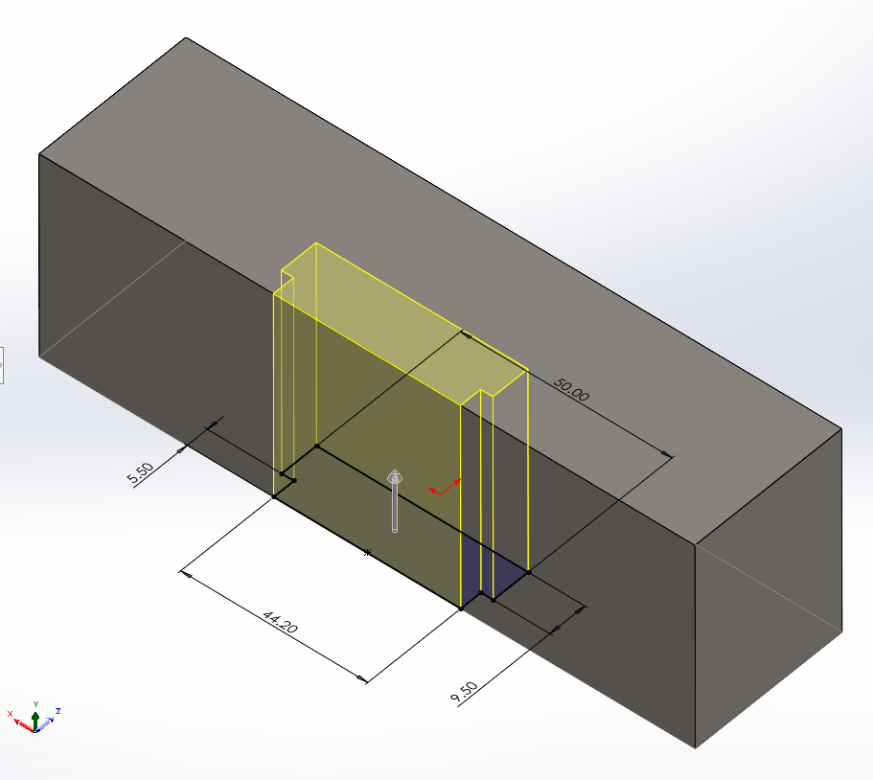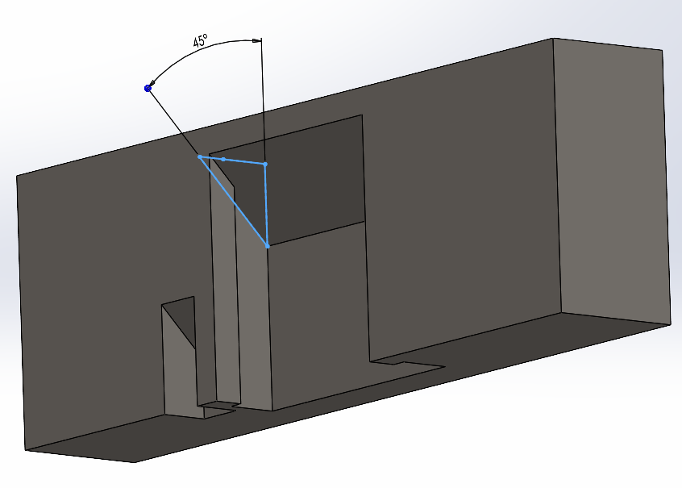
Figure 2 Removing Undercuts vs Adapting Them. Source: Self-created in Solidworks (Evans, 2023)

Generative design requires the allocation of geometry to bodies in the design space, specifying which to preserve and what is removable. For a vice jaw, the mating surfaces for both the vice body and held component appear green in Figure 3. The yellow is the starting shape and helps the software produce a satisfactory result. Red bodies represent obstacles and are invaluable as they restrict where the software can allocate material; for clarity, they are transparent in the figure below. Another necessary element of the process is to specify the structural loads the component must be able to withstand. Initially, a value of approximately twenty-seven kilonewtons appears appropriate as this is the maximum clamping force of the vice (Chick Workholding, 2009). However, in use and reflection, this value was excessive and resulted in a component only producible in type 304 stainless steel, costing as much as £931 (see Appendix A for these results).

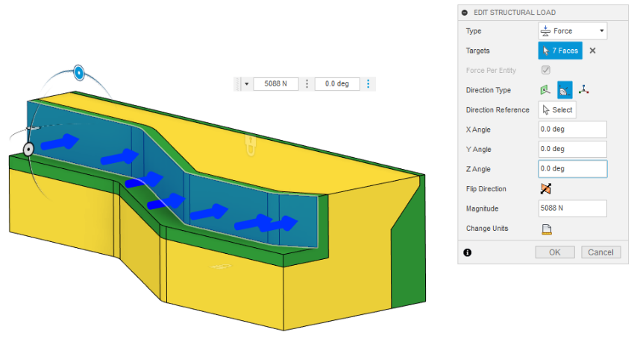
Figure 3 Allocating Geometric Constraints and Specifying Loads. Source: Self-created in Fusion 360 (Evans, 2023)
Since the previous results are impractical and expensive, the second iteration of the design uses the necessary clamping force for the cutting forces that will be prevalent during operation. These jaws are only used during the second operation to remove excess clamping stock from the previous setup. For this, a twelve-millimetre end mill follows the perimeter of the final component in a slotting action to quickly part the excess. Rather than calculating the cutting forces manually, the FSWizard Pro software details all relevant information when calculating the speeds and feeds (See Appendix B for the report). The software returns a value of 77.83 kilograms, approximately 763.25 newtons. According to information on the Carr Lane Manufacturing (2023) website, the clamping force is equal to the cutting forces divided by the static friction coefficient, which is 0.15 for steel-on-steel surfaces. This calculation results in a necessary clamping force of 5,088 newtons or 10,176 newtons with a safety factor of 1.5 to account for irregularities and prevent premature failure.

The abovementioned changes resulted in a new study that successfully produced two convergent designs, one in type 304 stainless steel and the other in aluminium. Both are printable using direct metal laser sintering technologies (Xometry, 2023a). Fusion 360 estimates that the former will cost approximately £585 to produce, while the latter costs £353. Figure 4 is an overview of the outcome recommendations the software provides; note that the bottom two are plastic simulations, resulting in failures to converge and meet the boundary conditions regarding maximum displacement and structural loads. As such, the materials are deemed unfit for use in this component.

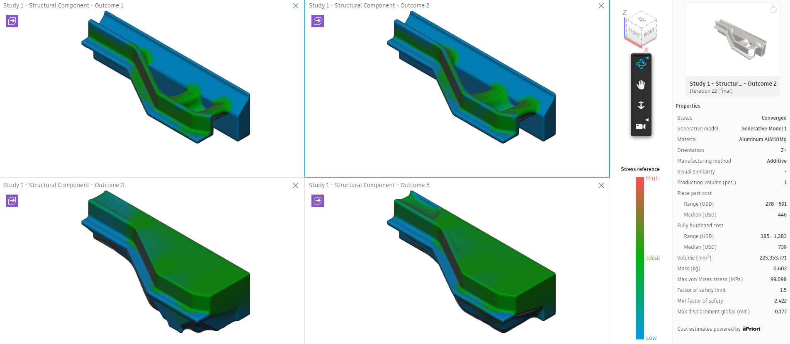
Figure 4 Generative Outcomes. Source: Self-created in Fusion 360 (Evans, 2023)

Optimising for Direct Metal Laser Sintering
Considering the study results, outcome number two, which uses aluminium AlSi10Mg, is likely the best option for a machine shop. However, the cost of the jaws in their generative design state is far too expensive, but there is room for improvement. For starters, the cost approximations consider the part of being a solid aluminium block. However, an advantage of direct metal laser sintering is that it can be hollow if the un-sintered material is removable through an exit hole or slot of at least 3.5 millimetres in diameter (Materialise, 2023). Figure 5 reveals the outcome of the shelling operation using a section analysis. This one change reduces the mass by 135 grams and is worth approximately £18.50, according to information provided by the MSE Supplies website (2023).
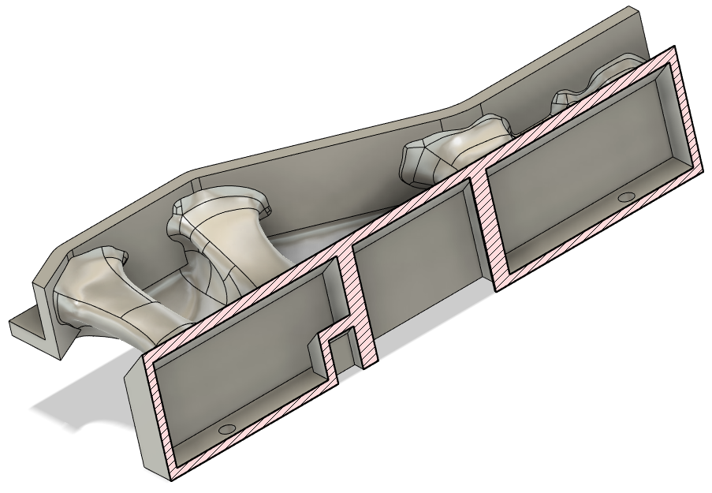
Figure 5 Section Analysis to Demonstrate Shelling Operation. Source: Self-created in Fusion 360 (Evans, 2023)

If these changes prove detrimental to the jaw's performance, ribs can be strategically placed within the hollowed sections to provide additional rigidity. While not utilised in this task, one benefit of three-dimensional printing is that internal structures like lattices are readily producible to increase strength and reduce the weight of parts (Shields, 2023). Another aspect to consider concerning additive manufacturing is the efficient use of build volume; ideally, the printer will produce multiple parts during the same operation. According to Xometry (2023a), a website dedicated to on-demand manufacturing, the maximum build volume for direct metal laser sintering is 400 x 400 x 400 millimetres. Knowing this, Figure 6 offers a solution to optimising the build volume for producing sets of vice jaws. Since the two jaw profiles use the original components' shape through combined subtraction in Solidworks, they can nest to reduce the wasted volume in the machine. This solution uses 200 x 111 x 50 millimetres, allowing the machine to print three sets simultaneously using the current orientation, with the potential to optimise for more.

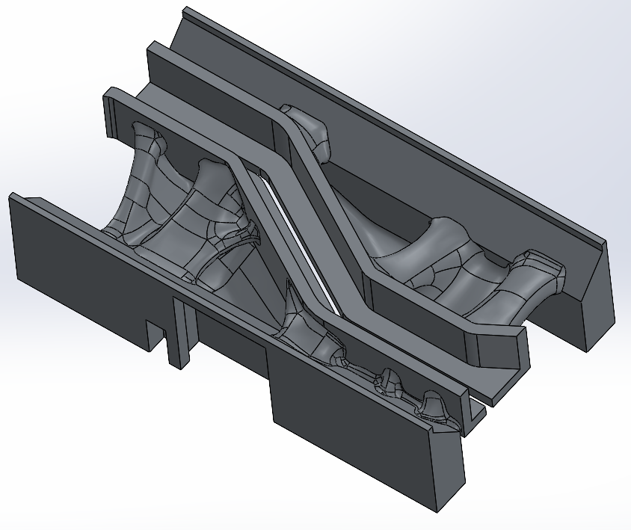
Figure 6 Testing Build Volume for Printing. Source: Self-created in Solidworks (Evans, 2023)

Analysis

Design Failure Mode and Effects Analysis
Considering the purpose of this task, a way of analytically comparing the original design with the new one is necessary. The design failure mode and effects analysis (DFMEA) will result in a risk priority number; the abbreviation is RPN (Eisner, 2022), a numerical method of comparing previous failure modes with actions taken to mitigate them in the new design. Table 1 consists of the DFMEA for the original component, note that most, if not all, failures are preventable by incorporating new jaws that consolidate the several components of the design into two single vice jaws. While there are alternative methods to prevent them, the most effective would be reassessing and redesigning the existing work-holding and processes.

Table 1 DFMEA for Original Components. Source: Self-created in Excel (Evans, 2023)

The table above provides a clear understanding of the potential failures that the subject of this task seeks to improve. By consolidating the clamping and riser blocks into the jaws, the design reduced the number of components from six to two. Also, the extension of the clamping faces encapsulating more of the component profile results in a manufacturing process that reduces the likelihood of operator mistakes, otherwise known as Poka-Yoke, since the jaws can only hold the components in a single orientation. Table 2 analyses the potential failure modes of the new design. Despite solving most of the issues associated with the original jaws, the new design has some drawbacks. The most severe is the potential to overtighten the vice since the jaws can only withstand the cutting forces. If an operator tightens the vice to the maximum, the jaws will likely distort and fail prematurely.

Table 2 DFMEA for New Components. Source: Self-created in Excel (Evans, 2023)

Limitations of Additive Manufacturing
Direct metal laser sintering, an exciting technology that can produce complex components, has several limitations and disadvantages compared to traditional subtractive manufacturing methods. For starters, it can be costly to produce specific components and will often require additional post-processing (Xometry, 2021; Bakhshivash, 2022). The vice jaws, for example, will need machining operations for both clamping features for the component and vice mounting mechanisms due to shrinkage and porosity. The vice jaws may also require heat treatment and stress-relieving, affecting dimensional accuracy. The design must account for them and be printed at a larger scale than the final component to facilitate final machining. For these reasons, it is unlikely that many machine shops will be willing to finance these endeavours, as the alternatives are significantly less time-consuming and require identical machine setups as the three-dimensionally printed alternatives.

Final Rendering of the Vice Jaws

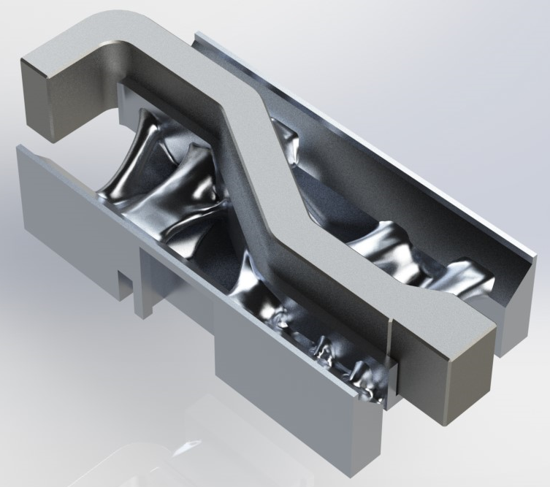
Figure 7 Final Rendering of the Vice Jaws. Source: Self-created in Solidworks (Evans, 2023)

Conclusion
Task One ends in a semi-success and includes the application of additive manufacturing principles to the subject component. It includes generative design, component consolidation, build volume optimisation, and mass customisation, as the jaw base can easily suit another component by modifying the starting shape while retaining the preservable regions. However, following the analysis, the design could be more suitable for machine shops, like the one the original component originates. The time it took to design and generate the solutions vastly exceeds the time it would have taken to manufacture an alternative using subtractive technologies. Despite this conclusion, there is potential here. More experience and a better understanding of the technology might improve both the workflow and print optimisation of the components.

Task Two: Portable Wind Turbine Redesign (2,500)

Introduction
Additive manufacturing is an exceptional tool for prototyping and producing complex components. However, it currently does not suit mass production (Costabile, 2017: Slant 3D, 2023). Therefore, this task will focus on reviewing and adapting the Windturner, a portable wind turbine, to facilitate the production of 1000 to 2000 units a week. Furthermore, as stated by Cubas (2022a; 2022b), the product's purpose is to act as a backup source of electricity while away on expeditions and can recharge NP-F970 batteries using the wind. Hence, this section will follow a structured approach by appraising the initial concept and developing a design specification before assessing the manufacturability of the current product and offering suggestions on how redesigning certain aspects for assembly and manufacturability might improve prospects.

Concept Design Appraisal

Quality Functional Deployment
Before any significant redesign work can commence, a quality functional deployment analysis, as shown in Figure 8, is conducted to identify customers' most desired traits and translate them into quantifiable design constraints. Two additional products that serve similar purposes have been selected for a more comprehensive analysis and are discussed further following the analysis. The purpose of this analysis is to understand what to prioritise during the design and development stage of the project by looking at both shortcomings and strengths of the concept design. The results of the quality functional development prove helpful in the development of a design specification.

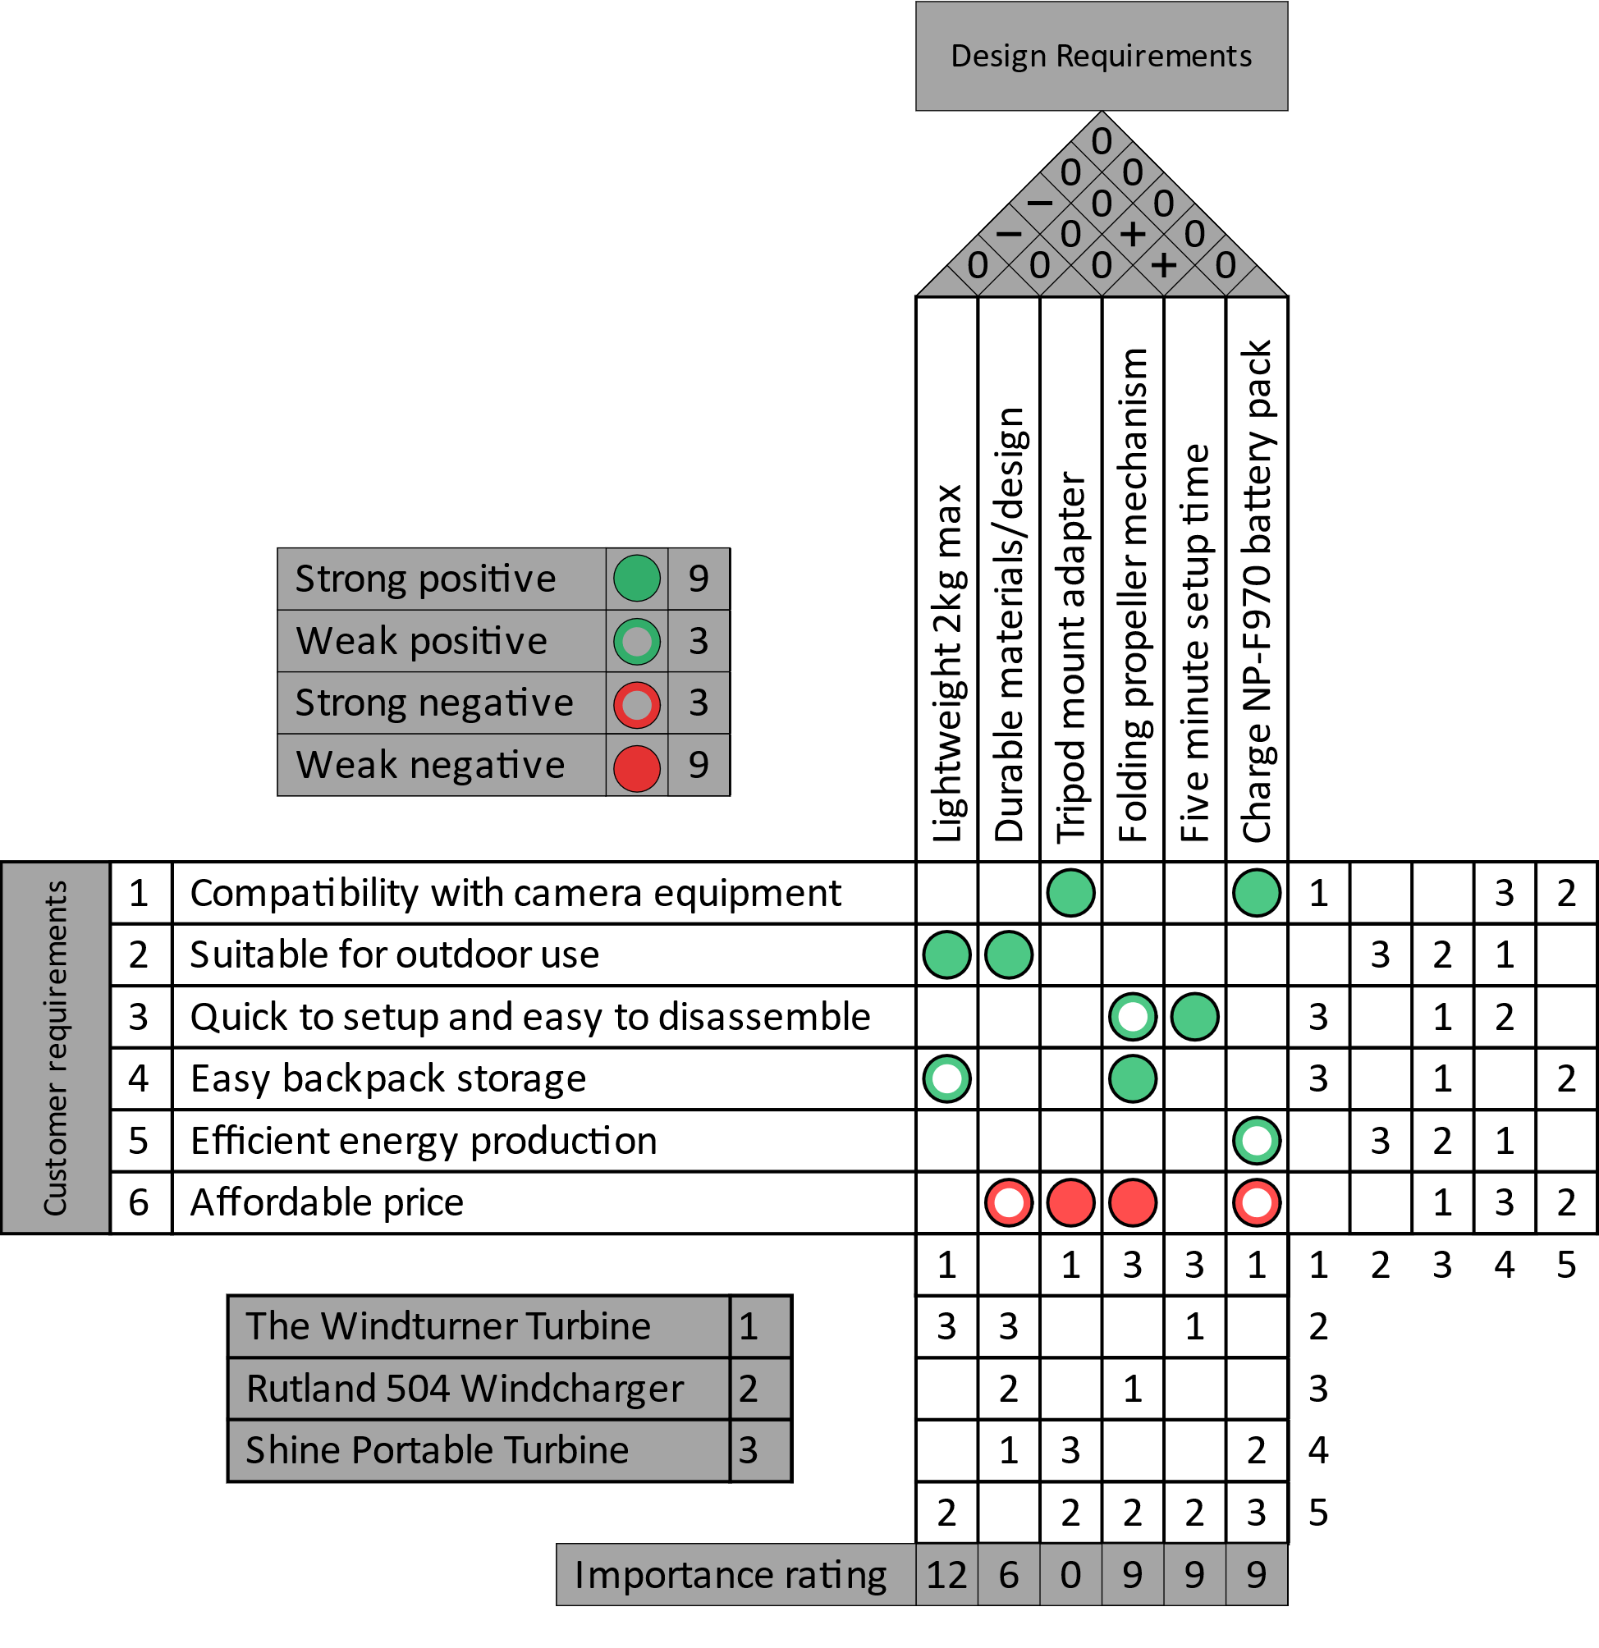
Figure 8 Quality Functional Deployment of the Windturner. Source: Self-created in Visio (Evans, 2023)

A thorough understanding of what customers value the most in these products is necessary. This section will assess the technical specifications of the most significant competitors against those of the Windturner to better understand the portable wind turbine market. Initial research found the market to be scarce, with only one other product offering similar features with intentions to supply the outdoors community. However, a similar product is available and identified as a compact trickle charging unit for motorhomes and marine activities that might provide additional insight. All information regarding these products originates from the manufacturer's websites and those with affiliations.

For starters, the average windspeed in the United Kingdom is 8.5 knots or 4.373 meters per second (Statista, 2023). The first product is the Rutland 504, which claims to be suitable for caravans, boats, and as an educational tool (Marlec, 2023). It weighs 3.5 kilograms and can produce approximately 3 watts with winds of 5 meters per second. The second product is the Shine Turbine which only weighs 1.3 kilograms (Aurea Technologies, 2023a). Unlike the Rutland 504, it intends to be a portable wind turbine that can fit within a backpack for camping and emergencies (Aurea Technologies, 2023b). It is capable of 5 watts with winds of 5 meters per second. The takeaway is that for the Windturer to compete with its closest competitor, the Shine Turbine, it must either produce more energy or excel at portability by being lightweight and easy to store and carry.

Design Specification
Windturner is a portable turbine that provides an emergency source of power for electrical goods that uses NP-F970 batteries. The propellors and tail can fold to facilitate ease of storage, making it ideal for camping and hiking trips. As such, the target audience will be outdoor enthusiasts seeking an additional source of power generation for their camcorders. Since there is already a superior portable wind turbine product on the market, the focus of this one must be to produce an exceptionally lightweight product at a lower cost. The design and manufacturing method must result in a component that is producible in quantities of 2000 a week, with the ability to scale in the future.

Functionally the redesign must not result in an inferior product to the prototype. Most of the construction will be plastic, apart from specific hardware and electronics, as this material lends well to mass production and can be a more sustainable process. According to the British Plastics Federation (2023), the production of plastics is much more energy efficient than other materials. Additionally, it is a lightweight and durable material that will assist in meeting the specifications above. The product must also be safe for use and produce as little noise as possible to avoid disturbing other outdoors people and wildlife.

Aesthetically, the current design has some charm with its vibrant choice of colours. Since this is an outdoor product, maintaining this colour scheme is necessary. If the user was to drop this product while out hiking unknowingly, the bright colours could assist them in locating it and are achievable without additional post-processing, such as painting or dip-coating.

Manufacturing Process Proposal
Expectations for this product are high, with initial market research suggesting production volumes as high as 2000 units a week. As such, the product must be producible, mainly using automated processes to achieve and satisfy demands. For these reasons, this section proposes a re-evaluation of the current prototype with intentions to manufacture using injection moulding and numerically controlled turning machines. The former is efficient in high production with good scalability (Hatch, 2022; Formlabs, 2023), with very little waste and the ability to produce components in specific colours to reduce post-production processes. As for the latter, a cylindrical component presses into a bearing requiring a manufacturing process that can produce high-precision parts. A numerically controlled turning machine equipped with live tooling and bar feeders to automate the process will be ideal.

Injection moulding will require a significant redesign of the current concept with considerations for draft angles and undercuts for mould ejection and can require a significant upfront investment. However, once set up, the cost to produce the components is low (Hatch, 2022), and it can be considered a sustainable manufacturing process due to the little waste. For a more environmentally friendly product, the components will utilise sustainable materials that can either be recycled at the end of their life or are biodegradable plastic if possible (Essentra Components, 2023). As for the component that requires turning and milling operations, assuming the lathe has live tooling to enable milling, it can be produced in a single setup and parted to length.

Cost Drivers
The price of a product depends on the cost drivers, factors that increase the costs associated with manufacturing a product (Gold, 2020; CFI Team, 2023). Regarding injection moulding, the most significant cost driver is the initial investment to manufacture the moulds for production. According to Ferreira (2023), production moulds can cost up to £100,000 or as little as £2,000, depending on the size and complexity of the part and the mould material. By reducing the number of moulds, initial costs can be minimal. The only way to reduce the moulds is by consolidating several components into one and mirroring and repeating components like the propellors to maximise mould usage. Following this initial investment and assuming adequate implementation of automation, labour and post-processing costs will be low.

As for the machining operations, the most significant cost drivers will be tooling, setup times, and cycle times (Rapid Direct, 2022). Material selection will also be a significant factor in what tooling is needed and how long each component takes to produce. Like the injection moulding method, there will be some initial costs for the programming and creating jigs and fixtures to streamline manufacturing. As for setup costs, these are reducible by dedicating a specific machine to produce one component type but would incur the costs associated with purchasing, installing, and maintaining additional machinery. Lastly, costs will be associated with the final assembly of the product. Depending on the workload, the company will have to decide between the investment of a fully automated process and the cost of labour (Sprovieri, 2023). The former will incur high initial costs to set up and maintain but will result in a consistent process. However, the latter can also be expensive depending on the workforce, as vocational training may be necessary for machine operation and assembly tasks.

Design and Development Work Undertaken
While additive manufacturing can be a suitable technology for some products, the sheer number of units for this wind turbine requires injection moulding technologies. As such, the design for manufacturing and assembly (DFMA) principles will help evaluate and decide on changes to improve the manufacturability of the product. This methodology is often used in industry to reduce the complexity and costs associated with production (Siemens, 2022). According to Ulrich and Eppinger (2016), the DFMA method calls for reducing manufacturing and assembly costs and eliminating secondary processing steps through component redesigns to consolidate and standardise hardware. As such, with the intention to injection mould many of these components, this section will seek to consolidate and simplify aspects of the design.

Currently, the body of the product consists of four different components: the riser, lower, battery mount, and tube. However, with a redesign, injection moulding may produce the entire body using two components assembled using a series of snap hooks. Figure 9 shows the lower half of the body; before manufacturing any moulds to produce these components, a consultation and re-evaluation with an experienced mould maker are of the utmost importance. Solidworks generates the snap hooks and matching grooves using the corresponding operations using the provided data. These features reduce the number of components necessary to assemble the body, are easier to automate than their hardware alternatives (Rapid Direct, 2021), and are producible using additive manufacturing for prototyping before producing the moulds.

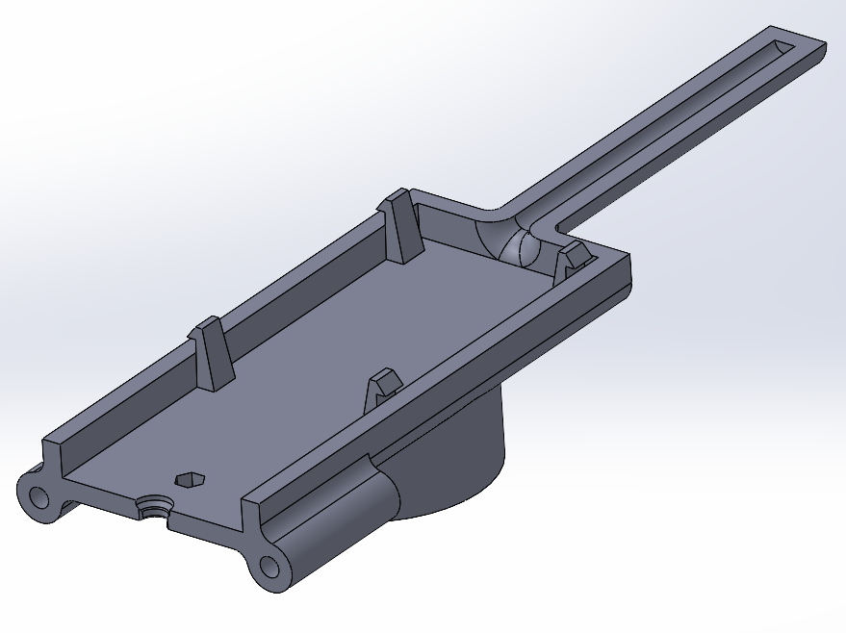
Figure 9 Component Consolidation with Snap Hooks. Source: Self-created in Solidworks (Evans, 2023)

One requirement for the product is to rotate freely on top of a tripod, achievable using a standardised bearing. However, since injection moulded products require a draft angle for extraction, achieving a press fit can be challenging. As an alternative, many manufacturers use crushed ribs to achieve a tight fit and a draft angle (Rapid Direct, 2022b). Figure 10 shows how these apply to the design; note that round crush ribs are manufacturable using milling machines, as opposed to the point ribs that require electrical discharge machining (3 Space, 2019). The use of the former will reduce mould-making costs. Based on the guidelines provided by FacFox Docs (2020), the radius of each rib is 2mm, with a 0.25mm interference with the 40mm bearing.
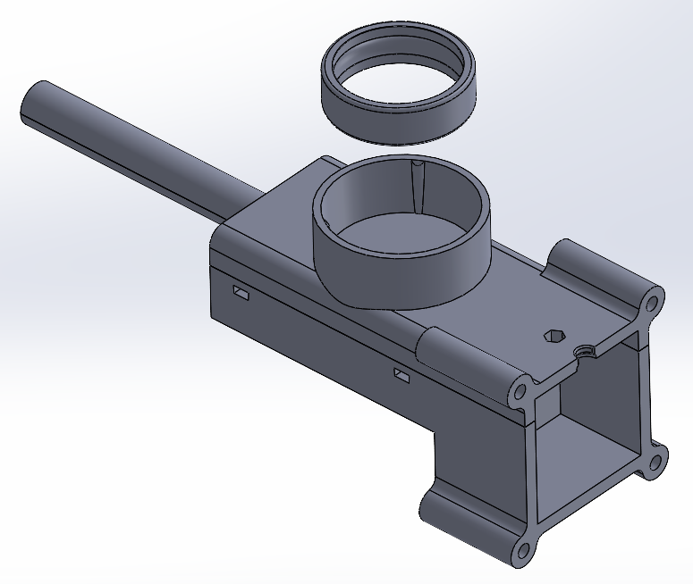
Figure 10 Three Crush Ribs for a Press Fit Bearing. Source: Self-created in Solidworks (Evans, 2023)

As per the DFMA principle of simplifying components, the final subject of this section is the tail rotational subassembly. Currently, the triangular locating features allow for twenty positions for the tail. However, based on the provided information, this is unnecessary. The tail only needs to be able to be repositioned into two states, folded in for transportation, and extended for use. Figure 11 is an exploded view of the subassembly redesign. By replacing the triangular features with two dimples, the subassembly no longer needs the spacer that attaches to the wing. This results in simpler components that eliminate four screws from the product while achieving the functionality necessary. Due to the thread and repeating clamping and unclamping the components will experience during their lifetime, the thumb nut and screw will also require a numerically controlled machine to produce them from a more durable material.

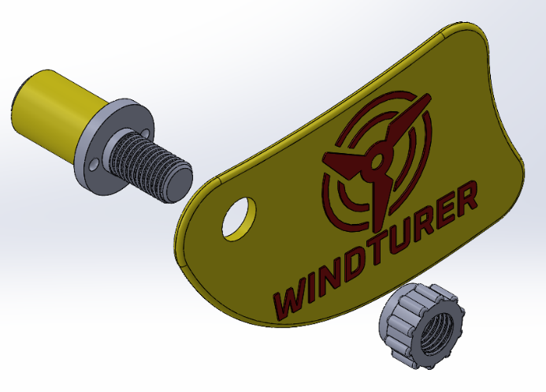
Figure 11 Exploded View of the Subassembly Redesign. Source: Self-created in Solidworks (Evans, 2023)

Draft and Undercut Analysis
During the previous sections, the decision to produce the body in two components led to both halves receiving snap hooks and grooves. While this is not problematic, the model will require additional analytical techniques to deduce what faces will require drafting and to locate all undercut features that will affect the mould design (FacFox Docs, 2020). Xometry (2023b) advise that injection moulded products have a draft angle of at least two degrees, with shut-off surfaces needing three degrees minimum. Continuing with the development of the lower half, Figure 12 features the draft analysis results. The green surfaces denote a positive draft and will not require attention. Similarly, the red surfaces represent a negative draft and are formable by the other half of the mould. The yellow surfaces will need draft angles, while the snap hooks require additional attention.

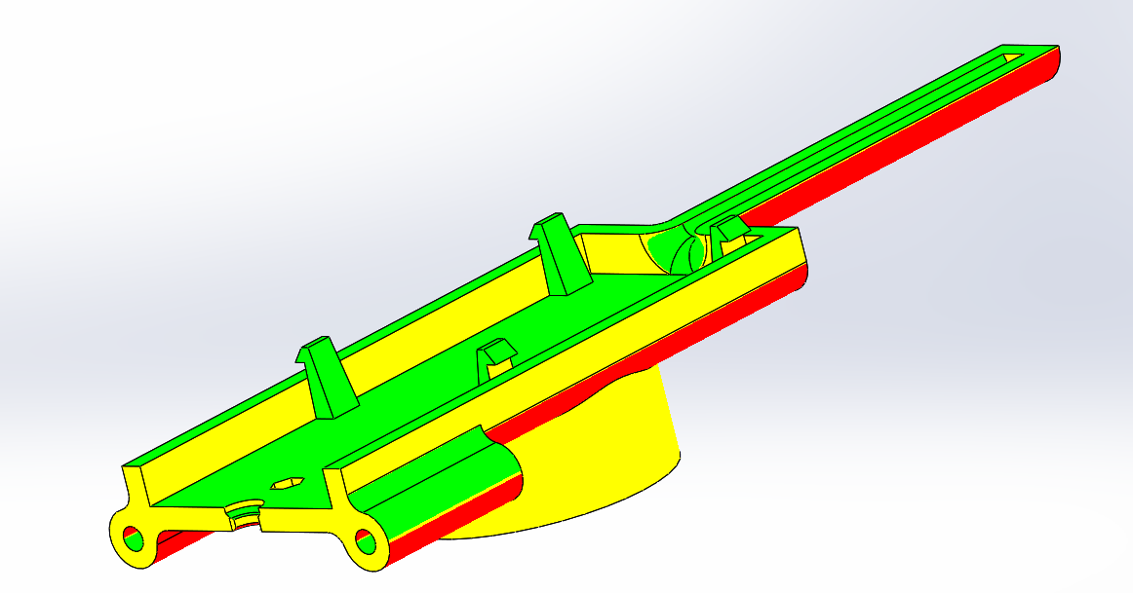
Figure 12 Results of the Draft Analysis. Source: Self-created in Solidworks (Evans, 2023)

Undercuts can be injection moulded in several ways, but the simplest is to use a shut-off (DiMonte Group Inc, 2018; Xometry, 2023b) by creating a slot beneath the undercut so that the core half of the mould may form it. The alternative to this is to design a sliding action into the mould. However, this would make the initial investment significantly more expensive and cumbersome. The shut-off is achievable in Solidworks by extrude-cutting the linework for the underside of the snap hook through the body, as shown in Figure 13. This technique also applies to the upper half of the body to form the undercuts that hold the battery in place during use.

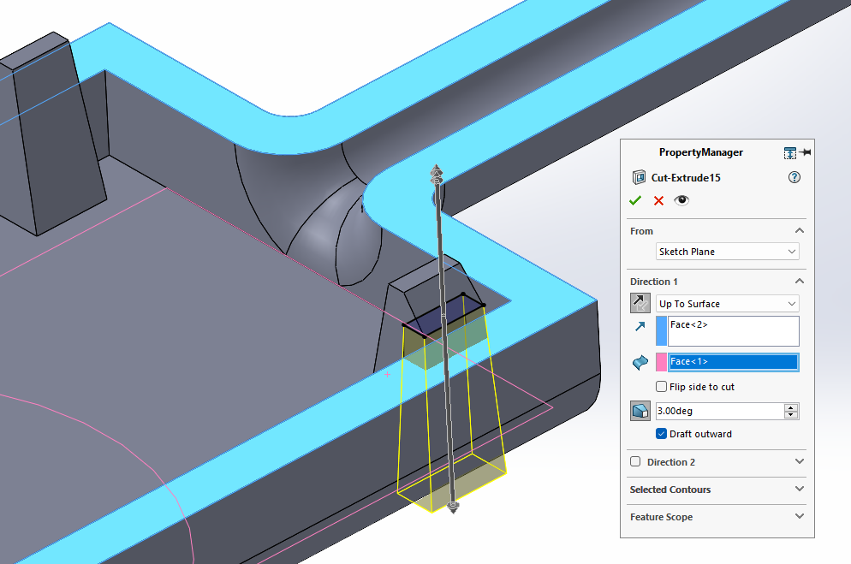
Figure 13 Designing the Snap Hook with a Shut-Off. Source: Self-created in Solidworks (Evans, 2023)

Conclusion
Task Two concludes with several changes to the design and a proposal to redesign the component so that most of the components are producible via injection moulding. Despite the focus being on the body and the tail, there is still room for significant improvements to other design aspects, such as consolidating the propellors and their hinges into a single component. Mould design was beyond the scope of this report and would require consultations with experts in the field to decide on the best approach. It is possible to produce the entire body in a single component using sliding mechanisms, shut-offs, and inserts. While it would be an expensive initial investment, it would significantly reduce the assembly processes.

Bibliography
3 Space (2019) Injection Moulding: Crush Ribs. Available at: https://3space.com/injection-molding-crush-ribs/ (Accessed: 1 July 2023).
Agnusdei, L. and Prete, A.D. (2022) ‘Additive manufacturing for sustainability: A systematic literature review’, Sustainable Futures, 4, pp. 1-9.
Ahlers, D. (2018) 3D Printing of Nonplanar Layers for Smooth Surface Generation. Master’s Thesis. University of Hamburg.
AMPOWER GmbH & Co. KG (2022) Sustainability of Metal Additive Manufacturing. Available at: https://ampower.eu/insights/sustainability-of-metal-additive-manufacturing/ (Accessed: 19 June 2023).
Aurea Technologies (2023b) Shine Turbine Product Page. Available at: https://shineturbine.com/products/shineturbine (Accessed: 10 June 2023).
Aurea Technologies (2023b) Shine Turbine. Available at: https://shineturbine.com/ (Accessed: 10 June 2023).
Autodesk (2023) Generative Design for Manufacturing with Fusion 360. Available at: https://www.autodesk.com/solutions/generative-design/manufacturing (Accessed: 31 May 2023).
Bakhshivash, S. (2022) ‘What is Direct Metal Laser Sintering (DMLS) And How Does It Work?’, Trimech [blog]. 20 January. Available at: https://trimech.com/blog/what-is-direct-metal-laser-sintering-dmls-and-how-does-it-work (Accessed: 21 June 2023).
Behrens-Thomsen, C. (2023) ‘How 3D Printing Soft Jaws Can Save You Time and Money’, LinkedIn [blog]. 14 March [blog]. Available at: https://www.linkedin.com/pulse/how-3d-printing-soft-jaws-can-save-you-time-money-behrens-thomsen/ (Accessed: 7 June 2023).
Bintara , R.D. et al. (2019) ‘The Characteristic of Overhang Object to Material Usage on FDM 3D Printing Technology’, Journal of Mechanical Engineering Science and Technology, 3(1), pp. 35-41.
British Plastics Federation (2023) Plastics: Recycling and Sustainability. Available at: https://www.bpf.co.uk/Sustainability/Plastics_and_Sustainability.aspx (Accessed: 11 June 2023).
Bromberger, J., Ilg, J. and Miranda, A.M (2022) ‘The mainstreaming of additive manufacturing’, McKinsey & Company, 15th March. Available at: https://www.mckinsey.com/capabilities/operations/our-insights/the-mainstreaming-of-additive-manufacturing (Accessed: 5 June 2023).
Carr Lane Manufacturing (2023) Clamping Force Calculations. Available at: https://www.carrlane.com/engineering-resources/fixture-design-principles/clamping-force-calculations (Accessed: 19 June 2023).
CFI Team (2023) ‘What is a Cost Driver?’, CFI [blog]. 28 June. Available at: https://corporatefinanceinstitute.com/resources/accounting/cost-driver/ (Accessed: 24 June 2023).
Chick Workholding (2009) One-Lok Single Station CNC Vise. Available at: https://chickworkholding.com/4dcgi/public/featured/onelok_cnc_vise.shtml (Accessed: 17 June 2023).
Costabile, M. et al. (2017) ‘Cost Models of Additive Manufacturing: A Literature Review’, International Journal of Industrial Engineering Computations, 8, pp. 263-282.
Cubas, A. (2022a) Project Details for 3D Printed Portable Wind Turbine. Available at: https://hackaday.io/project/185070-3d-printed-portable-wind-turbine/details (Accessed: 02 June 2023).
Cubas, B. (2022b) WINDTURNER Wind Turbine (Introduction Video) [video]. Available at: https://youtu.be/HI2dkgJIIVw (Accessed: 02 June 2023).
DiMonte Group Inc (2018) Fantastic Plastic 13- Shut Offs - SOLIDWORKS Tutorial [video]. Available at: https://youtu.be/eXor1ep8x3k?list=PLYzQjNWm2a7rJ6yi6uKLOIa9JTxmxiJKr (Accessed: 1 July 2023).
Eckhoff, A. (2022) ‘Removing the Boundaries of 3D Printing with Multi-Axis Additive’, SME [blog]. 15 June. Available at: https://www.sme.org/technologies/articles/2022/june/removing-the-boundaries-of-3d-printing-with-multi-axis-additive/ (Accessed: 18 June 2023).
Eisner, C. (2022) ‘DFMEA: The Beginner’s Guide to Design Failure Mode and Effects Analysis’, MaintainX [blog]. 24 May. Available at: https://www.getmaintainx.com/blog/beginners-guide-to-dfmea/ (Accessed: 19 June 2023).
Essentra Components (2023) Is injection moulding environmentally friendly? Available at: https://www.essentracomponents.com/en-gb/news/manufacturing/injection-moulding/is-injection-moulding-environmentally-friendly (Accessed: 24 June 2023).
FacFox Docs (2020) The Design Guideline for Injection Moulding. Available at: https://facfox.com/docs/kb/the-design-guideline-for-injection-molding (Accessed: 1 July 2023).
Ferreira, W. (2023) ‘How much does Injection Moulding cost?’, Get It Made [blog]. 21 February. Available at: https://get-it-made.co.uk/resources/how-much-injection-moulding-costs (Accessed: 24 June 2023).
Formlabs (2023) Guide to Manufacturing Processes for Plastics. Available at: https://formlabs.com/uk/blog/guide-to-manufacturing-processes-for-plastics/ (Accessed: 11 June 2023).
Gold, K. (2020) ‘Cost Drivers in Manufacturing: Managing Complex Interactivity’, aPriori [blog]. 29 January. Available at: https://www.apriori.com/blog/cost-drivers-in-manufacturing-managing-complex-interactivity/ (Accessed: 24 June 2023).
Grand View Research (2023) 3D Printing Market Size, Share & Trends Analysis Report by Component (Hardware, Software, Services), By Printer Type, By Technology, By Software, By Application, By Vertical, By Region, And Segment Forecasts, 2023 – 2030. Available at: https://www.grandviewresearch.com/industry-analysis/3d-printing-industry-analysis (Accessed: 18 June 2023).
Hatch, M. (2022) ‘Injection moulding – What are the advantages?’, Protolabs [blog]. 7 January. Available at: https://www.protolabs.com/en-gb/resources/blog/injection-moulding-what-are-the-advantages/ (Accessed: 11 June 2023).
Hong, F. et al. (2023) ‘5-axis multi-material 3D printing of curved electrical traces’, Additive Manufacturing, 70, pp. 1-10.
Javaid, M. et al. (2021) ‘Role of additive manufacturing applications towards environmental Sustainability’, Advanced Industrial and Engineering Polymer Research, 4, pp. 312-322.
Kondo, H. (2022) ‘3D Printing Overhang: How to 3D Print Overhangs’, ALL3DP [blog]. 17 June. Available at: https://all3dp.com/2/3d-printing-overhang-how-to-master-overhangs-exceeding-45/ (Accessed: 17 June 2023).
Markforged (2023) Soft Jaws. Available at: https://markforged.com/resources/manufacturing-applications/soft-jaws (Accessed: 7 June 2023).
Marlec (2023) 12V Rutland 504 Wind charger. Available at: https://www.marlec.co.uk/product/12v-rutland-504-windcharger/ (Accessed: 10 June 2023).
Materialise (2023) Design Guidelines – Aluminium (ALSi10Mg). Available at: https://www.materialise.com/en/academy/industrial/design-am/aluminum (Accessed: 19 June 2023).
MSE Supplies (2023) MSE PRO AlSi10Mg Aluminium Based Metal Powder for Additive Manufacturing (3D Printing). Available at: https://www.msesupplies.com/products/mse-pro-alsi10mg-aluminum-based-metal-powder-for-additive-manufacturing-3d-printing?variant=32224600424506 (Accessed: 19 June 2023).
NYC CNC (2021) Machine Shop Fixturing & Workholding: Soft Jaws [video]. Available at: https://youtu.be/Eex2Xei9koU (Accessed: 31 May 2023).
O’Neill, B. (2023) ‘How to 3D print overhangs: supports, bridging, new innovations’, Wevolver [blog] 29 March. Available at: https://www.wevolver.com/article/how-to-3d-print-overhangs-supports-bridging-new-innovations (Accessed: 17 June 2023).
Penn Tool Co. (2011) The One for CNC Machining Chick One-Lok [video]. Available at: https://youtu.be/kXefDoIKOh4 (Accessed: 17 June 2023).
Rapid Direct (2021) ‘Snap Fit Design: Types of Snap Fits and Best Practices, Rapid Direct [blog]. 7 December. Available at: https://www.rapiddirect.com/blog/snap-fit-design/ (Accessed: 30 June 2023).
Rapid Direct (2022a) ‘CNC Machining Cost Calculation: All Factors and Tips You Must Know’, Rapid Direct [blog]. 21 January. Available at: https://www.rapiddirect.com/blog/cnc-machining-cost-calculation/ (Accessed: 30 June 2023).
Rapid Direct (2022b) ‘Add Crush Ribs in Injection Moulded Parts’, Rapid Direct [blog]. 7 December. Available at: https://www.rapiddirect.com/blog/crush-ribs/ (Accessed: 1 July 2023).
Sandvik (2023) Additive Manufacturing – Sustainable by Nature. Available at: https://www.additive.sandvik/en/about-us/sustainable-business/additive-manufacturing-sustainable-by-nature/ (Accessed: 18 June 2023).
Shields, G. (2023) ‘3D Printing Lattice Structures – The Ultimate Guide’, ALL3DP [blog]. 15 June. Available at: https://all3dp.com/1/3d-printing-lattice-structures-the-ultimate-guide/ (Accessed: 19 June 2023).
Siemens (2022) Design for Manufacturing and Assembly (DFMA). Available at: https://www.plm.automation.siemens.com/global/en/our-story/glossary/design-for-manufacturing-and-assembly-dfma/53982 (Accessed: 30 June 2023 ).
Slant 3D (2023) The Cost of Mass Production 3D Printing Explained [video]. Available at: https://youtu.be/0zLWaEarbj4 (Accessed: 08 June 2023).
Sprovieri, J. (2023) Manual, Semiautomatic or Fully Automatic? Available at: https://www.assemblymag.com/articles/97869-manual-semiautomatic-or-fully-automatic (Accessed: 30 June 2023).
Statista (2023) Annual average wind speed in the United Kingdom (UK) from 2001 to 2022. Available at: https://www.statista.com/statistics/322785/average-wind-speed-in-the-united-kingdom-uk/ (Accessed: ).
Stratasys (2023) The Benefits of 3D Printed Soft Jaws and How to Make Them [video]. Available at: https://youtu.be/WBvd5k_FAYo (Accessed: 5 June 2023).
TAMS UHAM (2019) 3D Printing of Nonplanar Layers for Smooth Surface Generation [video]. Available at: https://youtu.be/km1lvuva5mI (Accessed: 18 June 2023).
TCT Magazine and Altair (2020) Additive Manufacturing for Production 2020 Survey Report. Available at: https://www.tctmagazine.com/3d-printing-resource-center/additive-manufacturing-for-production-survey/ (Accessed: 5 June 2023).
Tormach (2017) ‘The Basics of Soft Jaws’, Tormach [blog]. 28 November. Available at: https://blog.tormach.com/basics-soft-jaws (Accessed: 31 May 2023).
Trimech (2023) ‘3D Printed Soft Jaws in Nylon CF10’, Trimech [blog]. 20 January. Available at: https://trimech.com/blog/3d-printed-soft-jaws-in-nylon-cf10 (Accessed: 7 June 2023).
Ulrich, K.T. and Eppinger, S.D. (2016) Product Design and Development. 6th edn. New York: McGraw-Hill Education.
Xometry (2021) Direct Metal Laser Sintering (DMLS) 3D printing: Technology overview. Available at: https://xometry.eu/en/direct-metal-laser-sintering-dmls-3d-printing-technology-overview/ (Accessed: 21 June 2023).
Xometry (2023a) Metal 3D Printing (DMLS) Services in the UK. Available at: https://xometry.uk/direct-metal-laser-sintering/ (Accessed: 19 June 2023).
Xometry (2023b) Design Guide: Injection Moulding. Available at: https://www.xometry.com/resources/design-guides/design-guide-injection-molding/ (Accessed: 1 July 2023).

Appendices

Appendix A

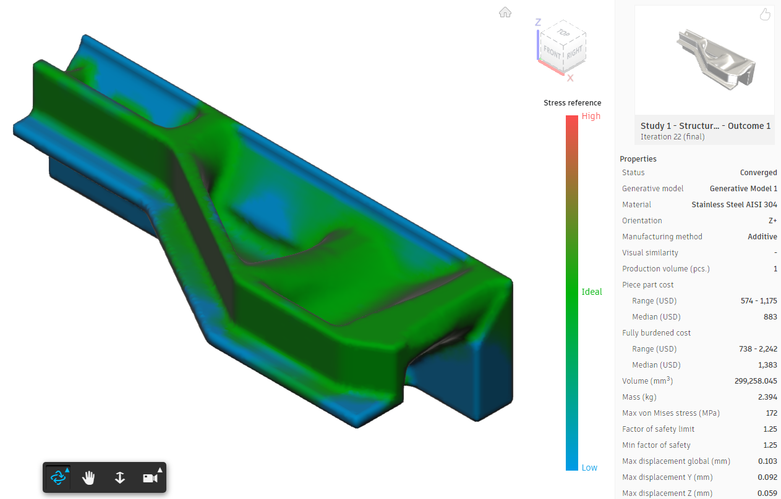
Figure 14 Stainless Steel Outcome. Source: Self-created in Fusion 360 (Evans, 2023)

Appendix B

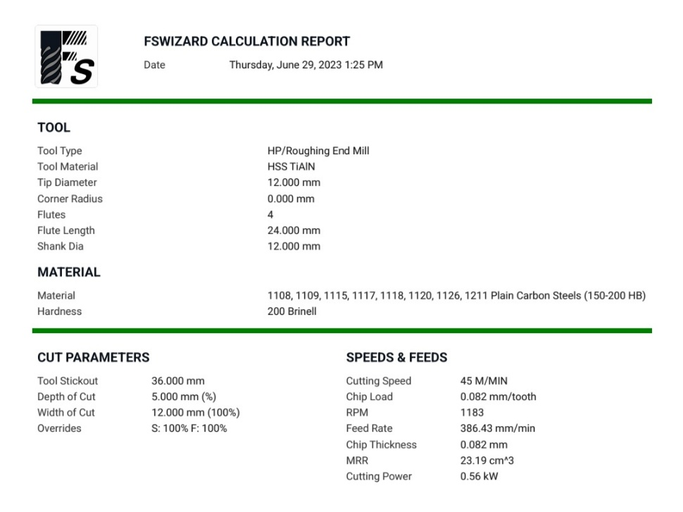
Figure 15 FSWizard Calculation Report. Source: Self-created in FSWizard (Evans, 2023)

