AI Acknowledgement
I confirm that I have not used any AI tools in the research and creation of this assignment. I confirm that I have not presented any AI generated materials as my own work. I confirm I have copies of my drafts, notes, and other resources I used, which I may be asked to provide in evidence.
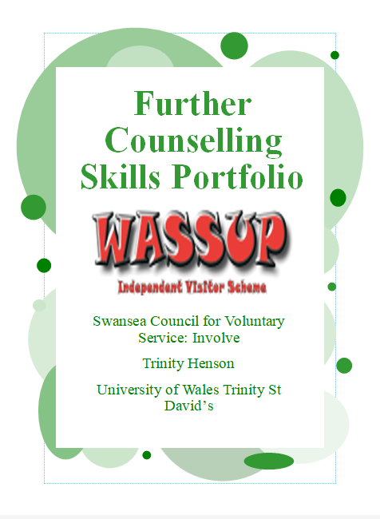
Table of Contents
Reflective Commentary 3
Reference List 6
Swansea Council of Voluntary Service’s Values Statements 7
Involve’s Induction Training 8
Documents Completed for Each Meeting with The Service User 15
Reference List 18
Appendix A. Correspondence with Involve 19
Appendix B. Approval Of the Placement 22
Appendix C. Record Of Time Spent on The Placement 24
Appendix D. Reflective Logs 28

Reflective Commentary
Critical reflection is essential for practitioners to identify their strengths and weaknesses and effectively develop their professional skills (Thompson & Thompson, 2023). I kept this in mind when completing my own work-related experience, which I chose to complete with Wassup: an independent visitor scheme within the Involve Volunteering Project. The Swansea Council of Voluntary Service [SCVS], (2015) describes Wassup as a scheme that matches looked after children with volunteers, whose role is to be a consistent figure in the child’s life. I was matched with an adolescent boy who I will be referring to as ‘the service user’ throughout this commentary to abide by the SCVS’ (2018) privacy policy. As an independent visitor, I was given the opportunity to utilise many skills including proactivity, active listening and silence. This reflective commentary aims to explore what I have learnt using Gibbs' Reflective Cycle (The University of Edinburgh, 2024).
My journey with Involve began during my university’s employability week, in which the SCVS held a session to encourage students to join their volunteering projects. I had never worked with people at risk before, so I emailed a request to volunteer with Involve. As I waited to begin the volunteering, my worry about whether I was going to complete enough hours grew. My lecturer’s advice helped to quell my anxiety, which was put to rest when Wassup matched me with a service user. Although I learnt a lot from Involve about the training and checks required before working with people at risk, the process took longer than I anticipated. This was due to multiple factors such as the frequency of the online training, the slow pace of the Disclosure and Barring Service check over the summer holiday and the lack of children in Swansea on the Wassup scheme. Even though I had immediately completed the necessary forms, I realised that proactive communication with Involve was crucial in things progressing. Nevertheless, I was surprised that the preparation process still took nine months. Upon reflection, I will ask more questions about an organisation’s time frames before committing when I have a deadline.
For the first meeting with the service user, I booked bowling because the development officer had mentioned he enjoyed sports. During the games, I tried to appear friendly by smiling, being attentive, and having an open, relaxed posture. This seemed to work in building rapport to the point where he started to voice some strong opinions. Despite feeling surprised at how early in the relationship this occurred, I appreciated that he felt comfortable to speak his mind. I paid attention and responded without judgment. Hough (2021) has highlighted how the voluntary sector can benefit from Carl Roger’s person-centred approach, which emphasises the core conditions: empathy, unconditional positive regard and genuineness in building positive relationships. These attributes help clients to feel understood, respected and valued. Moreover, Midwinter and Dickson (2015) have noted in their relational skills model that communicating these core conditions, through means such as attending and listening skills, is essential in establishing the helping relationship. Thus, I believe the service user became comfortable to voice his opinions with me because he felt they were being respected. I found this satisfying because it indicated I was achieving a positive relationship. On the other hand, I found not just going along with everything he said to be challenging. I tended to respond with paraphrasing, which added little to the discussion on its own, and was likely why he would sometimes trail off. To explore what is said and offer alternative viewpoints, Westergaard (2017) suggests helpful questioning and the advanced counselling skill of challenge. I can practise these when conversing in my personal life.
As I became more familiar with the service user, I learnt to recognise when he needed silence. For example, when I would ask him a question about his interests, he would sometimes pause and look down thoughtfully. I would give him time to think. This appeared to work as once he had finished processing, he would respond. I felt comfortable sitting with the silence and found it also gave me time to reflect. This contrasts with how I felt during lecture roleplay, where silence made me feel awkward. I think my management of silence helped our conversations to have a pleasant flow. Westergaard (2017) has highlighted the importance of silence in allowing clients to explore their thoughts and feelings about a situation, rather than helpers attempting to rectify said situation with assurances and questions. I believe this is why my silence worked in helping the service user to fully express himself with his responses. If I had kept interrupting his train of thought, it would likely have been frustrating for him and resulted in him not wanting to talk. However, one interaction where silence did not work was when ordering milkshakes. I asked him which flavour he would like when we were already at the counter and, when he did not respond, gave him time to think. Looking back, I think my silence put him on the spot. Overall, these interactions have taught me the value of managing silence to allow people to process their thoughts and feelings. To avoid causing discomfort, I need to better judge when a situation requires silence or not. From now on, I’ll refrain from managing silence in situations where the service user is forced to make spontaneous decisions in front of an audience.
To conclude, volunteering with Involve has been an enlightening experience which has given me the opportunity to reflect on my abilities in a helping role. I realised how important it is for volunteers to be committed and proactive during the application process because of the potentially long waiting times. It also became apparent to me how imperative the skills I have learnt in the classroom were in building a positive relationship with the service user, such as attending and listening skills, paraphrasing and managing silence. In hindsight, a better understanding of advanced counselling skills would have enabled me to respond in ways that would have maintained and explored the dialogue better. I recognise that I still have a lot to learn and plan to further develop my questioning and challenge skills by reading up on them in academic textbooks and practising them in roleplay and my personal life.

Reference List
Hough, M. (2021). Counselling skills and theory (5th ed.). Hodder Education Group.
Midwinter, R., & Dickson, J. (2015). Embedding counselling and communication skills: a relational skills model (1st ed.). Routledge. https://doi.org/10.4324/9781315730493
Swansea Council of Voluntary Service. (2015, November 30). Wassup. https://www.scvs.org.uk/wassup
Swansea Council of Voluntary Service. (2018, May 15). Privacy and Cookie Policy. https://www.scvs.org.uk/privacy
The University of Edinburgh. (2024, October 15). Gibbs' Reflective Cycle. https://reflection.ed.ac.uk/reflectors-toolkit/reflecting-on-experience/gibbs-reflective-cycle
Thompson, S., & Thompson, N. (2023). The critically reflective practitioner (3rd ed.). Bloomsbury Academic.
Westergaard, J. (2017). An introduction to helping skills: counselling, coaching and mentoring (1st ed.). SAGE Publications Ltd.

Swansea Council of Voluntary Service’s Values Statements
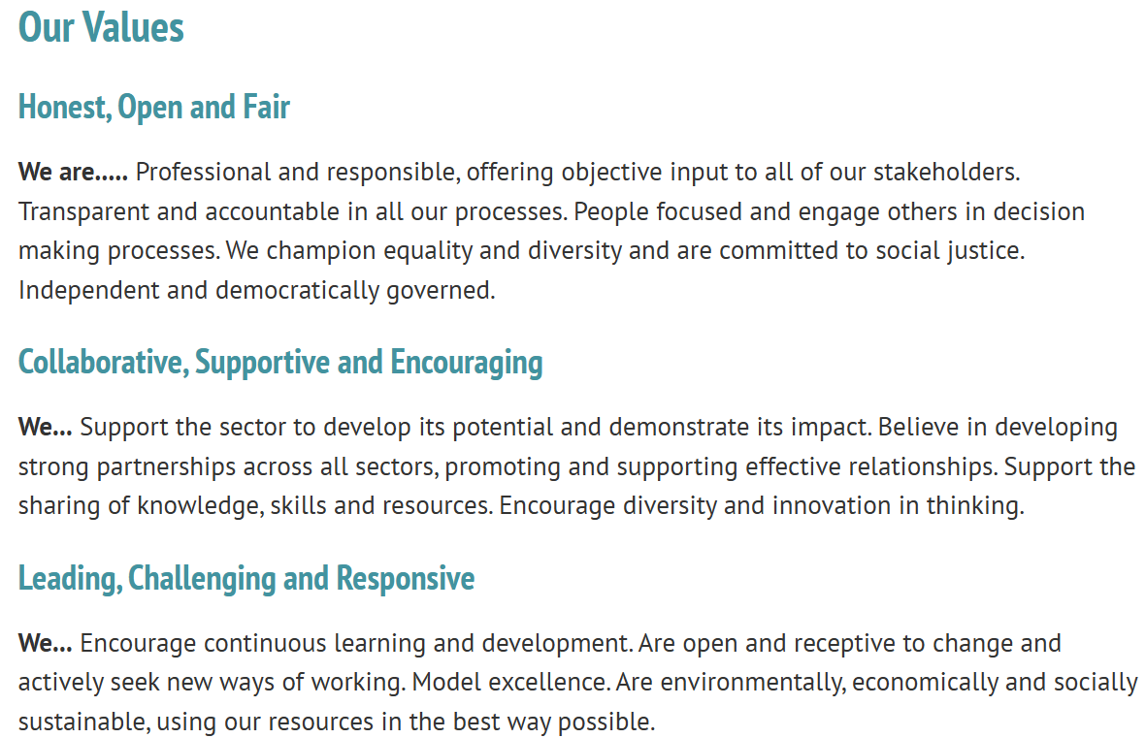
As can be seen above, Swansea Council of Voluntary Service (2015) has listed their organisation’s values on their website.
The values of being honest, open and fair align with legislation and national policies that health and social care services must abide by in Wales. This quality of practice helps to safeguard service users, which will be discussed in later sections of this portfolio.
The values of being collaborative, supportive and encouraging suggest that the organisation prioritises community. This fits well within the purpose of the organisation, which is “to support the Third Sector by providing a wide range of information, advice and support services and by representing the views of the sector to government and policy makers” (Swansea Council of Voluntary Service, 2015, About us heading). Therefore, these values ensure that all people needing support in Swansea can access and will benefit from their services.
The values of leading, challenging and being responsive help the organisation to maintain a high quality of service. For example, these values suggest that workers regularly undertake training to ensure their knowledge is up to date on the latest procedures and practices, and that the organisation is open to improving areas that may have received criticism. Thus, these values help ensure that the organisation is providing a service of ‘model excellence’ and helps to promote quality service in the Third Sector.

Involve’s Induction Training
All individuals who want to volunteer with the Involve Volunteering Project must first complete Involve’s Induction Training. This is so volunteers are aware of what will be expected of them within Involve’s voluntary roles. Volunteers are also required to participate in refreshers training to refresh their memory and remain up to date on the latest regulations.
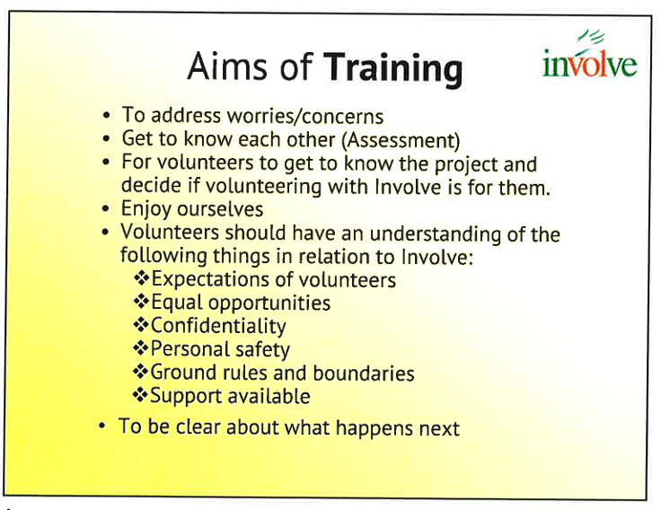
The training was offered in two forms: a two-day in person course or a four-evening online course. I chose to complete the training online because the in person training clashed with my university lectures.
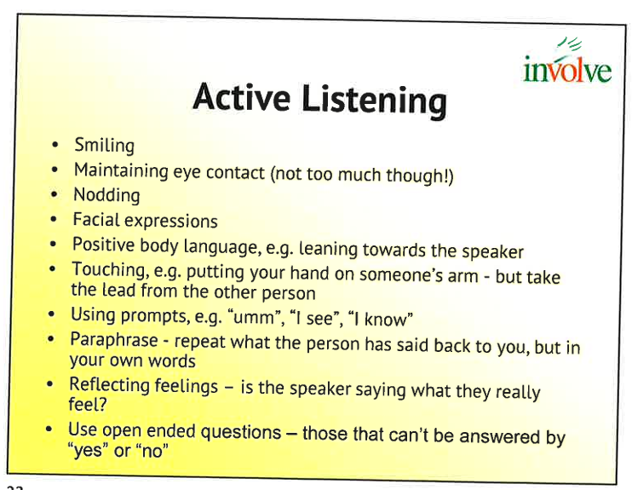
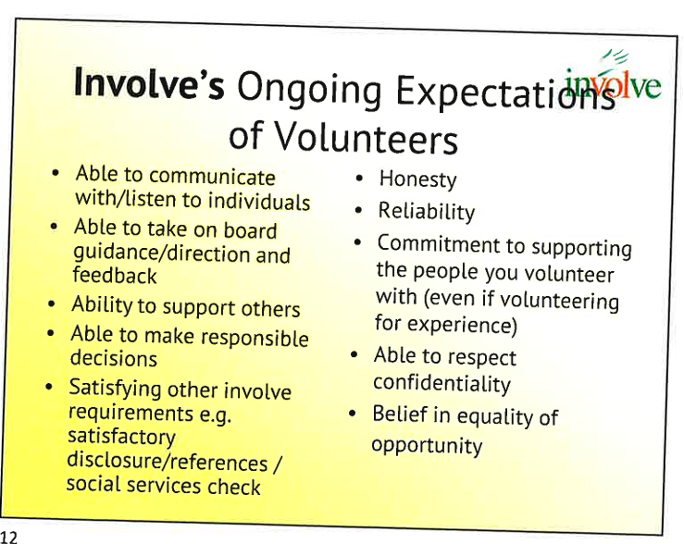
Involve’s training upholds similar expectations to the British Association of Counselling and Psychotherapy [BACP], (2020) Counselling Skills Competence Framework; both emphasise the importance of counselling skills, such as empathy, active listening and responding skills, when interacting with service users.

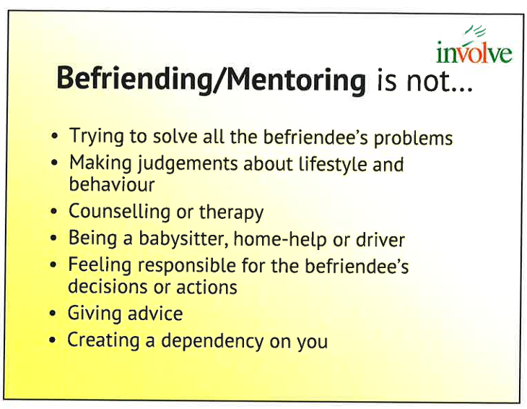
However, Involve makes sure to highlight how volunteers are not counsellors. Similarly, I am aware I am not a counsellor nor in a practice-based programme. Therefore, I have made sure to act only within the boundaries of my independent visitor role. This abides by the BACP (2020) Counselling Skills Competence Framework.
The training encouraged a person-centred approach to recognise service users as individuals. This was outlined as planning activities the service user would enjoy, establishing a helping relationship so the service user feels comfortable to be open with the volunteer, encouraging the service user’s decision making and independence, and establishing the service user’s personal goals. This is achieved with embedded counselling skills.
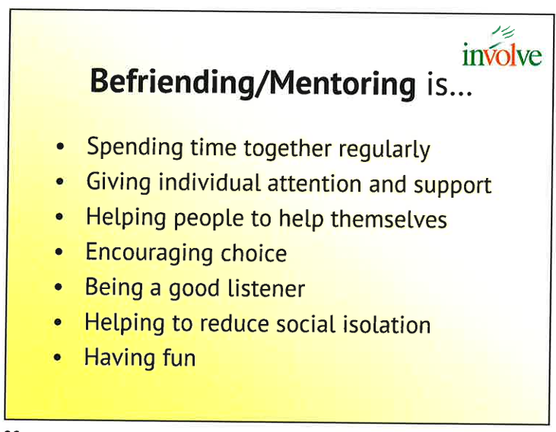
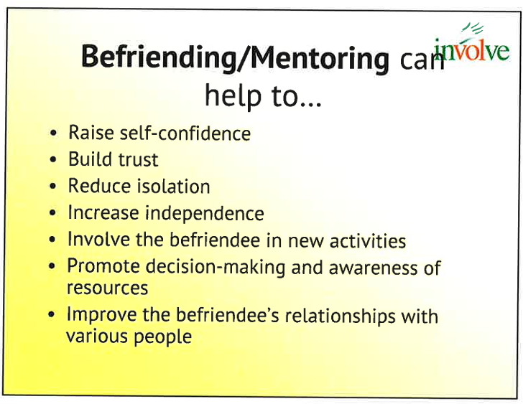
While enabling me to utilise my own skills, this approach also enables service users to develop their social and life skills. For example, many young people referred to the Wassup scheme may have low self-esteem, low confidence, social anxiety or other difficulties. The support provided by the independent visitor allows them to do things outside of their comfort zone, thus developing their social and life skills.

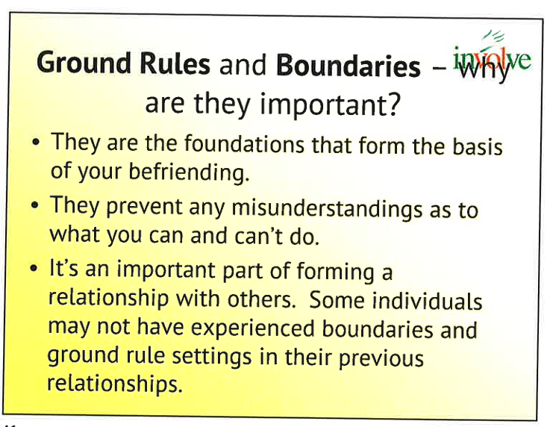
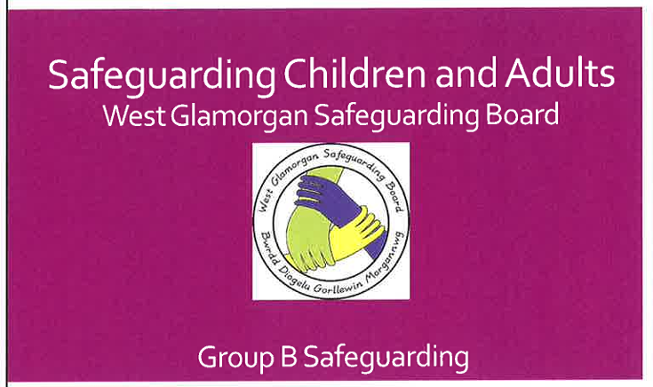
Though volunteers are encouraged to form relationships with service users, these are not friendships but helping relationships. Therefore, it is important that volunteers are aware of the boundaries of the relationship. We were instructed not to do domestic tasks for the service user, offer our phone number or address, or to drink alcohol while volunteering. This protects both the volunteer and service user, allowing for a trusting relationship to be formed.
The second part of the training was the West Glamorgan Safeguarding Board’s course for Group B safeguarding. Group B refers to individuals who work directly with people and are a key part of the safeguarding process. These roles require people to know who to talk to if they think something is wrong and how to report concerns (Social Care Wales, 2024).
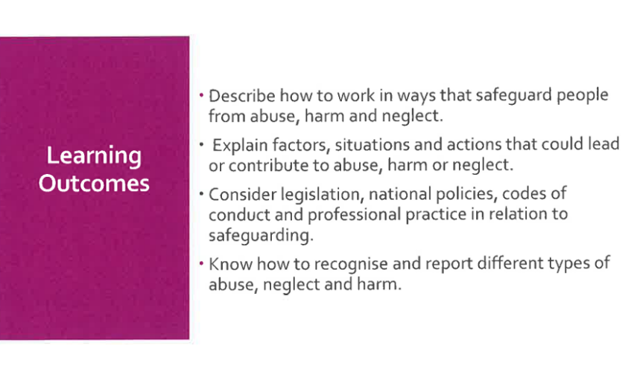
I have never participated in safeguarding training before and so gained a lot of new knowledge about the safeguarding process. I noticed that the training held many similarities with the BACP (2018) Ethical Framework for the Counselling Professions; both highlight the need to prevent harm, protect the self, notify supervisors when something is wrong and maintain confidentiality.
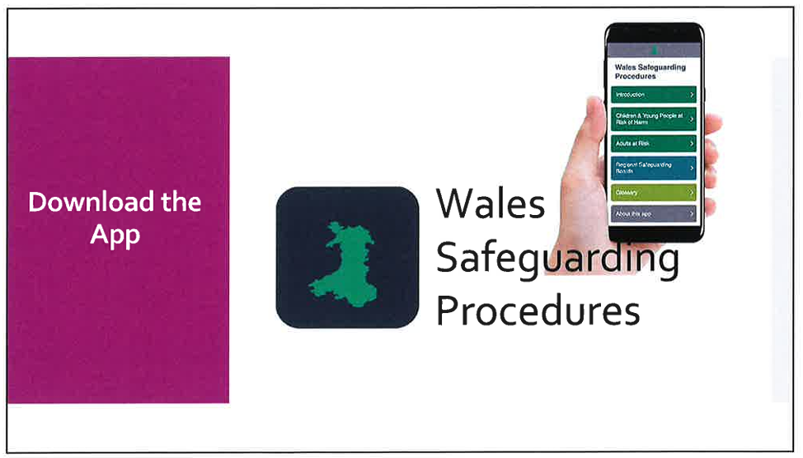
During the session, we were signposted to the Wales Safeguarding Procedures (2019) website. This is an easily accessible source that volunteers and professionals can refer to in everyday life. The procedures outline recommended safeguarding practice to help practitioners abide by the Social Services and Well-being (Wales) Act 2014.

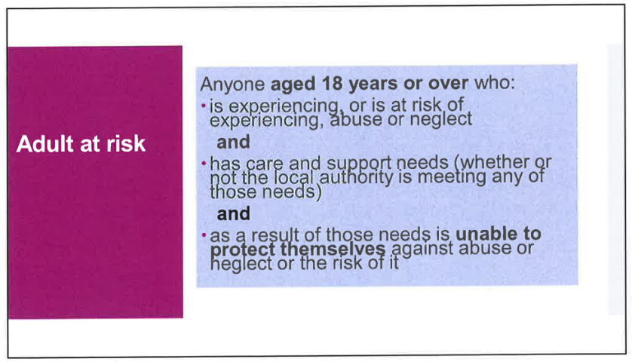
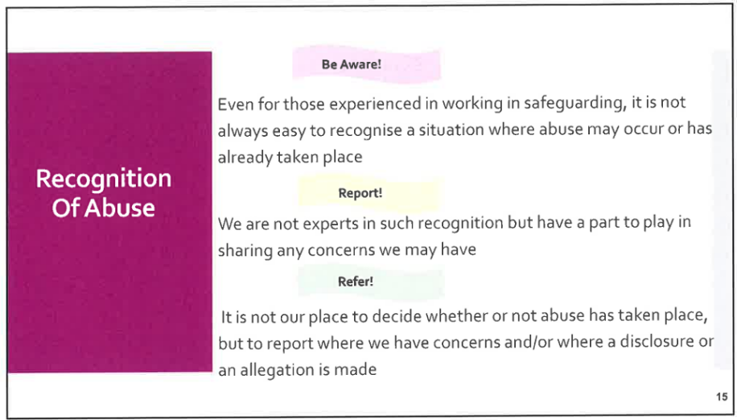
I also learnt how to recognise signs of abuse. Typical injuries usually occur on bony parts of the body, for example, the knees and elbows. So, if there are injuries to soft tissue, such as the inner thighs, forearms or neck area, then this may be a sign of physical abuse. Possible signs of financial abuse include the sudden inability to pay bills, a contrast between income and living conditions, and missing possessions.
Something new I learnt on the training was non-stigmatising language. We were taught to refer to people as “at risk” rather than “vulnerable”. This is because the latter implies a permanent state of dependency while the former implies a current factor affecting wellbeing that may be overcome with the right support and interventions – it emphasises empowerment and agency.
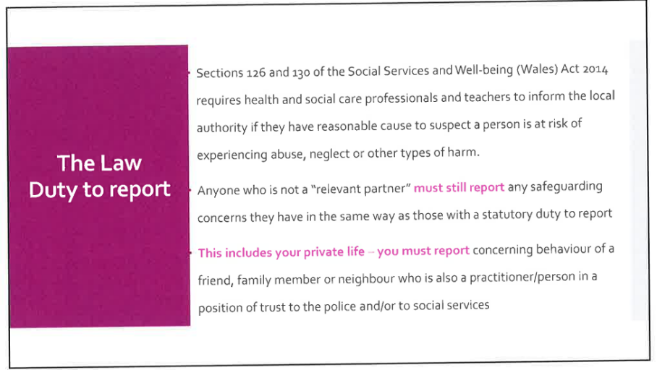
As well as signs, we were taught what different forms of abuse can look like. For example, emotional abuse may include deliberately humiliating, mocking, constantly criticising, blaming, scapegoating, threatening, shouting at, name calling or isolating another person. If a volunteer suspects a person to be at risk of harm, they have a duty to report it under the Social Services and Well-being (Wales) Act 2014.
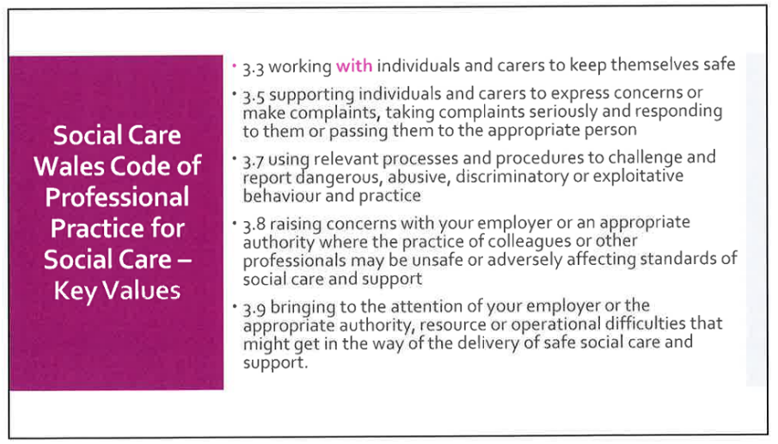
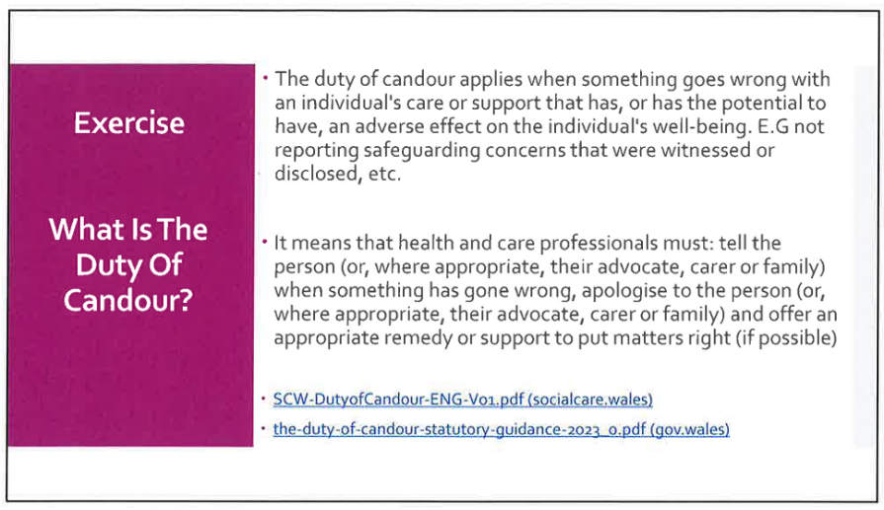
The duty of candour is defined by Gov.Wales (2023) as the requirement of health care workers to be open and honest with service users, colleagues and employers. This ensures that practitioners are transparent when something goes wrong with the care they are providing. The aim of this is to protect the wellbeing of service users and hold organisations accountable for the quality of their services.
Social Care Wales (2023) describes their Code of Professional Practice as a set of standards designed to keep service users safe and well. Guidance for different areas of work is provided, such as social workers, residential childcare workers and social care managers. This code applies to independent visitors and other voluntary roles in social care. If not abided by, the individual may face disciplinary action.
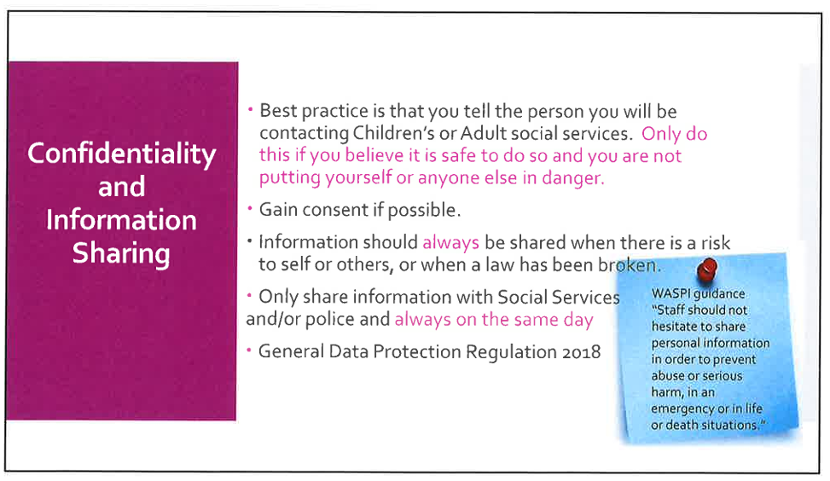
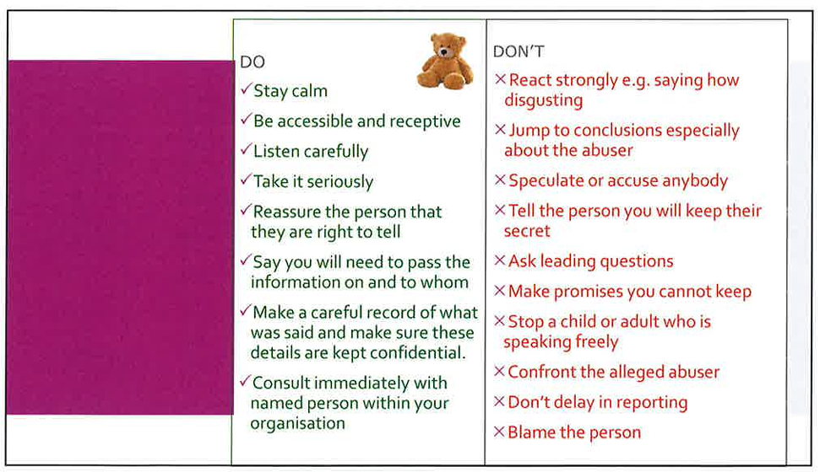
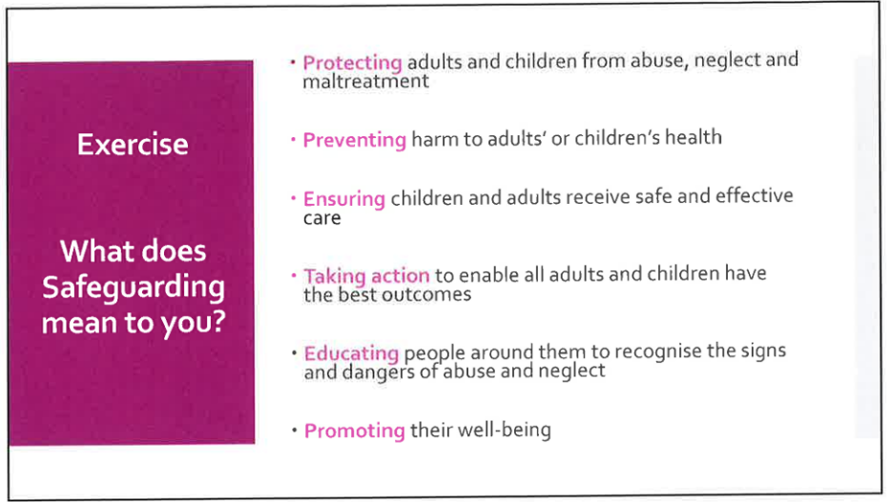
As highlighted by the Data Protection Act 2018, ensuring service user’s personal information is kept confidential is essential for ethical practice. However, in situations where there is risk to the self or others, breaching confidentiality is acceptable because protection from harm is more important. Volunteers should try to gain consent, where possible, but should still act even without it.

Embedded counselling skills are crucial when a person at risk discloses something has happened or is still happening. To not emotionally escalate the situation, volunteers should remain calm. Counselling skills communicate to the person at risk that the volunteer accepts what they are saying and is taking it seriously. The volunteer should never promise that “everything is going to be okay” or that they will “keep it a secret”.
If a volunteer suspects abuse or someone discloses it to them, they must report this to Involve during office hours or contact the Social Services Emergency Duty Team on 01792 775501. If the person is in immediate danger, then emergency services should be called. Volunteers are also required to record what has happened in the Involve volunteer diary sheet we fill out after each meet up.
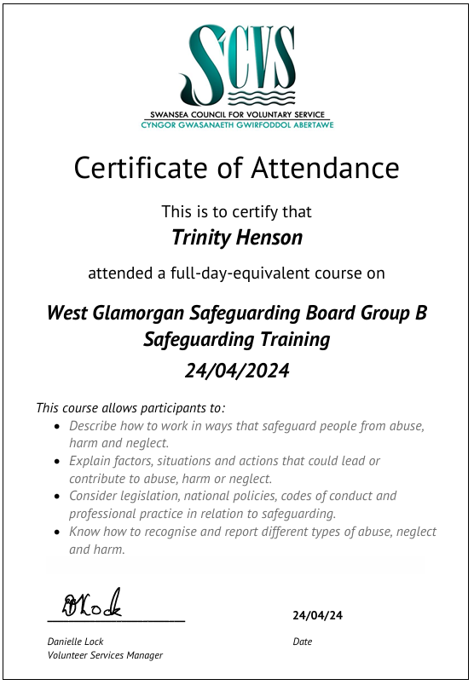
Upon completing the safeguarding training, we received a certificate.

Documents Completed for Each Meeting with The Service User

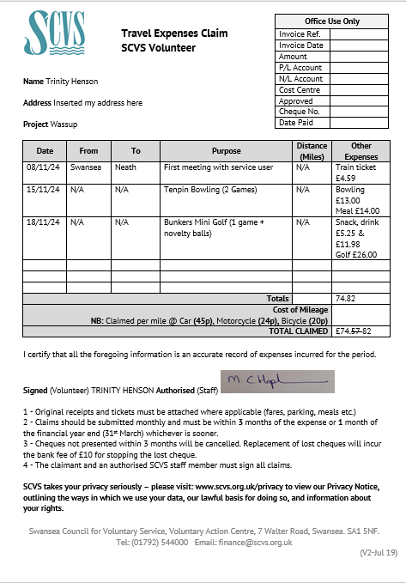
After I completed the training, I was required to provide two references and undertake a Disclosure and Baring Service check (DBS). I had a meeting with Involve to support me in filling out the necessary forms. Something new I learnt was that criminal records do not necessarily exclude someone from volunteering. However, depending on what they have been convicted of, it may limit what they can do.
For the meet ups with the service user, I would plan and organise activities I thought the service user would enjoy. I made these decisions based on what he or others had said about his interests. Certain activities, such as theme parks, require risk assessments before being authorised. All costs concerning the volunteering are paid by Involve, so I would fill in their expenses form and send it to them via email to claim the money back.

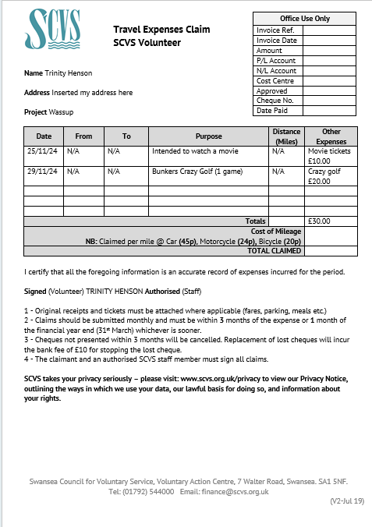

As well as the expense form, I would complete Involve’s diary sheet. The diary sheet ensures regular communication is maintained between volunteers and Involve. This allows Involve to supervise the volunteer’s activity and track how the service users are doing. It is also an important part of safeguarding to protect both the volunteers and service users. It enables volunteers to promptly communicate any concerns they may have to the project.
Once the diary sheet has been sent to Involve, volunteers are required to delete it from their computer to protect the service user’s personal information.
During the meet ups, I would manage the time to ensure I knew where we were when to record on the diary sheet. Additionally, I was expected to arrive on time and have the service user back at the car park to be picked up at the agreed upon time.
After I completed the training, I was required to provide two references and undertake a Disclosure and Baring Service check (DBS). Something new I learnt was that criminal records do not necessarily exclude someone from volunteering. However, depending on what they have been convicted of, it may limit what they can do.
For the meet ups, I would plan and organise activities I thought the service user would enjoy. I made these decisions based on what he or others had said about his interests. Certain activities, such as theme parks, require risk assessments before being authorised. All costs concerning the volunteering are paid by Involve, so I would fill in their expenses form and send it to them via email to claim the money back.

After I completed the training, I was required to provide two references and undertake a Disclosure and Baring Service check (DBS). Something new I learnt was that criminal records do not necessarily exclude someone from volunteering. However, depending on what they have been convicted of, it may limit what they can do.
For the meet ups, I would plan and organise activities I thought the service user would enjoy. I made these decisions based on what he or others had said about his interests. Certain activities, such as theme parks, require risk assessments before being authorised. All costs concerning the volunteering are paid by Involve, so I would fill in their expenses form and send it to them via email to claim the money back.

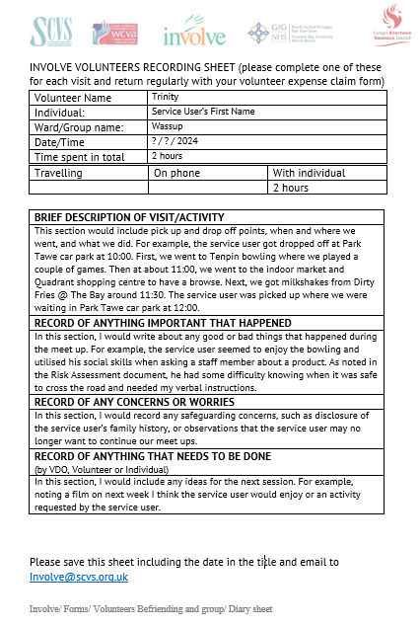

Reference List
British Association of Counselling and Psychotherapy. (2018, July). Ethical Framework for the Counselling Professions. https://www.bacp.co.uk/media/3103/bacp-ethical-framework-for-the-counselling-professions-2018.pdf
British Association of Counselling and Psychotherapy. (2020, May). Counselling Skills Competence Framework. https://www.bacp.co.uk/media/8890/bacp-counselling-skills-competence-framework-may20.pdf
Gov.Wales. (2023, April 1). The Duty of Candour Statutory Guidance 2023. https://www.gov.wales/sites/default/files/publications/2023-03/duty-of-candour-statutory-guidance.pdf
Social Care Wales. (2023, July 20). Codes of Professional Practice and guidance. https://socialcare.wales/dealing-with-concerns/codes-of-practice-and-guidance
Social Care Wales. (2024, September 13). Safeguarding standards group B. https://socialcare.wales/resources-guidance/safeguarding-list/national-safeguarding-training-learning-and-development-standards/safeguarding-standards-group-b
Swansea Council of Voluntary Service. (2015, November 30). About us. https://www.scvs.org.uk/about-us
Wales Safeguarding Procedures. (2019). Wales Safeguarding Procedures. https://safeguarding.wales/en/

Appendix A

Correspondence with Involve
When I requested to do my voluntary experience with the Wassup scheme, I used the term ‘placement’ which caused a misunderstanding with the development officer. She thought I was requesting an official work placement linked to the university, rather than simply wanting to complete my voluntary hours with the scheme. I cleared up this misunderstanding over the phone and sent her my tutor’s email to further discuss the nature of my request. Following this, she agreed over Teams.
Figure A1
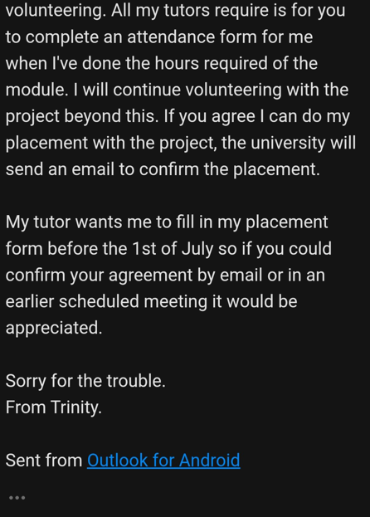
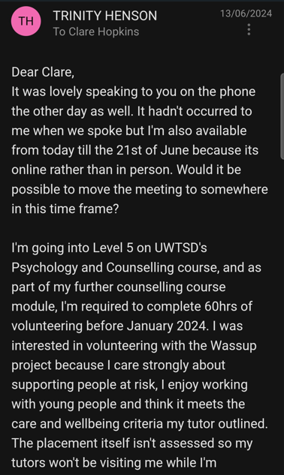
My Emailed Request
Figure A2
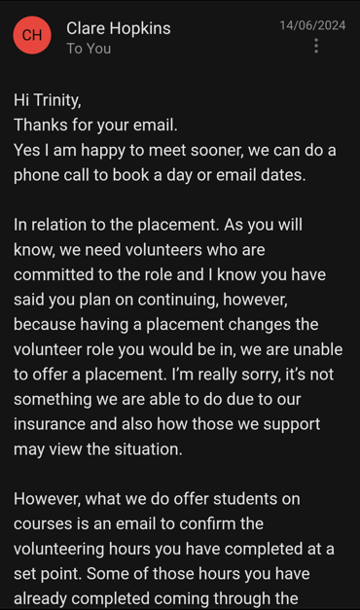
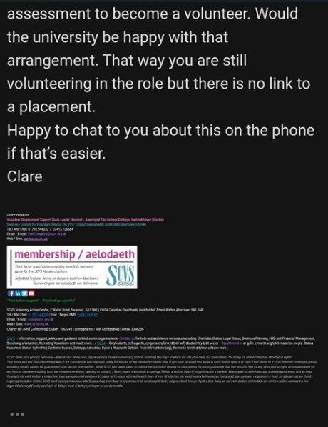
The Response from The Development Officer
Figure A3
Emailing The Development Officer My Tutor’s Contact
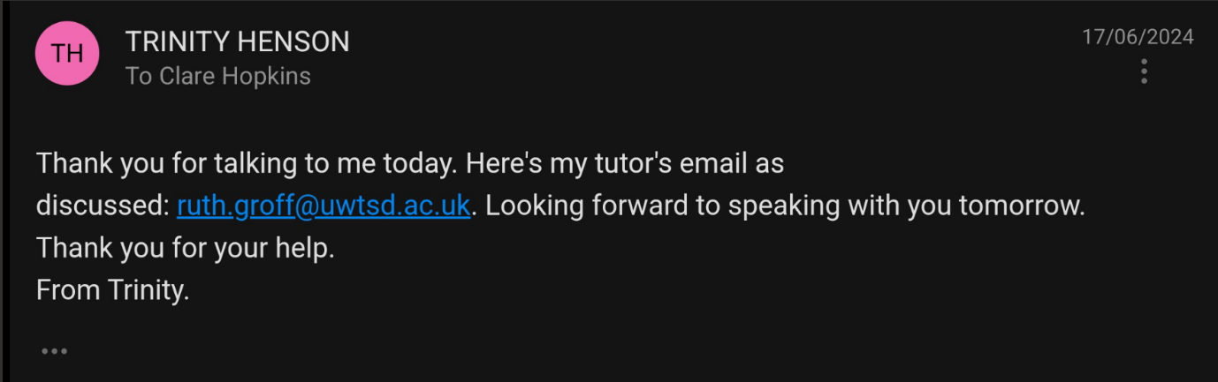

Figure A4
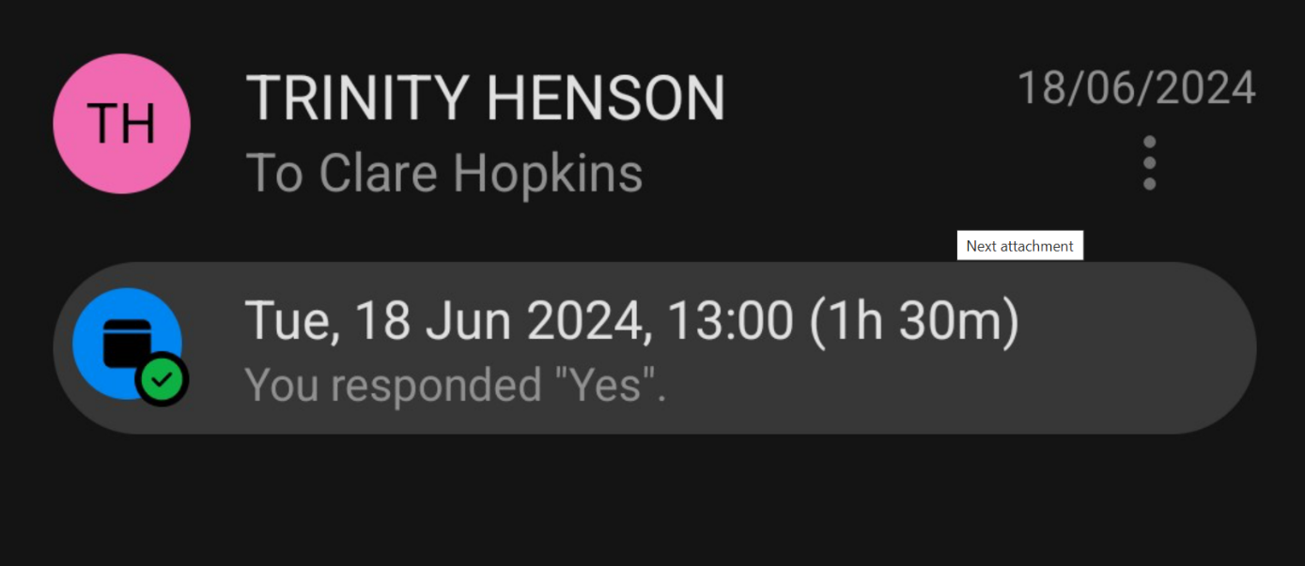
The Teams Meeting

Appendix B

Approval Of the Placement
Figure B1
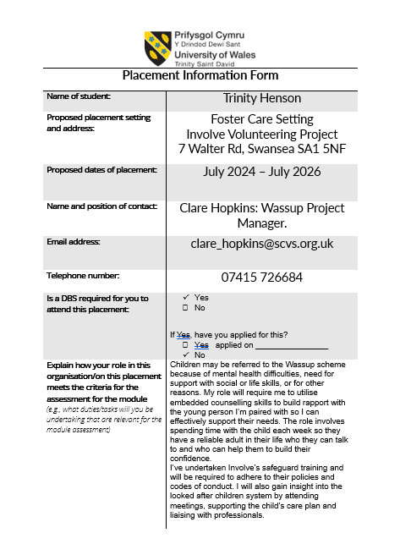
Placement Information Form
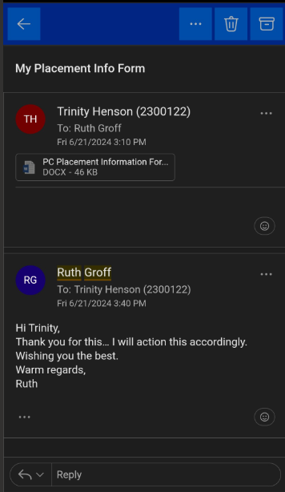
Figure B2
Approval From Module Lead

Appendix C

Record Of Time Spent on The Placement
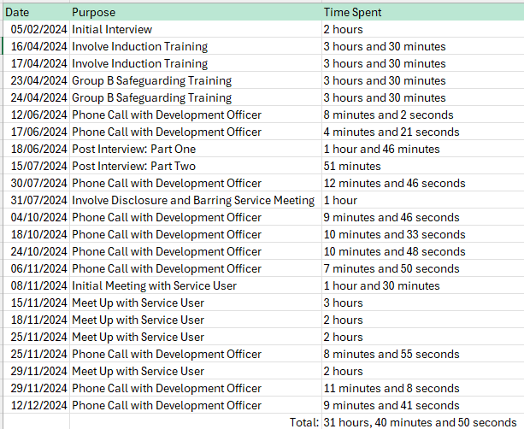

Appendix D

Reflective Logs
Student Name: | Trinity Henson
Name of Host Employer: | Swansea Counsel of Voluntary Service: Involve

Record of project work carried out (add more entries as needed)
Date: | 16th & 17th April
Tasks completed: | - Involve’s Induction Training
Reflection: | I was informed of the non-stigmatising language I should use, such as “mental ill health” instead of simply “mental health” and “older person” instead of the now derogatory term “elderly”. Something I learned was that the reason we should refer to a person as “at risk” rather than “vulnerable” is because the latter implies a permanent state of dependency while the former implies a current factor affecting wellbeing that may be overcome with the right support and interventions – it emphasises empowerment and agency. I also learned of confidentiality practice, e.g. I was surprised volunteers are allowed to discuss their service user with their family (confidentiality is maintained by not revealing any information that may identify them). I felt excited when counselling skills were outlined and applied to case studies within the training because it confirmed the skills were a requirement of the role and I would be gaining valuable experience while volunteering.

Date: | 23rd & 24th April
Tasks completed: | - Group B Safeguarding Training
Reflection: | In the safeguarding training, we learnt about the different legislations and procedures that health and social care workers must abide by. I have never completed safeguarding training before, so this was a new experience that taught me a lot about working with people at risk. What was taught aligns well with what I have learnt about ethical counselling practice on my undergraduate course. Before the training, I was unsure of what to do if you witness abuse. We were taught to not engage and to contact Involve/ social services. In case of emergencies, call emergency services asap. I felt prepared to volunteer upon completing this training.

Date: | 31st July
Tasks completed: | - SCVS Disclosure and Barring Service Meeting
Reflection: | I’d never completed a DBS application before; thus, this meeting taught me what is included within each section of the form. I filled in the personal information and learnt that a DBS requires 3 different types of ID: a primary identity document, a trusted government document and a financial/ social history document. These documents provide a comprehensive verification of identity. I didn’t realise that applicants with criminal offenses can still be accepted for their applied role. Before reaching a decision, the employer considers the nature of the offense, its relevance to the role and the applicants transparency about their criminal record.

Date: | 6th November
Tasks completed: | - Phone Call From Development Officer To Inform Me She Had Found A Match
Reflection: | I got matched nine months after I completed my initial interview. I was surprised at how long some people must wait until they can start their volunteering because of how long the induction process, safeguarding checks and matching can take. I thought it would only take a few months, but it was a much longer process. This has encouraged me to be very proactive when communicating with Involve as I was anxious that I wouldn’t start volunteering soon enough to complete my voluntary hours. I have ensured through my communication that I know where in the process I was. I did apply to Matthew’s cafe as a backup, but I have been matched before getting off the café’s waiting list. I did inform Involve of my time limit, but I should have asked more questions about Involve’s usual waiting time frames before committing to the project.

Date: | 8th November
Tasks completed: | - Introductory Meeting and Befriending Agreement
Reflection: | I did not know what was involved in an introductory meeting between an independent visitor and service user, so followed the developmental officer’s lead. We went to the service users house and introduced ourselves. Once we had sat down, the development officer started asking the service user questions to fill in the volunteer agreement she had in front of her. The service user was very shy and quiet. I observed that the development officer adopted a confident but kind tone. I realised how if you appear warm and confident that it can help the other person to relax around you. She also used a lot of open questions to encourage the service user to talk about his interests and engage in friendly conversation. Whilst some of his answers were quite clipped, the service user engaged with these questions. I noted how one visit isn’t enough time to build a strong rapport with someone; it happens over time. When we got on the topic of what really interested him, he seemed to be more at ease.  Like a counselling contract, we discussed the boundaries of our helping relationship with the development officer. This demonstrated to me how important it is to clearly communicate boundaries of the relationship, so everyone is on the same page about what the relationship and service is. I felt quite nervous during the visit and found it challenging to find an opening to speak to the service user with others leading the conversations. This was because whenever I mustered up the courage to say something the development officer would take the opening. I did manage to speak to him a bit about his interest in video games which was satisfying because I felt it built a bit of rapport.

Date: | 15th November
Tasks completed: | - Meet Up With Service User  - Completion of Expense Claims Form and Involve Diary Entry
Reflection: | I found it a lot easier to communicate with the service user this time around as it was one on one. The service user seemed a bit chattier with just the two of us as well. I booked some bowling for us. Like the initial meeting, I found the best way to get him talking was asking open questions about his interests and school life. This helped me to get to know him as an individual and seemed to build further rapport with him as he got to know me also. I imitated the friendly demeanour I had seen the development officer use in the initial meeting which seemed to help in the service user being at ease with me. I also used active listening and paraphrasing which I found helpful in communicating that I was paying attention to him and clarifying that I understood him correctly. I realised paraphrasing is useful in breaking up the questions, so the conversation flows and does not feel like an interrogation. I found it challenging to keep the conversations going as I do not really have much in common with an adolescent boy, but my use of open questions and paraphrasing did enough to prevent the awkward silences. The service user disclosed some of his family history to me, and my reaction surprised me as I was not as calm as I thought I would be. However, I tried not to let that show in my expression and thanked him for telling me. This information was included in the diary sheet. What I did find satisfying was watching the service user slowly open up to me about himself because I felt I was successfully building rapport with him. I felt a lot of the nervousness about volunteering disappear in this session and felt relatively comfortable in my independent visitor role.

Date: | 18th November
Tasks completed: | - Meet Up With Service User  - Completion of Expense Claims Form and Involve Diary Entry
Reflection: | I noticed that the service user would sometimes need silence when considering a question or in the middle of conversations from his thoughtful expression. This taught me the importance of managing silence to not interrupt his thoughts. This demonstrated the value of the skill I had not recognised in the classroom. Something I found challenging was he kept complaining there was nothing to do in Swansea. Even after I tried utilising the counselling skill of challenge by listing off activities, he kept repeating the complaint. I was surprised when the service user started to voice some quite strong opinions with me. This was because I did not think we were at the point in the helping relationship when he would start sharing these types of personal opinions with me. I responded with paraphrasing and reflection to show I was listening, but sometimes I felt this was not enough as he would trail off. What I found satisfying was that I was still able to get conversations going in this meet up and so further building the rapport between us. Overall, I enjoyed the meet up.

Date: | 25th November
Tasks completed: | - Meet Up With Service User  - Completion of Expense Claims Form and Involve Diary Entry
Reflection: | I waited in our usual meet up spot for an hour, but the service user never arrived. I rang the development officer to tell her this so Involve was informed for safeguarding reasons. She advised I ring his home. A staff member picked up the phone and informed me that the service user’s schedule had changed, and he was in class currently. I asked about his knew timetable and requested we meet Friday’s instead. Something new I did was hide my number from the service user’s home by typing in #31# as per the befriending agreement.  I informed the staff member picking the service user up from the last meet up that we had agreed to meet today, so there must have been a lapse in communication to explain why I was not informed by the home that the service user could not meet me today. Next time, I may not wait as long before ringing staff if a service user does not arrive and now know the process of ringing the staff in this situation. I felt apprehensive when the service user did not arrive but understood what had happened when ringing the home. I was not happy that no one had contacted me to cancel but recognised it was likely just an oversight. I considered how the development officer did not seem happy that no one had contacted me to cancel, and it demonstrated to me how important time boundaries are in this type of role so time is not wasted.

Date: | 29th November
Tasks completed: | - Meet Up With Service User  - Completion of Expense Claims Form and Involve Diary Entry
Reflection: | The service user behaved very differently in this session. He seemed unhappy, very quiet and kept looking at his phone. This was surprising as I thought I had established some rapport with him in our previous meet ups. I concluded that something may have happened in his personal life.  I found this behaviour challenging as he did not want to converse with me, and I did not know what to say to fill the silence.  At first, I tried to ask him open questions about his likes and hobbies, but this did not work for the situation. He would either shrug or ask me why I was asking the question. This would often leave me feeling a bit unsure and uncomfortable. I ended up maintaining the silence for the rest of the time, as he seemed to want me to, but this did not feel right either. I may need to research what counselling skills best work for this type of situation if I encounter it again in the future.  I felt concerned for this change in behaviour and thus included it in the diary sheet. Later, the development officer rang me.  The service user decided to end our match after this meet up due to personal circumstances. The development officer is now looking for a new match for me.

