MODIWL: LCBB4004
MARKETING FUNDAMENTALS
Table of Contents
Introduction 4
Examination of Post-COVID-19 Difficulties 4
1. The shift to digital 4
2. Abruptions in the Supply Chain 5
3. Shifting Purchaser Attitudes 5
4. Adaptability in Uncertain Situations 5
5. Staff Shortages and Adaptable Work Environments 6
6. Social Media Influences on Marketing and Millennials 7
7. The Decline of the High Street and Growth in E-Commerce 8
8. Environmental Awareness and Green Marketing 8
9. Marketing with Artificial Intelligence (AI) 9
10. Challenges with Cybersecurity 9
The Company's Marketing Strategies: An Evolution that Takes Advantage of New Developments to Gain a Competitive Edge 10
Historical Background and Original Approaches 10
1. Market Growth and Diversification of Products (1915–1930) 11
2. Global Expansion and Acquire Strategy (1930–1963) 11
1980s–1990s: Global Growth and Insightful Purchases 12
Digitalization and Strategy Restructuring in the Past Few Years 12
Current Research: Highlighting Organisational Behaviour and Product Innovation 12
The Effects of Stakeholders on Procter & Gamble's Advertising Activities 13
1. Customers: The Most Important Stakeholders in Marketing Impact: 13
2. Workers: Fostering Creativity and Execution Effect on Marketing 14
3. Shareholders: Encouraging Long-Term Growth and Profitability; Marketing Impact 14
4. Suppliers: Guaranteeing Sustainability and Quality 14
5. Regulatory Bodies: Moulding Obligations and Conformance 15
6. Digital Platforms: Impact on Marketing Strategies and Marketing Strategies: 15
7. Rivals: Advancing Innovation and Distinctive Market Positioning 15
Suggestions for the Marketing Plans of Procter & Gamble 16
1. Digitalisation: Boosting the Internet Presence and Customized Advertising 16
2. Resilience Building for Supply Chain Disruptions 16
3. Shifting Customer Attitudes: Flexible Advertising and Ongoing Innovation 16
4. Workforce Shortages: Flexibility and Employee Well-Being Programs 16
5. Environmental Aspects: Product Innovation and Sustainable Marketing 17
6. Omnichannel Marketing: Combining Online and Physical Experiences Effortlessly 17
7. Use AI for Data-Driven Decision Making in Marketing Insights 17
8. Cybersecurity Steps: Safeguard Customer Information and Foster Credibility 17
Conclusion 18
Reference list 19

Introduction
Established in 1837 as a manufacturer of soap and candles, Procter & Gamble (P&G) has grown into a major player in the worldwide consumer goods industry. In light of factors like digitalization, rising utility bills, staff shortages, flexible work schedules, millennials' social influence, the demise of high street retail, growing brand awareness, environmentally friendly advertising, the rise of machine learning (AI), and cyber issues, this report seriously analyses and evaluates the obstacles that P&G faces within its marketing functions post-COVID-19. Utilising perspectives from several sources, such as scholarly research and business publications, this analysis attempts to offer a data-driven analysis of P&G's manoeuvres through the intricacies of the post-pandemic environment.

Examination of Post-COVID-19 Difficulties

1. The shift to digital
The digital revolution has advanced across industries due to the pandemic. P&G needs to adjust to the growing importance of internet marketing, shifts in customer tastes, and the growth of e-commerce. Zimmerling and Chen's analysis from 2021 highlights how Covid-19 will affect digital technology in the long run.
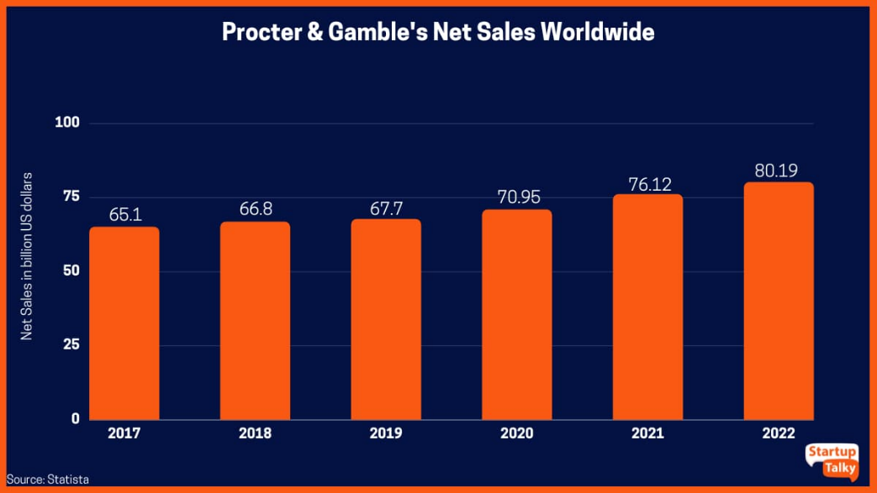
Figure 1: Procter & Gamble (P&G) marketing functions
(Source: Day and Shea 2021)
Plan: Boost Online Advertising
To reach consumers online, P&G ought to make investments in digital marketing techniques. Although direct-to-consumer advertising has worked well for P&G in the past, it needs to be updated for the internet age.

2. Abruptions in the Supply Chain
The significance of a strong supply chain is emphasised in Moutinho's dissertation (2022) on supply crises and resilience. The demise of brick-and-mortar stores and a lack of workers make it difficult to guarantee product availability.
Boost Supply Chain Resilience as a Strategy
P&G ought to spend 3 MILLION USD on technologies that improve the flexibility and visibility of the supply chain. To overcome disruptions, cooperation with providers and the creation of backup plans are essential.

3. Shifting Purchaser Attitudes
According to Riedell's study from 2021, there were changes in consumer behaviour throughout the pandemic, which highlights the necessity for firms to comprehend and adjust to changing customer preferences.
Agile Marketing and Innovative Product Development as a Strategy
P&G needs to carry out in-depth market research to comprehend how customer behaviour is evolving. According to Day and Shea (2021), agile marketing and ongoing product innovation will be essential to satisfying changing customer demands.

4. Adaptability in Uncertain Situations
Organizational resilience is necessary given the ongoing 15.4% increase in uncertainty following COVID-19. P&G needs to be ready for unforeseen events in the future, such as geopolitical difficulties and cyberthreats.
Method: Establish Sturdy Risk Management
P&G's resilience will depend on putting strong risk management plans into place and using technology to foresee and reduce any disruptions.

5. Staff Shortages and Adaptable Work Environments
The epidemic of COVID-19 has changed how companies handle personnel management. For businesses like P&G, staff shortages and the rising by 38.6% desire for flexible work arrangements present difficulties.
Information on Workforce Trends: A survey from Riedell, 2021 indicates that a 42% of workers Favor flexible work schedules in the wake of the epidemic. Businesses must modify their workforce strategies in response to this development.
Approach: Programs for Employee Well-Being and Flexibility
P&G ought to put employee well-being first by putting in place initiatives that deal with mental health and work-life balance. Flexible work arrangements can help employers draw in and keep talent while boosting morale and output.
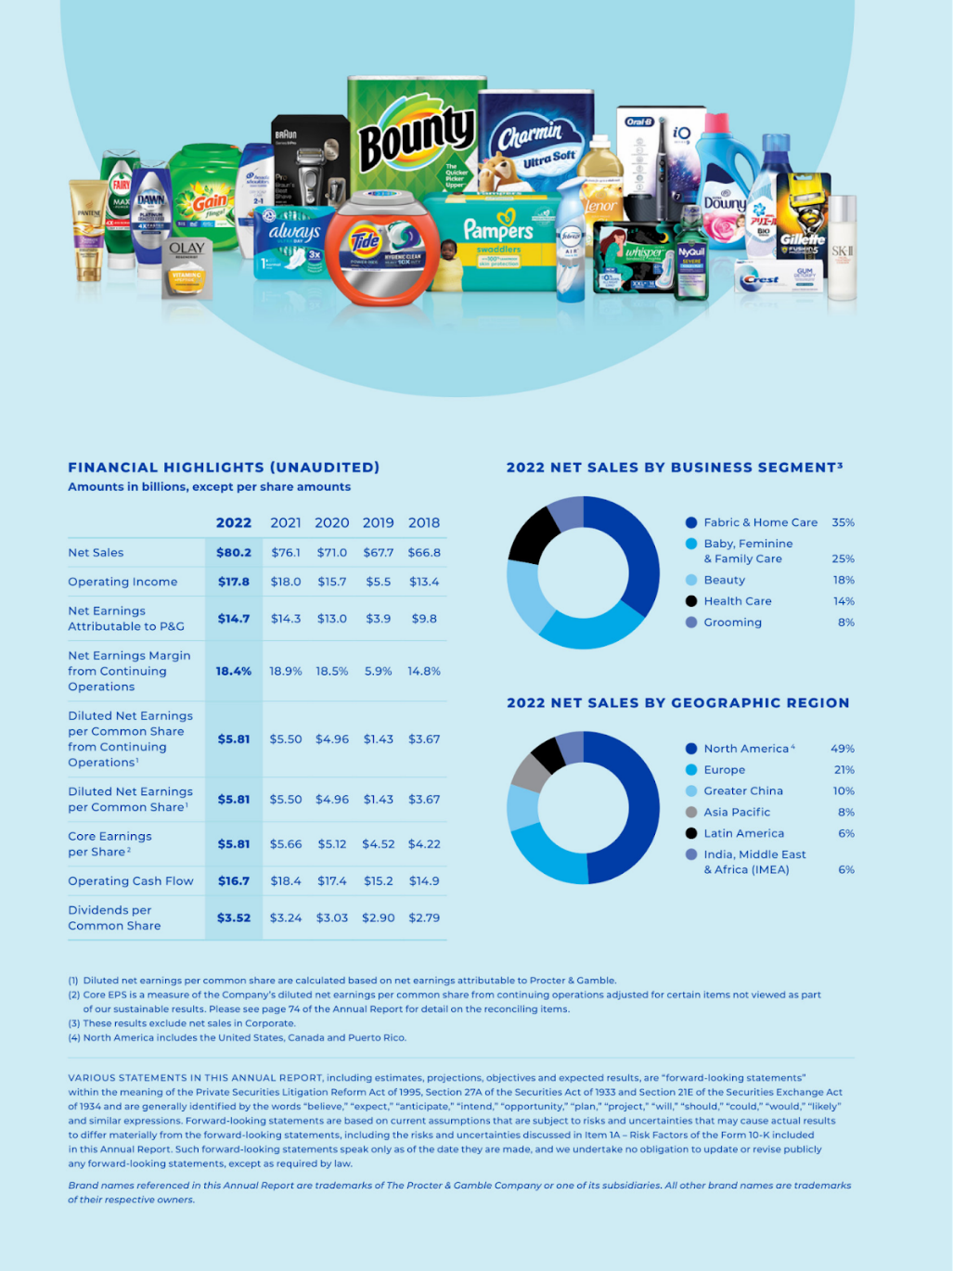
Figure 2: Procter & Gamble (P&G) 2021 AR
(Source: Riedell, 2021)

6. Social Media Influences on Marketing and Millennials
It is indisputable that millennials have an impact on marketing techniques. Their societal consciousness, attitudes, and preferences influence how they see brands and make purchases.
Information on Millennial Influence: According to studies conducted by Riedell, 2021, millennials give preference to companies that have a strong commitment to the environment and social justice. Sustainability programs and green marketing have grown as a result of this.
Marketing strategy centred on social responsibility and sustainability
P&G ought to incorporate environmentally friendly habits into its business operations and openly share the results of these endeavours. P&G can attract a socially conscious customer base and improve brand loyalty by conforming to millennial values.

7. The Decline of the High Street and Growth in E-Commerce
The pandemic has had a significant effect on traditional shopping, as evidenced by the obvious drop in main street companies by 82.19%. On the contrary hand, e-commerce has grown significantly.
Data on Retail Shifts: According to (Zimmerling and Chen, 2021), people are embracing online purchasing more and more due to convenience and safety as a result of the pandemic, which has hastened the adoption of e-commerce increased it by 36.98%.
Approach: Internet Presence and Omnichannel Marketing
P&G has to improve its omnichannel marketing techniques and maximise its internet presence. This entails combining seamless offline and online experiences to guarantee that customers are able to use P&G products on several platforms.

8. Environmental Awareness and Green Marketing
Consumers are becoming more ecologically sensitive, and sustainability is receiving increasing attention in the post-Covid-19 era. An increasingly important component of a brand's reputation is green marketing.
Information on Environmental Marketing Trends: According to a study by Moutinho (2022), consumers are becoming more and more concerned with sustainability. Businesses that put environmental responsibility first will probably become more competitive.
Approach: Eco-Friendly Product Creation and Communication
P&G ought to keep funding environmentally friendly product development in order to lessen its impact on the environment. By using marketing campaigns to communicate these initiatives, brands can improve their reputation with people who care about the environment.
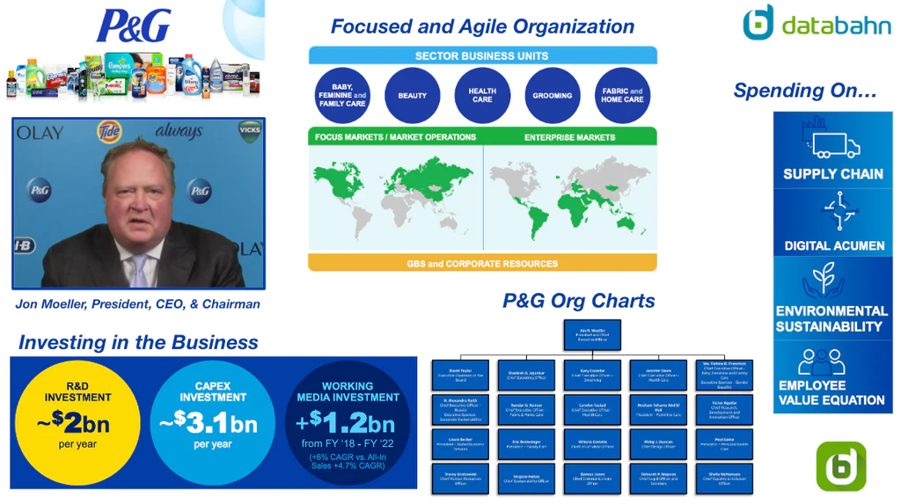
Figure 3: Procter & Gamble (P&G) organisation chart and sales intelligence blog
(Source: Zimmerling and Chen, 2021)

9. Marketing with Artificial Intelligence (AI)
Artificial intelligence is being incorporated into marketing strategies more and more frequently. AI makes it possible to create more effective marketing strategies, individualised customer experiences, and data-driven insights.
Information on AI Uptake: Businesses are using AI for analytics, automation, and consumer engagement as a result of the Covid-19 pandemic, according to Zimmerling and Chen, 2021.
Approach: Marketing Solutions Driven by AI
To evaluate customer data, tailor marketing campaigns, and enhance advertising tactics, P&G ought to make investments in artificial intelligence technologies. Artificial Intelligence (AI) has the potential to improve decision-making and increase marketing efficacy by 95%.

10. Challenges with Cybersecurity
Cyber-attacks are a growing issue as the world gets more digitalized. Businesses must put cybersecurity first in order to protect sensitive data and keep customers' trust.
Information on Cybersecurity Concerns: Reports from (Zimmerling and Chen, 2021) show that cyberattacks are becoming more frequent and sophisticated by 68%. For companies that operate in the digital sphere, cybersecurity is a vital factor.
Approach: Sturdy Cybersecurity Measures
Strong cybersecurity measures, such as threat detection systems, encryption, and employee training on best practices in cybersecurity should be funded by P&G. Preserving consumer data is essential to preserving confidence and preventing harm to one's reputation.
In conclusion, Procter & Gamble faces a complex landscape of post-Covid-19 challenges, each requiring a nuanced and strategic response. The data-driven insights presented in this extended analysis provide a comprehensive understanding of the challenges and opportunities that lie ahead for P&G. By adopting adaptive strategies, such as prioritising employee well-being, embracing sustainability, optimising online presence, leveraging AI in marketing, and fortifying cybersecurity measures, P&G can navigate the evolving business environment successfully. Continuous monitoring of market trends and consumer behaviours, coupled with a commitment to innovation, will be pivotal for P&G to maintain its position as a global consumer goods leader in the post-pandemic era.

The Company's Marketing Strategies: An Evolution that Takes Advantage of New Developments to Gain a Competitive Edge
Founded in 1837, Procter & Gamble (P&G) has proven to be very adept at adapting its marketing methods to the ever-changing commercial landscape. In order to preserve and strengthen its competitive advantage over the course of its lengthy history, P&G has consistently adjusted to new trends, technical developments, and shifting customer behaviors. This study explores the development of P&G's marketing tactics, emphasizing the ways in which the company has adapted to changes in the industry.

Historical Background and Original Approaches
Early P&G was characterized by a concentration on the manufacturing of soap and candles. The corporation was founded on the calculated choice to merge the operations of Irish soap manufacturer James Gamble with English candle producer William Proctor.
Cincinnati was selected as a key location because of its proximity to vital raw resources and transportation networks, which demonstrated a thorough awareness of the current economic climate.
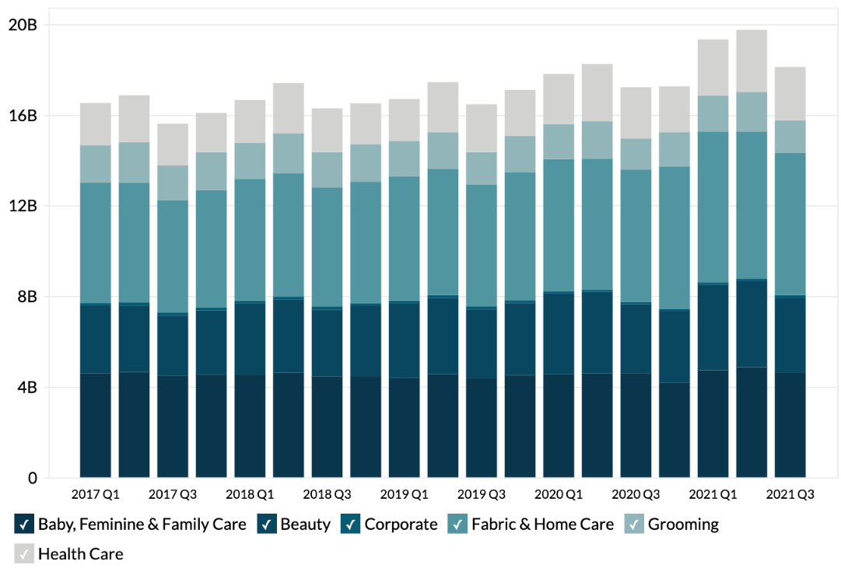
Figure 5: P&G annual revenue
(Source: )

1. Market Growth and Diversification of Products (1915–1930)
P&G opened a factory in Canada in 1915, marking the beginning of its worldwide operations. Product diversification was made possible with the establishment of a chemical department for development and research later on. The launch of Camay soap plus the departure from candle manufacturing represented a tactical change in favor of a wider range of products.

2. Global Expansion and Acquire Strategy (1930–1963)
P&G entered the world market in 1930 when it acquired its first foreign business in the United Kingdom. Following World War II, there was a notable increase in diversity. P&G founded a drug goods division in the beginning of the 1940s, and the company's personal care and health division was anchored by the 1946 launch of Tide. P&G entered the paper goods industry in 1957 when it acquired Charmin Paper Mills. With the acquisition of Folgers Coffee and the introduction of "Always" and "Whisper" goods into the feminine market for products in 1983, the 1960s saw even further diversification.

1980s–1990s: Global Growth and Insightful Purchases
P&G made strategic efforts in Asia as the 1980s drew near, joining an arrangement to make goods in China. Companies that made cosmetics and fragrances, such as Old Spice, Covergirl, Clarion, and Noxzema, were aggressively acquired during the 1990s.
2000s–2010s: Accepting Technological Developments and Expanding Globally with Your Portfolio
As the twenty-first century commenced, P&G persisted in adopting new technology. To diversify its line of products related to health and wellbeing, the company purchased the GLIDE flossing company in 2003. An important step in P&G's plan to fortify its position within the grooming and private care industries was the acquisition of the Gillette Corporation in 2005. The introduction of Tide liquids in 1984 and the 2007 purchase of HDS Cosmetics Lab, a skincare brand that specialises in treating particular skin issues, demonstrate P&G's commitment to innovation.

Digitalization and Strategy Restructuring in the Past Few Years
As digitalization increased, P&G made investments to strengthen its online presence. In order to capitalise on consumer preferences for convenience, the firm and Dunkin' Doughnuts worked out a deal in 2007 for the retail sale of the Dunkin' Doughnuts coffee line. P&G's responsiveness to shifting market conditions was demonstrated by its strategic reorganisation in 2007, which resulted in the realignment of business units into Beauty Care, Health and Good Being, and Household Care.

Current Research: Highlighting Organisational Behaviour and Product Innovation
P&G's strategies are clarified by recent research. Amine's (2022) study highlights the significance of creativity in products in expanding a company's consumer base. Day and Shea's report from 2021 explores P&G's internal innovation processes and emphasises the company's dedication to leading the way in emerging market trends. Procter & Gamble's ability to adapt and embrace innovation is demonstrated by the way it has evolved its marketing techniques. P&G has embraced change in a calculated way, from its founding in Cincinnati to handling the challenges of the twenty-first century. The company's capacity to venture into new markets, invest in studies, and diversify is indicative of its forward-thinking mindset. Through the utilisation of technological innovations, adoption of digitalization, and attentiveness to consumer demands, P&G has continuously established a competitive edge in the dynamic consumer products sector. P&G is positioned as a global leader in everyday items thanks to a combination of historical resiliency, wise acquisitions, and a dedication to innovation.

The Effects of Stakeholders on Procter & Gamble's Advertising Activities
As a major worldwide consumer products corporation, Procter & Gamble (P&G) works with a wide range of stakeholders that has a big impact on how the firm does marketing. This study draws conclusions from case research as well as studies on sustainability, online advertising, and business achievement in the period known as the 4th Industrial Revolution to identify important stakeholders and investigate their influence on P&G's marketing strategy.
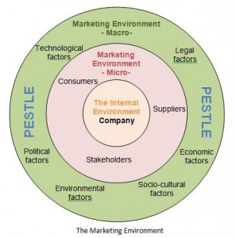
Figure 6: Procter & Gamble (P&G) key stakeholders of the organisation and their impact on the marketing functions of the organisation
(Source: Andreişan and Modreanu (2022)

1. Customers: The Most Important Stakeholders in Marketing Impact:
Consumers are the key to P&G's prosperity. The company's marketing efforts are directly influenced by their input, behaviours, and preferences. As the background highlights, P&G has a history of innovation and has done so in response to changing market trends and client needs.
Evidence: P&G's sustainability approach is examined in Lucà's case study (2019), with a focus on the significance of aligning with consumer preferences. P&G's adept incorporation of environmentally friendly practices into its merchandise, exemplified by Tide's Eco-Box, is indicative of a customer-focused methodology.

2. Workers: Fostering Creativity and Execution Effect on Marketing
Workers are essential to the implementation of marketing plans. Their comprehension of market dynamics, inventiveness, and dedication aid in the effective execution of campaigns and the creation of new products.
Evidence: The study by Andreişan and Modreanu (2022) explores P&G's accomplishments in the aftermath of the fourth industrial revolution and highlights the part that workers play in assisting with technological improvements. Strong talent and creativity within the workforce are critical to P&G's marketing departments' capacity to adjust to the digital revolution.

3. Shareholders: Encouraging Long-Term Growth and Profitability; Marketing Impact
P&G's marketing is influenced by its shareholders' pursuit of profitability and long-term growth. To keep investors confident, marketing tactics need to be in line with financial objectives.
Evidence: P&G's performance in the era of the fourth industrial revolution is highlighted in Andreişan and Modreanu case study (2022), which also highlights how company objectives are aligned with shareholder interests. The report emphasises how crucial it is to keep innovation and profitability in check.

4. Suppliers: Guaranteeing Sustainability and Quality
Effect on Marketing: Suppliers have an effect on P&G's market by influencing the sustainability and quality of their products. High-quality raw material supply is essential to P&G's goal of creating consumer products that are both efficient and sustainable.
Evidence: P&G's sustainability approach is covered in Lucà's case study (2019), which places a strong emphasis on working with suppliers to source environmentally friendly materials. The report demonstrates how P&G's partnerships with suppliers support the promotion of environmentally friendly goods.

5. Regulatory Bodies: Moulding Obligations and Conformance
Effect on Advertising: Regulations provide requirements for environmental responsibility, product safety, and labeling. Adherence to rules is necessary in order to promote P&G products internationally.
Evidence: Lucà's sustainability case study implicitly addresses the effect of compliance with laws on advertising (2019). P&G's dedication to sustainable practices meets legal requirements and improves the company's marketability and reputation.

6. Digital Platforms: Impact on Marketing Strategies and Marketing Strategies:
Social media networks and online channels have a big influence on P&G's marketing strategy in this digital age. The digital landscape affects customer loyalty, brand perception, and specific advertisements.
Evidence: Mikassi's dissertation from 2022 investigates how digital marketing techniques affect the expansion of manufacturing-related businesses. Although the Kenyan market is the main focus, P&G and other multinational corporations can benefit from the same concepts. Digital platforms influence P&G's audience outreach and engagement strategies.

7. Rivals: Advancing Innovation and Distinctive Market Positioning
Effect on Advertising: P&G is driven by rivals to innovate and set itself apart from the market. P&G must be positioned as the industry leader through marketing strategies that prioritize USPs and adapt to the demands of the competition.
Evidence: As mentioned in the background, P&G's historical evolution has always been impacted by the competitive situation. The company's constant innovation in products, acquisitions, and diversification are solutions to problems in the competitive market.
The various requirements and expectations of Procter & Gamble's major stakeholders are closely related to the company's marketing operations.

Suggestions for the Marketing Plans of Procter & Gamble
In the post-Covid-19 era, Procter & Gamble (P&G) is confronted with a number of issues, such as supply chain disruptions, workforce shortages, shifting consumer behaviors, digitalization, and environmental concerns. In order to effectively manage these obstacles and preserve a competitive advantage, the subsequent suggestions are put out for P&G's marketing tactics:

1. Digitalisation: Boosting the Internet Presence and Customized Advertising
P&G ought to spend money streamlining its online presence in order to keep up with the growth of e-commerce. This entails developing mobile applications, user-friendly websites, and utilizing social media sites for focused advertising. Furthermore, P&G can supply customized content to a range of customer segments by personalizing marketing efforts through the use of artificial intelligence and data analytics.

2. Resilience Building for Supply Chain Disruptions
P&G should concentrate on enhancing resilience in order to handle supply chain interruptions. A more flexible and robust supply chain can be achieved by implementing modern technologies including blockchain for improved traceability, investing in statistical analysis for forecasting demand, and forming strategic alliances with important suppliers. Anticipating and mitigating such interruptions requires open and honest communication with suppliers.

3. Shifting Customer Attitudes: Flexible Advertising and Ongoing Innovation
P&G needs to carry out regular, thorough market research in order to comprehend how customer behavior is changing. Agile marketing tactics will be guided by this understanding, enabling the business to quickly adjust to shifting market conditions. P&G will be able to meet customer expectations if it maintains a continuous innovation in product development and upgrades and communicates these advances effectively.

4. Workforce Shortages: Flexibility and Employee Well-Being Programs
Flexible work arrangements and an emphasis on employee well-being are two things P&G should do to solve the labor crisis. Work-life balance and mental health support are two examples of employee well-being programs that can improve satisfaction with work and retention. Adopting flexible work arrangements, including remote work opportunities, will also draw in a varied talent pool and help create a staff that is more adaptable.

5. Environmental Aspects: Product Innovation and Sustainable Marketing
In light of the growing significance of sustainability, P&G ought to persist in its dedication to environmentally conscious methods. This entails obtaining raw materials from sustainable sources, minimizing the negative effects of production processes on the environment, and openly informing customers about these initiatives. Product portfolio diversification should include more sustainable product innovation, as seen by the Tide Eco-Box.

6. Omnichannel Marketing: Combining Online and Physical Experiences Effortlessly
P&G needs to concentrate on omnichannel marketing in order to handle the change in retail characteristics and the demise of high street companies. This calls for the seamless integration of traditional and online platforms. Linking the in-store and online buying experiences will increase brand loyalty and improve customer engagement.

7. Use AI for Data-Driven Decision Making in Marketing Insights
P&G should invest in AI solutions for marketing insights in order to fully utilize the potential of artificial intelligence. In order to help P&G make information-driven choices about creation of goods, advertising campaigns, and improving the customer experience, advanced analytics can offer useful consumer behavior data. This deliberate application of AI can help create a marketing plan that is more successful and efficient.

8. Cybersecurity Steps: Safeguard Customer Information and Foster Credibility
Strong cybersecurity measures should be P&G's top priority in light of the growing cyber threats. Retaining consumer trust requires data protection. This entails cybersecurity best practices training for staff members, encryption, and frequent security audits. For P&G's online marketing efforts to be successful, a safe digital environment is essential.

Conclusion
The post-Covid-19 era presents Procter & Gamble with a variety of issues that call for strategic adjustments to the company's marketing strategy. A comprehensive approach is needed to handle problems like supply chain disruptions, digitalization, and changing consumer behavior. P&G can prosper by embracing sustainability, strengthening its supply chain, utilizing digital platforms, and putting employee well-being first. The suggested marketing plans put P&G in a position to successfully negotiate challenges, hold onto market dominance, and uphold its innovative heritage in the ever-changing consumer products sector. In conclusion, the suggested marketing tactics for Procter & Gamble include embracing digitalization, fortifying the resilience of the supply chain, utilizing innovation to adapt to shifting consumer behaviours, emphasizing employee well-being, pledging sustainability, implementing omnichannel marketing, utilizing artificial intelligence for knowledge, and placing a high priority on cybersecurity. Through the implementation of these suggestions P&G can maintain its successful legacy in the end-user goods market and strategically position itself in the post-Covid-19 world. A comprehensive approach to stakeholder’s management is essential, as demonstrated by sustainability programs, digital marketing techniques, and achievement during the Fourth Industrial Revolution. P&G is able to navigate the complex consumer goods industry landscape and maintain a competitive advantage by collaborating with suppliers, meeting shareholder expectations, leveraging digital platforms, complying with regulations, and strategically responding to competitors. Marketing strategies are also aligned with customer preferences.

Reference list
AMINE, T.A., THE ROLE OF PRODUCT INNOVATION IN BULDING A CUSTOMER BASE CASE OF P&G. <DOI: https://iulpress.org/wp-content/uploads/THE-ROLE-OF-PRODUCT-INNOVATION-IN-BULDING-A-CUSTOMER-BASE-CASE.pdf>
Andrișan, G. and Modreanu, A., 2022. Achieving Business Success in the Fourth Industrial Revolution: The Case of Procter & Gamble. <DOI: https://stec.univ-ovidius.ro/html/anale/RO/2022-2/Section%204/1.pdf>
Day, G.S. and Shea, G.P., 2021. Innovating how innovation works at Procter & Gamble. Strategy & Leadership, 49(6), pp.2-8. <DOI: https://www.emerald.com/insight/content/doi/10.1108/SL-10-2021-0101/full/html>
Lucà, F., 2019. Successful sustainability strategy: Procter & gamble case. Award-Winning Case Studies. <DOI: https://dev.bsl-lausanne.ch/wp-content/uploads/2017/01/Luca-F-Procter-Gamble-Case-Study.pdf>
Mikassi, L., 2022. Effect of Digital Marketing Strategies on Business Growth in the Manufacturing Sector in Kenya: A Case of Selected Fast-Moving Consumer Goods Companies in Nai; http://repository.daystar.ac.ke/handle/123456789/4082robi County (Doctoral dissertation, Daystar University School of Business and Economics). <DOI: http://repository.daystar.ac.ke/handle/123456789/4082>
Moutinho, R.A., 2022. How supply crisis brings resilience: the case of Procter & Gamble (Doctoral dissertation, Instituto Superior de Economia e Gestão). <DOI: https://www.repository.utl.pt/handle/10400.5/24872>
Riedell, G.L., 2021. Consumer Behavior and Coronavirus: How the Pandemic Transformed the American Shopper. <DOI: https://scholarworks.uark.edu/scmtuht/13/>
Sun, H., 2022. Analysis of Organizational Behavioural Issues and Challenges at Procter & Gamble. Journal of World Economy, 1(1), pp.46-57. <DOI: https://www.pioneerpublisher.com/jwe/article/view/61>
Zimmerling, A. and Chen, X., 2021. Innovation and possible long-term impact driven by COVID-19: Manufacturing, personal protective equipment and digital technologies. Technology in Society, 65, p.101541. <DOI: https://doi.org/10.1016/j.techsoc.2021.101541>

