Report: Academic report
To: UWTSD
From: Sophie Akhtar (2123642)
Date: 1st February 2022
Subject: Academic and Employability skills BMSW4001_BIRM
Lecturer’s name: Isaiah Oino

Introduction: What Is the most effective way to motivate staff?
The most important way to when building a report, it needs different information. You can find these sources on Google, Gov.uk, NHS and the most effective source is UWTSD library. These sources give the ability to learn and research on the assignment given by the lecturer. This will also be a life skill and you could also experiment different experiences based on motivation depending on the job role and working your way up. You could also boost up your ability skills motivating one another leaving them with a positive thought. Motivating is a positive thing everyone should do it will not just make the staff it will also make the employee happy knowing they done a good deed encouraging one another. In this report you will gather information from the following sources: Armstrong and Brown (2019), CMI (2021), Cohen (2006) finally Phillips et al (2017).

Motivation is all about keeping a positive attitude and encouraging yourself every day that you can do it whatever your goal is. The main thing about being motivated is being confident in yourself and showing off your best interests. It’s about being enthusiastic and being productive. In this assignment I am going to report the effective ways to motivate staff. I will be discussing the advantages of motivating staff in any workplace. Motivating staff is a challenging task for every employer not everyone is compatible and has got the right mind set to complete this everyday mind task.



Main headings –
- Communications.
- Support
- Recognition
- Respect
- Pay rise
- Reward management
- Encouragement
- Opportunities

Let’s break it down,

Communication - it is very important to communicate with your staff it will build the relation also it will make it a lot easier to work with each other. If there’s a disagreement communication can be made to clear out all the differences. Communication is key to motivate staff as you can get your points across and work together as a team without any complications. I will encourage my staff to encourage one another to communicate as it will make it easier for everyone else. Communicating is a positive thing not just for work but it is vital for day-to-day basis. It leaves a fantastic impact on other people making them feel much better knowing someone is interested to speak to them.
Key facts of communication
- Happy
- Making them feel wanted
- Positive impact
- Shows interest
- Communicating makes it easy
- Better understanding

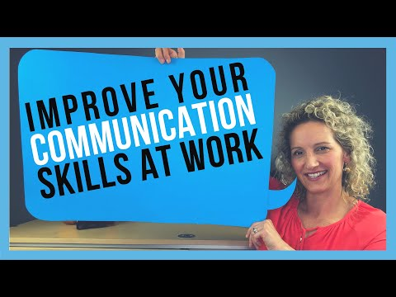


https://youtu.be/knUEdy-kOIQ
Support – supporting your staff will not just motivate them but also will increase their confidence within the job role. Supporting staff will make the job a lot easy they will feel a lot more comfortable achieve the goal set by the organizations. I will encourage my staff to support one another.
Here some of the examples people are struggling with
- Finances
- Health (such as mental health, mentally unstable etc)
- Individual accountability
- Healthy communication

People struggle with these on a day-to-day basis. There struggling can lead to mental health problems which is a negative thing. We can help these people by making them feel comfortable listening to them. Listening is very important because mental health people should feel like people are listening to them and helping them express their feelings. Staff shouldn’t feel neglected when working in a working environment they should be able to work if needed or take time off if it’s effecting their mental health. People get judged for having mental health which is something no one can take control over. People with mental health should speak to the right people and get there advise to make them feel much better.
A healthy communication all it takes for someone to open and express how they are feeling. Failing with healthy communication could also lead to neglect which is a negative impact.
Here is a useful link to help those vulnerable people with mental health.
What are mental health problems? - Mind

No one should ever feel afraid talking to an expert who knows better about mental health then anyone else does. Working in a working environment I will encourage my staff reassuring them they are comfortable enough coming with there mental health that it will get sorted. It will be private and confidential but if I feel like it’s a danger to my staff then the right experts will get involved

Recognition – recognising and praising the staff work is very incredible and very motivating doing this will boost their ego and will make them do even better as a team member. This will also make them feel much better about themselves and gives them confidence to even proceed making the company recognise the work they do. I will encourage my staff and give them recognition because they deserve the credit they need.
https://youtu.be/UYsvLQWZzoU
Every staff member should be given credit for work they have done whether it’s outside of work or at a working environment. Giving credit also gives the organization positive feedback it implies that the company appreciates their staff and will give good feedback of it outside of the work role. Having good recognition will make the feel staff feel more wanted and want to do more to get more praised within the job role. This will also build a good connection with staff. I will encourage my staff to work hard and give them the recognition they deserve.
To break down this word recognition it implies that staff should get the credit they deserve and be recognised from the company and make them feel privileged. Doing this positive thing will leave them happy when they at work or outside of work.
BT
- business linkage
- clarity and transparency
- market competitiveness
- performance differentiation
- choice and flexibility
- equal pay

Armstrong and Brown (2019)

Respect – Personally I think having respect is a big aspect in every sector. Having respect for staff is positive this shows them that they are worth whatever they are doing. Having respect will motivate them even more to do better to get more respect elsewhere within the job. Respect for staff is outstanding this will make them feel comfortable and make them engage within the job. I will encourage my staff to respect one another so they can work more effectively in an environment without any problems caused.
Giving respect to staff makes the feel they are in a safe and comfortable place. This will motivate staff to come to work knowing they coming to a working environment where they going to be respected from one another. I will encourage my staff if they want respect, they will have to give it back. This strong mindset will leave a good attitude towards staff and people outside of work as well. This is also called basic manners to be giving out respect it will make others happy too.
(news, 2018) (Beach, et al., 2007)
Having respect doesn’t mean your different from one another it just makes you feel much better about yourself knowing if you give respect, you will receive respect back. Which will leave a positive attitude on you around the people you’re with.

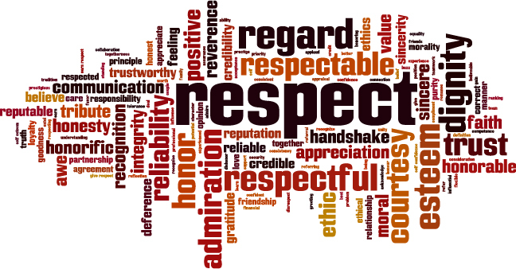
Pay rise – I mean who doesn’t like extra money so if you know you have earned it is very important to highlight and appreciate the staff for the work, they provide for the company Personally I think this is the main reason to motivate staff as most income is good but a higher one is even better! This will encourage staff to do more and be more motivated with their job. I will encourage my staff to work and give them a pay rise they deserve it.
Giving a high pay rise would motivate the staff to do even more better than they already have. I will encourage my staff to give them the high pay rise they deserve because I want them to feel like they are being appreciated. Doing this will make the staff love there job even more and have a positive outcome. Giving good feedback to others outside of work.
Having staff employed should understand pay rise is a positive outcome for their own benefits and will give them a lot more opportunities what they want to do in life. In order to achieve this staff must achieve the required organizations goals also try to achieve for something higher, something organizations are not even expecting it. This will highlight the fat that you went out your way to achieve this it will make the organization happier which will be easily more recognised within the job role. Hence the pay rise is a MUST.

https://youtu.be/Yjc3te-MrC4


Encouragement - encouraging staff is very IMPORTANT when working in a working environment failing to do this could mean failing the whole company as they will lack staff.
What does encouragement mean?
Encouragement means reassuring and giving one another support in whatever they are doing. For example, working in a working environment giving support to one another could also mean the company could become a successful one. Without this the company isn’t going anywhere.
Why is encouragement important?
It is VITAL to encourage your staff and push them further as we go along because they might have some hidden skills that you might not know off and if they are not confident enough showing it then the company will lose out if its beneficial to the organizations.
Encouragement will also make the staff support one another without a doubt.
Talking to each other and giving each other ideas will also boost there confident and give them the support they need because they will know and understand you are interested in what they are talking about and like to participate. By achieving this it will make the staff feel very happy.
I will always encourage my staff to try and work there best if they do more then expected they will be getting a recognition. This is an advantage to the staff one goal achieved. By doing this they will need encouragement as well.

Here’s a link for more information
(Tillott, Walsh, & Moxham, 2013)


Opportunities - working in a working environment it is very important you take advantage of all benefits and opportunities that comes your way. You might not get a second chance.
I will always encourage my staff to grab there opportunities as fast as they can and always will give them a chance to let them know. There will always be positive feedback and rewards when working as a staff member.
It is very important for staff to know what benefits they have as a staff so they can take full use of the advantage.

Here’s a link for more information about opportunities
e (Salary and Benefit Discussions Among Employees, n.d.)
The benefits and opportunities are good and come into favour for some. A lot of people take real use of this one advantage for working as a staff. I will always encourage my staff to work hard so they can grab all the opportunities and benefits they can.

REFERNCES:
Armstrong and Brown (2019) – RECOGNITION
Armstrong and Brown (2019) – REWARD MANAGEMENT
https://youtu.be/knUEdy-kOIQ - COMMUNICATION
https://youtu.be/UYsvLQWZzoU - RECOGNITON
https://youtu.be/Yjc3te-MrC4 - PAY RISE
(News, 2018) (Beach, et al., 2007) – RESPECT
(Tillott, Walsh, & Moxham, 2013) – ENCOURAGMENT
What are mental health problems? - Mind – SUPPORT

