Effective Team Working & Communication (BMSW4002_LON)
Communication
Maryam Malik (1919971)
Dr Gulnar Ali (Lecturer)
Contents
Introduction…………………………………………………...........1
Models of Communication……………………………….............2
Communication Skills …………………………………................5
Verbal Communication ……………………………………………6
Non-Verbal Communication ……………………………………...7
Listening …………………………………………………………….8
Recommendation…………………………………………………. 10
Conclusion …………………………………………………............10
References ………………………………………………………… 11
Appendix (A) ………………………………………………………. 12
Appendix (B) ………………………………………………………. 13
Appendix (C) ………………………………………………………. 14

Introduction
Communication is ability to connect and interact with other people in a socially appropriate way. Skill that could be developed by active listening, observing and reflecting on another human interaction. Range of different communication skills can help to create strong and meaningful relationship. Communication is the exchange of ideas, knowledge or thoughts that ensures mutual understanding between two people ore a team. Meaningful communication occurs when the receiver precisely understands the information transferred by the sender. By analysing the main models of communication, we will be able to understand the components of poor communication. Also, by analysing main aspects of communication skills we will be able to establish success for effective communication.

Models of communication
Models explain process of human communication. There are three main models that explain basic process of communication. The prime Linear model was developed in 1948 by mathematician Claude Elwood Shannon and scientist Warren Weaver it was called:

Shannon and Weaver Model
This model was first made to improve technical communications aiming to maximize telephone capacity with minimum noise. However later it became famous as a model that helped to develop effective communication in various areas. As information is being sent in a linear platform it becomes apparent that this model supported information being sent however, omitted any feedback to the sender from the recipient. For example, information on an eviction notice can be sent to a tenant with instructions of what actions they must take. Their views, thoughts and any constraints however will not be known. This therefore renders the goal of this message and not be actioned.
Instructions in an educational format may however be effectively be delivered through this method as the initial form of an on-going communication between sender and receiver can begin. In current society this is very much seen in social media such as YouTube, Zoom and other similar platforms.
A disadvantage to using this model is where background and passive noise interfere with the communication. In ‘Maria and Pedro’ case study, the communication channel is replaced by noise: Pedro was unable to decode the message correctly due to the background noise. Due to passive role of feedback the communication was unsuccessful (Appendix A, ‘Maria and Pedro’ case study).
The Interactive model allows a feedback element it was proposed in 1954 by Wilber Schramm and was called:

Schramm’s model of communication
This model acknowledges that communication is a social interaction that builds partnership between sender and receiver therefore encoding plays a very important role by converting thought into content. Until the decoder understands the message that the encoder wants to communicate, the transmission of information is of no use. This is demonstrated in Appendix B: The professor and the village people whereby communication is effective only when the receiver understands what is being communicated with them. It points out that knowledge, experience and cultural background also play an important part in communication.
A higher educated individual may have expert knowledge and it is therefore important to be mindful on the use of language expressed in a communication and this must be understood by the receiver(s).

The third Transactional model reproduce face to face interaction by David Berlo (1960) and named:
The third Transactional model reproduce face to face interaction by David Berlo (1960) and named:

Berlo’s model of communication
The focal point of this module is to concentrate on encoding and decoding which occur before sender sends the message and prior to receiver receives the message accordingly. David Berlo includes factors such as communication skills, awareness level, social system, cultural system and attitude. The decoding action is where the awareness skills take place by seeing, hearing, feeling and touching. For instance, some cultures greet people with hugs and kisses, and this shows a form of love and compassion. In other situations, for instance, in the current Covid-19 pandemic, this is very much frowned upon even by close relatives and loved ones. It is here where other forms of communication are required to be the focus, such as tones of voice and choice of language and expressions used.
Case study “A day with a Chef” reflects theory of Berlo model of communication whereby a person’s own interpretation of a sender’s message can impact on the message between the sender and receiver. Mark is rewarded by a free trip in California to meet Chief Executive Officer for being the top salesman. Mark is nervous about meeting his top boss, he has created a horrible characteristic picture of his boss in his minds. That did not help him to concentrate on his main task to impress. Therefore, once he was proved otherwise that his boss was in fact a very pleasant person to be around Mark relaxed and was not able to realise that his body language and attitude was totally inappropriate for occasion. Leading to all failed messages prior actual communication Marks meeting was highly unsuccessful (see Appendix C questionnaire).

Communication skills
Communication skills are foundation in the world of work and organizational success. Communication ‘bridge’ that relationship provide acts as appoint of human connection. Using range of communication skills people finds easier to move where they are, to where they want to be.
Therapeutic Communication Techniques
Therapeutic | NON-Therapeutic
Active listening  Sharing observation  Sharing empathy  Sharing hope  Sharing humour  Sharing feelings  Using touch  Silence  Providing information  Clarifying  Paraphrasing-Restating  Asking relevant questions  Summarizing  Self-Disclosure  confrontation | Asking personal questions  Giving personal opinion  Changing the subject  Automatic responses  False reassurance  Sympathy  Asking for explanation  Approval or Disapproval  Defensive responses  Passive or Aggressive responses  Arguing
By analysing Therapeutic communication techniques, I am able to learn great deal about interpersonal relationship. Looking back to my own life experience while caring for my mother. I was lacking in these vital techniques that could comfort her and grow our relationship in difficult times. Due to lack of communication we grow in distance and lost pressures memories. It is a common issue by trying to protect feelings we stop interacting, therefore by gaining the right knowledge of effective communications difficult times could indeed bring us closer.

verbal communication
Is an act of transmitting words, message through language or written communication.
Oral communication ranges from speaking clearly to more complex act such as reflecting and clarifying. Words play important role in transmitting message successfully sometimes we use different words in different situation to describe identical information. Oral communication is the oldest and most rapid transmission and a prompt reply is also received. However, there are downfalls and limitation such as once spoken, the words cannot be taken back. Is important to clarify that spoken element of verbal communication is incomplete without interaction of body language, tone of voice, attitude and facial expression. For example, saying a statement with a smile could be interpreted as friendly and polite; or negative and sarcastic.
Written elements of verbal communication do not require any interaction of non-verbal elements to transmit effective verbal communication. Therefore, it requires careful drafting and formatting in written form. That’s way is considered as most reliable way of communication. Business world preferers written communication channels such as letters, e-mails, journals, magazines, newspapers, text messages, reports, and so on. It considered as more reliable method of communication. Written communication provides a permanent record of information and can be Stord for future access. With rapid growth of technology in the workplace electronic mail has become vital tool in business communication world. However, everything has two aspects, many users of e-mail pay little attention to rules of grammar and appropriate format. Writing communication lack of immediate response from receiver and is time consuming process (Maund, 2017, pp. 67-85).

non-verbal communication
Act of communication without using words that sends meaning to someone. Nonverbal behaviour may shape parts of a verbal message. There are many types of non-verbal communication. They include:
Space is often related with social rank and play important part in business communication. People from different cultural background may have different understanding of space expectation norms. Amongst most humans there is a basic requirement of personal space.
Environment is an important part of the passionate communication process. The awareness of one’s environment influences one’s reaction to it. Environment designed to facilitate creativity, interaction and collaboration are worth the effort. ‘Sometimes it is more about the atmosphere of a certain place than the place itself ‘(Maund, A., Schriek, M., Tinkler, P. K., 2017).
Vocal expression gives away our thoughts, our emotions and the relationship with others. The human voice is an important channel for nonverbal communication of emotion expression. The pitch of voice can determine the mood of conversation.
Physical appearance expresses who we are and gives impression to people we interact. Is not necessarily the case that our personality, behaviour reflects our physical appearance. However, it certainly helps in professional environment as people say firs impression is the last impression. Self confidence boost expression of physical appearance.
Body movement is key to understanding nonverbal communication. Body movements can add to the verbal message by clarifying main idea. Body language has power for verbal and nonverbal message reinforce each other addition to that body movements can also regulate and dominate conversation. Body language able to replace verbal message. Body posture can show confidence, a shy nature, anxiety, submissive personality, assertiveness as well as aggressive dominant behaviour.
Facial behaviour able to communicate countless emotions without saying a word. The emotions shared through facial expression are universal unlike other forms of nonverbal communication. Human face is a vocal point to both verbal and nonverbal communication. Remarkable part of facial expression cove use of the eyes. Amount of eye contact often determines the level trust and trustworthiness’. Looking at another person’s eyes one can sense if that person is interested ore attractive.

listening
Is one most valued act of successful communication. Listening however is not the same as hearing. One must pay attention not just what they hear but in what way they received the message, how it connects to the sender of the message. As we analysed communication models, we able to conclude that noise interacts every communication. External noise is not difficult to control by making sure that we illuminate the chances of interrupting conversation such as switching of the phone ore choosing quiet place. Internal noise mostly effects ability to focus on the message. It could be Couse of personal problems that worries ore loss of interaction due to physical needs. By taking a break and dealing with occurred issue ore just stepping back and reflecting acknowledging the situation should help to illuminate distractions, other ways is best to reschedule the meeting.
Active listening can improve with practice. It is conscious decision that involves use of all senses, focus fully on the speaker, actively show verbal and nonverbal signs of listening. The HURIER model method define a six-step process to improve active listening such as: Hearing, Understanding, Remembering, Interpreting, Evaluating and Responding. Listening no doubt is a main and complex element of communication.
Empathetic listening is a skill that requires great deal of understanding without judgmental approach. It’s very important to understand that is not about you. Therapeutic communication techniques would highly relate to empathetic listening by analysing that technique we could improve in this particular element of listening (Maund, 2017, pp. 87-101).

Recommendation
There are a number of key elements that formulate good enough communication. Whilst some of these can come out naturally when one is communicating, it is important to ensure the correct message or intentions are conveyed to the receiver. The Shannon and Weaver model is best used for informative communication and is a good way of opening dialogue between sender and receiver. Schramm’s model can be effective over time when both the sender and the receiver acknowledge the information conveyed by other. Berlo’s model is used well when combined with appropriate and effective verbal and nonverbal expression.

Conclusion
Report helps to acknowledge the importance of communication between humans in order to build relationship. Looking at various elements of communication we must apply practise to improve essential skills. Oral communication provides rapid transmission and prompt reply. Electronic mail is highly appreciated in a business sector of communication. Nonverbal communication plays important role in decoding and passing meaningful message. Listening is equally important as talking to maintain successful verbal communication.

Reference

Littlejohn, Stephen W. (2002). Theories of Human Communication. CA, USA: Wadsworth/Thomas Learning.
Maund, A. Schriek, M. and Tinkler, P. (2017) ‘Communication’, Certificate in higher education: skills for the workplace student yearbook, (pp. 45-66), London: Sage
Maund, A. Schriek, M. and Tinkler, P. (2017) ‘Listening’, Certificate in higher education: skills for the workplace student yearbook, (pp. 87-101), London: Sage
Maund, A. Schriek, M. and Tinkler, P. (2017) ‘Verbal and non-verbal communication’, Certificate in higher education: skills for the workplace student yearbook, (pp. 67-85), London: Sage
Therapeutic Communication Techniques: http://www4.napavalley.edu/Projects/102/N141_Powerpoint_Handouts/Therapeutic_Communication_Techniques.pdf

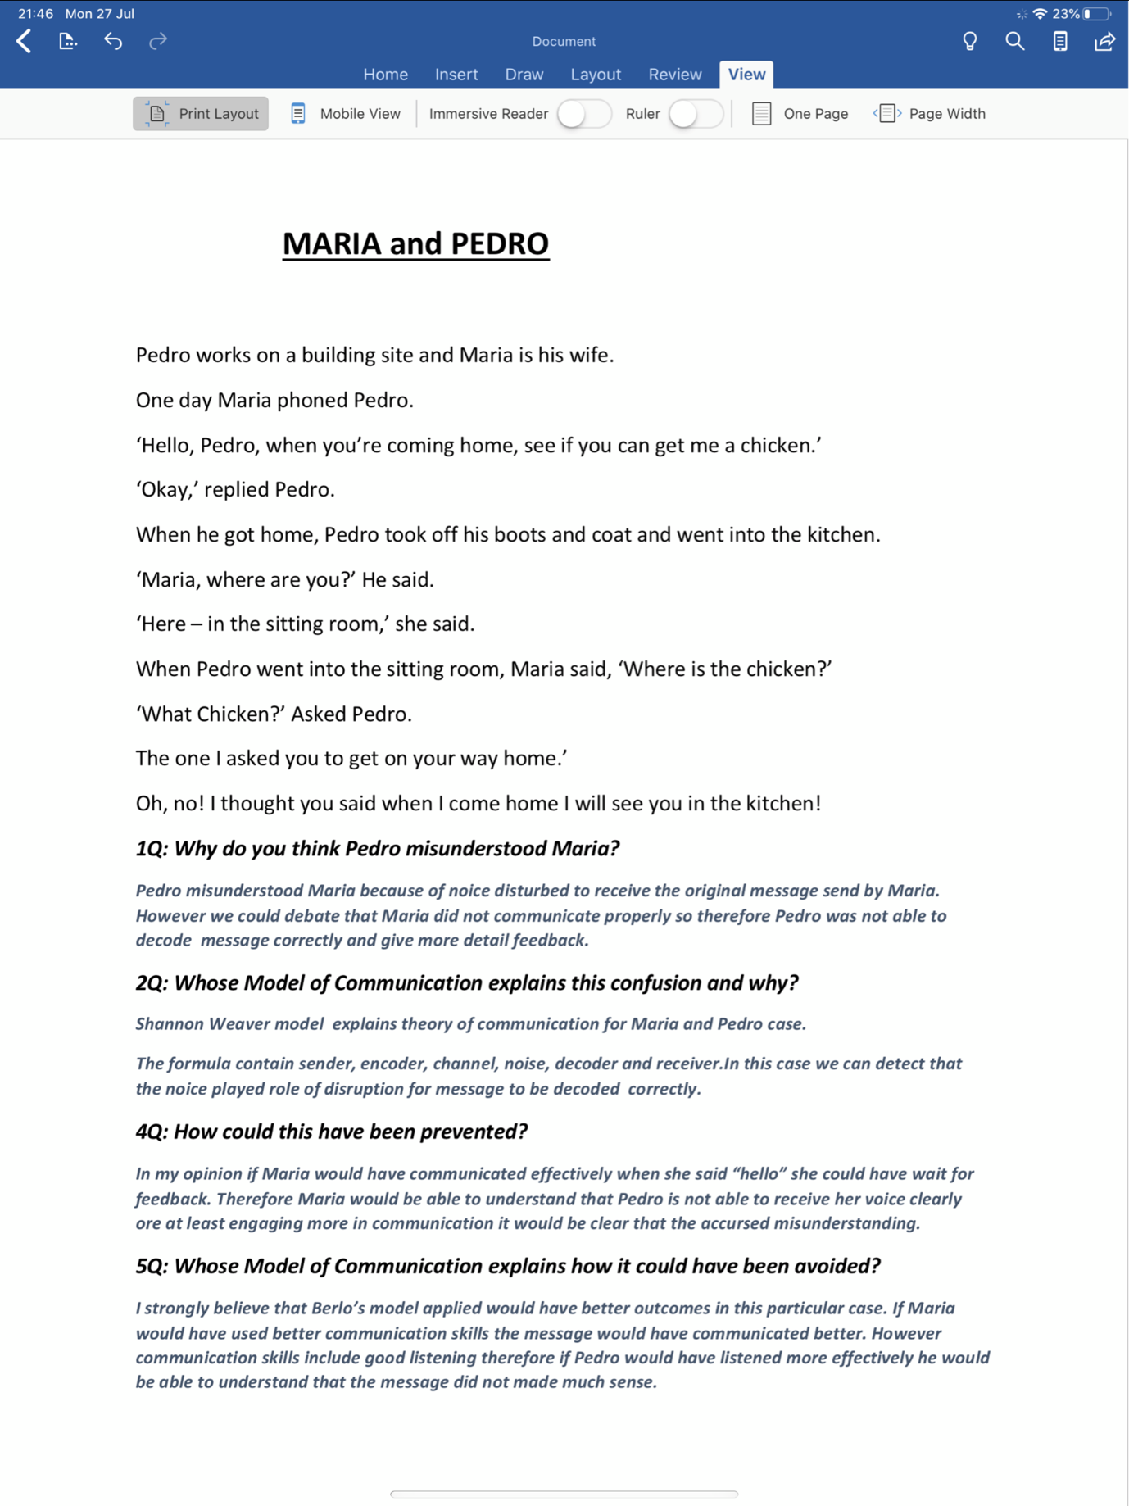
Appendix (A)

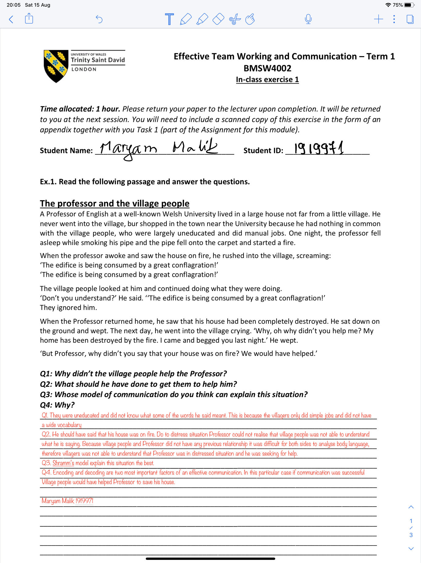
Appendix (B)

Appendix (C)


