Effective Teamworking & Communication

Michael Cappelli
Student ID: 1914610
University of Wales Trinity Saint David

April 2020
Table of Contents
Executive summery 1
1 Introduction 2
2 Methodology 2
3 Results 3
3.1 THE PROFESSOR and THE VILLAGE PEOPLE Lloyd B. 7/19 3
3.2 Analysation of communication in my own workplace 5
3.3 The importance of non-verbal communication 6
4 Discussion 6
5 Conclusion 8
6 References 8
7 Appendix 8

Executive summery

Communication can be effective when taken into account a number of factors which, depending on the context may include different models of communication which are themselves partially influenced by diverse communication approaches such as verbal and non-verbal communication. Considering feedback in a different way so to let the information-sharing process evolve into a conversation. Taking into consideration every single element and analysing them will support the development of communication skills which leads to an effective teamwork.

Introduction

Communication is the act of delivering messages from one entity or group to another through the use of mutually understood languages, symbols and signs. However, an effective communication is more than just the exchange of information. It is essential to understand the emotion and intentions that follow the information. Delivering a message is not the main focus, indeed, the person who is talking also needs to be able to listen in a way that gathers as more information as possible so to make the other person feel heard.

All too often, when a conversation takes place something can go wrong. The arise of misunderstandings, frustration and conflicts can be caused when a person says one thing and who is listening hears/interpret a different message. This can originate problems in a household, school or workplace. Learning to communicate clearly and effectively in management can improve the relationship between workers and managers, co-workers or co-managers. Communication skills can deepen connections within individuals or groups, build respect and trust, increase teamworking abilities and problem solving and one’s overall social and mental health.

Communication is identified as Verbal and Non-Verbal communication; facial expressions and general body language can communicate more things than spoken words. Taking in consideration the non-verbal communication when possible, can result on a deeper understanding of the interlocutor’s words.

Theoretically talking, applying a model of communication helps evaluate whether a communication is effective or not, what can help to improve it and what action must be taken to do so. It helps in the identification of any flaws in a conversation and eventually suggest a change in order to progress to an effective communication.

Methodology

Overall approach

This report has been processed by following a methodical plan, based on a combination of two taught skills: critical thinking and research method. A great amount of information contained in this report comes from in-class exercises and lectures during the academic year at University of Wales Trinity Saint David as well as personal experiences that have been affected negatively by communication. Tools made available by the university itself such as the library, combined with the academic skills like paraphrasing and writing skills taught by the lecturers, facilitated the development of this report.
As well as using the library as source of articles related to communication, it is due to mention the importance of other helpful tools. Such tools are Google Scholar which help was essential to find a wider range of professional and academic articles and journals.

Results

THE PROFESSOR and THE VILLAGE PEOPLE Lloyd B. 7/19
“A Professor of English at a well-known Welsh University lived in a large house not far from a little village. He never went into the village, bur shopped in the town near the University because he had nothing in common with the village people, who were largely uneducated and did manual jobs.
One night, the professor fell asleep while smoking his pipe and the pipe fell onto the carpet and started a fire. When the professor awoke and saw the house on fire, he rushed into the village, screaming:
‘The edifice is being consumed by a great conflagration!’
‘The edifice is being consumed by a great conflagration!’
The village people looked at him and continued doing what they were doing
‘Don’t you understand?’ He said. ‘‘The edifice is being consumed by a great conflagration!’
They ignored him.
When the Professor returned home, he saw that his house had been destroyed. He sat down on the ground and wept.
The next day, he went into the village crying. ‘Why, oh why didn’t you help me? My home has been destroyed by the fire. I came and begged you last night.’ He wept.
‘But Professor, why didn’t you say that your house was on fire? We would have helped.’ “
(The Professor and the village people, 2019)
The case above can be evaluated by taking in consideration the model of communication developed by David Berlo in 1960. His model (SMCR) is based on four elements named:
- Source
- Message
- Channel
- Receiver

Every element includes a number of factors that mandatorily influence the success of a communication.

Figure 1 adapted from communicationtheory.org
- Source

The factors that influence the source:

Communication skills – It is the ability of the communicator to convers through speech, body language etc.

Attitudes – The approach used towards the subject or an audience and changes the significance of the message.

Knowledge – The sender needs to be well-informed about the subject or topic.

Social system – It includes values, beliefs, culture, religion and a general understanding of society.

Culture: Culture of a particular society is also part of a social system. Cultural differences can result in the communication to be interpreted in different ways.

The source creates a message by encoding. This is where the source elaborates a message following its factors.

- Message

The message is the method used to deliver an information. It is included in the message:

Content – The meaning of a message contained in it.

Elements – It includes various objects like gestures, body language etc. Any matter must be accompanied by any amount of elements.

Treatment – It indicates the method in which the information is carried, and the approach used to deliver it.

Structure – It is the way the message is structured.

Code – The code of the message is the meaning through which the message is sent and in what form.

- Channel

It indicates the five sense organs: seeing, smelling, touching, tasting, smelling and hearing.
An interaction happens through one or more of these organs.

Decoder: The process of understanding the message. It is the elaboration of an information carried by the receiver.

- Receiver

All the elements and contents of the source are elaborated by the receiver (communication skills, attitudes etc.) in order to respond to sender efficiently.

In accordance to Berlo’s model, for an effective communication to take place, source and receiver require to be on similar levels. Hence, source and receiver should have something in common. When the sender and receiver are on different levels it cannot be said that the destination of the message does not receive the message, however it can be said that even though the receiver does get the message, they might not be able to understand its meaning. That could be caused by many reasons included a lack of communication skills, low education level etc.

Analysation of communication in my own workplace

The communication used by the company that I work for (Estee Lauder companies) is a direct and familiar approach that makes its employees feel part of a family. Especially during the hard period that the entire world is facing after the outbreak of COVID-19, all employees globally receive many emails from the CEO and Executive Chairman sending messages of support and updates on the current situation.
In this case communication has been a key for the company to stay connected with its employees and keep them united and informed.
It is considered a linear model of communication and the communication becomes a one-way process. This model is founded on three elements:

- Sender
- Channel
- Receiver

RECEIVER
CHANNEL
SENDER

Created by the Author

This model assumes a one-way process in which one side is the sender that encodes and transmits the message and the other side is the recipient that receives and decodes the message. This model is typically used by companies for marketing, sales and PR purposes.

The importance of non-verbal communication

“Actions speak louder than words”

When interacting with others there is a number of signals that our body creates unconsciously. Such signals can either confirm or deny what is being said. This body process is included in the non-verbal communication. This includes:

- Body language: body movements and posture.

- Facial expression: expression of emotions such as happiness, sadness etc.

- Gestures: while facial expressions are universal, gestures can have different meaning across different cultures.

- Eye contact: it is a significant part of the non-verbal communication.

- Voice: the tone; how a message is said is as important as what is being said.

- Space: physical space communicates contrasted messages e.g. intimacy or aggression.

- Touch: communication through touch tells a lot about one’s personality e.g. hand shaking, pat on the shoulder etc.

Five roles are played by non-verbal communication.
- Repetition: strengthen what is being said verbally.
- Contradiction: tells the listener that what is being said could be a lie.
- Substitution: when a verbal message is substituted by a body sign.
- Complementing: increases the impact of a verbal message.
- Accenting: highlights the importance of a verbal message.

It is of significant importance to mention that non-verbal communication is not an international recognised language, meaning that attention is needed when communication occurs in a cross-cultural context. For instance, the same gesture or expression might have a different meaning across cultures.

Discussion

Berlo’s model does not mention an important step for an interactive communication; the feedback. When taken in consideration Berlo’s model, the interchange of information is a one-way process therefore it makes the communication incomplete in this case. The Schramm’s model of communication (1954) is a good example of complete communication.
Later on, developed around Berlo’s model in 1973 by “authority on mass communication” Wilbur Lang Schramm, this model is designed to covey an effective communication between individuals.
The Schramm’s model of communication adds the feedback in an interactional way, moving from a linear to a circular model.
This means that while in Berlo’s model the conversation starts from “A” and ends with “B”, in Schramm’s model “B” is not always the last

OSGOOD-SCHRAMM’S MODEL OF COMMUNICATION

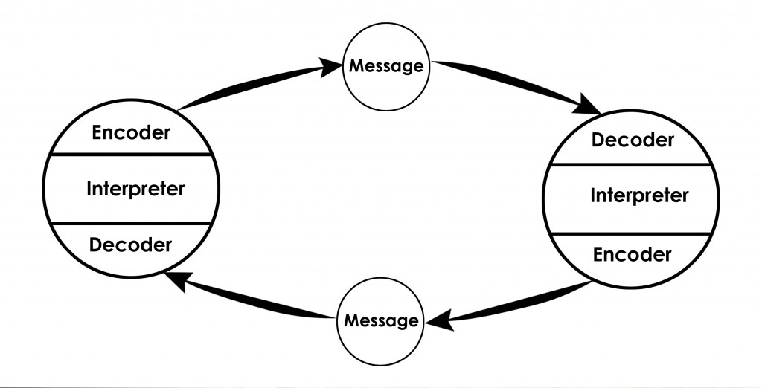
Figure 2 adapted from communicationtheory.org

Since it is been developed around Berlo’s model of communication, this model keeps some of its characteristics and elements. As mentioned in Berlo’s model, Schramm acknowledge the fact that for the understanding to take place between the source and destination, they both must have something in common. The elements are:
Encoder: encodes or sends the information (where the message is originated)
Decoder: who receives the information
Interpreter: Person who analyses and interpret the message.

Interpretation is the key of this model, from the message starting to ending.

Semantic noise is a concept not introduced in this model. It appears when sender and receiver give diverse meaning to a same message. It happens mostly because of words and phrases for e.g. Technical Language. Therefore, some words and phrases can cause the receiver to deviate from the main meaning of the message.

These are the pros of Osgood-Schramm’s model of communication:
- It is a dynamic model; it demonstrates how a situation can change thanks to the presence of feedback.
- It demonstrates the importance of redundancy in a conversation.
- In accordance with this model, communication is naturally circular.
- Feedback is described as a vital feature.

Conclusion

In light of the information gathered in the report, an effective communication happens essentially when sender and receiver both interpret the same meaning of a message. An effective communication is responsible for an effective teamworking. These two are connected to each other when the purpose of an individual is to gain support from another individual or a group. Doing so requires the use of a model of communication suitable for the circumstances which is itself conditioned by verbal and non-verbal communication and the channel used through which the message is being conveyed. It is potentially true that an effective communication is the foundation of an equally effective teamwork.

References

Lawrence Robinson, Jeanne Segal, Ph. D., and Melinda Smith, M.A., 2019. Effective communication. [online] Available at: <https://www.helpguide.org/articles/relationships-communication/effective-communication.htm> [Accessed 13 March 2020].

Jeanne Segal, Ph.D., Melinda Smith, M.A., Lawrence Robinson, and Greg Boose, 2019. Non-verbal communication. [online] Available at: <https://www.helpguide.org/articles/relationships-communication/nonverbal-communication.htm> [Accessed 14 March 2020]

Communication Theory, 2020. Berlo’s SMCR model of communication. [online] Available at: <https://www.communicationtheory.org/berlos-smcr-model-of-communication/> [Accessed 20 March 2020]

Communication Theory, 2020. Osgood-Schramm model of communication. [online] Available at: <https://www.communicationtheory.org/osgood-schramm-model-of-communication/> [Accessed 17 April 2020]

Carl Stanford, 2020. What is a linear model of communication?. [online] Available at: <https://fleximize.com/articles/000561/a-linear-model-of-communication> [Accessed 24 April 2020]

Appendix

Case study:



