‘Based on evidence from current research and policy as well as on data gathered from a group questionnaire, critically discuss an inclusive approach to supporting the needs of a particular group of pupils. Focus on one specific learning difficulty, disability or additional need for your discussion.’
This portfolio highlights the inclusively, diverse approaches to an aspect of Additional Learning Needs involving learners with English as an Additional Language (EAL). This research was under took independently and collaboratively to create a questionnaire that will support the findings of this specific selection of individuals whilst complementing practice during a special educational visit and through placement. In accordance with Dauncey (2016) and the Welsh Government’s ALN Code of Practice (2018b), there are multiple terminologies to defining an additional learning need, however, it is referred to individuals who may have limitations on their learning in comparison to most of their peers, as a result of their difficulty. Armstrong and Squires (2012) adheres with this where they emphasise that the multiple definitions allow inclusivity for the learners with regards to the differentiation of meanings. According to Dauncey (2016), “approximately one in five learners in maintained schools in Wales have SEN” to which it currently exceeds 100,000 learners (Dauncey, 2016, p7-8) emphasising the growth. However, pupils with additional learning needs will no longer be referred to as those with ‘SEN’ as a result of the scheme no longer fulfilling the support and equality needed for these learners in comparison to peers (Welsh Government, 2018a; 2018b). The newly proposed act for learners with ALN emphasises the rise of involvement from both the learners, parents and the education systems thereby highlighting the hope of decreasing any dispute towards the support through allowing feedback and resolving queries (Welsh Government,2018c). Additionally, introducing the legislation of ‘ALN’ allows education systems and authorities to provide IPs for learners to support the health and wellbeing of each individual (Peer and Reid, 2016; Welsh Government, 2018c). Furthermore, according to Armstrong and Squires (2012), this will attempt to diminish any discrimination towards pupils with learning needs ,whilst complementing the UNCRC (1989) Article 28, stating that each learner has the right to receive and attend an education.
Ensuring inclusive environments are provided for all learners is essential as Armstrong et al (2010) synthesises that it may be the most beneficial in approaching social diversity and generates a thriving education. Alternatively, inclusivity, according to Willis (2009) and Petrescu (2013), should assist the needs and abilities of all learners to actively partake in an education system in order to be considered meaningful. According to Grigg (2015), inclusion frequently relied on how learners with ALN were implemented in to a mainstream school, in comparison to the current view of those who are approaching underachievement. However, stimulating environments are essential to a child’s learning when the learning and engagement of both the child and their peers, is a long-term process (Willis, 2009). Additionally, Donaldson (2015) proposes that learning environments require inclusivity within their structure of learning in order that all learners, including those with additional learning needs, improve their own learning simultaneously and that each individual achievement should be acknowledged and praised. However, Armstrong and Squires (2012) and Nottingham (2013) indicate that praising an individual may only be beneficial with regards to the effort of the individual. Whittaker (2018) connotes that inclusivity should not rely only on the academic achievement of the child, but on the social skills of the individual which will then prepare them for later stages of their lives. Despite this, the Guardian (2019) emphasises that the current principles of education do not support those learners with ALN, as a result of the attentiveness of differentiating depending on level outcomes and assessment, which may lead to negative attitudes towards learning from the learner. In addition to this, education systems should acknowledge the various methodologies required to be inclusive to those individuals, who are from an ethnic minority background or categorised as economically disadvantaged, in order to integrate them into the curriculum (Armstrong and Squires, 2012). Moreover, Cologan (2014) emphasises that learning can only be inclusive with a continuum of commitment and reflection on the strategies and knowledge demonstrated by practitioners. According to Ofsted (2010), it was discovered that inclusion in both mainstream schools and specialist schools complement each other with regards to commitment and the effectiveness of specific strategies. Commitment to exceeding the learners’ potentials in education is considered effective where it involves the learners’ choices and decision to their learning (Grigg, 2015; Donaldson, 2015; Welsh Government, 2016).
In accordance with the Bell Foundation (2017), a learner with English as an additional language is referred to an individual who is either not familiar with English or has a minimum knowledge of the language in comparison to those who are fluent. The Welsh Government (2014) emphasises that “the number of pupils from minority backgrounds has increased by approximately 35 percent” (Welsh Government, 2014, p5) thereby indicating that enhancing the support for these learners is vital. Being a learner with EAL does not necessarily indicate a learning difficulty, however, it is vital to consider whether the learner may have an additional difficulty that does not rely on the challenge of learning an additional language (Welsh Government, 2018b). Illustrating this, many learners with EAL may be experiencing poverty or have been socially deprived of an education in which could influence their willingness to learn along with their progress (Welsh Government, 2015).
From personal experience within a school, it was evident that identifying an additional challenge to learning ,whilst attempting to communicate through a language that is not familiar to the child, is difficult to transfer successful pedagogy which may affect the inclusivity of both the learner and their peers (Armstrong and Squires, 2012). Therefore, in accordance with Graf (2011), assessment is a significant for practitioners to observe as monitoring the learners’ understanding progresses future targets and identifies problems. Moreover, Brentnall et al (2015) acknowledges that supporting and monitoring learners from ethnic minority backgrounds, is an essential teaching standard that should be followed holistically from practitioners and trainees. With regards to assessing learners with EAL, it is necessary to monitor the attainment and knowledge of the language the learners hold with regards to newly arrived, intermediate learners and expertise ranged on a stage model, A to E (Brentnall et al, 2015; The Bell Foundation, 2017). In addition to this, Naldic (2015) emphasises that learners may acquire multiple stages at once but to achieve the final stage, it may take a much longer period of time as currently, there are “4,805” learners who have achieved fluency (Stats Wales, 2018). However, according to Leung and Lewkowicz (2008, cited in Leung and Creese, 2010) monitoring and assessing learners’ second language skills against the school’s first language curriculum may limit the performance of the learner.
In order to portray inclusive education for learners with EAL, it relies on the practitioners’ abilities to support them bilingually as intertwining the home language of the child and the current language being learnt ,promotes positive attitudes to learning as well as encouraging peers to acknowledge the diversity (Leung and Creese, 2010). Additionally, bilingualism and multilingualism should be supported to achieve the potential level of literacy in English as well as the home language of the learner (EALAW, 2003). Furthermore, Leung and Creese (2010) state that it is vital that practitioners model the use of language and work simultaneously with support staff in order to integrate a curriculum that is linguistically inclusive to all learners. Additionally, Vygotsky’s theory of cognitive development synthesises with this whereby language is enhanced through the continuum of communicating and cognitive thinking skills including the use of memory (1999, cited in Daniels and Hedgegaard, 2011, p. 213). Thereby ensuring appropriate measures are taken to provide support, particularly the employment of EAL specialists and sufficient planning is required to promote a successful learning environment (Grigg, 2015). In accordance with Gershon (2011), effective pedagogy is required to be able to communicate and transfer understanding as practitioners who focus excessively on a child’s progress may interfere with how they approach their teaching. Supporting this, the Welsh Government (2014) acknowledges that the lack of language skills can negatively affect communication, however, aims to highlight the learners’ individual outcomes in order to transfer support where necessary whilst embedding them in to the curriculum.
Unfortunately, the language skills transferred relies on the training and knowledge of the practitioner and the education system where according to Armstrong et al (2010), the standard of learning and support delivered to learners with EAL relies on funding and policy. Despite this, the Welsh Government (2014) recognises that there is funding directed to all schools across Wales annually, in order to provide additional support for the learners if necessary. Supporting this, between 2008-2013, it is evident that the percentage of learners with EAL requiring support has risen 17% (Welsh Government, 2015). Consequently, the increase of learners with EAL also indicates that funding from the ‘Ethnic Minority Achievement Grant’ (EMAG) is not effective alone, thereby indicating that authorities need to incorporate strategies to complement this (Welsh Government, 2014). Moreover, the EMAS perceived of ‘EMAG’ as a weak approach to funding, particularly as the grant is dependent on the quantity of learners in a school (Welsh Government, 2015). Although, with regards to question twenty-two of the questionnaire (see appendix one), many schools are unaware of the funding they receive whilst many do not receive any.
In accordance with Unicef (2018), using questionnaires to demonstrate experience and knowledge of practice within an education system is an essential methodology to learning and can help schools improve their strategies. Gillham (2008) states that a hypothesis is required for all questionnaires enforcing the research question which is then necessary to pilot it. For example, the hypothesis of the questionnaire highlights pupils with English as an additional language and offers opportunities for a variety of staff within education to feedback on their experience. The use of this methodology granted the opportunity to distribute it across a variety of schools both online and through visiting schools, in hope of a variety of responses. Unfortunately, the number of responses received, a total of nine, did not meet the expected which may have been a result of the deadline. Therefore, this implies the primary research limits the knowledge on the experience schools have with English as an Additional Language both locally and nationally. In similarity with this, there was a lack in the range of occupations within the responses (see appendix two) to which were mostly class teachers with approximately 78% within the questionnaire. However, this did not limit the quality of responses to which most responses were informative and gave insight on how their learning environments support the learner with EAL.
Additionally, the Welsh Government’s (2018d) General Data Protection Act states it is vital that consent is given with regards to obtaining any personal data. Therefore, a link to the questionnaire was sent through email and a box to allow the respondents the option to participate and share experience was positioned at the start. Similarly, Unicef (2018) recognises the safety of the children within the schools making it an essential attribute that no information is shared. Furthermore, Brace (2018) emphasises that online questionnaires allow anonymous responses which allows discussions of sensitive topics and confidentiality, portraying the ethical format.
Brace (2018) states that online questionnaires, as well as being cost free, are beneficial to research as it allows respondents time to perceive or research their answers. However, achieving qualitive research such as this through ‘open questions’ can be considered time consuming for the respondents (Ross et al, 2015). This was demonstrated to an extent within the questionnaire where one response increased the average time from approximately 10 minutes to approximately an hour which could be an attribute to improve for future questionnaires. Nevertheless, most questions were closed questions which implied that the variety of responses within a question was already provided, thereby, saving time (Gillham, 2008). Alternatively, although questionnaires are an informative method of research, Ross et al (2015) states that interviews may be at an advantage, as a result of receiving the information and personal experience on a first-hand experience with instant qualitative feedback on the quality of questions thereby granting the opportunity to improve quality of research. However, as a result of approaching half term, there was a lack of time in order to complete one.
Regardless of the lack of responses, it was evident that all responses currently encounter experience with ‘EAL’ within their class. However, minimum confidence in teaching and supporting the learners was demonstrated within Figure One where most of the responses stated that they were moderately confident. This may be as a result of lack of confidence, funding or support given to the schools as according to Willis (2009), effective practice requires beneficial resources with the complementation of funds, additional staff particularly those equipped with enough language skills and time to implement the learners into the curriculum. Supporting this, Brentnall et al (2015) insinuates that the classification of English as an Additional Language is not prioritised with regards to training and courses implying that there is no consistency of knowledge and experience for schools to implement their own strategies and support systems. During a professional bridging placement, this was demonstrated through using computers to translate instructions and communicate to learners with EAL thereby emphasising the limitation of inclusive support for both learners and practitioners. Simultaneously, Florian and Hegarty (2004) state that introducing technology opportunities allows the learners to communicate with their peers and access the curriculum. Moreover, reducing training and support depending on funds would demonstrate a lack of confidence as without specialist teachers, it coerces education systems to exceed their learners’ needs (NASUWT,2012). Additionally, in accordance with figure two, it is evident that most responses receive training from local authorities (56%) and schools (22%), however, the remaining 22% of responses indicate that there is no support or training for their school, hence, the moderate level of confidence observed in Figure One.
However, the employment of EAL specialists such as SENCOs may reduce the confidence of class teachers and teaching assistants approaching the numerous stages of second language acquisition (Brentnall et al, 2015). Despite this, Donaldson (2015) and Dauncey (2016) synthesise that in all schools, it is a requirement that SENCOs must be available to accompany practitioners in teaching a child with an additional learning need, whilst determining future stages of that child, which thereby increases the confidence.
Figure One

Figure Two

In similarity with this, sufficient support, training and confidence in teaching learners with EAL provides education with appropriate resources and strategies to allow learners to exceed each stage (Armstrong et al, 2010; Armstrong and Squires, 2012). According to Peer and Reid (2016), a child’s language development is a significant factor to improving their literacy as the increase of linguistic resources provided enhances the engagement of the learner over a specific period. Supporting this, Leung and Creese (2010), emphasise the inclusion of a ‘Content and Language Integrated Learning’ (CLIL) approach when teaching learners with EAL as it may demonstrate the additional language with similarity of content and resources from their first language in order to understand. Baker (2011) states that using this approach requires learners to activate their prior knowledge and develop their cognitive thinking skills simultaneously. However, for the learners to develop these particular skills, enhancement of teacher support is required to scaffold understanding where Vygotsky’s (1962, cited in Baker, 2011, p294-295) ‘Zone of Proximal Development’ states that successful language development requires the learner to inquire their ability to learn alongside the help of their practitioner. Although, this may be considered as a difficult attribute for learners with EAL as a result of a variety of cultures and views on education (Graham and Kelly, 2008).
Reflecting on this, it is significant to recognise strategies that benefit the learner using their first language and additional language (Graham and Kelly, 2010). Analysing the research shown in figure Three, the use of audio and visual resources is seen to be a beneficial factor for the respondents’ learners which supports Bandura’s (2015) analysis whereby modelling resources socially acquires the appreciation and positive behaviour to learning. Moreover, Graham and Kelly (2008;2010) indicate that learners, particularly those who are bilingual, need to be able to hear the language from fluent readers, through differentiated groups or with the practitioner, in order to identify how the language is portrayed. Despite this, Jenkin (2018) emphasises that writing has been equally identified a beneficial tool to learning an additional language through structures and patterns within grammar, a current difficulty for learners with EAL. Therefore, indicating that in order to develop language successfully, integration of the language strategies holistically is required in all areas of learning (Macblain, 2014; Peer and Reid, 2016). Additionally, Wittgenstein’s (1953, cited in Barker and Jane, 2016) theory of ‘language games’ supports this as language development requires the senses in order to portray meaning to the words learnt. Although a holistic approach may be required, Graham and Kelly (2010) emphasise the difference of transitioning learners from speech to written work, whereby it is significant to acknowledge that learners with EAL are beginning to adapt to basic skills of English. Therefore, the level of written work will defer from most of their peers (Graham and Kelly, 2010).
However, as a result of the shortfall of respondents, the percentage of beneficial strategies within the questionnaire could be considered as biased compared to those who did not contribute. Therefore, the results received may not be as successful to supporting learners with EAL, indicating a gap in the research. In contrast with this, during Professional Teaching Practice, a multilingual child, newly learning English, would support the findings shown in Figure Three due to visualising actions and listening to peers being beneficial to the individual in comparison to writing where modelling the words was required within any piece of work. However, it was acknowledged that the learner’s written skills would improve whilst working within a group, which moderately supports research analysed in Figure Four, such that four responses, out of the possible nine, support learners within groups. Allowing learners with EAL to work collaboratively with peers in groups, according to the teacher’s planning, is beneficial to the learner as it creates insight on the learning environment whilst enabling practitioners to assess the learners’ social abilities (Leung and Creese, 2010). Supporting this, useful materials to complement their abilities and prior experiences should be enhanced to extend their language acquisition through English and Welsh (Welsh Government, 2008). Arguably, differentiating learners into small groups or working individually allows learners to develop their social skills and to admire the help of peers (Grigg, 2015).
Figure Three

Figure Four

Furthermore, in order to enhance language development, education is required to deliver inclusive teaching and values demonstrating appreciation for social diversity which will reflect on the school’s values (Pestrescu, 2013). Supporting this, the UNCRC (1989) states that each child, despite ethnicity or language spoken, acquires the right to education whilst expressing their own values and language. Therefore, emphasising that ensuring a learner with EAL is welcomed into the school, from the start of their transition, is essential as learners require acceptance as part of the school’s community and being involved in inclusive policies (Armstrong and Squires, 2012). For instance, Figure Five demonstrates how a quantity of schools in Wales include learners with EAL to which most responses embed the learners into the ethos of the school, the policies and provide displays within the class. Ofsted (2010) indicates the requirement that all schools must establish a whole school policy, including those with additional learning, through both early provision and Key Stage Two in order to promote effective practice. Therefore, it is essential to acknowledge all ethnicities positively thereby enhancing the engagement and achievement of all learners (Brentnall, 2017). In accordance with Grigg (2015), an education that is successful in effective attainment, have dynamic policies that involve both parents and high expectations for all learners within their school. Regarding a learner’s attainment, it is essential that the implementation of targeted grants such as the Pupil Development Grant and engaging in the level of home language allows the effective communication to acquire attainment in the key areas of learning (Welsh Government, 2014). For instance, with reference to question sixteen (see appendix three) and the Welsh Government (2014), encouraging the home language and the additional language, allows the learners to achieve their potential using their familiarity on specific language particularly within Maths and Numeracy where 35% of respondents claimed that this area has the highest attainment for their learners. However, the Welsh Assembly Government (2012) connotes that practitioners should not imply any stereotypical expectations towards the learners as this may enforce negative behaviour and reduce attainment.
Figure Five

In relation to parental involvement, providing universal and harmonious relationships with parents and guardians of learners with EAL helps the learner successfully overcome any obstacles within their learning (Grigg, 2015). Illustrating this, figure six demonstrates that many responses prefer to communicate through a translator and translated letters sent home. In accordance with this, the Welsh Assembly Government (2010) and the Welsh Government (2014) support the inclusion of parents through similar strategies as it engages parents to participate in various opportunities within the community which encourages the learners’ performance. Therefore, involvement in extra-curricular activities, particularly courses and meetings with the class teacher, emphasises strong partnerships with parents (Welsh Assembly Government, 2010). Thus, parents require guidance on how they can support their child to achieve their abilities (Welsh Government, 2018). However, as acknowledged in figure six, it is significant to recognise the home language in order to ensure effective practice whilst valuing the encouragement of parents continuing to use the child’s first language may assist the learning of the second language and value their efforts (Epstein et al, 2018; Morrison, 2014). Consequently, it is vital to integrate the home language as Leung and Creese (2010) indicate that there is a limitation when communicating with parents as a result of the lack of literacy skills. Despite this, it is a necessity for all practitioners, regarding the QTS standard of S.1.4, to create positive relationships between the school and parents (Welsh Assembly Government, 2009). Therefore, emphasising that ensuring that learning environments and communication is delivered through welcoming and simplified measure (Ofsted, 2010). Regarding promotion of the home language, the findings demonstrated in question eight (see appendix four) states that 67% of responses do not continue to implement the first language within their schools. Although, the evidence indicates that those who do, promote the home language through inclusive routines and key phrases. However, with additional reference to figure three where encouraging parents to enhance their language development holistically particularly as aspects from one language can be applied to another (Graf, 2011).
According to Armstrong and Squires (2012), positive commitment towards communicating with parents is required, however, with reference to question twenty-one (see appendix five), it is evident that many practitioners and teaching assistants lack in confidence when communicating with the family members of learners that are EAL which stimulates through the lack of training of the class teacher in comparison to specialists. Additionally, Leung and Creese (2010) state that many practitioners may lack confidence in communicating with parents with the implication that EAL specialists experience most of the child’s language development. Hence, the rise of confidence within practitioners and schools in general, relies on the diplomatic structure and positivity of the approaches they deliver in order to welcome parents and learners (Brentnall. 2017).

Figure Six

To conclude, learners with EAL require inclusive support from education systems that recognise all ethnicities and cultures, in order for learners to identify and engage in their own values, complementing ‘article 29’ (UNCRC, 1989) whereby emphasising enhancing respect for the learner and their parents whilst preparing all learners within the school for future stages of their lives. Additionally, Donaldson (2015) synthesises with this whereby it is intended in the proposed curriculum that for learners to be ‘ambitious, capable learners’ (Donaldson, 2015, p49), experiencing competence in both English and Welsh whilst embedding any additional languages is significant to exploring language. As summarised through research and data, it is evident that many schools indicate that there is a lack of training and funding in order to support the individuals such that Brentall (2017) emphasises that there is a requirement for all teachers, as well as upcoming teachers, to receive training in equality and diversity. However, Brentnall (2017) states that the current teaching training does not satisfy the expectations as a result of insufficient coverage of ethnic minorities which is also highlighted through training within university, where there is a shortage of time for trainee teachers. Hence, Graf (2010) and Grigg (2015) synthesise that inclusive strategies in order to support learners through language acquisition, as well as avoiding stereotypical attitudes, is required to enhance knowledge and understanding of the learning environment whilst increasing attainment. In contrary to this, ensuring effective practice is delivered to all learners is intended within the Qualified Teaching Standard S.1. where understanding each learning need is required for the learners to exceed their potentials (Welsh Government, 2015).
Word Count= 4136.
Reference List
- Armstrong, A, C. et al (2010) Inclusive Education: International Policy and Practice. Los Angeles, Calif; London: SAGE.
- Armstrong, D. and Squires, G. (2012) Contemporary Issues in Special Education Needs Considering the whole child. Maidenhead: McGraw Hill, Open University Press 2012.
- Baker, C. (2011) Foundations of Bilingual Education and Bilingualism. 5th edn. Bristol: Multilingual Matters 2011.
- Barker, C. and Jane, E. (2016). Cultural Studies: Theory and Practice. 5th edn. London: SAGE.
- Bandura, A (2015). ‘On Deconstructing Commentaries Regarding Alternative Theories of Self-Regulation’, Journal of Management, May 2015, Vol.41(4), pp.1025-1044. DOI: 10.1177/0149206315572826.
- Brace, I (2018). Questionnaire Design: How to Plan, Structure and Write Survey Material for effective Market Research. 4th edn. London: Kogan Page.
- Brentnall, J. et al (2015) ‘Identifying Challenges and good practices in preparing trainee teachers in Wales to meet the needs of additional language learners’ British Council 2015. Available at:
https://ealresources.bell-foundation.org.uk/sites/default/files/document-files/British%20Council%20EAL%20Nexus%20ITT%20and%20EAL%20WAL%20in%20Wales%20Report.pdf [Accessed: 16th April 2019].
- Brentnall, J. (2017) Promoting Engagement and academic achievement for black and mixed-ethnicity pupils in Wales. Crown. Available at:
https://gov.wales/sites/default/files/publications/2018-11/promoting-engagement-and-academic-achievement-for-black-and-mixed-ethnicity-pupils-in-wales.pdf [Accessed: 27th April 2019].
- Cologan, K. (2014) Inclusive Education in Early Years: Right from the Start. Sydney: Oxford Press University.
- Daniels, H. and Hedegaard, M. (2011) Vygotsky and Special Needs Education. London: Continuum.
- Dauncey, M. (2016) Additional Learning Needs (ALN) in Wales. Cardiff: National Assembly for Wales. Available at:
http://www.assembly.wales/Research%20Documents/16-059%20SEN/16-059-Web-%20English.pdf [Accessed: 16th April 2019].
- Donaldson, G (2015) Successful Futures. Cardiff: Crown. Available at: https://gweddill.gov.wales/docs/dcells/publications/150225-successful-futures-en.pdf [Accessed: 16th April 2019].
- EALAW (2003) The Achievement of ethnic Minority pupils in Wales: An EALAW Research Report for the Welsh Assembly Government. Crown. Available at: https://learning.gov.wales/docs/learningwales/publications/121119ethnicminoritypupilsen.pdf [Accessed: 23rd April 2019].
- Epstein, J. L. et al (2018). School, Family, and Community Partnerships: Preparing Educators and Improving Schools. 2nd edn. Oxon: Routledge.
- Florian, L. and Hegarty, J. (2004) ICT and Special Needs. Maidenhead: Open University Press.
- Gershon, M. (2011) ‘How to Succeed with EAL students in the classroom.’ , The Guardian., November 2011. Available at: https://www.theguardian.com/teacher-network/2011/nov/07/eal-students-classroom-teaching-resources [ Accessed: 24th April 2019].
- Gillham, B. (2008) Developing a Questionnaire. 2nd edn. London: Continuum.
- Graf, M. (2011) Including and Supporting Learners of English Additional Language. London: Continuum.
- Graham, J. and Kelly, A. (2008) Reading Under Control. 3rd edn. Oxon: Routledge.
- Graham, J. and Kelly, A. (2010) Writing Under Control. 3rd edn. Oxon:Routledge.
- Grigg, R. (2015) Becoming an Outstanding Primary School Teacher. 2nd edn. London: Routledge.
- Jenkin, M (2018) ‘How Handwriting is helping EAL pupils to leap the language barrier’, The Guardian, March 2018. Available at:
https://www.theguardian.com/teacher-network/2018/mar/15/handwriting-eal-pupils-language-barrier-teachers [Accessed: 25th April 2019].
- Leung, C. and Creese, A. (2010) English as an Additional Language. Los Angeles, Calif; London: SAGE.
- Macblain,S. (2014) How Children Learn. London: SAGE.
- Morrison, N. (2014) ‘How Schools are breaking down the language barrier for EAL students’, The Guardian. Available at: https://www.theguardian.com/teacher-network/teacher-blog/2014/mar/05/teaching-eal-foreign-languages-students-integration-schools [Accessed: 27th April 2019].
- Naldic (2015) ‘EAL pupils in schools: The latest statistics about EAL Learners in our schools.’ NALDIC 2015. Available at: http://www.naldic.org.uk/research-and-information/eal-statistics/eal-pupils/ [Accessed: 25th April 2019].
- NASUWT (2012) Ethnic Minority Achievement. Equality Matters. Available at: https://www.naldic.org.uk/Resources/NALDIC/Research%20and%20Information/Documents/EMAG_Survey_Report.pdf [Accessed: 26th April 2019].
- Nottingham, J. (2013) Encouraging Learning: How you can help children Learn. London: Routledge.
- Ofsted (2010) ‘The Special education needs and disability review.’ Manchester: Crown.
Available at:
https://assets.publishing.service.gov.uk/government/uploads/system/uploads/attachment_data/file/413814/Special_education_needs_and_disability_review.pdf [Accessed: 26th April 2019]
- Petrescu, C. (2013). ‘Inclusive Education.’ Euromentor Journal. Vol.4(2), pp.149-152. Available at:
https://search-proquest-com.ezproxy.uwtsd.ac.uk/docview/1449574691/fulltextPDF/1AA2ECB085404ABAPQ/1?accountid=130472 [Accessed: 20th April 2019].
- Peer, L. and Reid, G. (2016) Special Educational Needs: A Guide for Inclusive Practice.2nd edn. London: SAGE.
- Ross, A. et al. (2015) Field Trials of Health Interventions: a tool box. 3rd edn. Oxford University Press.
- Stats Wales (2018) ‘Pupils in Nursery, primary, middle and secondary schools acquiring English as an additional language by local authority and stage of development’, Welsh Government. Available at: https://statswales.gov.wales/Catalogue/Education-and-Skills/Schools-and-Teachers/Schools-Census/Pupil-Level-Annual-School-Census/Ethnicity-National-Identity-and-Language/pupilsacquiringenglishasadditionallanguage-by-localauthorityregion-stagedevelopment [Accessed: 27th April 2019].
- The Bell Foundation (2017) ‘Language Levels of EAL Learners.’ Available at: https://ealresources.bell-foundation.org.uk/school-leaders/language-levels-eal-learners [Accessed: 24th April 2019].
- The Guardian (2019). ‘Special Educational Needs require Inclusion’, March 2019. Available at: https://www.theguardian.com/education/2019/mar/25/special-educational-needs-require-inclusion [Accessed: 22nd April 2019].
- UNCRC (1989) United Nations Convention on the Rights of the Child. Unicef. Available at:
https://downloads.unicef.org.uk/wp-content/uploads/2010/05/UNCRC_united_nations_convention_on_the_rights_of_the_child.pdf?_ga=2.178849190.342959305.1556293209-431006848.1556020113 [Accessed: 22nd April 2019].
- Unicef (2018) School Questionnaires: Guidance. Available at: https://www.unicef.org.uk/rights-respecting-schools/wp-content/uploads/sites/4/2018/04/Measuring-our-impact_Guide-for-Schools_April-2018.pdf [Accessed: 23rd April 2019].
- Welsh Assembly Government (2008) Personal and Social Education framework for 7 to 19-year-olds in Wales. Available at:
https://learning.gov.wales/docs/learningwales/publications/130425-personal-and-social-education-framework-en.pdf [Accessed: 28th April 2019].
- Welsh Assembly Government (2009) Becoming a Qualified Teacher: Handbook of Guidance. Cardiff: Crown. Available at: https://www.discoverteaching.wales/media/2760/becoming-a-qualified-teacher.pdf [Accessed: 28th April 2019].
- Welsh Assembly Government (2010) Unity and Diversity. Cardiff: Crown. Available at: https://learning.gov.wales/docs/learningwales/publications/121115unityanddiversityen.pdf [Accessed: 16th April 2019].
- Welsh Government (2014) Minority Ethnic Achievement in education in Wales. Cardiff: Crown. Available at: https://learning.gov.wales/docs/learningwales/publications/140327-minority-ethnic-achievement-in-wales-policy-statement-en.pdf [Accessed: 24th April 2019].
- Welsh Government (2015) Evaluation report on capacity building approaches to support the delivery of English as an additional language in Wales. Cardiff: Crown. Available at: https://gov.wales/sites/default/files/publications/2018-11/evaluation-report-on-capacity-building-approaches-to-support-the-delivery-of-english-as-an-additional-language-in-wales.pdf [Accessed: 24th April 2019].
- Welsh Government (2016) Inclusion and Pupil Support. Cardiff: Crown. Available at: https://gov.wales/sites/default/files/publications/2018-05/guidance-inclusion-and-pupil-support_0.pdf [Accessed: 24th April 2019].
- Welsh Government (2018a) Additional Learning Needs and Educational Tribunal (WALES) Act: Explanatory Memorandum; Incorporating the Regulatory Impact Assessment and Explanatory Notes. Available at: https://gov.wales/sites/default/files/publications/2018-04/additional-learning-needs-and-education-tribunal-wales-act-2018-explanatory-memorandum.pdf
- Welsh Goverment (2018b) Draft Additional Learning Needs Code. Cardiff: Crown. Available at: https://gov.wales/sites/default/files/consultations/2018-12/draft-additional-learning-needs-code-for-wales_0.pdf [Accessed: 16th April 2019].
- Welsh Government (2018c) Additional Learning Needs and Educational Tribunal (Wales) Act: Factsheet 2. Crown 2018. Available at: https://gov.wales/sites/default/files/publications/2018-06/aln-factsheet-how-will-the-act-affect-maintained-schools-including-maintained-nurseries.pdf [Accessed: 23rd April 2019].
- Whittaker, N. (2018). ‘High Standards – and highly inclusive’. Ofsted.
Available at:
https://educationinspection.blog.gov.uk/2018/09/10/inspecting-special-educational-needs-and-disabilities-provision/ [ Accessed: 22nd April 2019].
- Willis, C. (2009) Creating Inclusive Environments for Young Children. SAGE: London.
Appendix One
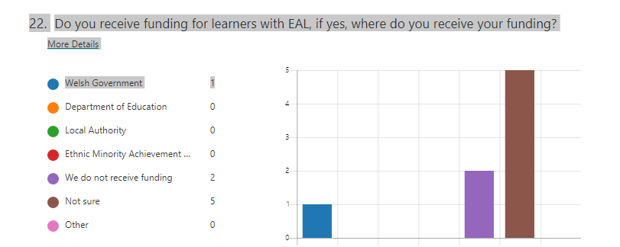
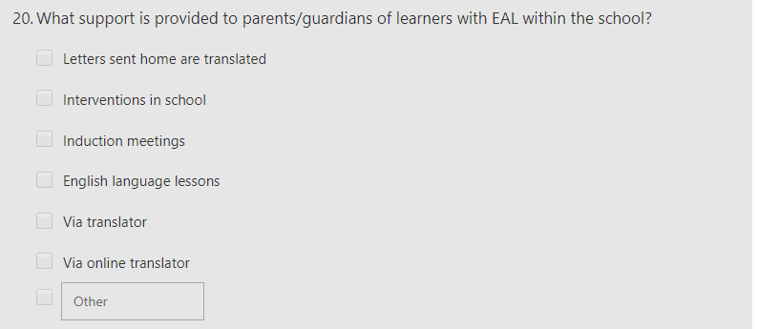

Appendix Two

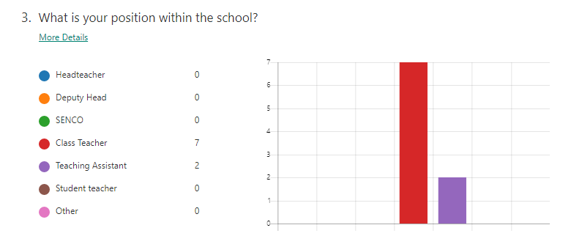

Appendix Three
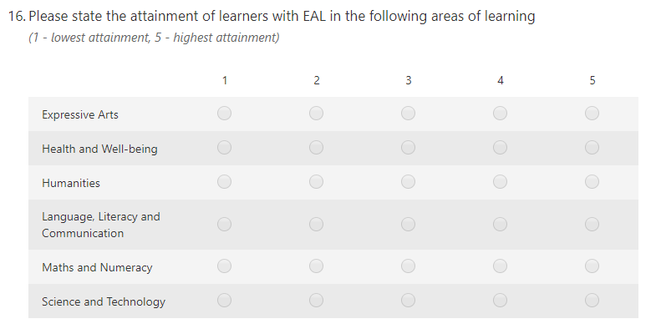

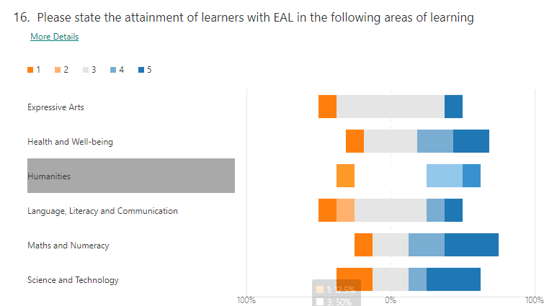

Appendix Four
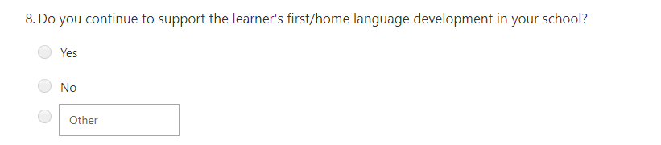

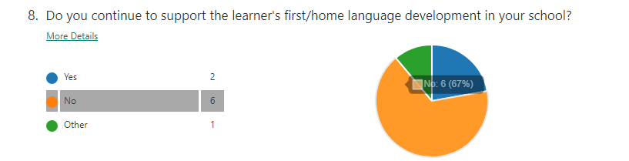

Appendix Five


