University of Wales Trinity Saint David
School of Engineering

Analyse and Simulate a Mechanical Energy Recovery System

Stress Analysis and Dynamics
ACMA5010

Shanjidah Ahmed
2309702
13/11/25
Contents
1 Introduction i
2 Flywheels in Context ii
2.1 Historical Application of Flywheels ii
2.2 Current Demands iii
3 Energy Storage v
3.1 Kinetic Energy Recovery Systems and Regenerative Braking Systems v
3.2 Mechanical and Chemical Storage Systems vi
4 Analytical Investigation of Flywheels viii
4.1 Kinetic Energy viii
4.2 Stored Energy in Flywheel viii
4.3 Rotational Speed ix
4.4 Final Velocity from Re-acceleration Energy ix
4.5 Re-acceleration at 60mph x
5 Discussion and Results xi
5.1 Braking Speed vs Re-acceleration Speed xi
5.2 Relationship between External Diameter and Rotational Speed xi
xii
6 Conclusion xv
7 References xvi
8 Appendix xviii
8.1 Results from Increase of Braking Speed vs Final Speed xviii
8.2 Results from Increasing Diameter of Flywheel vs Rotational Speed xviii

Figure 1 - Development of Pottery Wheel (Ouellette, 2024) ii
Figure 2 - Flywheel Configuration (Alamy, 1888) iii
Figure 3 - Electromagnetic Bearing System (Sun et al., 2024) vi
Figure 4 - Flywheel KERS and CVT Layout (de Santiago et al., 2014) vii
Figure 5 – Graph - Effects of Braking Speed on Re-acceleration Speed xi
Figure 6 - Graph - Relationship between External Diameter and Rotational Speed xii
Figure 7 - Graph - External Diameter Change (0.12-0.16 m) xiii
Figure 8 - Graph - External Diameter Change (0.2-0.24 m) xiii
Figure 9 - Inertia Equations (LibreTexts Physics, 2025) xiv

Equation 1 - Kinetic Energy Equation viii
Equation 2 – Efficiency Equation viii
Equation 3 - Inertia Equation (Wheeler, 2010) ix
Equation 4 - Energy Storage (Haefele, 2010) ix
Equation 5 – Rearranged Energy Storage Equation ix
Equation 6 – Rearranged Kinetic Energy Equation ix
Equation 7 - Velocity Equation x
Equation 8 - Rearranged Velocity Equation x

Table 1 – Experiment 1 - Vehicle and KERS Specifications viii
Table 2 - Experiment 2 - Vehicle and KERS Specifications xii
Table 3 - Results from Increase of Braking Speed vs Final Speed xviii
Table 4 - Results from Increasing Diameter of Flywheel vs Rotational Speed xviii

Introduction
This report looks to highlight the significant milestones achieved with regards to flywheels from the initial uses to modern day and its implications with energy storage. As well as it’s advancement within motor sports and fuel economy for hybrid use. Emphasising its importance to clean kinetic energy as opposed to finite chemical batteries.
Additionally, this report determines the key aspects of flywheels for energy retention, delving into equations comprising of inertia and mass. With the objective to calculate re-acceleration values from given data, carried out on Microsoft Excel. The analysis looks to define a kinetic energy recovery system in conjunction with a continuous variable transmission. The two analytical issues relaying in this text looks to define the final velocity of a vehicle if braking is initiated at different speed intervals. As well as the impact of flywheel diameters/radius with respect to the energy recovery and value of inertia.

Flywheels in Context

Historical Application of Flywheels
The concept of flywheels dates back to ancient times with the use of pottery wheels around 6000 BCE and similar mechanisms to store and release kinetic energy (Bender, 2015)(Olabi et al., 2021). However, advancements within this field to elevate efficiency has moved towards its use within high-speed applications. Predominant changes look at the material composition moving from wood and steel to composites allowing for a higher rotational stress, therefore aiding with the energy recovery of such systems (Olabi et al., 2021). Figure 1 shows numerous stages of pottery wheel development, from handheld application to pedal powered wheels.
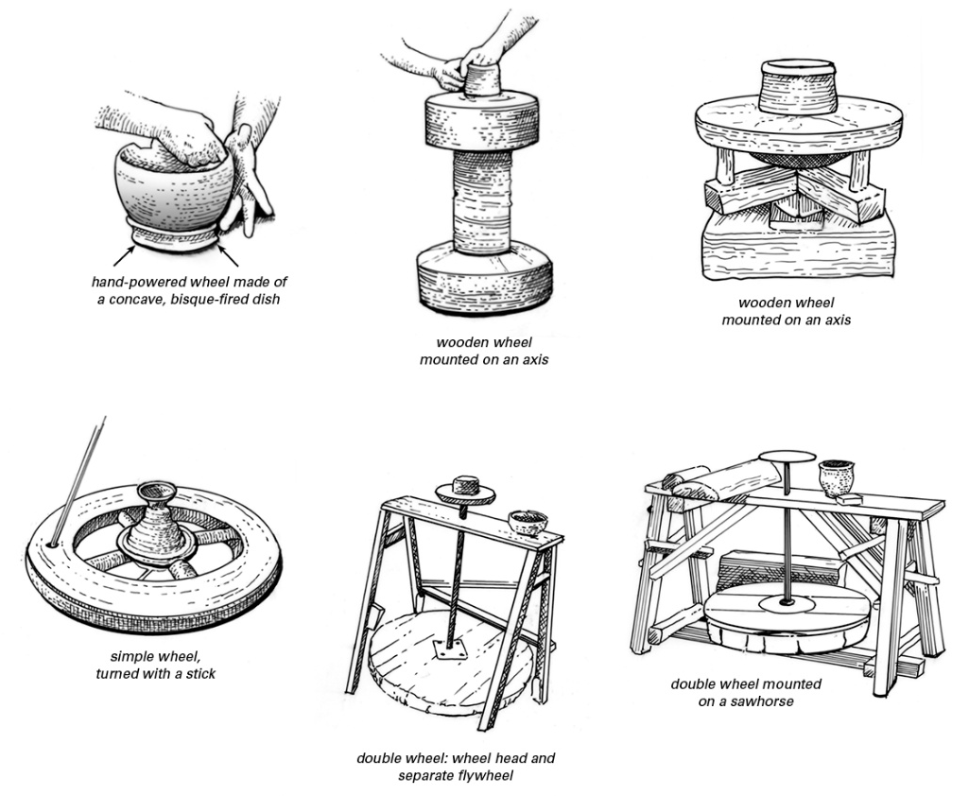

Figure 1 - Development of Pottery Wheel (Ouellette, 2024)

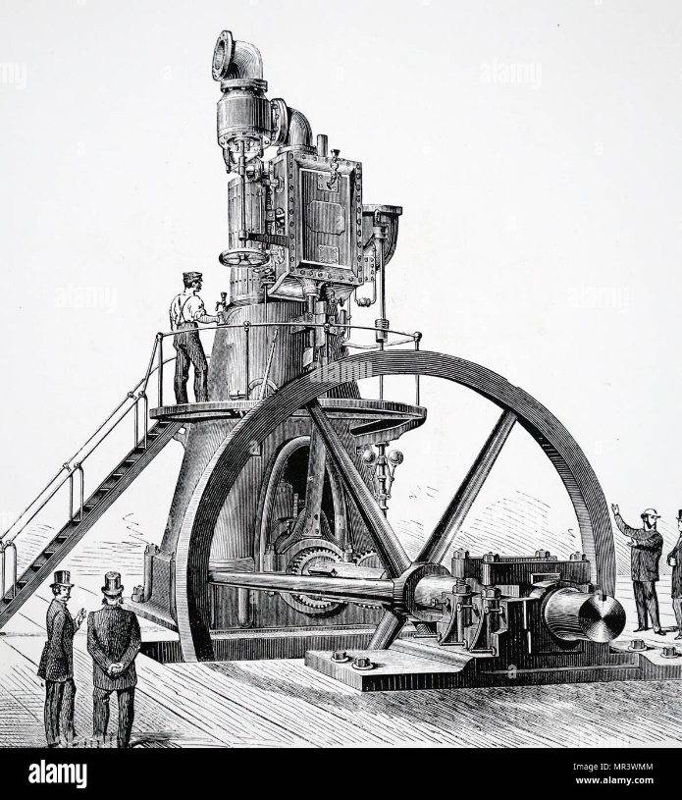
Additional uses of flywheels in history influence the innovation and progression of steam engines during the 1780s, which previously saw flywheels as more hands-on human powered applications (Bender, 2015). The premises of such machines look to convert the reciprocating force into uniform motion, developing into the more common configuration (seen in figure 2) often seen in the industrial age. These larger scale flywheels measured up to 9 meters producing a power of 1MW (Bender, 2015), however current applications of flywheels far exceed the efficiency seen in previous years (Bender, 2015).

Figure 2 - Flywheel Configuration (Alamy, 1888)

Current Demands
Modern day looks towards the need to develop flywheels for both performance and environmental impacts, such as sustainable energy solutions (Olabi et al., 2021). Sustainable energy resources are paramount due to the demand for energy consumption in modern day (Amiryar and Pullen, 2017). Numerous energy storage systems are currently used such as flywheels incorporated within wind diesel turbines, aiding with the influx of demand needed during tourists’ seasons (Amiryar and Pullen, 2017). These changes lessen the dependency of diesel thus lowering the overall emission caused as by product of combustion (Amiryar and Pullen, 2017). Stabilising electric grid and enabling a more consistent power supply to consumers, between wind and solar fluctuations (Olabi et al., 2021). This occurs due to flywheels application in ensuring stability and lag control to improve output (Choudhury, 2021). As well as reducing congestion on national grids, releasing storage energy when required, improving both quality and service for consumers (Carbone, 2011) for example within hospitals and high-stake situations (Olabi et al., 2021).
Off grid energy storages are typically located in areas detached from main power grids, flywheels are often used to store energy from electrical to kinetic energy, this is then held within the system until required, changing the kinetic energy back to electrical (Olabi et al., 2021). The key disadvantages seen with such application, are the frictional forces impeding on the systems efficiency, producing both heat and friction energy loss. However, the overall interest to create more low emission energy relays well with such concepts, energy efficiency focusing heavily on the inertia and mass of flywheel (Olabi et al., 2021)(Seneca Notes, 2025).

Energy Storage
In order for flywheels to gain optimal energy, design looks to maximise its ratio between mass, shape and speed (Amiryar and Pullen, 2017). Composites are typically used as an alternative due to its mass and longevity benefits with materials such as carbon fibre reinforced polymer (CFRP) improving performance and output (Boretti, 2013)(Olabi et al., 2021).
To gain advantageous results with regards to its energy storage, torque and inertia must be considered in order to determine the angular motion and thus the kinetic energy derived (Krack, Secanell and Mertiny, 2011). Angular motion of such operations are directly related to the storage capacity of the flywheel, for example a faster rotational speed will generate a higher capacity of energy storage (Bender, 2015)

Kinetic Energy Recovery Systems and Regenerative Braking Systems
Formula 1 racing is often seen to be the inception of KERS (Kinetic Energy Recovery Systems), using stored kinetic energy gained from heat dispersion on deceleration to advance performance (Chai, 2015). Releasing energy during acceleration and thus reducing the reliance on fuel consumption (Boretti, 2013). With data suggesting a reduction in fuel consumption by 25%, thus KERS has largely redefined transport use in the modern era (Olabi et al., 2021). This energy is generally stored with a mechanical flywheel or electric motor, providing a boost to the acceleration when necessary. Typically produced within a vacuum chamber to reduce energy loss, however the requirements and conditions needed for such operation takes further action. Balancing of mass also adds numerous factors with its concerns to minimise frictional loses (Olabi et al., 2021). Magnetic bearing are commonly used to retain axial position of flywheel mass along shaft, as seen in figure 3, furthermore with its high affinity to repel and attract varying degrees of magnetic field its ability to remain constant during high stressed intervals is key to its performance, and energy output (Olabi et al., 2021).

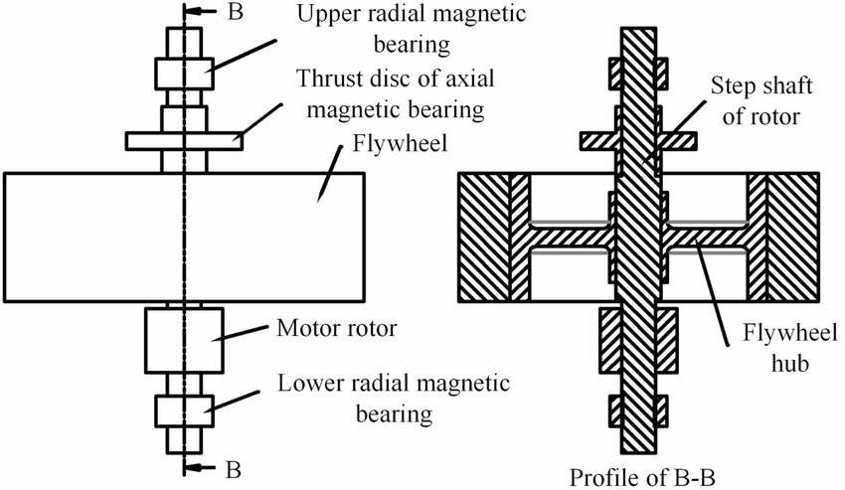
Figure 3 - Electromagnetic Bearing System (Sun et al., 2024)

Mechanical and Chemical Storage Systems
Due to flywheel storage capabilities, they are often known as mechanical or electromechanical batteries (Krack, Secanell and Mertiny, 2011). With their high-power outage and longevity, they provide a good alternative to chemical batteries for short term storage needs, as well as being used in combination with traditional chemical batteries, increasing their lifespan (Olabi et al., 2021).
Comparisons between traditional chemical batteries and mechanical batteries (flywheels) are often debated to select the most appropriate option for defining use. Chemical batteries are known for their environmental impact and depletion of raw materials such as lithium. Therefore, kinetic energy recovery within flywheels is seen as potential alternatives with the addition of their superior energy retention (up to 95% in some ironless machine cases) (Bianchini et al., 2020). Mechanical storage requires less maintenance and can also be reused numerous times thus the life span vs chemical equivalents are again superior (Bender, 2015) (Bianchini et al., 2020). However, their reliance on energy due to angular speed and inertia, makes them limited in their use (Bianchini et al., 2020).
Hybrid regenerative braking systems on the other hand uses mechanical energy from deceleration to be converted to electrical which is then stored as chemical energy within batteries, in order to power the electric motor, this reserves around a third of the braking energy (Boretti, 2013). This concept is more widely used in society within vehicles, providing both efficiency and reduction in fuel use.
KERS uses a system known as Continuous Variable Transmission (CVT) this application connects the flywheels to the drive train, fluctuating its output due to requirement and ratio demands of vehicle (Boretti, 2013). Providing a lightweight and energy efficient system, however partial energy loss due to friction and clutch slippage is seen during this energy conservation, effecting the performance of vehicle (Boretti, 2013). Containment and reliability of such machinery is critical for the longevity and future of KERS therefore rigorous testing in varying speed and conditions are performed, ensuring bearing and properties remain constant and can withstand high intensity speed intervals (Boretti, 2013). Figure 4 below highlights the key aspects seen within such systems, with the flywheels connecting directly to the CVT for use via the gear train.
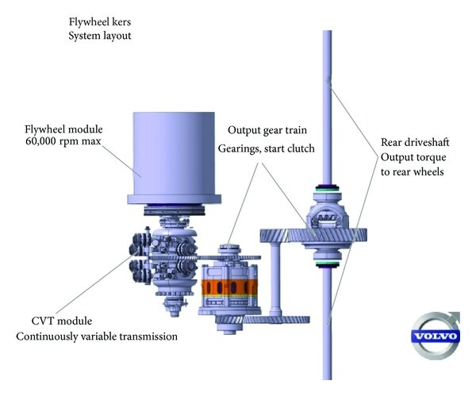

Figure 4 - Flywheel KERS and CVT Layout (de Santiago et al., 2014)

Analytical Investigation of Flywheels
Assuming a high-performance hybrid vehicle has specification as listed in table 1), and the KERS flywheel is a thin ringed configuration secured within a vacuum sealed casing. The effects of braking speed on the re-acceleration of a vehicle as well as the final velocity can be determined.
Table 1 – Experiment 1 - Vehicle and KERS Specifications
Parameters | Data | IS Units
Conversion mph to m/s | 0.44704
Vehicle Gross Mass | 2080 | kg
Flywheel Mass | 6.5 | kg
External Diameter | 0.3 | m
Efficiency | 0.8

Kinetic Energy
The equation used to calculate the kinetic energy before a braking speed of 55mph is seen below. Using vehicle mass of 2080kg (seen in table 1).
$$KE= \frac{1}{2}mv^{2}$$
Equation 1 - Kinetic Energy Equation

KE = ½ (2080)(55 * 0.44704)²
KE = 628711.62 kgm²s⁻²
Kinetic Energy = 628711.62 J

Stored Energy in Flywheel
The efficiency as seen in table 1 states a retention of 80% energy, therefore using equation 2, the efficiency of the flywheel is calculated to be 502.97kJ (2dp).
$$E_{flywheel}=Efficiency*KE$$
Equation 2 – Efficiency Equation

= 0.8 * 628711.62
E _{flywheel} = 502969.296 J

Rotational Speed
In order to find the rotational speed/angular velocity (ꞷ) from equation 4, the inertia must first be calculated as seen in (equation 3). Using mass of 6.5kg and radius calculated as half of diameter stated in table 1. It is important to note that due to the configuration of a thin ringed flywheel the equation for inertia is key to deriving the correct angular rotation.
$$Inertia=mr^{2}$$
Equation 3 - Inertia Equation (Wheeler, 2010)

= (6.5)*(0.3/2)²
Inertia = 0.14625 kgm²

$$E_{flywheel}= \frac{1}{2}Iω^{2}$$
Equation 4 - Energy Storage (Haefele, 2010)

Rearrangement to find rotational speed (ꞷ) looks at equation 5 below (Boretti, 2025)
$$ω=\sqrt{\frac{E_{flywheel}(2)}{I}}$$
Equation 5 – Rearranged Energy Storage Equation

$$=\sqrt{\frac{502969.296(2)}{0.14625 }}$$
= 2622.634667 rad/s
=(2622.634667 *60)/2π
= 25044.31627 rpm

Final Velocity from Re-acceleration Energy
Rearranging equation 1 to calculate velocity of vehicle, gives rise to equation 6 below.
$$v=\sqrt{\frac{KE(2)}{m}}$$
Equation 6 – Rearranged Kinetic Energy Equation
$$v=\sqrt{\frac{KE(2)}{m}}$$
$$=\sqrt{\frac{502969.296(2)}{2080 }}$$
= 21.99146023 m/s
To convert back to mph;
= 21.99146023 /0.44704
Final Velocity = 49.1934955 mph
Final Velocity = 49.19 mph (2dp)

Re-acceleration at 60mph
Assuming the KERS system is in place and final speed is attained at 6.5 seconds. Equation 7 can be used below. The final velocity achieved through similar application above (equation 1-6), generate a value of 23.99 m/s (as seen in appendix 8.1, table 3). As it is known that re-acceleration occurs, initial velocity at rest would equate to 0 m/s. Therefore, with rearrangements made, equation 8 is derived.

$$v_{1}​=v_{0}+at$$
Equation 7 - Velocity Equation
$$a=\frac{v_{1}-v_{0}}{t}$$
Equation 8 - Rearranged Velocity Equation
$$= \frac{23.99-0}{6.5}$$
Acceleration = 3.69 m/s²

Discussion and Results

Braking Speed vs Re-acceleration Speed
Calculations were determined to predict the final velocity of vehicle if the braking speed were to increase incrementally from 20mph to 60mph, data seen in appendix 8.1 (table 3).

Figure 5 – Graph - Effects of Braking Speed on Re-acceleration Speed

The above figure (figure 5) suggests that with an increase in braking speed the overall velocity will also increase in a linear fashion. This corresponds to research suggesting that an increase in energy input will ultimately result in a higher output for consumers (Bender, 2015). Looking at braking speed of 30mph, the final speed incurred 26.83mph. This giving a percentage of energy retention of 89.4%. Similarly looking at the braking value at 60mph a value achieved at final velocity was 53.67mph giving a percentage of 89.45%. Again, this supports research with a KERS and CVT mechanism rigged to a V8 engine, the results of such experiment gave an efficiency percentage of 86% (Boretti, 2013).

Relationship between External Diameter and Rotational Speed
Further investigation looked to showcase the angular velocity of a flywheel with an increase in diameter. The parameters used for this are seen in table 2 below, key differences emphasis the vehicle and flywheel mass as well as the assumption that braking speed remains at 60mph for each variant, further information seen in appendix 8.2 (table 4).

Table 2 - Experiment 2 - Vehicle and KERS Specifications
Parameters | Data | IS Units
mph to m/s | 0.44704
Vehicle Gross Mass | 1510 | kg
Flywheel Mass | 4.5 | kg
Efficiency | 0.8
Velocity | 26.8224 | (m/s)
Kinetic Energy | 543178.062 | J
Efficiency of Flywheel | 434542.4496 | J
Braking Speed | 60 | mph

Figure 6 - Graph - Relationship between External Diameter and Rotational Speed

Looking at figure 6 from the outset it seems that with an increase in external diameter the rotational speed on the flywheel uniformly reduces, this is indicative of the increase of inertia present as the diameter increase. However, on closer inspection a step change is seen between the first two increments (0.12-0.16m) and the last two increments (0.2-0.24m), as highlighted in figures 7 and 8.
Figure 7 - Graph - External Diameter Change (0.12-0.16 m)
Figure 8 - Graph - External Diameter Change (0.2-0.24 m)

Figure 7 shows a change in rotational speed from 69,943.12 rpm to 52,457.34 rpm, a difference of 17,485.78 rpm. However, in comparison with figure 8, (again showing a 0.4m change) the difference between higher and lower limits gives a value of 6,994.31 rpm. Less than half the values attained by smaller diameters, this evidence corresponds to that of other research emphasizing the importance of on inertia for the energy retention (Olabi et al., 2021). With an increase in inertia (seen in appendix 8.2, table 4) over an increase in diameter a smaller angular acceleration will be achieved, regardless of torque input (LibreTexts Physics, 2025). As inertia is also dependant on mass (equation 3), the configuration of the flywheel is key, however due to our assumptions that the flywheel is a thin ringed cylinder, the equation used is correct for its design. Further to this with the mass being closer to the centre of axis the rotational speed will increase as a reduction in radius is seen (Milica and Andrei, 2020). Figure 9 below shows varying inertia equation that may have been relevant if geometry was not specified, however the assumption of such experiments defines its application to a thin ringed design.

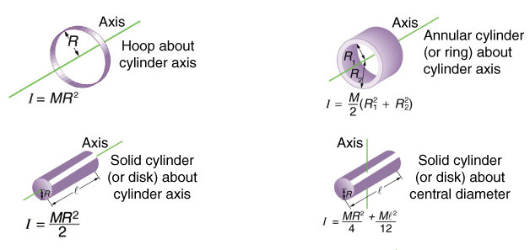
Figure 9 - Inertia Equations (LibreTexts Physics, 2025)

With all these analytical results it is assumed that additional energy loss past 80% flywheel efficiency has been accounted for. And the KERS and CVT models remains intact within its vacuum enclosed casing as well as bearings which cause little to no additional energy loss. It is also assumed that the friction against the wheels and the car is of little importance and any external parameter that could impede on such an investigation is negligible.

Conclusion
The dependence on flywheels over time has become key to social development in both economic, environmental and mechanical assets. With its ability to hold kinetic energy for periods of time whilst also sustaining large percentages of energy for dispersion, around 86% in above experiment. Such operations look to advance green energy into more efficient means, harnessing wind power to engage flywheels and releasing energy between low winds speeds. Thus, outputting a constant stream of energy with little to no lagging effecting consumers.
From the development of ancient flywheel applications to kinetic energy recovery systems (KERS), flywheels have made themselves useful for fuel economy and motor sports competitions. Generating energy on deceleration to gain advantage on reacceleration (Chai, 2015) and boosting the output a single machine typically makes. Further to this the mechanical integrity of such designs looks to reduce and diminish frictional energy loss, predominantly with bearings and resistance in casing. Therefore, modern technology aids the implementation of vacuum sealed housing and the reduction of energy loss (Olabi et al., 2021).
Analytical analysis looked to define the most effective use of flywheels, determining which configuration would be effective for a KERS model using CVT as a transmission link. It was suggested through figure 5, that with a higher acceleration before braking, a greater amount of energy could be stored within the flywheel. This proportional result emphasised the ratio between energy recovery and energy generation. As it was assumed the KERS flywheel could attain 80% efficiency thus the outcome of experiment showcased this.
Further to this, flywheels with varying wheel diameters were investigated and the results were key to the definition of equation 3. Emphasising the importance of radius on inertia. Due to the fact that mass was kept at 4.5kg, the significane of radius was shown in figures 6-8. With the smaller diameter achieving a larger rotational speed of 69,943.12 rpm compared to that of larger diameters 0.24m achieving a speed of 34,971.56 rpm. Therfore with the mass of flywheel being closer to the axis of rotation a higher rotational value is produced (Milica and Andrei, 2020). This was also related to the assumption that the flywheel would be a thin ringed design therefore governing the correct equation to be used in order to determine inertia, and thus rotational speed.

Word count: 2415

References
Alamy (1888) Engine Flywheel Stock Photos and Images, Alamy. Available at: https://www.alamy.com/illustration-showing-direct-action-vertical-steam-engine-with-flywheel-shaft-near-floor-level-1888-image235260208.html?imageid=6AA902EB-CC8B-4F1D-8E2E-9B2E9E024DE9&pn=1&searchId=6fa354f83e34cc9cf215a7d1233a6762&searchtype=0 (Accessed: 9 November 2025).
Amiryar, M.E. and Pullen, K.R. (2017) ‘A review of flywheel energy storage system technologies and their applications’, Applied Sciences, 7(3), p. 286. Available at: file:///C:/Users/UB08982/Downloads/applsci-07-00286%20(2).pdf (Accessed: 6 November 2025).
Bender, D. (2015) Flywheels, Storing energy. Elsevier. Available at: chrome-extension://efaidnbmnnnibpcajpcglclefindmkaj/https://www.osti.gov/servlets/purl/1182678 (Accessed: 8 November 2025).
Bianchini, C. et al. (2020) ‘Design of motor/generator for flywheel batteries’, IEEE Transactions on Industrial Electronics, 68(10), pp. 9675–9684. Available at: file:///C:/Users/Student/Downloads/09211803.pdf (Accessed: 11 November 2025).
Boretti, A. (2013) Kinetic Energy Recover Systems for Racing Cars. Warrendale, UNITED STATES: SAE International. Available at: http://ebookcentral.proquest.com/lib/trinity/detail.action?docID=5341841.
Boretti, A. (2025) ‘Advancing sustainable mobility: Integrating flywheel kinetic energy recovery systems with high-efficiency hydrogen internal combustion engines’, International Journal of Hydrogen Energy, 125, pp. 354–363. Available at: https://doi.org/https://doi.org/10.1016/j.ijhydene.2025.04.094.
Carbone, R. (2011) Energy Storage in the Emerging Era of Smart Grids. London: IntechOpen. Available at: https://doi.org/10.5772/737.
Chai, P. (2015) ‘Design and Optimization of a Flywheel Based Kinetic Energy Recover System’. Available at: https://www.researchgate.net/profile/Patrick-Chai/publication/281108962_Design_and_Optimization_of_a_Flywheel_Based_Kinetic_Energy_Recover_System/links/55d5e5d108aec156b9a667ec/Design-and-Optimization-of-a-Flywheel-Based-Kinetic-Energy-Recover-System.pdf?__cf_chl_tk=cMifXV6jOdFmgguAatfpPneB.9K_gfFAlU6v7z18VqI-1762164442-1.0.1.1-qRUl5eL_A2ZpuXAD2o447D7196Qt27cgc91OUmh14Ps (Accessed: 6 November 2025).
Choudhury, S. (2021) ‘Flywheel energy storage systems: A critical review on technologies, applications, and future prospects’, International Transactions on Electrical Energy Systems, 31(9), p. e13024. Available at: https://doi.org/https://doi.org/10.1002/2050-7038.13024.
Haefele, T. (2010) Superconducting Bearings for Flywheel Energy Storage, Stanford University. Available at: http://large.stanford.edu/courses/2010/ph240/wheeler1/ (Accessed: 10 November 2025).
Krack, M., Secanell, M. and Mertiny, P. (2011) ‘Rotor Design for High-Speed Flywheel Energy Storage Systems’, in. Available at: https://doi.org/10.5772/18359.
LibreTexts Physics (2025) 10.3: Dynamics of Rotational Motion - Rotational Inertia, The LibreTexts. Available at: https://phys.libretexts.org/Bookshelves/College_Physics/College_Physics_1e_%28OpenStax%29/10%3A_Rotational_Motion_and_Angular_Momentum/10.03%3A_Dynamics_of_Rotational_Motion_-_Rotational_Inertia (Accessed: 12 November 2025).
Milica, L. and Andrei, G. (2020) ‘Influence of the flywheel profile on the energy storage capacity of the kers system’, IOP Conference Series. Materials Science and Engineering, 997(1). Available at: https://doi.org/https://doi.org/10.1088/1757-899X/997/1/012123.
Olabi, A.G. et al. (2021) ‘Critical Review of Flywheel Energy Storage System’, Energies, 14(8). Available at: https://doi.org/10.3390/en14082159.
Ouellette, R. (2024) ‘Pottery Illustrated: Throwing Wheels in History’, Pottery Making Illustrated, August. Available at: https://ceramicartsnetwork.org/pottery-making-illustrated/pottery-making-illustrated-article/pottery-illustrated-throwing-wheels-in-history (Accessed: 11 November 2025).
de Santiago, J. et al. (2014) ‘A Power Buffer in an Electric Driveline: Two Batteries Are Better Than One’, ISRN Automotive Engineering, 2014, pp. 1–9. Available at: https://doi.org/10.1155/2014/525630.
Seneca Notes (2025) Mass & Inertia, Seneca Notes.
Sun, B. et al. (2024) ‘Design and control of radial electromagnetic bearing for flywheel battery’, Measurement Science and Technology, 36. Available at: https://doi.org/10.1088/1361-6501/ad9bd1.
Wheeler, B. (2010) Flywheel Energy Storage. Stanford. Available at: http://large.stanford.edu/courses/2010/ph240/wheeler1/ (Accessed: 5 November 2025).

Appendix

Results from Increase of Braking Speed vs Final Speed

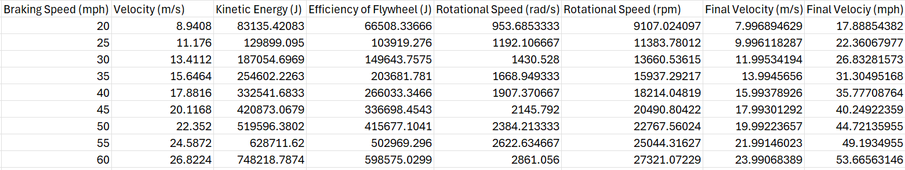
Table 3 - Results from Increase of Braking Speed vs Final Speed

Results from Increasing Diameter of Flywheel vs Rotational Speed

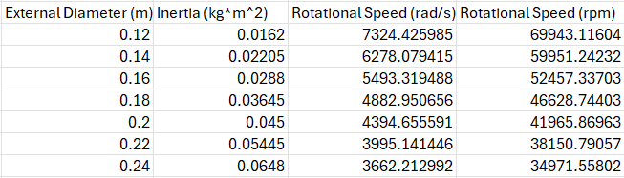
Table 4 - Results from Increasing Diameter of Flywheel vs Rotational Speed

