Data Handling & Business Intelligence

adrian neacsu
2312529 – UWTSD Birmingham

Name: Adrian Mihai Neacsu
Student number: 2312529
Module Code: LCBB5014
Module Title: Data Handling & Business Intelligence
Assignment Title: Component 1: Coursework: Individual Report
UWTSD Birmingham

Table of Contents
2 Introduction 3
3 Understanding Business Intelligence Concepts 4
4 Business Intelligence Applications 5
5 Real-World Examples 7
6 Benefits and Challenges of Business Intelligence 9
7 Conclusion 10
8 References: 11

Introduction

Business Intelligence (BI) has become an essential part of decision-making in modern organisations, particularly in sectors that operate with large volumes of data and intense competition.
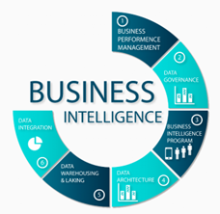
BI can be defined as the use of technologies, processes and analytical methods to collect, integrate and analyse data to support informed business decisions (Sharda, Delen and Turban, 2020). Academic research also describes BI as a means of converting organisational data into useful information that supports both strategic planning and day-to-day operational decisions (Trieu, 2017). Together, these perspectives highlight BI as more than a reporting function, positioning it as a key contributor to organisational performance.
In the retail sector, the importance of BI has increased due to changing consumer behaviour, complex supply chains and growing pressure to operate efficiently across physical and digital channels. Retail managers rely on BI to support decisions related to demand forecasting, stock control, pricing strategies and customer analysis. The ability to access timely and accurate information allows retailers to respond more effectively to market changes while reducing operational risk and inefficiency.
The purpose of this report is to examine the fundamental concepts of Business Intelligence and assess its strategic relevance in contemporary organisations, with particular attention given to retail decision-making. The report outlines key BI components, reviews how BI tools are applied across industries, analyses real-world case examples, and discusses the main benefits and challenges associated with the implementation of BI systems.

Understanding Business Intelligence Concepts
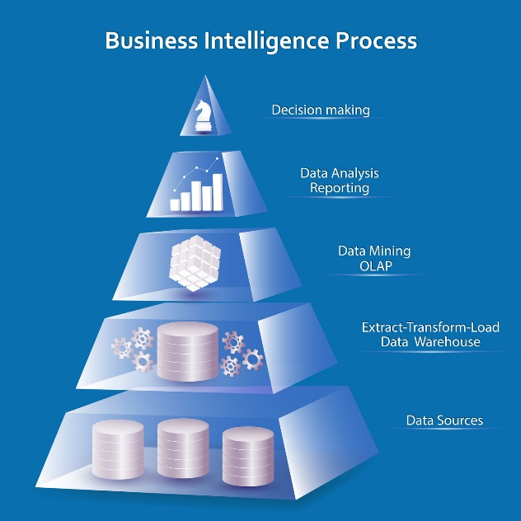
Business Intelligence (BI) refers to a structured approach to managing and analysing organisational data to support informed decision-making. Rather than functioning as a single system or tool, BI represents an integrated framework that combines data management, analytical techniques and reporting mechanisms to provide meaningful insights for managers. At its core, BI focuses on improving the quality, speed and reliability of decisions by ensuring that relevant information is available in an accessible and usable form (Sharda, Delen and Turban, 2020). In business environments characterised by uncertainty and rapid change, BI supports evidence-based decision-making and reduces reliance on intuition alone.
A key component of BI is data collection, which involves gathering data from multiple internal and external sources such as point-of-sale systems, customer loyalty programmes, e-commerce platforms and supply chain systems. In retail, this allows organisations to capture detailed information on customer behaviour, sales patterns and inventory movement. Once collected, data is stored within data warehouses or similar central repositories, where it is cleaned, standardised and integrated to ensure consistency and accuracy across the organisation (Inmon, 2005). This process is essential for producing reliable analyses and reports.
Data mining and analytics form the analytical core of BI. Data mining techniques are used to identify patterns, trends and relationships within large datasets, while analytics applies statistical and computational methods to interpret these patterns and support decision-making. In retail contexts, these techniques are commonly used for demand forecasting, customer segmentation and pricing analysis (Chen, Chiang and Storey, 2012). Data visualisation and reporting then present analytical results through dashboards, charts and performance reports, allowing managers to monitor performance and respond quickly to emerging issues.
The role of BI has evolved significantly over time. Early BI systems focused primarily on descriptive reporting, providing summaries of historical performance through static reports. While useful, these systems offered limited support for forward-looking decisions. Modern BI now incorporates predictive and prescriptive analytics, allowing organisations to assess future scenarios and evaluate alternative courses of action. More recently, advances in Artificial Intelligence have extended BI capabilities further by automating pattern recognition and supporting real-time analysis (Trieu, 2017). Despite these developments, effective BI still depends on sound data governance, managerial judgement and alignment with organisational objectives.

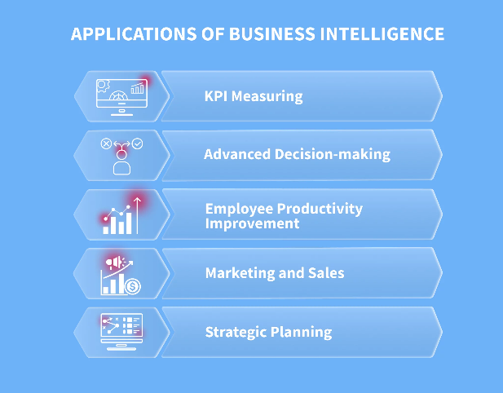
Business Intelligence Applications
Business Intelligence applications are used by organisations to support decision-making through systematic data analysis, performance monitoring and forecasting (Wixom, Yen and Relich, 2013). BI tools allow decision-makers to consolidate data from multiple sources and interpret organisational performance in a structured manner, improving the consistency and reliability of managerial decisions (Popovič et al., 2019). Common BI applications include dashboards, reporting systems, data mining techniques and predictive analytics, each contributing to different stages of the decision-making process (Delen and Demirkan, 2013).
Dashboards represent one of the most widely adopted BI applications due to their ability to present key performance indicators in a visual and accessible format (Wixom, Yen and Relich, 2013). By displaying metrics such as sales trends, inventory levels and customer activity, dashboards allow managers to monitor performance and identify deviations from targets in near real time (Popovič et al., 2019). In retail environments, dashboards are frequently used to support operational decisions related to stock availability, promotional performance and store productivity, where timely information is critical (Delen and Demirkan, 2013). Reporting tools complement dashboards by producing structured summaries of historical performance, supporting accountability, auditing and regulatory requirements across industries (Chen, Chiang and Storey, 2012).
Data mining and predictive analytics extend BI functionality beyond descriptive reporting by identifying patterns and relationships within large datasets (Chen, Chiang and Storey, 2012). Data mining techniques are commonly applied to customer transaction data to uncover purchasing patterns, detect anomalies and support segmentation analysis (Delen and Demirkan, 2013). Predictive analytics uses statistical and computational models to forecast future outcomes based on historical data, supporting decision-making under uncertainty (Wixom, Yen and Relich, 2013). In the retail sector, predictive analytics is widely used for demand forecasting, inventory planning and pricing decisions, helping organisations reduce stockouts and excess inventory (Popovič et al., 2019).
The application of BI extends across multiple industries. In finance, BI tools are used to support credit risk assessment, fraud detection and performance monitoring, where accurate and timely analysis is essential for regulatory compliance and risk management (Delen and Demirkan, 2013). In healthcare, BI supports patient flow management, resource allocation and service planning by analysing clinical and operational data, contributing to improved efficiency and service quality (Raghupathi and Raghupathi, 2014). Manufacturing organisations apply BI to production planning, quality control and supply chain coordination, using trend analysis and performance monitoring to reduce downtime and improve operational efficiency (Chen, Chiang and Storey, 2012).

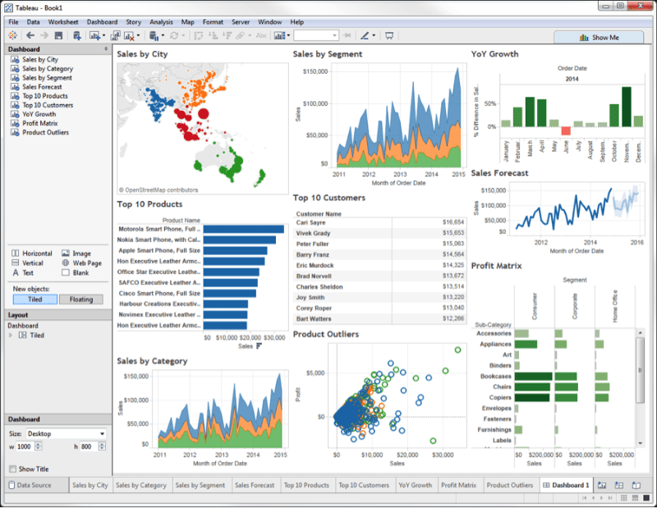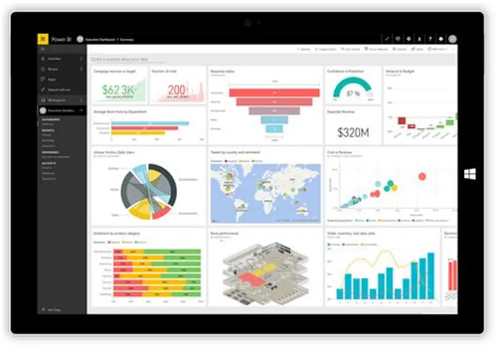
A range of commercial BI platforms support these applications. Tableau is commonly used for data visualisation and interactive dashboards, enabling users to explore complex datasets through intuitive graphical interfaces (Wixom, Yen and Relich, 2013). Microsoft Power BI integrates reporting, dashboards and analytics within a single platform, making it suitable for organisations seeking scalable BI solutions that support both operational and strategic decisions (Popovič et al., 2019). SAP Business Intelligence is frequently adopted by large organisations to integrate BI with enterprise systems, supporting organisation-wide data integration and standardised reporting (Chen, Chiang and Storey, 2012). Across industries, these platforms support evidence-based decision-making by improving access to reliable and timely information (Wixom, Yen and Relich, 2013).

Real-World Examples
Retail organisations increasingly use Business Intelligence to improve forecasting accuracy, operational efficiency and customer satisfaction. The following case studies examine how BI is applied in practice by two global retailers and assess the impact of data-driven decision-making on organisational performance.

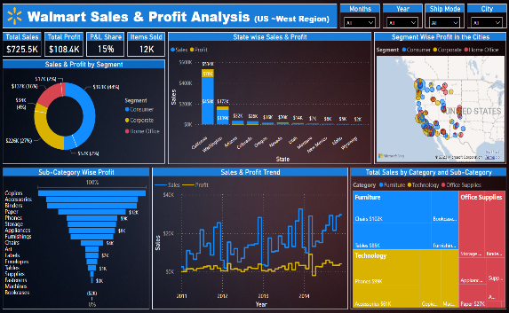
Walmart provides a well-documented example of BI use in large-scale retail operations. Walmart integrates data from point-of-sale systems, supply chain platforms and inventory management systems to monitor sales performance and stock movement across its global store network (Chen, Chiang and Storey, 2012). BI tools are used to support demand forecasting, replenishment planning and supplier coordination, enabling managers to respond more effectively to changes in consumer demand. Academic studies indicate that retailers applying advanced analytics to inventory and supply chain data achieve reductions in stockouts and holding costs while improving product availability (Popovič et al., 2019).
In Walmart’s case, BI-supported forecasting and real-time reporting have contributed to improved inventory turnover and more consistent service levels, particularly in high-volume product categories (Wixom, Yen and Relich, 2013).
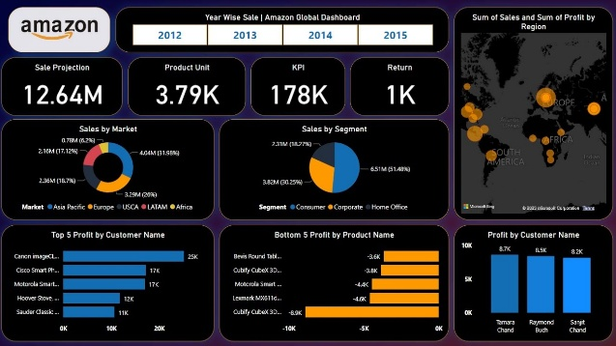

A second example is Amazon, which uses BI extensively across customer analytics, logistics and pricing decisions. Amazon collects large volumes of customer interaction data, including browsing behaviour, purchase history and delivery performance, to support personalised recommendations and operational planning (Delen and Demirkan, 2013). BI-driven predictive analytics are applied to forecast demand at the fulfilment-centre level, optimise warehouse operations and support dynamic pricing strategies. Research shows that organisations using predictive analytics in fast-moving retail environments improve decision accuracy and responsiveness, leading to faster fulfilment and improved customer satisfaction (Wixom, Yen and Relich, 2013). Amazon’s use of BI has supported shorter delivery times, improved order accuracy and more informed strategic planning across its logistics network (Chen, Chiang and Storey, 2012).
Across both cases, BI contributes to measurable organisational outcomes. Improved demand forecasting and inventory visibility reduce excess stock and operational waste, while customer analytics support more targeted services and consistent service quality (Popovič et al., 2019). However, academic literature also highlights that the benefits of BI depend on data quality, governance and organisational capability. Without reliable data integration and managerial understanding, BI outputs may lead to delayed or inaccurate decisions (Delen and Demirkan, 2013). These case studies demonstrate that while BI can significantly improve retail decision-making, its effectiveness is closely linked to how analytical insights are embedded within everyday management practices.

Benefits and Challenges of Business Intelligence
Business Intelligence delivers significant value to organisations by improving the quality and consistency of managerial decision-making. By integrating data from multiple sources and presenting it in a structured and accessible form, BI supports managers in making decisions based on evidence rather than personal judgment alone (Laursen and Thorlund, 2016). In retail contexts, this leads to more informed decisions relating to demand forecasting, pricing strategies and inventory management, reducing uncertainty and operational inefficiencies (Trkman et al., 2010). Over time, organisations that embed BI into decision processes tend to achieve more stable performance and improved coordination across business functions (Seddon et al., 2017).
Another important benefit of BI is improved customer understanding. Through analytical techniques such as segmentation and behavioural analysis, organisations are able to identify customer preferences and purchasing patterns more accurately (Yeoh and Koronios, 2010). This supports more targeted marketing activities and service improvements, contributing to higher customer satisfaction and retention in competitive retail environments (Laursen and Thorlund, 2016). When used consistently, BI can also contribute to competitive advantage by enabling organisations to respond more quickly to market changes than competitors that rely on traditional reporting approaches (Seddon et al., 2017).
Despite these benefits, organisations face several challenges when implementing BI systems. Data quality and governance remain major concerns, as inconsistent or poorly managed data can undermine the reliability of BI outputs and lead to incorrect decisions (Otto, 2011). BI initiatives may also involve high implementation and maintenance costs, particularly in large organisations that require enterprise-wide integration of systems and data sources (Yeoh and Koronios, 2010). In addition, a persistent skills gap can limit the effective use of BI, as managers may lack the analytical capability required to interpret and apply insights appropriately (Seddon et al., 2017). Privacy and ethical concerns further complicate BI adoption, especially when organisations analyse detailed customer data, increasing the risk of misuse or regulatory non-compliance (Martin, 2015).
To address these challenges, organisations should establish clear data governance frameworks that define ownership, accountability and data standards across the organisation (Khatri and Brown, 2010). Phased implementation strategies can help control costs and reduce disruption, while targeted training programmes can improve managerial confidence in using BI outputs (Yeoh and Koronios, 2010). Furthermore, aligning BI initiatives with ethical guidelines and regulatory requirements helps ensure that BI supports responsible and sustainable decision-making practices (Zarsky, 2016).

Conclusion
This report has examined the role of Business Intelligence in contemporary organisations, with particular focus on its application within retail decision-making. It has shown that BI is not a single tool but an integrated framework combining data collection, analytics, visualisation, and reporting to support informed managerial decisions. The analysis demonstrated how BI tools such as dashboards, predictive analytics and data mining are applied across industries, while real-world cases illustrated how retailers use BI to improve forecasting accuracy, operational efficiency and customer satisfaction. The evaluation of benefits and challenges highlighted that while BI can significantly improve decision quality and competitive positioning, its effectiveness depends on data quality, governance, organisational capability, and ethical use.

Looking ahead, the future of BI is shaped by developments such as AI-driven analytics, real-time data processing and self-service BI platforms. These trends allow organisations to move beyond historical analysis towards faster, more adaptive decision-making, though they also increase the need for strong governance and managerial oversight (Trieu, 2017; Zarsky, 2016). As BI systems become more accessible, organisations must ensure that analytical outputs are interpreted responsibly and aligned with business objectives.
To maximise the potential of BI, organisations should invest in data governance frameworks, develop analytical skills among decision-makers and align BI initiatives with strategic priorities (Khatri and Brown, 2010; Yeoh and Koronios, 2010). By embedding BI into everyday management processes, businesses can strengthen their ability to remain competitive in increasingly data-driven markets.

References:
- Chen, H., Chiang, R.H.L. and Storey, V.C. (2012) ‘Business intelligence and analytics: From big data to big impact’, MIS Quarterly, 36(4), pp. 1165–1188.
- Delen, D. and Demirkan, H. (2013) ‘Data, information and analytics as services’, Decision Support Systems, 55(1), pp. 359–363. https://doi.org/10.1016/j.dss.2012.05.044
- Inmon, W.H. (2005) Building the data warehouse. 4th edn. Hoboken, NJ: John Wiley & Sons.
- Khatri, V. and Brown, C.V. (2010) ‘Designing data governance’, Communications of the ACM, 53(1), pp. 148–152.
- Laursen, G.H.N. and Thorlund, J. (2016) Business analytics for managers: Taking business intelligence beyond reporting. Hoboken, NJ: John Wiley & Sons.
- Martin, K. (2015) ‘Ethical issues in the big data industry’, MIS Quarterly Executive, 14(2), pp. 67–85.
- Otto, B. (2011) ‘Organizing data governance: findings from the telecommunications industry’, Journal of Enterprise Information Management, 24(4), pp. 441–456.
- Popovič, A., Hackney, R., Tassabehji, R. and Castelli, M. (2019) ‘The impact of big data analytics on firms’ high value business performance’, Information Systems Frontiers, 21(2), pp. 209–222. https://doi.org/10.1007/s10796-017-9760-8
- Raghupathi, W. and Raghupathi, V. (2014) ‘Big data analytics in healthcare: promise and potential’, Health Information Science and Systems, 2(3). https://doi.org/10.1186/2047-2501-2-3
- Seddon, P.B., Constantinidis, D., Tamm, T. and Dod, H. (2017) ‘How does business analytics contribute to business value?’, Information Systems Journal, 27(3), pp. 237–269.
- Sharda, R., Delen, D. and Turban, E. (2020) Business intelligence, analytics, and data science: A managerial perspective. 4th edn. Harlow: Pearson Education.
- Trieu, V.-H. (2017) ‘Getting value from Business Intelligence systems: A review and research agenda’, Decision Support Systems, 93, pp. 111–124. https://doi.org/10.1016/j.dss.2016.09.019
- Trkman, P., McCormack, K., De Oliveira, M.P.V. and Ladeira, M.B. (2010) ‘The impact of business analytics on supply chain performance’, Decision Support Systems, 49(3), pp. 318–327.
- Wixom, B.H., Yen, B. and Relich, M. (2013) ‘Maximizing value from business analytics’, MIS Quarterly Executive, 12(2), pp. 111–123.
- Yeoh, W. and Koronios, A. (2010) ‘Critical success factors for business intelligence systems’, Journal of Computer Information Systems, 50(3), pp. 23–32.
- Zarsky, T. (2016) ‘The trouble with algorithmic decisions’, Science, Technology & Human Values, 41(1), pp. 118–132.

