BMSW4001 ACADEMIC AND EMPLOYABILITY SKILLS
Lecturer: Sylvia Hoffmann
Student: Lavinia Mariana Tudor ( 1921596 )

TASK 2
Executive summary
This report focuses on developing a reflective analysis on my personal learning in this module. 4 topics have been analysed according to Kolb's reflective cycle. Detailed information regarding my paraphrasing skill, reflection skill, cover letter, writing skill and online learning experience has been discussed in this study.

Introduction
Reflective analysis is an essential tool for increasing personal knowledge regarding personal strengths and weaknesses and it also helps to evaluate personal understanding and learning on a particular topic. There are multiple reflective models available for analysing personal understanding but Kolb's reflective cycle is a simple and effective tool for evaluating personal strengths and weaknesses. It also identifies the potential opportunities for developing personal development plans. Describing 4 topics such as paraphrasing, reflection, cover letter writing and online learning experience through Kolb's reflective cycle is the main motive of this study.

Paraphrasing
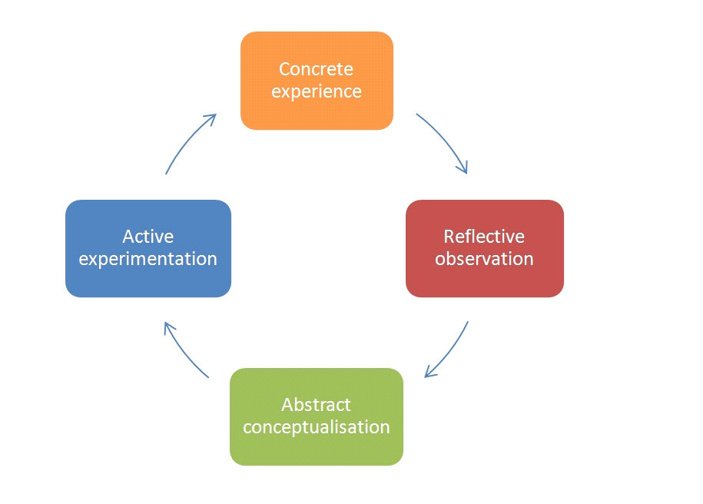
Figure 1: Kolb's reflective cycle
(Source: Based on Din et al. 2020)
Concrete experience
Paraphrasing is an important part of academic writing as it helps to convert the ideas of another person in my own words. According to the opinion of Lewis et al. (2020), it is very important to change the words and structure but maintain the same meaning while paraphrasing. It is one of the most authentic ways to acknowledge the authors for their work through providing reference.I have faced difficulties at the initial stage of my academic career to paraphrase important sections from journal articles and books. I had very limited knowledge regarding multiple techniques of paraphrasing and my vocabulary knowledge in English is very low as Romanian is my mother tongue. I have faced difficulties using synonyms of complex English words.

Reflective observation
According to the guidelines of Kolb's reflective cycle the second stage is reflective observation and this stage helps to reflect more deeply on what has happened in that particular time or situation. It has been highlighted by Din et al. (2020), the implementation of this stage is crucial for identifying what has worked and what has failed during the time period. My academic knowledge is efficient and I have no issues reading and understanding the English language. However, I had effective knowledge regarding the concept of changing word order for paraphrasing. This technique was not sufficient for developing appropriate paraphrasing practice and I had limited knowledge regarding the concept of changing word class and the utilisation of synonyms. I have understood that it is very important to increase my vocabulary strength for developing successful paraphrasing practices.

Abstract conceptualisation
The learning module has helped me to identify multiple techniques to develop a successful paraphrase. I have understood it is essential to retain the meaning of the original text and we can develop a different structure for paraphrasing. I can change the class of the words and I can change the order of the words for paraphrasing. I have understood my personal strengths and weaknesses while starting this module as my reading skill is very impressive but my vocabulary knowledge is very poor. I have decided to perform online courses to increase my vocabulary knowledge.

Active experimentation
It is the last stage of Kolb's reflective cycle and I have practiced effectively according to the findings of the above sections. For instance, I have understood my weaknesses in using synonyms for paraphrasing and I have provided comparatively higher attention towards increasing my vocabulary knowledge through online activities. I have also solved the paraphrasing exercise given in this module to evaluate my personal growth. It has helped me to increase my overall efficiency and I have also attended some online courses and online vocabulary exercises for regular practice.
Reflection
Concrete experience
Personal reflection is an important task to perform as it helps to identify personal strengths as well as flaws. As stated by Karnieli-Miller (2020), the successful implementation of reflective practice can be very effective for identifying an appropriate development plan. I had proper theoretical knowledge regarding reflective practices. For instance, I used to evaluate my personal learning on the basis of examination results. It increased my challenges while developing continuous development plans. I had developed multiple irrelevant personal development plans due to lack of knowledge regarding reflection. It has hampered my professional and educational career.

Reflective observation
I have already pointed out that I used to evaluate my personal learning by academic results. I used to believe that academic results are the final statement for my learning skills. I have noticed that academic results are not able to evaluate my practical skills that are required for gaining success in the professional career. I have worked as a house cleaner and cleaning team leader. This job was completely new to me as I am a student of social science background. I faced difficulties to evaluate my skills and capabilities due to lack of knowledge regarding personal SWOT analysis and personal planning.

Abstract conceptualisation
Kolb's reflective cycle has multiple stages and each stage provides a proper opportunity for analysing personal learnings. I have learnt about multiple things such as personal SWOT analysis and personal planning in this module. I have also understood the application process of self-learning journals. As stated by Cirocki and Widodo (2019), the concept of a self-learning journal is essential for recording detailed information regarding each week. I think this method is very effective for cracking personal development and it also helps to increase self-awareness. I think I was not informed regarding my personal skills and abilities at my initial stage. According to me the concept of personal SWOT analysis is one of the most authentic ways to increase awareness regarding strengths and it also helps to identify the potential opportunities.

Active experimentation
The last stage of this reflective life cycle highlights the importance of regular practice. According to the opinion of McLeod et al. (2020), it is very important to practise the newly acquired theoretical knowledge as it helps to increase personal efficiency. I have started to maintain a reflective learning journal for recording my day-to-day development process. I also developed personal SWOT analysis for identifying potential opportunities in the field of cleaning manager. I was successful in increasing my strength such as nonverbal communication and active listening through the implementation of personal planning and it has increased my self-awareness. My verbal communication skill is poor in English and it is a required skill for gaining success in the position of cleaning manager. I have developed proper continuous development planning for increasing my English communication skill.

Cover letter writing
Concrete experience
The concept of a cover letter can be described as a professional business letter that provides a clear conception regarding the intention of the candidates to the employer. As stated by Hirata (2019), the implementation of a cover letter provides proper conception to the employer regarding the suitability of the candidate for the particular job. I had no knowledge regarding the writing process of a cover letter. I had worked as a house cleaner in 2015 and I had not provided a cover letter while submitting my CV for this particular position. There was a vacant place for the cleaning team leader in the same organisation and I was not selected for that post. I have faced difficulty in establishing a good impression at the time of interview for the position of Supermarket shop assistant due to a lack of an appropriate cover letter.

Reflective observation
It is very important to introduce myself in the cover letter for establishing a great impression on the employer. I had very limited knowledge regarding the structure and process of writing a cover letter. I have only introduced my personal strengths in the cover letter while applying for the post of supermarket shop assistant. According to the feedback of the employer it was necessary to provide a clear conception regarding my capabilities and strengths. However, I have not mentioned the position that I was applying for and it was a major disadvantage for me to make a great impression on the employer.

Abstract conceptualisation
I have understood regarding the appropriate structure of writing a cover letter as it is essential to mention the individual or employer at the starting of the cover letter. I can write the name of the employer or I can mention the position of the manager While submitting my CV with the cover letter. The next stage is to introduce myself on the basis of academic degree and professional experiences. The learning module helps me to align my career goals and business goals of the company. According to my understanding it would make a great impression on the employer. I also need to mention my previous job experience in the cover letter as business organisations for employers provide comparatively higher tension towards hiring experienced employees.

Active experimentation
My mother tongue is Romanian and my English communication skill is not very attractive. I have started to increase my vocabulary skill and grammatical skill for writing a flawless cover letter. I have understood that the CV is the bones and the job is the muscle and the cover letter provides the linkage between bones and muscles. I have started to attend my online classes on a regular basis to increase my English writing skill. I have understood the importance of background research for writing a cover letter and I have searched regarding the jobs of cleaning manager on online portals. I also developed a background research of the business organisations. It has increased my capability for writing a successful cover letter.

Online learning experience

Concrete experience
Online learning has become one of the most important parts during the pandemic period. It has been highlighted by Dhawan (2020), online learning activities are crucial for developing the academic procedure through maintaining Covid protocols. The implementation of technology is one of the most important parts of modern civilization as it helps to make that life simple for us. I had faced difficulties attending online classes at the initial stage as I had no previous experience. I am an introverted person and it was very difficult for me to solve my queries with the other colleagues or teachers through the online medium. My English communication skill is also not good and I have faced difficulties communicating with other learners and teachers regarding my personal queries.

Reflective observation
According to the above description it can be understood that my active questioning skill is very poor and I have failed to extract effective educational knowledge throughout my online courses. As stated by Adnan and Anwar (2020), it is very crucial to identify personal strengths and weaknesses at the initial stage as it helps in personal development. According to my personal SWOT analysis I have understood that my active listening skill is impressive and I have started to observe other learners for solving my queries. It has worked well and it has provided proper confidence to me for completing my learning schedule.

Abstract conceptualisation
I have increased my English communication skill throughout the life cycle of this module. I have increased my English vocabulary skill and I have started to write grammatical error free English sentences. I used to participate in online crash courses for understanding my personal efficiency in English writing and it is a great medium for introverted people like me to increase my academic skills. According to the above analysis it has been understood that participating in spoken English courses might be effective for me to increase my personal confidence for solving the queries in online learning courses.

Active experimentation
I have joined a spoken English course to increase my English communication skill and I am very serious about maintaining the regularity of this course. The learning module has helped me to understand the basic characteristics of report writing and summary writing and it has helped me to be proficient in the English communication sector.

Conclusion
Based on the above discussion it can be stated that reflective writing is crucial for increasing self-awareness regarding potential opportunities, personal threats, strengths as well as weakness. Kolb's reflective cycle is an important tool for dividing the whole experience into multiple sections. Each section is equally important for increasing personal awareness. I have understood the importance of multiple factors such as personal SWOT analysis, paraphrasing and cover letter writing for gaining success in the professional sector. I have also understood that only academic grades are not sufficient for evaluating personal strengths as well as weaknesses. Evaluating the practical implementation is also crucial for maintaining sustainability in the professional sector.

References
Adnan, M. and Anwar, K., (2020). Online Learning amid the COVID-19 Pandemic: Students' Perspectives. Online Submission, 2(1), pp.45-51.
Cirocki, A. and Widodo, H.P., (2019). Reflective practice in English language teaching in Indonesia: Shared practices from two teacher educators. Iranian Journal of Language Teaching Research, 7(3 (Special Issue)), pp.15-35.
Dhawan, S., (2020). Online learning: A panacea in the time of COVID-19 crisis. Journal of Educational Technology Systems, 49(1), pp.5-22.
Din, W.M., Idris, F. and Tajuddin, M., (2020). Adapting Kolb’s Experiential Learning Cycle in Enhancing Attitude and Skills Among Undergraduates through Volunteerism. Asean Journal of Teaching and Learning in Higher Education (AJTLHE), 12(2), pp.122-139.
Hirata, M., (2019). An English cover letter essential wordlist for second language learners. The Language Teacher, 43(1), pp.3-8.
Karnieli-Miller, O., (2020). Reflective practice in the teaching of communication skills. Patient education and counseling, 103(10), pp.2166-2172.
Lewis, M., Ghazvininejad, M., Ghosh, G., Aghajanyan, A., Wang, S. and Zettlemoyer, L., (2020). Pre-training via paraphrasing. arXiv preprint arXiv:2006.15020.
McLeod, G.A., Vaughan, B., Carey, I., Shannon, T. and Winn, E., (2020). Pre-professional reflective practice: Strategies, perspectives and experiences. International Journal of Osteopathic Medicine, 35, pp.50-56.

