

Rate of Reaction

  - ACDB 4011 Chemistry OME
  - Level 4 Ordnance, Munitions and Explosive Engineering
  - School of Applied Computing

Ellen James

Table of Contents
1. Introduction 5
2. Results 6
2.1 Data 6
2.1.1 Effects of concentration of HCl on speed of H₂ hag evolution 6
2.1.2 Effect of temperature on speed of H2 gas evolution 8
2.1.3 Effect of the surface area of Mg on the speed of H2 gas evolution 10
2.2 Graphs and calculations 11
2.2.1 Graphs 11
2.2.2 Average rate of reaction 12
2.2.3 Instantaneous rate t = 0 14
3. Discussion 16
3.1 HCl concentration 16
3.2 HCl Temperature 16
3.3 Surface area of Mg 16
3.4 Sources of Error 16
4. Conclusions 17
5. References 18
6. Appendix 19
6.1 Materials and Methods 19
6.1.1 Materials and Equipment 19
6.1.2 Methods 19
6.1.2.1 Effect of HCl concentration on the speed of H₂ gas evolution 19
6.1.2.2 Effect of temperature on the speed of H2 gas evolution 19
6.1.2.3 Effect of the surface area of magnesium on the speed of H₂ gas evolution. 20
6.2 Copy of Data Sheets 21

Table of Figures and Tables

Table 1 - 0.5M concentration Results 5
Table 2 - 1.0 M and 24.3C °C concentration Results 6
Table 3 - 1.5M concentration Results 6
Table 4 - 2.0M concentration Results 7
Table 5 - 34.3°C HCl temperature results 7
Table 6 - 44.3°C HCl temperature results 8
Table 7 - 54.3°C HCl temperature results 8
Table 8 - Mg shavings 1.0M results 9
Table 9 - Average rate of reactions 12
Table 10 - Instantaneous rate of reactions 14

Figure 1 - Effect of concentration of HCl on speed of H2 gas evolution 10
Figure 2 - Effect of temperature of HCl on speed of H2 gas evolution 10
Figure 3 - Effect of Temperature of HCl and surface area of Mg on speed of H2 gas evolution 11
Figure 4 - Effect of concentration of HCl on speed of H2 gas evolution with trendlines 13
Figure 5 - Effect of temperature of HCl and surface area of Mg on speed of H2 gas evolution with trendlines 13

Introduction
This experiment aims to determine the effect of concentration, surface area, and temperature on the rate of reaction between HCl (Hydrochloric acid) and Mg (magnesium) from the volume of H₂ gas produced.
The effect of HCl concentration hypothesises that as the concentration of HCl increases the rate of the H₂ gas will increase. This is due to a higher concentration of a HCl means that there are a higher number of molecules per unit volume, which will subsequently raise the frequency of collisions between the HCl and Mg atoms and therefore will speed up the reaction.
For the hypothesis on the effect of temperature, it is predicted that if the temperature increases, the rate of H₂ gas will also increase. This is due to a raise in temperature will increase the kinetic energy of the molecules and therefore this will require a larger proportion of collisions between the HCl and Mg to exceed the activation energy barrier and will consequentially lead to a faster reaction.
The hypothesis on the effect of surface area is that the shavings of Mg have a higher surface area than the 4cm strip of magnesium and therefore will react faster with the HCl solution. This is because a larger surface area gives more sites for the molecules to collide and therefore increases the number of collisions in period of time and the reaction rate will increase.
There are three variables in this experiment these being:
Independent variables: the HCl concentration, the reaction temperature and the surface area of the Mg.
Dependent variables: Rate of reactions/ the volume of H₂ gas produced per unit of time.
Controlled variables: Size of the Mg ribbon, volume of HCl and the general experiment conditions, such as equipment configurations and the same timing method.
The rate of a chemical reaction shows how quickly reactants are converted into products. In this experiment, this is measured as the change in volume of H₂ gas per unit of time. In Collision theory, it is stated that for a chemical reaction to happen, the particles reacting must collide with each other. Therefore, the rate of reaction is dependent on the frequency of the collisions. It is also possible for the particles to collide without reacting, and therefore, to have successful collisions, they must collide with a minimal energy value and have the right orientation.[1] Chemical reactions are known to happen more rapidly at higher temperatures. This is because when temperatures rise, the molecules will move faster and therefore collide more frequently. This can be seen in the Arrhenius Equation.
$$K=A e-\frac{E_{a}}{RT}$$
This displays that an increase in temperature (T) will enhance the fraction of collisions that overcome the activation barrier (E_{a}). This will therefore lead to a higher rate constant (K) [2].

Results

Data

Effects of concentration of HCl on speed of H₂ hag evolution

Table 1 0.5M concentration Results
0.5 M HCl
Time (s) | V H₂ (ml) | Time (s) | V H₂ (ml) | Time (s) | V H₂ (ml)
0 | 0 | 380 | 38.5 | 760 | 57
20 | 2 | 400 | 40 | 780 | 57.5
40 | 5 | 420 | 41.5 | 800 | 58
60 | 7 | 440 | 43 | 820 | 58.5
80 | 10 | 460 | 44 | 840 | 59
100 | 12 | 480 | 45 | 860 | 59
120 | 14 | 500 | 46.5 | 880 | 59.5
140 | 17 | 520 | 47 | 900 | 60
160 | 19 | 540 | 48.5 | 920 | 60
180 | 21 | 560 | 50 | 940 | 60
200 | 23 | 580 | 50.5 | 960 | 60
220 | 25 | 600 | 51 | 980 | 60
240 | 27 | 620 | 52 | 1000 | 60.5
260 | 29 | 640 | 53 | 1020 | 60.5
280 | 31 | 660 | 53.5 | 1040 | 60.5
300 | 32 | 680 | 54
320 | 34 | 700 | 55
340 | 35 | 720 | 56
360 | 37 | 740 | 56.5

Table 2 1.0 M and 24.3C °c concentration Results
1.0 M HCl |  | T1 = 24.3°C
Time (s) | V H₂ (ml) | Time (s) | V H₂ (ml)
0 | 4 | 130 | 68
10 | 9 | 140 | 68
20 | 30 | 150 | 69
30 | 27 | 160 | 69.5
40 | 35 | 170 | 70
50 | 42 | 180 | 70
60 | 47 | 190 | 70.5
70 | 53 | 200 | 71
80 | 57 | 210 | 71.5
90 | 61 | 220 | 72
100 | 64 | 230 | 72
110 | 66.5 | 240 | 72
120 | 67.5 | 250 | 72
Table 3 1.5M concentration Results
1.5 M HCl
Time (s) | V H₂ (ml) | Time (s) | V H₂ (ml)
0 | 5 | 80 | 72
10 | 24 | 90 | 73.5
20 | 42 | 100 | 74
30 | 54 | 110 | 74.5
40 | 62 | 120 | 75
50 | 64 | 130 | 75
60 | 67 | 140 | 75
70 | 70 | 150 | 75

Table 4 2.0M concentration Results
2.0 M HCl
Time (s) | V H₂ (ml) | Time (s) | V H₂ (ml)
0 | 6 | 60 | 67
10 | 29 | 70 | 68.5
20 | 45 | 80 | 68.5
30 | 52 | 90 | 68.5
40 | 57 | 100 | 68.5
50 | 63 | 110 | 68.5

Effect of temperature on the speed of H₂ gas evolution

Table 5 34.3°C HCl temperature results
T2 = 34.3°C
Time (s) | V H₂ (ml) | Time (s) | V H₂ (ml)
0 | 5 | 120 | 73.5
10 | 19 | 130 | 74
20 | 32 | 140 | 74.5
30 | 42 | 150 | 75
40 | 49 | 160 | 76.5
50 | 56 | 170 | 77
60 | 62 | 180 | 77.5
70 | 67 | 190 | 78
80 | 70 | 200 | 78
90 | 71 | 210 | 78
100 | 72 | 220 | 78
110 | 73

Table 6 44.3°C HCl temperature results
T3 = 44.3°C
Time (s) | V H₂ (ml) | Time (s) | V H₂ (ml)
0 | 3 | 120 | 68
10 | 18 | 130 | 69
20 | 32 | 140 | 70
30 | 43 | 150 | 70
40 | 49 | 160 | 70.5
50 | 54 | 170 | 71
60 | 60 | 180 | 71.5
70 | 63 | 190 | 72
80 | 65 | 200 | 72.5
90 | 66 | 210 | 72.5
100 | 67 | 220 | 72.5
110 | 67.5 | 230 | 72.5

Table 7 54.3°C HCl temperature results
T3 = 54.3°C
Time (s) | V H₂ (ml) | Time (s) | V H₂ (ml)
0 | 5 | 120 | 61.5
10 | 20 | 130 | 62.5
20 | 31 | 140 | 63
30 | 38 | 150 | 64.5
40 | 44 | 160 | 65
50 | 49 | 170 | 66
60 | 54 | 180 | 66.5
70 | 56 | 190 | 67
80 | 58 | 200 | 67.5
90 | 59 | 210 | 68
100 | 60 | 220 | 68
110 | 60.5 | 230 | 68

Effect of the surface area of Mg on the speed of H₂ gas evolution

Table 8 Mg shavings 1.0M results
T5 = 24.2°C
Time (s) | V H₂ (ml) | Time (s) | V H₂ (ml)
0 | 2 | 140 | 67
10 | 9 | 150 | 70
20 | 15 | 160 | 72
30 | 23 | 170 | 74
40 | 30 | 180 | 75
50 | 35 | 190 | 75.5
60 | 40 | 200 | 76
70 | 47 | 210 | 76.5
80 | 50 | 220 | 77
90 | 52 | 230 | 77
100 | 55 | 240 | 77
110 | 60 | 250 | 77
120 | 62
130 | 64

Graphs and calculations

Graphs
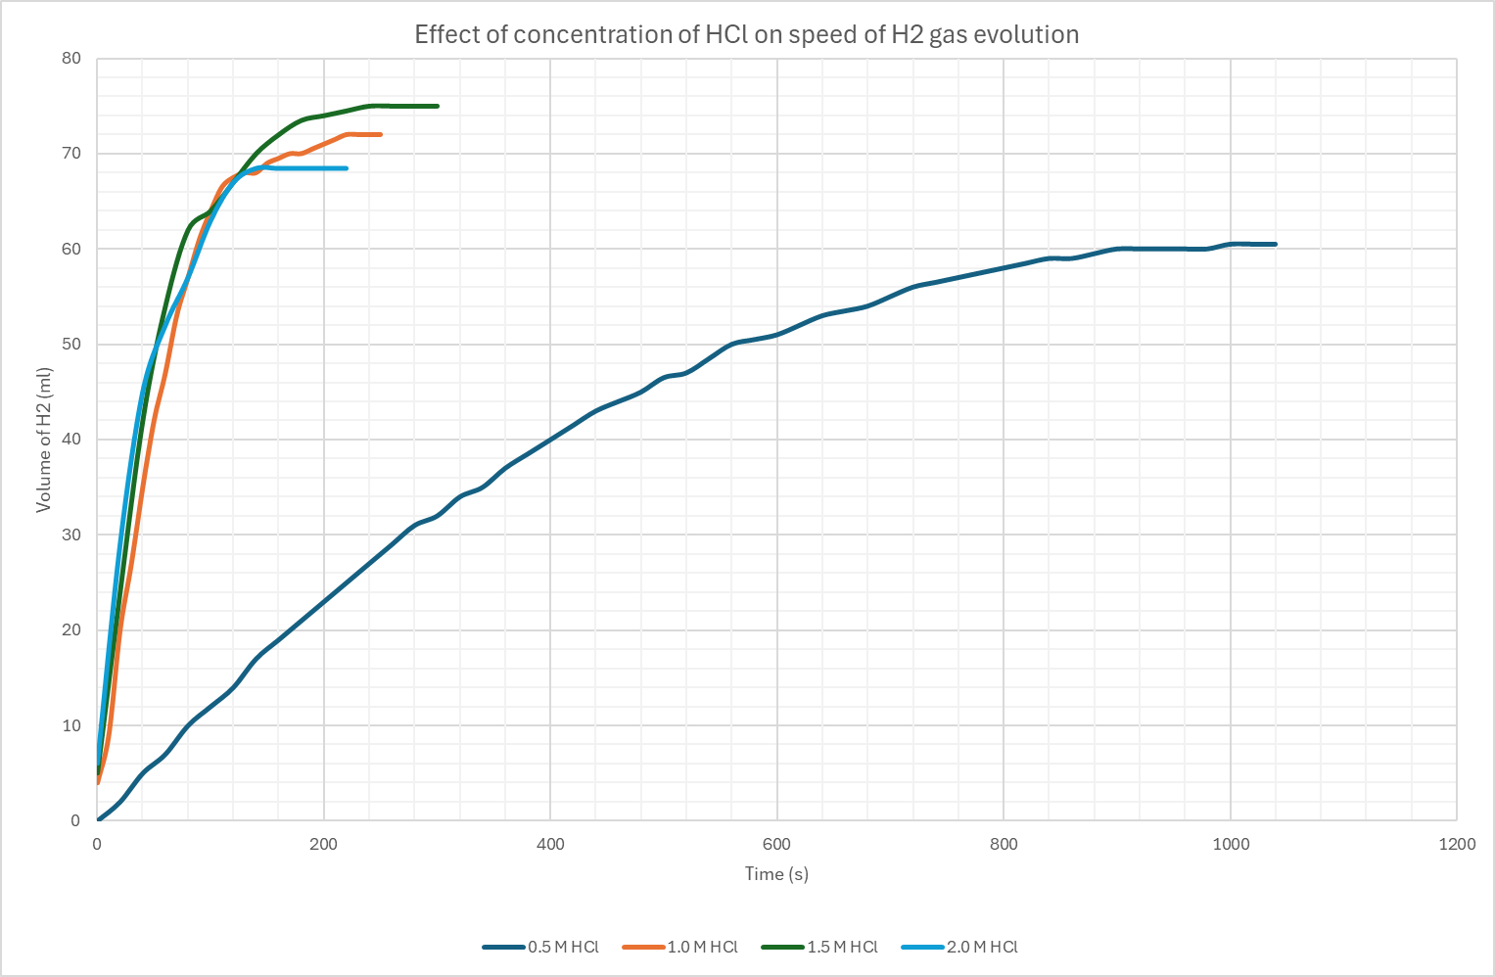
Figure 1 Effect of concentration of HCl on the speed of H2 gas evolution

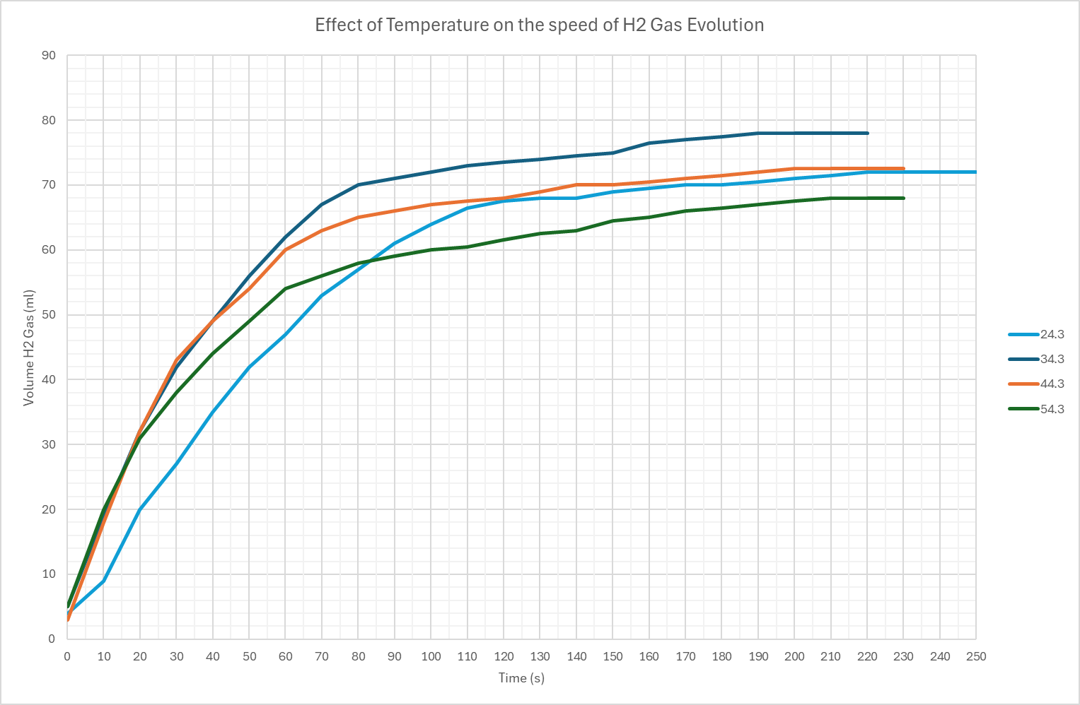
Figure 2 Effect of temperature of HCl on the speed of H2 gas evolution

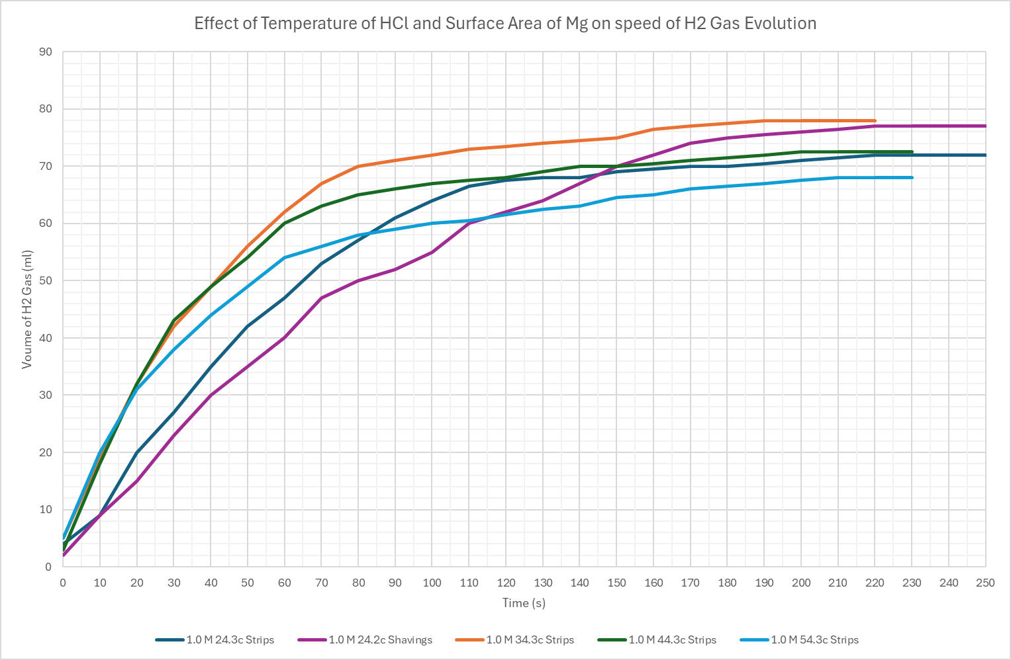
Figure 3 Effect of Temperature of HCl and surface area of Mg on the speed of H2 gas evolution

Average rate of reaction
$$Average rate= \frac{∆V}{∆T}$$
Concentration of HCL
$$Average rate\left(0.5M\right)= \frac{12.0-0}{100s-0s}=0.120{cm}^{3}/s$$
$$Average rate\left(1.0M\right)= \frac{64.0-4.00}{100s-0s}=0.600{cm}^{3}/s$$
$$Average rate\left(1.5M\right)= \frac{74.0-5.00}{100s-0s}=0.690{cm}^{3}/s$$
$$Average rate\left(2.0M\right)= \frac{68.5-6.00}{100s-0s}=0.625{cm}^{3}/s$$
Temperature of HCl
$$Average rate\left(24.3\right)= \frac{64.0-4.00}{100s-0s}=0.60{0cm}^{3}/s$$
$$Average rate\left(34.3\right)= \frac{72.0-5.00}{100s-0s}=0.670{cm}^{3}/s$$
$$Average rate\left(44.3\right)= \frac{67.0-3.00}{100s-0s}=0.640{cm}^{3}/s$$
$$Average rate\left(54.3\right)= \frac{60.0-5.00}{100s-0s}=0.550{cm}^{3}/s$$
Shavings of Mg
$$Average rate\left(Mg shavings\right)= \frac{55.0-2.00}{100s-0s}=0.530{cm}^{3}/s$$

Table 9 Average rate of reactions
Average rate of reactions
HCl concentration, Temp/Mg strip or Shavings | Average Rate
0.5M HCl | 0.120cm³/s
1.0M Mg Shavings | 0.530 cm³/s
54.3 °C HCl | 0.550 cm³/s
1.0M 24.3°C HCl | 0.600 cm³/s
2.0M HCl | 0.625 cm³/s
44.3°C HCl | 0.640 cm³/s
34.3°C HCl | 0.670 cm³/s
1.5M HCl | 0.690 cm³/s

Instantaneous rate t = 0
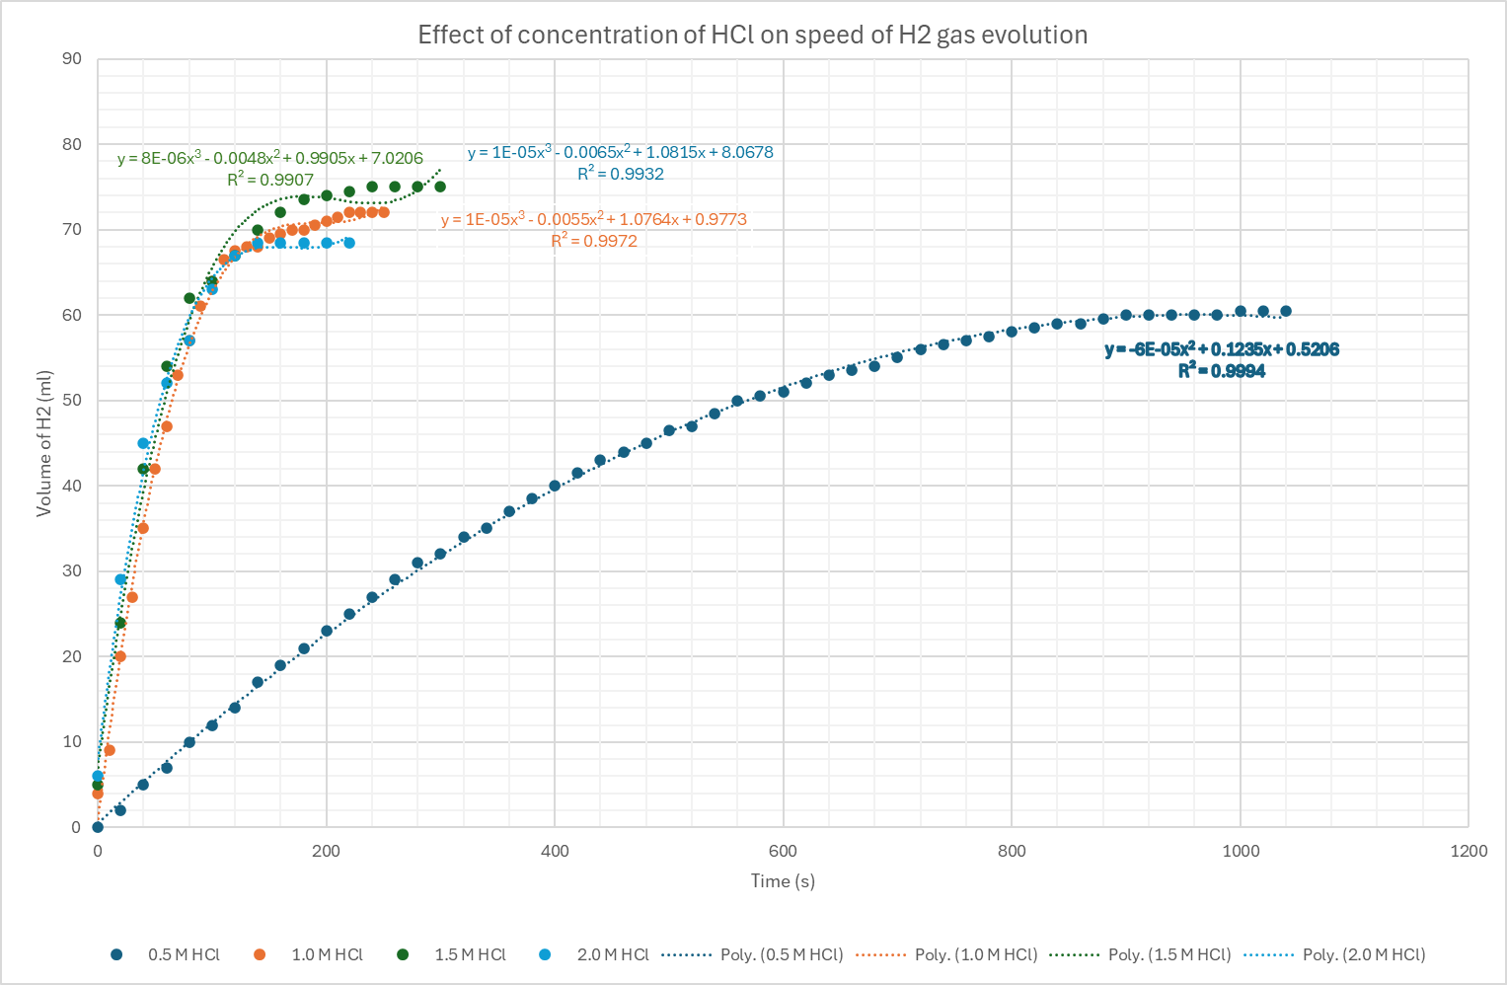
Figure 4 Effect of concentration of HCl on the speed of H2 gas evolution with trendlines
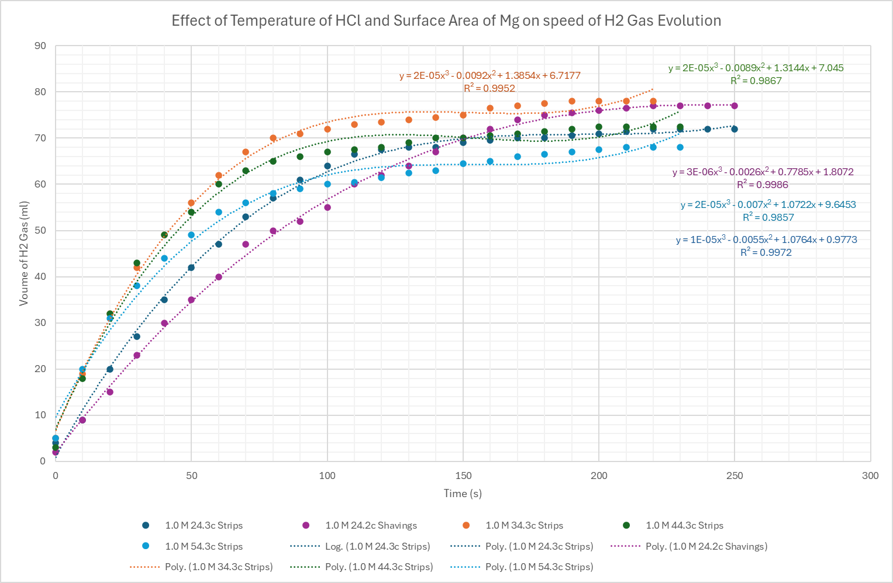
Figure 5 Effect of temperature of HCl and surface area of Mg on the speed of H2 gas evolution with trendlines

$$V=at^{2}+bt+c$$
$$\frac{dv}{dt}=2at+b$$
$${\frac{dv}{dt}}_{t=0}=2a\left(0\right)+b=b$$

Therefore, instantaneous rate at t = 0 = b cm³/s
$$\frac{dv}{dt}=2at+b$$
e.g.
0.5M HCl = $V=-6×{10}^{-5}t^{2}+0.1235x=0.5206$

$${\frac{dv}{dt}}_{t=0}=2(-6×{10}^{-5})\left(0\right)+0.1235=b$$

$$b= 0.1235$$

$$Instantaneous rate at t=0= 0.1235 {cm}^{3}/s$$

Table 10 Instantaneous rate of reactions
Instantaneous rate of reactions
HCl concentration, Temp/Mg strip or Shavings | Instantaneous rate
0.5M HCl | 0.1235cm³/s
1.0M 24.3°C HCl | 1.0764 cm³/s
1.5M HCl | 0.9905 cm³/s
2.0M HCl | 1.0815 cm³/s
1.0M Mg Shavings | 0.7785 cm³/s
34.3°C HCl | 1.3854 cm³/s
44.3°C HCl | 1.3144 cm³/s
54.3°C HCl | 1.0722 cm³/s

Discussion

The aim of this experiment was to investigate how three different factors – temperature, concentration and surface area effect the rate of hydrogen gas evolution. In accordance with collision theory the results largely support that increasing these factors increases the reaction rate, despite some outliers.

HCl concentration
As predicted, increasing the concentration of the HCl did lead to an increase in average and instantaneous reaction rates. The 0.5M concentrations have an average rate of 0.120 cm³/s, and this rate increased to 0.690 cm³/s and 0.625 cm³/s for 1.5M and 2.0M, respectively. The instantaneous rate also rose from 0.1235 cm³/s for 0.5m to 1.0815 for 2.0M.

This shows a clear increase due to concentration. Despite the obvious increase, a small anomaly did appear where the average rate for 1.5M was slightly higher than 2.0M. This could be due to human error when measuring or inconsistency in the experiment set-up across the concentrations. Despite this, you can see from Figure 1 that the higher concentration leads to steeper curves at the start of the reaction and therefore is indicative of a faster initial rate.

HCl Temperature
The results of this experiment also concur with the hypothesis that higher temperatures increase the rate of reaction. The average rate rose from 0.600 cm³/s at 24.3°C to 0.670 cm³/s at 34.3°C and 0.640 cm³/s at 44.3°C. The instantaneous rate, however, peaked at 1.3854 cm³/s at 32.4°C, higher than the 44.3°C and 54.3°C rates. This could indicate fluctuation due to human error, timing issues or heat loss during the experiment.

Surface area of Mg
The hypothesis of increasing the surface area of the Mg was that it should significantly increase the reaction rate as it exposes more molecules to collide with, and therefore, a greater number of successful collisions per unit of time. This, however, was not evident in this experiment. The average rate of reaction for the shavings was 0.530 cm³/s, which is lower than the same test using the 4cm Mg strip at 0.600 cm³/s. This was also seen in the instantaneous rate, which was 0.7785 cm³/s for the shavings and 1.0764 cm³/s for the strip. This could be due to a delay in sealing the tube at the start of the experiment, which would lead to delayed gas collection, or it could be due to the shaving settling poorly in the test tube, causing clumping and therefore reducing the larger area of the shavings.

Sources of Error
As mentioned previously, the experiment overall aligned with the hypothesis; however, variations in the data meant that there could have been a few sources of error or limitations in the experiment.
- Timing inconsistencies could have been a major factor, with delays between inserting the Mg and sealing the system, therefore delaying the capture of H₂ gas. Other timing issues could have been not starting the stopwatch at t = 0, and therefore not recording the units accurately as well.
- The system might not have been completely sealed by a leak in the syringe system, causing volume measurements to be underestimated.
- There could have been temperature fluctuations, causing the HCl to have cooled from a delay in putting it in the test tube, meaning the results were not a true representation of the recorded temperature.
- General human error in measurement, reading or missing a recording could have also resulted in slightly skewed results.

Conclusions
This experiment successfully showed that varying HCl concentration, temperature or surface area will affect the rate of hydrogen gas in the reaction. As hypothesised increasing the concentration and temperature of the HCl will lead to a higher average and instantaneous rate of reaction and this is consistent with collision theory which states that increasing the frequency and energy of collisions will speed up a reaction.

Increasing the Mg surface area however did not align with the hypothesis. As the larger surface area should have provided a faster reaction than the Mg strip. This discrepancy is likely due to experimental errors such as delays in sealing the tube or gas leakage.

Despite this, the overall experiment displayed the predicted trends and showed key kinetic principles. Future work in this area could be exploring the different reaction rates with other acids to compare results, introduce a catalyst to the reaction to see how it impacts the rate of hydrogen gas evolution or just conducting the experiment again using more precise equipment such as a digital gas syringe to eliminate human errors.

References

[1] ‘Collision theory | Definition & Explanation | Britannica’. Accessed: Apr. 19, 2025. [Online]. Available: https://www.britannica.com/science/collision-theory-chemistry

[2] ‘6.2.3.1: Arrhenius Equation’, Chemistry LibreTexts. Accessed: Apr. 19, 2025. [Online]. Available: https://chem.libretexts.org/Bookshelves/Physical_and_Theoretical_Chemistry_Textbook_Maps/Supplemental_Modules_(Physical_and_Theoretical_Chemistry)/Kinetics/06%3A_Modeling_Reaction_Kinetics/6.02%3A_Temperature_Dependence_of_Reaction_Rates/6.2.03%3A_The_Arrhenius_Law/6.2.3.01%3A_Arrhenius_Equation

Appendix

Materials and Methods

Materials and Equipment
- 1 x Test tube with arm
- 1 x Gas syringe
- 1 x Delivery tube and rubber bung for test tube
- 2 x Large beakers
- 1 x pipette and pipette filler
- 2 x Clamp stands
- 1 x Test tube holder
- 1 x Stopwatch
- 1 x Stand tripod
- 1 x Bunsen burner
- 1 x Fireproof mat
- 1 x Thermometer
- DI water
- HCl 1.0M and 2.0M
- 7 x 4 cm Magnesium strips
- 1 x Magnesium shavings

Methods

Effect of HCl concentration on the speed of H₂ gas evolution

- Use a pipette to prepare four 20.0 ml solutions of HCl and DI water in test tubes with the concentrations of 2.0M, 1.5M, 1.0M and 0.5M.
- Pour the 0.5M concentration into the test tube with the arm.
- Place a 4 cm magnesium strip in the test tube with the HCl and replace bung immediately and start stopwatch.
- Record the volume of H₂ gas given off at intervals of 20 seconds for 0.5M and 10 seconds for the other concentrations.
- Time and record until no gas is being given off and the volume stabilises.
- Discard the reaction mixture in the waste beaker.
- Repeat for the three other concentrations and record the starting temperature for the 1.0M solution.

Effect of temperature on the speed of H₂ gas evolution

- Pour water into a beaker and heat it over a Bunsen burner until it reaches 10°C higher than the recorded temperature for the 1.0M solution in the previous experiment.
- Using a pipette, place three 20 ml of 1.0M HCl solution in three test tubes.
- Place the first test tube in the water bath and heat until the HCl solution is the same temperature as the water.
- Once hot enough, transfer the test tube solution into the tube with the arm.
- Place a 4cm strip of magnesium in the tube and replace the bung and start the stopwatch.
- Record the results every 10 seconds until no gas is given off.
- Discard the solution in the waste beaker.
- Repeat this with the other two test tubes for 2 more temperatures, increasing each time. (e.g 20°C starting temperature 1 - 30°C, 2 - 40°C and 3 - 50°C.

Effect of the surface area of magnesium on the speed of H₂ gas evolution.
- Use a pipette to transfer 20 ml of the 1.0M HCl at room temperature into the test tube.
- Add the magnesium shavings into the test tube and replace the bung and start the stopwatch.
- Record the volume of gas every 10 seconds until no more gas is given off.
- Discard the mixture in the waste beaker.

Copy of Data Sheets


