Resubmission word count: Total 4265

Introduction

This report evaluates the concept of evidence-based practice, explores analysis tools and methods, discusses critical thinking principles, decision-making processes, ethical perspectives, and ways to measure financial and non-financial performance within people practices.

Evaluation of Evidence-Based Practice (AC 1.1)

To support decisions that are sound and of value for the organisation, the People Team use effective methodical Evidence Based Practice (EBP) tools and systems which are used to assist understanding, authenticate and to uphold crucial decisions made by management teams. Evidence-based practice uses critical a thinking approach to assist problem solving in the workplace and to make well informed decisions by using tried and tested protocol drawn from a variety of sources to achieve a desired outcome (CIPD 2023a). In opposition, the reliance solely on personal experience potentially allows for unconscious or cognitive biases, lack of experience and personal preference to take precedence and influence critical business judgements. Implementing EBP further reduces the inclination to rely on methods used that have served managers well in the past, ‘heuristics’, or to integrate ‘fads’ into general practice which don’t stand the test of time (CIPD 2023). Other barriers to decision-making without the use of EBP include attitudes of resistance, fear of change, tendencies to favour over pre-existing views, time limitations, information overload, inflexible thinking, and even emotion getting in the way of objective analysis.
As a basis for Human Resource Management (HRM) contribution to EPB, the people team aim to use four key resource areas to formulate credible pathways to gain holistic insight for decision making and therefore contribute to overall business performance: Scientific exploration in existing literature, use of both current and historical organisational data, gaining professional knowledge from those with expertise in the relevant area and seeking the views of key stakeholders (Taylor & Woodhams 2022).
The more evidence gained through a variety of reliable sources, the more informed and solid the argument. One must remain vigilant through research to conclusion to use reflective practice to both identify and account for one’s own biases. Without doing so it’s possible to present divisive arguments, or to conclude a more favourable outcome to suit one’s own ideals. Best practice recommends group working to navigate biases in decision-making. Group working also presents issues; Establishing and agreeing specific control measures in advance, setting boundaries and parameters is crucial so as not to conform or make extreme decisions (group polarisation) (Kaplan & Miller 1987).
Whilst it is good to call upon well-tried formulae (evidence-based), it should be used in combination with both principle-led and outcomes-driven practice. Hargreaves and Fullan (2012) describe limitations to EBP in the following points:
- evidence-based decisions can be tainted with self-interest
- cast-iron evidence can get rusty later on
- evidence-based principles are used very selectively
- evidence isn’t always self-evident
- evidence on what to change isn’t the same as how to change
- positive initiatives based on evidence in one area can inflict collateral damage
- people can cook the data
- evidence-based teaching is only somewhat like evidence-based medicine
- evidence comes from experience as well as research (Hargreaves and Fullan 2012).
Analysis Tools and Methods (AC 1.2)

Varying decision-making tools have been developed for effective critical thinking, ease of use and consistency. When using the same tools and methods one can compare data holistically over time. However, some tools are more suitable than others for specific decision-making criteria. Popular tools include ‘SWOT analysis’ (Strengths, Weaknesses, Opportunities, Threats, and ‘Stakeholder analysis’ (e.g. surveys) which is often best conducted in the initial stages of the decision-making process to find evidence to best understand the needs of the project or in this matters that may affect performance regarding organisational issues or business opportunities.

McKinsey’s 7-S Framework is suitable for analysing, designing, and planning both smaller and larger objectives and focusses on how collaboration within an organisation can contribute to growth and efficiency (MSG 2023). From a strategic viewpoint, it can be used to connect departments, create affiliate links within industry or even for procurement purposes when growing a business. The 7-S framework is best for resolving internal structures, conflicts, skills gaps and informing change management; It takes a holistic approach by combining all 7 elements (listed below). As opposed to PEST(LE) analysis, which mostly focusses on external factors, it doesn’t account for external influence that may affect business and can seem quite complex, leading to barriers in successful execution for larger organisations. With an organisation focussed on business culture and a principles-led approach, it does address ‘shared values’ and can contribute positively to company behaviours and collective decision-making. The framework addresses both ‘hard elements’ (Strategy, Structure, and System) and ‘soft elements’ (Skills, Staff, Style and Shared Values) (Cascade 2023). To use McKinsey 7S Model most effectively, benchmarking should be used well, and a lot of prep-work and research is required.

Questionaries and surveys are most favourable in collecting data from both internal and external sources linked to an organisation. Both qualitative and quantitative data can be gain from this analysis method and inform EBP. The public are also most familiar with this method. The application of ‘people analytics’ is an efficient and popular analysis method for decision-making used to inform management of barriers and prospects for future improvements by analysing data provided by the workforce (CIPD 2022). Insight and expertise from HRM professionals are utilised to create well planned and thoughtfully phrased questionnaires, surveys, interviews, supervision, group feedback, individual questioning, recruitment data and even social media sentiment (HR Daily Advisor 2020). The use of people analytics requires careful management of data to provide an accurate and reflective sample of the workforce (CIPD 2022). Areas to consider might include the recruitment and onboarding process, workforce performance, retention statistics, engagement, and learning and development. Data can provide useful insight into all areas of the business and works well in larger teams to gain a consensus insight. Smaller teams could provide warped data based on too personal an experience. Data analysed can inform the best motivations to drive change and performance most effectively. This method is used regularly to inform continuous improvement and reward programmes. People analytics assist organisations to make evidence-based decisions and align them with strategy for both sustainable growth and employee retention (CIPD 2022).

Critical Thinking Principles (AC 1.3)
Critical thinking is about listening to, reflecting on, and critiquing the thoughts and ideas of others through rational debate. It’s about analytical communication, decision making, influencing, negotiation, identifying behaviours and conflict management. Its aids us in making informed decisions, homing in on our problem solving ability by weighing up information and forming a justified argument (MindTools 2023).
“Wade (1995) identifies eight characteristics of critical thinking. Critical thinking involves asking questions, defining a problem, examining evidence, analysing assumptions and biases, avoiding emotional reasoning, avoiding oversimplification, considering other interpretations, and tolerating ambiguity” (The University of Tennessee Chattanooga 2023).
In the critical thinking podcast on the CIPD website, Tim Coburn describes how he has used the learning and development function in the past to raise awareness of skills used for critical thinking to great popularity amongst HR professionals and contribute to performance for the business. He explains how critical thinking contributes to the evaluation of conversation, thoughts, and objectives of others, analysing them, picking out key points of information and identifying business ‘manipulation’ methods and formulating compelling arguments; Readiness in identification of these methods contribute greatly toward strategic planning, business conversations, stakeholder interactions, proposals and constructive discussion (How to think well and reflect objectively on the ideas, opinions and arguments of others. 2019).
As a learning and development professional I can see how my function can assist others in general team performance – liaising with stakeholders, commissioning teams, selling products and on the other side of the coin, selling our services as a company; perhaps even contributing to team members ability to sell themselves as part of their CPD.
By using critical thinking, we filter out misinformation. We aren’t we always good at it as our own bias, social influences from the media and environment, time and economical constraints almost always factor in our thinking which often inhibit our ability to think critically alone (MindTools 2023).
To do this successfully, one needs to reflectively analyse each step in the process and as explained previously in the report, is often best practiced when analysed collaboratively. One must need to be curious, logical and self-aware.

Critical thinking processes take time to rehearse, and human resource practitioners benefit from developing their existing values, as described in the CIPD professions map (‘principles-led’, ‘evidence-based’ and ‘outcomes driven’), by using the people teams’ Learning and Development function to contribute to Continual Professional Development (CPD) to enhance their HRM practice (CIPD 2023b).

Decision-Making Processes (AC 1.4)

Organisations can adapt and apply the following decision-making processes in-order-to achieve effective outcomes.

Edward de Bono’s Six Thinking Hats process guides us through the decision -making process either as a group or as an individual. The theory is to wear one hat at a time which forces the wearer to think with a certain viewpoint or set of values.
- The Blue Hat: Organisation and planning (the control hat).
- The Green Hat: Creative thinking (new ideas and exploring innovative solutions).
- Red Hat: Feelings and Instinct (gut feelings and emotions).
- Yellow Hat: Benefits and Values (optimism).
- The Black Hat: Negatives (problems and risks).
- The White Hat: Data Study and analysis data you already possess (objective and neutral).
This method navigates the wearer away from confusion and to through a clearer thinking pathway. Each participant in the group can wear each hat in turn – this also assists in moving us away from any predisposition. Wearers should thus feel akin to each other once each hat has been worn and collectively conclude similarly (parallel thinking) (TSW Training 2021). It encourages balance and fair decision making.

Deming’s PDCA Cycle “the Deming Wheel” is used widely for decision-making within quality improvement. Its key principles are Plan, Do, Check, Act.
- Plan – defining the issue and an outcome to work towards. Gather and analyse information. Suggest potential solutions to the problem. Create controlled perimeters and a timeline.
- Do – implementation of the plan. Thoroughly document the process and write reflective account of any issues encountered.
- Check – evaluate the outcomes of the implemented plan against the original plan. Make a comparison of the expected outcomes versus the actual outcomes.
- Act – those actions that were successfully identified in the ‘check’ stage will remain. Those elements that were unsuccessful with cycle back to the plan phase to repeat the cycle (MindTools 2023).
This method is relatively simple and most frequently used when designing systems and protocol. It can be upscaled or downscaled relatively easily and be implemented straight away. The PDCA cycle is responsive to regularly changing practice and formulates observable experienced data quickly for analysis. This theory heavily focusses on reflective practice and encourages collaboration within teams.

The ‘OODA Loop’ decision-making tool was conceived by Colonel John Boyd, a military strategist and retired U.S. Air Force Colonel and used for prompt assessment to changeable and uncertain situations in warfare. Its concept relies on:
- Observation (assessing, collecting, and understanding data).
- Orientation (comprehension of the situation, identifying patterns and considering from a variety of perspectives).
- Decision (creating a plan of action).
- Action (taking action and adapting to any deviations in condition).

Whilst the concept of OODA Loop originated within the context of military combat, it has been integrated into training by the U.S. Marine Corps and has been applied to business and strategy by various industries to adapt to changing markets and strategic planning (Looping the Loop 2021).

The ‘OODA Loop’ and Deming’s PDCA Cycle are similar in nature as they both have a cyclical pattern for their use; However, they are used in in different contexts and fundamentally designed for a different purpose, the OODA Loop for dynamic, potentially risky situations that could change rapidly and the PDCA Cycle focusses on organisational improvement and problem-solving through people management processes on a regular basis.

Ethical Perspectives (AC 1.5)

There are many ethical perspectives to consider when attempting to inform and influence moral decision-making. Focussing on the following three perspectives offer differing approaches.

Accruing a better understanding of varying perspectives assist HR professionals in negotiating ethical challenges that might arise and make a balanced judgement considering one’s duty in the workplace, what will be best to take action on for the greater good and moral behaviours (virtue) (CIPD 2023). Ethics underpin the fundamental behaviours and cultural practice within an organisation and greatly contribute to recruitment and retention. People practice is often governed by codes of conduct, policy and procedure (with their foundations governed by law), organisational values and behaviours. It is, however, the way we approach decision-making around these guidelines, that contributes most greatly to organisational success, which is often conflicting when working with people. It is important to recognise that ethical perspectives are subjective; Based on our own experiences, past and current. Ethical and moral outcome in decision-making will therefore likely be subject to change depending on those making decisions, current affairs, and company culture (CIPD 2023).

Utilitarianism focusses on the maximum happiness and well-being for the greater good. It does not focus on a specific individual but attempts to create balance by considering in individual equally and taking action to reach the greatest outcome for all (National Library of Medicine (2021).
Pros:
- Maximising the collective good.
- Weighs up consequences of actions.
- Can be used in a variety of contexts or situations.
- Flexible approach to specific circumstance.
- Can be measurable against other potential actions.
Cons:
- A disregard for the minority for the majority.
- Happiness and well-being is subjective.
- Principles don’t integrally account justice and moral rights.
- Could potentially lead to exploitation.
- Doesn’t account for long-tern vs. short-term happiness.

Advantages include: maximising collective good, considering consequences, versatility, flexibility, and measurability. Disadvantages include: disregarding minority interests, relying on subjective happiness, lacking justice and moral rights integration, potential for exploitation, and neglecting the distinction between long-term and short-term happiness.

Deontology is the theory that each action should be judged on its own moral merit. Each individual should be treated with a moral obligation, regardless of the consequential outcome for society (National Library of Medicine (2021).
Pros:
- Moral behaviour and principals at its foundation.
- A focus on individual rights.
- Consistent and principled approach.
- Maintains moral integrity earn acting with a sense of duty.
Cons:
- Inflexible when duties are conflicting.
- Without outcomes as a focus, one can ignore the consequences of their actions.
- No guidelines that are fixed which doesn’t allow for diversity and cultural influence.
- Moral codes can be difficult to agree on and rules or duties may differ from person to person.

Advantages: Moral foundation, individual rights focus, consistent approach, maintains moral integrity through duty.

Disadvantages: Inflexible in conflicting duties, overlooks consequences without outcome focus, lacks fixed guidelines for diversity, differing moral codes and duties.

Virtue ethics focuses on the individual deciding or taking action rather than the action itself. If you are a morally good person making decisions, then theoretically the decision should be good (Seven Pillars Institute 2023).
Pros:
- Making decisions with inherently good character traits, e.g. honest, kind, generous, modest, with integrity, etc.
- Holistic approach – considering the individual as well as the action.
- Flexible.
- A focus on personal development and improvement y considering one’s virtues.
- Allows for diversification and cultural influence.
Cons:
- Rules are not set of specific and can lose clarity.
- Assumes that the decision maker is of virtuous character.
- Cultural influence may vary.
- One may value one virtue over another.
- Could be difficult to apply to practical solutions.

Advantages: Decision-making with good character traits, holistic approach, flexibility, and focus on personal development, allowing for diversification.

Disadvantages: Lack of clear rules, assumes virtuous decision-makers, varying cultural influence, potential conflicting values, and difficulty in practical application.

Financial and Non-Financial Performance Measurement (AC 3.1)

Financial performance can be measured by calculating profitability and efficiency. It is relatively easy to calculate and can be used in a variety of situations; This is known as Return on Investment (ROI). ROI calculations can be used to decide on whether to buy or invest in a product or company and to make sound business judgements. The advantage to using ROI is that it can be scaled to suit the need of the situation as it is calculated as a percentage so can be applied more easily to an asset that might grow depending on additional factors (CFI 2023a). You must factor in the cost and the return of an investment which is readily available internally and can be a faster method to use than others. Disadvantages include that time factors into the calculation when comparing one ROI over another and it doesn’t account for sustainability based on external factors out of your control. The important thing to consider when calculating is how you measure cost and how you measure profits.
Formula for working out ROI is: Gain minus cost, over cost of investment, multiplied by 100 (CFI 2023a).
Non-financial performance can be measured by using stakeholder engagement surveys which can assess satisfaction and commitment to the organisation. Cost effective, simple to use and ask people to complete – people are familiar with this kind of interaction. Surveys can measure the effect of performance over time. Surveys can assist in predicting future behaviours as the format often allows for additional explanation, also allowing those surveyed a voice and feeling of being heard. Surveys can be used as an influencing tool.
Disadvantages are that not all surveys are completed even when targeting control groups and they can be timely to receive a response. Judging the right time to survey a member of staff is difficult and biases can compromise the data. Anonymity can provide better information in some cases however other statics must fall by the wayside. This is often due to staff member fear in providing honest feedback.

Stakeholder engagement surveys offer an economical, simple way to measure non-financial performance, providing insights into satisfaction, commitment, and predicting future behaviours. However, challenges include incomplete survey responses, timing difficulties, biases compromising data, and the trade-off between anonymity and certain statistical details due to staff fear of providing honest feedback.

Adding Value in People Practices (AC 3.2)

As specialists in in maintaining the organisations relationship with their workforce, people practices (in human resources management) play a vital role in adding value to recruitment, retention, and efficiency of the organisation by boosting performance, satisfaction, and organisational culture. Drawing on research from sociology, psychology, and behavioural theories in combination with expertise in employment law, ethics and EBP to inform current practice (Forbes 2023).

Methods in measuring impact include conducting pre-and-post training assessments to gauge skill improvement and use employee feedback to assess the perceived impact of HR initiatives.

Human Resources Management (HRM) adds value by contributing positively the successful performance and overall objectives of the organisation and ultimate success.

Recruitment and Retention:
Bringing strategic approach to recruitment and onboarding processes ensures that the organisation attracts and retains employees with the right skills, ethos and behaviours which for the values of the business.
Use of systems to measure recruitment costing, and employee turnover can be used to assess the strategic efficiency. Employee satisfaction surveys and engagement markers inform best practice for onboarding new employees.

Learning and Development:
Informing investment strategy for the continuous development of staff enhances the skills, knowledge, and capability of the workforce. Investment in these areas has proven to increases employee contribution and better understand the need for flexibility within a business environment.
Learning and Development Key performance indicators (KPIs) include training completion percentages, can demonstrate understanding and overall competency in the workplace. Impact professionals can also help to link employee performance to specific organizational outcomes.
Investing in staff development informs investment strategy, enhancing workforce capability, ultimately increasing employee contribution, and adapting to business needs. Learning and Development KPIs can demonstrate understanding and overall competency in the workplace., while impact professionals can link employee performance to specific organisational outcomes.

Impact measurement methods:

ROI evaluates the financial return produced by an investment in relation to its cost to the business. ROI can be used in HR to assess the financial implication of specific people practices. An example, to assess the cost of training programmes and relate to the financial impact for the business. One would consider employees time spent learning, facilitation cost, reduction in error, contribution to effective practice post-course and assessing against pre-course statistics.

HR Reporting focusses on daily operational performance and assists with short-term decision-making. Data is presented in a regular format to allow for detailed analysis. HR Dashboards are a more advanced way to assess metrics; often interactive and use charts and other visuals to easily present data. Dashboards can be manipulated to present data in a clear fashion by filtering information.
Talent Metrics identify gaps work force competency and evaluate recruitment and attraction strategies. This can assist with recruitment, retention, and reward strategies (Deloitte 2016).
The Balanced Scorecard management tool that strategically measures performance of the business from various perspectives: financial, stakeholder, procedure, growth and development. Balanced Scorecard is used to relate people practices with desired organisational outcomes (CFI 2023).

HR related metrics can be designed to suit varying situations, customisable to business needs to directly assess, and align the overall impact of HR proposals for both short-term and long-term accomplishment.

Section Two – Quantitative and Qualitative Analysis Review
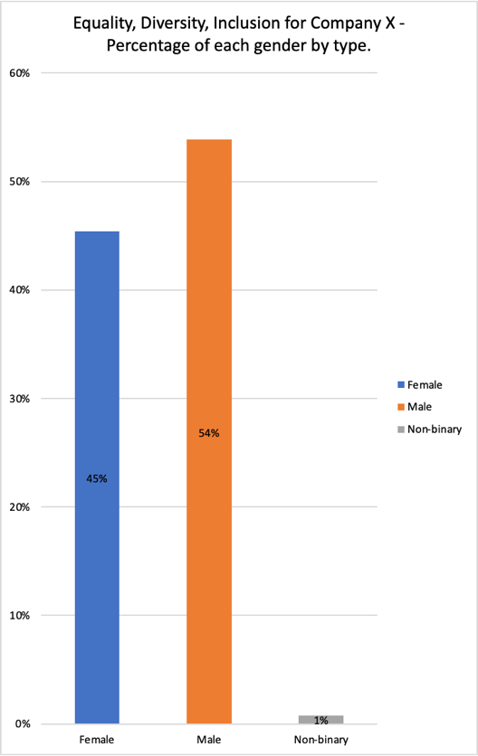
Analytical Data Interpretation (AC 2.1)

a) Percentage of each gender by type:
The workforce is predominantly male, constituting 54% of the total, females make up 45%, and non-binary 1%.

b) Ethnicity as a percentage per team:

Key observations (Appendix1):
Ranging from 57% to 100%, White British ethnicity represents the highest percentage in all teams across the organisation (91% of the business).

Some ethnic groups, such as Black - Other, Mixed - Other, White and Black Caribbean, and White Irish, appear to have limited or no representation in most departments.
Ethnic groups represent only 9% of the workforce.

The lowest representation from ethnic groups are within Facilities, Green Spaces, Lettings, Regeneration, Property and Marketing departments.

Further analysis would provide a more comprehensive understanding of diversity and inclusion within the organisation; To consider other factors such as gender, age, and job roles would allow for a more holistic perspective on diversity.

Disability Status:
Disabled individuals make up a small portion of the workforce (8%). The highest representation in IT, Customer Services and Finance Teams.

Salary difference across genders (Gender Pay Gap):
Comparing Men and Women - The average Full Time Equivalent (FTE) salary for men is £31,812.18, and for women, it’s £31,900.30. The calculated gender pay gap is -£88.12 - on average, women earn slightly more than men.

Men to Non-binary - The average FTE salary for men is £31,812.18, and for non-binary individuals, it’s £19,500.00. The calculated pay gap is £12,312.18 - on average, men earn more than non-binary.

Women to Non-binary - The average FTE salary for women is £31,900.30, and for non-binary individuals, it’s £19,500.00. The calculated pay gap is £12,400.30 - on average, women earn more than non-binary.

On average, the FTE salary per employee is calculated as £31,757.46. The average FTE for non-binary is significantly lower than average.

Observations:
On average, gender pay gap analysis demonstrates that, women earn slightly more than men and there are significant pay gaps when comparing all employees to non-binary employees. However, when considering roles and typical pay scale to job role, non-binary employees are employed in roles that are of typically lower salary. 57 males (representing 22% of the workforce) are trades operatives; 41 of which are on lower than average salaries.
The distribution of disabled individuals across different departments may indicate efforts towards inclusion and diversity, with higher representation in departments like IT, Customer Services, People, Community Engagement & Partnerships.
Further analysis and conducting analysis over a length of time, would generate a better understanding of diversity and inclusion within the workforce. Considering the distribution of roles and seniority across genders and disability statuses, would provide a more comprehensive understanding of workplace dynamics and potential areas for improvement for diversity and inclusion.

Feedback Scores from Employee Survey (Table 2) (AC 2.2)

For hybrid working:
Enjoyment of Working from Home (WFH) - Most employees (56%) fully agree or agree that they enjoy WFH sometimes. There is a significant number (37%) who disagree or strongly disagree.

Support for Work-Life Balance and Well-being – 83% fully agree or agree that hybrid working practices support their work-life balance and well-being. The overall response is positive.

Challenges of Remote Work - There is a mix of responses regarding finding remote work challenging, with significant numbers (76%) expressing not sure, disagreement or strong disagreement.

Impact on Cross-functional Communication and Collaboration - A substantial number (60%) disagree or strongly disagree that working from home affects cross-functional communication and collaboration with their team.

Connection to Company Culture – The majority (59%) agree that since hybrid working has been in place, they feel more connected to the company culture.

Reduced Conflict with Remote Work - A substantial number (59%) strongly agree or agree that working from home removes conflict.

Against hybrid working:
Engagement with Colleagues - A significant portion (83%) disagrees or strongly disagrees that they miss engaging with colleagues in the workplace. This could suggest that remote work may not be negatively impacting social interactions for these employees.

Difficulty Separating Work from Personal Life - A considerable number (63%) fully agree or agree that they find it difficult to separate work from personal life when WFH. Balancing work and personal life seems to be a challenge for over half of the employees sampled.

Feeling Supported at Work - A large number (80%) disagree or strongly disagree that they feel fully supported when working at work. This may indicate issues with the support system in the workplace.

Meeting Targets while WFH - A significant number (66%) disagree or strongly disagree that working from home allows them to meet their targets.

Neutral

Hybrid Working and Productivity - Responses are spread across the scale and are equal in value (strongly agree and agree at 49%, disagree and strongly disagree at 49%) that hybrid working practices make them more productive.

Access Resources – Even distribution of opinion with a 49% equal split between agreement and disagreement that employees can easily access resources at home.

Reduced Stress Away from the Workplace - The majority (83%) strongly disagree that they feel less stressed when away from the workplace.

Recognition of Work while WFH - The responses are spread, but a marginal increase of 7% disagree that they get the same amount of recognition for their work.

Overall Implications:
  - Employees generally find hybrid working supportive of their work-life balance and well-being.
  - There’s a mix of sentiments regarding engagement with colleagues, support at work, and the challenges of remote work.
  - Productivity and the ability to meet targets seem less favourable for many employees.
  - There is a positive perception of the impact of hybrid working on company culture, working relationships and collaboration.
  - Remote work seems to increase stress for a significant portion of employees.

Justified Recommendations (AC 2.3)

It's important for the organisation to address concerns raised by employees, particularly regarding support at work and challenges associated with remote work, to ensure a successful implementation of hybrid working practices. A more flexible approach to working environment could lead to an increase in productivity, retention, and organisational culture. A split week could be an option to find a balance between positive and negative impact. Regular communication and adjustments to policies will be necessary based on this feedback. Learning and development processes would require amendment and employee management and engagement provision would require a purposeful and well organised framework.

Equality Diversity and Inclusion

Maximised hybrid working arrangements could also support further diversity and inclusion within the workforce and contribute greatly to recommendations and observations stated above. Accessibility to the workplace and employee relations would be greatly improve and appeal to a wider audience for recruitment purposes.

Investment into well designed technological automation will support inclusion and diversity in the workplace as a low cost, long-term KPI measurement tool; minimising employee bias, tracking progress in an accessible way, allowing benchmarking both internally and externally and allowing HR teams more time to act on identified needs (CIPD 2024).

CIPD (2024) suggest the use of ‘person-first’ language with awareness training in-order-to amplify all voices in the organisation. No notable cost involved to integrate this approach into regular contact (e.g. pronouns included into email signatures).

The business should be aware and take action to mitigate potential machine learning biases and protect against data security threats.

Hybrid working

Employees should be able to utilise the officiously office should they wish. A flexible approach to working environment could continue to lead to an increase in productivity, employee retention, wellbeing, and positive organisational culture.
A split week could be an option to find a balance between positive and negative impact. Regular communication and adjustments to policies, to include hybrid etiquette, will be necessary based on this acquired feedback at a low cost to the business.

To mitigate risks whilst remote working, priorities should focus on stress management and wellbeing awareness training sessions. eLearning and webinars can be provided at a low cost and communicated to all employees with a consistent message. Improved communication, investment in technology to enhance communication and automate automating administration tasks, allow more HR time to introduce and facilitate to team trust exercises, introduce regular employee feedback and diversity channels, and provide leadership training for effective management of the hybrid workforce. Management training will be at a higher cost and require HR support – utilising in-house HR support to facilitate training will be less costly than an outside facilitator and offer consistency and benefits to productivity and an improved workplace culture will greatly outweigh costs the incurred, the risk to negative retention statistics and potential future reputational damage if changes aren’t made.

The HR function should further utilise automation to analyse employee feedback surveys to better understand challenges affecting employee ability to meet targets whilst remote working.

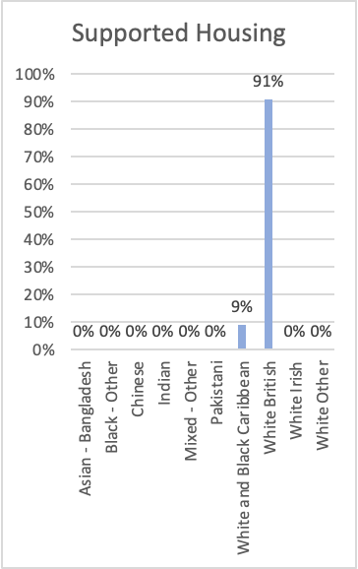
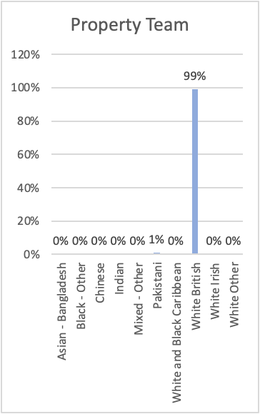
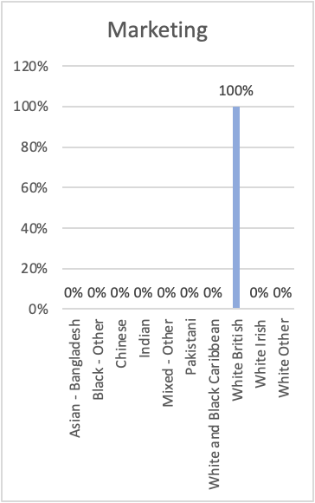
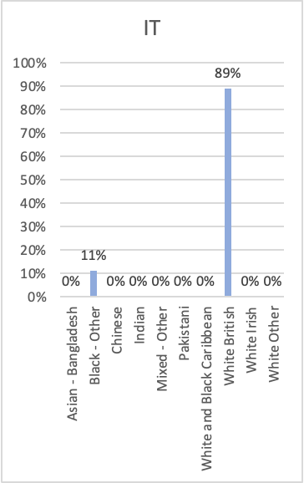
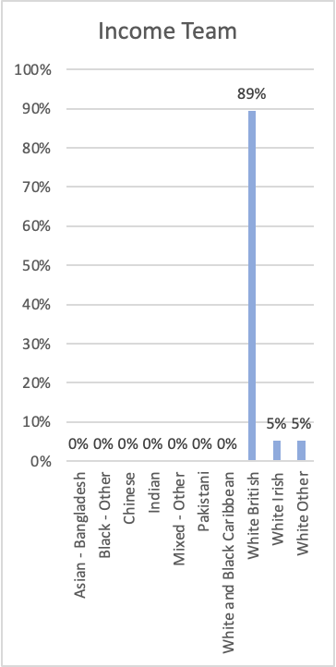
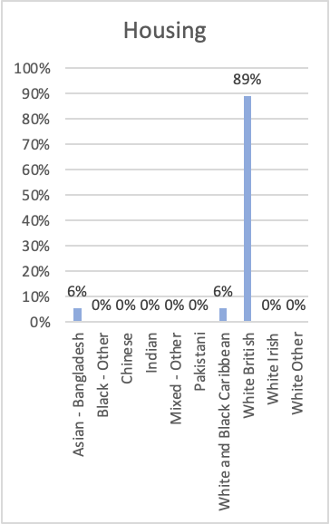
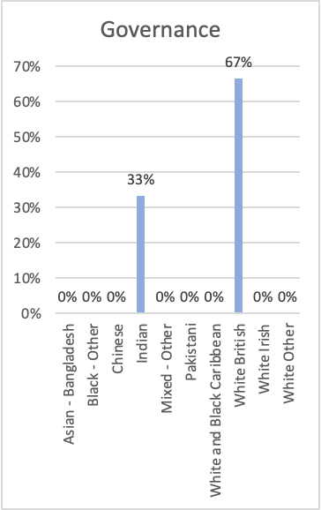
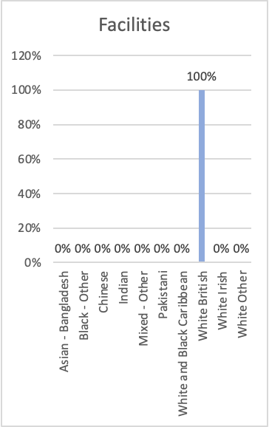
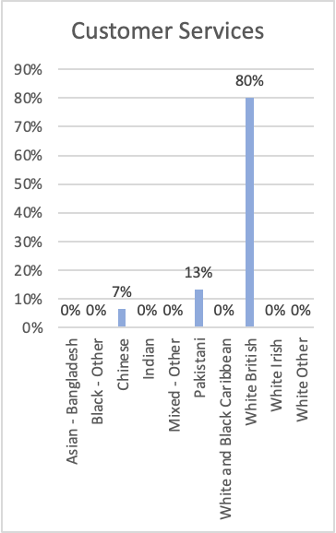
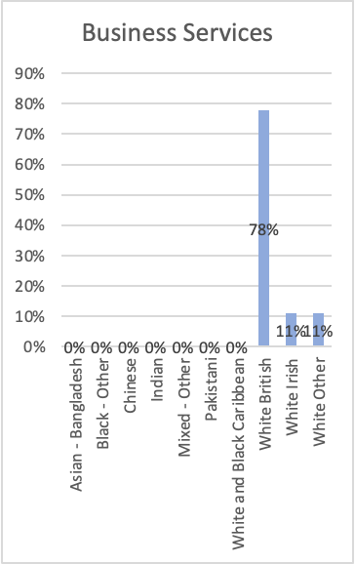
Appendix1:
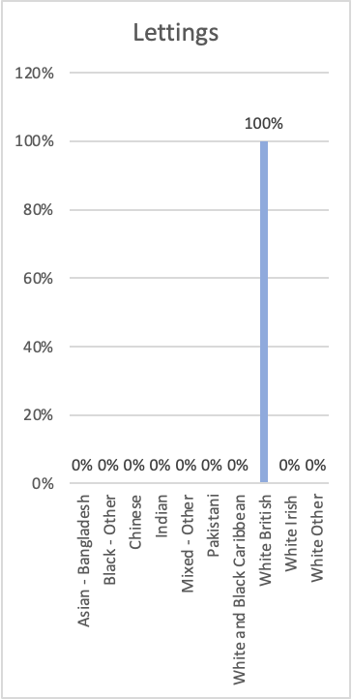
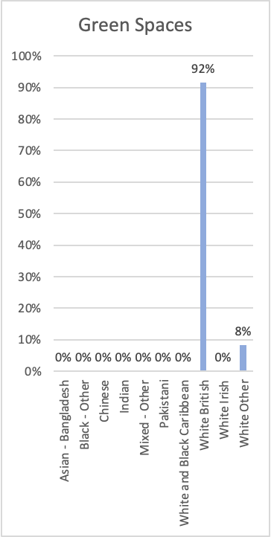
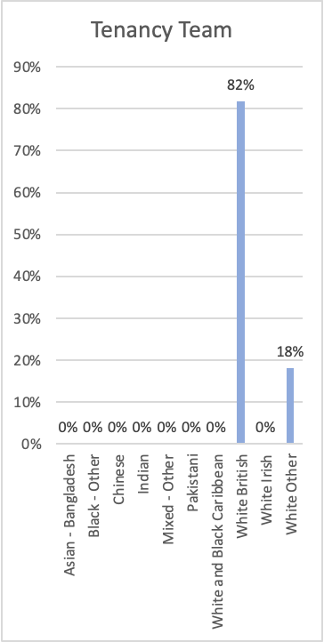
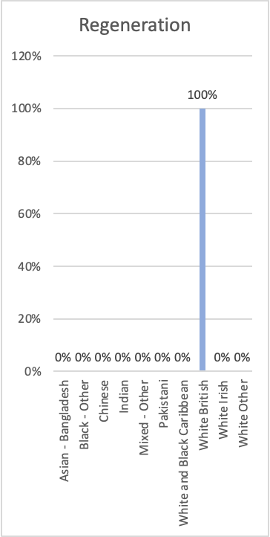
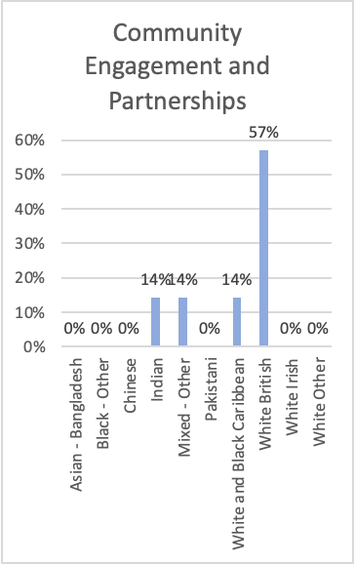
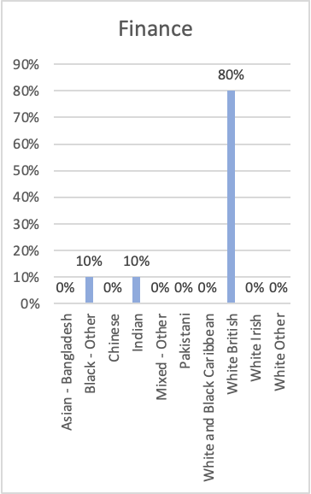
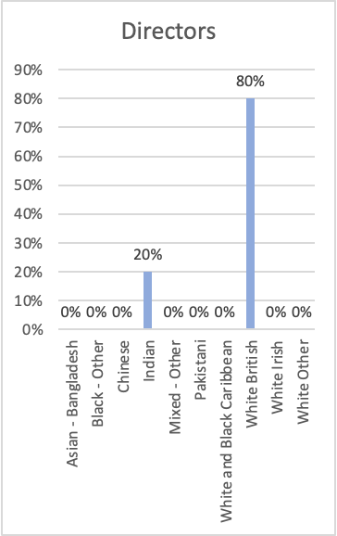

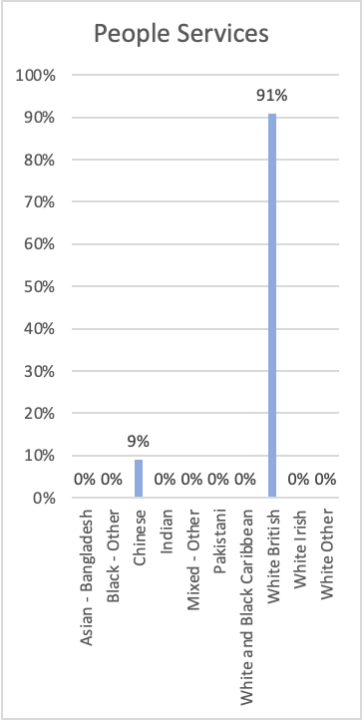

Appendix2.

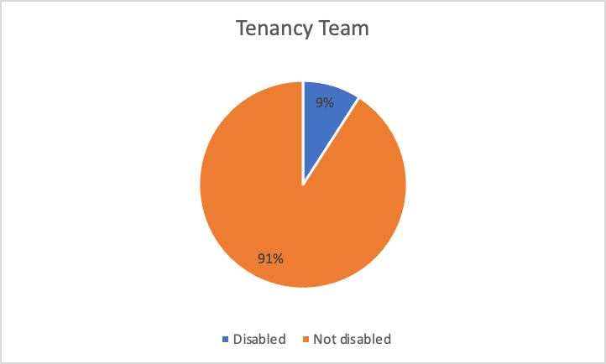
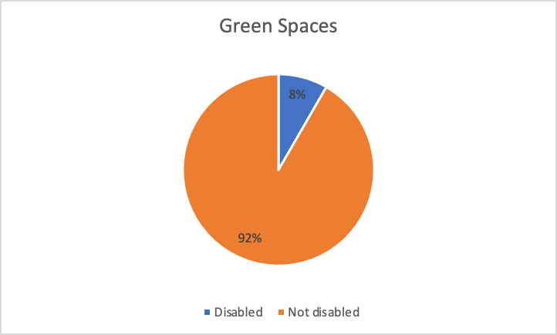
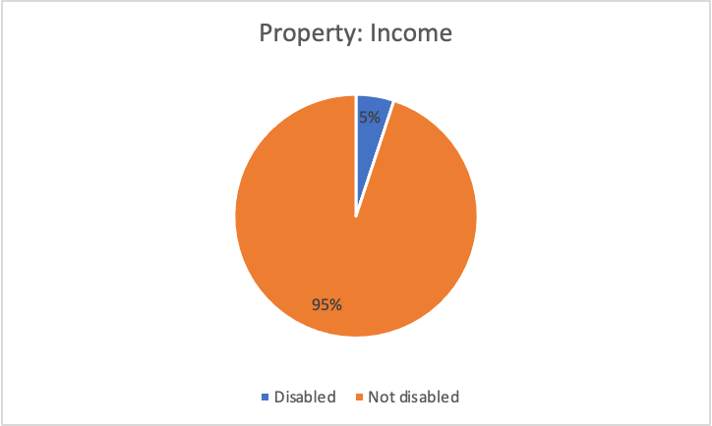
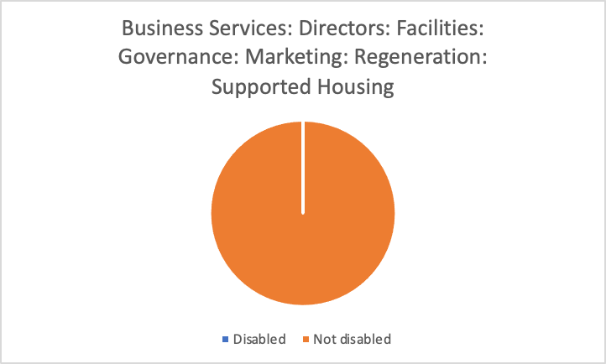

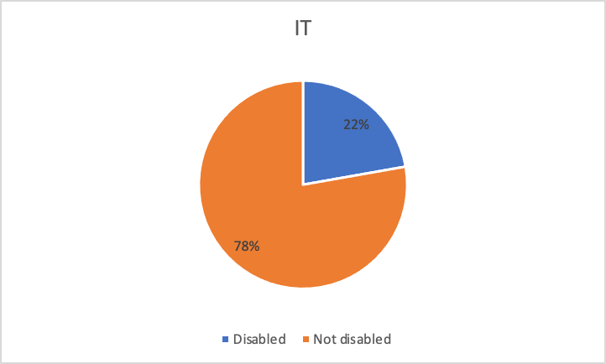
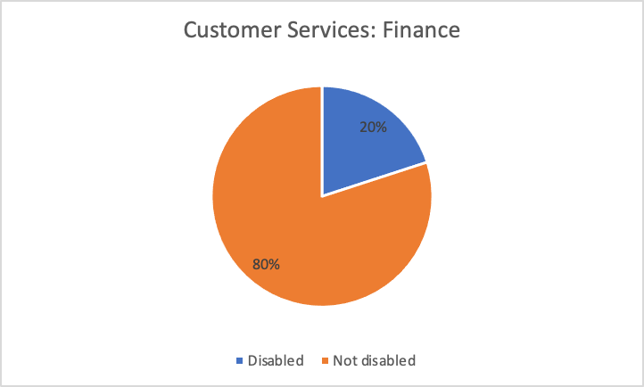
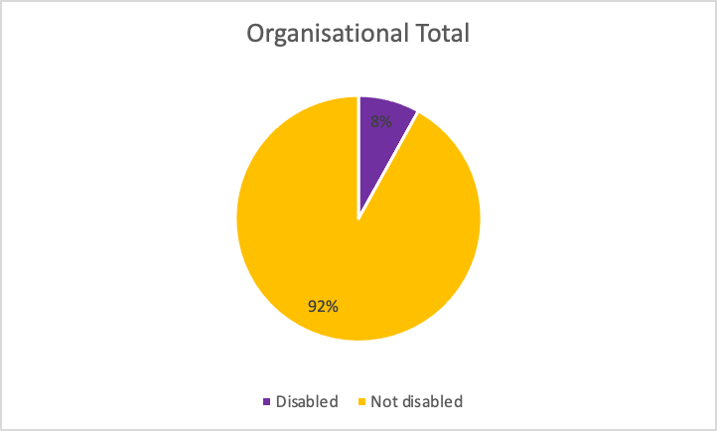
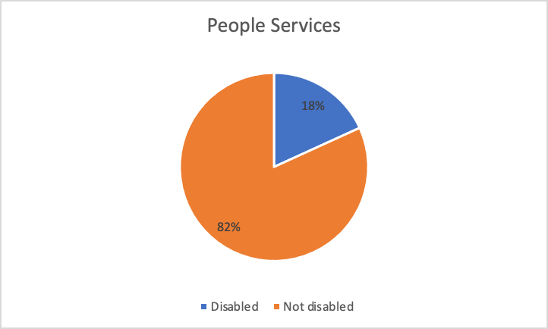
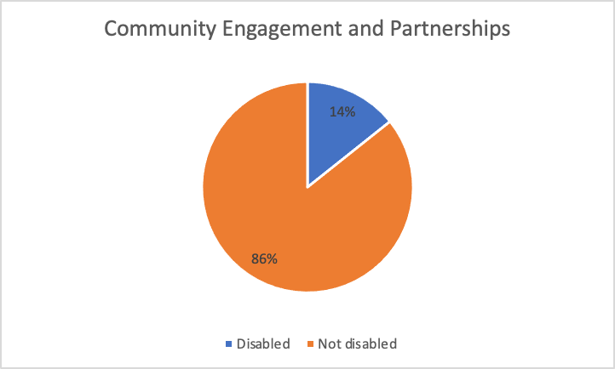
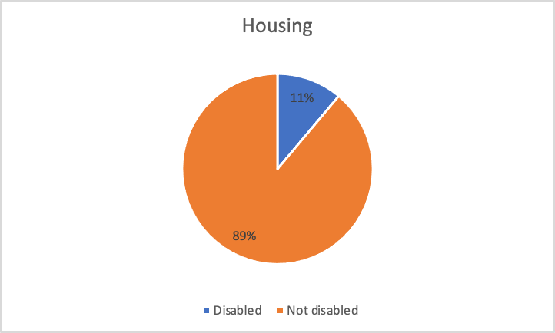
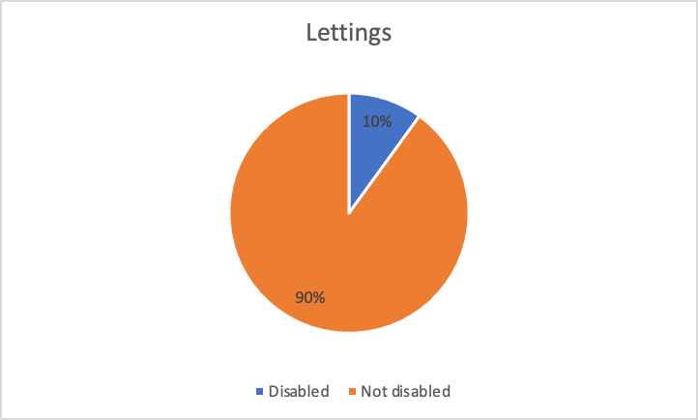

Bibliography:

Cognitive Bias2023-last update.
Critical Thinking2023-last update.
Critical Thinking and Problem-Solving2023-last update.
Explore the Profession Map2023-last update.
McKinsey 7S Model: Importance & How To Use It 2023-last update.
What is evidence-based management and why do we need it? 2017.
Evidence Based Practice.
Gender pay gap reporting guide.
CFI TEAM, 2023-last update, Financial Performance.
CHANNELL, M., 2021-last update, The Six Thinking Hats: How To Improve Decision Making, With Examples.
CIPD, 2023a-last update, Evidence-based HR: Make better decisions and step up your influence.
CIPD, 2023b-last update, People analytics.
CIPD, 2019. Podcast 154: Critical Thinking.
CIPD, 2018. Creating and capturing value at work: who benefits? .
CIPD, Ethical practice and the role of people professionals.
CORPORATE FINANCE INSTITUTE, 2020. ROI: Return on Investment Explained.

DENISE M. ROUSSEAU, ERIC G. R. BARENDS, 2011-last update, Becoming an evidence-based HR practitioner.
Hargreaves A and Fullan M (2012) Professional Capital: Transforming, teaching in every school. Abingdon: Routledge.
HOORY AND and BOTTORFF, 2022. What Is A Stakeholder Analysis? Everything You Need To Know
INT J ENVIRON RES PUBLIC HEALTH, 2021-last update, Int J Environ Res Public Health.
JUDD, S.E.A., , Employee Surveys Are Still One of the Best Ways to Measure Engagement.
KAPLAN, M. F., & MILLER, C. E., 1987-last update, Group decision making and normative versus informational influence: Effects of type of issue and assigned decision rule.
MILLER, B., 2020-last update, Pros and Cons of Employee Surveys.
MINDTOOLS, 2023-last update, McKinsey 7-S Framework.
SIDEWAYS, 2021. 4. Looping the Loop.
TAYLOR AND WOODHAMS, 2022a. Studying Human Resource Management. 3rd Edition edn.
TAYLOR AND WOODHAMS, 2022b. Studying Human Resource Management. 3rd Edition edn.
TAYLOR AND WOODHAMS, 2022c. Studying Human Resource Management. 3rd Edition edn.

References

"Creating and capturing value at work: who benefits?", CIPD: Research report Part 2 – Measurements report. January 2018
BBC (2021) BBC Radio 4 podcast: Looping the Loop. 2021. Available at: https://www.bbc.co.uk/programmes/m000sr4s (Accessed 23 November 2023).
Cascade (2023) McKinsey 7S Model: Importance & How To Use It. Available at: https://www.cascade.app/blog/mckinsey-7s-model (Accessed 12 December 2023)
Centre for Evidence Based Management (2017) What is evidence-based management and why do we need it? Available at: https://www.youtube.com/watch?v=nwK7IgmygBc&list=PLEMvjZY799c_oRzhKvHbbLukBzCY5I6qo&index=3 (Accessed 12 December 2023)
CFI (2020) ROI: Return on Investment Explained. Available at: https://www.youtube.com/watch?v=wPVZBPWYYXY (Accessed 11 December 2023)
CFI (2023) Balanced Scorecard. Available at: https://corporatefinanceinstitute.com/resources/management/balanced-scorecard/ (Accessed 11december 2023)
CFI (2023a) Financial Performance. Available at: https://corporatefinanceinstitute.com/resources/accounting/financial-performance/ (Accessed 11 December 2023)
CIPD (2019) CIPD Podcast, Critical thinking, Episode 154: How to think well and reflect objectively on the ideas, opinions and arguments of others. 05 November 2019. Available at: https://www.cipd.org/uk/knowledge/podcasts/critical-thinking/#:~:text=There%20are%20three%20key%20parts,they%20are%20communicating%20to%20others (Accessed 12 December 2023)
CIPD (2022) People analytics. Available at: https://www.cipd.org/uk/knowledge/factsheets/analytics-factsheet/#_ga=2.170353952.1246059219.1635951255-1362614769.1635951255 (Accessed 10 December 2023)
CIPD (2023) Ethical practice and the role of people professionals. Available at: https://www.cipd.org/uk/knowledge/factsheets/ethics-role-hr-factsheet/ (Accessed 11 December 2023)
CIPD (2023a) Evidence-based HR: Make better decisions and step up your influence. Available at: https://www.cipd.org/uk/knowledge/guides/evidence-based-profession/ (Accessed 11 December 2023)
CIPD (2023b) Explore the Profession Map. Available at: https://www.cipd.org/uk/the-people-profession/the-profession-map/explore-the-profession-map/ (Accessed 12 December 2023)
CIPD (2023c) Gender pay gap reporting guide. Available at: https://www.cipd.org/uk/knowledge/guides/gender-pay-gap-reporting-guide?_gl=1*1nyxe64*_ga*MTYyOTA5MDQzNi4xNjc4MzcwNzg0*_ga_D9HN5GYHYY*MTY5NjI2NDI0Ni43MC4xLjE2OTYyMzY1MjMuNjAuMC4w (Accessed 12 December 2023)
CIPD (2023d) People analytics. Available at: https://www.cipd.org/uk/the-people-profession/the-profession-map/explore-the-profession-map/specialist-knowledge/people-analytics/ (Accessed 10 December 2023)
CIPD (2024) Technology use in equality, diversity and inclusion. Available at: https://www.cipd.org/en/knowledge/guides/technology-use-equality-diversity-inclusion/ (Accessed 26 February 2024)
Deloitte (2016) Enabling business results with HR “Measures that matter”. Available at: https://www2.deloitte.com/content/dam/Deloitte/us/Documents/human-capital/us-hc-enabling-business-results-with-hr-measures-that-matter.pdf (Accessed 11 February 2024)
FlourishDx (2022) What is EVIDENCE Based Practice?! – with Rob Briner. Availble at: https://www.youtube.com/watch?v=tSfo2XhEWkE&t=29s (Accessed 12 December 2023)
Forbes (2023) Why HR Is Key To Executive Success: How The Human Resources Function Impacts Business Growth. Available at: https://www.forbes.com/sites/forbeshumanresourcescouncil/2023/02/08/why-hr-is-key-to-executive-success-how-the-human-resources-function-impacts-business-growth/ (Accessed at 12 December 2023)
Forbes Advisor (2022) What is A Stakeholder Analysis? Everything you need to know. Available at: https://www.forbes.com/advisor/business/what-is-stakeholder-analysis/#:~:text=The%20stakeholder%20analysis%20is%20conducted,and%20current%20or%20future%20customers (Accessed 12 December 2023)
Harvard Business Review (2018) Employee surveys are still one of the best ways to measure engagement. Available at: https://hbr.org/2018/03/employee-surveys-are-still-one-of-the-best-ways-to-measure-engagement (Accessed 11 December 2023)
HR Daily Advisor (2020) Pros and Cons of Employee Surveys. Available at: https://hrdailyadvisor.blr.com/2020/09/28/pros-and-cons-of-employee-surveys/#:~:text=If%20there's%20a%20low%20response,more%20likely%20to%20be%20dated (Accessed 11 December 2023)
MindTools (2023) Cognitive Bias. Available at: https://www.mindtools.com/a0ozgex/cognitive-bias (Accessed 12 December 2023)
MindTools (2023) Critical Thinking. Available at: https://www.mindtools.com/a3ixqae/critical-thinking (Accessed 12 December 2023)
MindTools (2023) McKinsey 7-S Framework. Available at: https://www.mindtools.com/aicks4s/the-mckinsey-7-s-framework (Accessed 12 December 2023)
MindTools (2023) PDCA (Plan Do check Act). Available at: https://www.mindtools.com/as2l5i1/pdca-plan-do-check-act (Accessed 23 November 2023)
Morrell, K. and Dahlmann, F., 2023. Aristotle in the anthropocene: the comparative benefits of Aristotelian virtue ethics over utilitarianism and deontology. The Anthropocene Review, 10(3), pp.615-635.
MSG (2023) McKinsey &S Change Model. Available at: https://managementstudyguide.com/mckinsey-7s-change-model.htm (Accessed 10 December 2023)
National Library of Medicine (2021) Deontological or Utilitarian? An Eternal Ethical Dilemma in Outbreak. Available at: https://www.ncbi.nlm.nih.gov/pmc/articles/PMC8391290/#:~:text=Unlike%20utilitarianism%2C%20in%20which%20the,the%20action%2C%20not%20its%20consequences. (Accessed 12 December 2023)
Procaccini, J. (2012) “Professional Capital: Transforming Teaching in Every School by Andy Hargreaves and Michael Fullan: (2012). New York, NY: Teachers College Press, 219 pp., $29.95,” Journal of School Choice. Taylor & Francis Group, pp. 515–517. Available at: https://doi.org/10.1080/15582159.2012.733288.

Rousseau, D.M. and Barends, E.G.R. (2011) “Becoming an evidence-based HR practitioner,” Human resource management journal, 21(3), pp. 221–235. Available at: https://doi.org/10.1111/j.1748-8583.2011.00173.x.

Seven Pillars Institute (2023) Moral Theories. Available at: https://sevenpillarsinstitute.org/ethics-101/moral-traditions/ (Accessed December 12 December 2023)

Taylor, S. and Woodhams, C. (eds) (2022) Studying human resource management : a guide to the study, context and practice of HR. Third edition. London: KoganPage.

The University of Tennessee Chattanooga (2023) Critical Thinking and Problem-Solving. Available at: https://www.utc.edu/academic-affairs/walker-center-for-teaching-and-learning/teaching-resources/pedagogical-strategies-and-techniques/ct-ps#:~:text=Wade%20(1995)%20identifies%20eight%20characteristics,other%20interpretations%2C%20and%20tolerating%20ambiguity (Accessed 12 December 2023)
TSW Training (2021) The Six Thinking Hats: How To Improve Decision Making, With Examples. Available at: https://www.tsw.co.uk/blog/leadership-and-management/six-thinking-hats/ (Accessed 12 December 2023)

