Video Review
This review focuses on the Sledgehammer game Call of Duty World War 2. The gameplay being analysed is the first mission, D-day, where the main character joins the American forces to storm Omaha beach at Normandy. The video’s creator is the igcompany and was uploaded onto YouTube on the eighth November 2017 (igcompany, 2017), just five days after the game was released on the third for the PlayStation four, windows and Xbox one (Activision, 2018). The purpose of the video was to present a non-commentary gameplay of the first mission of the eight hour campaign, mainly for the enjoyment of viewers to watch without the sound effects and voiced lines being spoken over, giving the video an almost movie-like feel. This review will therefore analyse the gameplay through a historically accurate lens as a way to determine its legitimacy, the cinematography and the ethical concerns surrounding video games that involve controversial and taboo topics.
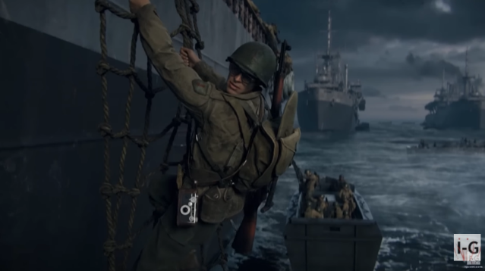
The video starts with the mission’s opening scene, narrated by the main character Ronald Daniels, referred to as Daniels throughout, a Texan who is part of the US first infantry. Soldiers are sent into Higgins boats and transported to the shore where they are targeted at from pill boxes raining bullets from machine guns. Hiding behind hedgehogs, halftracks and in craters this is where the main gameplay begins as the objective is to now reach the sea front where they can begin their invasion. Blowing up the barbed wire fences and defences with a bangalore the characters order now changes to clearing out five bunkers which each increase in difficulty. The first begins with wood and wire, open and easy to clear while the last is fully concrete walls and a more maze-like pattern to navigate. During the last bunker one of the characters' squadmates is injured, again shifting the purpose to getting that soldier down to the CCP, casualty collection point. After this is achieved, the main goal is back to advancing up the beach and destroying German artillery which is stored near two barns. Waves of enemies attack before the video concludes with the character achieving his objective and going back to the CCP where it ends with a shot of blood on his hands.
Figure 1-(igcompany, 2017)
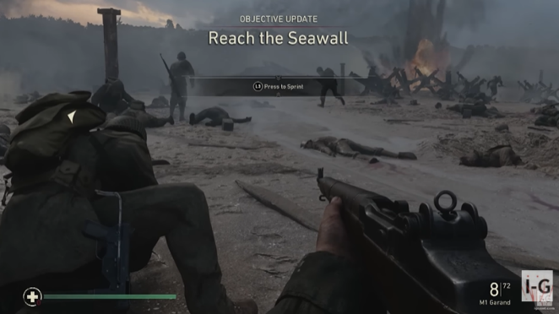
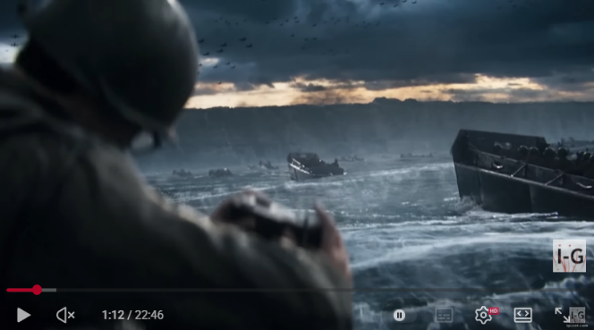
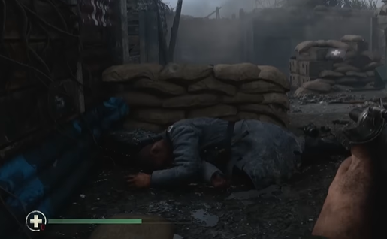
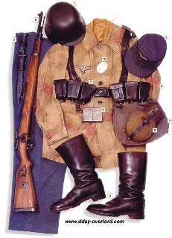
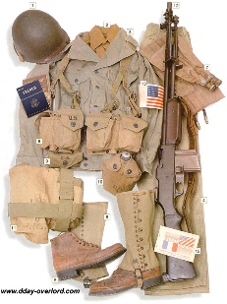
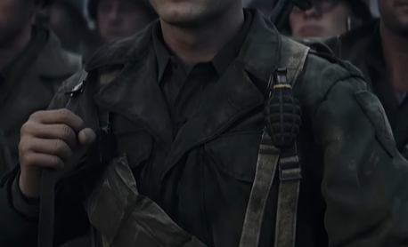
Aspects of the video showcase historical accuracy, however, the game also takes creative liberties in its approach. The exposed Czech hedgehogs, alongside the strong waves and currents, closely reflected the conditions at Omaha beach. Any observations taken earlier in the morning occurred during low tide, but by the 6:30 assault the tide had begun to rise (Drez, 2019). With the tide intensifying the surf, operators had a harder time controlling the navigation of their landing boats causing them to crash into obstacles and each other, resulting in numerous drownings (Drez, 2019). Despite what looked like the tall sea wall and bluffs from the shots on the boats (Drez, 2019), once on land the terrain flattened out, devoid of the geometrical challenges soldiers had to face and instead turning the danger to the Nazi attackers. This switch negates the Nazi’s use of natural defences on Normandy and pushes the narrative that there were stages of bunkers, from outdoor trench-like structures to the full concrete tunnel-like constructions on the top of the sea wall. Bunkers at the bottom of the sea wall would not have been present at Normandy as there was no need for men to be stationed lower (Penguin Books UK, 2023), this theme of creative freedom continues with the use of weaponry in the video. Many of the weapons are accurate, the use of German Mauser 98k rifles (Laurenceau, 2016) is dominant in the enemy territory. However, notable guns such as the PPSH- 41s which are spotted in the hands of some of the American soldiers would not have been used in Normandy despite the German liberation of them; its presence on Omaha would be rare if impossible (Billingsley, 2019). Uniforms follow the same pattern with the accuracy of the American first infantry, but are then lacking in the long coats the Nazi’s are wearing alongside the grey colour that was not present in any unit of the Nazi army (Laurenceau, 2016). What isn’t represented in the video and therefore the mission itself is the mass miscommunication that affected the Normandy landings, it spanned from the lack of intelligence on German positions and the first waves landing in water too deep for men to get out (History Skills, 2026). Overall the historical accuracy of the video lacks the depth which would allow for it to be a one for one recreation of D-day.
Figure 2- (igcompany, 2017)
Figure 3- (igcompany, 2017)
Figure 4- (igcompany, 2017)
Figure 5- (Laurenceau, 2016)
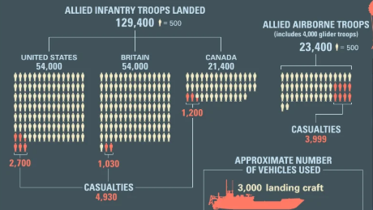
Cinematographically the video presents its purpose seamlessly, the graphics do not dip or lag throughout its playtime and the voice lines are audible for the audience to understand the story. However, the lack of captions in both the game and on YouTube itself means that it dampens the accessibility to those who have hearing difficulties or rely on subtitles to stay focused. In addition with the loud chaos that is representative of the storm of the beaches, voice lines do get lost and would therefore cause more of a problem for those who need hearing support.
Figure 6-(igcompany, 2017)
Ethically, is it disrespectful to play a game based on a traumatic event that caused the deaths of thousands of soldiers? Through deduction it can be assumed that with the amount of views the video has received, twenty million, the creator will have monetary motives to keep the video up despite the games historical inaccuracy. With the inaccuracies in the video it oversimplifies D-day to a twenty minute mission which the user can breeze through without the emotional ramifications that affected real soldiers. Additionally, games such as these have been called for promoting the US military as a heroic organisation with some flagging it as propaganda (Tomkow, 2024) that may cause those playing to view the battlefield as less intense and dangerous than it actually is. This sanitisation of violence distorts historical events into palatable games rather than deeply catastrophic events.
Figure 7- (Drez, 2019)
In conclusion the video itself is succinct and presents its purpose effectively with uninterrupted gameplay footage that doesn’t involve unnecessary deaths or discord. The game the video is presenting however is riddled with historical inaccuracies that may influence the perception of younger minds who play COD games and therefore cause them to have a false narrative of D-day overall. Furthermore, it is ethically questionable whether to present such material to wider audiences as it oversimplifies and glorifies the events, heroizing the US military despite the known miscommunications that occurred.

Bibliography:
Activision (2018). Call of Duty®: WWII. [online] www.activision.com. . Available at: https://www.activision.com/games/call-of-duty/call-of-duty-wwii..
Billingsley, L. (2019). Veterans, Normandy and ‘Those Guys’ | Frontpage Mag. [online] Frontpage Mag. Available at: https://www.frontpagemag.com/veterans-normandy-and-those-guys-lloyd-billingsley/ [Accessed 19 Feb. 2026].
Drez, R. (2019). Omaha Beach | World War II. In: Encyclopædia Britannica. [online] Available at: https://www.britannica.com/place/Omaha-Beach..
igcompany (2017). WW2 - Normandy Landings - D-Day - Call of Duty WW2. YouTube. Available at: https://www.youtube.com/watch?v=yAk_ZNbq0k4 [Accessed 18 Nov. 2019].
Laurenceau, M. (2016). WW2 German Wehrmacht uniform - D-Day Overlord. [online] D-Day Overlord. Available at: https://www.dday-overlord.com/en/material/uniforms/wehrmacht..
Penguin Books UK (2023). WW2 Historian James Holland Breaks Down Call of Duty: WW2. [online] YouTube. Available at: https://www.youtube.com/watch?v=WU-qSo0fw9o..
Tomkow, A. (2024). War Games: How America’s Military-Entertainment Complex Spreads Propaganda Through Entertainment - Viterbi Conversations in Ethics. [online] Available at: https://vce.usc.edu/semester/fall-2024/war-games-how-americas-military-entertainment-complex-spreads-propaganda-through-entertainment/?utm_source=copilot.com [Accessed 19 Feb. 2026].

