 | Targets | What I have done in this assignment
Target 1: | Revise and follow all appropriate reference conventions. | I have looked over the Harvard referencing guide to identify where I was making errors in previous essays, so in this one I can use the correct referencing techniques.
Target 2: | Proofread written expression with care. | I have proofread my essay thoroughly.
Target 3: | Continue to strategise on identified targets. | I have continued to strategies on identified targets from my last assignments.

Demonstrate how cross curricular teaching and learning can influence in depth skills and understanding. Underpin this with reference to relevant research, a detailed lesson plan and an enhanced provision material.
Cross curricular learning is an approach which links multiple subjects together and incorporates more than one subject into a lesson (Barnes, 2018). It gives an opportunity for teachers to create innovative and creative lessons which can develop their learners' understanding and skills through stimulating and interconnected subjects (Harrod and Kerry, 2015). In Graham Donaldson’s review of the education system in Wales in 2015, he underpinned twelve pedagogical principles which he believed were the twelve most important ones and should be considered by teachers and schools when creating their curriculum. Donaldson also created the four purposes which schools should aim to support and develop their learners into (Donaldson, 2015). One of twelve pedagogical principles of the curriculum for Wales is ‘regularly reinforces the cross-curricular skills of literacy, numeracy and digital competence, and provides opportunities to practice them’ (Welsh Government, 2023). Cross curricular learning can also be interpreted to come into another principle which is ‘ranges within and across Areas of Learning and Experience’ (Welsh Government, 2023). These two principles show the need for cross-curricular teaching to be considered and used in the planning of teachers. In the new curriculum for Wales there are six areas of learning and teachers are expected to draw links from different areas of learning into each other when planning lessons (Welsh Government, 2020). The curriculum for Wales insures that within cross curricular learning it is essential that literacy numeracy and digital competence skills are taught and developed within lessons on the areas of learning and experience (Welsh Government, 2022). The concept of cross curricular views learning in a holistic way. Holistic learning focuses on the development of the whole child not just their cognitive ability, it is also at the forefront of the pedagogy of Foundation Learning in Wales, as it links closely to the four purposes and concentrates on child-centred learning (Early Years Wales, 2020). Cross curricular learning can be taught around a school’s termly theme, where the theme chosen can link to various subjects and learning objects which allow for subjects to be integrated together to prevent them being taught in isolation (Harrod and Kerry, 2015). However, the curriculum for Wales’s key focus is progression in learning should be the centre of the curriculums design and not having to fit learning in around a theme (Welsh Government, 2023). Cross curricular teaching can provide many opportunities and challenges, opportunities that can rise with cross curricular teaching can be the sense of motivation the learners get from a meaningful lesson which is requiring them to use a range of their skills (Xerri, Hili and Schembri, 2022). Challenges can also rise with cross curricular teaching that can be related to time as in Foundation Learning lessons tend to be shorter, it can be harder to incorporate a range of areas of learning and use of different frameworks into one short lesson (Hegwood, 2023).
In the curriculum for Wales the cross curricular skills that need to be taught within the areas of learning are literacy, numeracy and digital competence, these skills are expected to fit into the school’s themes and approaches and incorporated into lessons. These literacy, numeracy and digital competence frameworks apply to all primary age learners as to assist schools in incorporating these skills, the Welsh Government have released frameworks for the three skills on what knowledge of the skill is expected at each progression step throughout primary school, so schools can teach accordingly (Welsh Government, 2022). A lesson plan shown in appendix two demonstrates how the literacy, numeracy and digital competence framework can be incorporated into one lesson and how the skill being used in that lesson can be compared against the progression step.
An opportunity of cross curricular learning is that it brings together subjects that may be isolated and allows opportunities for teachers to create creative and imaginative lessons which incorporate the frameworks whilst also going with their theme (Barnes, 2018). It is recognised that creativity within lesson plans is essential instead of a one subject work sheet tasks as McGilchrist (2010, states in Barnes, 2015) warns schools and education practitioners that one subject work sheet tasks does not incorporate ‘right brain’ thinkers and favours ‘left brain’ thinking and intuitive and imaginative approaches are unincluded. Cross curricular learning allows for both sides of the brains thinking to be activated as it’s an approach that considers learning as a whole and focuses on two or more skills into every lesson through an inventive way of incorporating them that allows the learners to develop critical thinking skills (Neuenhaus, Artelt and Schneider, 2013). The lesson plan, in appendix two has been created with a lot of consideration to achieving literacy, numeracy and digital competence skills, into just one lesson whilst also sticking to the school's theme and on the area of learning which is humanities, this requires planning and lots of thought with creative ideas of how to incorporate these into one lesson, it also demonstrates a way of not using worksheets and instead using materials from the school yard to create the Venn diagram which can be seen in appendix one which is the resource where there is an image of a Venn diagram for an example however the learners will make their own Venn diagram out of the hula-hoops like the picture, which is allowing the learners to build on their knowledge through a more hands on approach. John Dewey, an educational psychologist believes strongly in children learning through hands on approaches as it aids more engagement in the they are completing (Sikandar, 2016).
In contrast to this, a challenge that can occur in cross curricular learning is a lack of resources. Cross curricular teaching requires plentiful resources which assist teachers in collaborating different skills and areas of learning into one engaging learning experience (Earley, 2019). Cross curricular teaching relies on having all sorts of resources such as hands on outdoor experiences and school trips, all the way to different technology devices in the classroom. However, many schools find they do not have enough access and funding for the recourses they need for their lessons and there are not enough recourses for them to be able to teach how they would like to (Trainer, 2020). This can then result in teachers not being able to incorporate cross curricular teaching into their lessons as much as they do not have the recourses to be able to carry it out. In appendix one, the resource consists of materials that most schools would have to carry out, however, some resources require different technologies like a Sphere and Beebots, and the lesson would not be able to be carried out without them.
A theorist that supports cross curriculum learning is Maria Montessori, who believes children need a holistic education, where all aspects of the child is developed (Gu, 2020). Cross curricular learning can be connected to holistic learning as it also focuses on not just teaching isolated subjects and focuses on building the skills and knowledge of the whole child. Montessori then created her own method to learning which is called the Montessori approach which is very well suited to when trying to achieve cross curricular learning (Start right nursery, 2024). However, John Dewey believed the Montessori theory and approach is outdated as it was formed in the 1990’s (Mead, 2024). Although, it has been proven that strategies and bits of the Montessori approach is still used in education today (Sills, 2023).
I intend on using the resource in Appendix one in a whole class setting by recapping on how to use Venn diagrams and what the learners saw on their school trip as a whole class and then in groups of ability they will create their own Venn diagrams as also displayed in Appendix one on the yard, this can be used in a whole class setting with the support of an learning support assistant as the learning support assistant will offer prompts to the lower ability groups if needed such as when they are justifying their choices and explaining why they put what where, the lower ability groups can be offered sentence starters to support them. Also, the higher ability groups will have more images in the recourse than lower ability, in order for the task to be finished at the same time. I would engage the children by asking them questions that allow them to access their critical thinking skills such as ‘what can we remember about life in Victorian times?’ ‘Why do you think we don’t have that today in school?’ and ‘why does that image belong there?’ The use of asking questions and the learners recording themselves justifying their choices, will allow me to assess the children’s knowledge and understanding on this topic. Peer assessment will also be a form of assessment as the learners will be encouraged to discuss their choices with each other and share opinions of what belongs where and if any changes should be made.
As I have previously discussed, the resource in appendix one has the strength that it will only require two large hula-hoops and chalk which are typical school supplies meaning it can be carried out within a lesson with no budget or funding needed. However, a challenge that could arise with the resource could be that some learners may finish the enhanced provision task before the estimated time given for it on the lesson plan in appendix two. So, the resource could be improved by a further challenge created in preparation for learners who may finish the enhanced provision task before others, which is images of what future schools could look like and the learners would be expected to place them in the outside column of the Venn diagram to provide a further challenge and expand their skills.

As I have previously discussed, the resource in appendix one has the strength that it will only require two large hula-hoops and chalk which are typical school supplies meaning it can be carried out within a lesson with no budget or funding needed. However, a challenge that could arise with the resource could be that it may not take all learners the time predicted to complete it in the lesson plan. So, the resource could be improved by a further challenge created in preparation for learners who may finish the enhanced provision task before others, which is images of what future schools could look like and the learners would be expected to place them in the outside column of the Venn diagram to provide a further challenge and expand their skills.
To conclude, during this assignment I have learnt the big significance of the literacy, numeracy and digital competence frameworks within the curriculum being integrated into lessons on the areas of learning as the in-depth lifelong skills they are learning through these frameworks and the access to knowledge they are receiving can be applied in all different educational settings and in real world settings (Verma, 2005). I have also realised that cross curricular teaching enables the learners to access the full curriculum, which is equipping them with the opportunities to understand and realise the four purposes (Gatley, 2020). Furthermore, I have discovered through this assignment how large of an impact cross curricular learning has on Foundation Learning as Foundation Learning it is the learners first couples years in school, some of the learners have never had the experience or resources at home to access these cross curricular skills, so it is their first time learning a lot and getting a basis of these essential skills, as I observed on bridging early into Foundation Learning, a lot of learners may be at different stages of skills of the literacy, numeracy and digital competence framework, that’s why it is essential for teachers to ensure their cross curricular teaching can be adapted to all levels of ability (Earley, 2019). This assignment has also given me an opportunity to use my innovative and creative thinking skills when creating a lesson which incorporates the literacy, numeracy and digital competence framework skills for the specific progression step, and how to interweave the learning of these skills into lessons instead of teaching them in isolation. Which also links into the professional standards of teaching in the developing new techniques strand of the innovation standard as well as this it links to the secures the best outcome for learners strand under the pedagogy standard (Welsh Government, 2019). As cross curricular learning teaches essential skills allowing the children to be supplied with the skills and knowledge, they will need for the next progression step (Timmerman, 2019). Cross curricular learning will influence me to take great consideration when planning lessons when I am on my teaching placement, to think how I can creatively fit some skills of the literacy, numeracy, and digital competence frameworks into my lessons. I plan to set myself a target of encouraging at least one of the cross curricular frameworks into every lesson I carry out, no matter what area of learning it is. A further target I plan to set myself is that is that all resources I create that incorporate cross curricular learning can be assessed against the progression steps, so the progress of the learners can be tracked.

Appendix
Appendix 1:
Resource-
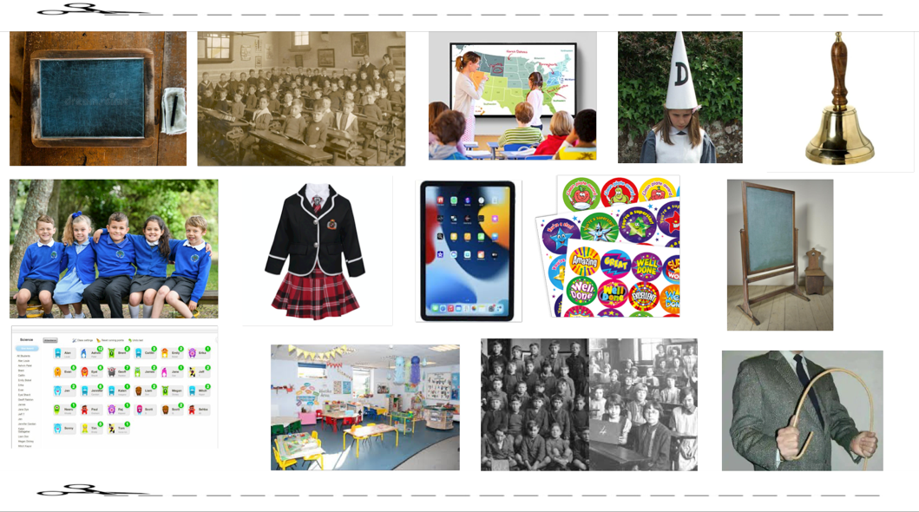
(Images that will be cut out into small individual pictures)
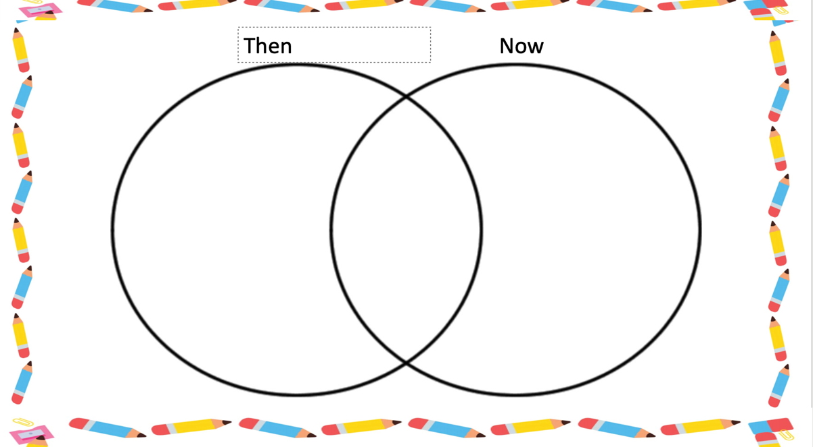
(An example of the Venn diagram the learners are required to make)

Appendix 2:
Lesson plan-
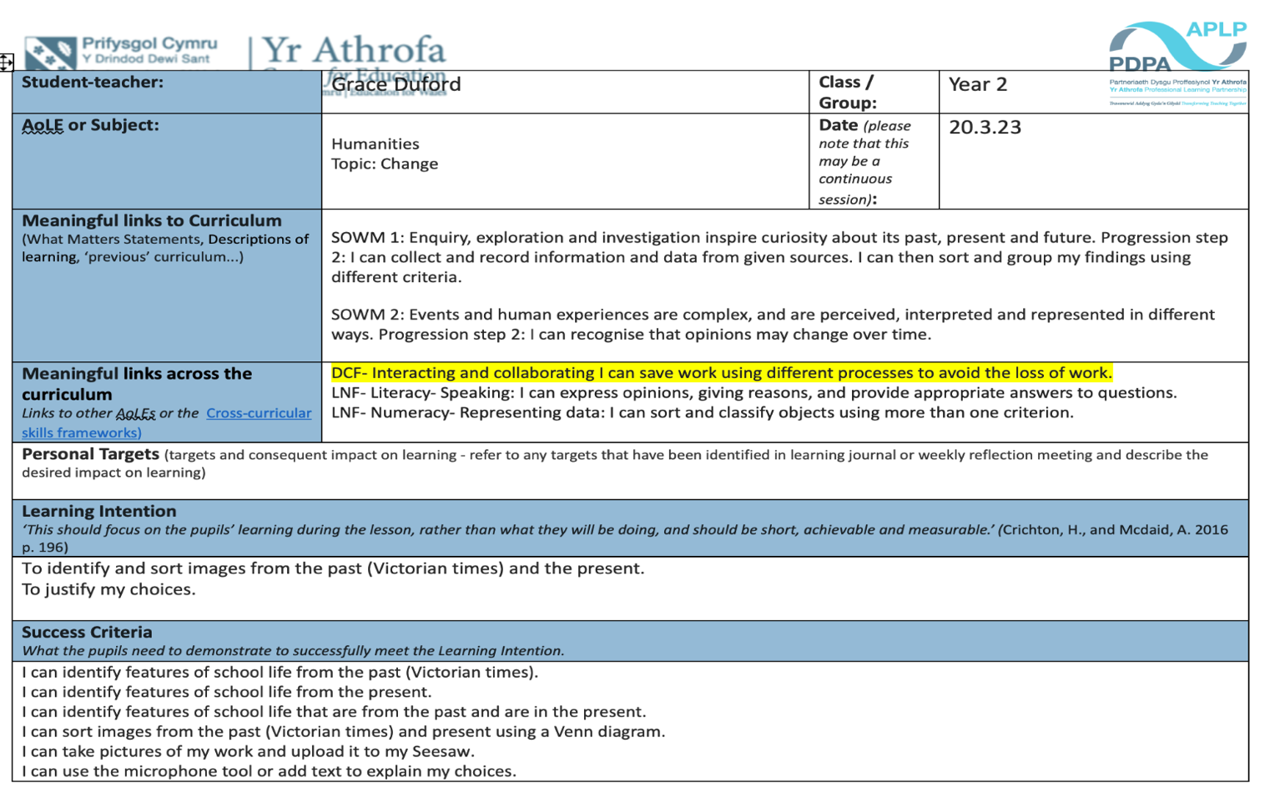
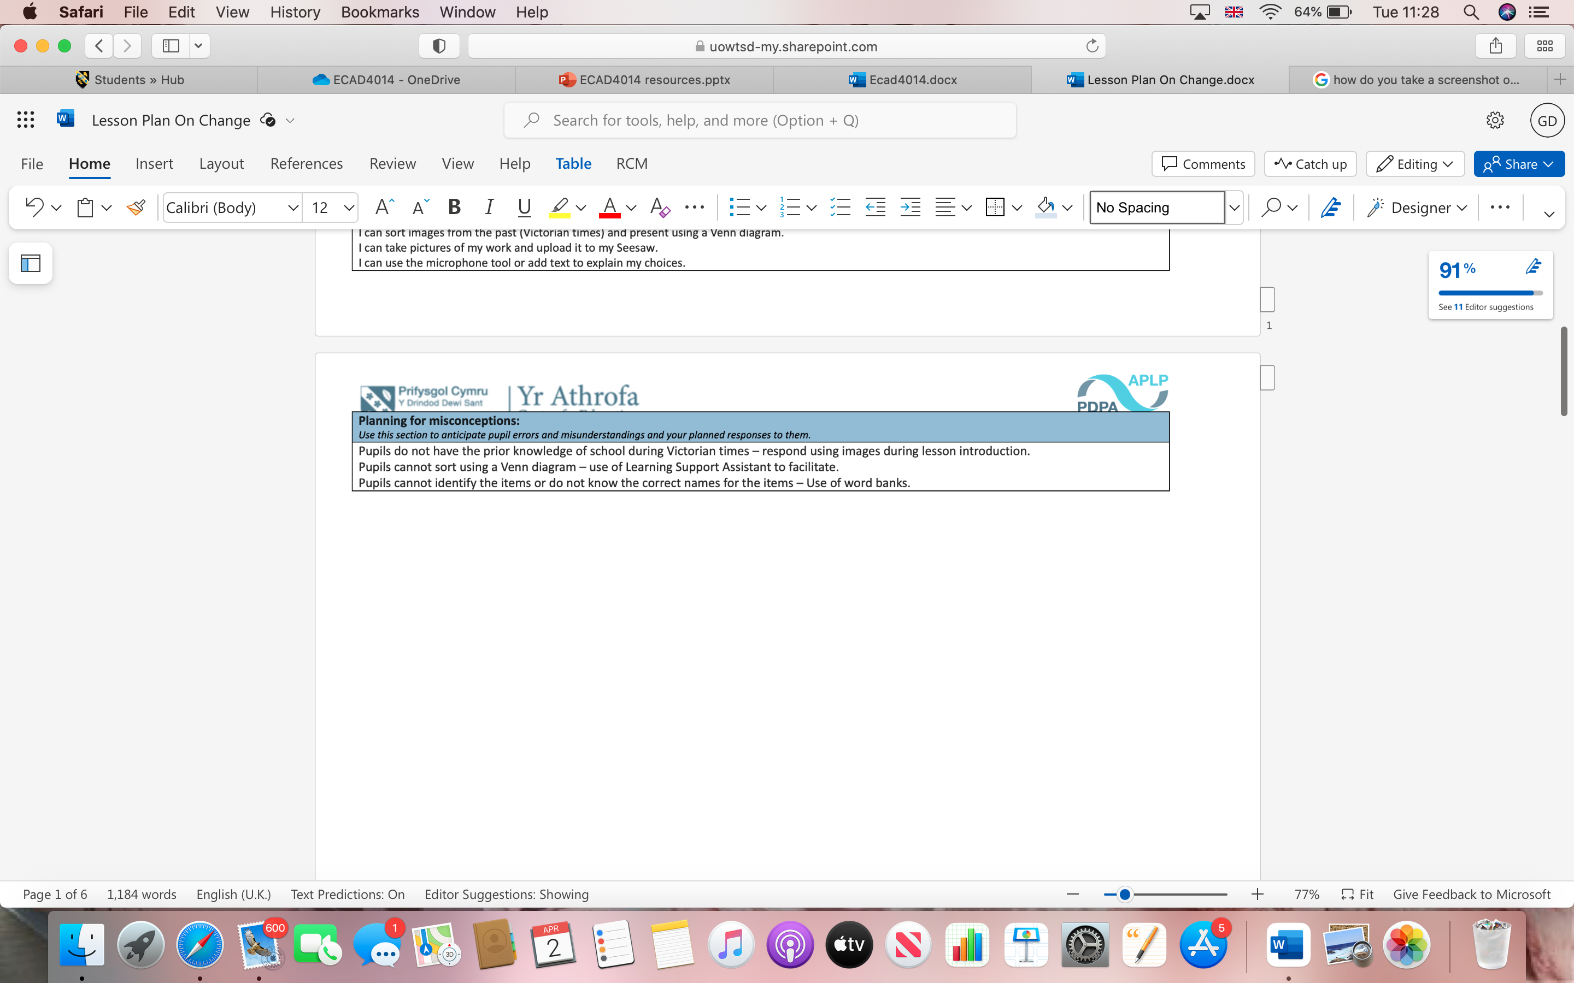
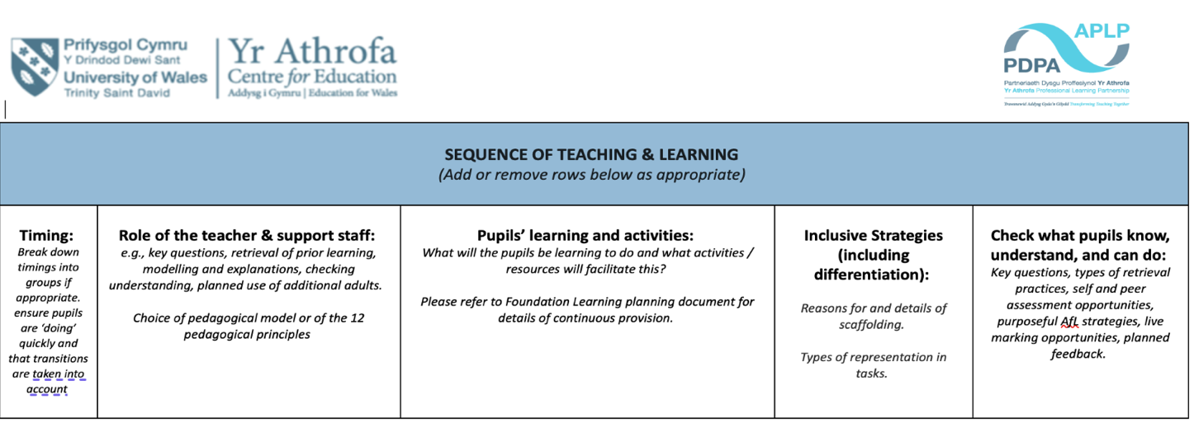
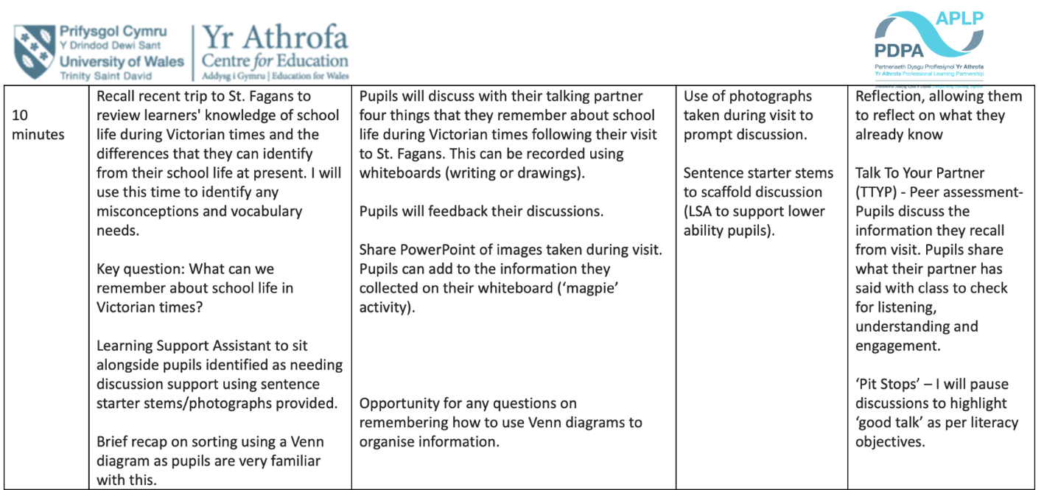
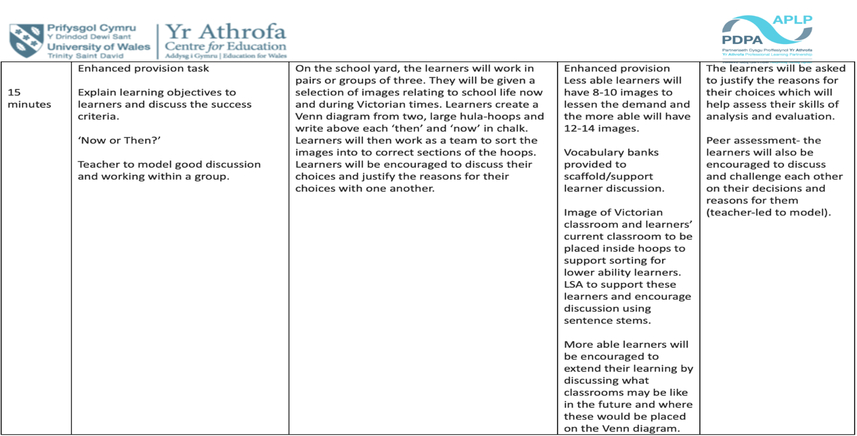

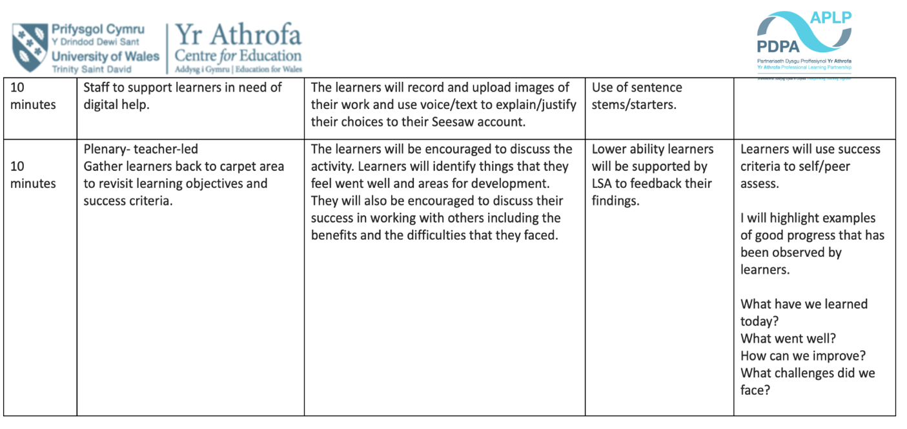

Reference list
Barnes, J. (2015). Cross-curricular learning 3-14. third ed. London: Sage.
Barnes, J. (2018). Applying cross-curricular Approaches Creatively. Abingdon: Routledge.
Donaldson, G. (2015). Successful Futures Independent Review of Curriculum and Assessment Arrangements in Wales. [online] Available at: https://www.gov.wales/sites/default/files/publications/2018-03/successful-futures.pdf [Accessed 20 Mar. 2024].
Earley, S. (2019). An Investigation into the Implementation of a Cross-Curricular Approach in an Irish Primary School Classroom. International Journal for Cross-Disciplinary Subjects in Education, [online] 10(2), pp.4031–4040. doi:https://doi.org/10.20533/ijcdse.2042.6364.2019.0492.
Early Years Wales (2020). Foundation Learning. [online] Early Years Wales. Available at: https://www.earlyyears.wales/en/foundation-learning#:~:text=Childrens%20holistic%20development%20is%20at [Accessed 20 Mar. 2024].
Gatley, J. (2020). Can the New Welsh Curriculum achieve its purposes? The Curriculum Journal, [online] 31(2). doi:https://doi.org/10.1002/curj.26.
Gu, C. (2020). The Influences From Montessori to the Early Years Children. Proceedings of the 2020 5th International Conference on Modern Management and Education Technology (MMET 2020), [online] 480. doi:https://doi.org/10.2991/assehr.k.201023.056.
Harrod, P. and Kerry, T. (2015). Cross-Curricular Teaching in the Primary School. 2nd ed. Routledge.
Hegwood, V. (2023). 10 Challenges Teachers Face In The Classroom. [online] www.prodigygame.com. Available at: https://www.prodigygame.com/main-en/blog/challenges-of-teaching/ [Accessed 20 Mar. 2024].
Hwb.gov.wales. (2022). Cross-curricular skills frameworks - Hwb. [online] Available at: https://hwb.gov.wales/curriculum-for-wales/cross-curricular-skills-frameworks#:~:text=Literacy%2C%20numeracy%20and%20digital%20competence [Accessed 20 Mar. 2024].
Mead, S. (2024). The History of the Montessori Education. [online] www.whitbyschool.org. Available at: https://www.whitbyschool.org/passionforlearning/the-history-of-the-montessori-education#:~:text=A%20student%20of%20educational%20reformer [Accessed 8 Apr. 2024].
Neuenhaus, N., Artelt, C. and Schneider, W. (2013). The Impact of Cross-curricular Competences and Prior Knowledge on Learning Outcomes. International Journal of Higher Education, 2(4). doi:https://doi.org/10.5430/ijhe.v2n4p214.
Sikandar, A. (2016). John Dewey and His Philosophy of Education. Journal of Education and Educational Development, [online] 2(2), pp.191–201. doi:https://doi.org/10.22555/joeed.v2i2.446.
Sills, D. (2023). What the Evidence Says About Montessori Education | Psychology Today United Kingdom. [online] www.psychologytoday.com. Available at: https://www.psychologytoday.com/gb/blog/evidence-based-living/202309/what-the-evidence-says-about-montessori education#:~:text=It's%20been%20more%20than%20100,widespread%20alternative%20to%20traditional%20education. [Accessed 12 Apr. 2024].
Start right nursery (2024). Curriculum | Start Right Montessori | Southgate. [online] Startright Montessori Nursery. Available at: https://startrightmontessori.co.uk/curriculum/#:~:text=Montessori%20education%20is%20particularly%20suited [Accessed 8 Apr. 2024].
Trainer, T. (2020). Teaching with limited resources: challenges and potential benefits. [online] TEFL Trainer. Available at: https://tefltrainer.com/general/teaching-limited-resources-challenges-potential-benefits/ [Accessed 4 Apr. 2024].
Verma, G.K. (2005). Cross Curricular Contexts, Themes and Dimensions in Primary Schools. London: Routledge.
Virginie Timmerman, V. (2019). Recommendations for cross-curricular teaching implementation. [online] Cross cut. Available at: https://repositorioaberto.uab.pt/bitstream/10400.2/14970/1/Crosscut%20eBook_project%202016-1-FR01-KA201-024206.pdf [Accessed 8 Apr. 2024].

Welsh Government (2019). Professional Standards for Teaching and Leadership. [online] Available at: https://hwb.gov.wales/api/storage/19bc948b-8a3f-41e0-944a-7bf2cadf7d18/professional-standards-for-teaching-and-leadership-interactive-pdf-for-pc.pdf [Accessed 8 Apr. 2024].
Welsh Government (2023). Pedagogy - Hwb. [online] hwb.gov.wales. Available at: https://hwb.gov.wales/curriculum-for-wales/designing-your-curriculum/pedagogy.
Xerri Hili, C. and Schembri, H. (2022). Cross-Curricular Teaching Within the Learning Outcomes Framework: The Experiences of Primary Teachers in Two State Schools in Malta. Malta Journal of Education, 3(2,231-258).

