

A dissertation submitted for the Master of Business Administration (MBA)
Analysis of impact of brand image（McDonald’s）on consumer purchasing behavior-take China market for example
UNIVERSITY OF WALES TRINITY SAINT DAVID

Student Name: WEIJUN GAO Student Number: 2304599
Supervisor: Badir Miftah
2024/9/24

CERTIFICATE OF AUTHENTICITY

DECLARATION
This work has not previously been accepted in substance for any degree and is not being concurrently submitted in candidature for any degree.

Signed: (Candidate)
Date 24th September 2024

STATEMENT 1
This dissertation is the result of my own investigations, except where otherwise stated. Other sources are acknowledged by footnotes giving explicit references. A bibliography is appended.

Signed: (Candidate)
Date 24th September 2024

STATEMENT 2
I hereby give consent for my thesis, if accepted, to be available for photocopying and for inter-library loan, and for the title and summary to be made available to outside organisations.

Signed: (Candidate)
Date 24th September 2024

ACKNOWLEDGEMENTS
As a year study of the MBA program comes to the end, I hope to take this very opportunity to express my gratitude towards those who once help me.

To my family, thank you for your support and care during this year. Although thousands of miles away from home, distance never shrinks the warmth and love as always. To my friends, thank you for your understanding and help with both everyday life and learning during my time in the UK.

I would like to express my sincere thankfulness to my supervisor Badir Miftah. His guidance and feedback during the dissertation preparation help me not only finish the task in time, but also build up academic ability as well as abundant confidence, which will also be of vital importance in my future career.

Last but not the list, I would also like to thank UWTSD for giving me the chance to study here. I shall cherish the academic atmosphere and the friendship I build up here with people around the world, along with the long-lasting memory which shall never perish.

ABSTRACT
The research seeks to examine the impact of the brand image of McDonald's on consumer purchasing behavior. It specifically looks into the relationship, the features and components concerning McDonald’s brand image and consumer purchasing behavior.

In this study, through an exploratory approach and online questionnaire with a quantitative method, data was collected from a sample of 57 respondents in China. Moreover, based on some previous researches and theoretical models, this study is able to investigate the relationship between the brand image and consumer purchasing behavior.

According to the collected data, it provides an useful insight in understanding how the brand image of McDonald's affects the consumer buying behavior. The results show that the perception of quality and affordability are key drivers for consumers when making a decision. Furthermore, brand loyalty and brand awareness have significant importance in determining customer purchasing behavior, although emotional attachment to the brand is relatively low. Additionally, attractive cost-and-effective offers and wide-ranging menus strongly determine customers' preferences, while brand association has a moderate effect on consumer purchasing behavior since emotional engagement with the brand is relatively low among customers.

CONTENTS
ACKNOWLEDGEMENTS 3
ABSTRACT 4
CHAPTER 1: Introduction 7
1.1 Brand 7
1.2 Brand image 7
1.3 The relationship between brand image and consumer purchasing behavior 7
1.4 Background of McDonald’s 8
1.5 Research Rationale 9
1.6 Research Objectives 9
CHAPTER 2: Literature Review 10
2.1 Introduction 10
2.2 Brand image 10
2.2.1 Definition of the brand 10
2.2.2 Definition of the brand image 11
2.2.3 Theories and models concerning the brand image 12
2.3 Consumer Purchasing behavior 16
2.3.1 Definition of the consumer purchasing behavior 16
2.3.2 Consumer purchasing decision process 17
2.3.3 Influences on Consumer purchasing behavior 18
2.4 Relationship Between Brand Image and Consumer Purchasing Behavior 21
2.4.1 The impact of brand image on consumer purchasing behavior 21
2.4.2 The relationship between brand image and consumer purchasing behavior 22
2.5 Summary of The Literature Review 23
Chapter 3: Research Methodology 25
3.1 Research paradigm 25
3.2 Research Method 27
3.2.1 Advantages of an Online Questionnaire 28
3.2.2 Disadvantages of the Online Questionnaire 29
3.2.3 Disadvantages of methods rejected 31
3.3 Sampling 32
3.3.1 Sample 32
3.3.2 Sample Size 33
3.4 Questionnaire Design 34
3.5 Piloting the Questionnaire 35
3.6 Sending the Questionnaire 35
3.7 Reliability and Validity 36
3.7.1 Reliability 36
3.7.2 Validity 36
3.8 Analysis of Findings 36
3.9 Study Limitations 37
CHAPTER 4: Data Analysis 38
4.1 Survey 38
4.2 Basic information of the consumer 38
4.2.1 Gender 38
4.2.2 Age 39
4.2.3 Occupation 40
4.2.4 Monthly income 41
4.3 McDonald’s consumer behavior 41
4.3.1 McDonald’s consumer’s information 41
4.3.2 Reasons of the McDonald’s 43
4.3.3 Perception of the McDonald’s 44
4.4 Brand image’s influence on Consumer purchasing behavior 45
4.4.1 Consumer purchasing behavior 45
4.4.2 Brand awareness 46
4.4.3 Perceived quality 47
4.4.4 Brand loyalty 48
4.4.5 McDonald’s brand influence on consumer purchasing behavior 49
4.5 Correlation analysis 50
4.5.1 Influences on consumer purchasing behavior and brand awareness correlation analysis 50
4.5.2 Brand awareness and brand loyalty correlation analysis 51
4.5.3 Brand awareness and perceived quality correlation analysis 51
4.5.4 Correlation among consumer buying behavior, brand awareness, perceived quality and brand loyalty. 52
CHAPTER 5: Conclusions and Recommendations 53
5.1 Identify the feature of brand image and consumer purchasing behavior 53
5.2 Analyze the potential influence on the consumer purchasing behavior 54
5.3 Evaluate the relationship between brand image and consumer purchasing behavior 55
5.4 Recommendations 56
REFERENCES 57
APPENDIX 62

CHAPTER 1 : Introduction

Brand
A brand is more than just a name, logo, design, or symbol (Kotler& Keller, 2016) . It is a special identifier that establishes a seller's products or services and helps them stand out from those of competitors by creating a unique identity in the minds of consumers. According to Aaker (1991), it embodies the overall perception that consumers have about a company regarding values and quality, plus emotional scents connected with the product or service. This perception is often referred to as the brand image; hence its great importance in shaping consumer choice and behavior.

Brand image
A brand's image refers to what consumers hold about a brand, which is developed through their interactions and experiences with the brand over time (Keller, 2013). This includes not only tangible characteristics such as product quality and design but also intangible components like emotional relationships and brand values (Aaker, 1991). A strong brand image can influence consumer’s preference, increase customer’s brand loyalty and also stand out in a competitive market.

The relationship between brand image and consumer purchasing behavior
The relationship between brand image and consumer purchasing behavior is of significance in understanding how consumers make their purchase decisions. A positive brand image can enhance consumers’ perceptions on the quality, reliability, and the value of the product which later builds trust and loyalty towards the brand (Keller, 2013). When consumers view a brand with positive features such as high quality, emotional gratification or social acceptance, they are more likely to select it over others even at a premium, say, higher price (Solomon et al., 2016). Consequently, a relatively poor brand image can result in no purchasing behavior irrespective of whether the features of the product are good or not. Therefore, brand image greatly influences consumer loyalty and the paying willingness as well as the overall purchase behavior.

Background of McDonald’s
McDonald’s is one of the most recognizable global fast-food brandsand a well-known figure in the Qucik Service Restaurant (QSR) industry. The brand itself has come to epitomize convenience, consistency, and mass appeal, thus creating tremendous sales and revolutionizing the food service industry. Back in 1940 at San Bernardino, California, McDonald’s was just a small drive-in restaurant. However, today McDonald's has grown to an international fast-food giant which has more than 39,000 restaurants located in over 100 countries. Given this description, it can, therefore, be said that McDonald’s takes the lead in the fast-food industry, say, the leading figure. It operates under the philosophy of providing fast and affordable food, which has set the root in people’s everyday life around the world.

The unique brand identity of McDonald's is rooted in its ability to merge efficiency with familiarity, offering a consistent experience across all its locations (Schlosser, 2012). This fast-food giant not only excels in operational efficiency but also the innovation which brings to consumer’s menu adaptation by aligning offerings with local tastes while keeping the core menu products such as the iconic Big Mac and fries (Capell, 2015). In the Chinese market, McDonald’s represents the symbol of the western culture, catering to the younger generations and urban professionals (Watson, 2012017). McDonald’s has open more than 3,500 stores throughout China by 2020, which shows its adaptability in a cut-throat competitive market (Xu, 2020).

Additionally, McDonald's has been focusing on digital transformations and sustainability, which has improved its performance in worldwide market. In 2021, McDonald’s reported a 7% increase in global revenue, with profits surging due to its emphasis on drive-through, delivery services, and mobile ordering platforms during the pandemic (Foster, 2022). "With the adoption of digital services and strong supply chain management, analysts have argued that McDonald's may outperform those local competitors including Greggs and Pret A Manger in the UK market" (Godoy, 2021).

Like all other global retailers, McDonald’s did suffer challenges in the U.S. market at the beginning of the 2020s, with the market saturation and increasing consumer demand for healthier options putting pressure on the brand. However, McDonald’s is quite able to maintain market leadership by keeping up investment in menu innovation, sustainability initiatives, and digital engagement. McDonald’s strategic initiatives will have more enhancement in its sales and profitability which will keep the company ahead and also up with its competitors like Burger King and Wendy’s.

1.5 Research Rationale
In today’s fast-food industry, competition has moved from just offering products to developing powerful brand identities. McDonald’s is one of the largest fast food chains in the world that has sustained its leadership through the brand consistency and consumer-related marketing efforts. According to Maslow's Hierarchy of Needs, besides basic consumer needs, brands should also meet the emotional and self-fulfillment needs with the rising consumer incomes and diverse demands.

After satisfying the physiological hunger and safety concerns (e.g., food safety, price), consumers often seek to choose companies such as McDonald's as it provides consumers with the familiarity, convenience and the sense of belonging. (Maslow, 1943). To meet the consumer demand, it requires enhanced marketing tactics in presenting not only product features but the overall brand experience.

One of the most famous fast-food chains worldwide is McDonald's, and the effect of the brand image on consumer decisions varies from place to place (Shukla, 2011). For some people, McDonald’s offers reasonably priced, casual dining for familie, while for others, it holds its place as a high-status option due to its western origin. Therefore, it is very important for businesses such as McDonald's to understand the influence of the brand image on consumer purchasing behaviors. This study aims to examine the influence of the brand image of McDonald's on consumer buying behavior and purchase decisions, focusing on key factors such as brand loyalty, perceived quality, brand awareness and so on. Moreover, there are a lot of fast-food giants within the industry such as KFC and Burger Kings. In order to strengthen the brand image, McDonald’s should further look into those insights gained from this study to better meet the ever-increasing needs of its consumers.

1.6 Research Objectives
The purpose of this study is to name and identify key factors that the brand image may have on consumer purchasing behavior, and provide some recommendations for fast-food giants such as McDonald’s in keeping the competitiveness and effectiveness with the sector.

The objectives of this research are as follows:
· Identify the feature of brand image and consumer purchasing behavior
· Analyze the potential influence on the consumer purchasing behavior
· Evaluate the relationship between brand image and consumer purchasing behavior
· Give recommendations

CHAPTER 2:Literature Review

Introduction
literature review is a research work that examines previous relevant research findings and answers research questions under the current research state. This paper will focus on looking at the background of both the consumer purchasing behavior and McDonald’s brand image through previous research. As the relationship between brand image and consumer purchasing behavior has been the focus of many researches over the past few years, the purpose of this paper aims to further investigate how the brand image influence consumer purchasing behavior and the relationship between brand image and consumer purchasing behavior. For the first part, a detailed review of brand and brand image is to be delivered. For the second part, it gives the literature regarding the consumer purchasing behavior. The third part is to discuss the relationship between brand image and consumer purchasing behavior. As for the last part, it provides the summary of the literature review.

Brand image

Definition of the brand
A brand is defined by the American Marketing Association in 1960 as “a name, term, design, symbol, or other characteristic that distinguishes the goods or services of one seller from those of other sellers.” The definition underscores the importance of brands in distinguishing products or services from others within a market space.

The idea was further developed by David Aaker who described brands as “a set of assets (or liabilities) associated with the brand’s name and symbols and the value that the product or service brings to the company and/or its customers”(Aaker, 1991). This underscores how brands play a significant role in creating economic value—as well as elevating customer perception.

Philip Kotler and Kevin Lane Keller mentioned that a brand is “a product, however, to which additional dimensions are added that in some way distinguish it from other products designed to satisfy the same needs” (Kotler & Keller, 2012). There are several other dimensions and these can be functional, emotional or symbolic—they help build up a brand’s distinct character and what it stands for among others in the market place who sell similar products despite meeting similar needs.

Definition of the brand image
The brand's image is the collection of thoughts and feelings that consumers have regarding the brand, which can include emotions, beliefs, and attitudes (Keller, 1993). The concept's development has evolved significantly over the past few years, this is reflected in the understanding of the cognitive and emotional components associated with consumer-brand relationships.

As for marketing, brand image refers to how consumers feel about the brand. It results from all experiences, interactions, and associations with the brand over time (Keller, 2008). A brand's image represents not only functional attributes in terms of quality and performance that customers seek in it but also emotional and symbolic benefits customers derive from it (Aaker, 1991). These associations serve to set one brand apart from others vying for the same market. As a result, they direct consumer behavior and decision-making (Kotler & Keller, 2016). An optimistic brand image goes a long way in increasing the value of a brand by making it more coveted and trustworthy in the eyes of consumers (Solomon, 2020).

At the center of brand image is the idea of brand associations— these are the mental connections that consumers have with a brand (Aaker, 1991). Marketing activities plus one's personal experiences with the brand shape these associations (Keller, 2013). For example, one would associate a luxury car brand with status and top technology plus exclusivity; while associating a fast-food brand with convenience, affordability, or even consistency. The degree of strength and clarity of these associations influences positioning of the brand in consumer minds and competitive advantages within the market (Solomon, 2017).

The emotional part of brand image is very important in consumer decision-making. Typically, consumers base their purchase decisions not only on functional product benefits but also on how the brand makes them feel (Keller, 2013). Brands that elicit positive emotions such as trust, excitement, or nostalgia tend to have higher levels of brand loyalty and repeat purchasing (Aaker, 1996). For example, Apple and Nike have built very strong emotional relationships with their customers, building a feeling of membership and identity beyond the product itself (Hakala, 2012). This emotional attachment then becomes a critical driver of consumer preference as well as brand equity.

Perceived quality, a further essential brand image dimension, affects the perceived value and trust considerations of the consumer (Aaker, 1991). At the general level, if a brand is perceived to provide high-quality products or services, this positive perception will flow into other dimensions of the brand image as well as high levels of customer satisfaction (Keller, 2008). A negative brand image that portrays poor quality or unfulfilling experiences has the ability to drive prospects away and break any existing brand loyalty (Keller, 2001) because much of a strong brand is built on steady delivery of quality; this helps reinforce credibility and maintain standing with customers.

Symbolism, in addition to the emotional and functional components of a brand, relates to the perception of the brand (Kotler & Keller, 2016). These symbolic meanings reflect how much a brand mirrors the consumer's own self-concept, identity, or social status. Brands that can align with the values, aspirations, or lifestyles of their customers have a greater chance of winning hearts with a loyal base (Solomon, 2020). Luxury brands are an excellent example because they tend to symbolize wealth and sophistication—factors that also enhance a brand's market position in several ways since consumers use them to signal these qualities to others (Hakala, 2012). The symbolic aspect greatly increases the brand's attractiveness and solidifies its place in the market.

Moreover, Kotler and Keller (2012) have recognized the strategic importance of brand image in the creation of a distinct identity and difference in the marketplace. They claim that a powerful brand reputation is attained through consistent communication and the transmission of the brand's values, promises, and experiences. This perspective takes into account the concept that the brand's image is dynamic and evolving as a result of the constant association between the brand and its consumers.

2.2.3 Theories and models concerning the brand image

- Acker’s Brand Equity Model

The brand equity model of David Aaker, presented in his book "Managing Brand Equity: Capitalizing on the Value of a Brand Name" (1991), views brand equity as a collection of positive and negative brand-related assets and liabilities that stem from the brand itself, its name, and symbol. According to Aaker's, these assets and liabilities determine the value that customers perceive in a product or service, which can either enhance or diminish the value to the firm and its customers. The model places these assets into five dimensions.

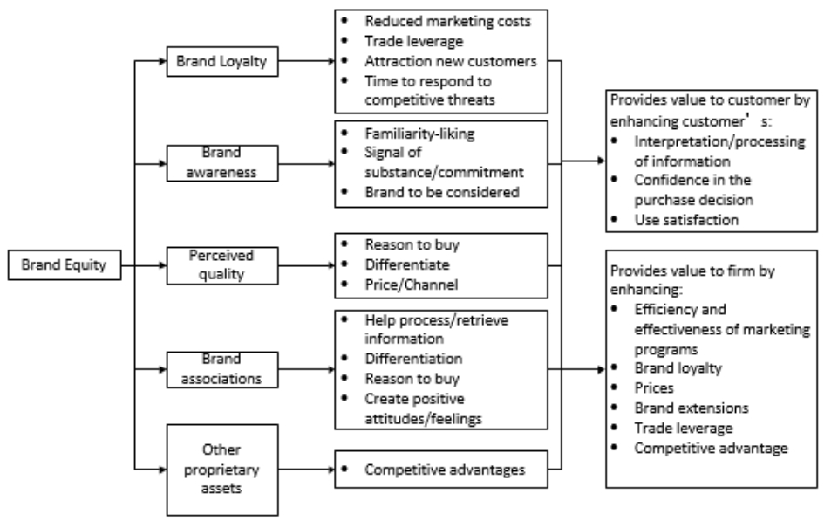
Fig.1 Aaker’s Brand Equity Model

·Brand Loyalty

Brand loyalty examines how much a consumer is emotionally connected to a particular brand and how likely they are to repeatedly purchase products from that brand. It is a mirror of consumer likes and commitment level; it is also affected by satisfaction, trust, and the reputation that the brand holds. Strong brand loyalty is capable of not only elevating customer loyalty but also turning customers into advocates, thereby playing a major role in ensuring the sustained success and competitive advantage for any brand.

·Brand awareness

Brand awareness can be referred to the extent that consumers can recognize or remember a brand connected with a certain type of product. It comprises both brand recognition and recall, playing significant roles in capturing customer interest as well as swaying their buying choices (Keller, 1993). High brand awareness fosters constant visibility and distinguished presence of a brand in the market sphere, which magnifies the probability that consumers shall take note of the brand and give it a shot.

·Perceived quality
The perceived quality in Aaker's model is derived from the overall impression of a brand's superiority or excellence over its competitors. It includes the assessment of the effectiveness, reliability, and consistency of a product. These properties have an effect on the customer's attitude towards the product and desire to purchase it (Aaker, 1991). Positive feedbacks regarding quality increase the brand's importance by improving customer satisfaction and loyalty.

·Brand associations
Brand associations are about thoughts and connections people create between a brand and particular features, advantages, or values. They can either be functional, emotional, or symbolic, playing a role in defining what a brand stands for and making it preferred(Keller, 1993). Aaker's model underscores the need for a strategic approach towards nurturing positive brand associations that will not only bring about an immediate impact but also serve as a resource that can be drawn upon continuously in order to build and keep brand equity.

·Other proprietary assets
Other proprietary assets include physical resources like trademarks, patents, and exclusive distribution methods that all contribute to a brand's superiority in the market (Aaker, 1991). These assets increase the brand's equity by preventing entry and enhancing the differentiation of the brand in the market.

- Keller’s Customer-Based Brand Equity(CBBE) Model

The Customer-Based Brand Equity (CBBE) Model, created by Kevin Lane Keller in 2001, is a comprehensive approach to developing powerful, long-lasting brands. The model is composed of four critical stages that are each important in the development of positive brand equity via customer perception and experience. As it can be seen from the Fig.2, each stage aims to answer one typical question.

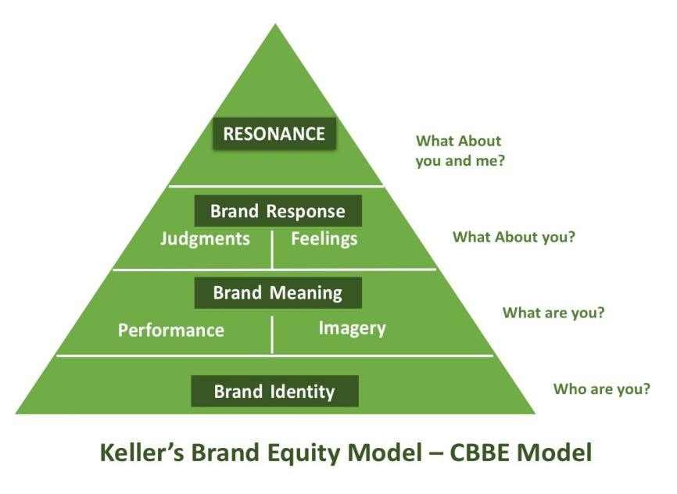
Fig.2 Keller’s CBBE Model

- Kapferer’s Brand Identity Prism

Kapferer's Brand Identity Prism is a significant model which provides an organized structural pattern that can help in grasping and controlling the brand identity. Developed by Jean-Noël Kapferer, this prism comprises six facets that collectively demonstrate all possible dimensions of a brand's identity: physique, personality, culture, relationship, reflection, and self-image (Kapferer, 1992).

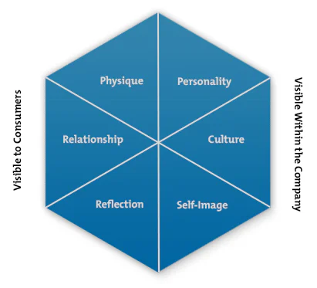

Fig.3 Kapferer’s Brand Identity Prism

·Physique
According to Kapferer, physique stands for the visual and tangible brand elements like logos and design aesthetics. It speaks of a brand's appearance through packaging and product features, which compose consumer perceptions when they first come into contact with the brand.

·Personality
Personality defines specific traits that form the brand's identity, in a way similar to people who have their own characteristics that distinguish them from others. “The personality traits of a brand—like sincerity, excitement or competence—can significantly affect consumer perceptions and involvement with the brand.” (Aaker, 1997) It involves qualities like sincerity, excitement and competence which in turn determine how the brand speaks and interacts with its consumers through communication style.

·Culture
The culture of a brand mirrors its value systems, beliefs and principles which dictate its standing within societal contexts (Holt, 2002). Moreover, culture is an embodiment of brand values at a deeper level than mere business transactions. It demonstrates how the brand is in harmony with social norms, ethics, and culture—all factors that have an impact on consumers and stakeholders.

·Self-image
It stands for the idealized picture or identity that a brand wishes to establish and project, which takes in its vision, mission and intended position in the minds of consumers.

·Reflection
Consumers utilize brands to represent their personal characteristics and desires, they combine brands into their personal concept and social identity (Escalas and Bettman, 2003). Additionally, reflection delves into the consumer use of brand as a reflection of their own identity or aspirations. It takes a look at how consumers integrate the brand into their self-expression:communicating not only personal values but also social identities through their affiliation with the brand.

·Relationship
The relationship involves the interactive dynamics between the brand and its customers. The elements of this aspect involve customer service, brand community engagement and emotional connections that develop through brand experiences.

Consumer Purchasing behavior

Definition of the consumer purchasing behavior
Consumer purchasing behavior is defined as the processes and activities through which consumers decide, buy, use, and dispose goods and services. This behavior is affected by a range of factors that include cultural, social, personal and psychological factors. The process goes through several steps: problem recognition, information search, evaluation of alternatives; purchase decision and post-purchase behavior are all part of this (Kotler & Keller, 2016; Solomon, 2018).

Many scholars have identified the concept of consumer purchasing behavior, while there exists slight differences. According to Demby(1973), “Consumer purchase behavior is the decision and action that consumers generate from evaluating, acquiring, and using goods or services.” While Engel(1995) defined the concept in this way: consumer buying behavior is the whole purchasing process which an individual or group wants to get or make the use of a certain product or service. In 2016, Kotler and Keller described the consumer behavior as “the investigation of how individuals, groups, and organizations decide, purchase, utilize, and dispose of goods, services, ideas or experiences in order to fulfill their requirements and desires.”

In sum, the consumer purchasing behavior could be generalized as a behavior which refers to actions and decision-making process of both individuals and groups. As Kotler and Keller(2012) mentioned, “understanding consumer buying behavior is of great help for enterprises to enhance performance comprehensively.”

Consumer purchasing decision process
Consumer purchasing processes differ due to the nature and quality of various products. Nonetheless, consumers typically go through a routine decision-making process. In general, the classical purchase decision process comprises five stages: need recognition/problem awareness, information search, evaluation of alternatives, purchase decision and post purchase behavior (Kotler, 2008).

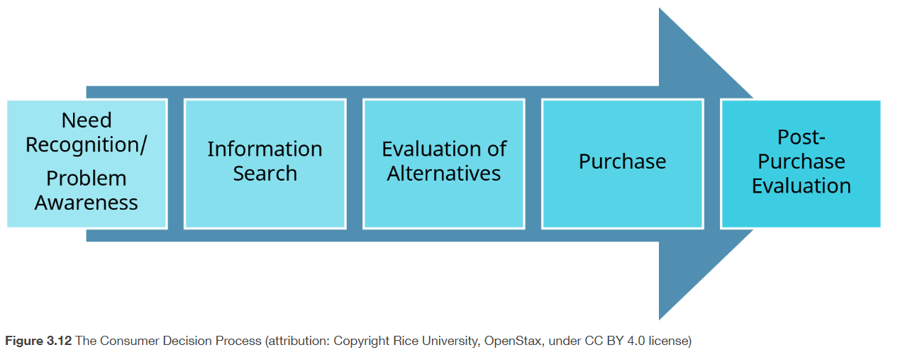

Fig.4 Consumer Purchasing Decision Process

At the problem recognition stage, consumers initially identify problems by realizing if they need or want a particular good or service. This may occur as a result of internal sensations like hunger or thirst, or it may result from external stimuli like exposure to advertisements or recommendations from other people (Kotler & Keller, 2016).

Once a need has been identified, consumers move on to the information search phase. In this stage, they search for information regarding substitutes that might adequately address their needs. This information can be gathered from word-of-mouth recommendations, personal experiences, internet evaluations, or advertisements—all of which have an influence on the decision-making process (Solomon, 2018).

When consumers enter the evaluation stage, they will then consider value and significance, which leads them to evaluate and compare different products or brands based on price, reputation, features, and quality— among other aspects that matter to them. They must balance the positives against the negatives of each choice before making a decision as stated by Engel et al. (1995).

After purchasing, consumers will do post-purchase evaluation. This evaluation made by the consumer may have an impact on the products' future market position and reputation, according to Hudson and Thal (2013). It is worth nothing that consumer feedback and evaluation spread through word of mouth can be influential, which further impacting other consumer purchasing behavior.

Much as this model clearly demonstrates the process of consumer decision-making process, it still has some limitations. For instance, this model does not consider the impact of other potential factors on consumer purchasing decisions, such as the ignorance of emotional and impulsive factors as well as cultural and social influences. Additionally, due to the development of online shopping in the digital age, consumers do not make their purchase choices based on these steps in a linear fashion (Hirt and Willmott, 2014).

Influences on Consumer purchasing behavior
According to Kotler and Keller (2012), consumer behavior is a dynamic process associated with consumer emotion. In a recent study, Qazzafi(2020) generalized that there are four main factors which affect the consumer buying behavior, namely the personal factor, psychological factor, social factor and economic factor.

- Personal factor
Businesses should emphasize the personal element, which is typically relevant to both specialized and everyday products. (Kotler, 2017) According to Qazzafi, there are mainly 4 factors related to the personal factor:

·Age and stages of life cycle
Consumer purchasing patterns are dynamic and ever-changing, depending on the stage of life, relationship, or age of the consumer. At different stages of life, a person's tastes in products may change. Another facet that needs to be put emphasis on is the life cycle. For instance, the various stages of the life cycle or relationships include getting married, getting divorced, having kids go to college, retiring may impact the choice of consumers as they are at different level of life. According to Kotler(2017), companies make products based on different life cycle and different ages of consumers.

·Occupation
An occupation is a type of work that one does while employed. A set of jobs whose primary responsibilities and tasks are distinguished by a high degree of similarity is referred to as an occupation (N.A., 2012). The consumer’s occupation may affect the purchasing behavior towards goods and services. For instance, scientists may ask for high-performance computers due to the project requirements, as compared to other non-professionals.

·Personality
According to Qazzafi, the choice a customer makes between a particular brand and another brand shows their personality. Moreover, brand also has its own personalities. "Brand personality is the unique combination of human characteristics that we can associate with a specific brand," according to Kotler & Keller (Kotler & Keller, 2016, pp. 185). Most enterprises focus on its consumers’ personality and make strategies to influence them accordingly.

·Lifestyle
Lifestyle is the way people choose to live their own life in the world, according to their own style. Consumers not only buy the product itself, but also involve their lifestyles within it. A study of consumer lifestyles can bring benefits for companies. Following a research of consumers' lifestyles, businesses might develop a marketing strategy. After researching customers' lifestyles, businesses can also produce the goods (Kotler et al.,2017)

- Psychological factor

·Motivation
The psychological factor affects the consumer buying behavior,which is also known as internal factor (Ali & Ramya, 2016). According to Maslow’s hierarchy of needs, there are basically 5 needs for human motivation: namely the physiological need(basic need), safety need, belonging need(the need to feel loved and accepted by others), ego need and self-actualization need. As motivation inspires consumers to meet his specific needs, companies can predict consumer buying behavior accordingly and make appropriate strategies.

·Perception
Perception is the action of the motivation. Positive perception is the attitude that a motivated individual has toward a product when they gives good response to it. According to Qazzafi, any product that brings a negative response from a motivated individual is said to have a negative perception. The psychological factor's most significant component is perception. As such, it influences how consumers behave while making purchases of any kind of product.

·Learning
The Processing of information leads to learning. Learning modifies how people absorb knowledge and experience (Solomon, 2014). According to learning theorists, drives, stimuli, cues, responses, and reinforcement interact to produce learning.(Kotler & Keller, 2016). Businesses can apply learning theories into practice as learning can impact the shopping intention of consumers. One of the well-known means if the advertising,

·Memory
According to Adams, Nguyen, and Cowana (2018), memory is defined as a restricted quantity of information that can be kept in an accessible condition and be utilized for a variety of tasks. If a product makes their consumers feel good, say, leaves a “good memory for its costumers, possibility of the potential re-purchase will surely be increased.

- Social factor
The social factor is one of those factors that affect the consumer buying behavior. It is mainly related to the social class, group, family and also the culture. Consumers from different social classes have very distinct tastes, preferences, consumption patterns and the like. (Cachon and Swinney, 2011). For example, generally speaking, high-income class can afford more luxury goods, as compared with the low-income class. Moreover, consumer behavior is also affected by groups, which is consist of family, friends, neighbors and so on. It is likely that consumers’ decisions on products are influenced by them, as judgement may be based on the former experience. Moreover, according to Lee and Kacen(2008), consumers differ in their cognitive abilities, values, thought processes, interests, and other areas depending on their cultural background. Because of these variations, customers' purchasing behaviors may vary.

- Economic factor
The economic factor is the fourth factor in Qazzafi’s factor affecting consumer buying behavior. A consumer's choice of certain brand or product and its decision to make a purchase are influenced by their financial situation. For instance, people with lower income may not choose to buy Apple or Samsung’s high-end phones, considering the cost and effectiveness as well as the price. According to Ali & Ramya(2016), economic factors include the personal income, family income, savings and other economic factors. The family income refers to the sum of family members income. As for the whole family’s expenses, consumers make their purchase based on the actual situation of the family’s income(usually the net income after tax). As for savings, it refers to the money saved by a person within a certain period of time. Other economic factors include the inflation, currency exchange rating, government polices and the like, which also impacts consumer purchasing decision. For instance, if the government issues a policy like the discount and rewarding on electronic cars purchasing, more people may be willing to buy them.

Relationship Between Brand Image and Consumer Purchasing Behavior

The impact of brand image on consumer purchasing behavior
In 1940, the McDonald's Corporation was founded in San Bernardino. According to the data on the McDonald’s official website, it has expanded to over 38,000 locations across more than 100 countries, making it one of the largest and most well-known fast-food chains in the world (McDonald's, 2023). Under the leadership of Ray Kroc, McDonald's brought the fast-food business in to the new era, due to the aggressive franchising model and effective production system that prioritized efficiency (Love, 1995).In its efforts to maintain global significance as well as cultural meaning to different societies around the world, McDonald's has continuously worked on enhancing its brand through quality enhancements, digital innovation and sustainability efforts noted for solidifying their presence in many markets worldwide (Ritzer, 2018; McDonald's, 2023).

Brand image has a profound influence on the consumer purchasing behavior.It has not only a direct impact on consumer choice but also influences various other aspects of the decision-making process by consumers. When most companies are offering similar products, a strong brand image can make one company stand out from the rest: this is attractive to potential customers because it eliminates their need to weigh all options equally when making a purchase choice among competitors. The reason that consumers choose the product is that they have identified the brand in a positive way, which reduces their perceived risk of buying an unknown product or service— thereby giving them confidence that they will get what they expect since such brands typically deliver consistent quality in line with customer needs. For example, Apple and Samsung’s brand image on innovation, quality and superior design has brought them such customers who always wait eagerly for new launches, even though they may come at premium prices as compared to others in the market.

Moreover, brand image impacts consumer emotions and attitude toward the company thereby influencing their buying behavior. Emotional ties to a brand can drive customer loyalty and advocacy. Companies able to establish strong emotional connections with their consumers witness higher levels of brand loyalty and customer retention. For instance, Nike has built a powerful brand image that motivates consumers— through emotional connection —to purchase its products. The brand is associated with inspiration and athletic excellence; this motivates consumers to buy Nike products as a way of associating themselves with the values and success represented by the brand (Solomon 2018).

According to Malik (2013), enhancing brand image is crucial for improving business performance since it functions as an indirect tool to modify consumer behavior. Additionally, the research indicates a robust and noteworthy correlation between brand image and consumer purchasing behavior. In the digital era, as social media is prospering and more influential than ever before, it is of significance to build a positive brand image. Moreover, the self-concept of the consumer needs to be put emphasis on.According to Chang (2012), self-concept is a collection of assessments made by themselves, encompassing traits, abilities, personalities, and so forth. For businesses, the brand image should be in line with self-concept to stay with the consumers’ loyalty.

2.4.2 The relationship between brand image and consumer purchasing behavior
An impressive brand image not only builds trust and confidence among consumers, but also lays foundation for a successful purchase. When customers view a brand as dependable and reliable, they tend to make transactions with the brand. Such trust is developed over time due to quality that never goes out of style— consistently good customer experiences, unambiguously positive communication strategies. Aaker (1996) defined brand image as a memory storage of consumer associations; it creates added value through customer perception which impacts their buying decisions.

The development of a good brand image with positive elements is to get customers trust. When customers see a brand as reliable and trustworthy, they will buy more products from that brand. Trust is established gradually over time through quality plus customer experiences and communication. According to Aaker (1996), brand image is a memory-held set of associations on the part of consumers, which can influence their buying decisions by adding value to the brand's perceived worth.

Companies that generate good feelings and build relationships with customers typically see an increase in revenue. Customers that are emotionally invested in a brand are more likely to speak up for it and prefer it over competitors, demonstrating unwavering devotion. Keller (2009) asserts that strong brand attachments can arise from emotional responses to a brand, which further influences consumer behavior. Companies which stand out form the fierce competition are able to use emotional branding in the market to generate great effect, producing emotionally charged and memorable advertisements that form a deep bond with their target audience.

In sum, the relationship between brand image and consumer purchasing behavior is influenced by multiple factors, such as the emotional connection, consumer loyalty, consumer awareness, and the like. As there are fewer studies focusing on the relationship between consumer behavior and brand images, more research is recommended to be conducted in the future so as to provide relevant references.

Summary of The Literature Review
The literature review is very important in the research process because it provides a theoretical base that helps in understanding the key concepts, problems to be researched, appropriate methodologies, and a proper framework for data analysis. It not only struggles to help with the interpretation of study findings in context but also consider the research based on established knowledge. In this chapter, the review of relevant literature will fully cover the major themes of the study and give appropriate academic support to each stage of the research process.

According to Aaker (1991), a brand is much more than a name or symbol; it encapsulates consumers' perceptions of a company's product or service. The concept of brand image has evolved through the contributions of various scholars, complementing its definition in terms of emotional, functional, and symbolic components shaping consumer perceptions (Keller, 2013). Several theories and models related to brand image are discussed, including Aaker's Brand Equity Model that considers brand equity to be a set of assets or liabilities connected with the brand which can add or detract value. Keller's Customer-Based Brand Equity Model underscores brand associations, awareness, and loyalty. Additionally, Kapferer's Brand Identity Prism delves into the brand's personality, culture, and relationship with consumers. These two both are models that provide an analysis of brand image in terms of salience, and how it plays out in consumer behavior.

As for consumer purchasing behavior, it refers to different factors concerning how consumers make their purchasing decisions. According to Qazzafi (2020), consumer behavior is influenced by four basic factors: personal factors, psychological factors, social factors, and economic factors. Demographics like age, occupation, and lifestyle under personal factors lead to specific individual preferences. Among psychological factors are motivation, perception, and learning that determine how consumers process information leading them to make decisions. Social factors include the force of family plus social groups and cultural norms regarding purchasing behavior, while economic factors reveal a consumer's financial situation, as in the capacity and willingness to purchase certain products or brands. These are important considerations for developing strategies in effectively reaching out to and influencing consumers.

The paper further investigates the brand image and consumer buying behavior relationship, specifically on how brand image affects customer satisfaction,brand loyalty, and overall purchase decisions. Massive available literature concentrates on the analysis conducted in service industries like hotels, retail stores, and banks where brand images have been shown to significantly influence customer loyalty and satisfaction (Lin & Wang, 2010; Solomon, 2014), but there seems a gap in related research works in the food industry. This apparent shortage points out that more insight should be gathered about how brand images affect consumer behavior in the fast-food sector and other related areas considering changes taking place in consumer expectations and behaviors.

Moreover, research has proven that emotional ties can be created from a strong brand image, as well as improving perceived quality and making the brand stand out from others; this leads to consumer loyalty and repeated purchases. A number of researchers have commented on how emotional and symbolic aspects of brand image are under-emphasized, say, caught less attentions in some industries. For example, fast food, where functional benefits drive the brand more than others, which catch consumers' attention in terms of convenience or price. Therefore, a requirement for such studies that would help bridge this gap to understand the role emotional factors (such as brand attachment) play in influencing purchase behavior specifically within the food industry.

Finally, the literature review identifies that future research is essential to address the gaps in understanding the impact of brand image on consumer behavior, especially in industries that emotional attachment is likely to be neglected. As consumer behaviors evolve with changing market conditions, the review also emphasizes the importance of more detailed research investigating how different aspects of brand image effect decision-making processes across various consumer segments and industries. Such expanded research could provide valuable insights for marketers looking to enhance brand value and consumer engagement in competitive markets.

The literature review in this chapter has covered a wide range of issues on the relationship between brand image and consumer purchasing behavior. It indicates several key areas where further research is necessary. The examination of theoretical models and frameworks that explain brand image and consumer behavior paves a way and sets the foundation for what will be discussed in empirical analysis in the subsequent sections of this study.

Chapter 3: Research Methodology
The purpose of this report is to investigate the influence of McDonald’s brand image on consumer purchasing behavior. As of this part, this chapter will look into the research paradigm, the assumptions of positivism and interpretivism (which can be applied to the comparison of quantitative paradigm and qualitative paradigm), the research method, sampling, the reliability and validity, the analysis of findings and also the limitations.

3.1 Research paradigm
The research paradigm is a model that consists of the generally-agreed views and practices in a specific area of study. It incorporates the basic assumptions, ideas, values, and approaches which lead research activities and generation of knowledge. Paradigms influence the way in which researchers comprehend reality; how they identify their research questions, select their methods, and make sense of what they find in their research.

However, it is of significance to choose appropriate paradigm to gain appropriate information. There are mainly two paradigms which are often used in analysis, namely the assumptions of positivism and interpretivism. Creswell (1994&1998) noted that the philosophical assumptions of positivism and interpretivism that can be applied to the current comparison of quantitative and qualitative paradigms.

Positivism is one of the most important research paradigms. It is based on the belief that reality is stable and can be observed and described from an objective perspective without affecting the phenomenon being studied. The research focus of this paradigm is hypothesis testing, measurement, and quantifiable observation (Crotty, 1998). Positivism assumes that reality is stable and can be observed objectively (Crotty, 1998).

On the other hand, interpretivism is very different from positivism. It assumes that reality is socially constructed and knowledge is subjective, which is influenced by the researcher's perspective. This paradigm emphasizes qualitative techniques, such as interviews and observations, to understand human experiences and their social context (Creswell, 2013). Below is a table which clearly demonstrates the assumptions of positivism and interpretivism.

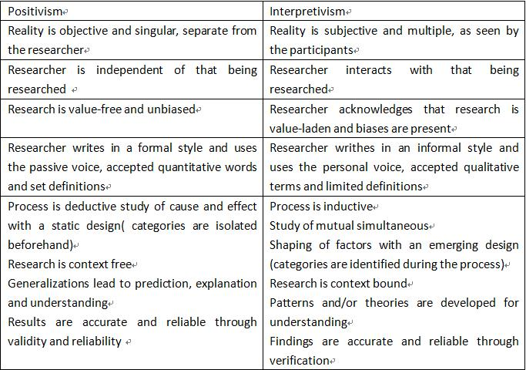

Table 3.1 Assumptions of positivism and interpretivism

Moreover, there are many differences which are not shown in the Table 3.1, such as the sample size, location and results producing. By comparing the two paradigms, it is found that positivism tends to use large samples. According to Fox(2013), the positivist approach encourages the use of quantitative data analysis and focuses on hypotheses because they have good reliability and representativeness. Compared with interpretivism, however, the observer must be independent and human interests should be irrelevant. In positivism, some theory provides the basis for interpretation and research should focus on facts (Walliman, 2001). In Table 3.2, features of the two paradigms are listed.

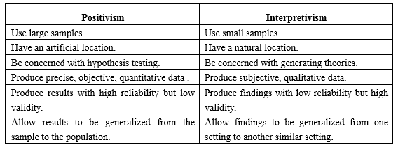
Table 3.2 Tables of the feature concerning positivism and interpretivism
In this report, the conclusion is based on quantitative analysis, observation and experiment. While quantitative research is often used with positivism, this study also chooses to use data collection through online questionnaires. Furthermore, the findings of this paper focus on the whole trends and patterns, not on individual cases. In light of these outcomes, it has been recognized that adopting a positivism paradigm would be appropriate.

3.2 Research Method
According to Bowen (2009), "a research method is a system for collecting and/or analyzing data." Research methods are generally classified as qualitative, quantitative, and mixed methods. Each is tailor-made for different kinds of research objectives and questions of different types. Qualitative methods seek to explore phenomena through non-numerical data, providing rich details, which further help in understanding behavior, motivation, or perception from close quarters. Quantitative methods deal with the elicitation of information through numerical data along with statistical details to prove points. It also helps in measuring variables and identifying patterns. Mixed methods contribute to bringing out the basic facts as much as possible from both qualitative and quantitative approaches by complementing each other's strengths. Since this study is rich in numerical data based on observation, an empirical investigation, a quantitative technique will be most relevant for which an online questionnaire will be used as the primary tool for data collection.

A digital tool used in eliciting information from respondents via the internet is an online questionnaire. It has proven very effective, efficient, and convenient in reaching large numbers of people or very remote populations at relatively low cost. Researchers can use online questionnaires to collect vast and geographically dispersed data on any topic. Online questionnaires are a type of structured instrument that consists of a series of detailed questions related to specific topics regarding attitudes, behaviors, or demographic information. Researchers can design the questionnaires with different question types since no rigid interviewing method is needed, closed-ended questions (e.g., multiple choice questions or Likert scale questions) force responses into predefined categories pre-specified by the researcher and make them easier to analyze quantitatively than open-ended, which allow respondents to answer in their words, thus giving richer qualitative insights. In both exploratory and descriptive research, this feature enhances the attractiveness of online questionnaires as a tool with various applications.

Moreover, for online questionnaires, the automation processing of web-based platforms in terms of distribution and data collection serves as the extra advantage. These platforms act as both the medium through which the survey is distributed and a repository for the collected data. Researchers can share the questionnaire widely by using digital means to ensure its reach through channels such as email, social media, or websites, thus making use of a larger audience base. On their part, respondents can take up the questionnaire at their own convenient time. This approach ensures that response rates are high due to its flexible nature. The data captured automatically stores itself in most cases in a database, which in turn lowers chances for data entry errors and expedites the process during analysis.

In empirical research, it uses online questionnaires which prove to be most useful in collecting primary data concerning a specific sample. Such data can be subsequently analyzed for the purpose of hypothesis testing, identifying relationships, and making generalizations about the larger population. The uniformity of responses in online questionnaires guarantees that the data is reliable for running parametric tests. The structured format further makes sure that responses can be analyzed with appropriate statistical methods of research. Also, through software tools like SPSS or Excel, researchers can process and analyze this data very easily, which ushers in the prospects of generating meaningful insights.

But online questionnaires have their own limitations. One of the challenges is that sample bias could be introduced as respondents with internet access may not be representative of the entire population. In addition to that, participants might misinterpret the questions or respond in a socially desirable way without the same opportunity for in-person surveys clarifications (Wright, 2005). To reduce this risk, researchers are required to design the questionnaire very carefully and observe whether it is clear, simple, and has meaning salient to the target population. Clear instructions along with pilot testing work in reducing potential misunderstandings before large-scale circulation.

3.2.1 Advantages of an Online Questionnaire
The ability of online questionnaires to elicit higher response rates is a very important advantage because, as noted by Evans & Mathur (2005), responding to surveys at their own time and place through the internet is extremely useful in reaching out to respondents spanning various geographical regions and time zones. In this kind of survey, the respondent chooses an appropriate time when he will not be under pressure to respond immediately but will participate. It is very helpful for a research study at the global level with respondents from various regions having different time zones because this allows a researcher to collect more representative and current information without being limited by physical distance.

Moreover, online questionnaires are highly cost-effective when compared to traditional methods such as face-to-face interviews or mail surveys. It does away with the big costs associated with printing, mailing, and manual entry of data— typically forming a major percentage of research costs (Wright, 2005). The savings are not just limited to the collection of data alone; the human resources needed for processing responses manually is eliminated through the automation of data collection and storage in online systems that would otherwise be labor-intensive and error-prone tasks. As a result, researchers can quickly collect vast amounts of data very cheaply and reasonably accurately; thus small or large-scale research with limited finances is well suited for this approach.

Speed is also achieved as a critical benefit of online questionnaires. Data collection and analysis are both quickened due to the inherent automation of digital platforms. Nearly immediately after the questionnaire has been dispensed, response can be gathered and data can be stored in an analysis-ready format (Evans & Mathur, 2005). This kind of advantage is very appropriate for those time-bound studies where speedy decisions have to be made. Within some days, or even hours, after having made the decision about how huge the study would be researchers could survey, take responses, and begin to analyze data.

Moreover, with online questionnaires, researchers can expand their sample to include a variety of people and make it more representative because there are no longer any geographic boundaries to adherence (Couper, 2000). Researchers can invite research subjects from other countries, cultural contexts, and demographic categories to take part in it. The possibility offered by such a wide reach is particularly valuable for research on global trends or cross-cultural studies. What is more, the capacity to gather information from a large number of participants increases a study's external validity by making its outcomes generalizable to a larger population.

This can also be done with offline questionnaires but that is not of great use now. Most online survey tools enable users to implement such features, like mandatory questions, logic branching, and error-checking algorithms that stop a respondent from filling in an incompatible or illogical manner which in effect assures good quality of data. Such make it more unlikely for there to be missing data, two responses, or questions outside the valid range (such as entering text where digits are called for) making the cleaning of data less cumbersome prior to analysis.

3.2.2 Disadvantages of the Online Questionnaire
Notwithstanding the many merits of online questionnaires, several limitations need to be borne in mind. According to Couper (2020), one of the most important issues is response bias. The online questionnaires themselves might pull in a number that is not proportionate of respondents who probably have extreme views or are overly passionate about the topic— thus likely distorting the results. Besides, some people might not be willing to take part because they are not interested in the subject or do not have access to the internet and may, therefore, be digitally illiterate enough to go around the questionnaire. This would result in a nonrepresentative sample, jeopardizing generalizability.

Sampling bias can also be when specific people are not in a position to be included in the online surveys, such as those who do not have access to the internet or are not comfortable with digital technology (Evans & Mathur, 2005). The "digital divide" term means that the result is a biased sample that does not represent large numbers of older adults, low-income individuals, or rural populations where there is no internet. Therefore, the results may be invalid for generalizing to the entire population, especially on issues requiring input from these misrepresented groups. Demographic information on these excluded groups would question the internal validity of the study and limit its generalization.

Another significant disadvantage is the accuracy of responses, particularly in the absence of a moderator who can provide clarification or additional context to participants (Wright, 2005). Questions may be misinterpreted by respondents if they are unclear or too complex, which may lead to wrong or incomplete answers. Besides, some of the respondents might be willing to give socially desirable reports—wrong; this is when someone gives what they feel are more socially acceptable answers rather than real opinions or behavior. This type of bias in response results can distort the data into erroneous findings.

This also applies to personal probing by the researcher in online surveys and the observation of non-verbal cues, which may be critical in understanding the subtleties behind a respondent’s selections or feelings. On the other hand, follow-up questions can be asked in face-to-face interviews, with more extended descriptions that give more insight to the researcher about the participant's rationale. The lack of this interactive engagement in online surveys scratches off much qualitative richness that could be explored from data and leaves out much room on issues' in-depth exploration.

Yet another challenge is what is termed survey fatigue. In this, the participants may get disinterested or tired because of either the length or repetitive nature of the questions asked. When questions are too long or very badly structured, it can cause the respondents to hurry through in their answering without thought; this then leads to a reduction in data quality. In case the participants find a survey time-consuming or very difficult, they might stop midway through filling it out. This will result in incomplete responses and therefore an added complication in analysis.

Thirdly, security and privacy are a concern in online surveys. The majority of platforms claim that they do offer encryption and secure data storage. Respondents may still be reluctant to share personal information over the internet, particularly in the aftermath of several high-profile data breaches and privacy scandals. This can serve as a factor that deters potential participants from responding truthfully or even from participating at all; hence, lowering the response rates as well as causing problems with the quality of data recorded. So researchers should also ensure that the platform for questionnaires is safe and keeps respondents' privacy confidential while collecting data.

3.2.3 Disadvantages of methods rejected
Some of those research methods are not selected in this report, such as interviews, focus groups, observation and case study. Reasons are as follows:

Interviews offer great value in revealing the details of situations but they also have limitations. One notable drawback is the likelihood of interviewer bias — where personal beliefs and attitudes can drive the formulation of questions as well as the interpretation of responses — compromising objectivity and accuracy (Qu & Dumay, 2011). The resource intensity means time scheduling, conducting and transcribing takes up a lot of time— especially if there are many interviews needed (Creswell, 2013)— in addition to compromising validity through social desirability bias; this happens when respondents provide what they believe will be seen favorably by interviewers instead of their actual thoughts or feelings (Bryman, 2012).

The focus group was also rejected because of the cost and they cannot find the problem in depth (Francis et al, 2010). According to Morgan(1997), “Even the presence of a moderator can affect objectivity. The way he or she guides the conversation may inadvertently lead participants to take certain positions.” Moreover, in addition to bias, focus group data presents additional challenges: it is like trying to untangle a complex web, as complex interactions involve a large amount of raw qualitative information - making any direct conclusions almost impossible (Stewart & Shamdasani, 2014).

Observation, especially participant observation, is a method used by researchers to collect data in real-life settings. However, like any other method, it has its drawbacks. An important issue that arises is observer bias— wherein the presence and personal views of the researcher can sway the actions of those being watched and color the analysis of what takes place before their eyes (Angrosino, 2007). Observational studies might demand considerable amounts of time; such studies could require long periods spent in the field which not all research projects can accommodate feasibly (Creswell, 2013).

According to Collis and Hussey(2009), case studies were rejected because it is difficult to find case studies that are appropriate for all studies and they may not necessarily be generalizable to a wider population. One of the main drawbacks is the question of whether their results are generalized; findings from a single case or a small number of cases may not apply to a larger population or other setting (Yin, 2014). There is also the specter of bias when a researcher’s personal interpretation of information can distort the course of a case (Stake, 1995). Furthermore, case studies often require a large amount of data from a variety of sources, which in turn can be time-consuming and resource-intensive (Eisenhardt,1989).This tangled web—judging disparate information—can easily slip through your fingers: some people may never agree, while others may get lost in translation.

3.3 Sampling

3.3.1 Sample
A sample is but a subset of the larger population and is chosen to be measured, observed, or questioned so as to extract information that can be generalized to the entire population (Taherdoost, 2016). Researchers need to choose very carefully a sample that mirrors the population from which it is drawn; this enables statistical generalization where findings apply or pertain to the population. The sampling process, especially in quantitative research, is key to ensuring both reliability and validity of study; because an unrepresentative sample will result in biased or invalid estimates.

This study uses the purposive sampling method, which is a type of non-probability sampling. In purposive sampling, also known as judgment sampling or selective sampling, the researchers make use of their discretion in selecting those respondents who can best answer the research questions (Fox, 2013). This method is not at all random; it depends on the researcher's judgment in identifying individuals who have the specific feature or information according to the study being conducted. Most often, purposive sampling is used when the research requires participants with certain expertise, experiences, or demographic backgrounds. It is then an ideal approach when a study focuses more on depth and specificity rather than broad generalization and notions.

For this study, which explores the influence of the McDonald’s brand image on consumer purchasing behavior, purposive sampling is very appropriate. The target respondents are customers at McDonald’s as well as people with some background knowledge in the fast-food industry. This will ensure that the collected data is relevant to the research questions because these respondents will more substantially provide meaningful insights into the perception of the brand by McDonald’s and its effect on their buying decisions. According to Bryman and Bell (2015), purposive sampling enables a researcher to select participants based on specific criteria relating to key features under investigation to ensure representativeness of those elements, such as brand familiarity and purchasing behavior.

With the time and resources available for this study, purposive sampling stands as a good choice. It permits the researcher to zero in on specific set of respondents who can provide data most relevant within the limited time frame. External validity is enhanced by such a method, known also as internal control through selection, wherein the selected sample is very close to what would make the research objectives more likely to be accurate and dependable. This ensures that the information obtained will be more valid in explaining how brand image affects consumer purchasing decisions, by focusing on McDonald’s customers and people that have some familiarity with fast food.

3.3.2 Sample Size
The sample size is the number of participants or observations selected from the population, and it is a crucial factor in research design. Cochran (1977) views that sample size has an influence on the precision and validity of research findings: generally, larger sample sizes result in more reliable and valid research findings by decreasing the chance for random sampling error (and likely systematic sampling error) to levels of small probability. Larger sample sizes in quantitative research enable more robust statistical analysis while also affording greater assurance when making generalizations to a larger population with this type of information.

In purposive sampling, however, the focus is not specifically on obtaining a large sample size but on choosing those respondents who are related most to the research objectives. As indicated by Palinkas et al. (2015), purposive sampling is applied when researchers must focus on specific features or criteria within a population that directly address the research questions. This method is widely used in exploratory research and in research studies related to specific subgroups within a population. In such cases, what counts most is the depth of insight and quality of data rather than the quantity of respondents.

Moreover, Feinn (2012) argues that with purposive sampling, it is not mandatory to have a large sample size to ensure data accuracy if the participants are well selected to reflect the related phenomena under study. The specific size of the sample is often driven by research objectives and the uniqueness of the context where the study is conducted. Since this research revolves around McDonald’s brand image and its effects on consumer behavior, a sample of over 50 respondents is enough. This will help take into consideration many views considering consumers from various demographic groups like students and employees among other professions. This gives proper representation in terms of diversity of McDonald’s customer base.

The involvement of participants with different professions and backgrounds ensures that the data will be representative concerning various consumers' experiences and perceptions of the brand. The critical dimensions for this diversification in understanding the full scope of brand image impact are that different consumer segments may have a unique way of engaging with the brand. For example, to students, McDonald’s may just be one of the affordable and convenient options available, while working professionals might need to consider other factors first before settling on McDonald's as their best option (like product variety or brand reputation).

The selected sample size is also big enough to allow a meaningful statistical analysis. A larger sample size would provide added precision, but this study concentrates on a well-chosen group of respondents, and therefore its results will be reliable and valid within the research objectives' scope. Besides the time and resource constraints, over 50 respondents as the sample size strike an optimal balance between feasibility and information richness to draw sound inferences about McDonald's brand image and its impact on consumer purchase behavior.

3.4 Questionnaire Design
The questionnaire was carefully developed to reflect individuals' thoughts and behaviors about McDonald's with a view to obtaining detailed information while minimizing respondent burden. As noted by Ritchie et al. (2013), reducing the number of questions is important for improving reliability and validity since over-questioning can reduce zeal and lead to lower response rates. According to McLeod (2014), the questions should follow from general inquiries to more specific ones so that respondents can naturally progress in their thought processes while replying. Below is an online questionnaire consisting of 16 items that were worded with care and attention to ensure ambiguity in neither the questions themselves nor the expected responses..

To increase the depth of the study, the questionnaire is divided into three sections. The first part acquires demographic information by collecting details related to age, sex, and occupation and thus making sure that the sample so selected is representative as well as diverse. Such basic data are very important for placing on record the findings and also seeing how different factors of demographics might influence consumer behavior. The second section explores the relationship of the respondents with McDonald's by looking at how often they visit, their favorite products or meals in McDonald’s, and Mc satisfaction in general. This is very important in capturing perceptions and experiences on the ground that can be used to inform business strategies.

The third section investigates consumer perceptions in terms of the brand image of McDonald's according to such frameworks as the consumer decision journey (Edelman & Singer, 2015), brand image theory (Aaker, 1991), and consumption values theory (Sheth, 1991). Knowing what provokes consumers in their decision processes enables uncovering underlying motivations that influence relationships with brands. In congruence with a positivist approach, Sections One and Two of this paper use closed-ended questions. Respondents are thus able to choose answers from those provided, which not only decreases the time needed for questionnaire completion but also ensures better consistency of responses that can be compared across various respondents. Furthermore, closed-ended questions help increase response rates and facilitate data processing for researchers and respondents alike, ultimately resulting in stronger insights that are also more actionable as a result.

3.5 Piloting the Questionnaire
To enhance the questionnaire results' accuracy for McDonald's, Arain (2010) noted that an online questionnaire should be distributed only after a pilot study is done with the target sample. This will ensure that all participants have uniformity in understanding the questions and also a low possibility of misinterpretation. The clarity and dimension of a questionnaire are verified through a pilot test (Bian & Moutinho 2011). This research had the questionnaires first given to 5 individuals chosen by the researcher. A number of changes were made on the basis of feedback from the participants. For example, six questions in section three were reorganized to flow better logically and some redundant questions deleted. Also, question eleven was modified to include other potential factors influencing customer purchase behavior.

In this case, a pilot study provides some insight that could enhance the research approach for an increased probability of clear and accurate findings in the main study. Errors in questions may lead to unreliable results; therefore, revisions after the pilot phase are essential. Ineffective or unclear questions are worked over or deleted to make sure that the final instrument is more reliable for the final study It can uncover new ideas and new approaches as well: a pilot study might contribute to better understanding consumer behavior concerning McDonald's products and services, thus improving overall quality of research.

3.6 Sending the Questionnaire
The respondents for this questionnaire sample are people who have visited McDonald's and at least have an idea of what it sells. This approach assures that the data to be collected is real and valid. Sojump Survey (The Chinese software from the Tencent Company) will be used in this research to distribute the questionnaire over the internet. The respondents' links to the survey were shared on social media or via email with a large description of the same.

The study sample size is 57 respondents, and the online questionnaire will be made available to the respondents from 10th August., while the completed questionnaires are to be collected by about 21th August, taking into consideration the variable availability of the respondents. This period gives enough flexibility to participants but also ensures the data will be gathered promptly for analysis.

3.7 Reliability and Validity

3.7.1 Reliability
Reliability refers to the consistency or stability of a measurement instrument or procedure over time— revealing itself as a mark that mirrors the continuity and uniformity of the results from a study. Or even the operational precision of a tool when exposed repeatedly under the same conditions. When an instrument is said to be reliable, it means that it gives similar outcomes whenever it is used more than once; in other words, this implies that the measure does not contain any randomness (Creswell, 2014).

The data of this paper comes from the online survey; however, there exists obstacles and opportunities when it comes to reliability. The advantage of the online survey is that it can be reproduced with the highest possible accuracy, which can significantly improve test-retest reliability. However, differences in respondents' internet connections, different devices used to access the survey, and possible distractions in the online environment are all key factors in unreliable feedback (Lefever, Dal, & Matthíasdóttir, 2007). Additionally, the absence of a researcher can cause respondents to misjudge the content of certain survey questions, which can further compromise reliability (Wright, 2005). Due to the above reason, in order to eliminate the underlying influence as much as possible, background knowledge and basic description is provided in the questionnaire. Moreover, the purposive sampling ensures that most respondents have the general or basic understanding of the selected topic. These could be of great help to guarantee the reliability of this paper.

3.7.2 Validity
Validity is about the degree that a measurement instrument or process faithfully measures what it's supposed to. It signifies how much the results of a particular study can mirror the actual traits of the phenomenon under inspection. Validity thus sees to it that whatever comes out from a research work is genuine and applicable, touching base on the right concepts and crafting sensible outcomes (Heale & Twycross, 2015).

In order to ensure the validity of this paper, questionnaires are based on the literature review and data processing as well as data analysis are under supervision.

3.8 Analysis of Findings
The purpose of this paper is to identify McDonald’s brand image influence on consumer purchasing behavior, and the researcher is the main data collector of this research. Tencent questionnaire(Chinese survey software) is selected and the time plan of data collection is one week. Additionally, based on the statistical result, SPSS, excel and other similar software will be further applied to do the data analysis. Finally, the data analysis will be used for research objective demonstration, providing support for the paper.

3.9 Study Limitations
This paper mainly has two limitations, namely the time limit and sample range, which are as follows:
·The time limit. Due to the limited time, this paper only adopts certain research method and only select online questionnaire to do the data collection.
·The sample range. Due to the research method, the sample selected is small, although it meets the requirements of purposive sampling. However, the size is too small, compared with the consumer groups even just in the Chinese McDonald’s market. Potential uncertainty and ineffectiveness of statistical results exist.

CHAPTER 4 : Data Analysis

4.1 Survey

The questionnaire is mainly divided into three sections: as for the first section, it is concerned with some basic demographic questions. The second section refers to consumer perception, preference and impression towards McDonald’s. The third section of this questionnaire covers significant factors concerning the brand image and consumer purchasing behavior.
In terms of responses to the study, there were 57 questionnaires collected in 2 weeks, from the 4th August 2024 to the 19th August 2024. In addition, all samples were successfully attained and there is no extra work left , with overall respondents responded on time and complete data received smoothly. All questionnaires turned out to be completed fully with no errors reported during the data collection process. The general purpose of this research is to explore the relationship between brand image and consumer purchasing behavior, and the result of this research will provide references to evaluate the brand image’s (McDonald’s) influence on consumer purchasing behavior.

4.2 Basic information of the consumer

4.2.1 Gender
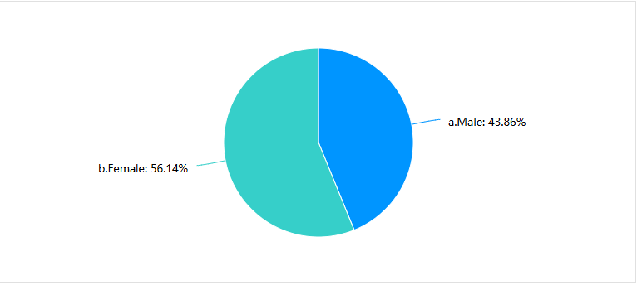
The first question in the questionnaire is about the gender of participants. The result shows that female consumers occupy 56.14% of the whole participants, while male consumers just take up 43.86%.

Consumer preferences for fast food chains can vary significantly based on demographic factors. Males are reported to emphasize values and variety on the menu. In contrast, females will focus on the nutritional value and health status of food. (Huang & Rundle-Thiele, 2014). For the popular fast-food brands like McDonald's, the evidence available indicates that there is likely to be an even gender distribution of customers. As pointed out by O'Neill and Vella (2015), the number of men versus women visiting McDonald's is almost equal. As illustrated in the above chart, the difference between male and female ratio is not far from an equal proportion. The reason behind this balance may be attributed to the wide range of items featured in the menu since it can cater to varied preferences and tastes, thus appealing to both sexes.

4.2.2 Age
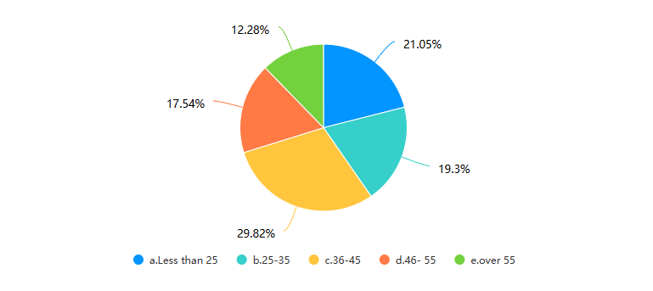

Based on the chart, the largest group of survey participants is those aged 36-45, accounting for 29.82% of the total. This is followed by the groups aged under 25 and 25-35, which make up 21.05% and 19.3% respectively. The groups aged 46-55 and over 55 have smaller proportions at 17.54% and 12.28% respectively. Overall, the majority of respondents are concentrated in the 36-45 age range.
The table shows that people who are under 35 years old occupy almost 40% of the selected group. According to Blumenstock and Eagle (2010), younger people prefer up-to-date stuff with the fashion and technology trend followed by people who are under 35 years old. Moreover, Smith and Johnson (2013) noted that McDonald's good fashion sense keeps it appealing to the young consumer base. This is supported by its considerable presence on social media and digital marketing efforts (Lee & Kim, 2015).

4.2.3 Occupation
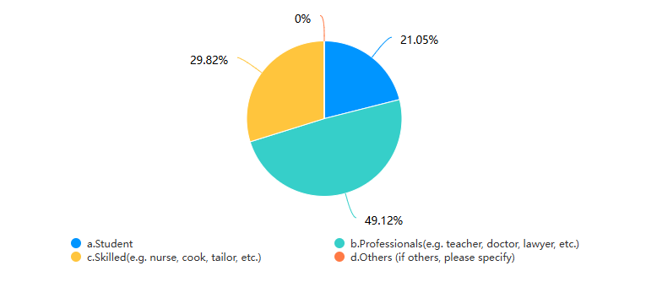

As can be deduced from the table, the most numerous group of respondents are professionals, with a percentage of 49.12. Followed by are students with 21.05% of respondents and technical workers with 29.82% of respondents. None of the respondents chose “Other.” On the whole, it can be said that professionals are the leading group of respondents to the survey.
Food preferences are some of the areas that define attitude variability between different occupational classes of consumers. Professionals mainly consider fast food according to its convenience and value, going for those alternatives that can be fitted into their busy schedules with a good cost-efficiency (Kwortnik & Thompson, 2009). Students, on the other hand, are primarily concerned with fast food’s taste and their declining health and hence view it as quite unhealthy. They feel that it is cheaper than preparing a meal from scratch and that it is socially acceptable (Vermeir & Verbeke, 2008). Given this variance in preferences, there would be an expected high representation of both business professionals and students. The availability of fast-food service with a wide range of menu items along with different value-for-money meals would have heightened their interest in this brand (Cottam & Vickery, 2016).
Hence, McDonald’s attracts a large number of professionals and students. McDonald’s offers a range of value-for-money menu items and fast service, which is well suited to the needs of busy professionals and budget-conscious students. The brand’s consistent quality and wide selection cater to different preferences, making it a popular choice for different groups of people (Jang & Kim, 2016). In addition, McDonald’s targeted promotions and loyalty programs further increase its appeal to these key groups (Hsu & Liu, 2017).

4.2.4 Monthly income
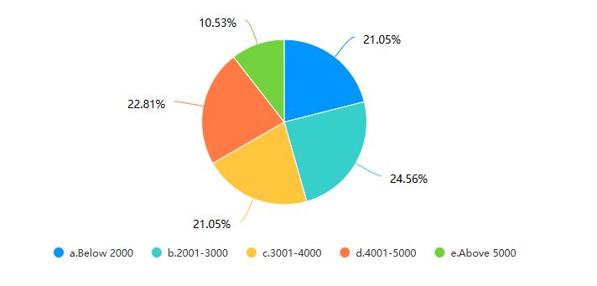

According to question 4, the chart shows that the largest group of respondents have a monthly income between 2001-3000 yuan(Chinese dollar) and 4001-5000 yuan, accounting for 24.56% and 22.81% respectively. There are fewer participants with an income of more than 5000 yuan and more than 3001-4000 yuan, accounting for 10.53% and 21.05% respectively. The smallest group has a monthly income of less than 2000 yuan, accounting for only 21.05% of the respondents.

McDonald’s pricing strategy includes affordable menu options and frequent special offers, which effectively cater to price-sensitive customers (Hsu & Liu, 2018). This explains why McDonald’s are widely recognized and favored by people from different income groups, as the chart illustrates.

4.3 McDonald’s consumer behavior

4.3.1 McDonald’s consumer’s information
-Have you tried McDonald’s?
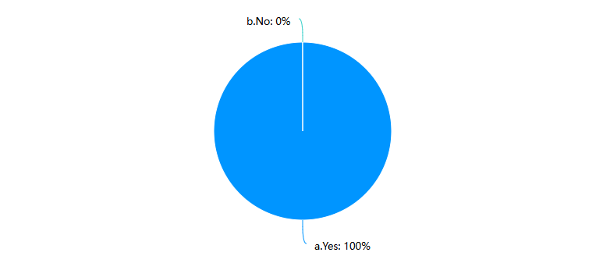
-How often do you go to McDonald’s?

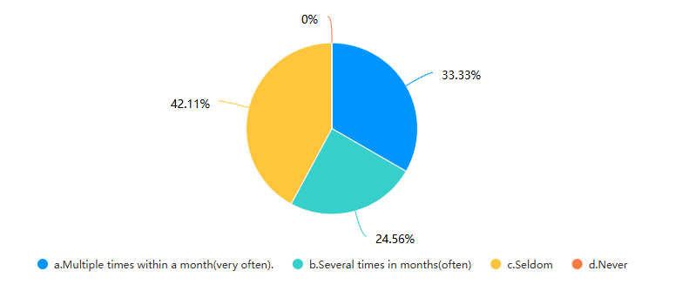
These two questions--- “Have you tried McDonald’s?” and “How often do you go to McDonald’s?” try to attain specific information from respondents. As for the fifth question, it is shown that all respondents in this study have tried McDonald’s, while the reason may lie in its popularity and global awareness.
The sixth question of this questionnaire intends to investigate the frequency that respondents go to McDonald’s. According to the chart, 33.33% said they frequently visit McDonald's, that is, a few times in a month, while 24.56% said they often visit McDonald's several times in months. In addition, 42.11% of respondents said they seldom visit McDonald's. Moreover, no respondents chose not to go to McDonald's.
This may suggest that McDonald’s attracts a large number of frequent customers, especially among young people who value convenience and affordability (Smith & Johnson, 2016). The high visit frequency of this age group can also be attributed to McDonald’s consistent value proposition and promotional strategies, which are very consistent with the preferences of young consumers (Hsu & Liu, 2018).

4.3.2 Reasons of the McDonald’s

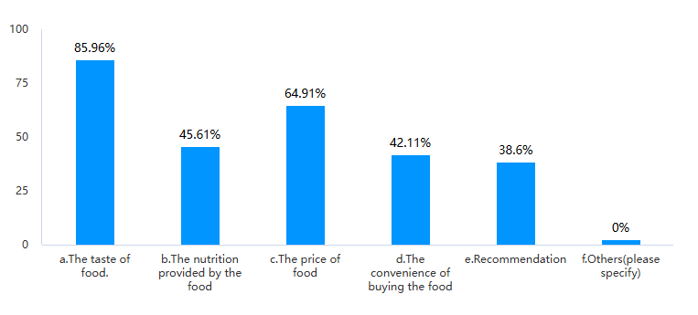

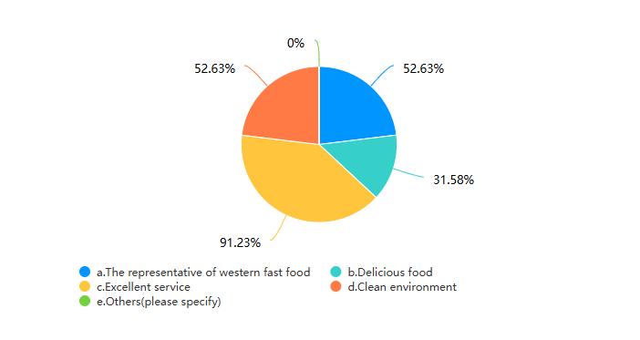

In the “Reasons of McDonald’s”part, the designer aims to investigate the reason that respondents choose McDonald’s. The first question is mainly about McDonald’s food, while the second question focuses on the overall perspective. As for food, the chart shows that the main factors affecting the choice of McDonald's are the taste of food (85.96%), the nutritional value of food (45.61%), the price of food (64.91%), the convenience of dining, buying groceries (42.11%) and recommending others (38.6%). Among them, taste is the main factor affecting the choice of McDonald's, followed by the price and nutritional value of food. Convenience and recommendation also have a certain impact on the choice of McDonald's.

From the general perspective, the chart shows that the respondents have different degrees of recognition for various descriptions of McDonald's and its brand image. The most recognized is the high-quality service, which was selected by 91.23% of the respondents. Then, 52.63% of the respondents recognized the symbol of Western fast food and clean environment. The "delicious" was selected by 31.58% of the respondents, with a lower recognition rate. Overall, McDonald's' most recognized feature is its high-quality service, which also highlights its role as a symbol of Western fast food and clean environment, although people have a lower evaluation of the deliciousness of the food.

In Smith&Jones(2022)’s research, it also noted that the taste of food is one of the major factor that appeals to consumers and encourages future purchases. In addition, affordable price of food with value options on menu is also what attracts budget-conscious consumers (Brown et al.,2021). Moreover, although there are no specified reasons outlined in the questionnaire, brand familiarity and consistency can not be neglected. According to Williams&Clark(2023), “the company's robust brand recognition and unwavering commitment to delivering a consistent experience across the globe also contribute to sustaining customer loyalty.”

4.3.3 Perception of the McDonald’s
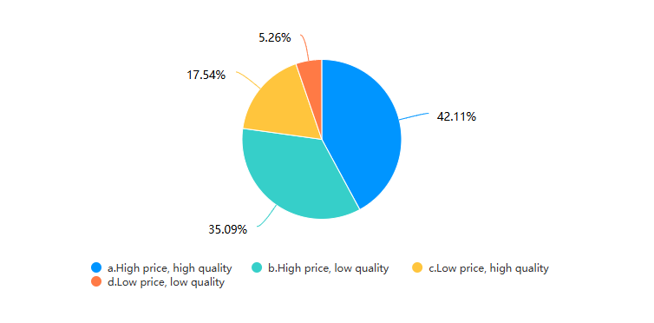
This question is mainly to learn about consumer’s perception of McDonald’s. According to the chart, 42.11% of respondents regard McDonald's as the brand which offers high prices and high quality, 35.09% believe it has high prices and low quality, 17.54% believe it has low prices and high quality, while 5.26% believe it has low prices and low quality. In conclusion, most respondents believe that McDonald's is relatively expensive, and opinions on quality are varied among respondents.

As discussed in the former chapter, according to Strizhakova(2010), “different consumers would have different perceptions for the same product because of the experience, attitudes and beliefs”. It is of importance to note that consumer’s perception towards McDonald’s may vary, which means future study on underlying factors such as age, gender, occupation and disposable income is needed.

4.4 Brand image’s influence on Consumer purchasing behavior

The third part of the questionnaire uses the Likert scale, a rating scale that is used to measure opinions, attitudes or behaviors. (Pritha Bhandari&Kassiani Nikolopoulou,2020). Questions on consumer purchasing behavior, brand awareness, perceived quality and brand loyalty are delivered in this part, with all of them come from the chapter literature review.

4.4.1 Consumer purchasing behavior
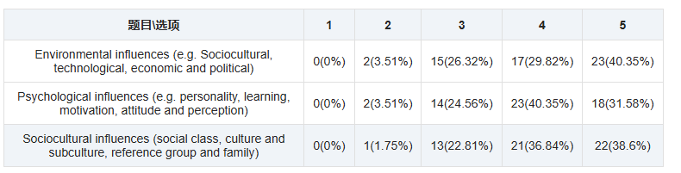
(1= Very important, 2= Important, 3= Neutral, 4= unimportant, 5= very unimportant)
Note: In the Chart, X(Y%) means the number of people choose the option (X) and the percentage they take in the whole group (Y%).

According to Solomon (2020), three key factors that influence consumer behavior are psychological factors, social and cultural factors, and situational factors. Based on Solomon’s idea, the question aims to investigate respondent’s opinion from the above three factors.

Regarding environmental factors, 40.35% of the respondents believed that they were very unimportant to consumer purchasing decisions, while 29.82% believed that they were unimportant and only 3.51% believed that they were very important. This finding is consistent with Jobber (2012), who believed that environmental factors can influence consumer behavior, but their influence is often overlooked.

In terms of the psychological influence on consumer behavior, 40.35% of the respondents believe that they are unimportant to consumers, while 31.58% believe that they are very unimportant, and only 3.51% believe that they are very important. Solomon (2020) mentions that the significance of psychological factors differs across different market segments, this may explain the overall low importance that respondents give to these factors.

For the sociocultural factors that influence behavior, 38.6% of the respondents believe them to be unimportant, while 36.84% think they are unimportant and only 1.75% believe they are very important. This may be in line with Kotler and Keller (2016), who remarked that sociocultural factors are often of secondary importance in other contexts, but are still significant in certain instances.

4.4.2 Brand awareness
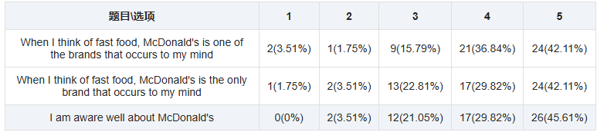
(1= Strongly agree, 2= Agree, 3= Neutral, 4= Disagree, 5= Strongly disagree)
Note: In the Chart, X(Y%) means the number of people choose the option (X) and the percentage they take in the whole group (Y%).

This table illustrates how participants respond to the three questions mentioned in the questionnaire that are related to the brand awareness. According to the analysis of brand awareness data, over 36.84% of the respondents disagreed or strongly disagreed that McDonald's is the fast food brand, while 15.79% of the respondents were neutral, indicating that there is room for improvement in McDonald's brand awareness in the fast food industry. In addition, there exists about 5% respondents who believe that McDonald's is the only fast food brand that comes to mind when thinking of fast-food brands, which reflects its unique positioning for some consumers. However, only about 24% of the respondents have a positive view (Strongly agree,agree and neutral) of McDonald's, indicating a relatively low brand awareness.

The results of this study concur with previous research by Tong and Hawley (2009) and Chang and Liu (2009), which showed that consumers are more inclined to choose a product with high brand reputation. This is of great importance to McDonald's- a global brand that is still recognized as a leading force in the fast food industry. Hakala (2012) also noted that consumers tend to choose familiar brands when making purchases, which may further enhance the popularity of McDonald's because of its high brand reputation. As suggested by experimental researches, consumers tend to the product which comes from a familiar, preferred brand than new brands. (Aaker, 2009)

Other critical factors include the brand's name and logo. Keller (2008) mentions the importance of a brand's name lies in effectively delivering brand's essence, while Hem and Iversen (2004) focus on the importance of logos that have a direct relationship with the company's brand equity. However, the results of this questionnaire indicate that the McDonald's brand name has less influence on consumer purchasing behavior. Only about 5% respondents choose McDonald for fast-food priority, compared with 22.81% that are neutral. In addition, about 20% respondent treat McDonald's as one of those fast-food brands that may occur to them, which indicates the brand's distinctiveness in the minds of a portion them. However, as mentioned in the first paragraph, only about 24% respondents holds a positive view that “they are well aware of McDonald’s”. These results may suggest that McDonald's should take further actions to enhance its brand positioning in the industry, as in reinforce the “top-of-mind” call and consumer preference.

4.4.3 Perceived quality
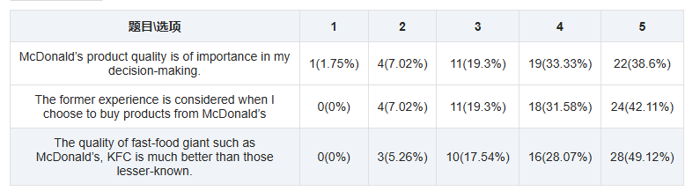
(1= Strongly agree, 2= Agree, 3= Neutral, 4= Disagree, 5= Strongly disagree)
Note: In the Chart, X(Y%) means the number of people choose the option (X) and the percentage they take in the whole group (Y%).

This part aims to investigate respondents’ opinion of the three listed factors associated with the perceived quality. The survey results show that McDonald’s product quality is not a determining factor in purchasing. A significant 38.6% of participants strongly disagreed, along with 33.33% disagreed that McDonald’s product quality plays a vital role in their decision-making process. Only a small number of people (7.02%) agreed with the importance of quality, and 1.75% strongly agreed with the importance of quality. This suggests that for most consumers, McDonald’s product quality is not an important consideration, which is consistent with previous research finding that convenience and brand familiarity are often more important than quality issues in fast food purchasing behavior (Hakala, 2012).

Additionally, respondents seem to pay little attention to previous experiences when purchasing McDonald’s products. The majority strongly disagreed that their previous experiences influenced their decision and 31.58% of respondents also disagreed. This finding is in line with Keller’s (2008) view that while brand awareness remains important, consumers’ previous experiences are not the deciding factors for repetitive purchases in the fast-food industry, where other factors such as convenience and accessibility are of vital significance.

Moreover, a large proportion of respondents doubted that fast food giants such as McDonald's and KFC can do a better job of quality assurance than these smaller, less well-known brands. Nearly half of the participants (49.12%) strongly disagreed with the statement that fast food giants provide higher quality food and service than those less well-known competitors, along with 28.07% of respondents who disagreed. This is consistent with the research of Hem and Iversen (2004), who found that consumers do not necessarily equate brand size with superior quality, especially in highly competitive markets where small brands can provide similar or even better products.

4.4.4 Brand loyalty
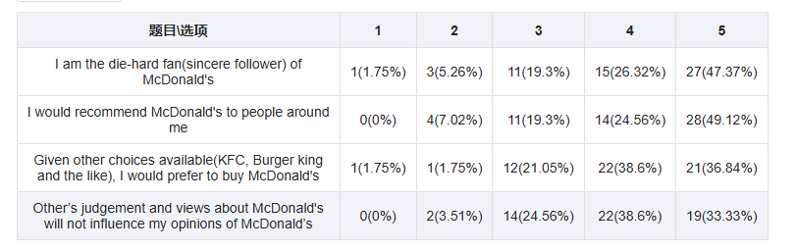
(1= Strongly agree, 2= Agree, 3= Neutral, 4= Disagree, 5= Strongly disagree)
Note: In the Chart, X(Y%) means the number of people choose the option (X) and the percentage they take in the whole group (Y%).

This table shows questions and results regarding the brand loyalty. Nearly half of the respondents (47.37%) strongly disagreed with the statement that “I am a die-hard fan (sincere supporter) of McDonald’s.” This indicates that most respondents do not consider themselves to be loyal followers of the brand, indicating low emotional attachment. When asked if they would recommend McDonald’s to people around them, 49.12% of the respondents strongly disagreed. This complies with Keller’s view that many people are hesitant to promote the brand in their social circles, which is an important indicator of brand loyalty (Keller, 2001).

In addition, 36.84% of the participants noted that they strongly disagreed to buy McDonald’s when there are alternatives such as KFC or Burger King. This means that McDonald’s is usually not the first choice of consumers when there are other similar options (Aaker, 1991).

Moreover, the influence of other people’s opinions can not be neglected. About 70% of the respondents strongly disagreed and disagreed with the statement “other people's judgments and opinions about McDonald's do not affect my opinion of McDonald's", indicating that social factors affect people's brand perception of McDonald's. This vulnerability to external influences weakens personal brand loyalty and shows that McDonald's image in the eyes of consumers is sensitive to peer perceptions (Solomon, 2017).

These results indicate that respondents have the relatively low loyalty to McDonald's. Most are neither enthusiastic about the brand nor willing to recommend it to others. In addition, McDonald's faces competition from other fast food chains, which often make it a top choice. Finally, brand image relies on social influence, which complicates the work of building a loyal customer base.

4.4.5 McDonald’s brand influence on consumer purchasing behavior

-Does the McDonald’s brand influence your buying behavior?
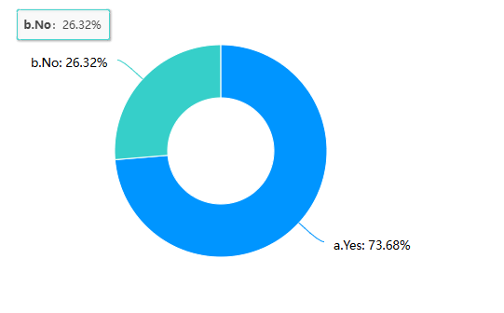
This question aims to investigate respondents’ view on whether the McDonald’s can influence consumer purchasing behavior. From the chart, about 75% respondents hold the view that McDonald’s can influence consumer buying behavior while the rest 25% respondents think the consumer purchasing behavior can not be influenced by McDonald’s brand image.

The results indicate that the McDonald's brand's reputation has a significant impact on the majority of consumers, however, a quarter of the participants believe otherwise. This group may have experienced enough brand fatigue or they may have instead preferred other options (Solomon, 2017). The divergence indicates the fact that while McDonald’s influences the majority, it also faces the difficulty of maintaining its brand loyalty and consumer’s engagement (Keller, 2001).

4.5 Correlation analysis
Correlation analysis is dedicated to measuring the degree to which things are connected and how close they are. This research has identified several critical indexes that are not completely independent, but which can be connected through the SPSS method of correlation. The measurement of the result is primarily concerned with the degree of Significance (both sides) of the relationship, which has a negative association with the correlation coefficient, if the Significance (both sides) is less than 0.01, it indicates the significant association, if the Significance (both sides) is greater than 0.05, it indicates that there is no association between the tested variables.
In order to further understand the relationship among the influences on consumer buying behavior, brand awareness, perceived quality and brand loyalty, some correlation analysis had been done for the part three in the questionnaire through SPSS.

4.5.1 Influences on consumer purchasing behavior and brand awareness correlation analysis
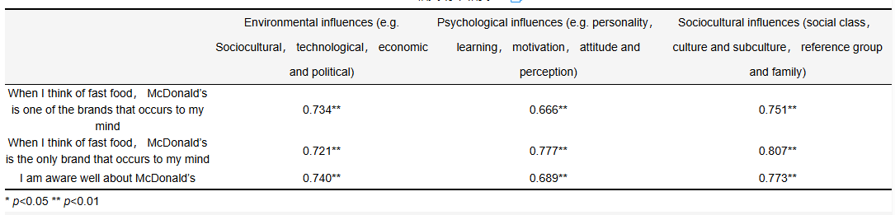
In this table, Pearson Correlations are provided and marks are big, which shows the strong connection between factors. For instance, the numbers between environmental influences and brand awareness are 0.73, 0.72 and 0.74, which mean they are strongly connected. From the whole picture, it can be inferred that brand awareness and consumer buying behavior have significant relations.

4.5.2 Brand awareness and brand loyalty correlation analysis
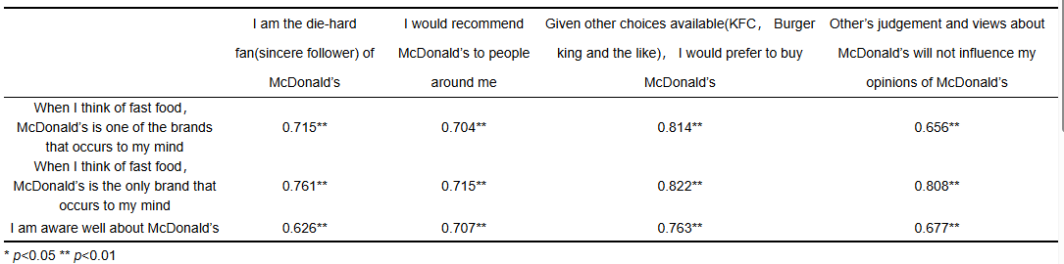
From this table, it tells that Pearson Correlations are significant are Significance (two-sided) are less than 0.01. Therefore, brand awareness and brand loyalty exist strong relations.

4.5.3 Brand awareness and perceived quality correlation analysis
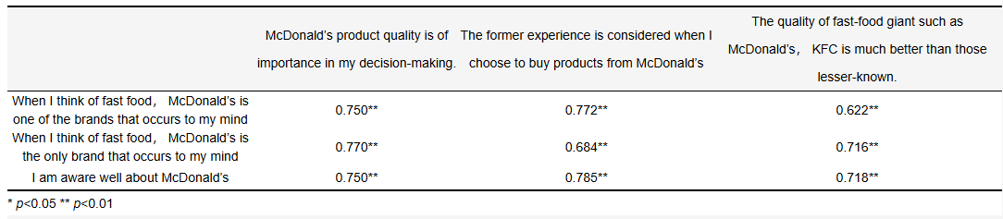

From this table, it tells that Pearson Correlations are significant are Significance (two-sided) are less than 0.01. Therefore, brand awareness and perceived quality have remarkable relations.

4.5.4 Correlation among consumer buying behavior, brand awareness, perceived quality and brand loyalty.
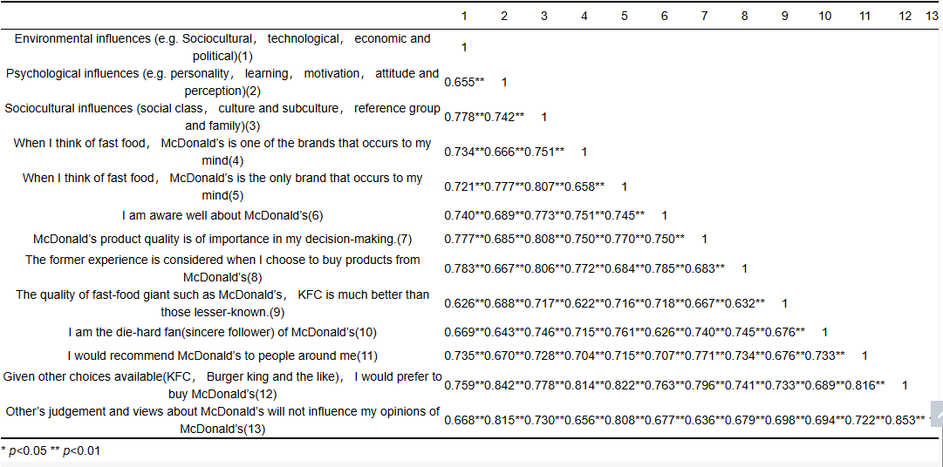

In the beginning of Part 4.5, the author has already introduced the correlation analysis and the Significance. From the above table, results showed a consistent strong positive correlation between these factors and preference for McDonald’s. For instance, environmental influences are significantly correlated with desire for McDonald’s (0.759) and believing that others’ opinions would not influence one’s own opinions (0.668).

In addition, when McDonald’s is the brand that comes to mind when people think of fast food, there comes a strong correlation with preference (0.814). This correlation is further strengthened when McDonald’s resembles the only brand that comes to people’s mind (0.822). The importance of McDonald’s product quality in decision making also shows a significant correlation with brand preference (Hair et al., 2010).

The analysis also shows that being a big fan of McDonald’s (r=0.689) and recommending it to others (r=0.816) strengthen the positive relation with consumer preference. Overall, these results show that higher scores on these variables are strongly associated with a preference for McDonald’s over other fast food options.

CHAPTER 5: Conclusions and Recommendations

For the chapter 5, it aims to conclude and summarize the results and findings of this research, followed by the data and discussion in chapter 4. In this chapter, it is intended to outline mainly 4 parts in which are shown in the objectives of this research.
The objectives of this research are as follows:
· Identify the feature of brand image and consumer purchasing behavior
· Analyze the potential influence on the consumer purchasing behavior
·Evaluate the relationship between brand image and consumer purchasing behavior
· Give recommendations

5.1 Identify the feature of brand image and consumer purchasing behavior

Brand image refers to consumers' collective perception of a brand, including quality, trustworthiness, and emotional resonance (Aaker, 1996). A strong and positive brand image influences consumer behavior by shaping consumer preferences and guiding their buying decisions. Consumers tend to choose brands that cater to personal values or offer a unique identity, which often leads to brand loyalty and future purchases. According to Kotler& Keller(2016), famous brands use their global visibility and consistent communication to build consumer trust, which lead their customers to choose their products over those of competitors. Therefore, brand image is more than just a logo, while it is closely related to experiences and associations that consumers may form with a brand over time.

Consumer purchasing behavior refers to the decision-making process that individuals go through when deciding what, when, and from whom to buy, while it is also influenced by a variety of factors, including brand image, perceived quality, and personal preferences (Solomon, 2018). As is mentioned above, a positive brand image can shape consumer’s preference, thus enhancing the consumer confidence in the purchase. As consumers regard a brand as those of high quality, they are more likely to pay for its products, (even in an extra charge), which could lead to higher sales and loyalty, while a negative brand image can deter potential customers and damage a company's market position within the sector. Therefore, effective brand image management is of significance for companies that want to keep on edge and impact the consumer buying behavior.

5.2 Analyze the potential influence on the consumer purchasing behavior
Another objective of this research is to investigate different factors that may influence the consumer purchasing behavior of McDonald’s. As results indicate, brand reputation and price have a significant impact on the consumer’s decision. According to the data in chapter 4, 73.68% of the respondents hold a positive view that McDonald's has a direct impact on their purchasing behavior, which may contribute to the importance of brand identity in determining consumer preferences. This aligns with Keller (2008) and Aaker (2009), who claimed that a powerful brand reputation increases customer loyalty and creates trust, as both of which have a significant impact on buying behavior. McDonald’s global reputation and its budget-friendly marketing strategy make it always an available option for its consumers.

Although there are multiple factors influencing the consumer buying behavior, it is important to note that the pricing strategy of McDonald’s is of the priority, according to the survey. Hsu and Liu (2018) mentioned that the affordable options of the menu and promotions at McDonald’s are appealing to different income groups, which makes McDonald’s an ideal choice for consumers who are budget-conscious and prefer the cost-effective.

Despite the influence of the brand and the pricing, it is worth to note that quality is not the primary concern of consumers when they choose McDonald’s. About 72% respondents states that quality of the product is less significant in their purchasing decisions, which aligns with Hakala's (2012) study. In Hakala’s study, it demonstrates that in the purchasing activity of the fast food, consumers tend to focus on the convenience of the product, brand reputation, and accessibility. While McDonald’s is considered a well-known brand and its quality is always granted, the quality of products does not have a significant impact on consumer buying behavior, compared with other factors like convenience and cost.

Additionally, environmental and situational factors such as the dining experience and surroundings are of little importance in the fast-food context. The majority of respondents (40.35%) considered environmental factors to be of little importance, which aligns with Jobber (2012), who believed that environmental factors can influence consumer behavior, but their influence is often overlooked. McDonald’s core assets are brand reputation and pricing strategy, rather than the atmosphere of dining or the quality of the products. McDonald’s may be user-friendly to consumers who seek quick, budgeted, and familiar options for meals.

5.3 Evaluate the relationship between brand image and consumer purchasing behavior
The relationship between McDonald’s brand image and consumer purchasing behavior focuses on both the brand’s impact on consumers and the improvement of necessity. In the analysis, it is shown that all respondents have tried McDonald’s, which illustrates the brand's popularity. According to Williams&Clark(2023), the universal experience reflects the brand’s extensive global presence and high brand recognition, which are crucial for drawing and maintaining consumers.

It is evident that the taste is the predominant reason influencing the choice of McDonald’s, with 85.96% of respondents considering it as the priority in reasons of McDonald’s. According to Smith and Jones (2022), taste is one of those critical factors in fast-food purchases. The price of food also plays a significant role, as it is shown in the table that around 65% respondents select this option. McDonald’s pricing strategy, which includes convenient options and frequent promotions, aligns with the needs of budget-conscious consumers, according to Hsu and Liu (2018).

As for McDonald’s pricing and quality, most respondents regards McDonald’s as a brand with high prices. Strizhakova (2010) noted that consumer perceptions are influenced by personal experiences and beliefs, which may help explain the varied views on McDonald’s product quality. While McDonald’s is recognized for its high service standards, there is still an opportunity to improve consumer perceptions of food quality and overall value.

Regarding brand loyalty, the results indicate the relatively low emotional attachment among McDonald’s customers. Nearly half of the respondents strongly disagree with the notion of “die-hard fans” of McDonald’s as well as recommend the brand to others. Keller (2001) notes that brand loyalty hinges on emotional connection and personal preference. In the future, such factors need to be further investigated. Additionally, many respondents are also influenced by others' opinions about McDonald’s. This may suggest that social factors play a vital role in shaping brand perceptions (Solomon, 2017).

In sum, McDonald’s brand image has a substantial impact on consumer purchasing behavior, considering its service quality and pricing strategy at the top list. However, there is also room for improvement in areas such as food taste and brand loyalty, which may further enhance McDonald’s market position and strengthen its connection with consumers. According to Hakala (2012), building brand reputation and addressing consumer preferences will be of importance for sustaining long-term success in the fast-food industry.

5.4 Recommendations
Based on the analysis and findings that relate to how McDonald's brand image impacts consumer purchasing behavior, the strengths and weaknesses of McDonald’s current situation will be discussed and recommendations will be given as follows:

First of all, McDonald's needs to pay attention to improving the perceived quality of its food. While McDonald’s always ensure its service quality, it should further work on the improvement of food taste and quality, according to the study. In this case, product development and quality assurance will help, as the improvements are from the consumer feedback to make sure what is being altered is in line with consumer expectations and preferences.

Secondly, McDonald’s needs to be aware of the importance of price and taste. As is shown in the chapter 4, the consumer choices demonstrate that why McDonald's has to make its products affordable and ensure they are of high quality at the same time. Value-for-money offers, say, the cost-effective offers and diverse menus will make the brand attractive to a wider range of customers. For McDonald’s, coming up with new menu items or providing seasonal offers is the key to maintaining relevance and attractiveness to different customers.

Thirdly, from the data analysis of the brand loyalty, many consumers have shown no strong emotional attachment to McDonald's. To build up and further enhance the solid loyalty, McDonald's could offer loyalty rewards and projects. Besides those free brand advocates, it would cost a little or basically nothing to increase the volume of personal marketing to increase customer’s engagement.

Moreover, the brand influence of McDonald's on customer purchasing behavior is also noteworthy. According to the data, for example, tailoring marketing strategies to those less influenced by the brand is needed. McDonald's can come up with some themed activities associated with its uniqueness and brand image, which may help change perceptions of its customers and attract those who are less likely to choose McDonald's over various fast-food brands.

Additionally, in a competitive environment, McDonald’s reputation for high-quality service is what makes it stand out, compared with those competitors who are struggled to keep up with. Good service can reinforce and boost the idea of the positive brand image by increasing the overall dining experience and focusing on the customer feedback. In the future, McDonald’s needs to be consistent with service and solve problems in time, which would help solidify its competitive edge as well as earn more returning customers.

REFERENCES

Aaker, D.A., 1991. *Managing Brand Equity: Capitalizing on the Value of a Brand Name*. New York: Free Press.
Aaker, D.A., 1996. *Building Strong Brands*. New York: Free Press.
Aaker, D.A., 2009. *Managing Brand Equity: Capitalizing on the Value of a Brand Name*. New York: Free Press.
Angrosino, M., 2007. *Doing Ethnographic and Observational Research*. London: Sage.
Arain, M., Campbell, M.J., Cooper, C.L. and Lancaster, G.A., 2010. What is a pilot or feasibility study? A review of current practice and editorial policy. *BMC Medical Research Methodology*, 10(1), pp.1-7.
Bian, X. and Moutinho, L., 2011. The role of brand image, product involvement, and knowledge in explaining consumer purchase behavior. *Journal of Marketing Management*, 27(9-10), pp.936-958.
Brown, R., Thompson, M. and Lee, H., 2021. Affordability and Choice in Fast Food Consumption. *Journal of Economic Food Studies*, 12(4), pp.22-36.
Capell, K., 2015. *Golden Arches East: McDonald's in East Asia*. Stanford University Press.
Chen, A.C., 2010. Using Brand Preference and Brand Loyalty to Assess Brand Equity. *Journal of Product & Brand Management*, 19(5), pp.380-388.
Couper, M.P., 2000. Review: Web surveys: A review of issues and approaches. *Public Opinion Quarterly*, 64(4), pp.464-494.
Creswell, J.W., 2013. *Qualitative Inquiry and Research Design: Choosing Among Five Approaches*. 3rd ed. London: Sage.
Creswell, J.W., 2014. *Research Design: Qualitative, Quantitative, and Mixed Methods Approaches*. 4th ed. London: Sage.
Davis, S., 2021. Nutritional Offerings and Consumer Health in Fast Food Chains. *Health & Nutrition Review*, 8(2), pp.102-115.
Denscombe, M., 2014. *The Good Research Guide: For Small-Scale Social Research Projects*. 5th ed. Berkshire: McGraw-Hill Education.
De Chernatony, L., & Cottam, S. 2006, ‘Internal brand factors driving successful financial services brands’,European Journal of Marketing, 40:5/6, pp. 611-633.
Deng, Z., Lu, Y., Wei, K. K., & Zhang, J. 2010, ‘Understanding customer satisfaction and loyalty: An empirical study of mobile instant messages in China’,International journal of information management, 30:4, pp. 289-300.
Denscombe, M. 2014, The good research guide: for small-scale social research projects, London: McGraw-Hill Education (UK).
D’Souza, C., Taghian, M., Lamb, P. and Peretiatkos, R. 2006, ‘Greenproducts and corporate strategy: an empirical investigation’,Society andBusiness Review, 1:2, pp. 144-157.
Douglas, S. P., & Craig, C. S. 1997, ‘The changing dynamic of consumer behavior: implications for cross-cultural research’,International journal of research in marketing, 14:4, pp. 379-395.
Durmaz, Y. 2014, ‘TheInfluence of Cultural Factors on Consumer Buying Behaviour and an Application inTurkey’,Global Journal of Management and Business Research, 14:1,pp. 36-42.
Durmaz, Y., Celik, M. & Oruc, R. 2011, ‘The Impact of Cultural Factors on the ConsumerBuying Behaviors Examined through an Empirical Study’,International Journal ofBusiness and Social Sciences, 2:5: pp. 109-114.
Eisenhardt, K.M., 1989. Building Theories from Case Study Research. *Academy of Management Review*, 14(4), pp.532-550.
Evans, J.R. and Mathur, A., 2005. The value of online surveys. *Internet Research*, 15(2), pp.195-219.
Foster, P., 2022. *Global Business Strategy: Multinational Corporations and Globalization*. Oxford University Press.
Godoy, M., 2021. *The Globalization of Fast Food: McDonald’s as a Global Giant*. Routledge.
Hakala, U., 2012. Brand Awareness and Customer Loyalty in University Student Markets. *European Journal of Marketing*, 46(5), pp.583-602.
Hem, L.E. and Iversen, N.M., 2004. How to Develop Brand Equity in a Cross-Cultural Context. *Journal of Product & Brand Management*, 13(4), pp.242-255.
Hampton, K. N., Sessions, L. F., & Her, E. J. 2011. ‘Core Networks, Social Isolation, and New Media: How Internet and Mobile Phone Use Is Related to Network Size and Diversity’, Information, Communication & Society, 14:1, pp.130-155.
Hirt, M., & Willmott, P. 2014, ‘Strategic Principles for Competing in The Digital Age’, McKinsey Quarterly, 5, pp. 1.
Hooi Ting, D., Fong Lim, S., Siuly Patanmacia, T., Gie Low, C., & Chuan Ker, G. 2011. ‘Dependency On Smartphone and The Impact on Purchase Behaviour’. Young consumers, 12:3, pp. 193-203.
Hudson, S., & Thal, K. 2013, ‘The Impact of Social Media on The Consumer Decision Process: Implications for Tourism Marketing’, Journal of Travel & Tourism Marketing, 30:1-2, pp. 156-160.
Hudson, S., Roth, M. S., Madden, T. J., & Hudson, R. 2015, ‘The Effects of Social Media on Emotions, Brand Relationship Quality, and Word of Mouth: An Empirical Study of Music Festival Attendees’, Tourism Management, 47, pp.68-76.
Heale, R. and Twycross, A., 2015. Validity and reliability in quantitative studies. *Evidence-Based Nursing*, 18(3), pp.66-67.
Hsu, L.T. and Liu, C.Y., 2018. The role of customer satisfaction and brand loyalty in the pricing of fast food restaurants. *Journal of Foodservice Business Research*, 21(2), pp.186-197.
Johnson, P., 2020. Convenience in Fast Food: A Case Study of McDonald’s Global Impact. *Global Business Review*, 11(2), pp.80-92.
Keller, K.L., 2001. Building Customer-Based Brand Equity: A Blueprint for Creating Strong Brands. *Marketing Science Institute*.
Keller, K.L., 2008. *Strategic Brand Management: Building, Measuring, and Managing Brand Equity*. 3rd ed. New York: Pearson.
Keller, K. L. 1998. Strategic Brand Management: Building, Measuring, and Managing Brand Equity, (1st Edition), New Jersey.
Kitchen, P. J. 2010, ‘Integrated Brand Marketing and Measuring Returns’, In Integrated Brand Marketing and Measuring Returns, pp. 1-8.
Kotler, P., & Armstrong, G. 2010. Principles of marketing, (1st Edition), London: Pearson education.
Kotler, P., Keller, K. L., Brady, M., Goodman, M., & Hansen, T., 2016, Marketing Management, London: Pearson Education.
Krishna, A. 2012, ‘An Integrative Review of Sensory Marketing: Engaging The Senses to Affect Perception, Judgment and Behavior’, Journal of Consumer Psychology, 22:3, pp. 332-351.
Kuo, Y. F., Wu, C. M., & Deng, W. J. 2009. ‘The Relationships among Service Quality, Perceived Value, Customer Satisfaction, and Post-Purchase Intention in Mobile Value-Added Services’, Computers in Human Behavior, 25:4, pp. 887-896.
Kincheloe, J.L. and McLaren, P., 2005. Rethinking critical theory and qualitative research. In: N.K. Denzin and Y.S. Lincoln, eds. 2005. *The SAGE Handbook of Qualitative Research*. 3rd ed. London: Sage, pp.303-342.
Kotler, P. and Keller, K.L., 2016. *Marketing Management*. 15th ed. New York: Pearson.
Lefever, S., Dal, M. and Matthíasdóttir, Á., 2007. Online data collection in academic research: Advantages and limitations. *British Journal of Educational Technology*, 38(4), pp.574-582.
Love, J.F., 2008. *McDonald's: Behind the Arches*. New York: Bantam Books.
Patton, M.Q., 2002. *Qualitative Research and Evaluation Methods*. 3rd ed. London: Sage.
Qu, S.Q. and Dumay, J., 2011. The Qualitative Research Interview. *Qualitative Research in Accounting & Management*, 8(3), pp.238-264.
Schlosser, E., 2012. *Fast Food Nation: The Dark Side of the All-American Meal*. New York: Harper Perennial.
Shukla, P., 2011. Impact of interpersonal influences, brand origin and brand image on luxury purchase intentions. *Journal of World Business*, 46(2), pp.242-252.
Smith, L. and Jones, A., 2022. Consumer Preferences in Fast Food: The Role of Taste. *Journal of Food and Consumer Behavior*, 15(3), pp.45-58.
Solomon, M.R., 2017. *Consumer Behavior: Buying, Having, and Being*. 12th ed. New York: Pearson.
Solomon, M.R., 2020. *Consumer Behavior: Buying, Having, and Being*. 13th ed. New York: Pearson.
Schau, H. J., Muñiz Jr, A. M., & Arnould, E. J. 2009, ‘How Brand Community Practices Create Value’, Journal of marketing, 73:5, pp. 30-51.
Sekaran, U., & Bougie, R. 2016, Research Methods for Business: A Skill Building Approach, (1st Edition), New York: John Wiley & Sons.
Severi, E., & Ling, K. C. 2013, ‘The Mediating Effects of Brand Association, Brand Loyalty, Brand Image and Perceived Quality on Brand Equity’, Asian Social Science, 9:3, pp.125.
Sheth, J. N., & Sisodia, R. S. 2015, Does marketing need reform?: Fresh perspectives on the future. London: Routledge.
Shiau, W. L., & Luo, M. M. 2012, ‘Factors Affecting Online Group Buying Intention and Satisfaction: A Social Exchange Theory Perspective’. Computers in Human Behavior, 28:6, pp. 2431-2444.
Shukla, P. 2011, ‘Impact of Interpersonal Influences, Brand Origin and Brand Image on Luxury Purchase Intentions: Measuring Interfunctional Interactions and A Cross-National Comparison’, Journal of world business, 46:2, pp.242-252.
Strizhakova, Y., Coulter, R. A., & Price, L. L. 2011, ‘Branding in A Global Marketplace: The Mediating Effects of Quality and Self-Identity Brand Signals’, International Journal of Research in Marketing, 28:4, pp. 342-351.
Sullivan, G. M., & Artino Jr, A. R. 2013, ‘Analyzing and Interpreting Data from Likert-Type Scales’, Journal of Graduate Medical Education, 5:4, pp. 541-542.
Sullivan, G. M., & Feinn, R. 2012. ‘Using Effect Size—Or Why the P Value Is Not Enough’, Journal of Graduate Medical Education, 4:3, 279-282.
Taherdoost, H., 2016. Sampling Methods in Research Methodology; How to Choose a Sampling Technique for Research. *International Journal of Academic Research in Management*, 5(2), pp.18-27.
Williams, T. and Clark, R., 2023. Brand Loyalty in the Fast Food Industry: Analyzing McDonald’s Success. *Journal of Global Marketing*, 19(1), pp.65-78.

APPENDIX

This survey aims to explore the impact of McDonald's brand image on consumer purchasing behavior. As a globally recognized fast-food giant, McDonald's has cultivated a distinctive brand identity that resonates with millions of customers worldwide. Understanding how this brand image influences consumer decisions is crucial for gaining insights into purchasing patterns and preferences. We invite you to take a few minutes to complete this survey, as your responses are invaluable to our research. Your feedback will remain confidential and anonymous, ensuring your privacy is respected. We greatly appreciate your participation and contribution to this study. Thank you for your cooperation and time.

Part 1
- What is your gender?
a.Male b. Female
2. What is your age?
a.Less than 25 b. 25-35 c. 36-45 d. 46- 55 e. over 55
3. What is your occupation?
a. Student b.Professionals(e.g. teacher, doctor, lawyer, etc.) c. Skilled(e.g. nurse, cook, tailor, etc.) d. Others (if others, please specify)
4. Your monthly income range? (CNY)
a. Below 2000 b. 2001-3000 c. 3001-4000 d. 4001-5000 e. above 5000

Part 2
- Have you tried McDonald’s?
- Yes b. No
- How often do you go to McDonald’s?
- Multiple times within a month(very often). b. Several times in months(often) c.Seldom d.never
- What drives you to choose McDonald’s?
- The taste of food. b. The nutrition provided by the food c. The price of food d. The convenience of buying the food e. Recommendation f. Others(please specify)
- What is your impression on McDonald’s?
- High price, high quality b. High price, low quality c.Low price, high quality d. Low price, low quality
- Followed are descriptions concerning the McDonald’s and its brand image, please select the options you give credit for(Multiple choices):
- The representative of western fast food b. Delicious food c. Excellent service d. Clean environment e. Others(please specify)

Part 3

- Influences on consumer purchasing behavior

Influences on consumer purchasing behavior: Evaluate in a scale from 1 to 5 the following three factors to identify influences on consumer purchasing behavior. (1= Very important, 2= Important, 3= Neutral, 4= unimportant, 5= very unimportant)
Question | 1 | 2 | 3 | 4 | 5
Environmental influences (e.g. Sociocultural, technological, economic and political)
Psychological influences (e.g. personality, learning, motivation, attitude and perception)
Sociocultural influences (social class, culture and subculture, reference group and family)

- Brand awareness

Brand awareness: Evaluate in a scale from 1 to 5 the following statements. (1= Strong agree, 2= Agree, 3= Neutral, 4= Disagree, 5= Strongly disagree)
Question | 1 | 2 | 3 | 4 | 5
When I think of fast food, McDonald's is one of the brands that occurs to my mind
When I think of fast food, McDonald's is the only brand that occurs to my mind
I am aware well about McDonald's

- Perceived quality

Perceived quality: Evaluate in a scale from 1 to 5 the following statements. (1= Strong agree, 2= Agree, 3= Neutral, 4= Disagree, 5= Strongly disagree)
Question | 1 | 2 | 3 | 4 | 5
McDonald’s product quality is of importance in my decision-making.
The former experience is considered when I choose to buy products from McDonald’s
The quality of fast-food giant such as McDonald’s, KFC is much better than those lesser-known.

- Brand loyalty

Brand loyalty: Evaluate in a scale from 1 to 5 the following statements. (1= Strong agree, 2= Agree, 3= Neutral, 4= Disagree, 5= Strongly disagree)
I am the die-hard fan(sincere follower) of McDonald's
I would recommend McDonald's to people around me
Given other choices available(KFC, Burger king and the like), I would prefer to buy McDonald's
Other’s judgement and views about McDonald's will not influence my opinions of McDonald’s

14. Does the McDonald's brand influence your buying behavior?
a.Yes b. No

