Initial exercises for Functions (3) (SOLUTIONS)

1a. Write a function to receive two numbers, and return the answer. (I have most likely done something like this in class already )

Solution:

def addnumbers(v1, v2):
total = v1 + v2
return total

1b Here is some code for the main program to allow the user to enter two numbers. Also a short menu system, for now, we'll just have one menu choice - "1. Add your numbers" (later we'll add a few more)

Your main() code might look something like this:

print("Welcome to the calculator program\n")
print("Enter your first number: ")
value1 = int(input())
print("Enter your second number: ")
value2 = int(input())
print("\nMenu - what would you like to do?")
print("1. Add your numbers")
print("\nEnter your choice:")
choice = int(input())
if choice == 1:
print("\nLet's add them...")
# Function call will go here
print("\nEnd of program")

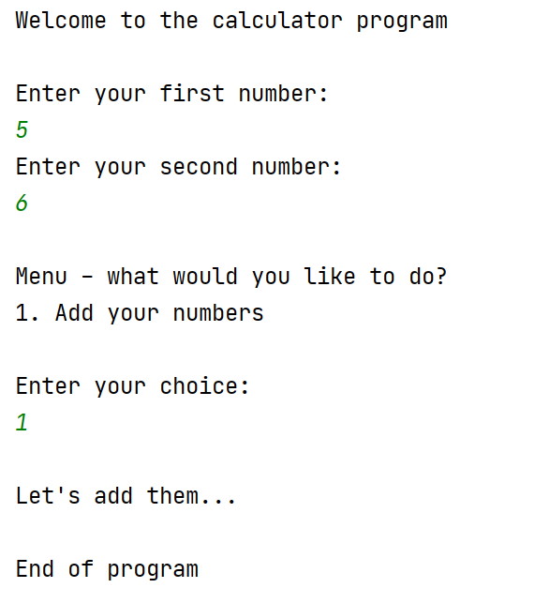

1c When the user chooses 1:
- call the function, passing the two numbers entered by the user into it
- add the numbers in the function
- return the answer to main the main program
- print the answer on the screen.

Sample output:

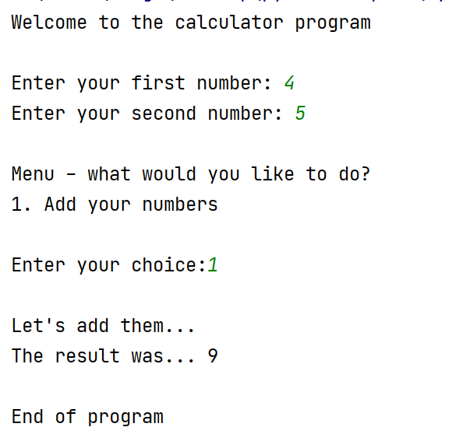

Solution:

def addnumbers(v1, v2):
total = v1 + v2
return total
print("Welcome to the calculator program\n")
value1 = int(input("Enter your first number: "))
value2 = int(input("Enter your second number: "))
print("\nMenu - what would you like to do?")
print("1. Add your numbers")
choice = int(input("\nEnter your choice:"))
if choice == 1:
print("\nLet's add them...")
result = addnumbers(value1, value2)
print("The result was...", result)
print("\nEnd of program")

1d Add code to extend the menu to allow the user to choose subtract, multiple or divide (as shown below). Use a separate function for each.
by
BUT, do not write 2 x subtract functions. Menu items 2 and 3 should both use the same subtract function (think carefully how the arguments are passed). Similarly, items 5 and 6 should both use the same divide function.

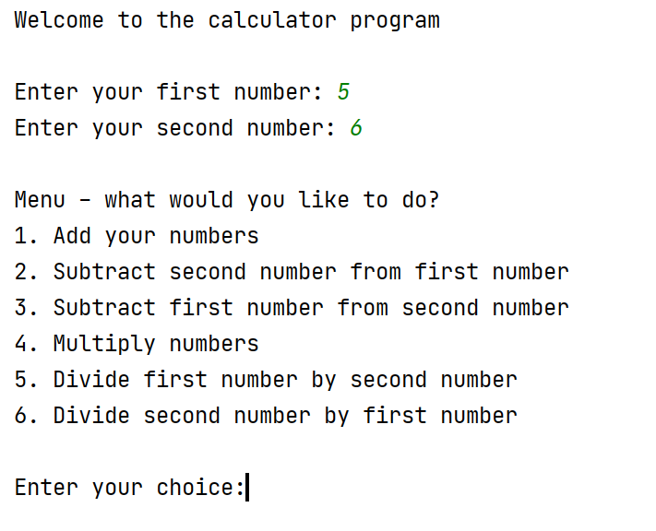

Sample output (all with 5 and 6 as the numbers used)

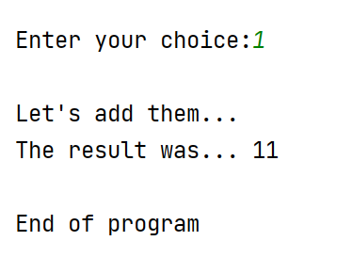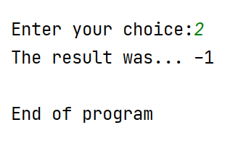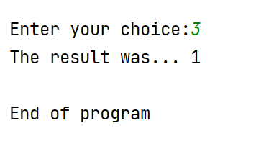

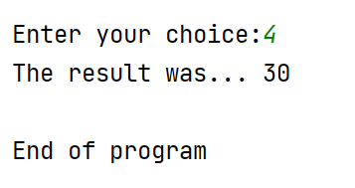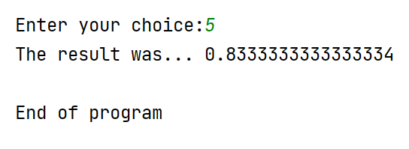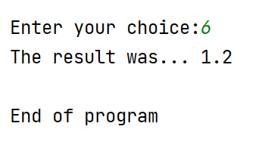

Solution:

def addnumbers(v1, v2):
total = v1 + v2
return total
def subnumbers(v1, v2):
total = v1 - v2
return total
def multnumbers(v1, v2):
total = v1 * v2
return total
def dividenumbers(v1, v2):
total = v1 / v2
return total
print("Welcome to the calculator program\n")
value1 = int(input("Enter your first number: "))
value2 = int(input("Enter your second number: "))
print("\nMenu - what would you like to do?")
print("1. Add your numbers")
print("2. Subtract second number from first number")
print("3. Subtract first number from second number")
print("4. Multiply numbers")
print("5. Divide first number by second number")
print("6. Divide second number by first number")
choice = int(input("\nEnter your choice:"))
if choice == 1:
print("\nLet's add them...")
result = addnumbers(value1, value2)
print("The result was...", result)
if choice == 2:
result = subnumbers(value1, value2)
print("The result was...", result)
if choice == 3:
result = subnumbers(value2, value1)
print("The result was...", result)
if choice == 4:
result = multnumbers(value1, value2)
print("The result was...", result)
if choice == 5:
result = dividenumbers(value1, value2)
print("The result was...", result)
if choice == 6:
result = dividenumbers(value2, value1)
print("The result was...", result)
print("\nEnd of program")

2. Write a function to allow the user to enter their age. Call your function enterage(). (No parameters to pass, only a return)

The age must be between 0 and 120 (write a while loop in the function for this)

Once a valid age has been entered, return age to main and print it on the screen

Your main code will look something like this:

print("Welcome to my program")
# Function call goes here
print("Verified age is:", finalAge)

Sample output:
main program
enterage()

main program

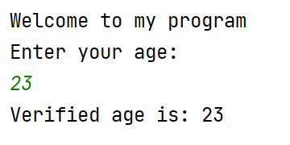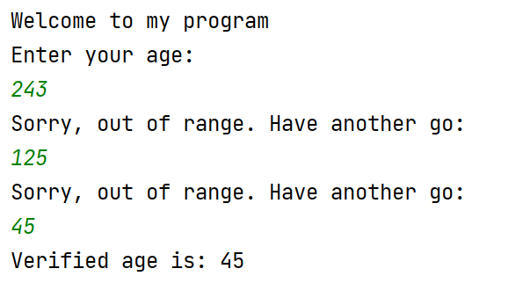
main program

enterage()

main program

Solution:

def enterage():
print("Enter your age: ")
userAge = int(input())
while(userAge > 120 or userAge < 0):
print("Sorry, out of range. Have another go:")
userAge = int(input())
return userAge
print("Welcome to my program")
finalAge = enterage()
print("Verified age is:", finalAge)

