Assignment Title: Business Plan and Reflection

Managing Enterprise (BMSW4011)

Student: Mari Barbu (2332258)

Lecturer: Melanie Squire

Submission date 21st March 23:59

Word Count 1603

Contents
Business Plan 3
“The story” 3
Legal Status 3
Mission Statement 3
Human Resources 4
Location 6
Marketing 7
8
Market Research 9
Financial Resources 12
SWAT Analysis 13
References: 15
Individual Reflection 17

Business Plan

“The story”
Becoming an entrepreneur means that some people can finally pursue their own ideas. They see an opportunity to turn those ideas into products or services and want to realize it. Many entrepreneurs feel huge satisfaction when their ideas catch on and see positive results (Barringer, 2021).“Delicious Cakes of Bath” is the name of my cake business; this idea has been associated with my passion for baking since I was a teenager.

Legal Status
In my opinion, being a sole trader suits me perfectly. I am the one who makes all the decisions. I decide my work hours, which gives me flexibility and ensures I leave enough time to spend with my friends and family. Of course, not having a partner or an investor means that if any problems occur, I must solve them myself and ensure I have enough business to cover all my expenses (Worthington, 2018).
Every year, most new businesses in the United Kingdom are established as sole traders. This option offers the advantage of minimal formalities, and if you don't plan to register for VAT, there are few regulations regarding the records you must maintain (Barrow, 2021).

Mission Statement
“Beautiful cakes, fabulous taste”! A mission statement that I believe represents me and my business. Creating delicious custom cakes for sale, I hope I can bring a little joy to my clientele, and I have the next twelve months to build a clientele and achieve my objectives (Drucker, 2007). Employing the SMART criteria to define goals increases the likelihood of attaining positive results (Doran, 1981).
- in the next two months, I plan to do some research consisting of visits to different bakeries and cake shops, looking for recipes, and watching cake tutorials.
- Attending a baking course will improve my knowledge and give me valuable tips that help a lot when making cakes, so for the next three months, I will enjoy studying and practicing different baking methods.
- I am allocating four months for marketing.
- Calculating the cost of materials to set up the prices will take another month.
- In the last two months before the big start-up, I will focus on setting up a budget to help me equip my kitchen with all the required tools and materials.
My business specializes in crafting delicious homemade cakes customized for events like birthdays, weddings, and other celebrations. Additionally, I intend to be actively involved in local community events each year to boost brand recognition and strengthen community ties (Kotler, 2016).
And not only cakes! My USP represents offering to cater on request for the customers that order a celebration cake. This way, not only will I go the extra mile in ensuring customer satisfaction, but I will also generate extra revenue. Companies that regularly surpass expectations can stand out in the market, thereby securing a competitive edge (Bitner, 1990).

Human Resources
Being at the beginning of my entrepreneurial journey, I will keep my business within the family for now. This means that my husband will assist me with marketing, cooking, washing up on my busy days, and delivering cakes on request. As he is an amazing cook, he will be an excellent addition to my business, greatly assisting me with catering. Human resources are crucial for the success and sustainability of every business (Amstrong & Taylor, 2020).
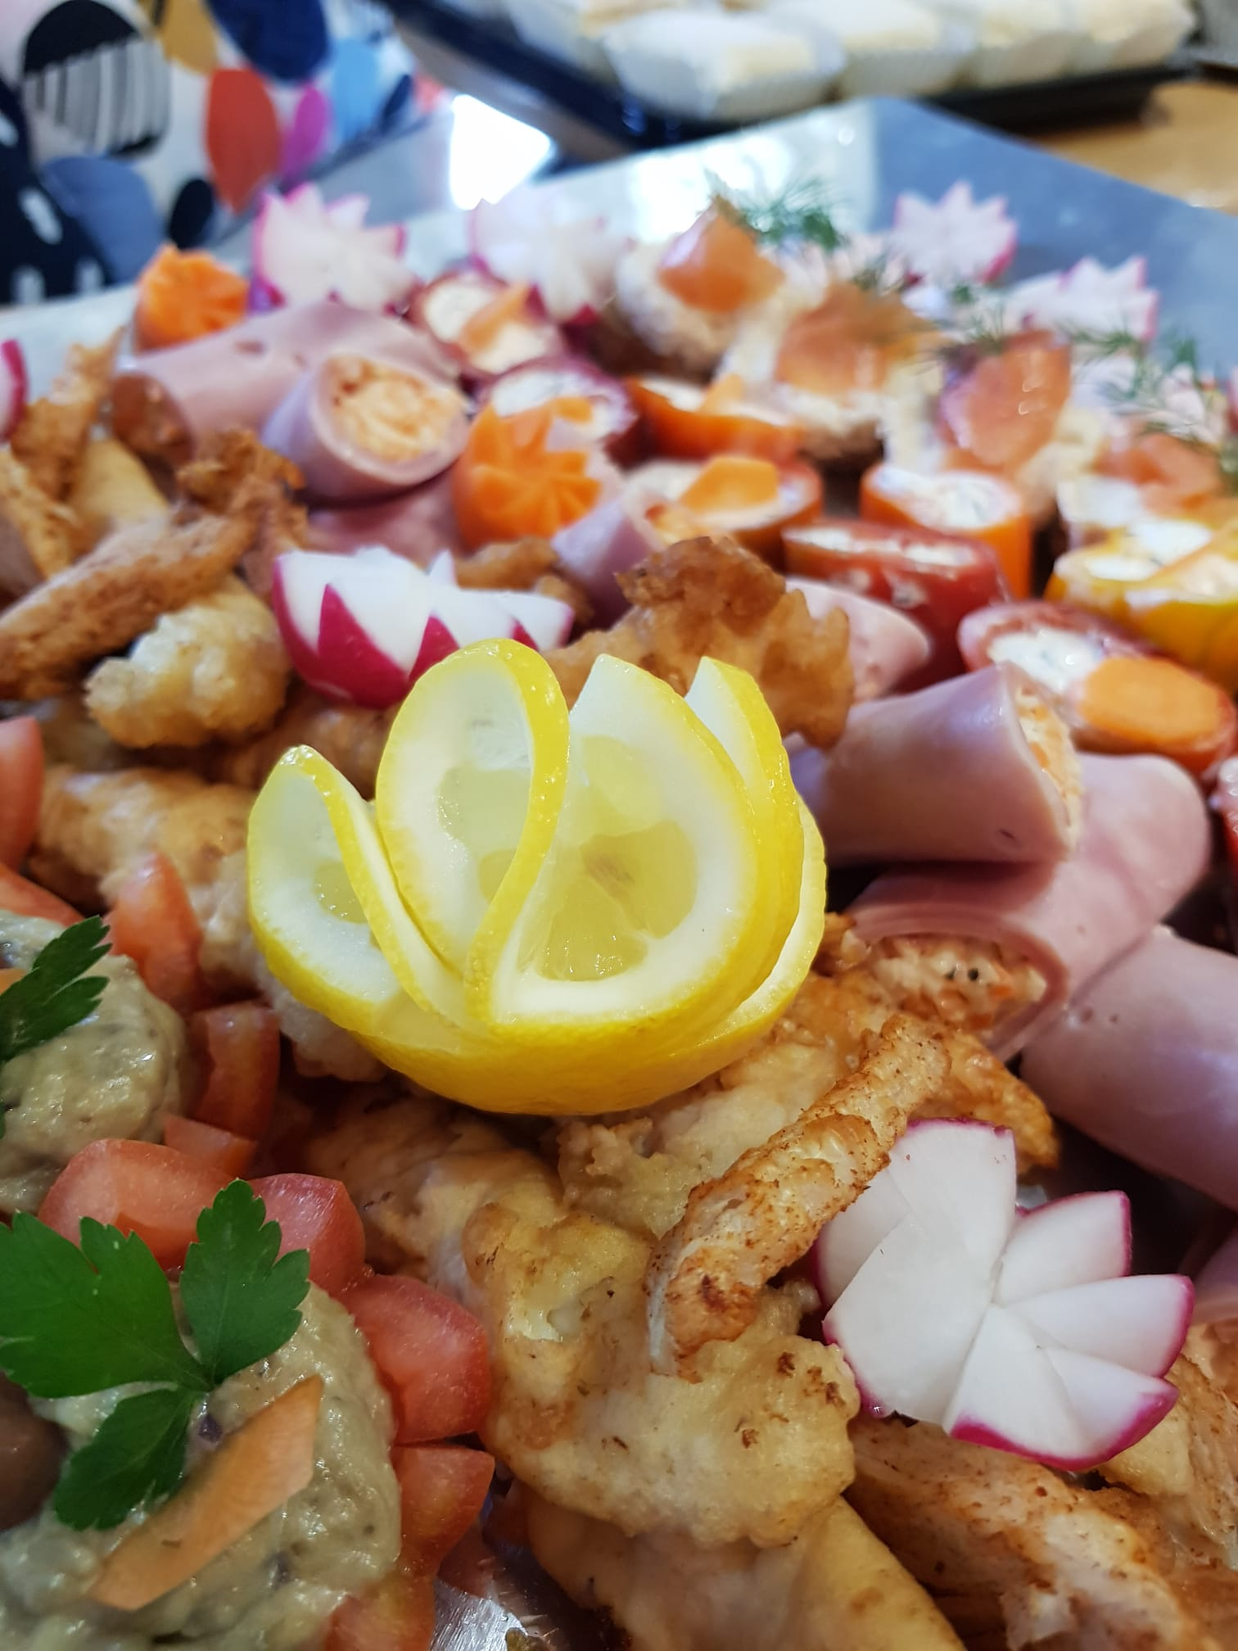

Location
I intend to establish my business at home to bypass fluctuating rental costs. This approach will help me save money that I can invest in marketing and kitchen equipment. While many home-based businesses function remotely, most operate full-time, with one in ten achieving significant scale. (Mason, 2010).
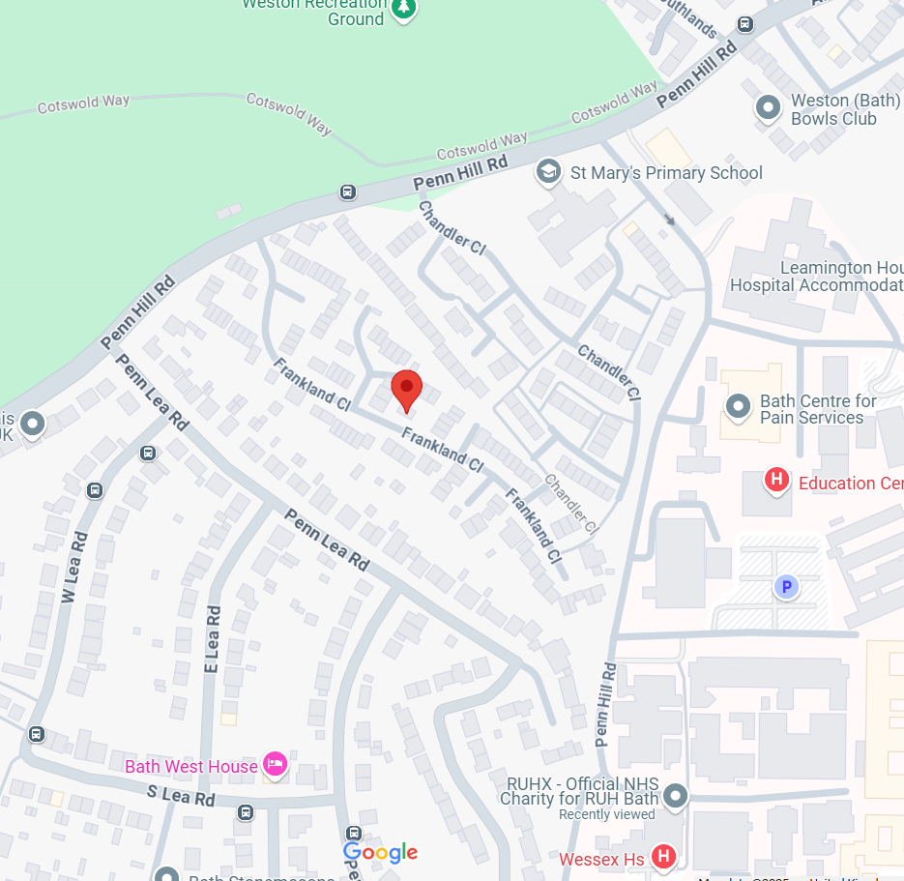

Marketing
Before embarking on a baking journey, a particularly important factor in setting up my business is marketing. That means advertising on social media, creating flyers and business cards, and attending different local fairs and events where I can display samples of cakes with different sponges, buttercreams, and frostings that will give me the feedback needed to discover the preferences of the local people.
Effective marketers understand that fostering long-lasting customer relationships carries more value than pursuing immediate sales (Peterson, 2007). To grasp the significance of digital marketing for the future of the marketing landscape, it is essential to consider the various audience interactions we must comprehend and navigate. (Chaffey, 2019).

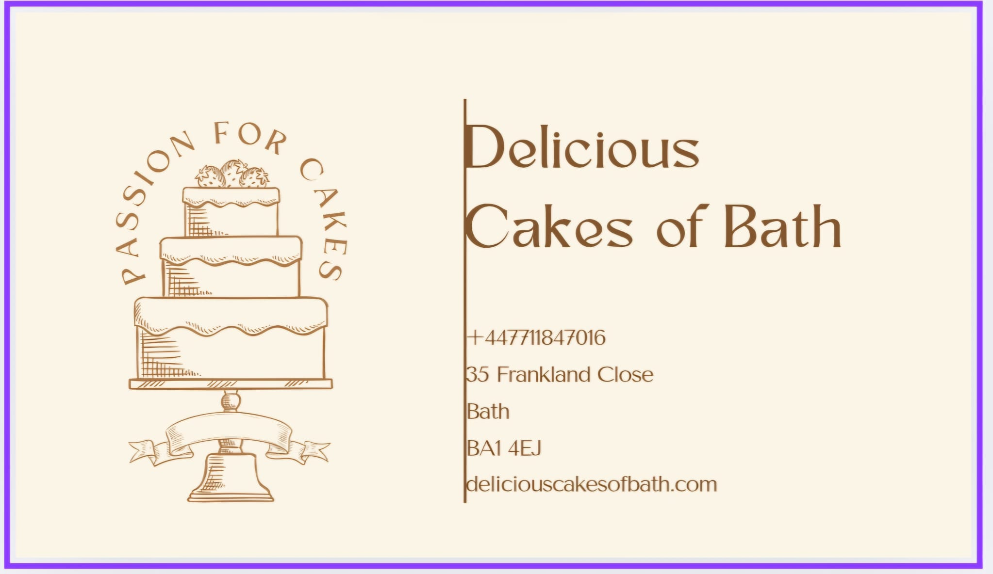

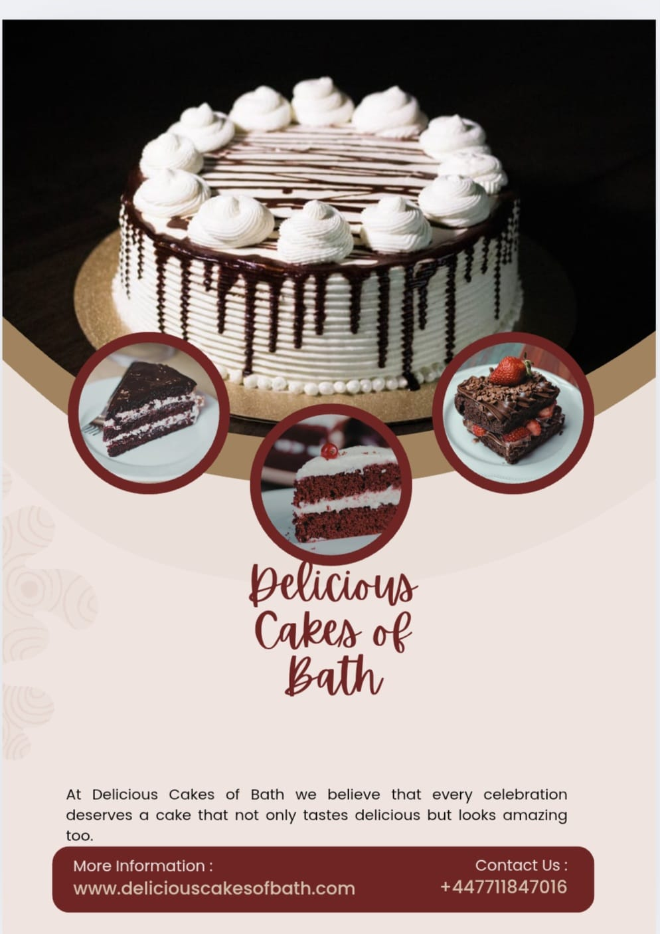

Market Research
Conducting market research is vital for a business to succeed in a competitive landscape. It offers valuable insights into consumer preferences, aids in identifying target demographics, and allows businesses to create products that satisfy customer needs (Creswell, 2018). With that in mind, I began visiting local cake shops to review their menus and sample various products. I also distributed a questionnaire to gather ideas for my website and menu, focusing on the most popular recipes.

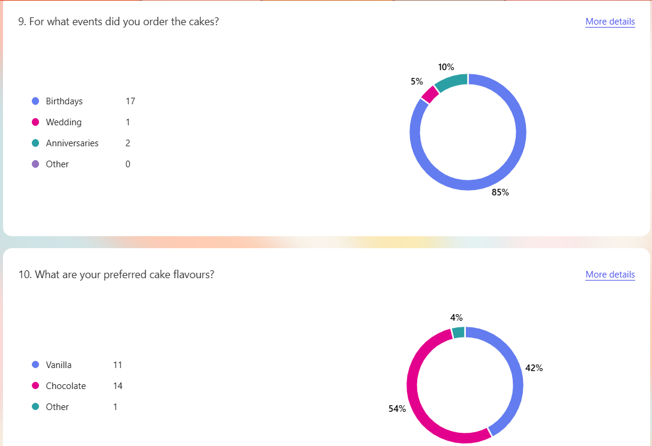
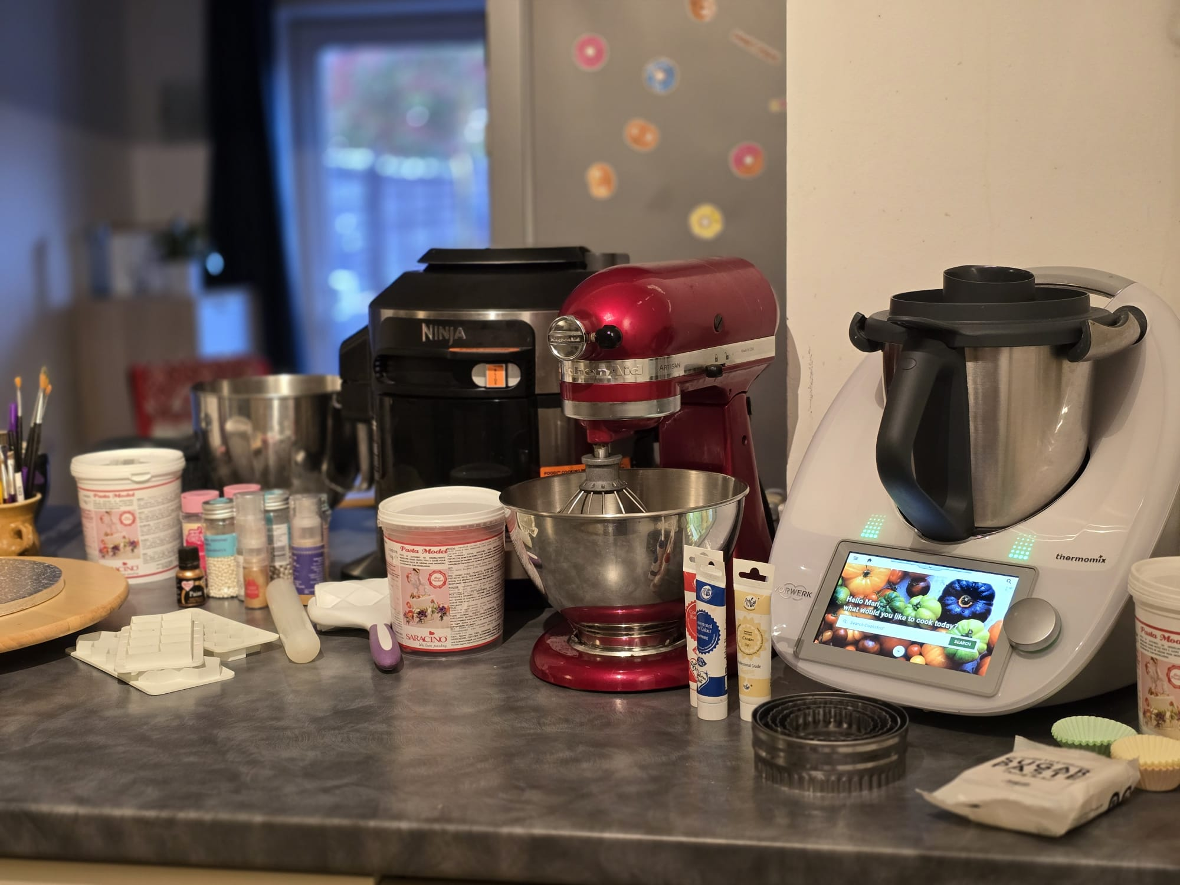
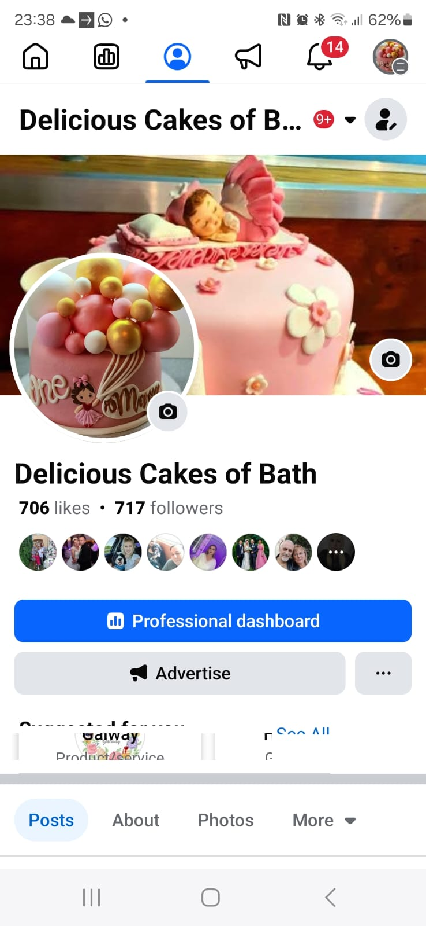

Financial Resources
Every decision-making process aims to shape future outcomes, and this holds true for financial choices as well. However, the one certainty about the future is our uncertainty regarding upcoming events. Outcomes may diverge from our expectations, and this risk must be thoughtfully assessed when making financial decisions (Atrill, 2012).
To launch my business, I have savings that will support my journey and allow me to outfit my kitchen with all the necessary tools and materials. I've developed a cash flow chart to visualize my anticipated cash inflows and outflows for the coming 12 months.

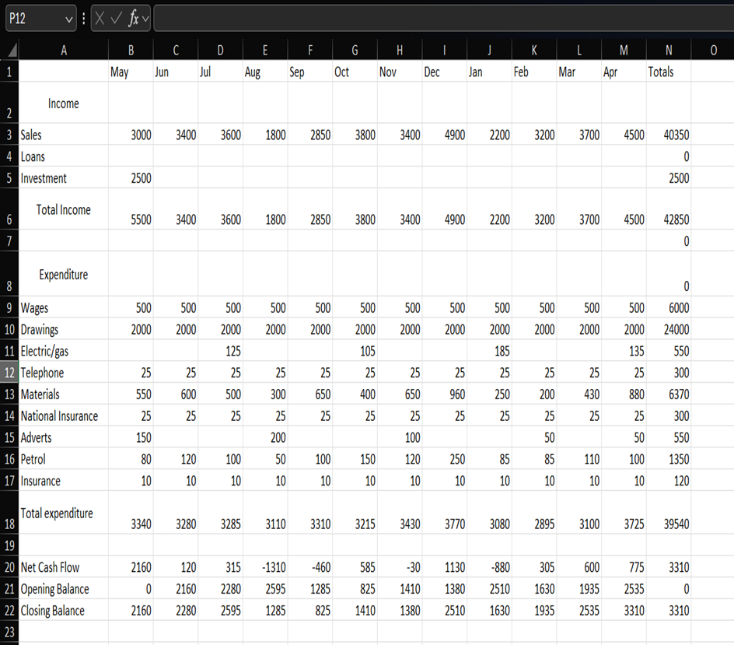

SWAT Analysis
SWOT is widely utilized by marketing researchers and is a favoured tool among business marketing and strategy students (Gurel, 2017). Its clarity and ease of use have made it valuable for many years, simplifying complex strategic situations by reducing the data required to improve decision-making (Helms, 2010).
Strengths:
- Homemade cakes typically highlight freshness, high-quality ingredients, and personalized options.
- Capacity to meet individual customer needs, including custom designs, dietary preferences (gluten-free, vegan), or themed cakes.
- Working from home minimizes expenses such as rent and utility bills typically linked to commercial bakeries.
Weaknesses:
- Small-scale operations may find it challenging to satisfy high demand or large orders.
- A home-based business might struggle to connect with a wider audience without considerable marketing investments.
- Seasonal variations or dependence on custom orders can result in unstable revenues.
Opportunities:
- Shoppers are showing a growing preference for handmade, premium products rather than mass-produced options.
- Addressing unique dietary preferences (like sugar-free or keto options) or special events (such as weddings and birthdays) can foster dedicated customer loyalty.
Threats:
- Competing against well-established bakeries, supermarkets, and fellow home bakers can be challenging.
- Increasing costs of key ingredients like flour, sugar, and butter may affect profit margins.

References:
Armstrong, M., & Taylor, S. (2020). Armstrong's Handbook of Human Resource Management Practice. 15th Edition. London: Kogan Page.
Atrill, P. (2012) Financial Management for Decision Makers. 6th edn. Harlow: Pearson Education Limited.
Barringer, B. R., Ireland, D.R. (2021) Entrepreneurship: Successfully Launching New Ventures. updated 6th edn. Harlow: Pearson Education.
Barrow, C., Barrow, P., Brown, R. (2021) The Business Plan Workbook: A step-by-step guide to creating and developing a successful business. 10th edn. London: Kogan Page.
Bitner, M.J., Booms, B.H., and Tetreault, M.S. (1990) The service encounter: Diagnosing favourable and unfavourable incidents. Journal of Marketing, 54(1), 71-84. https://doi.org/10.1177/002224379005400107.
Chaffey, D., and Ellis-Chadwick, F. (2019). Digital Marketing: Strategy, Implementation, and Practice. 7th Edition. Harlow: Pearson.
Creswell, J.W., and Creswell, J.D. (2018). Research Design: Qualitative, Quantitative, and Mixed Methods Approaches. 5th Edition. Los Angeles: SAGE Publications.
Doran, G.T. (1981) ‘There’s a S.M.A.R.T. way to write managements’s goals and objectives’, Management Review, 70(11), p. 35. Available at: https://research.ebsco.com/linkprocessor/plink?id=7586f64c-7d6f-331f-bddf-3bff79789fe1 (Accessed: 26 March 2025).
Drucker, P.F. (2007). The Practice of Management. New York: HarperBusiness.
Gurel, E., and Tat, M. (2017). SWOT Analysis: A Theoretical Review. Journal of International Social Research, 10(51), pp. 994-1006.
Helms, M.M. and Nixon, J., (2010) ‘Exploring SWOT analysis - where are we now?: A review of academic research from the last decade’. Journal of Strategy and Management, 3(3), pp. 215-251, (accessed on 26.05.24).
Kotler, P. and Keller, K.L. (2016) Marketing Management 15th edn. Upper Scaddle River, NJ: Pearson
Mason, C. M., Carter, S. and Tagg, S. (2010) ‘Invisible Businesses: The Characteristics of Home-based Businesses in the United Kingdom’, Regional Studies, 45(5), pp. 625–639. doi: 10.1080/00343401003614241.
Peterson, R. (2007) Principles Of Marketing.Delhi: Global Media.
Worthington, I., and Britton, C. (2018). The Business Environment. 8th Edition. Harlow: Pearson.

Individual Reflection

My business was born out of one of my biggest passions: baking. Growing up, my mother often cooked and baked at home, and I became fascinated watching her in the kitchen. I realized that I wanted to turn this hobby into a business, imagining how wonderful it would be to have a small cake shop and earn money while doing what I love most- a lovely dream without any clear idea of how to begin or what steps to take. I enrolled in this course, hoping it would provide guidance in that direction. And I was not wrong! From the start of the course, I gained extensive knowledge of various techniques and methods that proved incredibly helpful. However, when I reached the point of creating a business plan, I knew I had chosen the right course because I was finally where I wanted to be. I was beginning to understand how to start setting up my business.
The business plan helped me develop new skills. I needed to come up with a name and learn about mission statements, aims, and, importantly, my objectives, which I had to make SMART. This process helped me realize how crucial it is to set clear, realistic objectives. I learned about marketing, market research, financial resources, and HR management- all essential factors in running my own business. I came to understand that without this information, a business is doomed to fail before it even starts. The SWOT analysis prompted me to evaluate my strengths, one of which is my passion for baking. I have a desire to not only create beautiful cakes but also always to use fresh, high-quality products from sustainable sources, thus supporting other small businesses. I always remain loyal and honest with my customers. I enjoy listening to their demands, communicating with them, and seeking their opinions without fear of receiving constructive feedback. I am always willing to improve myself.
Throughout my life and during this course, I have learned that passion is not everything in making your dreams come true; you also need to be self-motivated, resilient, creative, adaptable, and more. However, one thing I find very challenging is overcoming my fear of taking risks. I need to address this fear, and I plan to do so by conducting more research. I have come to understand that the more knowledge I gain about my business, the more confident I will be when making decisions and, therefore, taking risks.
I understand that fearing risks is a widespread issue, particularly in the realms of entrepreneurship and major life choices. This apprehension often arises from concerns about failure, the unknown, or the possibility of losing what one already possesses. Such fear can prevent individuals from seizing opportunities, accomplishing their aspirations, or realizing their full potential. Therefore, I plan to take smaller, low-risk ventures to boost my confidence, view risks as chances for learning and growth irrespective of the outcome, and shift my perspective to regard failure as a stepping stone rather than a conclusion.
This way, I can embark on this entrepreneurial adventure and enjoy every step, without being afraid of failure, but learning from every mistake.

