University of Wales Trinity Saint David London,
The Global Business Environment,
LCBB4005
Assignment 1
Nadeem Mirza
student name: Desislava Zhelyazkova
student: ID 1917424

Contents
Introduction: 2
Analysis: 3
a) Evaluation of the major forces that are shaping the business environment of the car manufacturing industry and how the industry has changed in the last few years: 3
Porter five forces analysis: 3
PESTEL analysis: 5
b) A critical assessment of the opportunities and challenges that these forces present and discussion on how the firms can best position themselves for gaining competitive advantage: 8
SWOT: 8
Porter value chain: 9
Product lifecycle of Toyota: 11
Conclusion: 11
Reference: 13

Introduction:
The automobile or the car manufacturing industry is considered as the major industrial as well as economic force worldwide. The car manufacturing industry has a huge influence over the global economic growth and sustainability. In this report the context of Toyota has been taken for understanding how the major forces in the country is influencing and shaping the business environment of this manufacturing company. Suitable frameworks also have been applied in this regard. in addition, a critical assessment of the opportunities as well as the challenges faced by the organization due these forces and how the organization can obtain high competitive advantage has been discussed carefully in this paper. Toyota is a Japanese multinational automotive manufacturer company. The headquarters of the organization is in Toyota, Aichi, Japan. Currently, the organization has more than 362,445 employees all over the world. In this paper, the context of UK has been considered for understanding the influence over this multinational car manufacturing company.

Analysis:

a) Evaluation of the major forces that are shaping the business environment of the car manufacturing industry and how the industry has changed in the last few years:
In order to identify and understand the impact of the external forces, the suitable framework such as PESTEL and Porter five forces are extremely suitable. These have been applied in the context of Toyota, UK.

Porter five forces analysis:
The five forces analysis of the organization helps in identifying the intensities of the external forces in the business environment of the automobile industry.
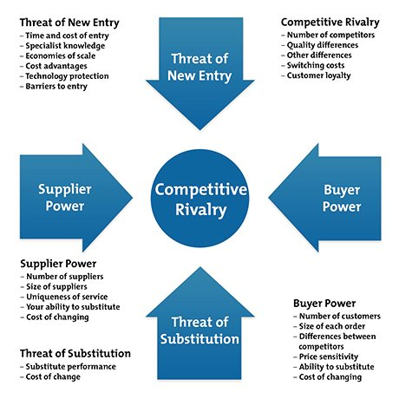
Competitive rivalry: Analyzing the context of the organization, it can be seen that the manufacturing company is dealing with a strong force of competition in the market. The competition in the market is very aggressive against each other regarding marketing as well as innovation. The organization is currently competing with a large number of organizations. Hence, it can be stated that the organization must have comprehensive strategies for addressing the strong forces of competitive rivalry.
Bargaining power of the buyers: The buyers of the business have direct impact upon the organizational revenue. Through this force, it can be seen that the influence of the buyers on business is very high. This force is very high upon the business due to low switching cost and availability of similar options in the market. the customers in the market can easily select their best option with the availability of information. In order reduce this force; the organization needs to ensure that their products are matching the customer expectations and preferences effectively.
Bargaining power of suppliers: In the context of UK, there are multiple suppliers present which offers the raw materials and different parts required for manufacturing their cars. This has created a positive opportunity for the organization to lower the bargaining power of the suppliers and gaining the products at the reasonable prices. Hence, this particular force in the context of Toyota is comparatively weak (Li, 2018).
Threat of substitute: The substitute products generally affect the business by competing with the parent company’s products. In case of Toyota it can be seen that the threat of substitute products is medium or moderate. The product design, innovation and comfort offered by the organization are hard to imitate for companies. This helps in lowering the threat of substitute products in the market and for Toyota.
Threat of new entrants:
Analyzing this context it can be seen that the organization faces a weak force regarding the market entry of new similar business. Entering the market of UK and compete against such established company requires high cost of establishing as well as maintenance which acts a barrier for the new market entrants. This particular force is less significant than the competition and the bargaining power of the customers for the business of Toyota.
Through this evaluation, it can be stated that though the organization is dealing with many external forces, however the company has a huge potential in the market due to their innovation, diversity and brand name in the context of UK.

PESTEL analysis:
This is the framework for the external environmental analysis which is extremely important for controlling the internal environment of the business.
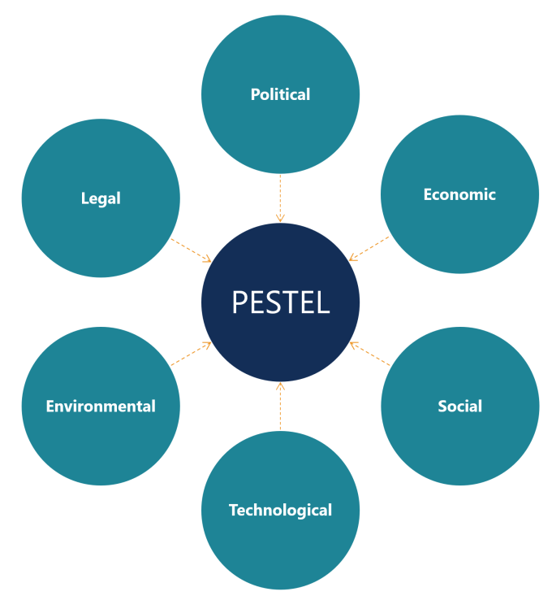
Political: UK is considered as one of the world’s most powerful countries. The government system of the country is comprised of constitutional monarchy and parliamentary democracy. The UK government is quite stable and the corruption level is also low which has a positive influence on the organization. However, the movement of Brexit has created an atmosphere of uncertainty in the present time. As per its result, the deal of UK leaving EU is established in January 24, 2020. This has the potential of creating employment opportunities in the country (Rajamohan, 2020).
Economy: as per report. The GDP of the country as per 2019 is 2.744 trillion US dollars which creates a huge opportunity for the organization of Toyota. However, due the sudden outbreak of Corona virus and the continuous lockdown in the country has negatively influenced the economy of the country. After this scenario, the current GDP rate in UK as per the report of 2020 is standing at 2.638 trillion US dollar (Inoue, 2020). The statistics show that the GDP of the country has gone downwards t0 -11.3 percent in the last year. this has highly affected Toyota and the entire car manufacturing industry to a great extend.
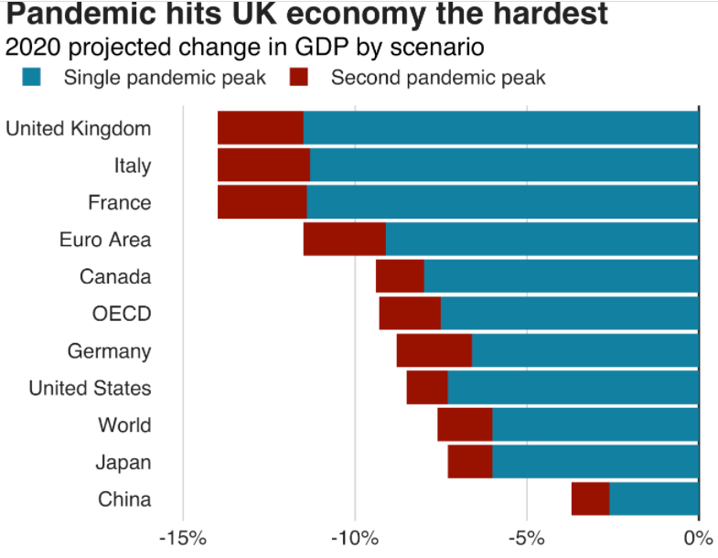

Social:
The population of the country is estimated to reach 74 million by the end of 2039. The standard of living of the people is also comparatively higher than most of the other countries over the globe. The lack of unemployment rate in the country indicates high-income earners in the citizens. However, the continuous lockdown due to the pandemic affected the employment and spending on cars, which influence the car industry negatively (Okorie, 2020).
Technological: UK is highly advance in technology. The country has the leading research and development institutes. This creates a positive influence over the car manufacturing industry to focus on innovation and latest technology (Toma, 2019). Toyota has gained effective support from the technical aspect of the country.
Legal: The organization is liable to follow the Employment act of 1996 in UK. the labour rights are strictly maintained in this country including minimum wages, maternity or paternity pay, sick pay, holiday pay etc. also, the Equality Act 2010 also protects the employees and people from any sort of discrimination in the workplace.
Environmental: In order to execute the business in the context of UK effectively, it is important to focus on the serious environmental issues and developing CSR policy for reducing negative impact from the environment and local community.. Recently, the organization has focused on reducing waste and carbon emission technology in their cars for contribution in the environment (Meckling, 2019).
Based on these external forces, the industry has transformed a lot in the last few years. The organization as well as the industry has focused on innovation, diversity and effective strategy of corporate social responsibility in order to increase competitive advantage and sustainability within the operating market successfully.

b) A critical assessment of the opportunities and challenges that these forces present and discussion on how the firms can best position themselves for gaining competitive advantage:
In order to understand the opportunities as well as the challenges, which the forces are creating for the organization conducting an internal analysis for understanding, capabilities are essential. for this reason, SWOT can be applied.

SWOT:
Strengths:  The key strengths of the organization are-  - the strong brand image  - rapid innovation capabilities  - worldwide supply chain and distribution  - research and development department  - global presence  - large product portfolio | Weakness:  The present weaknesses of the company includes-  - hierarchy organizational structure  - organizational cultural and no transparency  - effects of product recalls in the present time
Opportunities:  The present opportunities are-  - growing markets in the developing countries ]  - rising demand for the fuel efficient automobiles  - introducing AI and digital technology in their cars  - automatic vehicle technology (Singh, 2019) | Threats:  - competitive pressure within the company  - increasing cost of the raw materials  - rapid innovation of the competitors

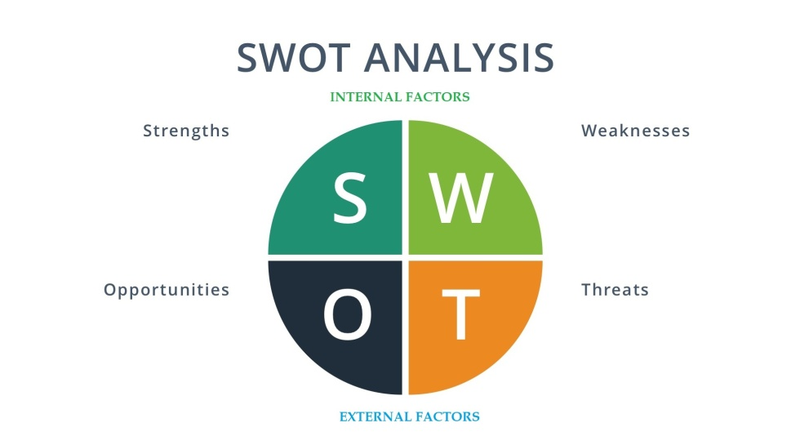
With the help of SWOT framework the internal condition of the organization including its strength, weakness, opportunities, and potential threats have been identified. It shows that in order to obtain the opportunities and reduce the threats, it is important for Toyota to select the right strategies and approaches.

Porter value chain:
This particular model states how the business input can be given to get the outputs in such a way that they can help the business to gain higher value. As per the model, there are a number of activities such as primary as well as support activities. The primary activities have influence on the production, maintenance, sales and supports. These activities has been explained-
Primary activities:
Inbound logistics: Toyota has managed a lathe supply chain and the business obtains parts and raw materials from numerous supplier located all around the globe. This has helped in handling the inbound logistics efficiently.
Outbound logistics:
The organization has its logistics centres in different countries across the world. Toyota ships orders and receives thousands of parts everyday from its network of warehouses as well as distribution centres. This creates a smooth execution in the business (Anning-Dorson, 2018).
Operations:
The organization being a global brand operates worldwide. It has its supply chain and research and development centre in many parts of the globe. In UK, the organization is operating successfully with their several distribution and supply chain networks.
Marketing and sales:
The competition for the company in UK is very high. In order to retain their market share, the organization invests highly on marketing and promotion. It uses both traditional and modern advertisement platforms for attracting customers.
Support activities:
Technology: The vehicles of the brand are known for their engineering and technology. The brand invests in innovation and technology which makes it diversified from others.
Infrastructure: the infrastructure of the company is very effective. The brand has increased its presence in the major markets of UK (Koc, 2017).
HRM: The organization has 364.5 k employees currently and the HRM of the organization maintains a human centric approach and focus on their development.
Procurement:
The company procures raw material from numerous suppliers. Through the strategy of procurement the organization has worked towards the contribution to local economy and communities.
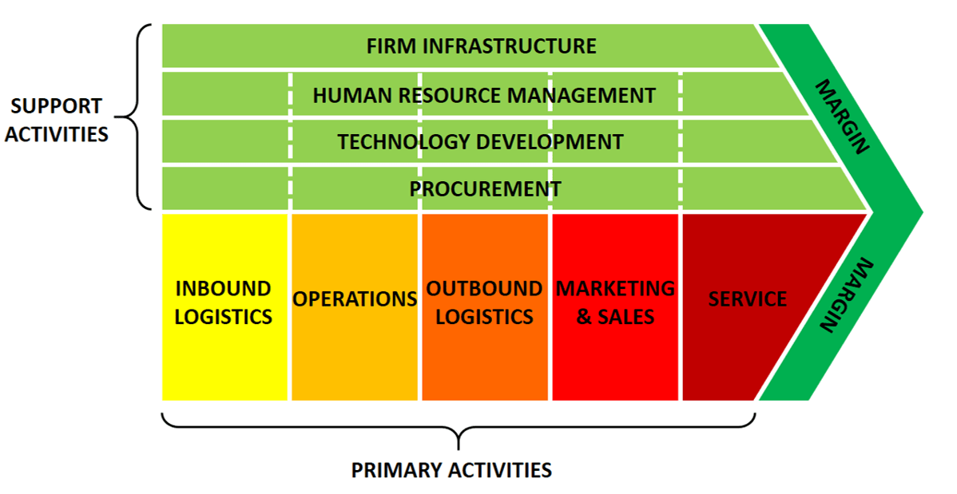
Through the help of the framework it can be identified that the organization has effective opportunities due to their capabilities. Expansion and increasing innovation are the key two essential opportunities which can be used by the organization in terms of generating higher growth and value in the business.

Product lifecycle of Toyota:
Analyzing the context of Toyota, it can be seen that the organization has risen to the product maturity stage with the product Toyota Qualis. Toyota Qualis is a ten seater car and it has an extremely powerful engine with 24 litre of diesel capacity (He, 2019). The maximum car speed is 130 km per hour. It has very low fuel consumption and has a tank of 53 litre fuel. In addition, this car has a very protective and safe body for the passengers. It comes with the features like central locking, power steering, power windows, fabric seats etc. this is considered as one of the most popular cars of Toyota motors. This particular product has reached to the stage of maturity in the present time. This is one of the most demanding and successful product of the organization.

Conclusion:
The overall report has been extremely useful and effective in terms of understanding the influence of the external forces upon the car manufacturing industry. In this report, the selected organization Toyota has how the organization is dealing with the eternal forces have been discussed effectively. In addition, the report has also provided a critical assessment of the opportunities and challenges that these forces are creating for the organization and how the organization can gain competitive advantage from the operating market, the overall report has been very significant, as it has given a very clear understanding on the car manufacturing industry.

Reference:
Anning-Dorson, T., 2018. Innovation and competitive advantage creation. International Marketing Review.
He, B., Luo, T. and Huang, S., 2019. Product sustainability assessment for product life cycle. Journal of cleaner production, 206, pp.238-250.
Inoue, H. and Todo, Y., 2020. The propagation of the economic impact through supply chains: The case of a mega-city lockdown to contain the spread of Covid-19. Covid Economics, 2, pp.43-59.
Koc, T. and Bozdag, E., 2017. Measuring the degree of novelty of innovation based on Porter's value chain approach. European Journal of Operational Research, 257(2), pp.559-567.
Li, Z., 2018. Business Network Positioning Analysis of Toyota. American Journal of Industrial and Business Management, 8(07), p.1693.
Meckling, J. and Nahm, J., 2019. The politics of technology bans: Industrial policy competition and green goals for the auto industry. Energy Policy, 126, pp.470-479.
Okorie, O., Subramoniam, R., Charnley, F., Patsavellas, J., Widdifield, D. and Salonitis, K., 2020. Manufacturing in the time of COVID-19: An Assessment of Barriers and Enablers. IEEE Engineering Management Review, 48(3), pp.167-175.
Rajamohan, S., Sathish, A. and Rahman, A., 2020. Impact of COVID-19 on stock price of NSE in automobile sector. Int. J. Adv. Multidiscip. Res, 7(7), pp.24-29.
Singh, S.K., Chen, J., Del Giudice, M. and El-Kassar, A.N., 2019. Environmental ethics, environmental performance, and competitive advantage: role of environmental training. Technological Forecasting and Social Change, 146, pp.203-211.
Toma, S.G. and Naruo, S., THE BEST PRACTICES AT TOYOTA MOTOR CORPORATION. Quarterly publication, p.566.

