Assessment 1- Community Engagement
LCBB4002

Lecturer’s name : Karen Howells

Student name: Ralitsa Yordanova

Student ID : 2023562

Table of contents
Introduction 3
Main body 4
Conclusion 10
References 11

Introduction
This assignment will be discussing about a programme that runs in UK and the programme chosen is The Hunger Project. As the name suggests, it is a project that focuses on eradication of hunger. The team works towards raising funds and awareness in respect to this concern. Hunger is an issue that is faced by poor or people who are below the poverty line globally. The project will discuss about community engagement principles, internal and external factors that are influencing the community development, along with issues faced by The Hunger Project. Additionally, stakeholder engagement activities in respect to social media marketing will be discussed along with use of social-media and various interpersonal skills and the benefits of stakeholder participation.
This project was chosen understanding that food is the most basic necessity of every individual yet, this basic need is not being fulfilled worldwide. Furthermore, due to the situation of covid-19, this issue has risen to a greater level due to various reasons like increase in unemployment and many more (Gangopadhyaya and Garrett, 2020).

Main body
About the program
The Hunger Project UK is a global charity non-profitable organisation. This program aims to wipe out hunger from the world. The Hunger Project strives to take sustainable measures to develop sustainable measures in order to assure problems related to hunger. It was founded in the year 1977 by Robert Fuller and its headquarters are located in New York, United States. The total number of employees connected with this organisation extends to 118. The mission of the Hunger Project is to develop strategies and methods that would be helpful in the creation of an environment in which every individual lives a healthy life with dignity and respect (thehungerproject.org.uk, 2021).

Community engagement principles
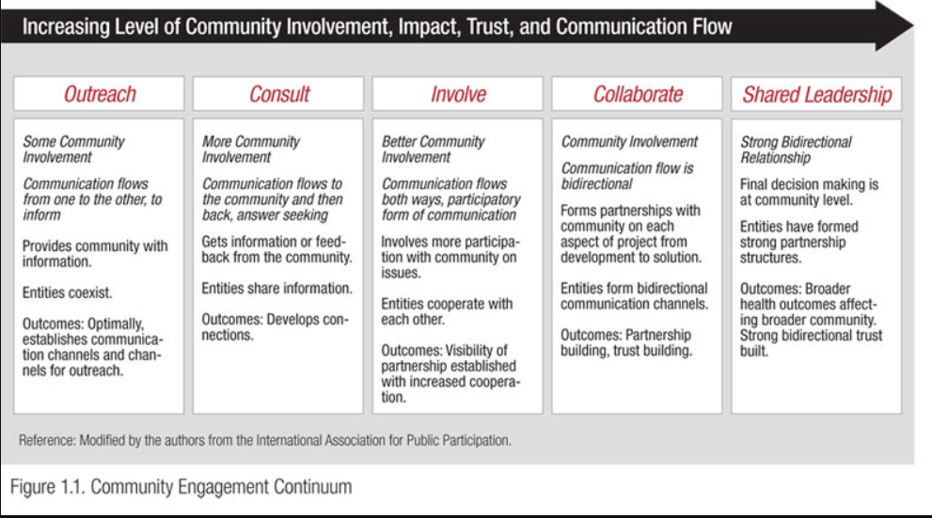
Figure 1. Community engagement principles
(Source: atsdr.cdc.gov, 2021).
To ensure a better community it would be essential for NGOs like The Hunger Project UK would need to outreach the prospective community. In order to fulfil the efficiency of the outreach principle, it would be necessary for The Hunger Project UK to develop a continuous communication channel.
The other important principle in the direction of the Community Engagement Principle would be to assure a proper consultancy and involvement. For instance, The Hunger Project would require making the communities aware of the growth of hunger and its adverse effects. Besides this, timely feedback and support from the community could be an added advantage. The Hunger Project can invite ideas, information and some more alternatives in direction of hunger eradication. A proper flow of feedbacks and suggestions could be helpful to The Hunger Project UK in assuring deep knowledge management and retaining important information that could assist in developing future programs. The involvement principle possesses the benefit of two-way communication (Alger, 2017).
Collaboration can be a significant principle in the area of community engagement that enables the organisations such as The Hunger Project UK in rapport building, gathering more partners, calling for sponsorships and so on. This principle would allow the community projects in maintaining bio-directional communication.
Shared leadership could be seen as another significant element in process of developing community engagement. This factor influences the decision making based on integrated strategies adopted by proper communication. NGOs like The Hunger Project UK could be able to retain better outcomes because of the strong leadership.

Internal and external factors influencing Community development
SWOT
Strength  The Hunger Project UK have implemented certain strategies for ensuring human dignity, maintaining gender equality and assuring sustainability (thehungerproject.org.uk, 2021). These strategies could be helpful to The Hunger Project UK, in pooling people of various communities towards it. Such charity strategies would be helpful to The Hunger Project UK in maximizing sustainability measures and bringing equal social transformation. | Weakness  Community programs and social organisations like The Hunger Project UK could be facing certain issues and limitations. For instance, lack of funds, a limited number of volunteers in some regions and countries, a lesser amount of resources and so on. Under such circumstances, NGOs like The Hunger Project UK could not be able to carry on the activities.
Opportunities  Fundraising could arise as a crucial opportunity for such community projects. Near about 71% of NGOs have admitted the use of social media for pooling funds from various social communities (Laura et al., 2019). | Threats  Lack of proper assistance, emigration, disinformation attacks and public scrutiny could arise as major threats for charity organisations like The Hunger Project UK.
Table 1. Factors of SWOT framework
PEST factors
Political | Some charity organisations tend to get benefits and advantages from the various governmental and political communities. For instance, Great Britain accumulated funds of 19.3 million with the help of various community donors (statista.com, 2021).
Economic | The economic impact can be seen in the form of inadequate supply of material and resources, lack of bond and trading relations with other nations and so on. These factors can influence the formation of community engagement on a national and global level.
Social | Social communities play a vital role in widening the relations with various population bases belonging to different regions.
Technical | The Hunger Project UK can utilize various digital marketing and Social media marketing platforms to influence the various communities. Community engagement can be maximized by implementing various promotional programs in the form of posts, pages and effective content on various social handles.
Table 2. Factors of external PEST Framework
(Source: Created by learner)

Issues faced by The Hunger Project
The Hunger Project UK has been providing help to various socially deprived regions. While intensity and ratio of social deprivation can arise as a major issue. For instance, as per Global Hunger Index, Chad was the most affected region influenced by hunger and poverty with an average index of 44.7 (statista.com, 2021). There could be many regions facing the same challenge, hence this issue can be a major problem.
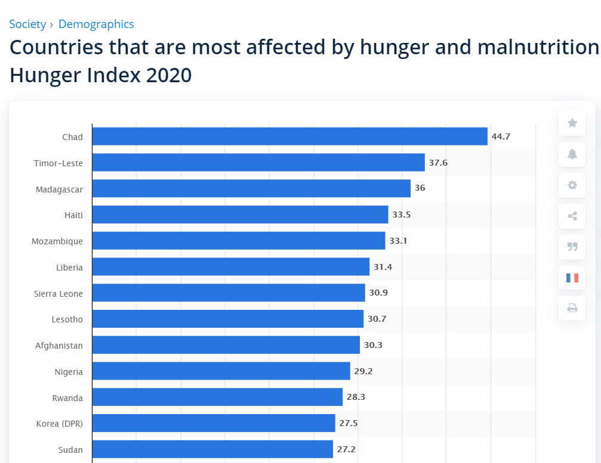
Figure 2. Global Hunger Index
(Source: statista.com:2021).
While issues such as the Corona outbreak and pandemic situation can also arise as a major obstacle as it creates problems in gathering volunteers or in carrying out routine tasks.

Stakeholder engagement activities- Social media marketing
- Social media enables the charity organisations like The Hunger Project UK in making a place for creating posts and pages. This helps such charity organisations in developing proper interaction with the communities present on social media handles.
- Social media marketing also passes on effective methods such as graphic creation, content generation and using more effective modes of promotion. Content creation enables charity organisations in conveying the message in an impactful, creative and elaborative manner (Duong, 2017). Besides this, The Hunger Project UK could be able to create the proper base of information for various communities.
- SEO, SMO, hashtags, keyword planning are some social media enabled tools that would help The Hunger Project UK is collaborating with other social groups, NGOs, charity associations and so on.
- Website marketing, influential marketing, blogging and vlogging are some other web-enabled marketing strategies that would be helpful to The Hunger Project UK in catering thorough information about its present events, fundraising campaigns, missions and so on (Jacobson et al., 2020).
- In this manner, several web-enabled platforms would be helpful to The Hunger Project UK in retaining the effectiveness of the various principles of community engagement. It can be identified that social media could be the convenient and sustainable medium of establishing rapport with communities and ensure effective engagement with them. The social communities can be attracted towards The Hunger Project UK with the help of a range of promotional advantages.

Use of Social-media by various interpersonal skills
Social media has been a constant contributor and has been acting as an advantageous aspect for all types of businesses including NGOs, commercial trade and others. Various interpersonal skills can be used in the favour of social media to achieve greater outcomes. Few of them are listed below-
- Creative thinking plays a crucial role in all areas of life as this quality/skill is what makes a person stand out from the crowd. Having creative thinking will help to come up with new ideas that can be applied to utilise the best of social media (Koch et al., 2018). Considering social media trends, they change everyday and it is necessary to stay updated about them and analysing how can these trends be used in the favour of The Hunger Project.
- Time management is one of the interpersonal skills that is a must. Considering social media, having a timing is necessary as trends change faster than people would normally notice and to deliver the right content related to the project to right audience, timing plays an important role. Different types of audience is active on social platforms at different times and hence, it is necessary to identify the most appropriate time to engage with the audience.

Benefits of stakeholder participation
Collaboration
Collaboration is a beneficial aspect for businesses as the concept of collaboration focuses on other fellow businesses or people coming together to support something similar or work on the same aspect. At The Hunger Project, they have multiple partners who have collaborated with them to be a part of a project that is working towards creating a self-reliant life filled with dignity for people. Few of the companies that have collaborated are:
- One of many is not just a partner but also the investor in the project as well their brand ambassador. It is network of women who are committed towards ending the hunger and supporting the project for the same.
- JMJ Associates are not just supporters but also investors in the project, along with working towards sustainability and transformation.
- Faberge is a jewellery brand that has been raising funds for the project (thehungerproject.org.uk, 2021).
They also organise fundraising events where in people collaborate with the project to do their bit in collecting/increasing funds for the project. Such events are a great initiative as people who cannot become partners, or cannot commit time to volunteer, can contribute towards the project by taking part in such fundraising events. They come up with various different fundraising events like sports and food challenges (thehungerproject.org.uk, 2021).
Social-cultural integration and multi-culturalism
Social-cultural integration can be explained as groups/people belonging to different social and/or cultural backgrounds are a part of the same society. Whereas, multi-culturalism can be explained as existence of diverse and varied cultures in a society. It can be said that The Hunger Project is a socio-cultural as well as multi-cultural platform or these two aspects are integrated as they have their partners wide across Africa, South Asia, and Latin America. This indicates that, the platform respects all cultures and backgrounds as irrespective of all these elements, they are just working towards eradication or minimisation of people who deal with hunger on daily basis.

Recommendation
It is recommended for The Hunger Project that they can focus more on promotion of the project among wider range of people not only in UK but globally. This will result in better results in favour of the project and also help to expand the project among various other countries as well. hunger is a worldwide issue and hence, expansion of the project would be beneficial for people across the globe and they will also receive greater support from people worldwide.

Conclusion
It can be concluded that the aim and vision of The Hunger Project is something to be paid attention towards as such noble causes should be supported. The project focuses on helping poor people to minimise their hunger levels which also aids in minimising the chances of issues like malnutrition. In addition, this project was chosen considering the situation of corona virus. Due to the virus, people have suffered globally in various aspects like economic issues, health issues, accommodation issues, business issues and a lot more. Among all the people, the ones who have suffered the most are poor as they could not even afford meals every day due to unemployment along with health issues.

References

Alger, C.F., 2017. Expanding involvement of NGOs in emerging global governance. In Subcontracting Peace (pp. 3-18). Routledge.
Bryer, T.A., Kalesnikaite, V., Butkeviciene, E., Vaidelyte, E. and Vaiciuniene, J., 2021. Emigration, population shrinkage and a rationale for local solutions: Lessons for local governments and NGOs. International Migration.
Di Lauro, S., Tursunbayeva, A. and Antonelli, G., 2019. How nonprofit organizations use social media for fundraising: A systematic literature review. International Journal of Business and Management, 14(7), pp.1-22.
Duong, H.T., 2017. Fourth-generation NGOs: Communication strategies in social campaigning and resource mobilization. Journal of Nonprofit & Public Sector Marketing, 29(2), pp.119-147.
Gangopadhyaya, A. and Garrett, A.B., 2020. Unemployment, health insurance, and the COVID-19 recession. Health Insurance, and the COVID-19 Recession (April 1, 2020).
Jacobson, J., Gruzd, A. and Hernández-García, Á., 2020. Social media marketing: Who is watching the watchers?. Journal of Retailing and Consumer Services, 53, p.101774.

Statista.com 2021 Funds raised by UK communities Online [Available At:] https://www.statista.com/statistics/263287/ranking-of-the-largest-development-aid-donors/ [Accessed on: 12th July 2021].
Statista.com 2021 Hunger index Online [Available At:] • https://www.statista.com/statistics/269924/countries-most-affected-by [Accessed on: 12th July 2021].
Thehungerproject.org.uk 2021 About Hunger Project Online [Available At:] thp.org.au/our-mission/ [Accessed on: 12th July 2021].
Thehungerproject.org.uk Corporate partners [Online] Available at: https://www.thehungerproject.org.uk/join-the-movement/partner/corporate-partners/ [Accessed on 15 Jul. 21]
Thehungerproject.org.uk Fundraise [Online] Available at: https://www.thehungerproject.org.uk/join-the-movement/fundraise/sports-challenges/ [Accessed on 15 July 2021]

