Module Code: LCLM 5005

ORGANISATIONAL CULTURE: INDIVIDUAL REPORT

Student Name: Blerina Barjami
Student ID:2327249
Modue lecturer:Toyin Adisa

Abstract
Organisation culture is very important for decision-making by of leaders and managers required in the workplace. The study includes discussion of leadership and management skills in the workplace of John Lewis. Coherent organisational culture is followed in the company. The PDI of the company is very low and improper decision-making is another drawback of using this organisational culture. Therefore, John Lewis should adopt the streamlining procedure of decision-making.

Table of Contents
1. Introduction 4
2. Organisational Culture, Company Structure and Decision 4
3. Types of Culture 6
4. Organisational culture and external environment 8
5. Organisational Culture and barriers to effective functioning 12
6. Organisational culture and organisational performance 13
7. Recommendations 14
8. Conclusion 15
References 16

1. Introduction
Leadership and management skills for the workplace is the ability to guide and influence people to achieve the goal of the organisation (Kapur, 2022). The study will discuss leadership and management skills of John Lewis. John Lewis is a British Waitrose supermarket and the headquarters of the company is in London. John Lewis earned £12.426 billion in 2024 but the profit before tax became from £42m to £126m (Johnlewispartnership, 2025). In 2024, the number of employees in the company was 74,000. Considering this fact, the study will discuss organisational culture, company structure, decision and types of culture found in John Lewis. Organisational culture impact on dealing with external environments and the way organisational culture creates barriers to effective functioning will be analysed in this section as well. The study will also include the discussion of the impact of organisational culture of the performance of John Lewis. Based on the issues identified, recommendations will be provided in the later part of the study.

2. Organisational Culture, Company Structure and Decision
Organisational Culture
The framework of Hofstede cultural dimensions distinguishes between organisational culture and national culture. Based on the framework the following description can be established.
PDI (Power Distance Index): Considering the PDI of John Lewis, it is said that it is low enough because of its democratic structure. Individual autonomy and separation of powers are some main characteristics of democratic structure (Bowie and Renan, 2021). The culture is also focused on non-hierarchical structures and communication.
IDV (Individualism vs. Collectivism): The IDV is hybrid in the company and this can be mentioned with respect to both collectivism and individualism. The success in the group is considered more than that of an individual level.
MAS (Masculinity vs. Femininity): The culture of John Lewis is more inclined to femininity and it prioritises quality of life along with collaboration.
UAI (Uncertainty Avoidance Index): The UAI of John Lewis varies from moderate to low and two factors like innovation and transparency can be mentioned in this aspect. Feedback in the organisational culture is important because it helps in improving communication and boosting the morale of employees (Okunade, 2025). However, feedback procedure is not properly followed in the company and therefore the variation is mentioned like this.
Short-Term Orientation vs. Long-Term Orientation: John Lewis is mainly focused on Long term orientation and therefore focus is given on legacy.
IVR (Indulgence (IVR) vs. Restraint): Indulgent culture is seen to be followed by John Lewis and under these generous benefits like share profit is provided to employees.
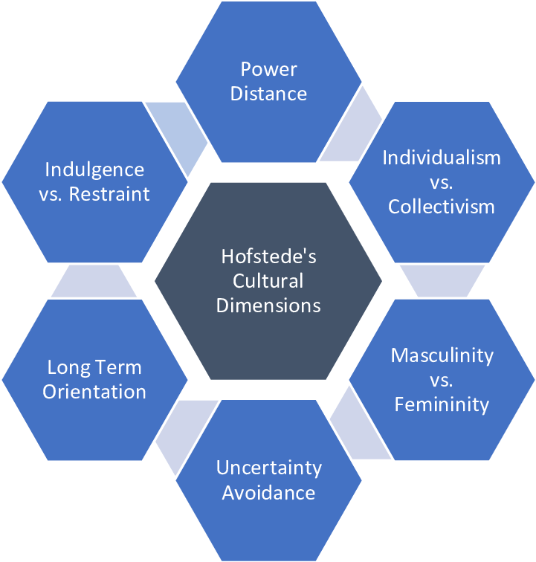
Figure 1: Hofstede cultural dimensions
(Source: Vizmonte and Ligot, 2024)
Company Structure
Governance structure is followed in John Lewis and it means external stakeholders of the company are not able to dictate about the direction of the company. The key components of the Governance structure include shareholders, BOD, executive management and other stakeholders like employees and financiers (Garg, 2022). The Governance structure of the business enterprise includes the chairman, the partnership board and the partnership council. The chairman refers to the senior executive of the company and the person is responsible for strategic decisions. The partnership board’s role is to manage the business and conduct the policy. The partnership council is the main body of the democratic structure.
Decisions
In order to make the final decision of the company, five step processes are followed. It includes initiation, development, feedback and consultation, decision and accountability. Executive leaders play an important role in the process of identifying an opportunity in the first stage. Plans are developed by the management of the company. Managers try to set plans for the company because they can provide better direct and coordinated effort better than other entities in the organisation (Gupta et al., 2022). Proposals are discussed in different forums and the partnership board plays the most important role in making the final decisions. The leadership of the company is mainly accountable for the election of representatives.

3. Types of Culture
In order to understand the culture type of John Lewis, it is important to consider Handy’s Model. The components of the model can be understood well from the following figure.
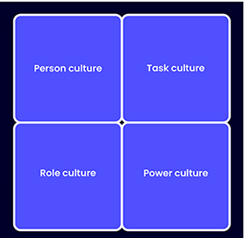
Figure 2: Handy’s Model
(Source: Businessballs, 2025)
Culture type | Application in John Lewis | Impact
Person culture | The application of personal culture in John Lewis can be mentioned in the context of the following Partner ownership model. It means it values happiness as well as autonomy. | Positive: The employee loyalty is high in John Lewis and most employees are very much satisfied in working in the company. Employee loyalty is important in the workplace because it helps in lowering the recruitment cost (Qi et al., 2024). A strong sense of shared purpose is seen within employees of the company.  Negative: Decision making process can become extremely slow sometimes.
Task culture | Project-based teams like marketing campaigns and IT development play a very important role in the process of solving problems in John Lewis. | Positive: Cross-functional collaboration and innovation can be mentioned under positive impact of it.  Negative: The possibility of having conflict can be mentioned under this particular aspect.
Role culture | Role culture is important because it helps in dealing with managing large scale and complex real operations. | Positive: Clear structure and efficiency is needed to be mentioned under positive impact of the role culture of John Lewis.  Negative: Under the rigid structure, individuals may not be able to express their creativity. Limited autonomy and fear of failure are two reasons for which creativity is not properly expressed by employees in the organisation (Manuoglu, 2023). Potential for bureaucracy in the highly structured areas can be mentioned under the negative aspect of it.
Power culture | Power culture is minimised by the governance structure as well as trust model. Power is properly distributed among different stakeholders of John Lewis | Positive: The positive impact can be mentioned in the context of concentrating power which helps in ensuring accountability and transparency.  Negative: Lack of top-down decision making is needed to be mentioned under the negative aspect of the culture of John Lewis.
Table 1: Culture type explanation by Handy’s Model
(Source: Self-created)

4. Organisational culture and external environment
The external environment will be analysed with the help of PESTLE framework
External Environment analysis
Factors | Explanation | Impact on the company
Political | The corporate tax rate in the UK has been increased in the present times. In order to understand the facts, the following figure is required to be considered.  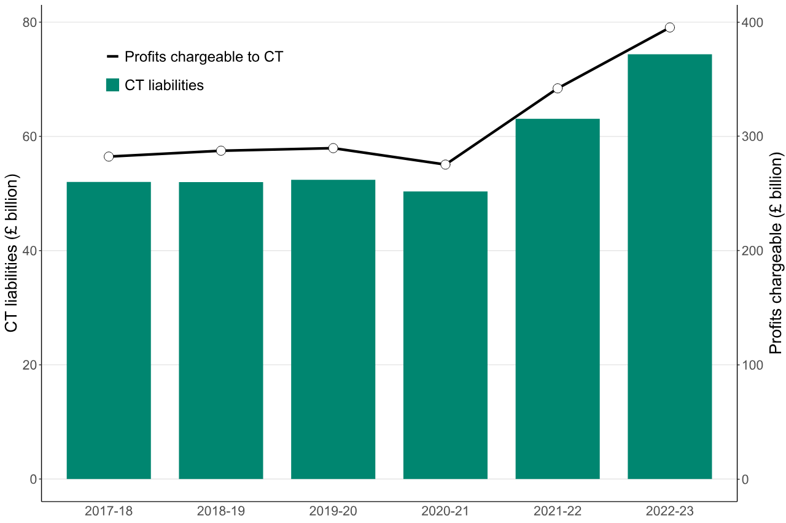  Figure 3: UK corporate tax rate  (Source: Gov, 2025) | The increased corporate tax rate is not good for John Lewis because it leads to increasing overall cost for the company.
Economical | The inflation rate is an important factor to make decisions about cost. The UK inflation in recent years can be understood from the following figure.  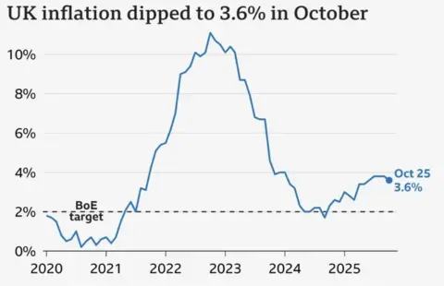  Figure 4: Inflation rate of the UK  (Source: BBC, 2025)  The rate of unemployment in the UK was 4.11 % in 2024 but it was 3.98 % in 2023 (O'Neill, 2025). | Due to the high inflation rate, John Lewis may be required to bear extra cost. However, the company will get advantage in the context of setting minimum wage. Considering both, it is said that economic factors have a moderate impact on the company.
Social | The purchasing power of the UK people has increased in recent times. It can be expected that it will be improved more in the coming future. | Social factors have a positive impact with respect to premium-priced products of the company.
Technological | The UK is a technologically developed country and the global innovation index of the country is quite high. Therefore, technology like AI, big data and different kinds of software can easily be incorporated. | Technological factors also have a positive impact on John Lewis because it can provide better satisfaction to the customers. At the same time, business practices can be implemented in a better way.
Legal | Employer responsibilities and employee rights are properly understood through Employment Rights Act 1996 (Taylor and Emir, 2025). Employment Rights Act 1996 is needed to be followed by almost all companies of the UK. | The legal factor has a negative impact on the company because it may reduce the profit of the company in the process of giving different kinds of benefits to its employees.
Environmental | As climate change has become one of the main concerns in the world, the companies in the UK are forced to follow act like Environment Act 2021and Environmental Protection Act 1990 | The aspect of the environment is not beneficial for John Lewis because it forces the company to follow the CSR aspect with respect to the environment. It leads to delaying the business practice and increasing overall cost.
Table 2: PESTLE analysis
(Source: Self-created)
In order to understand the influence of organisational culture for adapting the external environment, the Schein culture model is used. The level of the model can be understood from the following figure.
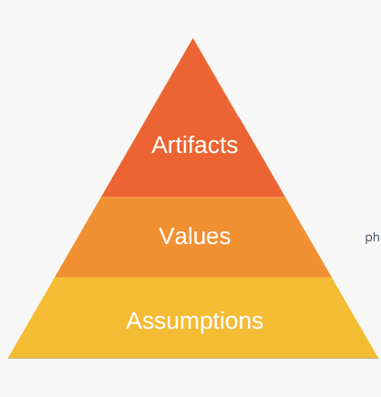
Figure 5: Schein culture model
(Source: Denis, 2025)
Level 1: Artefacts
This level can be considered as visible and observable as well and in this stage, unique benefits like holiday and exclusive leisure facilities are provided to employees. Apart from that, annual bonuses are also provided by John Lewis and in this way the company deals with the legal aspect which was mentioned in the above section. Giving an annual bonus to employees is important because it helps in increasing productivity and improving morale (Leonova et al., 2021). The title ‘Partner’ is used by the company instead of using employees which helped the company to gain a positive image. .
Level 2: Espoused Values
This level denotes stated mission and philosophy and the purpose of the partnership is cleared in this level. By telling about the goal and mission of the company, the company tries to deal with environmental factors as well. In this process, technological factors are properly followed by incorporating technology like AI and big data. Values of fairness and trust can be mentioned in this level and therefore proper training is provided to employees of John Lewis.
Level 3: Underlying Assumptions
Unconscious belief is considered under this level and the core assumption of the level is to provide long term sustainability. In this stage, the company tries to deal with the unconscious belief of employees. In this stage, the stakeholder engagement process is also properly followed. Creating a communication plan and analysing the priority of stakeholders are some effective ways to engage stakeholders (Koilakonda, 2024). In order to deal with rest factors like political, economic and social, the company is focused on research work. Based on this pricing strategy and cost factor of the company is set. Short-term profit is also considered in this stage and it includes maximising stakeholder return as well.

5. Organisational Culture and barriers to effective functioning
According to Mullins and Christy (2016), the internal process of a company depends on factors like shared values and practices of the company. The author has mentioned the importance of coherent culture and it is in demand in recent times because of globalisation. It is extremely important to deal with a diverse workforce to incorporate coherent culture in a proper way.
Considering the fact, it can be said that the organisational culture plays a very important role in the process of ensuring effective functioning in the workplace. However, the organisational culture of John Lewis creates different kinds of barriers with respect to effective functioning. The elaboration is as follows.
Barriers in decision-making: The PDI of the company is low enough and this is already mentioned in the above section. It leads to making the decision-making procedure much slower. The slow decision-making procedure results in missed opportunity and financial loss for the company (Nekrasov et al., 2023). Moreover, John Lewis is a power-centric organisation which is not helpful for employees to provide proper motivation. Even intrinsic motivation does not work properly under this kind of work environment.
Resistance to external expertise: John Lewis follows strong internal culture and core components of it include democratic principles and purpose-driven mission. Excessive rigidity is a responsible factor of creating hindrance in the process of dealing with external ideas. For this particular reason, senior management of the company faces problems sometimes. Many times it is seen that new leaders face problems to embrace the existing culture in a proper way.
Maintaining coherence with diversity: Considering the statement of Mullins and Christy (2016), it is said that effort is very much required to maintain harmony among a diverse workforce. The employees of John Lewis are not accustomed to this fact. Therefore, barriers are occurring in effective functioning in the organisation. The lack of proper training is also required to be mentioned in this regard. The operational division is not good enough and therefore conflict arises in case of making decisions among different operations. Resistance to change and flawed-decision making are some drawbacks of coherent culture (Mahbub et al., 2024). Therefore the chosen business enterprise is facing problems with regards to both factors. In future the chosen business enterprise may shift to choosing another type of organisational culture.

6. Organisational culture and organisational performance
The organisational culture of John Lewis has both positive and negative impact on the performance of the organisation.
Positive impact
The partner sense of ownership helps the employees of the organisation to be more knowledgeable and engaged. For this particular reason, it is possible for the company to provide proper satisfaction to customers. The customer rating of John Lewis is high for a longer period of time. Customer ratings are important because it helps in attracting new customers which leads to improvement of brand reputation as well (Shin et al., 2025). For this reason, the company is able to maintain the proper competitive advantage position with respect to other companies as well.
The organisational culture which is mentioned in the above section helped John Lewis to bring different kinds of innovation. Both process and product innovation is included under innovation (Duygan et al., 2023). The culture helped in adopting new working methods like digital innovation for which it is possible for the business enterprise to provide service like "Cook Well"
Negative impact
The organisational culture of John Lewis is not good in the process of making quick decisions (Globalassignmenthelp, 2025). . In other words, it is said that complexity is seen with respect to making important decisions by John Lewis. For this particular reason, a problem is seen in taking decisions about selection of leadership. Based on requirements and time, the leadership style should be changed in the company.
Inconsistency and financial loss are some negative consequences of organisational culture followed by John Lewis. Substantial investment costs may lead to reduction of financial flexibility and liquidity (Islam et al., 2022). Because of the axed staff bonuses in the current years, the company had to increase investment costs. This leads to the consequence of creating additional economic pressure on the company.
As per the statement of Mullins and Christy (2016), a diverse workforce needs to be dealt with in a proper way for maintaining the coherent culture. However, this culture provides inflexibility as well as shifted creativity. In this way, the company is not able to improve the performance as per desired level.

7. Recommendations
Recommendation 1: Streamlining procedure of decision-making for agility
In order to deal with decision-making problems identified in the above section, it is important to adopt a tiered decision-making framework. The Streamlining procedure of decision-making for agility should be adopted by agile methodology and incorporating cross-functional teams (Ojika et al., 2021). Differentiation should be made among time-sensitive, long-term and operational strategic decisions. Accountable tasks should only be provided to executives of John Lewis.
Recommendation 2: Enhancing agility with preserving the "Partner" Identity
It is extremely important to foster a continuous learning culture in John Lewis. The importance of continuous learning culture can be mentioned on the grounds of long-term survival (Ahsan, 2025). Launching internal campaigns can be an effective way to maintain consistency as well as service excellence. Apart from that, the company should provide proper training and in the process modern technology can be used. There are many employees in the company who do not have proper skills regarding technology and therefore they are not able to use data analytics in a proper way. The chosen business enterprise must be focused on this fact to bring improvement.
Recommendation 3: Integrating external perspectives
In order to deal with internal culture risk, it is important to inject external perspectives in a systematic way. Senior management of John Lewis should play an important role in this respect. Strategic planning meeting is important because it helps in creating a roadmap through which long term objectives can be met very easily (Adepoju et al., 2023). John Lewis should introduce a strategic planning meeting to identify the blind spot in the organisation. Focus should be given on formal mentorship as well to deal with different viewpoints of stakeholders of the business enterprise.

8. Conclusion
Based on the overall discussion, it can be concluded the present organisational culture of John Lewis is both beneficial and non-beneficial for business practice. The coherent organisational culture is not suitable for leadership as well as management skill in the organisation. John Lewis is a large organisation and therefore this organisational culture is suitable in the context of dealing with different kinds of workforce. However, decision-making is one of the most important factors for any kind of organisation. This particular culture is not able to provide the benefits of decision-making procedure. Financial loss and inconsistency are some other drawbacks of this organisational culture. In order to overcome the problem, it is extremely important to focus on streamlining the procedure of decision-making for agility. Integrating external perspectives under strategic planning is another factor which can be identified from the above discussion. Considering the external factors, it is said that some factors like political, legal, and environmental and some economic factors are not favourable for the company. Therefore, John Lewis should be focused on research work to reduce the negative impact of all these factors.

References
Adepoju, A.H., Eweje, A., Collins, A. and Hamza, O., (2023). ‘Developing strategic roadmaps for data-driven organisations: A model for aligning projects with business goals’. International Journal of Multidisciplinary Research and Growth Evaluation, 4(6), pp.1128-1140. Available at: https://doi.org/10.54660/.IJMRGE.2023.4.6.1128-1140 (Accessed: 22 November 2025)
Ahsan, M.J., (2025). ‘Cultivating a culture of learning: the role of leadership in fostering lifelong development.’ The learning organisation, 32(2), pp.282-306. Available at: https://doi.org/10.1108/TLO-03-2024-0099 (Accessed: 22 November 2025)
Bbc (2025). Why is UK inflation still high?. Available at: https://www.bbc.com/news/articles/c17rgd8e9gjo (Accessed: 22 November 2025)
Bowie, N. and Renan, D., (2021). ‘The Separation-of-Powers Counterrevolution’. Yale LJ, 131, p.2020. Available at: https://heinonline.org/HOL/LandingPage?handle=hein.journals/ylr131&div=40&id=&page (Accessed: 22 November 2025)
Businessballs (2025). Introduction to Handy's Model of Organisational Culture. Available at: https://www.businessballs.com/organisational-culture/introduction-charles-handy-organisational-culture/ (Accessed: 21 November 2025)
Denis G (2025). Edgar Schein’s Organisational Culture Model. https://expertprogrammanagement.com/2022/09/edgar-schein-culture-model/ (Accessed: 24 November 2025)
Duygan, M., Fischer, M. and Ingold, K., (2023). ‘Assessing the readiness of municipalities for digital process innovation’. Technology in Society, 72, p.102179. Available at: https://doi.org/10.1016/j.techsoc.2022.102179 (Accessed: 22 November 2025)
Garg, S., (2022). ‘A Critical Analysis of Corporate Governance and Board Management’. Jus Corpus LJ, 3, p.1097. Available at: https://heinonline.org/HOL/LandingPage?handle=hein.journals/juscrp3&div=465&id=&page (Accessed: 22 November 2025)
Globalassignmenthelp (2025). Organisation Behaviour. Available at: https://www.globalassignmenthelp.com/free-samples/business-assignment-help/organisation-behaviour#:~:text=Cultural%20Impacts%2D%20Role%20culture%20is,consumers%20about%20product%20and%20services. (Accessed: 24 November 2025)
Gov (2025). Corporation Tax statistics commentary 2024. Available at: https://www.gov.uk/government/statistics/corporation-tax-statistics-2024/corporation-tax-statistics-commentary-2024 (Accessed: 23 November 2025)
Gupta, M.J., Chaturvedi, S., Prasad, R. and Ananthi, N., (2022). Principles and practice of management. AG publishing house (AGPH Books).
Islam, R., Haque, Z. and Moutushi, R.H., (2022). ‘Earnings quality and financial flexibility: A moderating role of corporate governance’. Cogent Business & Management, 9(1), p.2097620. Available at: https://doi.org/10.1080/23311975.2022.2097620
Johnlewispartnership (2025). JOHN LEWIS PARTNERSHIP UNAUDITED FULL YEAR RESULTS FOR THE 52 WEEKS ENDED 25 JANUARY 2025. Available at: https://www.johnlewispartnership.co.uk/~/media/Files/J/john-lewis/Universal/documents/news/John-Lewis-Partnership-plc-2024-25-Full-Year-Results-Announcement.pdf (Accessed: 23 November 2025)
Kapur, R., (2022). ‘Leadership management and development in organisations’. International Journal of Information, Business and Management, 14(2), pp.47-57. Available at: https://www.researchgate.net/profile/Wilbert-Manyanga/publication/361739214_THE_EFFECT_OF_BRAND_IMAGE_ON_CUSTOMER_CHOICES_IN_THE_ZIMBABWEAN_FOOD_INDUSTRY/links/62c2dca15c293526ef88879e/THE-EFFECT-OF-BRAND-IMAGE-ON-CUSTOMER-CHOICES-IN-THE-ZIMBABWEAN-FOOD-INDUSTRY.pdf#page=52
Koilakonda, R.R., (2024). ‘Effective communication strategies for stakeholder engagement’. International Journal of Core Engineering & Management, 7(08). Available at: https://www.researchgate.net/profile/Raghunath-Reddy-Koilakonda/publication/385319028_EFFECTIVE_COMMUNICATION_STRATEGIES_FOR_STAKEHOLDER_ENGAGEMENT/links/672056a9edbc012ea14567b8/EFFECTIVE-COMMUNICATION-STRATEGIES-FOR-STAKEHOLDER-ENGAGEMENT.pdf
Leonova, I.S., Pesennikova-Sechenov, E.V., Legky, N.M., Prasolov, V.I., Krutskikh, I.A. and Zayed, N.M., (2021). ‘STRATEGIC ANALYSIS OF THE MOTIVATION ON EMPLOYEES'PRODUCTIVITY: A COMPENSATION BENEFITS, TRAINING AND DEVELOPMENT PERSPECTIVE’. Academy of Strategic Management Journal, 20, pp.1-11. Available at: https://d1wqtxts1xzle7.cloudfront.net/78834099/Strategic-analysis-of-the-motivation-on-employees-productivity-a-compensation-benefits-training-and-development-perspective-1939-6104-20-libre.pdf?1642278827=&response-content-disposition=inline%3B+filename%3DStrategic_Analysis_of_the_Motivation_on.pdf&Expires=1763988525&Signature=g5iyeGl3lzZS8iElYKNhpiZebAYRA4ROMSQWYC6x9A1HBVt5-UHg~PMDb4mKNS6sSWq5H3bkpR3~-4LtFjOq~D5yM-cyKD2ZqneFU4rKBeIr-VzyGf4~5HJunjycAuW0IW6qjQskANlmhLTB7u4VOH~Q11nNpmxKebk3CI6bbumZnsETPSLmej-h3y7ZQ44kMn83XTvHnav7Ngom8NnJNPjCYzDxZve3V~Ki2ou5L7rpx3aS7dt97BcEfaOYEJvt0ZdQNuTlga~PYYLSRy1Jw7AAkve5YOaj438Gw~gQiQOnP3CkYXAdIYqTSJ~sstQDyUvhpOP6gfkzDPDIzpquaA__&Key-Pair-Id=APKAJLOHF5GGSLRBV4ZA
Mahbub, M.B., Nabil, M. and Ahmed, T., (2024). ‘A qualitative analysis of the influence of management information systems on organisational decision-making processes’. Acta Informatica Malaysia (AIM), 8(2), pp.87-93. Available at: 10.26480/aim.02.2024.87.93
Manuoglu, E., (2023). ‘The role of perceived autonomy support and fear of failure: A weekly diary study on work-related rumination’. Plos one, 18(10), p.e0291312. Available at: https://doi.org/10.1371/journal.pone.0291312
Mullins, L., and Christy, G. (2016). Management & Organisational Behaviour (Eleventh ed., Always learning).
Nekrasov, A., Teoh, S.H. and Wu, S., (2023). Limited attention and financial decision-making’. In Handbook of financial decision making. Edward Elgar Publishing.
Ojika, F.U., Owobu, W.O., Abieba, O.A., Esan, O.J., Ubamadu, B.C. and IFESINACHI, A., (2021). Optimizing AI Models for Cross-Functional Collaboration: A Framework for Improving Product Roadmap Execution in Agile Teams. Journal name and details missing–please provide. Available at: https://www.researchgate.net/profile/Favour-Ojika-2/publication/390928998_Optimizing_AI_Models_for_Cross-Functional_Collaboration_A_Framework_for_Improving_Product_Roadmap_Execution_in_Agile_Teams/links/6802b65bded43315572ad388/Optimizing-AI-Models-for-Cross-Functional-Collaboration-A-Framework-for-Improving-Product-Roadmap-Execution-in-Agile-Teams.pdf
Okunade, J.K., (2025). ‘Exploring the Impact of Effective Internal Communication Strategies on Employee Morale, Productivity, and Organisational Culture’. Lakhomi Journal Scientific Journal of Culture, 6(1), pp.1-11. Available at: https://doi.org/10.56741/ohds.v1i02.718
O'Neill A (2025), \ Unemployment rate in the United Kingdom (UK) from 1999 to 2024. Available at: https://www.statista.com/statistics/263709/unemployment-rate-in-the-united-kingdom/#:~:text=Table_title:%20Unemployment%20rate%20in%20the%20United%20Kingdom,Characteristic:%202021%20%7C%20Unemployment%20rate:%204.83%25%20%7C (Accessed: 22 November 2025)
Qi, L., Yee, C.M., Chan, B. and Fah, Y., (2024). ‘The role of work-life balance in enhancing employee loyalty’. Accounting and Corporate Management, 6(1), pp.43-47. Available at: DOI: 10.23977/acccm.2024.060106
Shin, S., Shin, H.H., Lee, E. and Yhee, Y., (2025). ‘Do repeat customers effectively attract new customers? Reconsidering customer influence value of repeat customers’. Journal of Hospitality & Tourism Research, 49(6), pp.1096-1108. Available at: https://doi.org/10.1177/10963480241277093
Taylor, S. and Emir, A., (2025). ‘Employment law: an introduction’. SAGE Publications Limited.
Vizmonte E and Ligot D (2024). Analyzing the Relationship Between Cultural Dimensions and Educational Performance using Hofstede model and PISA Data. Available at: https://www.researchgate.net/figure/Hofstedes-Cultural-Dimensions_fig1_377219185 (Accessed: 22 November 2025)

