Programme: BA (Hons) Leadership and Management Skills in the Workplace
Module: Project Management
Module Code: LCLM5003

Student Name: SHAMIM YOUNIS
Student ID: 2313915

Assignment Title: A Project Portfolio.
DIGITAL MODERNISATION OF PASSENGER FLOW AND LOGISTICS COORDINATION

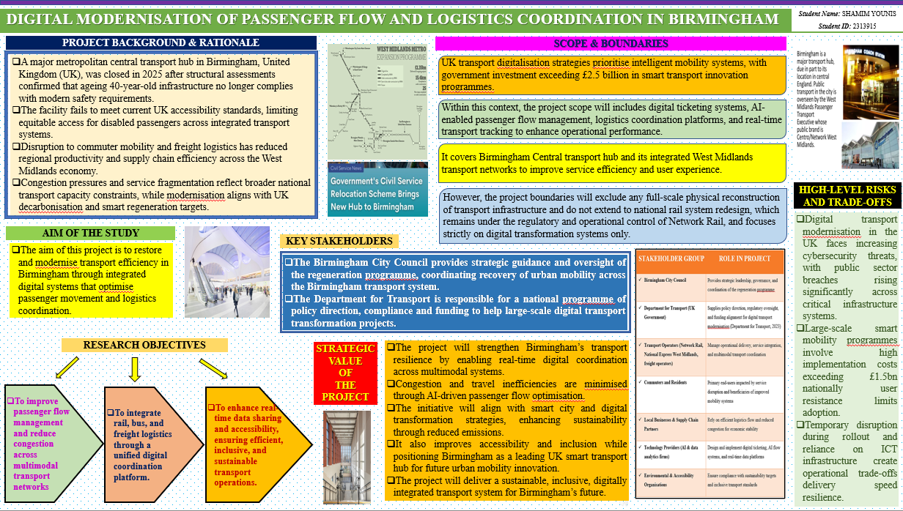
Part A – Project Proposal Poster

Table of Contents
Part B – Reflection on Feedback 4
References 18

Part B – Reflection on Feedback
The tutor and peer feedback confirmed that my poster established a coherent and credible rationale for the digital modernisation of Birmingham's transport hub. I communicated the relationship between hub closure, ageing infrastructure, passenger disruption, freight inefficiency, congestion and regional economic effects clearly. This was a huge asset as I didn't view digitalisation as a technological solution alone, but rather as a holistic solution to operational, social and environmental problems. My focus on the use of AI for managing passengers, digital ticketing, and real-time information and logistics coordination was very well received. This approach aligns with the priorities of the UK Government Project Delivery, which include digital transformation, sustainable outcomes and better public services as key benefits of effective project delivery (GOV.UK, 2025).
I also included current policy and industry evidence to support my proposal rather than just descriptive claims. For instance, I have been involved in the linkage of accessible transport design and inclusive user experience, and data sharing and better coordination of rail, bus, and freight services. I therefore realised that one single platform could be useful to a number of user groups. This aligns with the Government Functional Standard for Project Delivery, which states that stakeholder engagement, information management, planning, risk management and benefits management are delivery practices that are interconnected (Ominde et al., 2023).
The feedback suggested that my goals were not quantifiable. While they described the purpose of the project, they did not identify baseline performance, the target outcomes, accountable owners or the timeframe of delivery. Thus, the final project plan will turn each objective into a SMART commitment. I will set a target to reduce average peak-period passenger queuing time by 20% within 12 months of system deployment, measured through anonymised sensor data. Additionally, I'll aim for 95% uptime for real-time information about the services and set up a six-month pilot program for the freight coordination platform. These changes will ensure monitoring, remedial action and benefits realisation, rather than assuming the technology is best for performance.
The tutor further correctly identified a need for more project-management skills in the poster. The final plan will comprise a stakeholder power-interest matrix of Birmingham City Council, transport operators, freight companies, technology suppliers, disabled passengers, local businesses and regulators. I will also have disabled-user representatives during prototype testing, not after design decisions have been made. This adjustment directly addresses the need for inclusive governance and minimises the likelihood of unintentional exclusion due to digital interfaces.
Additionally, I will replace the short discussion on risk with a probability impact risk matrix, risk owners and explicit mitigations. Security in cybersecurity will need to be secured by design, access controls and testing; open standards in interoperability; and training, multilingual guidance and assisted support in adoption. I will also introduce a phased schedule, discovery, procurement, pilot, evaluation and a scaled implementation, and provide stage gate approval by a project board. Overall, feedback has shifted my work from a persuasive concept to a more accountable, measurable and governable final plan for project management.

Table of Contents
Part C – Project Management Plan 7
1. Introduction 7
2. Project Description 7
3. Scope 8
4. Work Breakdown Structure (WBS) 9
5. Quad Chart 12
6. Gantt Chart 13
7. Stakeholders’ Involvement 14
8. Allocation of Resources 15
9. Risk Analysis 16
10. Conclusion 17
References 18

Part C – Project Management Plan

Introduction
The central transport hub in Birmingham was closed in November 2025 following a structural inspection that revealed its 40-year-old facilities did not meet current safety and accessibility standards (Transport for West Midlands, 2025). The closure caused confusion for passengers, operators and businesses as it affected both rail and bus-freight interchange. In 2025, there were 3.738 billion vehicle miles travelled on Birmingham's roads, highlighting the extent of urban mobility demand that is being impacted by limited network capacity (Transoft Solutions, 2025). The lack of a coherent ticketing system, different operator applications and siloed data hinders users from understanding multimodal travel options well. The project will provide digital ticketing, passenger flow management with AI, real-time tracking and integrated logistics coordination to realize the sustainable, accessible and economically resilient mobility. The management plan outlines the project description, scope, work breakdown structure, quad chart, Gantt chart, stakeholder involvement, resource allocation, risk analysis and conclusion.

Project Description
The Digital Modernisation of Passenger Flow and Logistics Coordination project will establish the digital environment for the central transport hub and connected rail, bus and freight networks in Birmingham. It will implement account-based ticketing, real-time information on demand, passenger-flow analytics with AI support, dashboards and shared freight coordination. These interventions tackle issues with fragmented data, inconsistent disruption information and inefficient interchange decisions, ensuring that user-centred, accessible, secure and measurable services are delivered (Gethrude, 2024).
The project will be managed with a combination of management methods. A hybrid approach is better suited as Waterfall offers governance and regulatory control, and Agile allows for a digital development process that is incremental and allows users to provide feedback and flexibility during implementation without sacrificing accountability or compliance (Kavuru, 2024). This approach is a blend of traditional planning techniques and agile principles to balance structure, flexibility, and the ability to deliver projects quickly and effectively (Tettey et al., 2025). The procurement, budget approval, assurance and formal acceptance will be governed by predictive controls, and iterative development will support prototype testing and refinement with the users. This blend will serve as accountability while allowing operational evidence-based adaptation.
Objectives will be developed in accordance with the SMART framework, which sets objectives for effective planning that are specific, measurable, achievable, relevant, and time-bound (Mohammadi-Ghayeghchi et al., 2024). These objectives are:
- To reduce peak passenger queuing times by 20% within 12 months.
- To maintain 95% real-time journey information availability during year 1.
- To complete a 6-month freight coordination pilot with participating transport operators.
- To measure loading-bay conflicts against discovery-phase baselines throughout pilot delivery.
- To achieve booking compliance targets through monitored freight operator participation during pilots.
The results will be interoperable data architecture, application programming interfaces, accessible passenger interfaces, flow-monitoring sensors, cybersecurity controls, and staff training/handover documentation. The project manager will coordinate suppliers, operators, assurance and reporting, and Birmingham City Council will appoint a Senior Responsible Owner to coordinate and monitor the project. Success will be judged based on the reduction of queue times, the availability of the system, accessibility testing, stakeholder uptake, resolving incidents and verified benefits realisation. Technological outputs will be converted to operational results for passengers, freight operators and businesses throughout the metropolitan network with this structure.

Scope
The project scope includes the design, procurement, configuration, testing, deployment and operational handover of a digital coordination system for Birmingham's central transport hub. In-scope passenger deliverables include the integration of ticketing with accounts, user-friendly web and mobile journey interfaces, real-time disruption alerts, station information displays, and AI-powered analytics to detect congestion patterns. In-scope logistics deliverables will include freight-slot booking platform, shared operator dashboards, delivery-status tracking, and delivery-status data interfaces between participating rail, bus and freight organisations.
The implementation area is the closed hub, temporary interchange arrangements and designated connected services in the West Midlands network. It will also involve disabled-user feedback, user research with travellers, data-protection review, cyber security testing, staff training, pilot operation, and support for the implementation of the benefits. 95% real-time information availability, successful accessibility testing, secure data exchange and documented ownership of operation will be required for acceptance.
The scope will not include the replacement of the stations, rebuilding of stations, track replacement, road construction, procurement of rolling stock, or redesign of the national rail timetable. It will also remove the requirement for operators not included in the agreed pilot cohort to participate. It assumes that the organisations participating can make data available in a lawful manner, that existing communications systems can accommodate integration, and that funding will be approved prior to procurement. Proposed functionality outside these boundaries will need to be presented for formal change control, impact assessment and project-board approval prior to implementation.

Work Breakdown Structure (WBS)
A Work Breakdown Structure systematically divides project scope into manageable deliverables, tasks and work packages for effective planning, control and accountability (Odedairo, 2024).

Figure 1: WBS Structure of the Project

The WBS is a breakdown of the Birmingham digital modernisation project into seven controlled work packages, meaning that every delivery is identified, sequenced and assigned before the project gets started. The project initiation will set the charter, business case, governance board, budget baseline, procurement route and reporting calendar. This will be achieved through Discovery mapping of passenger journeys, freight movements, data ownership, accessibility requirements, and existing operational interfaces. These will involve meeting with the transport operators, disabled travellers, local businesses and technology specialists, taking into account operational needs and not assumptions.
Interoperable data architecture, application programming interface, ticketing interface, station dashboards, AI analytics, and freight slot functions will be described during the design and procurement of the solution. Technical capability, security, accessibility, whole-life cost and integration capacity will be evaluated by the supplier. Build and integration will include software configuration, integration of participating operator systems, flow-monitoring sensors and setup of secure data exchange. The cybersecurity needs will include threat modelling, role-based access controls, audit logging and penetration testing, all of which align with the National Cyber Security Centre's secure design principles (NCSC, 2025).
Testing and pilot delivery will ensure function, access, interoperability, resilience and operational readiness prior to larger-scale deployment. The pilot will gather baseline and comparative data on queue times, information availability, booking adherence and satisfaction. The implementation will be a phased approach, staff training, passenger communications, and assisted-digital support will be used to minimise disruption. Benefits realisation and closure will review and determine that the project met its SMART targets, hand over ownership to the operational teams, record lessons learnt and contracts closed. This hierarchy will enable the project board to track progress, permit stage transitions and manage changes within scope, budget, quality and schedule baselines. WBS will, therefore, ensure transparency in the control, accountability and coordinated delivery throughout the implementation stages.

Quad Chart
The Quad Chart is a summary of the objectives, milestones, resources, and risks in a single decision-focused project-control instrument (Bauer, 2025). The chart will set out a 20% reduction in average peak-period passenger queueing in 12 months; 95% availability of real-time information; and a six-month freight-slot pilot. These outcomes will be measured using anonymised sensor data, platform logs and operator booking records. This evidence-informed approach can help inform benefits management, as it links deliverables to measurable operational improvements (Mejía et al., 2025). By the 3rd month, discovery, user research and requirements approval will be completed. By the 6th month, procurement, architecture design and data sharing agreements will be finalised.
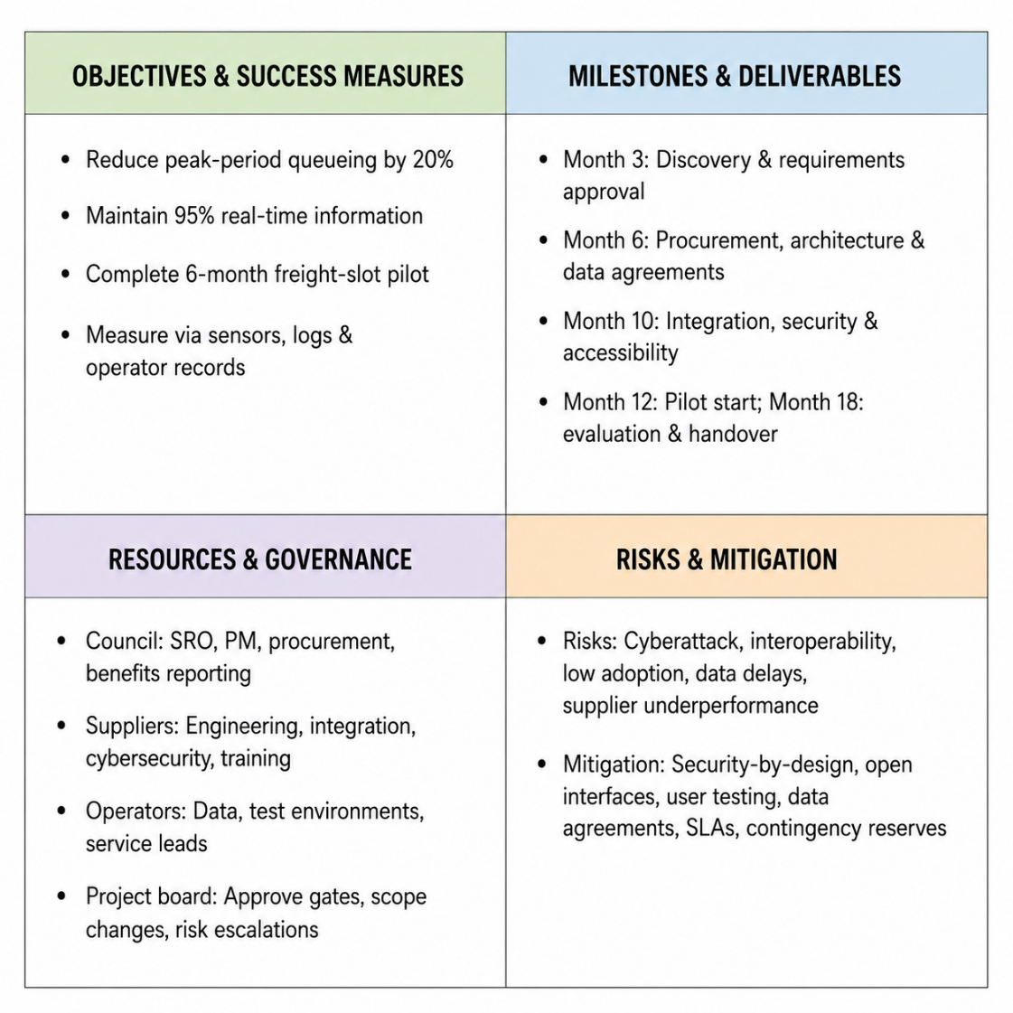
Figure 2:Quad Chart of the Project
System integration, cybersecurity testing and accessibility assurance will conclude by month ten. The controlled pilot will begin in month 12, and evaluation and operational handover will be carried out in month 18. Birmingham City Council will be the Senior Responsible Owner, project manager, procurement oversight and benefits reporting. Engineering, integration, cybersecurity and training will be supplied by technology suppliers, while operational data, testing environments and service leads are supplied by operators. Secure design, open interfaces, user testing, contractual service levels and contingency reserves will be used to control for Cyberattack, Interoperability failure, Low adoption, delayed data access and Supplier underperformance. Thus, the Quad Chart will facilitate timely decision-making, transparency, and supervisory oversight of disciplined delivery.

Gantt Chart
A Gantt chart is a visual representation of a project that displays the tasks, their durations, dependencies and milestones, allowing project managers to track progress, resource allocation, and project control (Sekuloska, 2025).
Key Project Phase | M1 | M2 | M3 | M4 | M5 | M6 | M7 | M8 | M9 | M10 | M11 | M12
Initiation and governance
Discovery and requirements
Solution design and procurement
Build and systems integration.
Testing and assurance
Training and change management
Controlled pilot and monitoring
Evaluation and project closure
Table 1:Project's Gantt Chart
The Gantt chart sets the baseline of project deliverables (12 months), sequences work packages, dependencies, decision points and resource commitments. In Months 1-2, governance is to be set up, the business case is approved, and reporting controls are set up. From Months 1-3, Discovery and requirements definition will be completed, which will deliver validated passenger, freight, accessibility and data requirements. Design and procurement will take place in Months 4-6, concluding with the appointment of suppliers, architect's approval and data-sharing agreements. Build and integration will take place in Months 6-8, configuring tickets, dashboards, analytics, sensors and freight coordination interfaces. Testing and assurance for Months 9-10 will evaluate cybersecurity, accessibility, interoperability, performance and operational readiness. Starting from Month 10 and continuing through Month 11, training and change management will be initiated to prepare the staff, operators and users. The controlled pilot will run over Months 11-12, collecting data on queue times, information availability and compliance with booking. Evaluation and formal handover/closure of operations will be carried out in Month 12. The schedule facilitates the stage gate governance that can facilitate the project board to approve the progression of the project only when the agreed criteria of quality, risk, and readiness are fulfilled.

Stakeholders’ Involvement
Decisions on stakeholder involvement will be managed using a framework of power and interest, and separate groups of decision makers, delivery partners, affected users and statutory consultees will be identified. Birmingham City Council will be the project sponsor, designate the Senior Responsible Owner and will lead the monthly project-board meetings. The council will authorise scope changes, fund releases, procurement and escalation responses. This governance model is reflective of project expectations in the public sector, where there is clear accountability, delegated authority and proportional assurance (Birmingham City Council, 2026).
Operational data will be provided by Transport for West Midlands, rail operators, bus operators and freight organisations, technical leads will be nominated, and interface requirements will be validated. They will be facilitated through data sharing agreements, service-level requirements and integration workshops, which take place every fortnight. Technology suppliers will set up ticketing, analytics, dashboards and freight-booking capabilities and provide weekly progress, quality and cybersecurity reports. The UK Government's Service Standard sets out that multidisciplinary teams should be aware of the needs of the users and test services and keep them accessible during delivery (Public Digital, 2026).
Passengers, disabled users, older residents, digitally excluded users, local businesses, and freight drivers will engage via structured interviews, accessibility workshops, prototype testing and pilot feedback surveys. Before user-acceptance testing, prototypes of interfaces will be checked by representatives of people with disabilities in accordance with Web Content Accessibility Guidelines 2.2. This involvement will minimise the risk of exclusion and provide assisted-digital support that meets actual travel needs. Under the Equality Act 2010 service providers are obliged to make reasonable adjustments for disabled individuals (Legislation.gov.uk, 2024).
Policy, regulatory and assurance oversight will be provided by the Department for Transport, West Midlands Combined Authority, Information Commissioner's Office and National Cyber Security Centre. The project manager will keep a register of stakeholders, an engagement calendar, an issue log and a communication dashboard. Monthly decision reports will be provided to high-power stakeholders, fortnightly coordination meetings will be held with delivery partners, and user consultation will be provided at each stage-gate, all of which will be accessible. Escalated conflicts will be resolved by the project board within 10 working days. As a result, the structured engagement will guarantee legitimacy, operational ownership, regulatory compliance, and continued adoption in the digital transport ecosystem.

Allocation of Resources
The allocation of resources will match people, finance, technology and information to the 12-month delivery schedule and approved scope. Birmingham City Council will provide a Senior Responsible Owner, a project manager, a finance officer, a procurement lead and a benefits manager. A team of dedicated digital delivery experts will comprise a solution architect, data engineer, cybersecurity specialist, accessibility lead, business analyst, change manager and service-design researcher. This multidisciplinary design is in line with the Government Service Standard, which calls for teams to have the right skills throughout service delivery (ModernGov, 2023).
External suppliers will provide cloud hosting, software development, application programming interface integration, sensor installation, testing tools and service-desk capacity. Operational managers, data stewards, station staff and freight coordinators will be assigned by transport operators to validate requirements, test and support pilots. Budget will be allocated over discovery, procurement, build, assurance, training and pilot operations with a contingency allocated for integration defects and security remediation. Resource loading will be checked against the Gantt baseline, expenditure forecasting, and supplier milestones on a monthly basis. Whole-life cost, technical capability, security compliance and interoperability will be used to evaluate the requirements of a procurement, and not the lowest initial price. Delivery will be supported by access-controlled data environments, temporary testing devices, and training venues. As a result, the project board will approve any material reallocations, maintaining the resource balance in line with priority risks, dependencies and measurable benefit.

Risk Analysis
Risk analysis processes are used to identify, assess, prioritise and manage uncertain events that may impact project objectives and performance, cost, benefits, schedule, or project benefits (Acebes et al., 2024). The project risk register will be scored using a 1–5 scale for probability and impact, resulting in an inherent and residual rating. High impact - Cyber Attack or unauthorised data access will cross multiple systems: passenger, operational and freight information. Before being granted pilot status, the cybersecurity lead will need to conduct threat modelling, multifactor authentication, encryption, audit logs, penetration testing and incident-response exercises. These controls are based on the principles of secure-by-design (Murat et al., 2024).
The chances of interoperability breaking down are high when the data structure and/or interfaces between rail, bus, freight and ticketing are incompatible (Concas et al., 2024). The solution architect will require open application programming interfaces, common definitions between applications, sandbox testing and staged application integration. Data-sharing agreements may be delayed, which may not allow development in time. The project manager will identify legal owners, will have deadlines for legal approval at month 6 and will escalate all outstanding issues to the project board. Even if technically completed, the benefits might be reduced because of low passenger or operator uptake. The change manager will carry out usability testing for disabled users, older users, freight drivers, and frontline staff, offering accessible guidance, assisted-digital support and role-specific training.
A Supplier underperformance would cause configuration delays or defects; however, procurement will contain a set of milestones, payments, service-level agreements, acceptance criteria and replacement provisions. This cost escalation can occur when sensors are not installed, or when there are defects in the installation of sensors, or when security measures need to be taken to remediate the situation. The finance officer will keep monthly earned value reporting and change-control thresholds, as well as contingency reserves. Testing disruption will be minimised by off-peak deployment, rollback and manual continuity plans. All risks will be assigned an accountable owner, mitigation action, review date and escalation pathway. High-rated risks will be reviewed monthly by the project board for residual risk acceptance, based on control validation that the project is ready for deployment.

Conclusion
In conclusion, this Project Management Plan offers a guided 12-month journey to rebuild capacity for Birmingham as a transport hub, without physically rebuilding the area. Its clearly delineated purpose combines the benefits of digital ticketing with the creation of real-time passenger information, AI-powered flow monitoring and the use of freight slots, for all of the services involved. The WBS, Quad Chart and Gantt Chart are used to define deliverables, milestones, dependencies, responsibilities and stage-gate decisions. Having stakeholders involved in design, testing and adoption helps them influence the process. Resource allocation ensures specialist capability, supplier capacity, information governance and contingency funding are matched to delivery priorities. The risk framework offers accountable cybersecurity, interoperability, adoption, supplier and operational threat mitigation. Collectively, these controls will enable measurable improvements in passenger movement, logistics reliability, accessibility, service resilience and regional economic continuity.

References
Acebes, F., González-Varona, J. M., López-Paredes, A., and Pajares, J. (2024). Beyond probability-impact matrices in project risk management: A quantitative methodology for risk prioritisation. Humanities and Social Sciences Communications, 11(1), 1-13.
Bauer, P. (2025). Project Controlling: Control and Reports. In A Comprehensive Project Management Guide: Quality Management, Integrated Six-Sigma and Change Management Compilation (pp. 303-317). Cham: Springer Nature Switzerland.
Birmingham City Council (2026). The way forward: an independent review of the governance and organisational capabilities of Birmingham City Council | Birmingham City Council. [online] Birmingham.gov.uk. Available at: https://www.birmingham.gov.uk/downloads/file/4311/the_way_forward_an_independent_review_of_the_governance_and_organisational_capabilities_of_birmingham_city_council [Accessed 24 Jun. 2026].
Concas, S., Kummetha, V. C., and Staes, L. (2024). Mobility data—standards and specifications for interoperability. FTA Res. Rep., (267).
Department for Transport (2026). Launch of the Better Connected transport strategy. [online] GOV.UK. Available at: https://www.gov.uk/government/speeches/launch-of-the-better-connected-transport-strategy [Accessed 16 Jun. 2026].
Gethrude, E. N. (2024). An end-user centred framework for data access management and security in the enterprise public cloud.
GOV.UK. (2025). Government Project Delivery Function Strategy 2025 (HTML). [online] GOV.UK. Available at: https://www.gov.uk/government/publications/government-project-delivery-function-strategy-2025/government-project-delivery-function-strategy-2025-html [Accessed 24 Jun. 2026].
Kavuru, L. T. (2024). Hybrid Methodologies for Next-Level Project Success When Waterfall Meets Agile. International Journal of Research Publications in Engineering, Technology and Management (IJRPETM), 7(1), 9931-9938.
Legislation.gov.uk (2024). Equality Act 2010, Section 20. [online] Legislation.gov.uk. Available at: https://www.legislation.gov.uk/ukpga/2010/15/section/20 [Accessed 24 Jun. 2026].
Mejía, C. A., Kang, M., and Shisler, S. (2025). Evidence Gap Maps as a Tool for Evidence-Informed Decision-Making.
ModernGov (2023). Public Sector Customer Service Training for Teams. [online] ModernGov. Available at: https://www.moderngov.com/customerservice [Accessed 24 Jun. 2026].
Mohammadi-Ghayeghchi, H., Bhagat, N., Campbell, M., Mayhew, M., Dufresne, R., Ewald, L., ... and Mansfield, A. (2024). Are specific, measurable, action-oriented, realistic, and time-bound (SMART) goals associated with improved walking outcomes for stroke survivors undergoing outpatient stroke rehabilitation? An observational cross-sectional retrospective cohort study. medRxiv, 2024-09.
Murat, D., Berkan, U., and Ali, I. (2024). An Overview of Secure by Design: Enhancing Systems Security through Systems Security Engineering and Threat Modeling. In 2024 17th International Conference on Information Security and Cryptology (ISCTürkiye) (pp. 1-6). IEEE.
NCSC (2025). Secure design principles - National Cyber Security Centre. [online] www.ncsc.gov.uk. Available at: https://www.ncsc.gov.uk/collection/cyber-security-design-principles [Accessed 24 Jun. 2026].
Odedairo, B. O. (2024). Assessing the influence of various work breakdown structures on project completion time. Engineering, Technology & Applied Science Research, 14(2), 13773-13779.
Ominde, D., Ochieng, E. G., and Omwenga, V. O. (2023). An assessment tool for stakeholder integration excellence and project delivery optimisation. International Journal of Productivity and Performance Management, 72(7), 2155-2182.
Public Digital (2025). Becoming the world’s leading digital government — Public Digital. [online] Public.digital. Available at: https://public.digital/pd-insights/client-stories/gds [Accessed 24 Jun. 2026].
Sekuloska, F. M. J. D. (2025). Increasing Project Efficiency by Utilizing Project Management Software & Gantt Charts. Preface to Volume 5 Issue 2 of the Journal of University of Information Science and Technology “St. Paul the Apostle”–Ohrid, 5(2), 5.
Tettey, D. J., Sunday, O. E., Azumah, N. C., Nwosu, N. C. P., Oluwatobi, B. T., and Chrisben, D. (2025). Agile hybrid methodologies for complex project execution: Balancing flexibility, control, and stakeholder value maximization. International Journal of Research Publication and Reviews, 6(3), 6190-6204.
Transoft Solutions. (2025). Highways UK 2025: Key Learnings and Takeaways from Birmingham’s Premier Roads and Highways Trade Show. [online] Available at: https://www.transoftsolutions.com/uk/transportation-safety-operations/resources/blog/highways-uk-2025-key-learnings-and-takeaways-from-birminghams-premier-roads-and-highways-trade-show/ [Accessed 24 Jun. 2026].
Transport for West Midlands (2025). Birmingham Bus Stop Changes Moor Street Queensway & Priory Queensway. [online] Available at: https://www.tfwm.org.uk/media/4cpbqmeu/moor-street-queensway-winter-2025-toolkit.pdf [Accessed 16 Jun. 2026].

