Application Development
Author: Gabor Jonas
Student number: 1705136
Course: Web Development HND
Module name: Application Development
Lecturer’s name: Dr Kemi Ademoye
Date of submission: 10/12/2018

- Contents
2. Introduction 3
3. Application Development Concepts 3
3.1. Product overview 3
3.2. System Requirements Specification 3
3.2.1. Functional requirements 3
3.2.2. Non-functional requirements 4
3.3. The breakpoints 5
4. Design 6
5. Implementation 8
5.1. jQuery scripts 8
5.2. Screenshots 9
6. Evaluation 28
6.1. Test cases 28
6.2. Reflection 29
7. References 29
8. Resources 30

Introduction
The purpose of this report is to investigate front-end web development concepts and present it with a real-world scenario.

Application Development Concepts

Product overview
NO1 Hosting is a game server hosting company that provides a website to order and manage servers. The target audience is people who play multiplayer games and would like their own server.

System Requirements Specification
In this section ISO/IEC/IEEE 29148:2011 international standard used to define the application requirements. [1]
User classes:
Customer
User who pay for service
Admin
User who operate the system

Functional requirements
Customer features
Server order
Customers must be able to:
- select server type, size, and length of subscription.
- choose username and password that can be used to log in.
- pay by debit/credit card.
Subscription management
Customers must be able to:
- change personal details
- view subscription details
- view and change server status
Problem management
Customers should be able to:
- report problem through a ticketing system
- see alert when perform a change
Admin features
NOT IMPLEMENTED
Service management
Admin must be able to:
- Add/remove/change service
- access customer details to solve problems
- block/ delete user subscription in case of irregular use
Admin should be able to:
- receive/view problems that user reported in a ticketing system
- send newsletters to customers
Other system features
The must to be able to automatically activate service after customer order and deactivate at the end of subscription period.

Non-functional requirements
Security requirement
The application
Quality requirement
The application must be browser and device independent to reach as many customers as possible. The pages must be displayed the same way in the top three browsers.
Desktop [2]:
- Chrome
- Firefox
- Internet explorer
Mobile [3]:
- Chrome
- Safari
- UC Browser
Performance requirements
The application should have low system requirement so customers with low end device and slow internet connection are able to use without performance issue. None of the pages load time should be more than 3 seconds using low end device and 3G connection.

The breakpoints
According to Statcounter the screen resolution statistics worldwide are the following [4]:
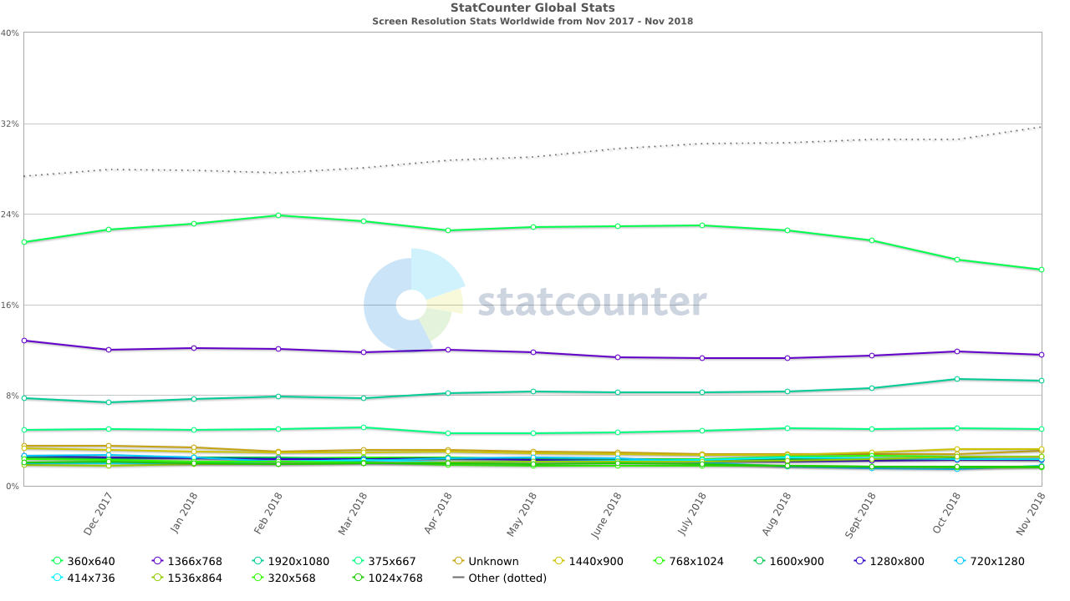
The application uses Bootstraps built in breakpoints, which are the following:
Extra small devices (portrait phones): less than 576px
Small devices (landscape phones): 576px and up
Medium devices (tablets): 768px and up
Large devices (desktops): 992px and up
Microsoft and Google recommend very similar breakpoints. [5] [6]
Content display strategy

Design
The purpose of a good web design is to influence potential customers or users. A good web design is visually appealing however every element has to be self-explaining [7].
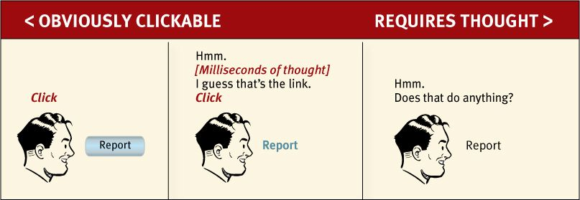
Figure 1 How most of the users think (Source: Don’t Make Me Think, revisited)
Eye tracking studies show that majority of people don’t read online pages, just scan them in an “F” pattern. [8]
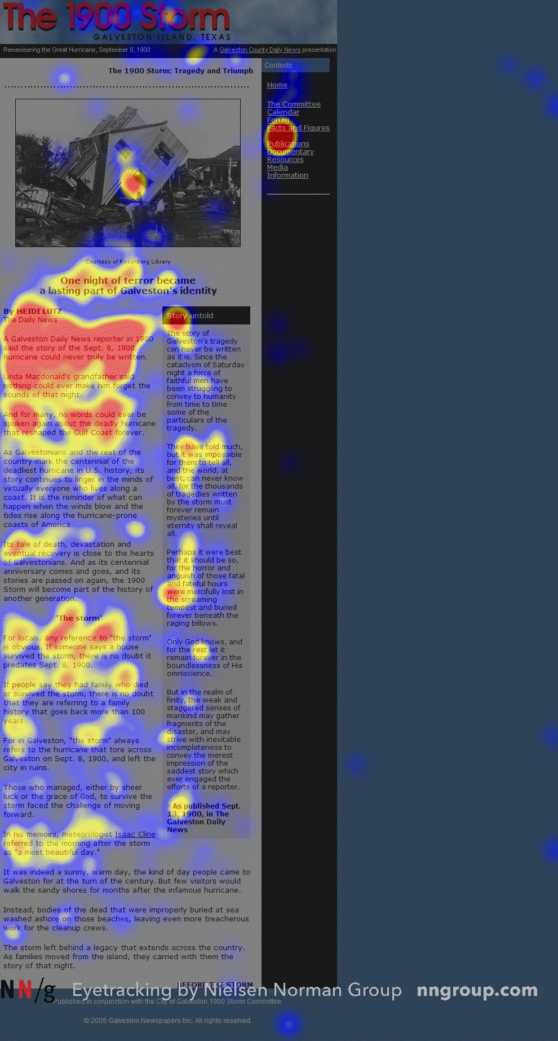
Figure 2 "F" shape scanning (Jacob Nielsen, 2006)
This is the reason why effective visual hierarchies are important.
- Size
- Colour
- Grouping
User want to find the information or product they are looking for in the fastest way. A visually outstanding navigation bar can be the starting point, which not just shows the options, but gives information where the user is currently.

Implementation

jQuery scripts
ordel-modal.js
Server ordering is done in a Bootstrap modal. This script loads html files with ajax into the modal at every step. On the second page it calculates the price of the rental depending on the game, number of slots and length.
contact-form-check.js
When the user submits the form on the contact page, the script checks if the input boxes are empty, if any of them is, notifies the user.
webadmin.js
On the web admin page the sub pages are loaded with ajax when the user click on the link.

Screenshots
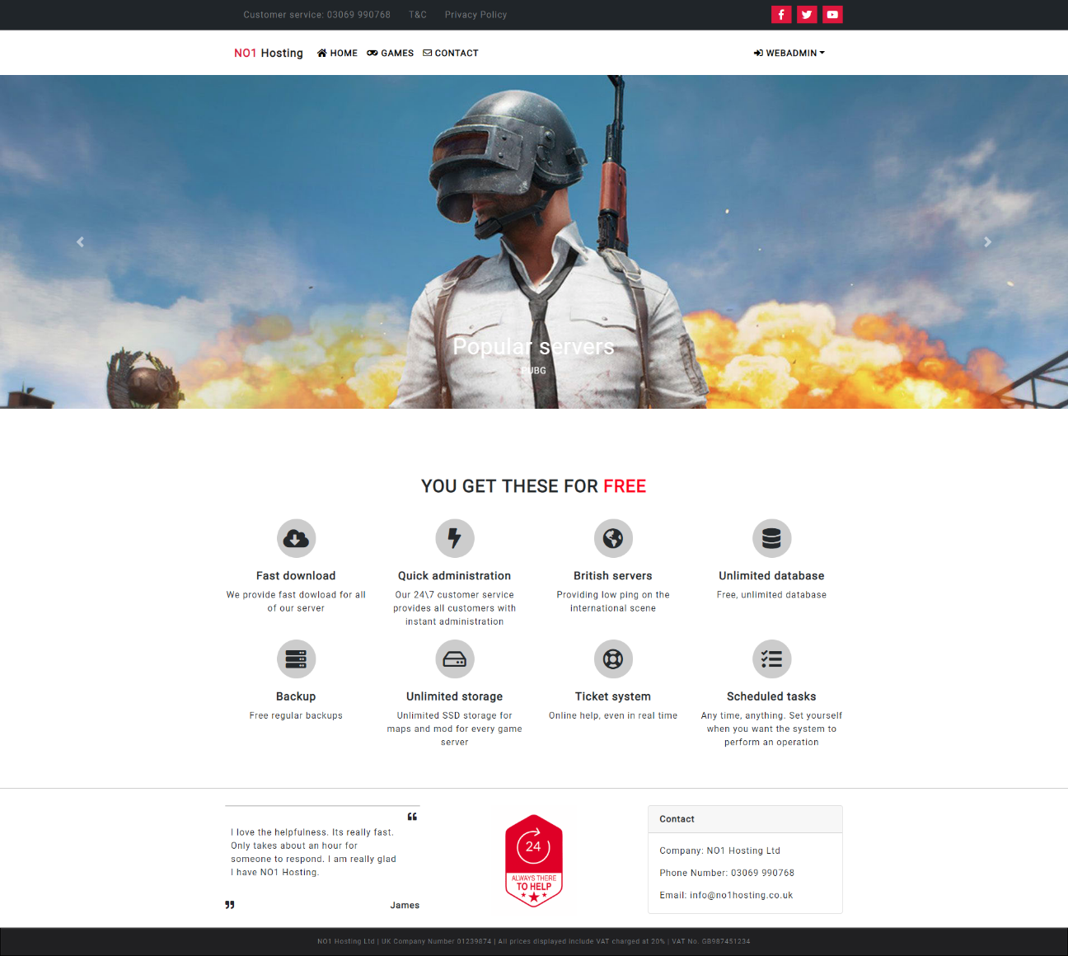
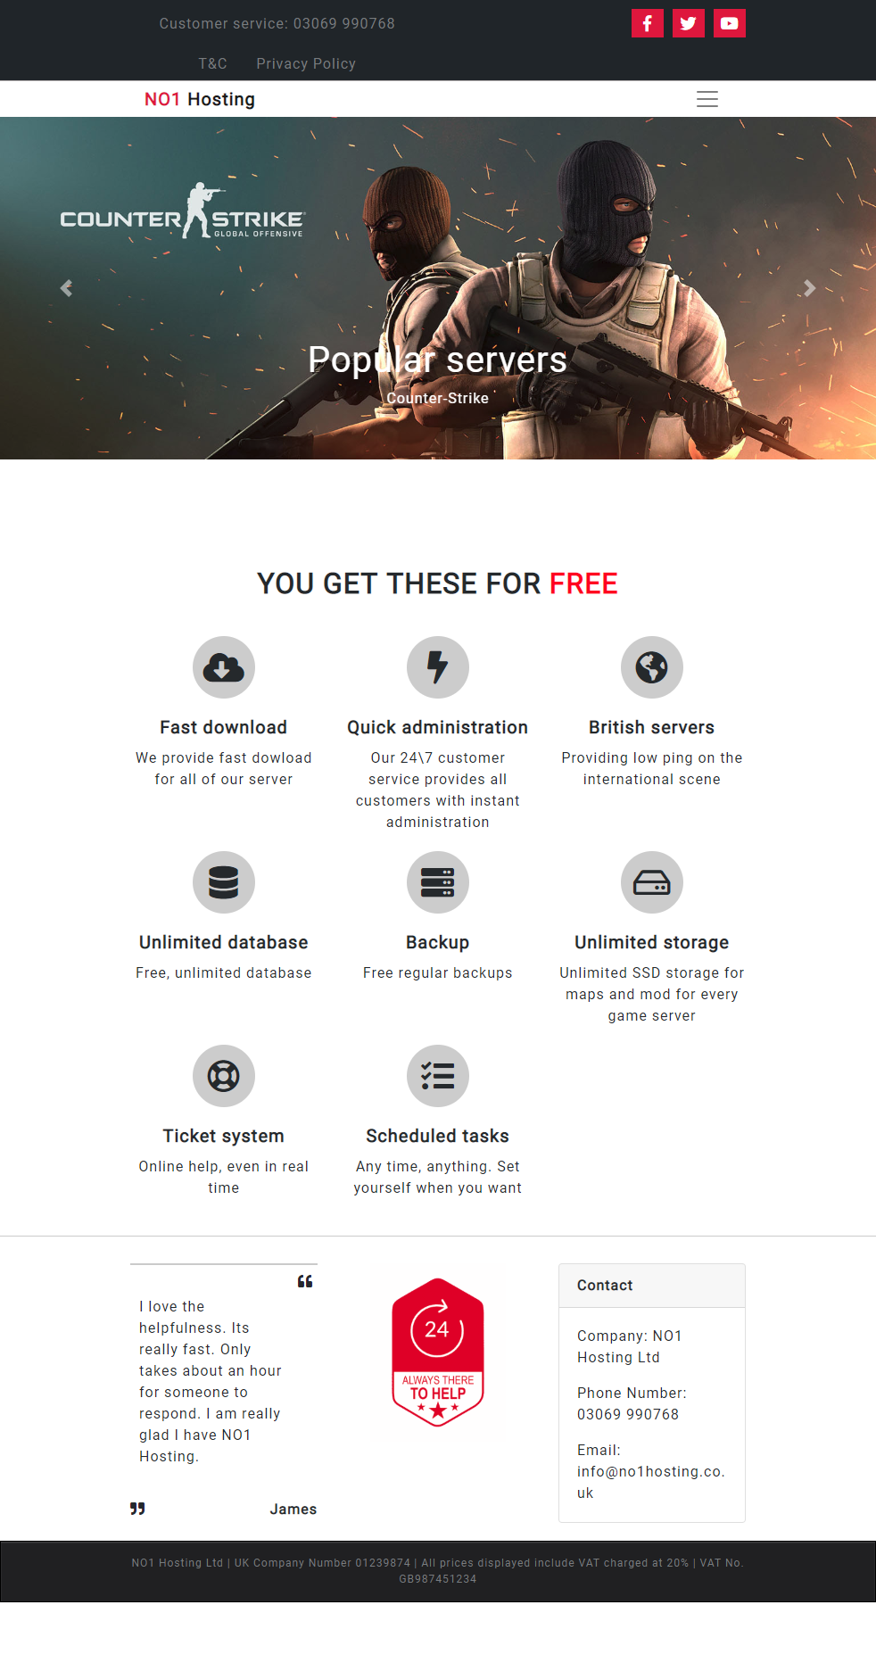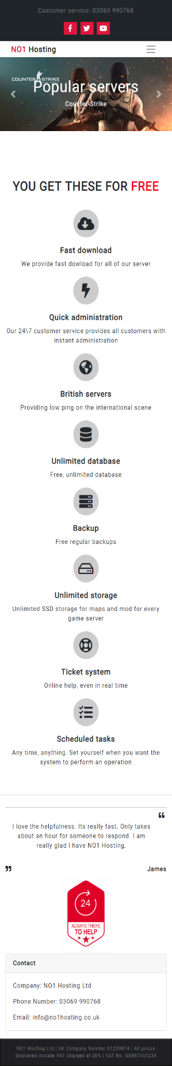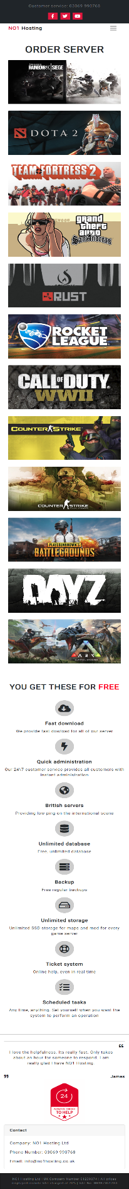
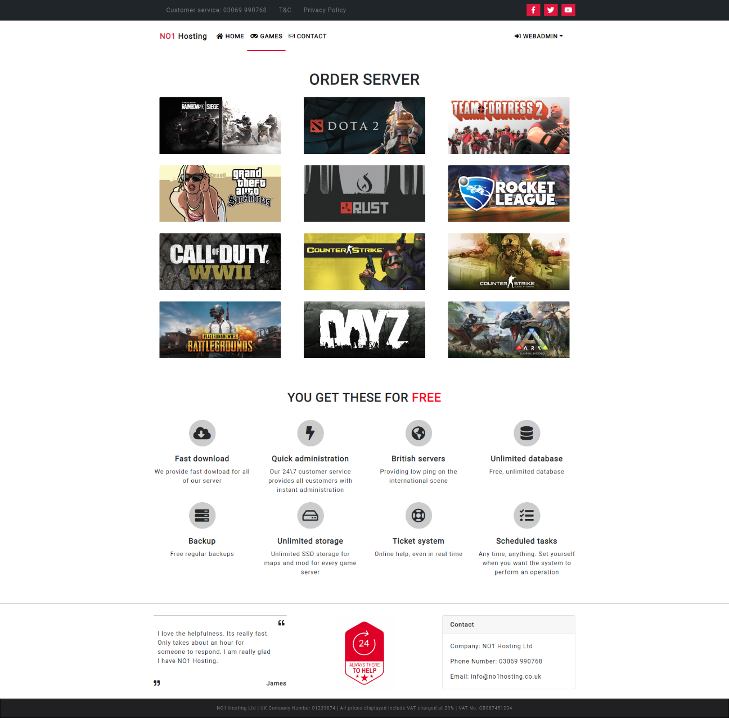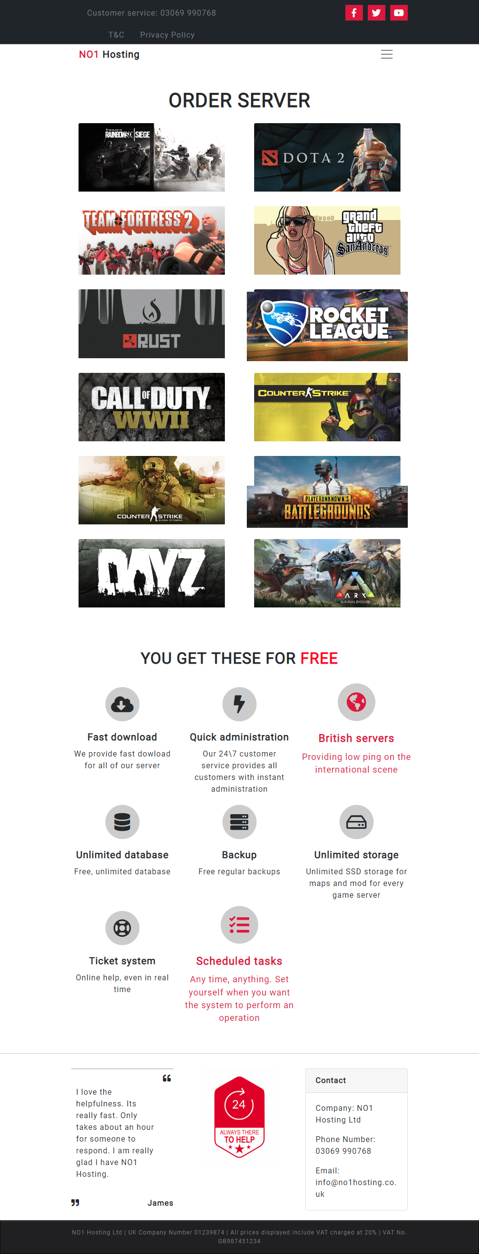
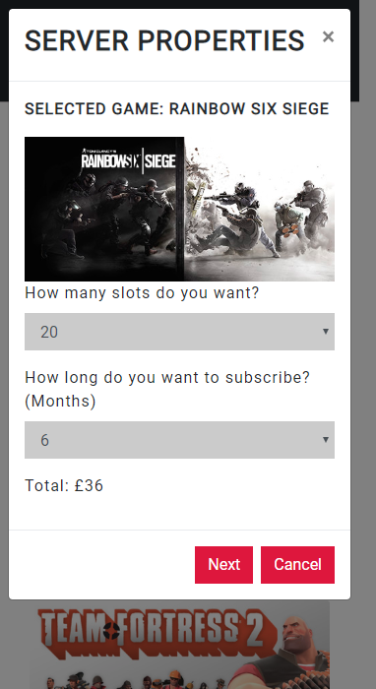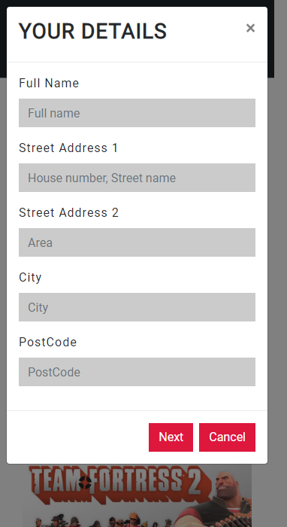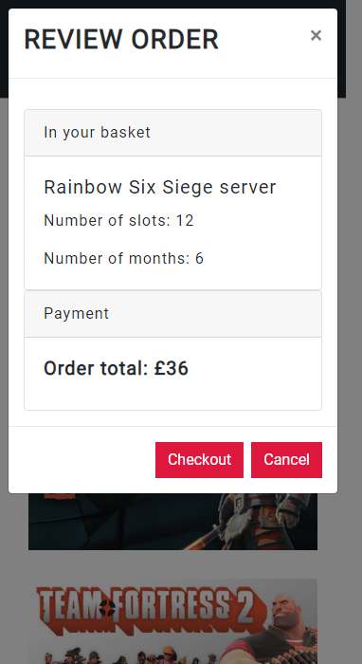
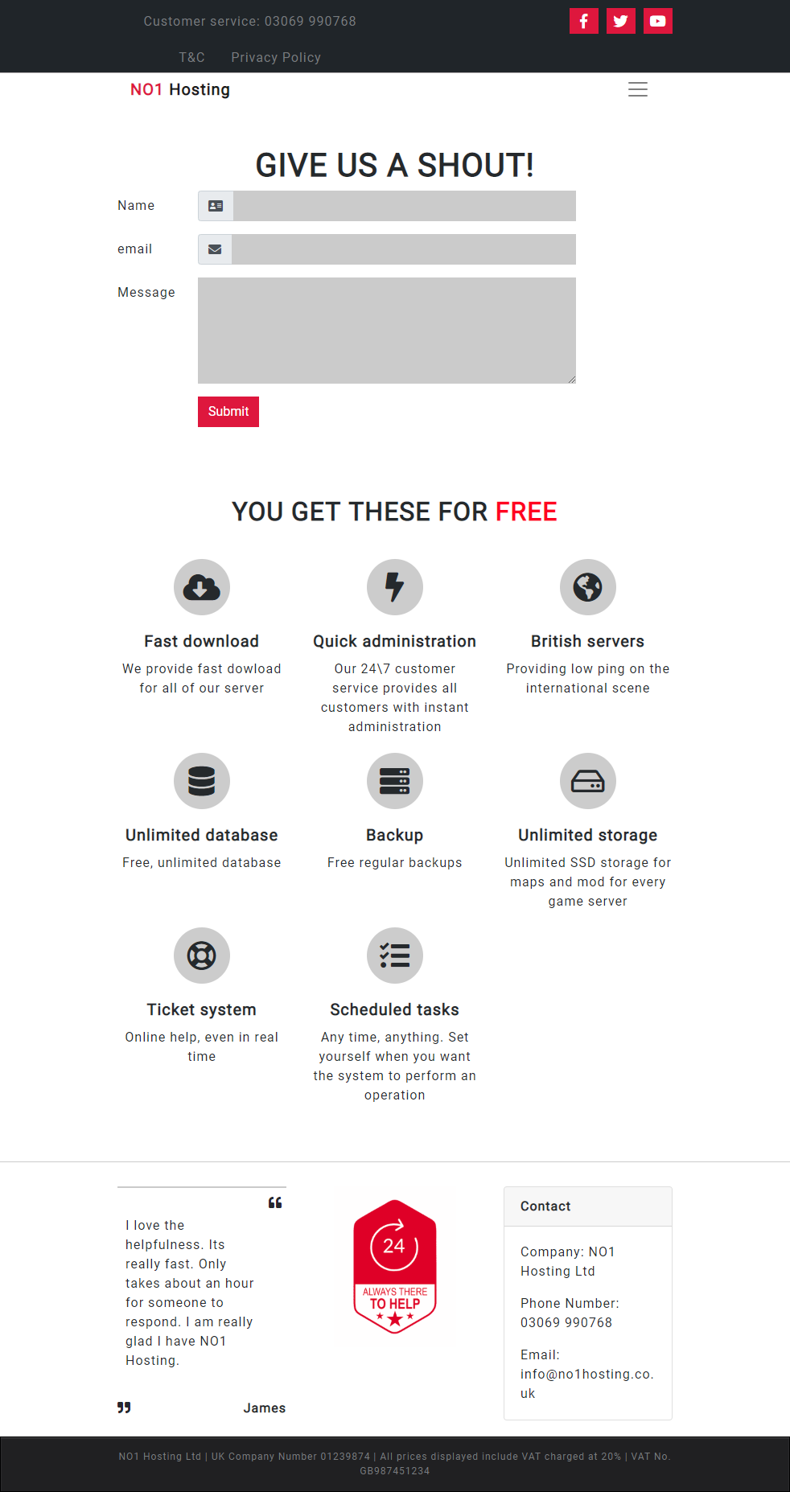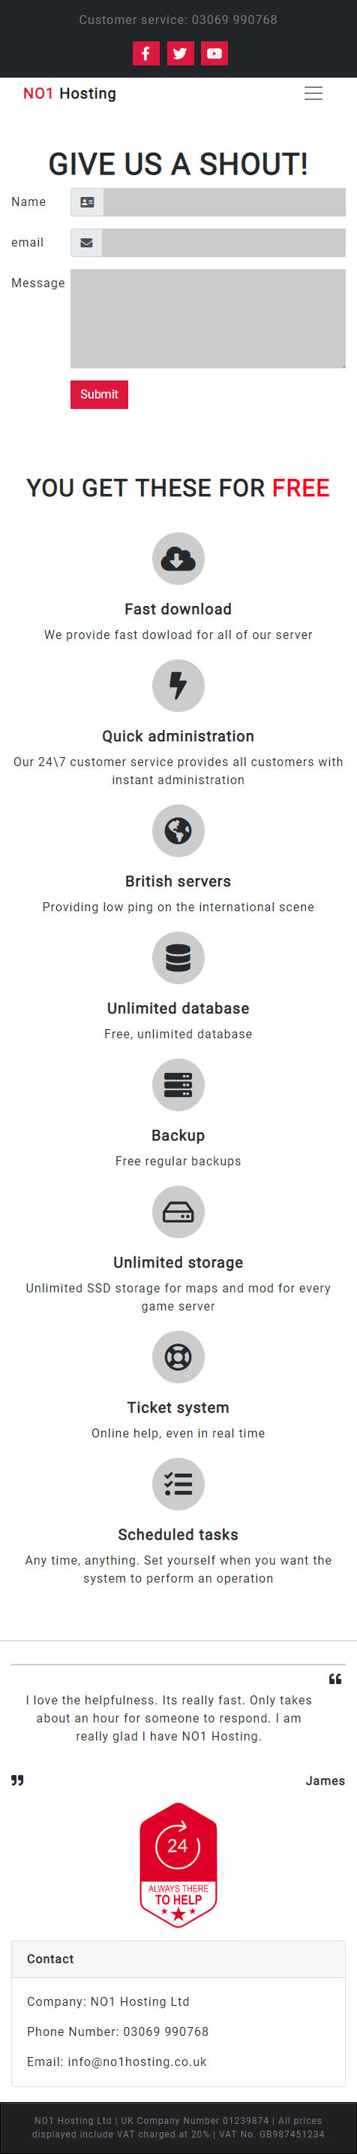
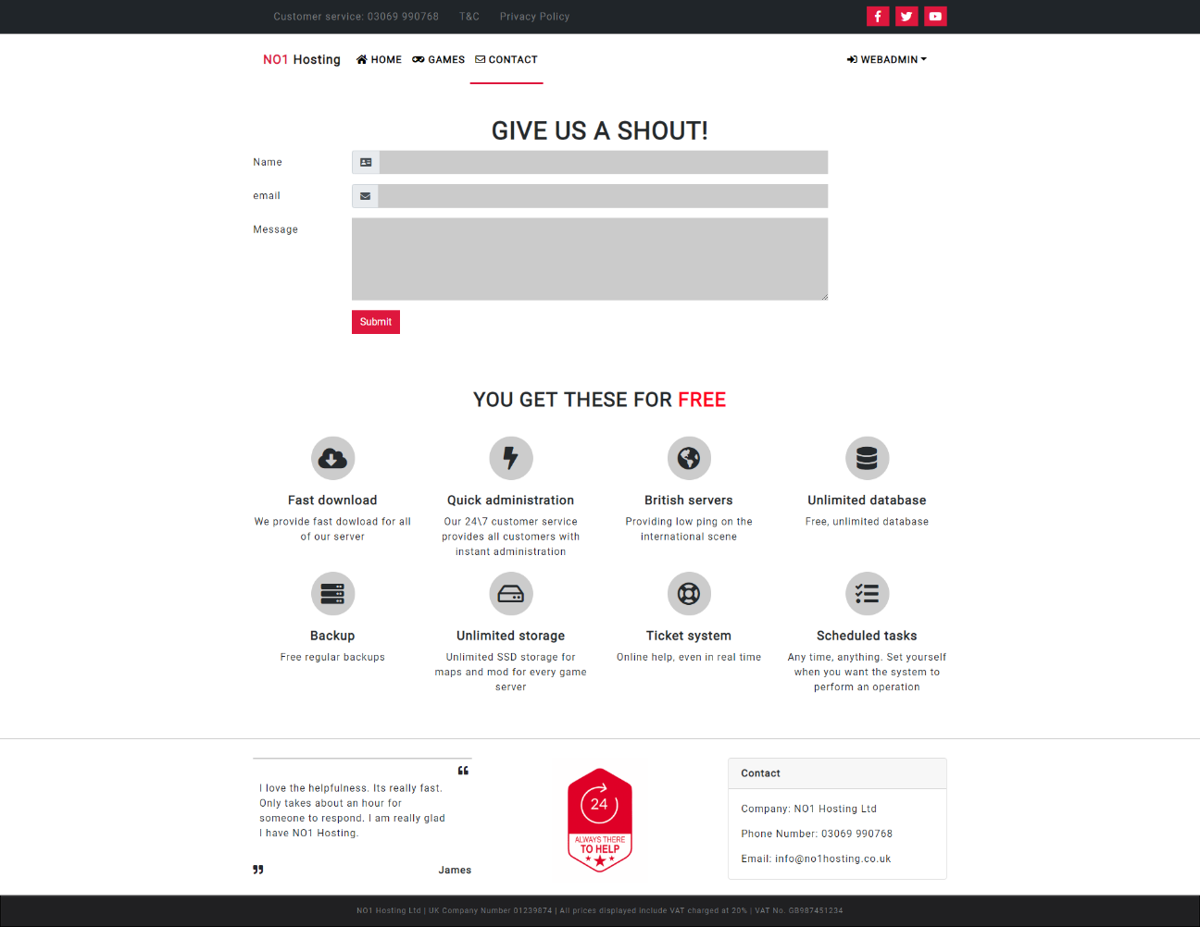
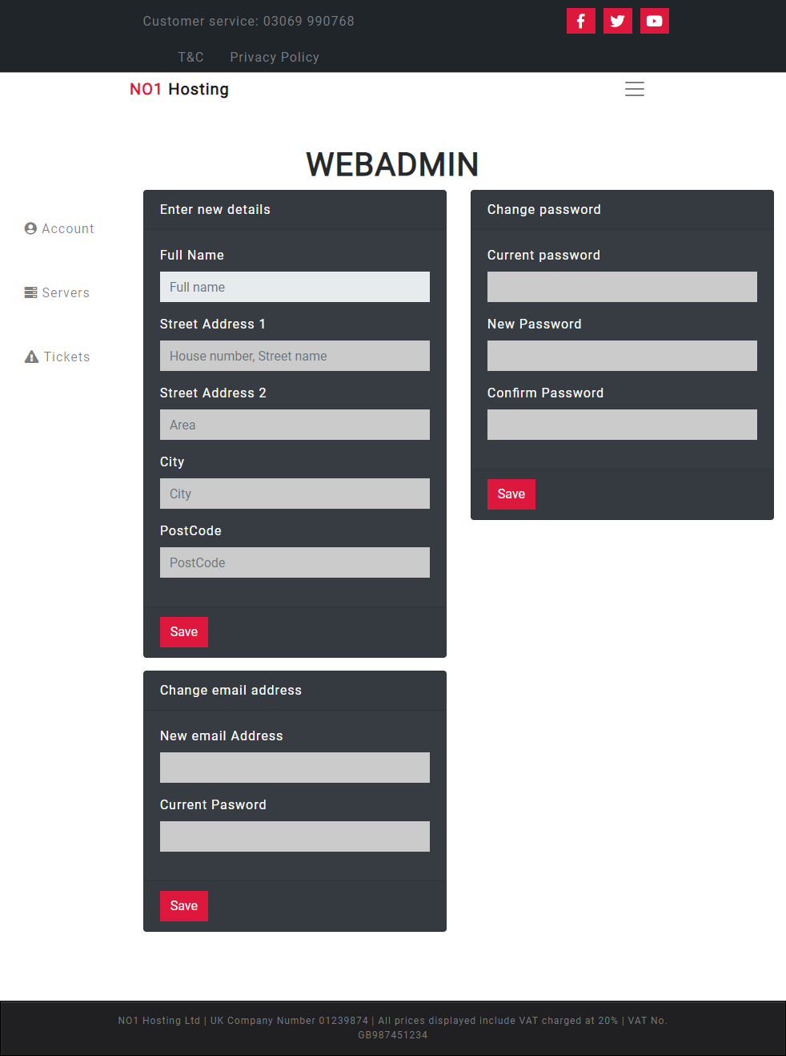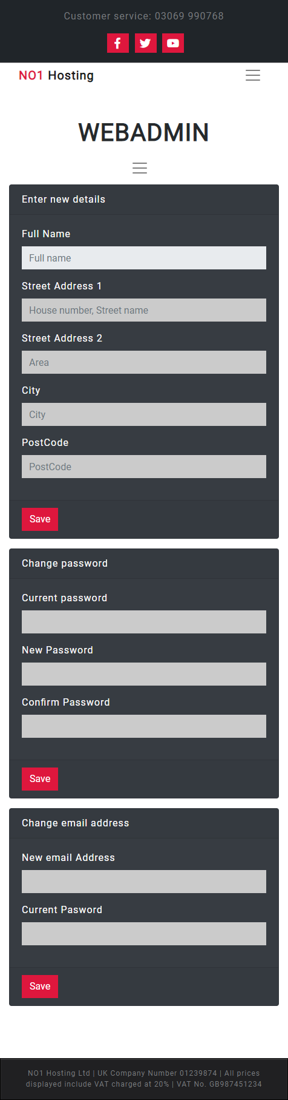
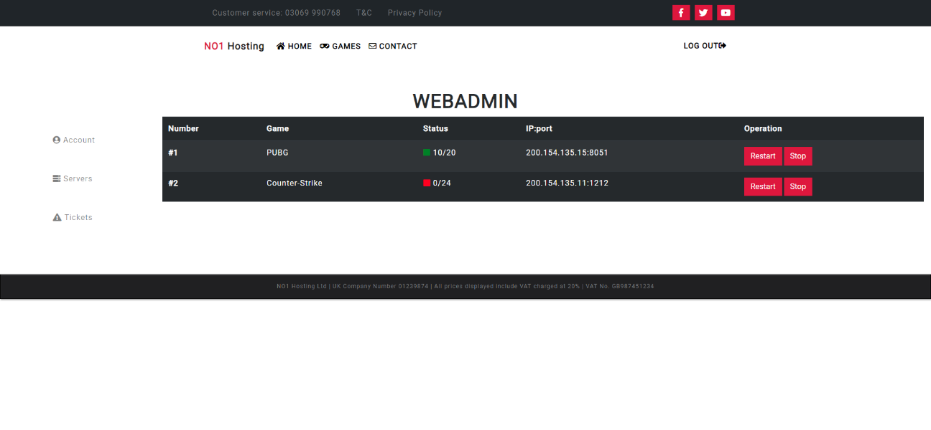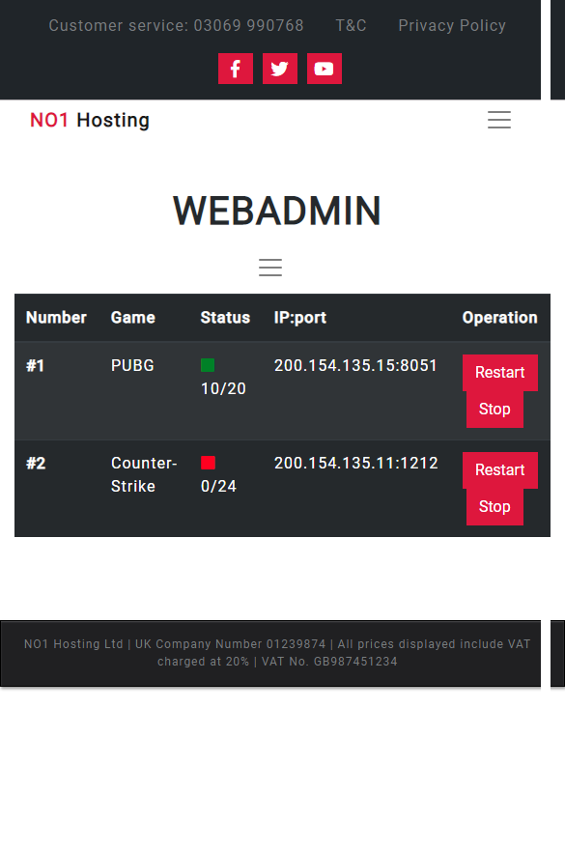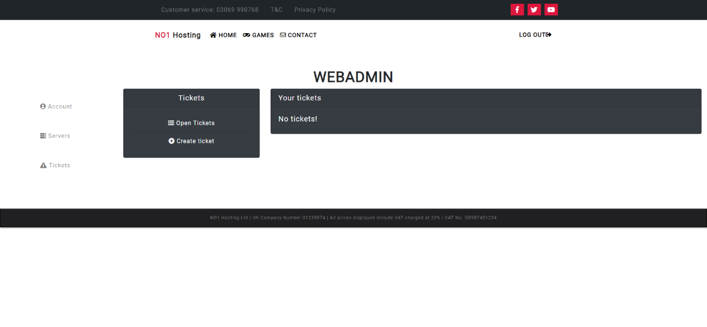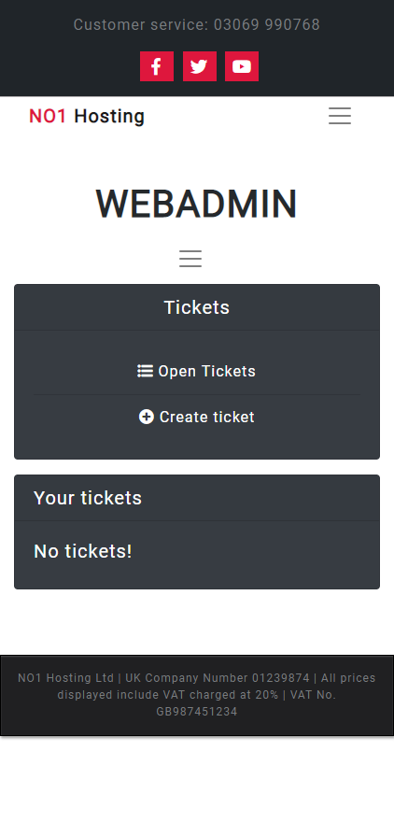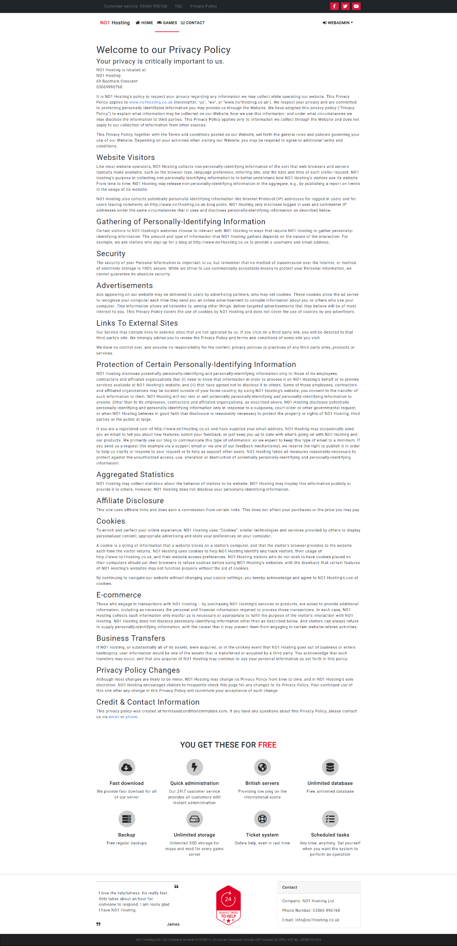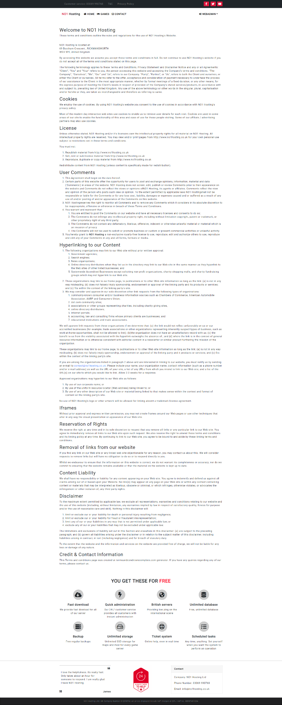

Evaluation

Test cases
#001 | User enter details on contact page
Description |  | User enter invalid details
 |  | Test Steps:
1 | Page is loaded
2 | User leaves the forms empty
3 | User click on send button

Response |  | The input fields should go red and tell the user to enter correct details.
Status |  |  | Date |  |  | Description
Pass |  |  | 10/12/18

#002 | User enter details on contact page
Description |  | User enter invalid details
 |  | Test Steps:
1 | Page is loaded
2 | User types in text into email field
3 | User click on send button

Response |  | The input field should go red and tell the user to enter valid email address
Status |  |  | Date |  |  | Description
Pass |  |  | 10/12/18

#003 | User enter details on contact page
Description |  | User enter valid details
 |  | Test Steps:
1 | Page is loaded
2 | User types in valid details
3 | User click on send button

Response |  | The input fields should go green and a popup should say thank you to the user
Status |  |  | Date |  |  | Description
Pass |  |  | 10/12/18

#004 | User orders server
Description |  | The application displays the price of the subscription
 |  | Test Steps:
1 | Order page loaded
2 | User chooses CS GO game, 20 slots for 12 months

Response |  | The application must display £114
Status |  |  | Date |  |  | Description
Pass |  |  | 10/12/18

Reflection
The example application is very basic. It lacks content and functions due to very short development time.
Recommendations:
- Fill home page with information
- Implement admin features
- Re design web admin menu
- Adding features to web admin menu
- Re design order menu, including scripts

References

[1] | I. S. Association, “IEEE 29148-2018 - ISO/IEC/IEEE International Standard - Systems and software engineering -- Life cycle processes -- Requirements engineering,” IEEE Standards Association, 23 10 2018. [Online]. Available: https://standards.ieee.org/standard/29148-2018.html.
[2] | “Desktop Browser Market Share Worldwide,” Statcounter, [Online]. Available: http://gs.statcounter.com/browser-market-share/desktop/worldwide#monthly-201801-201811. [Accessed 28 11 2018].
[3] | “Mobile Browser Market Share Worldwide,” statcounter, [Online]. Available: http://gs.statcounter.com/browser-market-share/mobile/worldwide#monthly-201801-201811. [Accessed 28 10 2018].
[4] | “Screen Resolution Stats Worldwide,” Statcounter, [Online]. Available: http://gs.statcounter.com/screen-resolution-stats. [Accessed 28 10 2018].
[5] | M. Jacobs, M. Satran and S. Zeng, “Screen sizes and breakpoints,” Microsoft, [Online]. Available: https://docs.microsoft.com/en-us/windows/uwp/design/layout/screen-sizes-and-breakpoints-for-responsive-design. [Accessed 28 10 2018].
[6] | “Material Design,” Google, [Online]. Available: https://material.io/design/layout/responsive-layout-grid.html#breakpoints. [Accessed 28 10 2018].
[7] | S. Krug, Don’t Make Me Think, Revisited, Unknown: New Riders, 2014.
[8] | k. Pernice, “F-Shaped Pattern of Reading on the Web: Misunderstood, But Still Relevant (Even on Mobile),” Nielsen Norman Group, 12 11 2017. [Online]. Available: https://www.nngroup.com/articles/f-shaped-pattern-reading-web-content/.

Resources
Bootstrap Front-end Framework - Free
https://getbootstrap.com/
Fake company details - Free
https://www.fakeaddressgenerator.com
Terms and Conditions, Privacy Policy template - Free
https://termsandconditionstemplate.com
Vector icons and logos - Free
https://fontawesome.com/
Game banners - Free
https://www.deviantart.com/zibbezabbe/art/Gamebanner-Collection-V-2-437811251
Images - Free
https://www.pexels.com/
Google Roboto font - Free
https://fonts.google.com/specimen/Roboto

marking criteria and Student FEEDBACK

This section details the extent to which the assessment criteria are demonstrated by you, which in turn determines your mark. The marks available for each category of skill are shown. Lecturers will use the space provided to comment on the achievement of the task(s), including those areas in which you have performed well and areas that would benefit from development/improvement.

Common Assessment Criteria Applied (Assignment 1) | Marks available | Marks  awarded
1. Engagement with Literature Skills

Although there is some good evidence of engagement with literature skills, particularly for the implementation, the main research element of the assessment is weak and there is room for improvement in the range of references consulted. Expanding the scope will also help you to further enhance your overall understanding, discussion and implementation of concepts. (Grade mark: 40.00%) | 5 | 2
2. Knowledge and Understanding Skills

Discussion of application development concepts is too brief and does not really demonstrate a sound and critical understanding or in-depth research of the concepts. Aiming to improve your work in research based elements of assignments will help you with the major project if you decide to continue on to the BSc. (Grade mark: 24.00%) | 25 | 6
3. Cognitive and Intellectual Skills

Excellent documentary evidence of testing the functionality of the implemented website application. A good evaluation with some very good future recommendations has also been provided. (Grade mark: 70.00%) | 20 | 14
4. Practical Application Skills

An excellent attempt featuring a professional-looking website with well-thought-out content and interactivity functionality. The implemented website demonstrates a very good understanding of RWD and how JS can be used to add relevant functionality and interactivity. See your report for a few minor comments/suggestions. (Grade mark: 91.11%) | 45 | 41
5. Transferable Skills for Life and Professional Practice

The report is of a very good standard but the section on application concepts can be improved. (Grade mark: 80.00%) | 5 | 4

Assignment Mark (Assessment marks are subject to ratification at the Exam Board. These comments and marks are to give feedback on module work and are for guidance only until they are confirmed. ) | Late Submission Penalties (tick if appropriate) |  | 67%
 | Up to 1 week late (40% Max) |  | 67%
 | Over 1 week late (0%) |  | 67%

