BMSK4003 – DIGITAL SKILLS AND RESEARCH METHODS
QUESTIONNAIRE
Team Members: Shelina Begum, Jahanara Uddin, Jasminara Ahmed and Indra Gurung.

Market research survey link: https://goo.gl/forms/9xQvxaWLNGxBJIBw2

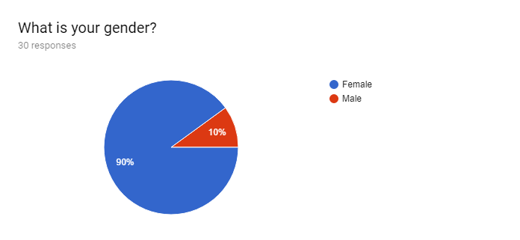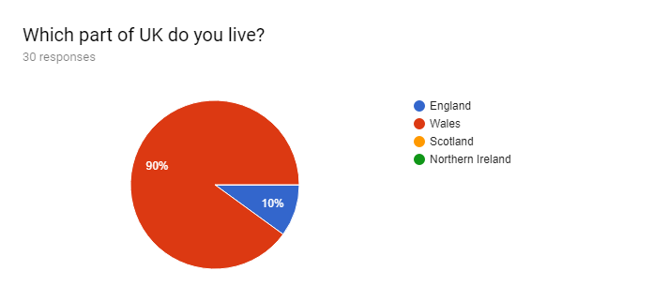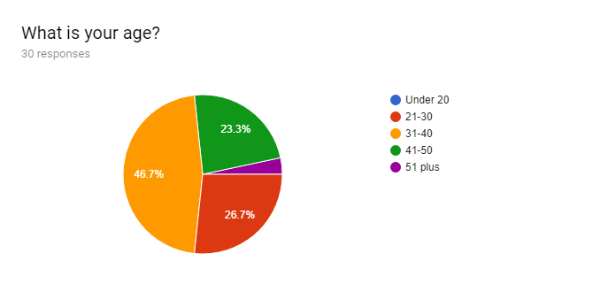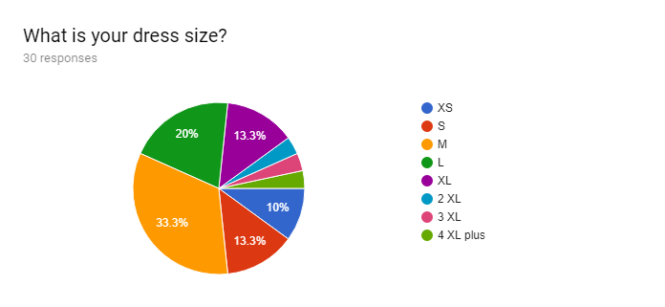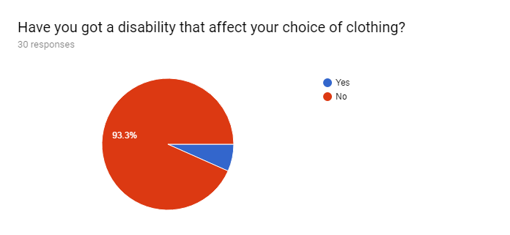

If you answered yes to disability, please can you tell us what is affecting you?
3 responses

No
Arthritis
My right leg infected by Polio so that i am all the time wearing the Caliper so I need wider cloths.

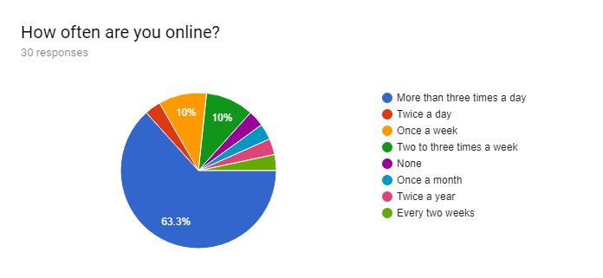

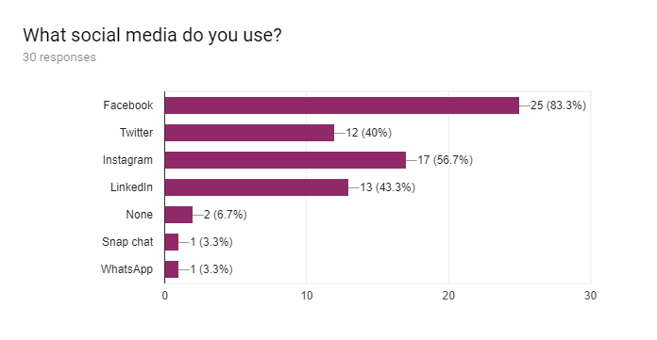
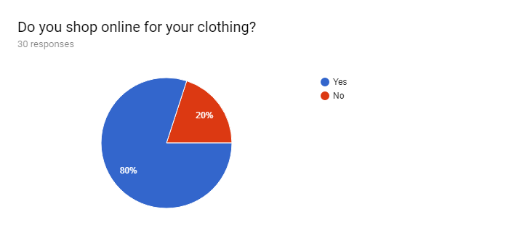

Where do you shop online for your clothes?30 responses
Amazon (3)
Next (2)
Asian websites
Divya and Rupali
Many shops
New look
Andaaz fashion
EBay instragam
Asos
All on line clothes shops
None
Diya
On line clothes shop
Any shop I see something I like
Groupon
Fabiya fashions
Diya online
No
QVC, DIYA, ANDAZ, FABIYA
Diya, Bombay, Fabeha and Rupali
Boohoo
I don't shop online
Mahir london
Diya and mahir london
Rupali, diya and mahir
All the Asian Shops
N/A

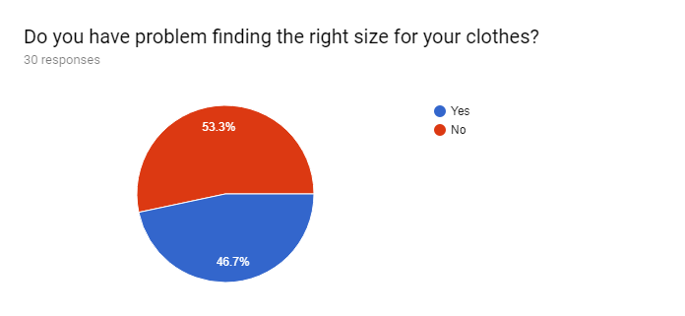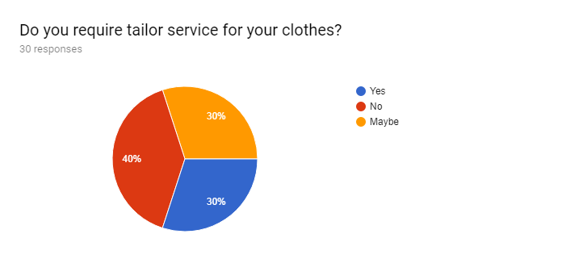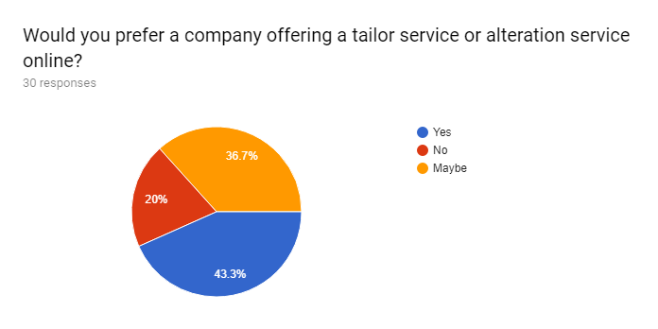
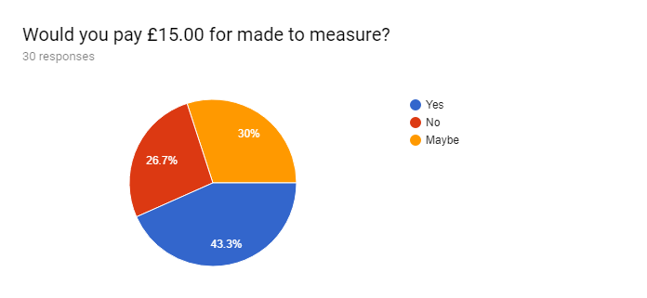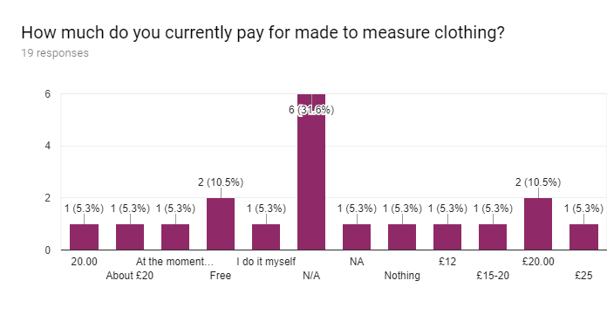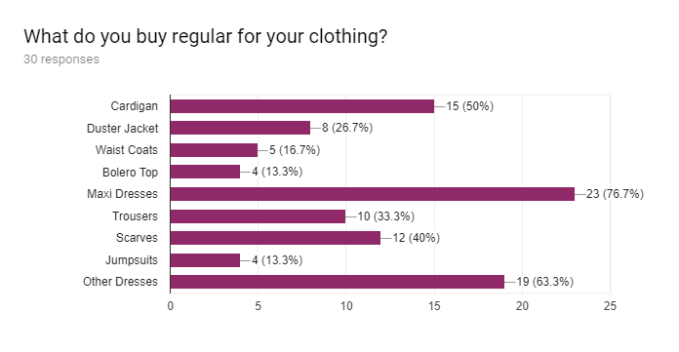
If any, what issues do you have with your current clothing retailer?
30 responses

No (5)
Nothing (3)
I do not find any comfortable clothes
The length, I’m not very tall, always have to cut to size
No issued
They do not stock natural fabrics such as cotton
Size
Size not being available
Cost
none
Not modest and varied
Flattering modest clothing
To big
Not the right size
I have smaller top than bottom so often I need to buy bigger size and have it altered
Sometimes the quality of the cloth is not good.
Finding the right size. The right colour. Fault in the clothes. Don't want to give refund.
Nothing
To long
Sometimes
Clothes are either too long or too tight. It is never the right size.
None
Take too long to come
Wrong size tops and bottom

