DS 1 Template

My Screenshots/Photos
- Please add 4–6 screenshots or photos of your digital life.
- You can use your phone or laptop.
- For each screenshot, write one or two sentences explaining what it shows.

Screenshot/Photo 1
[Insert Photo/Screenshot below]
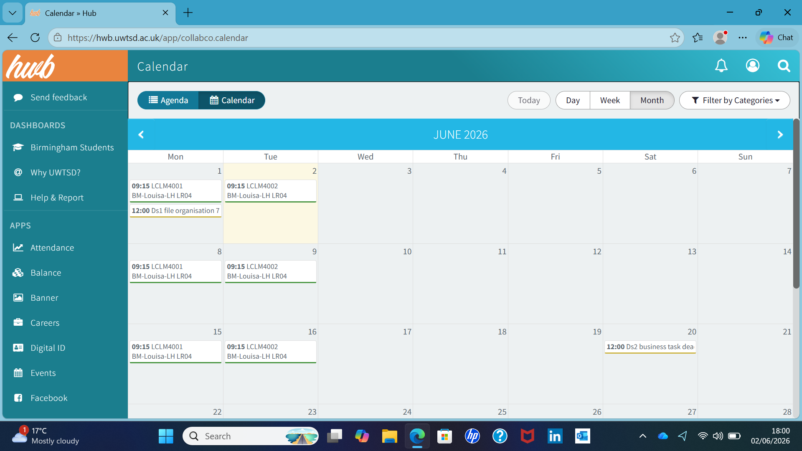
By using your calendar it shows digital calendar management and time management also you stay on top of your deadlines.

Screenshot/Photo 2
[Insert Photo/Screenshot below]
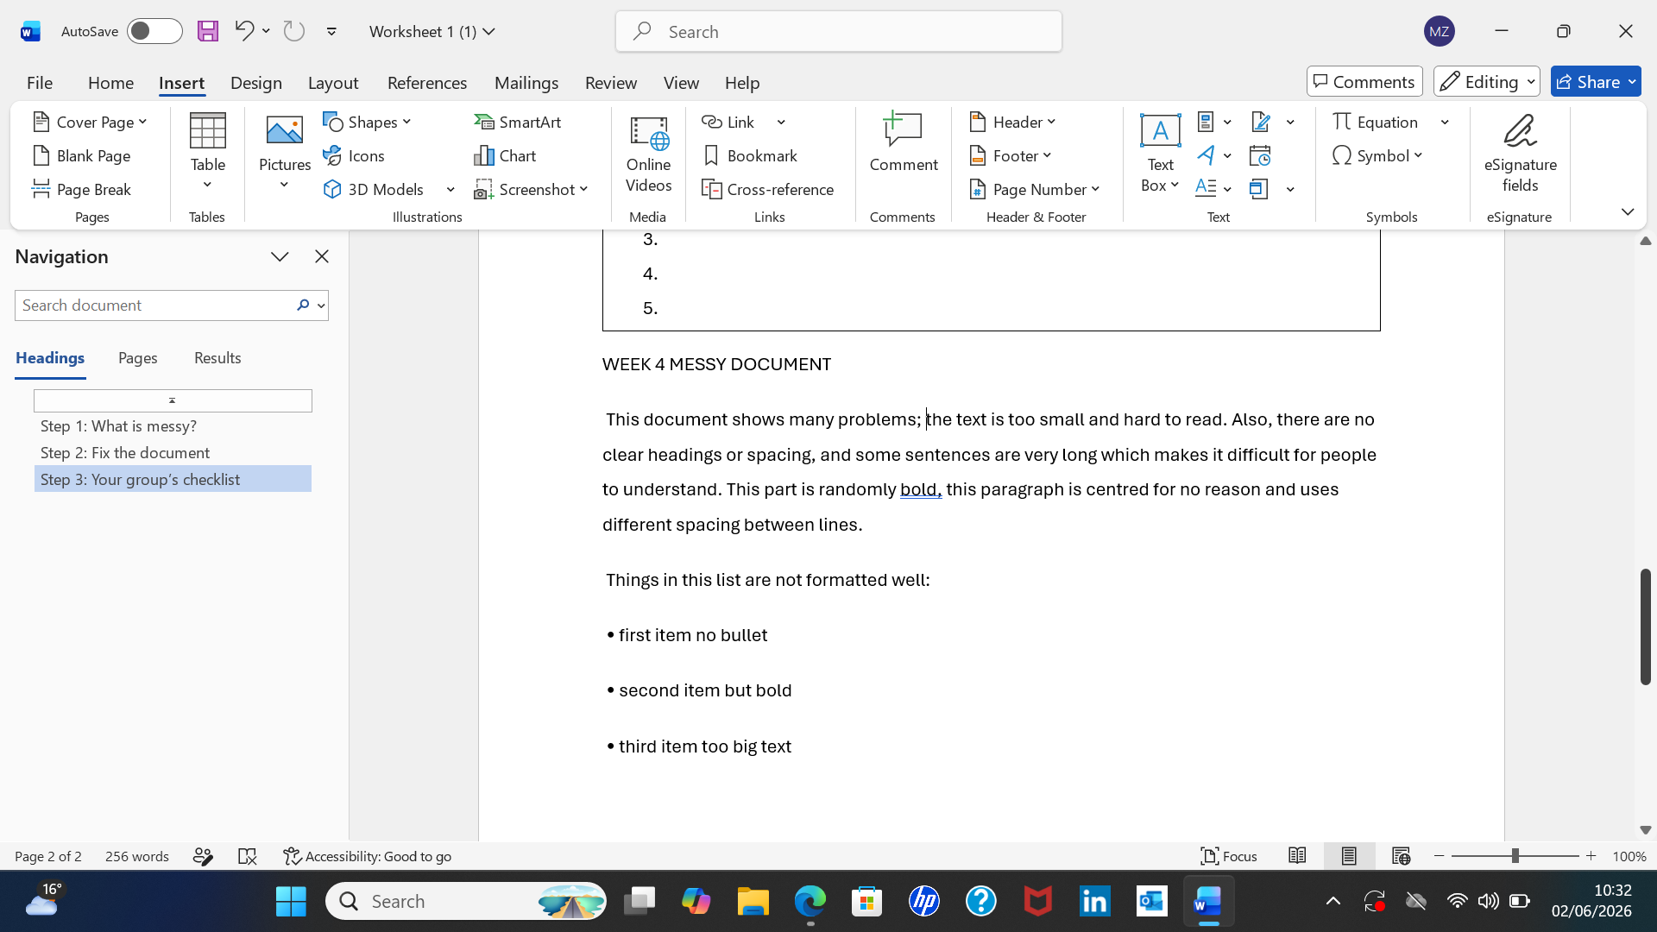
It shows me using a digital skill proof reading by writing a clearer paragraph.

Screenshot/Photo 3
[Insert Photo/Screenshot below]
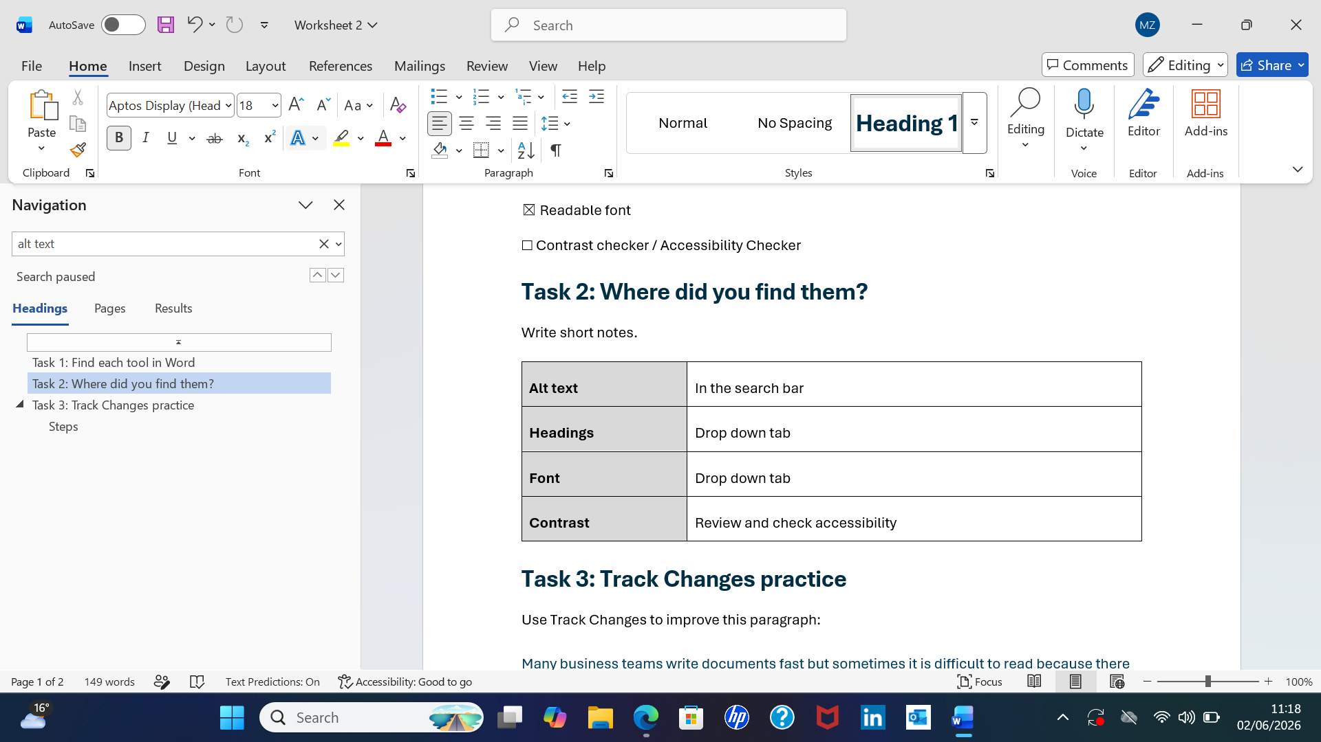
It shows me using a word processing skill.

Screenshot/Photo 4
[Insert Photo/Screenshot below]
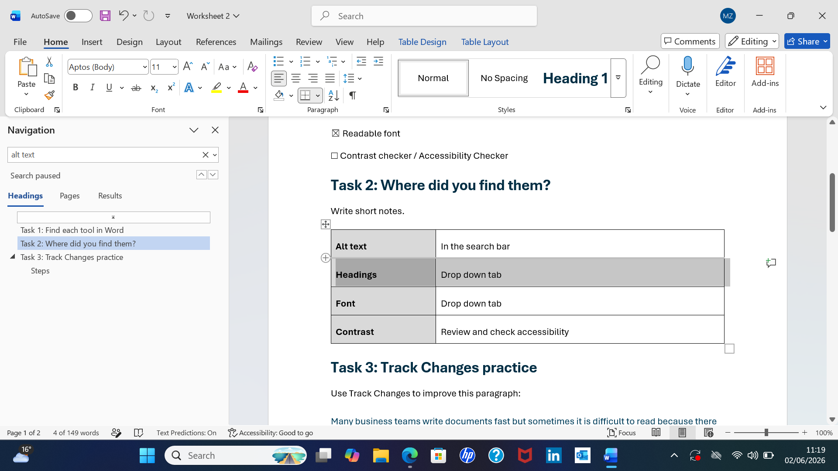
It shows document formatting on Microsoft word.

Screenshot/Photo 5
[Insert Photo/Screenshot below]
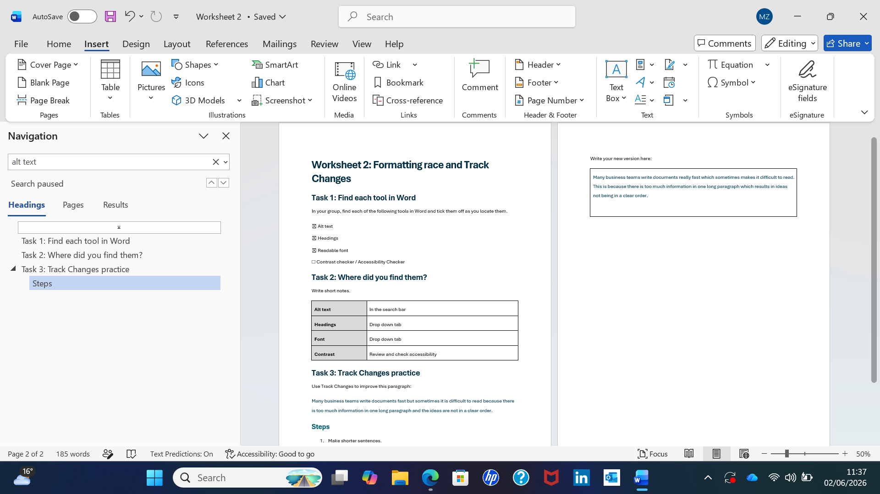
It shows me finding tools which falls under a software navigation skill.

Screenshot/Photo 6
[Insert Photo/Screenshot below]
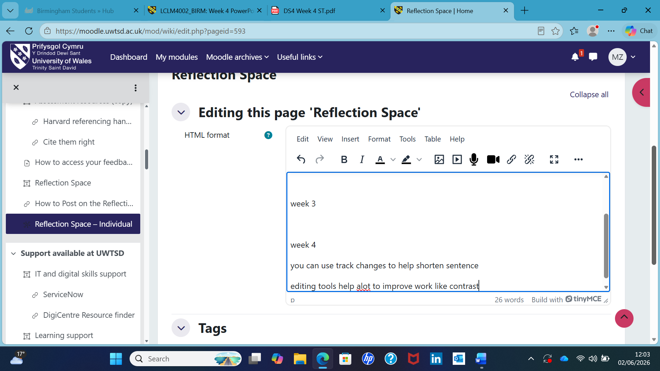
It shows me using track changes to shorten sentences which falls under sentence restructuring.

My Short Reflection
- Write 5–8 simple sentences about your digital life.
- You can use the sentence starters below if helpful.
I use digital tools to communicate with people and instant messaging allows real time connection. I feel confident using my messenger apps because I use them daily. I want to improve on storing and organising digital files and documents. I hope this module will help me because I want to improve on some of my digital skills, digital skills are important to me because I use them everyday and most of the jobs out there these days requires someone with good digital skills.

Sentence starters
- I use digital tools to …
- I feel confident when I …
- I want to improve …
- I often use these tools: …
- I sometimes feel nervous about …
- I hope this module will help me …
- Digital skills are important for me because …
You can write more if you want.

Submission Checklist
Before you submit, please check:
​​​ ☒ I added 4–6 screenshots
☒ I wrote short sentences for each screenshot
☒ I wrote my short reflection
☒ My work is my own
☒ My file opens correctly
​​☒ My file opens correctly

