What do I know already? / What have I learnt so far?
During my 3 years in a primary setting, I have encountered many situations. All of which I have learned from. I have completed all E-modules, and various safeguarding and handling training sessions. As a result, I have a great understanding of safeguarding procedures, especially when approached with issues by younger children, and the appropriate response needed by professionals. Also, I have become adept at basic first aid and wound care, when dealing with minor to severe injuries with children of all ages. Alongside this, I have received training in POPAT, in order to support children with speech, spelling, and writing difficulties with their work in the classroom and general communication with peers and practitioners.
What do I want to develop?
I would like to further advance my professional understanding of child development, and therefore be educated with a wide knowledge of children’s individual behavioural and communicational skills and difficulties, whilst advancing my comprehension of complex learning needs and developmental disabilities. This would be extremely useful when becoming a teacher, in order to correctly differentiate during lessons, and ensuring I accommodate every child’s need to the best of my ability.
Objective: | Actions: | Resources: | Target Date: | Success Criteria:
Develop my confidence in presenting and public speaking. | I will be building my confidence as I continue with my degree, by partaking in individual and group-assigned presentations. | As my first assignment was a presentation, the feedback will greatly benefit my future presentations; as I will be aware of the skills and information that are necessary to develop. | By the time I complete my degree, I will be confident in presenting, from the practice I have had during specifically presentation assignments. | A portion of the course assignments will be presentations. Therefore, I will improve with each assignment as a result of the feedback received from past presentations.
Graduate with a PGCE to become a teacher. | By November 2024, I will have needed to apply for the primary PGCE course, to ensure that I receive a place with the university of my choice. | I will seek support from my lecturers and colleagues for my personal statements. A meeting with the careers adviser after completing my PGCE will be necessary to receive an accurate action plan to seek further opportunities. | As a PGCE is a year's degree, I will be graduating by 2026. Following this, by the Autumn term, I would start my profession as a qualified teacher. | I will undergo an in-depth job search and various interviews – reflecting on the advantages and disadvantages of each one - to therefore venture into employment and secure my occupation within a primary school.
Become a first aider within a primary school. | By attending multiple courses -Paediatric First Aid, Emergency First Aid, and First Aid at Work – and also achieve a Level 3 First Aid at Work Certificate. | It will be crucial to attend these mandatory courses and therefore will need allocated leave of absence by my employer to attend. | As a result of there being a plethora of courses, I will obtain this status shortly after 2 years of becoming a qualified teacher. | In many primary settings, there is a head or main first aider. By obtaining this title, I will have achieved my goal. Although, I will continue to seek further training to stay up-to-dare.

Brock, (2015) asserts that reflection is a core value of a professional, as it is an essential element of professional practice and has a key aspect in professional training. According to PACEY, (2016), reflective practice is the action of analysing your practice, with the objective of challenging, modifying, developing, and improving, and that reflection is a perpetual cycle of improvement. The practitioner’s personal engagement with reflective activity comprises of, reflective thinking, reflective learning, and reflective action. (Reed and Canning, 2011). Durham University, (no date), maintain that it is vital to utilise collaborative reflection into professional practice; as it induces deeper levels of critical reflection, through involving a cluster of practitioners with different status’ converging to plan, execute, observe, evaluate, and critique their actions and reactions. Collaborative reflection allows practitioners to reflect from another perspective to therefore develop an in-depth analysis of the situation.
Reflection and its practice are all-important in the early years setting. As it enables practitioners to develop critical understanding of their practice, encourages one to become more proactive, increases confidence with identifying strengths and areas of improvement, and improves the quality of care and education. Birth to 5 matters (2021), supports this by maintaining that the higher the quality of care and education, the more positive impact it has on life-long outcomes.

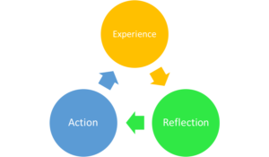
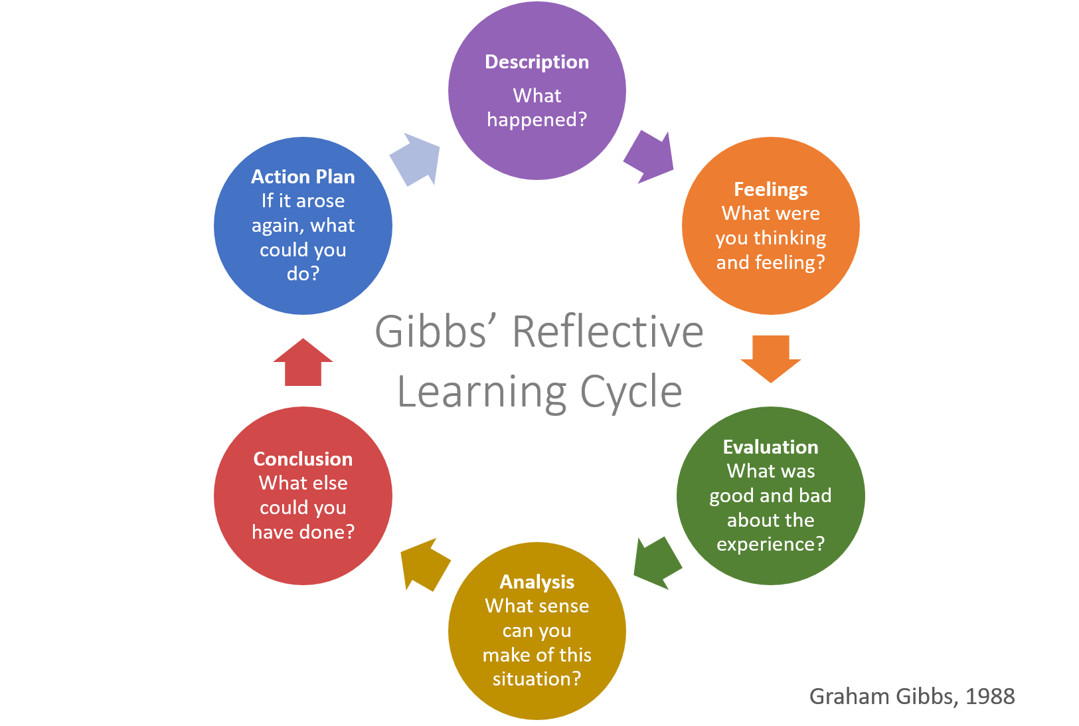
Assignment Desk (2022) Levels of Reflection. Available at: https://www.assignmentdesk.co.uk/blog/rolfe-reflective-model (Accessed: 23rd October 2023).
In closing, reflection and the mode in which practitioners reflect are beneficial to the outcomes of situations, where also past reflection was efficient and routinely completed. Reflection plays a vital role in successful environments across various occupations. One must be willing to observe and modify the way in which they teach in order to satisfy the needs of their classroom. A practitioner that reflects, analyses, and modifies, is a practitioner adept with a life-long transferable skill that can be utilised for a multitude of scenarios that they may experience during their career.
Above are models of reflection. Gibbs, (1988) argues that the deeper the reflection, the more effective the analysis. The leading distinction between the models are the number of phases included to successfully achieve reflective practice as a practitioner. Although there are benefits and drawbacks to either model. (Forrester, M., 2020) and (Assignment Desk, 2022). Forrester maintains the positives of Gibbs’ diagram, as they discuss how the stages configure a cycle, as the ‘action plan’ is applied to the next matter of the incident. Forrester also argues the possible disadvantages associated with Gibbs’ model. The leading being that the sheer quantity of stages within the cycle are highly time consuming and may often lead to ostensible reflection, and therefore, unlikely to touch on personal and professional development. The Assignment desk suggest that the benefits of the ERA Cycle are alike those of Rolfe’s reflective cycle. The primary benefit of practitioners using this model as a mode of practicing efficient reflection, is that the model is simpler than others to follow, as a result of there only being three steps. Consequently, newly qualified practitioners have a clear introduction and conclusion for handling a situation that may occur. A drawback that occurs whilst utilising this mode of reflection is that not all situations allow practitioners to analyse first before acting. Ultimately, the model utilised must be preferred by the practitioner, therefore, to effectively reflect on past situations and to modify and develop for future incidents, to avoid unnecessary behaviours and actions.

Figure 1: Gibbs’ Reflection Learning Cycle (1988).
Figure 2: The ERA Cycle (2013).
According to Bauer, N. (1991), Donald Schön built on Dewey’s theory of reflection, and further associated reflection with professional development and practice. Schön, (2016) proposes that there are two distinct types of reflective practice. Reflection in action, which consists of observing the situation and acting immediately. Moreover, there is reflection on action, which comprises of reconsidering the situation, and modifying to therefore understand what needs to be changed for future reference.
Schön extends on this argument by highlighting that a practitioner that neglects reflection on action fears the unknown and uncertainty. Said practitioner would also avoid situations where they would feel unaware of the outcomes, and therefore devote themselves to an image of pristine professional proficiency. In lieu, a practitioner that undertakes reflection on action, is a practitioner that involves themselves in unorganised, confusing, but crucial situations.
Slesser, et al. (2017), maintains Schön’s argument by indicating that a practitioner that deliberately involves themselves in situations that are uncertain are practitioners that when asked to describe their actions, they speak from experience, observation, and modification.

John Dewey is considered to be the deviser of reflection. (Southampton University, no date). Dewey’s experience is that reflection is not an active recall of the situation, but alternatively, an intentional and active process of analysis.
Dewey’s work provides the basis and foundation for the theory of reflection.
Dewey highlights that there are two separate forms of action, routine action, which is an action a practitioner would subconsciously perpetrate, and is unlikely to modify. Therefore, it is guided by tradition, habit, and clear requirements, including the law and workplace policies. Additionally, there is reflective action, where the practitioner would succumb to question their actions and appraisal of events. Consequently, signifying an alacrity to be flexible. (Dewey, 1933. Pg. 118).
Warwick, (2007) maintains this by arguing that by obtaining the status quo and resolving situations as they emanate are practitioners whose practice is lead by routine action. Conversely one that prioritises understanding the cause of the situation and is determined to evaluate and modify to therefore prevent repeated unintentional outcomes, is a practitioner whose practise is guided by reflective action.

Bauer, N. (1991) Dewey and Schon: An Analysis of Reflective Thinking. [Speech]. Annual Meeting of the American Education Studies Association. 23-26 October.

Birth to 5 matters. (2021) Professional reflective practice. Available at: https://birthto5matters.org.uk/wp-content/uploads/2021/03/PDF-20-Professional-Reflective-Practice-1-1.pdf (Accessed: 18th October 2023).

Brock, A. (2015) The early years reflective practice handbook. London: Routledge.

Dewey, J. (1933) How We Think: A Restatement of the Relation of Reflective Thinking to the Educative Process. Boston, MA: D.C. Heath & Co Publishers.

Durham University. (no date) Supporting and facilitating collaborative reflection: exploring the multiple roles of the facilitator. Available at: https://intref.webspace.durham.ac.uk/wp-content/uploads/sites/53/2021/06/Facilitating-collaborative-reflection_Meth_CS_DU_Final.pdf (Accessed: 18th October 2023).

Forrester, M. (2020) Reflection and Reflective Writing. Edinburgh Medical School. Available at: https://www.clinicaleducator.org/en-gb/resource/735#:~:text=They%20can%20be%20a%20really,for%20personal%20or%20professional%20development. (Accessed 23rd October 2023).

Gibbs, G. (1988) Learning by Doing: A guide to teaching and learning methods. Oxford: Oxford Polytechnic.

Gibbs, G. (1998) Gibbs’ Reflective Learning Cycle. [Diagram]. Available at: https://helendenheld.com/tag/gibbs-reflective-learning-cycle/ (Accessed: 20th October 2023).

Jasper, M. (2013) The Era Cycle. [Diagram]. Available at: https://www.bristolcbt.co.uk/on-reflection-part-1-reflective-practice-in-cbt/ (Accessed: 20th October 2023).

PACEY (2016) Developing Self Reflective Practice. Available at: https://www.pacey.org.uk/Pacey/media/Website-files/PACEY%20member%20practice%20guides%20(PDFs)/PG04-self-reflective-practice.pdf (Accessed: 18th October 2023).

Reed, M. and Canning, N. (2011) Implementing quality improvement and change in the early years. London, Sage Publications.

Schön, D. (2016) The reflective practitioner: how professionals think in action. England: Routledge

Slesser, S. et al. (2017) Iriss. Available at: https://content.iriss.org.uk/reflectivepractice/practitioner.html (Accessed: 19th October 2023).

Southampton University. (no date) EdShare. Available at: http://edshare.soton.ac.uk/11124/1/index.htm#:~:text=John%20Dewey%20is%20thought%20to,is%20about%20thinking%20to%20learn (Accessed: 19th October 2023).

Warwick, P. (2007) Reflective practice: some notes on the development of the notion of professional reflection. Available at: https://dera.ioe.ac.uk/id/eprint/13026/1/3573.pdf (Accessed: 19th October 2023).

