Table of Contents
Particulars | Page Number
Introduction | 1
Market needs and trends  SWOT analysis  Competitor analysis | 1-5
Marketing Strategy  Objectives  Market segmentation  Target market | 5-8
Marketing Programme  Marketing Mix | 8-9
Conclusion | 9

- Introduction
A Marketing plan can be defined as a written strategy for selling products and services of starter businesses. It is the most effective medium to make place in the mind of target customers based on their needs and demands. Moreover, it helps understanding the situation of the market, the competitors, and customers. More importantly, a proper marketing plan aids a company to improve productivity and profitability (Veresová, 2018).
This study related to the marketing plan of a propose restaurant business, whose goal is to serve the vegan customers, and which will be based in the Newport.
- Market needs and trends
As we all know food is one the basic requirements of human, food businesses never lack behind. However, modern customers prone to find the healthy and quality options which makes the food businesses more competitive. Moreover, community health and safety measures influence food businesses to maintain clean and tidy environment. Customers with the health issues are restricted to certain types of food. Alongside, health diseases and obesity are growing concern among many people in the UK (Jones, 2018).

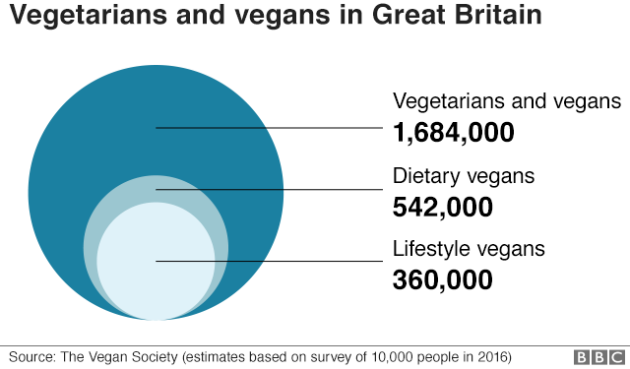

According to the chart, there are huge numbers of vegan number of customers in the UK. Veganism has different types including vegetarians and vegan, dietary vegan and lifestyle vegan. Vegetarian and vegans consisted top group, Dietary is the second group and Lifestyle vegans s in the third place.

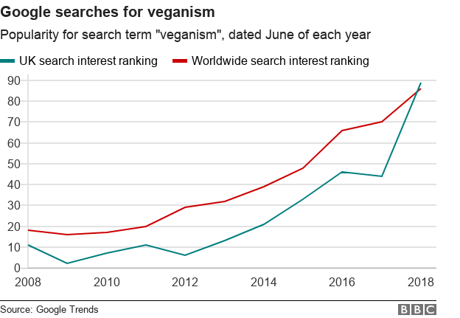
As we can see from the graph, veganism is in the rising trend and its getting more popular among the various types of eaters. Although the rise in the UK lower then worldwide average rate, vegan market has huge potential.
Market Analysis using SWOT
SWOT analysis involves identifying internal strength and weaknesses, as well as, external threat and opportunities of propose business. It helps to take appropriate marketing plan depending on the business circumstances (Sammut-Bonnici, 2015). Following is the SWOT analysis of the Vegan Indian Restaurant:
Strengths
- Cost efficient as it is limited to certain types of ingredients.
- Rare Indian Vegan options in Newport
- Team consisting of expert specialist stuff who understands the needs of the vegan customers
- Home delivery service
Weaknesses
- Lack of funds
- Lack of experience
- Inadequate human resources
- Expensive Marketing strategy
Opportunities
- Increasing numbers of vegan customers all over the UK
- Large untapped market
- Collaboration with renowned promoting agencies like Just-Eat, KUKD
Threat
- Highly expensive town centre
- Gaining public trust on new approach of vegan options
- High competition from established Indian restaurants
Competitor Analysis
Vegan Indian restaurant will be looking to offer distinctive products and services to the target customer. However, still there are many options for customers to switch on to different types of vegan options. Porters five forces model will be useful to tool identify the potential competition in the market.
Competitor Analysis Using Porter’s five Forces

Industry forces | Porter’s five forces
Threats of new entry | - Potential risk of entering into vegan market  - Requires substantial capital  - Government approval  - Health and safety measures
Bargaining power of the buyers | - Very few Indian vegan curry options in target market  - Ability to provide better service in low price
Bargaining power of supplier | - Availability of fairly large number of suppliers  - Local supplies
Threats of substitutes | - Presence of various substitutes  - Consumers can derive very few utility from substitutes
Rivalry among existing firms | - Limited number of the players  - Our products and service is highly differentiated

As we can see from the table threat of entering into the market is low with potential barratries cased by the high investment requirements, risks, and marinating health and safety measures and governments approval. Bargaining power of customers is moderate with some available option. Supply can be obtained easily with lots of local and outside options. Expected competition will be low with the product differentiation.
Main Competitors
From the analysis, it can be said that, there are so many competitors in the market, including various substitute products. The competitors can be divided into three groups, such as, fast food, fast casual and full service restaurants. The most foremost competitors are Indian vegan restaurants and Indian restaurants who keeping vegan as an option on their menu.
- Marketing Strategy
Marketing strategy is a process of efficient and effective utilisation of resources to achieve sustainable competitive advantages (Varadarajan, 2010). The aim of vegan Indian restaurant is to avail the healthy vegan food for customers living surrounding Newport and provide them with the excellent, quality service. Following are main objectives of vegan Indian restaurants:
Marketing Objectives
- Establish a position in the mind of target customer in order to maintain consistent growth and profitability
- Develop strong image through word of mouth and online advertising, alongside different colours, logos, and quality service
- Seize the vegan market located in Newport
Depending on the nature and situation of the business, the whole marketing strategy can divided into two stages, such as, before and after the staring of the business.
Phase one: before starting the business
The first job of marketing strategy should be doing a proper market research. In doing so, many focus group will be gathered to get the information of many other related restaurants. In addition to this, online websites and Social media will be used to get the information regarding pros and cons of similar other restaurants foods and services.
Restaurant businesses require customer awareness regarding possibility of oncoming options. Therefore, our first priority will be getting customer awareness thorough different types of promoting mediums. These can be done using maximum use of local media like Newspapers, leaflets, pamphlets and so on. There are several local restaurant promoting agencies like KUKUD, Just Eat, Uber eats, located in Newport. They can be useful to get the customer concentration. More importantly, Social media like Facebook and Instagram can be utilised for marketing and advertising purpose. A responsive website will be handy to reach the target customers.
Phase two: After business started
Business successes rely on proper use of the marketing strategy since it started. It also helps to get more customers and expand the business. There is variety of ways a business can follow to get customer attention and increase its profitability. Following are the promoting option we would like to go through once the restaurant is started:
- Distribution of Broachers
- Discount for inside and takeaway customers
- Value-for-meal menu
- Maximize use of social media for marketing and web site
- Competitive pricing strategy
- Distributing menus
Market Segmentation
The target market can be divided into three segments such as Local Vegan customers, customers within 10 miles radius looking for healthy vegan options, and non-vegetarians who are looking for healthy alternatives of meat and dairy products (vrg.org. (2019). Segment also consists of individual who love to enjoy meal with food alone or friends. There are many families who get together in a restaurant weekly or monthly basis. Some customers also like to get the food home, may be when the weather is bad or may be when they come back from the work or many be they can’t drive, or maybe they like to do so. Restaurant will cover men, women and families of three market segments. Our main target customers are vegans who are restricted to certain types of foods. Our main products are cooking Continental vegan curries which are, currently, keeping as an option in many restaurants. Target segments will be adjusted based on the demographic, geographic and behavioural variables.
Demographic factors include male and female in the Newport city. According to the research of the Newport city council, around 52% of populations are Female and 48% are male. Whereas, highest age group of the customers is located between 30-64 years (NewportcityCouncil, 2001). High income household will be targeted as they look for healthy option.
Target marketing strategy
The target market strategy will be communicating with target customer, on regular basis and cost efficient way, to reach the highest number of customers. The aim is to built awareness among the target customer, make them aware and ensure highest quality to retain them. Following are the various tools will be used to reach the target customers:
Website
Nowadays, almost every business have their own website. It reflects brand recognition as a crucial aspect of a business. According to the research, a website can enhance the company sell by around 45% (aligned-digital, 2019). A website, with one to five pages Template Design Hosting & domain Basic SEO, costs around £300-£600 upfront. Fowling will be basic features of restaurant website:
- Restaurant website will be used as a sales and marketing tools. The website will contain all the useful information including menu, contact and location map. Moreover, customer will be able order foods and book tables online.
- Online marketing will add Search Engine Optimization (SEO), SEM, online reviews and newsletters

Use of Online or Social media marketing
Online and social media marketing, by far, the most popular tool for advertising. Currently, more than 50% of the businesses use social media as a core advertising tool (DEPHILLIPS 2019). It is the best way to maintain two way communications. It can be used to develop long term relationship with the customers. With online, companies can achieve brand recognitions. They can promote new promote new products and services. According to the research, company can reach over thousand customers for less than £3. Moreover, they can share online commercial videos and pictures.
Estimated Costs of Various Media Channel
Currently, with the availability of different media channel the cost of promotion lower than ever. Social Medias like Facebook and Instagram can be used for £1 per day for impression and £5 per day for likes, views and clicks (lyfemarketing 2019). Following graph shows costs required to reach per thousand customers:

According to the graph, Direct mail is the most expensive advertising medium, while, Social Media is the cheapest. Apart from those, Newspaper and Magazine incur almost same costs as moderate. Whereas, costs of using Billboards is second lowest.

- Marketing Programme
A successful marketing campaign requires organised and scheduled utilisation of different marketing mix (Išoraitė, 2016). Marketing mix consisted with four Ps, such as, product, Price, place and Promotion.
Products
The main products of this restaurant are variety of vegan Indian curries. All the items will be meatless and dairy free. All the drinks will be natural without any artificial flavour. All the ingredients will be suitable for vegan customers.
Price
The price will be set considering the cost of the foods. As the restaurant is restaurant will be limited to vegan options, price will be cheaper comparing to the traditional Indian restaurants.
Place
Place is mainly refers to the distribution of foods to the takeout customers. As we will avail delivery options, drivers will deliver the foods within 15 mile radius. Customer can also order and collect the foods.
Promotions
As mentioned earlier, promotion will be done through restaurant website and maximum use of social media. Also, local promoting agency will be integral part of promotion.
- Conclusion
Vegan market in the Newport has huge potential. Although there are few other foods providers running around this area, still there are many places where business can be developed. With an effective marketing plan and intensive use adverting mediums business can be profitable.

Reference
DEPHILLIPS, K. (n.d.). https://www.contentfac.com/. Retrieved November 25, 2019, from https://www.contentfac.com/how-much-does-social-media-marketing-cost/
https://www.lyfemarketing.com/. (n.d.). Retrieved November 25, 2019, from https://www.lyfemarketing.com/traditional-media-versus-social-media/
Išoraitė, M. (2016). MARKETING MIX THEORETICAL ASPECTS. Internation Journal of research .
Jones, L. (2018, june 18). Veganism: Why is it on the up? https://www.bbc.co.uk/ .
NewportcityCouncil. (2001). Retrieved December 5, 2019, from http://www.newport.gov.uk/: http://www.newport.gov.uk/_dc/index.cfm?fuseaction=population.populationstats&titleid=12
Sammut-Bonnici, T. (2015). SWOT Analysis. Wiley Encyclopedia of Management .
Varadarajan, R. (2010). Strategic Marketing and Marketing Strategy: Domain, Definition, Fundamental Issues and Foundational Premises. Journal of the Academy of Marketing Science , 119-140.
Veresová, I. E. (2018). Marketing Plan. BIATEC . Econimics Forum.
https://www.vrg.org. (2019). Retrieved November 24, 2019, from https://www.vrg.org/nutshell/market.htm

