University of Wales Trinity Saint David
School of engineering
Study Skills
M4X02063
Lewis Millard (1903544)
Grain Orientated electrical steels

Abstract

This report states the developments of the quality and production processes of grain oriented electric steels over the past decade. The production improvements discovered in this report are removing an intermediate anneal, use of different types of rolling mills to achieve a final aim gauge of 0.23mm and the use of continuous casting to aid with austenitic phase transformation. Quality improvements discovered in this report are the addition of nitrogen as a grain growth inhibitor via cracking ammonia after the decarburising stage, using laser technologies to refine domains to improve core loss. This report will also state the current processes Orb electrical steels use to produce grain-oriented steel and compare these with other major producers.

Introduction

Electrical steel is a magnetic material which contains around 3% silicon. Due its good magnetic properties when steel is alloyed with silicon, it is widely used in magnetic core material for a large range of electrical machines such as, power and distribution transformers and inductor motors. Due to growing demands for a reduced carbon output, there has been a demand for low consuming transformers and electrical vehicles. Electrical steel sheet can be categorised into two types, grain-orientated and non-grain orientated. They have difference in magnetizing direction in that whereas grain-oriented steel has anisotropic magnetic property to the rolling direction, non-oriented has isotropic magnetic property in all direction. Grain-oriented steel has ‘Goss’ texture with (110) [100] crystallographic orientation whereas non-oriented steel has ‘Cubic’ texture with (001) or (110) planes parallel to the plane of the steel and [100] direction uniformly distributed. Due to the orientation of the crystal structure, GO products supply transformers and NO products supply electric car motors. The manufacturing process for GO electrical steels consists of steel making, continuous casting, hot rolling, ordinary annealing, cold rolling, decarburising annealing, box annealing and thermal flatting with laser treatment.
The are many reasons why silicon is used in GO steel, the first is because it reduces eddy currents and thus narrows the hysteresis loop of the material and lowering the loss. Silicon also increased the electrical resistivity by a factor of five. However, it does have its downfalls being that it hardens the grain structure and embrittles the material. This makes it difficult to roll too thin gauges where better magnetic losses are seen. When alloying GO steel, control of the chemistry must be kept tight. Elements such as carbon, sulphur and nitrogen must be minimal due to the presence of carbides, sulphides and nitrides can increased hysteresis losses and reduce magnetic permeability. Carbon has the biggest effect of the elements listed above as it the catalyst of magnetic ageing. The carbon content can be reduced by annealing at temperatures of 850°C with a hydrogen atmosphere.

Contents
Abstract 2
Introduction 3
Literature review 5
Methodology 7
Conclusion 11
Works Cited 12
Bibliography 13
References 14

Literature review

History of grain-orientated electric steel
As part of a global trend towards energy saving and the safeguarding of the environment, electrical consumption has become an essential affair. Due to energy saving and noise reduction requirements, grain oriented electrical steels are critical in reaching lower core loss and lower magnetostriction levels. [1] Silicon steel is a soft magnetic material used for transformer cores and it is of prime importance to the electrical market as it consumes hundreds of thousands of tons per year. In electrical steels, Si and Al are in solid solution and they influence the α- phase and ϒ-phase stability. Both are strong ferrite – stabilising elements and their addition may limits the austenite phase stability to the extent that is not present during heat treatment. [1]
In 1900, Hadfield found that reducing the effect of iron loss with the addition of silicon. Then N.P Goss in 1934 discovered that orienting grains in a magnetically favourable direction and corresponding texture {110} <001> is now referred to as Goss texture gives large improvements in magnetic loss. Goss then patented the method to manufacture grain orientated steel in the same year. Then in 1940 – 1950, ARMCO then invented the use of cold rolled Grain oriented steels with 3% silicon replacing the 4.5% hot rolled coil used in transformers prior to this. [2]
In 1961, Kawasaki steel started to produce cold rolled grain oriented electrical steel on a commercial basis [1]. Kawasaki process uses MnS as a grain growth inhibitor as well as the Americans. The Kawasaki process, which was independently developed, has a very different process route compared to conventional CRGO which Nippon produce. Nippon still produce CRGO as the ARMCO license allows. Nippon developed the world’s first high permeability in 1968 called Hi-B. In 1973 Kawasaki followed by created their own high permeability grade called RGH. High permeability CRGO steel has a larger grain size than any other grades made before. The higher the permeability, the greater the magnetostriction, which is the humming noise that transformers make. Nippon use a different grain growth inhibitor compared to Kawasaki which is Al N and follows the basic CRGO process route but skips the intermediate anneal step. [2]
As mention above, high permeability grades develop a larger grain size. Lager grains will produce lower hysteresis loss, but the disadvantage is that is gives a greater eddy current. To combat this issue, domain refining technologies were developed such as laser scribing and plasma jet irradiation. Domain refining introduces a strain into the grain which acts like another grain boundary which will reduce the eddy current but keep the hysteresis loss. Domain refined products were introduced by Nippon steel and then followed by Kawasaki in the late 70’s early 80’s. Domain refined CRGO has increased permeability and lower loss but is not adequate for wound core transformers due to stress relief annealing reducing the effect of domain refinement.
Due to the effect heat resistivity has on domain refined CRGO steel. Nippon produced grades like 27ZHKH95 that provided much lower core loss at 1.5T but with a higher induction which didn’t need to be stress relief annealed. Nippon then created CRGO with nearly zero magnetostriction by adding an extra 3.5% silicon to the 3% already in the substrate. They done this via chemical vapour deposition. This process involved diffusion annealing. [2]

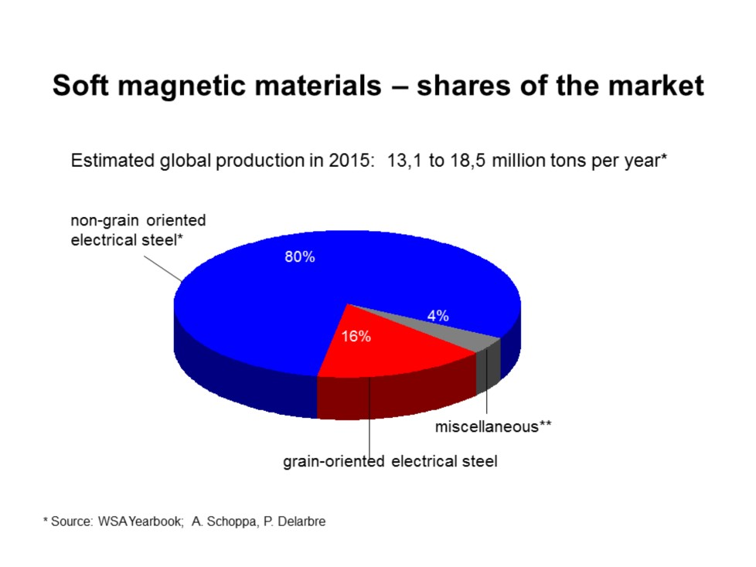
In 2015, the magnetic market compiles itself of 96% electric steel and the other 4% contains amorphous and powder shaped materials. Non-oriented electrical steel is 80% of the market which is used in core materials in rotating machines like electric motors used in electric cars. Also, there is grain-oriented electric steel which has more advantages in its hysteresis loss as these types of steels are used in large power transformers etc. [1]
Figure 1 [1]

Methodology
Below is Orb electrical steels current process route, that produces grades of Hi-B++ with produces core loss of 0.80w/Kg.
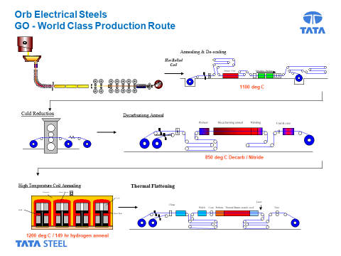
Figure 2 [3]
The first stage of the process is grading the incoming hot rolled coil. This means that depending on the chemistry of the coil will determine what process route it will take. Below is a table referencing the desired chemistry.
 | Range | Aim
C | 0.050 - 0.060 | 0.055
Si | 3.00 - 3.20 | 3.10
Mn | 0.18 -0.022 | 0.20
P | 0.015 max | 0.010
S | 0.005 - 0.009 | 0.007
sol-Al | 0.030 - 0.036 | 0.033
N | 0.006 - 0.008 | 0.007
Cu | 0.09 - 0.11 | 0.10
Sn | 0.080 - 0.10 | 0.090
Ti | 0.0030 max

Element | Purpose
Carbon | A strong austenite (solid solution of carbon and iron) stabilizer, which promotes grain refinement
Silicon | Key element. Promotes low power losses.
Manganese | Austenite stabilizer. Also combines with S and Cu to form precipitates
Phosphorous | Beneficial effect on the microstructure development by improving its homogeneity
Sulphur | This element will combine with Mn/Cu to form the inherent inhibitors
Soluble Aluminium | Al will combine with N to form AlN (Provide the inhibition)
Nitrogen | N – This element will combine with Si/Al to form inherent inhibitors Austenite stabilizer
Copper | Cu – Contributes to the acquired precipitation during nitriding
Tin | Sn – Promotes grain growth inhibition
Titanium | Ti - Unavoidable impurity element. High affinity for N, it tends to form highly stable TiN
Below in the table shows what purpose each element has on the production of a grain-oriented product. [4]
Annealing and pickle line (AP1)
Figure 3 [3]
AP1 is the first production line at orb and this process is often called an ordinary anneal. It is important that this process is run correctly as it is critical in setting the platform for hitting the low core loses in our final product. Please see the objectives of trimming, annealing and pickling hotn rolled coil below.
- Increase dispersion of precipitates.
- Ensure the inhibitor particles become the correct size.
- Securing carbon in solution (texture development).
- Side trim – sufficient to allow good cold rolling

Cold rolling

Figure 4 [3]
Cold rolling in the second process at Orb and this process is to reduce the thickness of the materials to aid reduce eddy currents that are detrimental to core loss. Please see objectives for cold rolling below.
- Warm’ roll to the required gauge.
- Increase the stored energy of the cold-rolled structure.
- Ensure good shape is achieved for further processing.
Decarburising
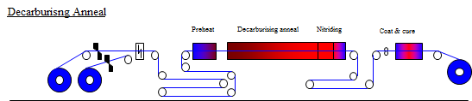
Figure 5 [3]
Decarburising process is the third process of the plant. The aim of the D line is to:
  - Reducing the carbon content in the material as carb increasing magnetic ageing.
  - Recover the grains after deformation from cold rolling.
  - Nitride the strip in order to form inhibitors that will hold back the Goss grains forming in the HTCA process.
  - Coat with MgO for glass film formation during HTCA process and to prevent coils from sticking.
High Temperature Coil Annealing
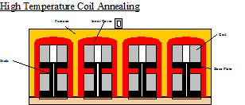
Figure 6 [3]
The HTCA process is the 4th stage of the production route. The aim of the HTCA process is to:
  - React MgO with the substrate to form an insulating glass film (forsterite)
  - Allow the Goss grains to grow with sufficient energy so they consume all the other grains that can harm magnetics.
  - Remove impurities (nitrogen and sulphur) that have a detrimental effect on magnetic properties.
Thermal Flattening lines (M2)

Thermal Flattening

Coat

Thermal flatten anneal / cool

Preheat

Pickle

Clean

Trim

Laser

Figure 7 [3]
The M line is the final process of making grain-orientated steel. The aim of this process is to:
- M-line is used to take out stresses that have been put in during the HTCA process.
- An insulations coating is also added to ensure that the strip is resistive for final application reasons
- The laser is used to improve magnetic losses.

Conclusion

Hadfield discovered that with the addition of silicon into iron you have a reduction in core loss. N.P gross invented an industrial method of producing grain-oriented steel in 1934. [4] Electric steel has a rapid rise in production in the last decade with 400 million tons being produced in 2010, this is around 29% of total steel production. Currently, only 20% of grain-oriented steel being produced is Hi-B grade. This is due to metallurgical problems occurred in making this product such as high slab reheating temperature to give the correct austenitic phase. The addition of Si into the substrate that will help improve core loss but is limited to around 3.2% due to issues seen when cold rolling to lower gauges (0.23mm) as it is so brittle. [1] New developments are being made for adding grain growth inhibitors like N after the decarburising process. This is done adding cracking NH3 to increase the amount of nitrogen in the substrate to give adequate grain growth in the HTCA process. [3]

The current Orb process is very similar to what Nippon steel use currently but without the chemical vapour deposition. They use the same grain growth inhibitor (aluminium nitrites) to control grain growth in the HTCA process. Orb adds nitrogen into the substrate via ammonia cracking after the decarburisation stage which is the same as Nippon and JFE steel. The current main differences between orb and Nippon is the cold rolling and domain refinement. Orb uses a 4 high reversing mill to reduce the hot rolled coil to 0.23mm. Nippon use a sendzimir rolling mill which gives you better shape control which aids with yield in further processing. See the difference between the mills below. [5]
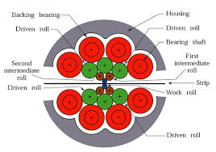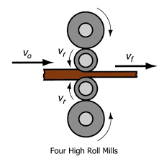
Figure 8 [5] Figure 9 [6]
Sendzimir rolling mill Four high reversing mill

The final difference come in the domain refinement stage. Orb uses laser domain refinement and Nippon use plasma jet irradiation. Both will reduce core loss by around 10%.

Works Cited

[1] | G. Ouyang, X. Chen and Y. Liang, “Review of Fe-6.5 wt%Si high silicon steel—A promising soft magnetic material for sub-kHz application,” Journal of Magnetism and Magnetic Materials, pp. 234-250, 2019.
[2] | A. Prakash, S. Ghosh and P. Kumar, “A review on the chronological dvelopment of CRGO steel,” Development of CRGO steel - A chronological review, vol. 1, no. 1, p. 1, 2013.
[3] | K. Price, B. Goode and D. Power, “Grain-oriented electrical steels for power and distribution transformers,” Ironmaking & steelmaking, vol. 43, no. 9, pp. 636 - 641, 2016.
[4] | Z. Xia, Y. Kang and Q. Wang, “Developments in the production of grain-oriented electrical steel,” Journal of Magnetism and Magnetic Materials, vol. 320, no. 23, pp. 3229 - 3233, 2008.
[5] | T. Kawaguchi, T. Yamada, K. Katayama and K. Kashiba, “OPTIMAL CONTROL OF SENDZIMIR MILL,” IFAC Proceedings Volumes, vol. 13, no. 7, pp. 553 - 563, 1980.
[6] | K. Kondo, Y. Misaka, M. Okamoto, Y. Matsumori and T. Miyag, “A New Automatic Gauge Control System for a Reversing Cold Mill,” Transactions of the Iron and Steel Institute of Japan, vol. 28, no. 6, pp. 507 - 513, 1988.

Bibliography

[1] | G. Ouyang, X. Chen and Y. Liang, “Review of Fe-6.5 wt%Si high silicon steel—A promising soft magnetic material for sub-kHz application,” Journal of Magnetism and Magnetic Materials, pp. 234-250, 2019.
[2] | A. Prakash, S. Ghosh and P. Kumar, “A review on the chronological dvelopment of CRGO steel,” Development of CRGO steel - A chronological review, vol. 1, no. 1, p. 1, 2013.
[3] | K. Price, B. Goode and D. Power, “Grain-oriented electrical steels for power and distribution transformers,” Ironmaking & steelmaking, vol. 43, no. 9, pp. 636 - 641, 2016.
[4] | Z. Xia, Y. Kang and Q. Wang, “Developments in the production of grain-oriented electrical steel,” Journal of Magnetism and Magnetic Materials, vol. 320, no. 23, pp. 3229 - 3233, 2008.
[5] | T. Kawaguchi, T. Yamada, K. Katayama and K. Kashiba, “OPTIMAL CONTROL OF SENDZIMIR MILL,” IFAC Proceedings Volumes, vol. 13, no. 7, pp. 553 - 563, 1980.
[6] | K. Kondo, Y. Misaka, M. Okamoto, Y. Matsumori and T. Miyag, “A New Automatic Gauge Control System for a Reversing Cold Mill,” Transactions of the Iron and Steel Institute of Japan, vol. 28, no. 6, pp. 507 - 513, 1988.

References

[1] | G. Ouyang, X. Chen and Y. Liang, “Review of Fe-6.5 wt%Si high silicon steel—A promising soft magnetic material for sub-kHz application,” Journal of Magnetism and Magnetic Materials, pp. 234-250, 2019.
[2] | A. Prakash, S. Ghosh and P. Kumar, “A review on the chronological dvelopment of CRGO steel,” Development of CRGO steel - A chronological review, vol. 1, no. 1, p. 1, 2013.
[3] | K. Price, B. Goode and D. Power, “Grain-oriented electrical steels for power and distribution transformers,” Ironmaking & steelmaking, vol. 43, no. 9, pp. 636 - 641, 2016.
[4] | Z. Xia, Y. Kang and Q. Wang, “Developments in the production of grain-oriented electrical steel,” Journal of Magnetism and Magnetic Materials, vol. 320, no. 23, pp. 3229 - 3233, 2008.
[5] | T. Kawaguchi, T. Yamada, K. Katayama and K. Kashiba, “OPTIMAL CONTROL OF SENDZIMIR MILL,” IFAC Proceedings Volumes, vol. 13, no. 7, pp. 553 - 563, 1980.
[6] | K. Kondo, Y. Misaka, M. Okamoto, Y. Matsumori and T. Miyag, “A New Automatic Gauge Control System for a Reversing Cold Mill,” Transactions of the Iron and Steel Institute of Japan, vol. 28, no. 6, pp. 507 - 513, 1988.

