


Network Management

Tutorial 9

Faculty of Architecture, Computing and Engineering
School of Applied Computing
Mount Pleasant Campus
Swansea
SA1 6ED

- INTRODUCTION AND OBJECTIVES OF THE Exercises
In the lecture, you learnt about Monitoring the Network, which is an essential factor in successfully operating a network. Apply your understanding and knowledge from what you learnt in the lecture about the topic and the previous lectures to do the following tasks:

Task 1:
- Read the Syslog output shown and match the output to the correct identifier. Note not all options will be used.
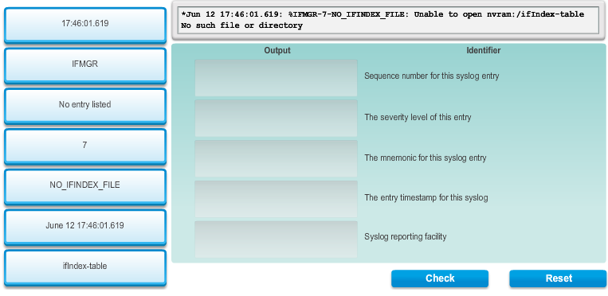
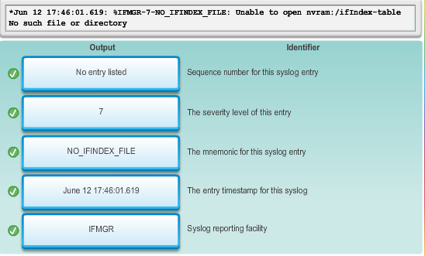
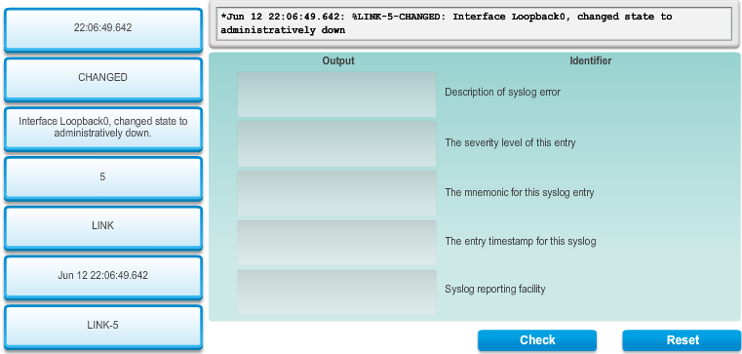

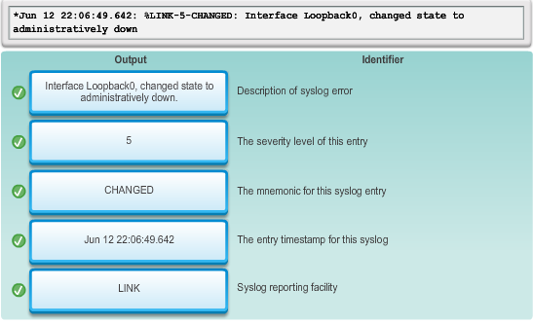

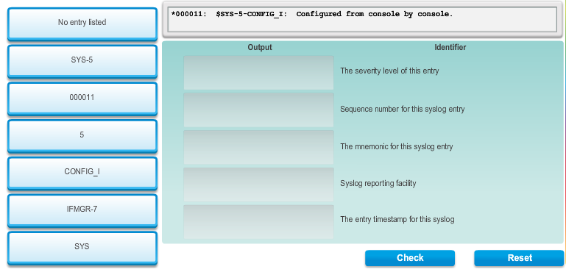

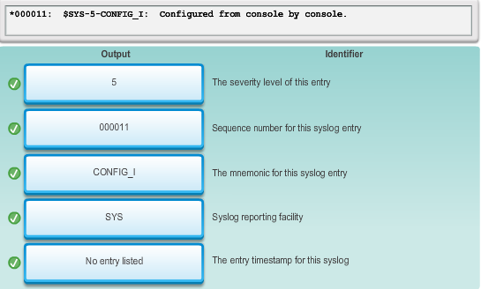

- Check the appropriate field to classify each SNMP characteristic version 2c, 3 or both
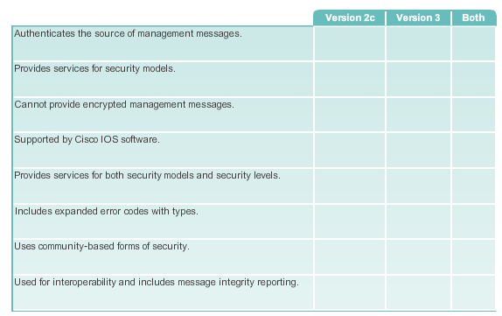
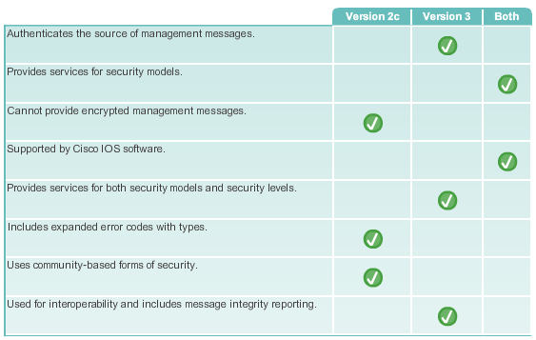

- Check the appropriate field to classify each Network Monitoring tools characteristic as either SNMP or NetFlow.
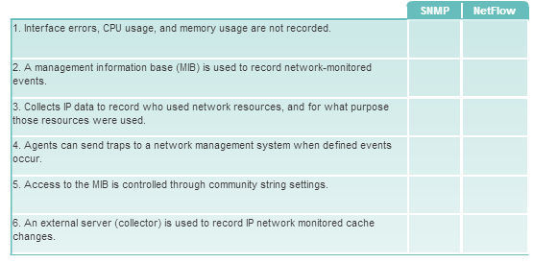

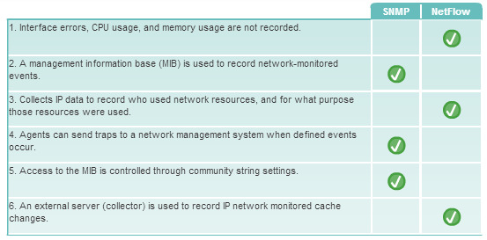

Task 2:

Use your lecture notes and/or the Internet to answer the questions.

- Explain the operation of Syslog operation

- What are the purposes of the following
  - Service Timestamp
  - Syslog server

- How does controlling broadcast benefit VLANs?

- Explain the operation of SNMP and SNMP Agent Traps

- Name at least three version of SNMP and describe one of them.

- What is the function of the two SNMP community strings?

- Outline the configuration steps for SNMP

- Refer to the SNMP viewer configuration diagram below, explain the configuration.

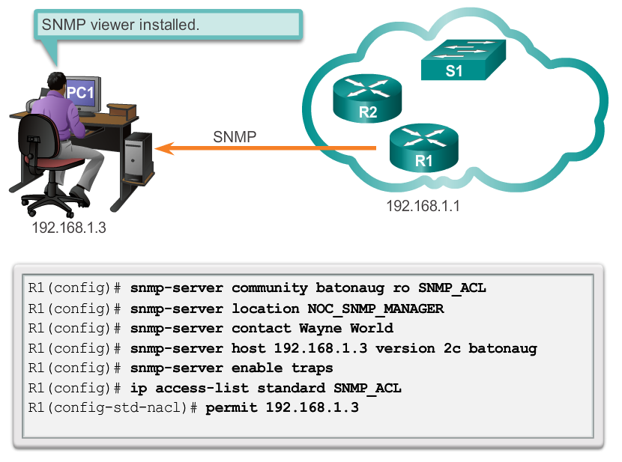

- Why is netflow important to Network Management?

- Refer to the diagram below, write the configuration command to configure netflow on R1.

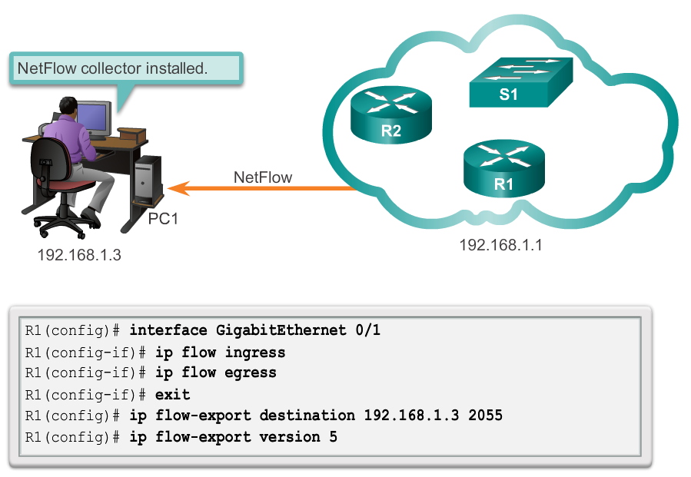

- Explain the NetFlow Collector functions

