Changemakers: Building your Personal Brand for Sustainable Employment

Student name: Rawan Abushamma
Student Number: 2407871

Introduction
A social worker is an important professional within the UK health and social care system, helping individuals, families, and communities overcome difficulties and improve their quality of life. The role involves assessing people's needs, protecting vulnerable adults and children, providing guidance and support, and working alongside healthcare professionals and other organisations to ensure the best possible outcomes (Social Work England, 2024). I am interested in becoming a social worker because I enjoy supporting others, making a positive difference in people's lives, and promoting fairness and inclusion. This report examines the employability skills required for this profession, assesses my current abilities and experience, and outlines a five-year action plan to develop the knowledge, skills, and professional identity needed to achieve this career (Social Work England, 2024).

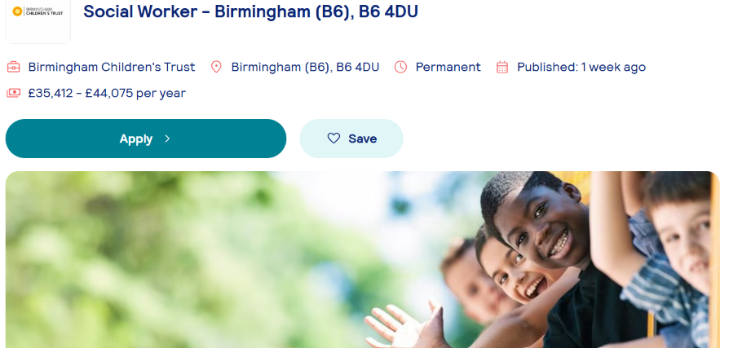

I have chosen to pursue a career as a Social Worker because I am passionate about supporting vulnerable children, families, and communities to improve their wellbeing and protect them from harm. For this report, I selected a current vacancy for a Social Worker at Birmingham Children's Trust, located in Birmingham (B6) (Birmingham Children's Trust, 2026). The role is a permanent position with a salary ranging from £35,412 to £44,075 per year (Birmingham Children's Trust, 2026). According to the job advertisement, the successful candidate is expected to demonstrate excellent communication, assessment, safeguarding, teamwork, and problem-solving skills while working effectively with children, families, and other professionals (Birmingham Children's Trust, 2026). This vacancy provides a clear understanding of the qualifications, responsibilities, and personal qualities required to work as a social worker in the UK (Birmingham Children's Trust, 2026).

Job Role Employability Skills
To perform effectively as a social worker, individuals need a combination of professional knowledge, practical abilities, and personal qualities. The vacancy advertised by Birmingham Children's Trust highlights several key employability skills, including effective communication, teamwork, decision-making, organisational skills, safeguarding awareness, and the ability to manage a demanding workload (Birmingham Children's Trust, 2026).

Effective communication is essential because social workers interact with people from a wide range of backgrounds, including children, families, carers, and professionals from different organisations. Being able to listen carefully, explain information clearly, and produce accurate written reports helps build trust and ensures that the needs of service users are understood and addressed appropriately (Social Work England, 2024). In addition, teamwork is a vital part of the role, as social workers must work closely with healthcare staff, schools, local authorities, and other agencies to deliver coordinated and person-centred support (Skills for Care, 2023).

Another important employability skill is problem-solving. Social workers often deal with complex situations that require them to assess risks, consider different options, and make informed decisions that protect vulnerable individuals. Strong organisational and time-management skills are also necessary to balance multiple cases, attend meetings, complete assessments, and meet legal deadlines while maintaining high standards of practice (Skills for Care, 2023).

Furthermore, safeguarding knowledge and professionalism are central to social work practice. Social workers have a legal and ethical responsibility to identify concerns about abuse or neglect, maintain confidentiality, and follow professional standards to ensure the safety and wellbeing of those they support (Social Work England, 2024). These employability skills are essential for delivering high-quality care, promoting positive outcomes, and ensuring that social workers can meet the expectations of employers within the UK health and social care sector.

Evaluate Your Own Skills
Evaluating my current skills and experience has helped me understand how well I meet the requirements for a career as a social worker. By comparing my abilities with the person specification in the Birmingham Children's Trust job advertisement, I have identified both my strengths and the areas where I need further development before entering the profession (Birmingham Children's Trust, 2026).

One of my strongest qualities is my ability to communicate effectively with others. I am confident when listening to people's concerns, explaining information clearly, and working respectfully with individuals from different backgrounds. Good communication is essential for social workers because they must build trusting relationships with service users, collaborate with colleagues, and prepare clear written reports to support decision-making (Social Work England, 2024). I also consider myself to be caring, patient, and understanding. These personal qualities help me show empathy towards others and support individuals in a respectful and non-judgemental manner.

My studies in [Health and Social Care] have provided me with a solid understanding of health and social care principles, including safeguarding, equality and diversity, ethics, and person-centred practice. Through assignments, presentations, and group work, I have improved my research, teamwork, and organisational skills.
Although I have developed many useful skills, I recognise that there are still areas where I need to improve. In particular, I would benefit from gaining more practical experience in a social care environment. Working directly with service users would help me develop my assessment, decision-making, and case management skills while increasing my confidence in dealing with challenging situations. I also plan to continue expanding my knowledge of social work legislation, safeguarding procedures, and professional standards through additional training and continuous professional development (Skills for Care, 2023).

To achieve these goals, I will seek support from my university lecturers, placement supervisors, and experienced social workers who can provide guidance, constructive feedback, and mentoring. Their advice will help me develop professionally and prepare for future employment. Overall, I believe my compassion, willingness to learn, strong communication skills, and commitment to supporting others are my unique strengths, and these qualities will enable me to make a valuable contribution as a future social worker.

Create an Action Plan and Timeline
Becoming a qualified social worker is one of my long-term career goals, and I understand that achieving this position requires commitment, continuous learning, and practical experience. To prepare myself for this career, I have created an action plan that focuses on developing the knowledge, skills, and professional qualities expected by employers. Following this plan will help me improve my confidence and ensure I am ready to work effectively with vulnerable individuals and families. Continuous professional development is an important part of social work because professionals are expected to keep their knowledge and skills up to date throughout their careers (Social Work England, 2024).

My first objective is to complete my Health and Social Care qualification successfully while strengthening my understanding of key topics such as safeguarding, communication, equality, diversity, and professional ethics. Alongside my studies, I will complete additional short courses in areas such as first aid, mental health awareness, and safeguarding children and adults. These courses will improve my knowledge and make my CV more attractive to future employers (Skills for Care, 2023).

After completing my studies, I plan to gain practical experience by volunteering or working in organisations that support vulnerable people, such as care homes, charities, or community projects. This experience will help me improve important employability skills, including teamwork, problem-solving, communication, and decision-making. It will also allow me to apply the knowledge I have gained during my studies in real-life situations.

As I continue to develop professionally, I will build my personal brand by maintaining a professional CV and LinkedIn profile that highlight my qualifications, work experience, training, and achievements. I also plan to attend career fairs, networking events, and professional workshops to connect with experienced social workers and learn more about career opportunities within the health and social care sector.

Within the next five years, I aim to secure a position as a social worker by applying for suitable vacancies and preparing thoroughly for interviews. I will continue to improve my knowledge through professional training and seek regular feedback from lecturers, supervisors, and colleagues to support my ongoing development. By following this action plan, I believe I will gain the skills, experience, and confidence needed to build a successful career as a social worker.
Five-Year Timeline
Time Period | Development Goal | Actions
Year 1 | Complete my studies | Successfully finish my Health and Social Care course and attend short training courses.
Year 2 | Gain practical experience | Volunteer or work in a care setting to improve communication, teamwork, and safeguarding skills.
Year 3 | Develop professionally | Attend workshops, build a professional network, and seek guidance from mentors.
Year 4 | Prepare for employment | Update my CV and LinkedIn profile, complete additional training, and improve interview skills.
Year 5 | Start my career | Apply for social worker positions and continue my professional development through further learning and workplace experience.

Building Your Personal Brand
Creating a positive personal brand is essential for establishing a successful career in social work. A strong professional image allows employers to recognise an individual's skills, values, and dedication to providing high-quality care. As an aspiring social worker, I want my personal brand to reflect qualities such as honesty, empathy, professionalism, and a commitment to improving the lives of vulnerable people. Demonstrating these values can help build trust with employers, colleagues, and service users while supporting my professional identity (Social Work England, 2024).

To promote myself professionally, I will develop an up-to-date LinkedIn profile that includes my education, qualifications, volunteering experience, work history, and relevant training. I will also prepare a well-structured CV that clearly highlights my achievements, skills, and career goals. Participating in career events, employer workshops, and professional networking opportunities will enable me to build relationships with experienced practitioners and gain valuable advice about working in the social work profession (Skills for Care, 2023).

Promoting Your Professional Identity
Developing a professional identity is essential for demonstrating to employers that I have the knowledge, skills, and values needed to become a successful social worker. I plan to present myself as a dedicated and responsible professional by effectively showcasing my qualifications, experience, and commitment to continuous learning. A well-prepared CV will be one of the main tools I use to highlight my education, relevant training, volunteer work, and transferable skills, including communication, teamwork, empathy, and organisation. Alongside my CV, I will write a tailored cover letter for each application to explain why I am suitable for the position and how I can contribute to the organisation (Skills for Care, 2023).

I also recognise the importance of having a strong online professional presence. To achieve this, I will keep my LinkedIn profile updated with my qualifications, work experience, achievements, and professional interests. This will enable employers and other professionals to learn more about my background and career aspirations. In addition, I plan to create a digital portfolio containing evidence of my academic work, certificates, training courses, and reflective practice. This portfolio will demonstrate my willingness to develop professionally and maintain high standards of practice throughout my career (Social Work England, 2024).

Building a Network for Successful Employment
Creating a strong professional network is an important part of preparing for a career in social work. Building relationships with professionals in the health and social care sector can provide valuable advice, increase knowledge of the profession, and create opportunities for future employment. Networking also allows individuals to learn from the experiences of others, develop new skills, and stay informed about changes within the social work profession (Skills for Care, 2023).

In addition, I will attend recruitment fairs, workshops, and conferences to meet employers and other professionals working in social work. I will also use LinkedIn to connect with practitioners, join professional groups, and engage with discussions on current issues in health and social care. Developing these professional connections will broaden my knowledge, strengthen my confidence, and improve my prospects of securing a social worker position after completing my studies (Social Work England, 2024).

Conclusion
This report has provided an overview of the requirements for a career as a social worker and highlighted the employability skills needed to succeed in this profession. By examining the chosen job role, I have developed a clearer understanding of the responsibilities involved and the importance of skills such as effective communication, teamwork, critical thinking, empathy, and safeguarding. Evaluating my own abilities has allowed me to identify the strengths I already possess, while also recognising the areas where I need to improve through further learning, training, and practical experience.

The action plan outlined in this report has given me a structured approach to achieving my career ambitions over the next five years. By completing my studies, gaining relevant work experience, participating in professional development opportunities, and continuously improving my skills, I will be better prepared to meet the expectations of employers within the health and social care sector. I also understand the value of developing a strong personal brand, maintaining a professional identity, and building relationships with experienced professionals to support my future career.

Completing this report has strengthened my determination to become a social worker. I am committed to continuing my personal and professional development so that I can provide high-quality support to vulnerable individuals and make a positive contribution to society throughout my career.

References

British Association of Social Workers (BASW) (2024) About BASW. Available at: https://www.basw.co.uk (Accessed: 9 July 2026).

Birmingham Children's Trust (2026) Social Worker – Birmingham (B6), B6 4DU [Job advertisement]. Available at: [Insert the job vacancy URL] (Accessed: 12 July 2026).

Skills for Care (2023) Social worker. Available at: https://www.skillsforcare.org.uk (Accessed: 17 July 2026).

Social Work England (2024) About social work. Available at: https://www.socialworkengland.org.uk/about/about-social-work (Accessed: 17 July 2026).

Social Work England (2024) Professional standards. Available at: https://www.socialworkengland.org.uk/standards/professional-standards/ (Accessed: 17 July 2026).

