
WEB AND MOBILE TECHNOLOGIES
Jake Rosser

January 18, 2023
ROS19845214
HND Applied Computing

Contents
Introduction 2
Website theme and audience 2
First Page – Home Page 2
Second Page – About Us 3
Second Page – JavaScript 3
Third Page – GCS Owls 3
Third Page – jQuery 4
Final Page – Contact us 4
Final Page – JavaScript 5
Universal JavaScript / Bootstrap 5
Conclusion 6
References 7

Introduction
Websites everywhere are made with many different sources of code that you can use to program them and get them to present exactly how you want, and there are many different extensions you can add your webpages to develop them further such as Bootstrap for extra designs and make it look blockier and have better formatting in your website developer of choice, there is also JavaScript that allows you to write programs that can be displayed on your webpage.
This assignment has requested that a webpage must be built, using HTML as the first source and then using elements so you are able to create a JavaScript entry form that users can enter data into, and it will validate if it is correct data or not, a jQuery page where you can interact with images and such, and the third component was completed induvial and personal, so slideshow was chosen. Then use Bootstrap to make it presentable.

Website theme and audience
The website’s theme is Gower College Swansea and it’s meant to be an introductory website for people who are looking to join to the college and showing what the college can offer, explaining about the different courses and the eSport team is. The eSport team is included because the audience being secondary school students are heavily interested in gaming so seeing that the college offers an eSport team can help them want to join. So, making the website have a lot of information for them to read without making it too complex was a necessity. Using eye catching colours allows the students to get attracted to the website. [1]

First Page – Home Page
The home page is one in contest for being one of the most important parts of the webpage, it’s used to attract and engage visitors of the webpage to your site and keeps them focused on your page without making them want to leave. [2] With the design of the first page, there was a want to keep it simplistic but also eye catching, using Gower College’s primary colour scheme and links to their social media with some text about the college, it gives a good introduction to the college.
The links to each social media pages are simple href links that when you click on the images they will transport you to the selected social media page.
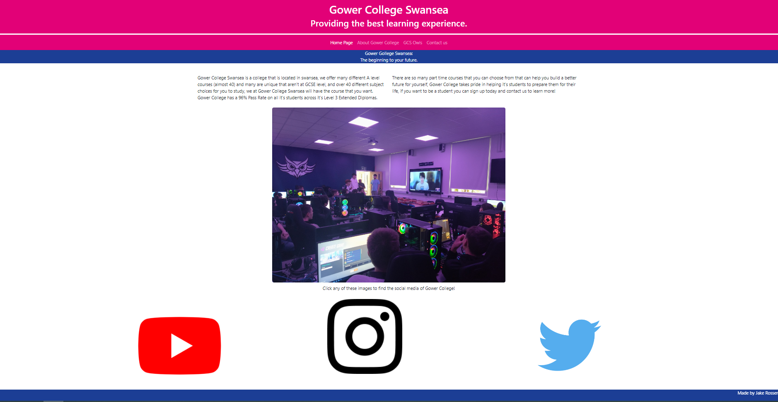

Second Page – About Us
The second page of the website is the “About Gower College” which has some information on what the college courses are with a JavaScript slideshow which was made with help from W3Schools [3]. The reason that you want your about us page to be eye catching is because users will be intrigued to know more if your about us page can show what the domain can offer to the users. [4] The images that were used on the select webpage for the slideshow were from a royalty free image website known as Pixabay, which in their License states that images can be used fairly for commercial use. [5] The webpage has information about the many different courses that Gower College can offer and would let the audience know that they will be able to find a good course that suits them.
The JavaScript behind the SlideShow has it so all the images are invisible when you bootup the webpage except for the first one, then as you click next it will hide the first image and present the second, and so on and so forth. The buttons at the bottom are in colour with Gower College and will show with slide you are on, ranging from 1-5. Pink being the active page of the slideshow. The Next and Previous buttons on the slideshow also have a colour highlight when you hover over them showing that you can click on them to move the slideshow to the next slide.
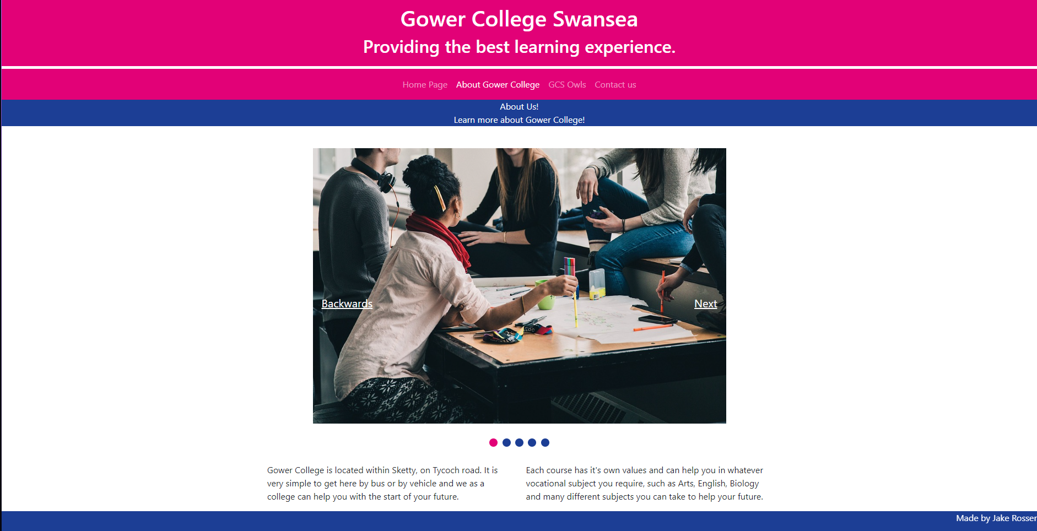

Second Page – JavaScript
The about us section has many different functions that allow the slideshow to work, including the functions that make the buttons move and the arrows going left and right. Pressing the buttons and arrow keys activates the function of ShowSlide which is another function that will determine which slide needs to be shown on the webpage for the user while the others are hidden. At the bottom of the script it indicates that all slides will be hidden except the first one that listed as ThisSlide(1) and the first dot will be highlighted as the selected block.
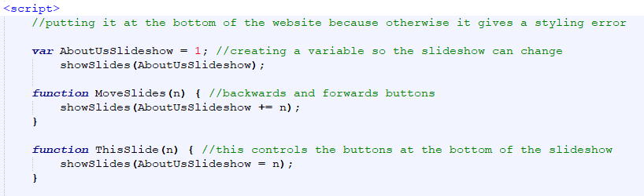
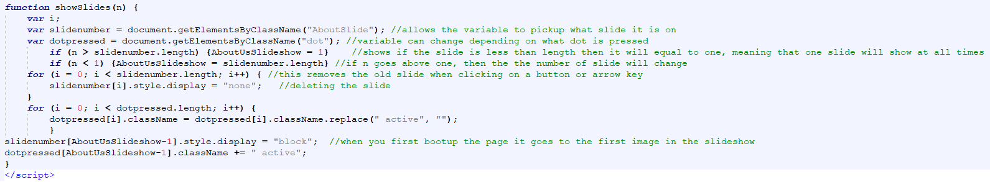

Third Page – GCS Owls
The GCS Owls is Gower College’s very own eSport team, the reason that the eSport team needs its own webpage on this website is because eSports is growing year by year and it will allow new upcoming students to look forward to an extra club, the eSport team would be able to help their physical and mental health as they would be socialising, it can relieve stress and teaches the students how to solve problems on their own. [6] The Website also has a hyperlink going to the GCS Owls Social media page so the viewer can look more into what the team is posting about online.
For the jQuery part of the website, it was 3 different images where when the viewer clicks on one, it will show some information on the team and what they do, interactivity is good on the webpage because it will create a more meaningful experience to the user, and they will be more inclined to read about it after they have interacted with the options available. [7] The website’s interactivity allows it so when you click onto a new image, the other text below the images will be deleted and the new one will appear, letting the viewer focus on one part of text at a time without feeling overloaded.
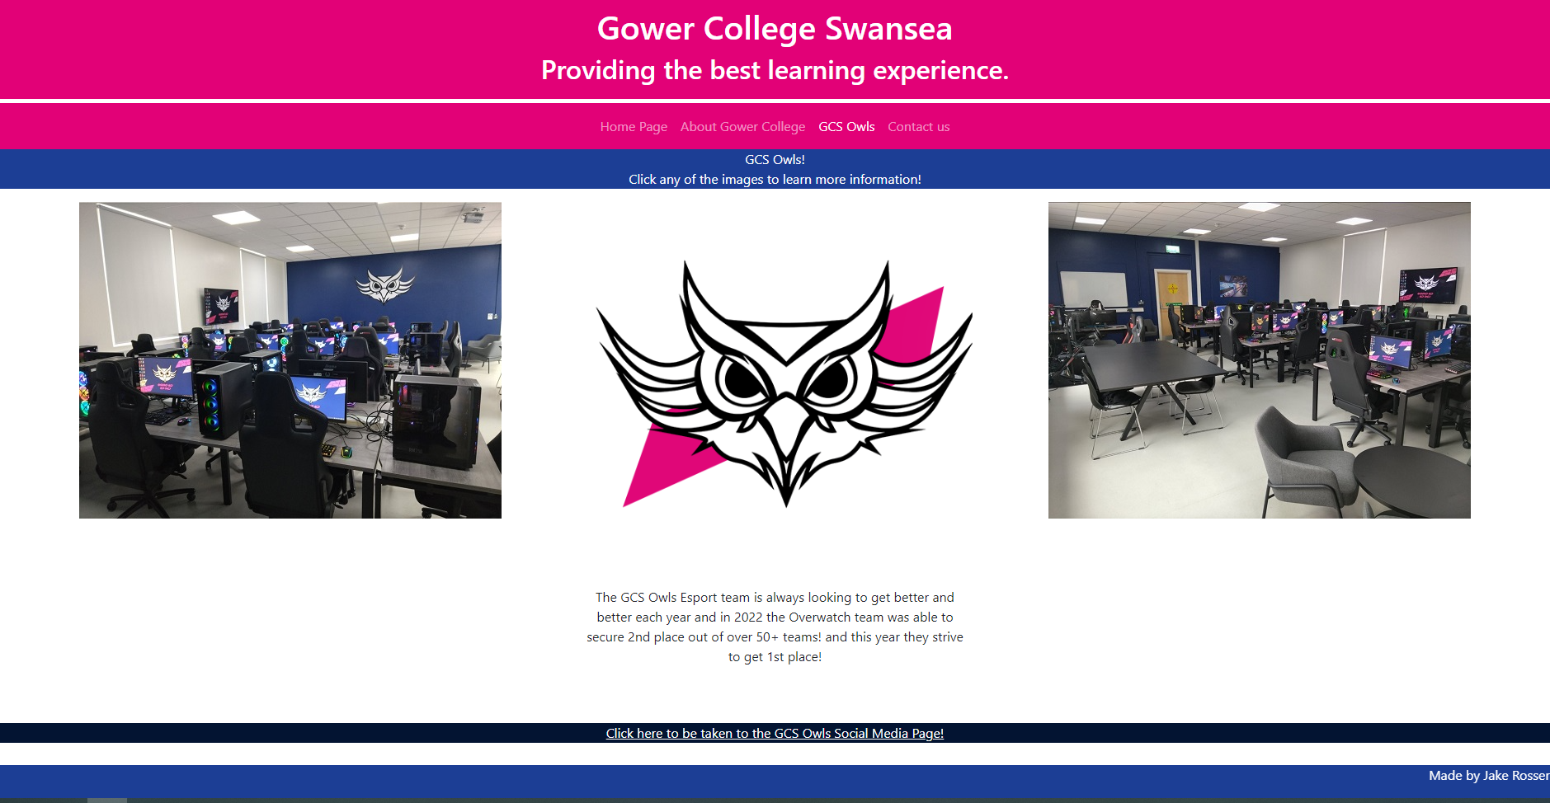

Third Page – jQuery
The jQuery work for the GCS Owls Page has it so when you click on an image, it will display text and run a function on the document that will present text under the image that you click relating to the GCS owls, when you click on one image then it will delete all the other text under the other images to make sure only one piece of text is showing.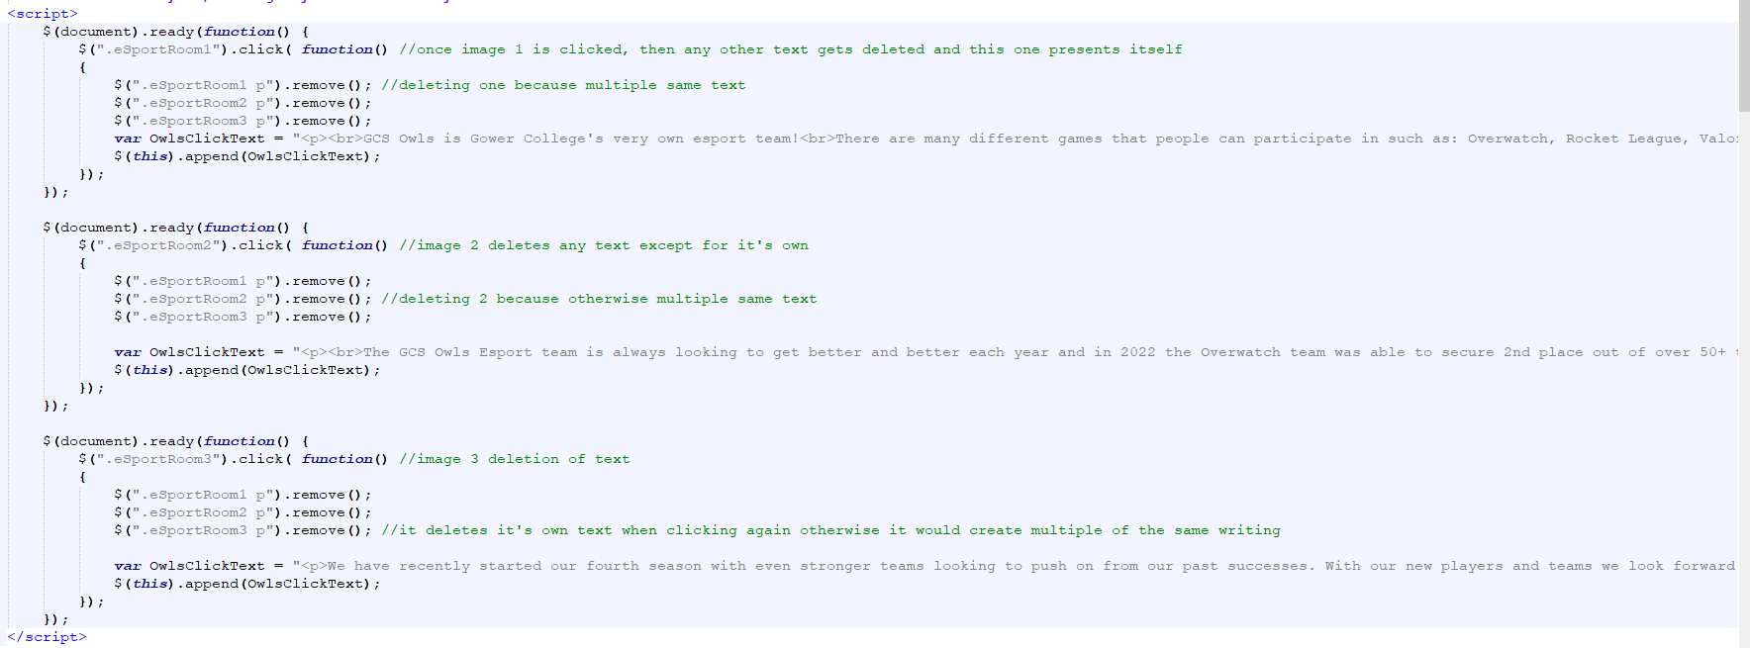

Final Page – Contact us
For the final page of the website, it was a simple contact form, the reason you need a contact form is because you can keep track of inquires that you may have about the college. [8] Users of the website can use to contact the college by sending them their information such as the Discord Tag, Email and Name. The information on this page is decently small but it has all the necessities that a contact form should have. Then at the bottom of the page it has some extra information if you want to go into the college and talk to someone as peer to peer about becoming a part of the college.
The JavaScript that was added is when you enter information into the contact form it looks to see if you have missed any boxes or have done them incorrectly such as putting your gender as other but then not entering any information into the box underneath and it will spit out an error saying that it needs the box to be filled otherwise it cannot continue the process.
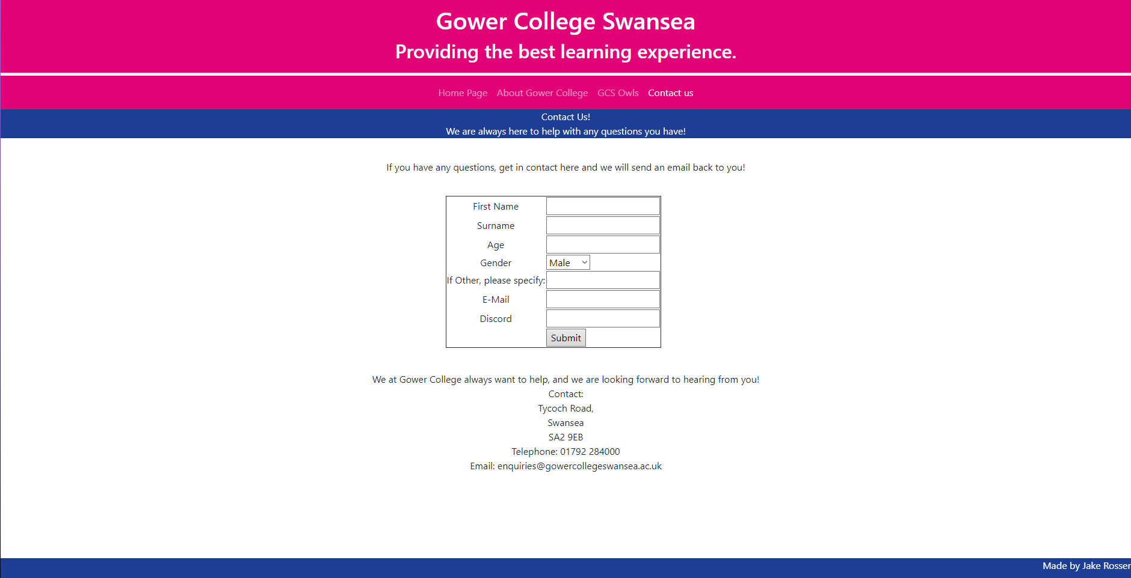

Final Page – JavaScript
The JavaScript on the final page is very simple, it’s all validation to make sure that text boxes have entered information in, and if they don’t then error text will appear on the parts where you need to enter information. This is to help the user find out where they need to insert information and the error message will highlight itself to show the user where they need to enter information.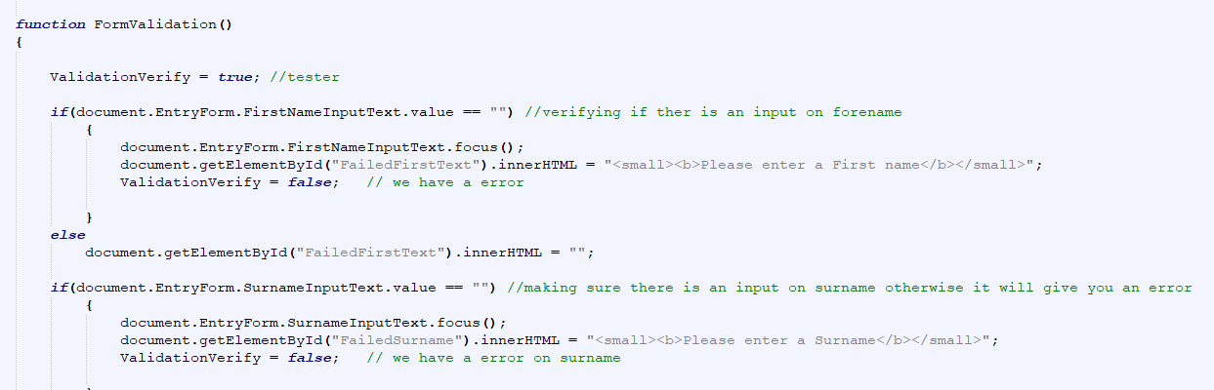

Universal JavaScript / Bootstrap
For the universal JavaScript / Bootstrap on the webpage, it was a need to make sure that each page of the website follows the same universal form, you want a consistent design for each webpage because users wont get mixed up when clicking between different links on your website and they will know where each thing is. They’ll have comfort knowing what each thing will look like rather than having to go on a treasure hunt to find something they need. [9]
The navigation bar is made with the use of bootstrap, where bootstrap does the layout and puts the bar where it needs to be and CSS styles it to the correct colouring scheme to fit Gower College Swansea.
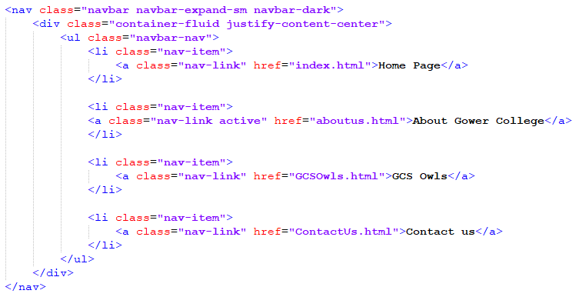
The header and footer are both designed using CSS and have their own margins and colours to stand out and make the website pop, using the colours of Gower College it allows for a mix of warm and cold colours that make the website pop enough without overloading the user with too much at once. [10]
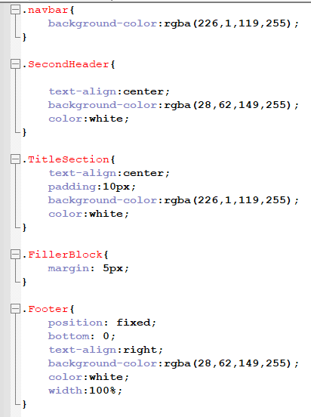

Conclusion
Overall, the website produces a good introduction into what life is like at Gower College, if there were to be an extension done to the website there could be a more universal page with images showing some of the courses you can take with break examples onto them, or to redo a page it would be the GCS Owls Page and there could be more user interactivity so they can see some pictures of the players on the website and the tourneys they have been apart of.

References

[1] | C. Ward, “The Impact of Knwoing your Website Audience,” Wired Impact, 9th Febuary 2022. [Online]. Available: https://wiredimpact.com/blog/knowing-audience-impacts-website/#:~:text=Knowing%20your%20audience%20will%20help,management%20system%20and%20event%20registrations.. [Accessed 18th January 2023].
[2] | UK2, “Why A Website’s Homepage Is Its Most Important Attribute,” UK2 - A THG Company, 2nd September 2019. [Online]. Available: https://www.uk2.net/blog/why-a-websites-homepage-is-its-most-important-attribute/. [Accessed 18th January 2023].
[3] | W3Schools, “How TO - Slideshow,” W3Schools, N/A. [Online]. Available: https://www.w3schools.com/howto/howto_js_slideshow.asp. [Accessed 20th December 2022].
[4] | N. Chandra, “Importance of the ‘About Us’ page for your Customers’ business,” resellerclub, 16th November 2017. [Online]. Available: https://blog.resellerclub.com/importance-of-the-about-us-page-for-your-customers-business/. [Accessed 19th January 2023].
[5] | Pixabay, “Simplified PIxabay License,” Pixabay, N/A. [Online]. Available: https://pixabay.com/service/license/. [Accessed 19th January 2023].
[6] | D. Bhati, “Benefits of eSports: Know how Mobile or PC gaming helping in improving mental and physical health.,” Jagrantv, 23rd Feb 2022. [Online]. Available: https://www.jagrantv.com/en-show/benefits-of-esports-know-how-mobile-or-pc-gaming-helping-in-improving-mental-and-physical-health-rc1028201. [Accessed 19th January 2023].
[7] | Sherman, “The Benefits an Interactive Website Design Offers Your Business,” Lyfe Marketing, 13th June 2022. [Online]. Available: https://www.lyfemarketing.com/blog/interactive-website-design/. [Accessed 19th January 2023].
[8] | C. Broadly, “11 Reasons Why You Need a Contact Form on Your Website (2023),” wpforms, 4th January 2023. [Online]. Available: https://wpforms.com/8-reasons-why-you-need-a-contact-form/. [Accessed 21st January 2023].
[9] | L. Wake, “Why is consistency important in web design?,” University of St Andrews, 7th April 2016. [Online]. Available: https://digitalcommunications.wp.st-andrews.ac.uk/2016/04/07/why-is-consistency-important-in-web-design/. [Accessed 21st January 2023].
[10] | G. Author, “6 Tips to Choose a Stunning Website Color Scheme,” WordStream, 17th July 2022. [Online]. Available: https://wpstackable.com/blog/5-great-ways-to-add-color-to-your-site/. [Accessed 21st January 2023].

