The Influence of Peripheral Temperature Modulation on Grip Strength and Hang-Time Endurance in recreational athletes

Abstract

Within the field of exercise physiology, enhancing physical performance continues to represent a primary focus, with particular emphasis on understanding the complex physiological mechanisms underlying strength, endurance and fatigue resistance. Muscle temperature is widely regarded as a critical determinant of neuromuscular performance, influencing both mechanical and metabolic processes within skeletal muscle. While previous literature has primarily examined whole body temperature manipulation, whereas limited studies have explored the localised effects of peripheral temperature modulation on smaller muscle groups.
The overall aim of the study was to evaluate the acute effects of forearm and hand temperature modulation on grip strength and hang time endurance in recreational athletes. The study introduced a repeated measures design, exposing participants to two temperature interventions (warm and cold). Prior to temperature assessments, participants baseline measurements were recorded to enable direct comparison across conditions.
The findings illustrated that grip strength enhanced in participants when following warm exposure, suggesting that increased muscle temperature is significant in force production and neuromuscular function. Notably, hang time endurance demonstrated minimal variation across conditions, implying that isometric endurance capacity may be less responsive to acute changes in localised temperature
During examination, the findings concluded that substantial inter individual variability was observed, identifying the variation in physiological response between participants. The evidence demonstrates that the effects of temperature modulation vary according to task specific demands, with warming strategies potentially improving maximal strength, while producing limiting impact on endurance-based tasks. Within exercise physiology, the study contributes to the growing body of literature by providing great insight into localised temperature interventions and their application to performance effectiveness in recreational populations.

Introduction
Within the field of exercise physiology, optimizing physical performance has consistently remained a central objective. Despite a substantial body of research exploring the determinants of muscular strength, endurance and fatigue resistance, the underlying mechanisms are persistently multifaceted with various research concluding interplay of physiological capacity and individual variability (Fitts, 1994; Allen, Lamb and Westerblad, 2008). Among the principal components underpinning neuromuscular performance, muscle temperature has been recognised as a fundamental factor in adapting muscular function, influencing mechanical and metabolic processes within skeletal muscle (Racinais and Oksa, 2010). Accordingly, considerable research investment has been directed towards development and application of temperature related interventions in both athletic preparation and recovery strategy.

Studies suggest Increasing muscle temperature is associated with overall enhancement to enzyme activity, positively influencing oxygen delivery and increasing nerve conduction velocity, all of which contribute to elevated force production and power output (Bergh and Ekblom, 1979). Conversely, research emphasising reduction to muscle temperature identified decreased muscle elasticity, reduced neuromuscular performance due to reduced nerve conduction velocity and slower contractile properties (Oksa, 2002). Although cooling interventions commonly implicate physiological performance, reductions in body temperature can decrease metabolic demand and delay onset muscle fatigue, therefore contributing to enhanced exercise resilience (Bleakley et al., 2012). Understanding the complexity of the relationship between muscle temperature and performance outcomes requires acknowledging its multifaced and contradictory nature. Elevated muscle temperature has been widely documented as an enhancer to physiological processes underpinning performance, however the enhancement is only contingent upon maintaining optimal temperature range. Excessive exposure to temperature elevation may induce thermal stress, destabilise homeostasis and overall compromise performance. The duality of both beneficial and adverse implications to muscle temperature modulation reinforces the need for precise thermal maintenance to optimise performance outcomes while mitigating potential physiological limitations

Despite the extensive research analysing the profound effects of temperature modulation on muscular performance, majority of studies had dedicated focus on whole body temperature manipulation or large muscle groups that were accessed in activities such as cycling or running. In contrast, relatively limited examination has been conducted on the localised effects of peripheral temperature modulation, especially in smaller muscle groups via forearm or hand. The limited body of research represents a gap in the literature that could be addressed by examining how the findings can be applied to muscle groups involved in sports or activities that depend heavily on strong grip strength and sustained isometric contractions.
Grip strength is renowned in exercise physiology as a key indicator of upper limb function and overall physical performance, with applications supported across a variety of sports including gymnastics, climbing, and resistance-based training. Similarly, athlete’s requiring resilient hang time endurance dependant on their forearm flexor muscles to sustain prolonged isometric contractions during fatigue conditions. Both measures have been shown to be influenced by temperature modulation, highlighting underlying adaptions in neuromuscular efficiency, metabolic processes and blood flow. Therefore, it is credible to invest extensive research into acute manipulation of forearm temperature on how it may provide significance in altering performance outcomes in drip dependant tasks.
Previous literature has demonstrated that increasing muscle temperature has the potential to enhance contractile speed and force production, providing beneficial interventions that apply warming techniques to improve grip strength performance (Racinais and Oksa, 2010). Alternatively, the potential benefits presented from cooling strategies have remained ill defined in relation to the recreational athletic populations. Furthermore, research evaluating the relation between temperature and localised muscular fatigue in small muscle groups is inadequate, minimizing the practical application of existing findings.
The studies aim is the address the gap in the exercise physiology literature by investigating the acute effects of peripheral forearm and hand temperature modulation via grip strength and hang time endurance in recreational athletes. By implementing a repeated measures design, the studies intention was exposing participants to 3 controlled trial conditions (warm, neutral and cold) prior to performance testing. The approach granted a direct comparison between the baseline outcomes and conditions while reducing inter variability to the findings.

The significance of this research is pertinent within the context of applied sport sciences as is seeks to identify evidence-based insight into simple and potentially effective strategies that may augment performance. By prioritising only recreational athletes as the sample population, the study can also extend beyond the elite athlete populations which ultimately contributes to a deeper understanding into performance optimisation. Evidently the findings will be utilised to the develop warm up routine efficiency and improve recovery protocols, with practical implications for athletes, coaches and practitioners.

Literature review
Muscle temperature and neuromuscular function
Muscle temperature is critically recognised as relevant determinant of neuromuscular performance, influencing both physiological and mechanical processes within skeletal muscle (Racinais and Oksa, 2010; Oksa, 2002). Various studies analysing muscle temperature have discovered enhancement to enzyme activity, refined oxygen delivery and accelerated metabolic reactions, all factors contributing to improved muscular performance (Bergh and Ekblom, 1979; Gray et al., 2006). In addition, elevated temperatures facilitate quicker cross bridge cycling while reducing internal muscle resistance, resulting in increased force production and contraction velocity (Bishop, 2003a; Bishop, 2003b). ‘
From a neurophysiological perspective, temperature performs a critical role in modulating conduction velocity and motor recruitment. Trial interventions assessing warmer muscle conditions have been associated with elevated signal transmission and optimised neuromuscular coordination, both mechanisms that contribute to improved performance in strength and power-based tasks (Racinais and Oksa, 2010; McGowan et al., 2015). Alternatively, decreased force output and slower contraction speeds have correlated with reduced muscle temperature exposure (Oksa, 2002; Davies and Young, 1983).
Although, the profound effects to increased muscle temperature on performance are well established, multiple research projects have suggested high excessive exposure to temperature can impact endurance performance due to elevated metabolic strain and earlier onset fatigue (Febbraio et al., 1996; Nybo et al., 2014).
The relationship between temperature and performance is not linear, rather the evidence indicates a variable and context dependant interaction influenced by both the type and duration of the activity performed.

Effects of warming on performance
In all sports, warm up strategies are widely utilised in enhancing athlete’s performance by increasing muscle temperature and neuromuscular readiness (Fradkin, Zazryn and Smoliga, 2010; Bishop, 2003a). The evidence into warm up protocols suggests that strength, power and performance can be acutely enhanced by increasing muscle elasticity, enhancing neural activation and overall reducing stiffness (McGowan et al., 2015; Silva et al., 2018). An example from a study by Bergh and Ekbom (1979) demonstrated that increasing muscle temperature provided a significant improvement in power output during a short duration exercise session. Similarly, Bishop highlighted warm up protocols can enhance performance via speed and strength by optimizing muscle contractile properties. Collectively, evidence synthesized from various systematic reviews indicates that warm up interventions generally elicit modest but practical significance to enhancing performance across a wide spectrum of athletic tasks (Fradkin et al., 2010; McGowan et al., 2015). Regarding the benefits, some studies signify that the effects of warming may be transient, with performance effectiveness diminishing dependent on delay between the warmup and exercise/activity (Kilduff et al., 2013; West et al., 2013). Understanding the implication has increased interest into re warming up strategies, with the aim to maintain an athlete’s muscle temperature prior to performance (Silva et al., 2018). In contrast, much of this research has mainly prioritised either whole body or lower body performance, with limited investigation into smaller muscle groups such as the forearm.

Effects of cooling on performance
Cooling interventions are generally associated with mitigating neuromuscular performance due to reduced muscle elasticity, decreased nerve conduction velocity and weakened contractile function (Oksa, 2002; Bleakley et al., 2012). Studies have illustrated that cold exposure can substantially suppress maximal strength, power output and rate of force development (Peiffer et al., 2009; Fischer et al., 2009).
Cooling has also been shown to negatively impact proprioception and coordination, both aspects that are in required to effectively perform actions with precision and control (Costello and Donnelly, 2010). The findings are extremely relevant in grip dependant activities considering the find motor control and sustained force production are essential to performance.

However, cooling is not entirely detrimental to performance. As extensive research has concluded that cooling interventions can improve endurance-based tasks by reducing metabolic demands and delays onset fatigue (Vaile et al., 2008; Stanley et al., 2010). Cooling interventions such as cold-water immersion are commonly utilised as a viable strategy in preventing perceived muscle soreness post exercise and has the potential to reduce inflammation (Bleakley et al., 2012; Hohenauer et al., 2015). The apparent contraindication within the findings exhibits cooling interventions as a multifaced nature of effects. As opposed to indicating an irreconcilable disagreement, these disparities are defined by critical influence of contextual variables, suggesting that cooling interventions are effective with the dependency of specific environmental and methodological parameters. Although cooling methods negatively influence immediate strength performance, their more substantive contribution aligns in the modulation of fatigue and enhancement of recovery processes, possibly underpinning enhanced performance throughout successive efforts
Localised and whole-body temperature
Within the existing literature there is significant limitation due to predominant focus towards large or whole-body muscle group manipulation (Racinais and Oksa, 2010; McGowan et al., 2015). Despite being informed by a substantial body of research that elucidates general physical responses, the findings may not sufficiently reflect the nuanced efforts of localised temperature variations on small muscle groups (Parkin, Carey, Zhao and Febbraio, 1999).
Assessing localised cooling and warming conditions in whole body interventions can display varying physiological responses, particularly in relation to muscle activation, fatigue resilience and blood flow (Cheng et al., 2014; Oksa, 2002). Localised cooling of the forearm musculature has been demonstrated to modulate fatigue responses and suppresses grip strength, therefore highlighting that peripheral temperature exerts a notable impact on neuromuscular performance and grip dependant tasks (Cheng et al., 2014).
However, there remains a paucity of research evidence prioritising the effects of acute localised temperature modulation within recreational populations. Existing literature examining the effects have usually conducted interventions on highly trained athletes or clinical populations, mitigating the generalisability of the findings. (Bleakley et al., 2012; Hohenauer et al., 2015). This observation warrants an unexplored area in the literature domain that requires sustained critical attention.

Grip strength and hang time endurance
Grip strength assessment is a widely utilised measurement of upper limb function, correlating with overall muscular strength and physical performance (Bohannon, 2001; Wind et al., 2010). In relation to sport performance, grip strength is a critical determinant for climbers, wrestlers and athletes participating in resistance-based training (Fryer et al., 2015).
Hang time endurance reflects the ability of the forearm flexor muscles sustaining isometric contraction for prolonged durations. As an athlete, the type of muscular endurance is highly dependable upon oxygen delivery, localised blood flow and strong fatigue resistance (España-Romero et al., 2009; Fryer et al., 2015). Considering the physiological processes are sensitive to variations in temperature, it can be argued that changes in thermal conditions are likely to exhibit substantial effect on task performance. however, limited research has been conducted examining the effects of temperature on grip strength and hang time endurance. While some studies have analysed the impact of fatigue and training adaptions on grip performance, relatively the role temperature as an independent physiological determinant remains unexplored, particularly within acute experimental settings.
Despite the extensive body of research conducted on temperature modulation and performance, inconsistencies remain in the literature. In context of localised muscular responses, discrepancies in the recorded findings highlight methodological heterogeneity, particularly in terms of exposure duration, participant characteristics and temperature intensity. Furthermore, various existing literature has primarily been conducted in controlled laboratory environments, which is likely to reflect real world sport context and limit ecological validity of the findings
Additionally, the interaction between neuromuscular performance and thermal responses is likely determined by complex physiological mechanisms that exceed beyond muscle temperature alone. Aspects such as central nervous system, blood flow redistribution and individual thermoregulatory capacity can potentially contribute to overall performance outcomes. Accordingly, there remains a compelling need for further investigation to elucidate the nuanced effects of localised temperature interventions on strength and endurance performance outcomes. New research should integrate a methodical approach, accounting for population specific characteristics and inter individual variability.

Summary and research gap
A critical appraisal of the existing literature demonstrates that muscle temperature serves an influential factor to in neuromuscular performance, such that increased temperatures generally are associated with enhanced performance outcomes, whilst lower temperature is frequently implicated in performance decrements (Racinais and Oksa, 2010; Bishop, 2003a).
Articulating the overarching relationship between temperature modulation and performance outcomes proved to be inherently complex and critically mediated by contextual factors. Importantly, examining localised effects of peripheral temperature modulation via grip performance tasks remains inadequately characterised within the current body of research, with emphasis placed on evidence facilitating whole body interventions and the assessment of large muscle groups.
Therefore, the study aims to address the gap through the systematic investigation the acute effects of forearm and hand modulation on grip strength and hang time endurance, with the intention of generating a deeper contextual understanding of temperature mediated performance optimisation methods
Despite the extensive body of literature examining temperature modulation and performance, inconsistencies remain within the findings, particularly in relation to localised muscular responses. Variations in methodology, including differences in exposure duration, temperature intensity, and participant characteristics, may contribute to the conflicting evidence observed across studies. Furthermore, much of the existing research has prioritised controlled laboratory environments, which may not fully reflect real-world sporting contexts. As such, the ecological validity of these findings may be limited.
Additionally, the interaction between thermal responses and neuromuscular performance is likely influenced by complex physiological mechanisms that extend beyond muscle temperature alone. Factors such as blood flow redistribution, central nervous system involvement, and individual thermoregulatory capacity may all contribute to performance outcomes. Consequently, further research is required to develop a more comprehensive understanding of how localised temperature interventions influence both strength and endurance-based tasks across different populations.

Research design
The present study employed a repeated measures experimental design to evaluate the acute adaptions of peripheral forearm and hand temperature modulation on grip strength and hang time endurance. A within subject design was utilised, enabling participants to serve as their own controls, this approach reduced interindividual variability and enhanced statistical sensitivity by providing within participant comparison across experimental conditions (Thomas, Nelson and Silverman, 2015; Hopkins, 2000). Exercise Physiological research favours this design due to its ability to reinforce reliability and minimise confounding variables associated with individual difference in strength and endurance capacity. Consequently, the design was considered appropriate for examining the effects of temperature modulation on performance outcomes in 3 controlled temperature conditions (warm, neutral and cold). All assessments were facilitated in controlled laboratory setting granted effective standardisation of environmental variables such as humidity and ambient temperature, both factors that influence physiological responses to exercise Kenney, Wilmore and Costill, 2020).

Participants
The study recruited a total of 12 recreational athletes between the ages of 18 and 40 years. Participants were university students volunteering and were selected based on their engagement in regular physical activity to ensure familiarity throughout performance outcomes. Recreational athletes were specified as the target population to enhance the findings ecological validity, as much of the existing literature prioritises studying highly trained individuals (Kenney, Wilmore and Costill, 2020).
Prior to testing, all participants completed a Physical Activity Readiness Questionnaire (PAR-Q) to determine any potential health risks or contraindications to exercise (Thomas et al., 2015). Written informed consent was obtained from all participants with the understanding of their right to withdraw from the study at any point without penalty. The procedures were in implemented in correspondence to established ethical guidelines for human research (British Educational Research Association, 2018).

Experimental conditions
The Participants completed three experimental trials under the following temperature conditions
- Warm (40°C)
- Neutral (25°C)
- Cold (10°C)
Each condition trial involved participants to endure forearm immersion prior to performance testing. The temperature was selected based on previous literature investigating thermal interventions on neuromuscular performance (Bleakley et al., 2012; Racinais and Oksa, 2010). The order the trial conditions were randomised for each participant to prevent potential order effects and individual learning bias, therefore sustaining the studies validity. (Hopkins, 2000).

Experimental procedures
While conducting testing in the controlled laboratory setting, the study monitored ambient temperature 22°C and relative humidity of ~50%. Standardisation of environmental conditions was considered throughout assessment to further ensure consistency and reliability of physiological measurements (Kenney et al., 2020).
Participants were instructed to immerse their forearm and in the water at the designated temperature condition for a duration of 10 minutes. The duration was determined to be sufficient to facilitating localised temperature modulation, without eliciting excessive participant discomfort (Bleakley et al., 2012).

Instantly following immersion, participants were instructed to complete two performance assessments:
- Maximal grip strength test utilising a Hand drip dynamometer
- Hangtime endurance test, measuring participant’s ability to sustain an isometric hold until fatigue
The grip dynamometry is widely regarded as a valid and reliable method for quantifying maximal voluntary contraction of the forearm muscles, commonly employed in both research and clinical settings (Bohannon, 2001). Additionally, hang time endurance provides a functional measurement of isometric muscular endurance and fatigue resistance of the forearm flexor musculature Fryer et al., 2015).
No verbal encouragement was permitted to ensure consistency across trial conditions, removing any influence on performance outcomes. Each participant followed the exact standardised procedures across all trials, guaranteeing any difference observed were due to the experimental conditions rather than procedural inconsistencies.
Data collection and analysis
Performance data were recorded and stored in accordance with the institutional data protection policies and ethical guidelines. All performance data was collected, including Grip strength (Kg) and the hang time duration (seconds). Prior to the assessing the temperature interventions, baseline measurements of grip strength and hang time endurance were recorded under standardised conditions. The baseline measurements were utilised to provide a reference point for comparison across the experimental conditions, enabling the performance outcomes relative to each participants average performance capabilities

Statistical analysis conducted utilising a repeated measures ANOVA to distinguish the significance existed between the three trial conditions. Accordingly, the statistical method is well suited for within subject interventions that involve multiple experimental conditions, facilitating robust assessment of variance and the identification of systematic variations in mean performance (Field, 2018). The study appropriately opted for post-hoc analysis to evaluate the differences in all conditions, setting the p < 0.05 as the statistical significance.

Validity and reliability
A comprehensive range of methodical procedures was systemically implemented to amplify the studies validity and therefore upgrading the methodical integrity of the research, while ensuring the findings are analytically defensible. The standardisation of the environmental conditions and the implementation of a repeated measures design overall reduced the variability between participants, while enabling consistency throughout the conditions (Atkinson and Nevill, 1998).
Randomisation of the trial order mitigated participants learning adaption and bias, while the utilisation of validated measurement tools strengthened the accuracy of the data collection (Bohannon, 2001). In addition, conducting all trial interventions within a laboratory environment inhibited all external variables that may influence the performance outcomes
The adoption of a repeated measures design enabled an effective comparison of performance outcomes within participants, establishing a clear evaluation of individual responses across differing temperature conditions. The approach enabled the sensitivity of statistical analysis but demonstrated reduced influence of inter individual variability, therefore limiting the exercise-based research
The reliability of the data collection remains adequate in consideration of testing procedures, relevant immersion durations, controlled environmental conditions and effective instructions provided for participants. The implementation of validated measuring tools, including the hand grip dynameter, enabling accuracy to the data collection while in turn provide reproduceable performance outcomes. Ultimately, the design of the study reinforces the credibility of the findings

Ethical considerations
Prior to data collection the study obtained ethical approval, adhering to the institutional guidelines for research related to human subjects. Participants were completely informed on the studies procedures, consent to withdraw at any duration of testing and the potential risks. The potential risks are associated with temporary discomfort during the cold-water immersion and muscular fatigue due to maximal effort testing. To minimize the risks, the study opted for time limiting water exposure in correspondence to existing studies, provided extensive monitoring and utilised validated safety measures. All data derived from the results were securely stored in accordance with strict data collection protocols, ensuring that all participants information remains anonymous and safeguarded throughout the research process. All informed consent was obtained prior to assessment; however, all participants consent forms were not retained, in accordance with the simplified ethical approval protocol.

The results
This section produces the findings the study examining the effects of peripheral forearm and hand temperature modulation on grip strength and hang time endurance. All performance variables across experimental conditions were reported for descriptive statistics. The findings observed the relationship between warmer and colder water conditions, with particular emphasis on analysing differences in performance outcomes. The findings are displayed in table 1, figures 1 and 2.

Descriptive statistics
All baseline data collected in the study is highlighted in table 1. The descriptive statistics for the participants grip strength and hang time endurance in all conditions are presented in table 1. The variables are reported as mean, standard deviation, minimum and maximum values to clarify the distribution of performance outcomes.

Baseline measurements
The mean baseline grip strength value recorded in table 1 were at 43.79 ± 10.70 kg, with values ranging from 28.7 to 62.5 kg, identifying variability in the participants strength capacity. Whereas baseline hang time endurance demonstrated a mean value of 49.22 ± 22.25 seconds, with a range of 28.3 to 89 seconds. The findings in hang time endurance reflect considerable variability in endurance-based outcomes.
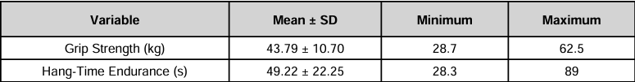

Table 1. Baseline grip strength and hang-time endurance values (mean ± standard deviation).

Grip strength
The mean grip strength values varied throughout the temperature conditions, with greater values recorded in the warm condition compared to the cold condition. The mean grip strength observed in the cold condition was 39.18 ± 10.49 kg, whereas the warm condition produced an increased mean value of 41.88 ± 10.64 kg.
The distribution of grip strength monitored in all conditions demonstrated a comparable range. In the cold intervention, grip strength values ranged from a minimum of 20.3 kg to a maximum of 56.7 kg. Comparably, the warm condition values extend from 24.6 to 60.8 kg. Indicating performance outcomes are more adaptive to warm conditions, with variability in participants remaining consistent across all trial conditions.
The median values supported the trend with a slightly elevated central tendency documented in the warmer condition. Majority of participants exhibited improved grip strength following the warmer exposure condition, whereas individual response varied with some participants distinguishing minimal effect across the conditions.
Figure 1 identifies the average mean grip strength values throughout the temperature conditions, outlining the increase in performance recording the warm condition relative to the cold condition.
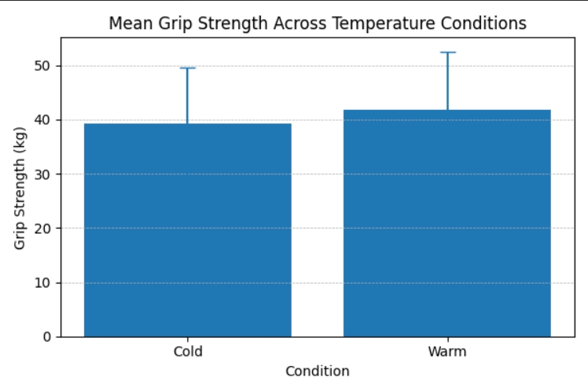
Figure 1. mean grip strength across both conditions, the error bars illustrate the standard deviation.

Hang time endurance
Mean hang time endurance values recorded in figure 2 were broadly equivalent across the two temperature conditions. The average duration recorded in the cold condition was 43.69 ± 24.03 seconds, in contrast the warm condition recorded 43.53 ± 24.60. In the cold condition, participants hang time values ranged from 7.36 seconds to 81.9 seconds. By comparison, the observed range for the warm condition (7.89-99.5 seconds) indicated a relatively large standard deviation, with substantial variability evident across both conditions.
In comparison to both performance outcomes, hang time endurance did not demonstrate a consistent directional trend between conditions. Examining the participants performance outcomes, the study revealed that some participants improved in the warm conditions, whereas others exhibited stronger endurance in the colder condition.

Figure 2 depicts the mean hang time endurance values for both conditions, demonstrating negligible variations between temperature conditions.
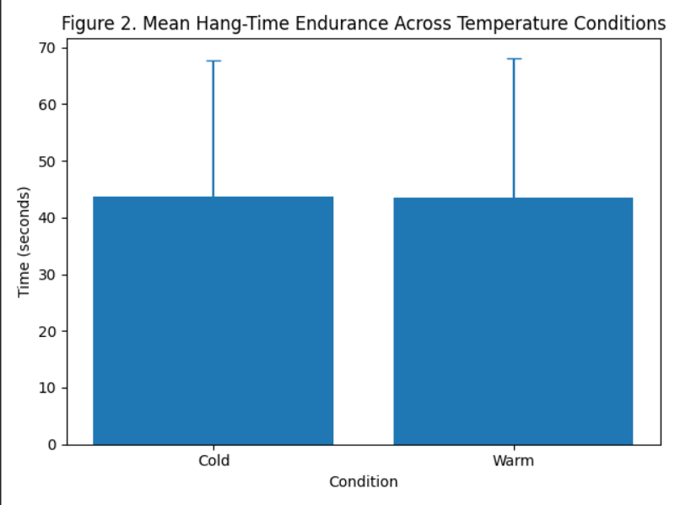

Performance variability
Measuring the performance outcomes, the findings indicated a degree of variability observed between participants. The standard deviation values were considerably elevated, particularly for hang time endurance (Cold: ±24.03 seconds; Warm: ±24.60 seconds) reflecting a wide spread of performance outcomes.
Grip strength variability among participants was relatively consistent with both conditions, however, its continued presence implies that individual differences influenced performance outcomes independent of temperature.
Summary of findings
In summary, the findings indicated that grip strength was higher in the warm when compared to the cold condition, proposing a potential effect of temperature on maximum force production. Conversely, when evaluating hang time endurance, participants exhibited marginal differences between conditions, with the findings uncovering a similar mean value in both temperature conditions.
Overall, the study determined that differing responses between performance measures, with grip strength illustrating a clear trend in the tested conditions, whilst hang time endurance remained relatively unaffected. The results demonstrated greater sensitivity to thermal changes in hang time endurance when comparing performance outcomes. Although, observed trends across participants were influenced by inter individual variability, the evidence suggests that temperature may exert an examinable but task specific effect on neuromuscular performance. The results collected from the study, facilitate a foundation for extensive analysis within the discussion, especially in relation to the physiological mechanisms governing strength and endurance adaptions.

Discussion
The aim of the study was to establish a stronger understanding into the acute effects of peripheral forearm and hand temperature modulation on grip strength and hang time endurance in recreational athletes. The primary findings determined that grip strength was greater in the warm condition compared to the cold condition, while hang time endurance facilitated marginal differences to across temperature conditions. The study observed substantial inter individual variability among participants which complicated the interpretation of performance measures.
The findings highlight that temperature can potentially influence maximal force production, whereas minimal development to isometric endurance performance. The influence signifies the task specific nature of temperature related physiological responses.

Effects of temperature on grip strength
The comparison with baseline values further enables the overall validity of the findings, as grip strength increased relatively to baseline following the warm intervention, whereas performance outcomes in the cold condition were slightly reduced or remained similar
Existing literature aligns with the observations conducted from the findings, the increase in grip strength following warm exposure demonstrates that increased muscle temperature can enhance neuromuscular performance (Racinais and Oksa, 2010; Bishop, 2003a). Force production in previous research has responded effectively when exposed to elevations to muscle temperature due to improvements to nerve conduction velocity, motor recruitment and cross bridge cycling efficiency (Gray et al., 2006; McGowan et al., 2015).
From a physiological perspective, increasing the muscle temperature in the forearm likely facilitates enhanced blood flow and oxygen delivery to the active musculature, mitigating internal resistance and authorising stronger contractile efficiency (Bergh and Ekblom, 1979). The relevancy for grip strength considering the reliance of rapid coordinated activation of the forearm flexor muscles.
Alternatively, the reduced grip strength in the cold condition can be expressed due to negative effects of cooling on neuromuscular performance. Cold exposure is widely documented to decrease in nerve conduction velocity, impair to muscle contractibility, which in turn leads to decreased force output, as demonstrated by numerous credible sources (Oksa, 2002; Bleakley et al., 2012). Additionally, increased muscle stiffness and reduced elasticity in colder conditions may further influence force production negatively (Peiffer et al., 2009).
Although the magnitude of the differences observed in in the present study were modest, the consistent trend indicating enhanced performance under warmer conditions was evident. The pattern suggests that environmental temperature performs a important role in influencing maximal strength outcomes. This relation aligns with relevant studies concluding that small increases in muscle temperature can produce meaningful improvements in acute high intensity tasks (Bishop, 2003b).

Effects of temperature on hang time endurance
In contrast, the findings demonstrated in hang time endurance exhibited minimal deviation from baseline values in both temperature conditions, therefore supporting the limited influence of temperature on isometric performance.
Unlike grip strength, hang time endurance did not exhibit any clear variation when assessing temperature conditions. Mean values were almost identical across both trial conditions and individual response varied considerably, suggesting that localised temperature modulation has the potential to negatively impact isometric endurance, within the context of the present research.
A plausible explanation for these findings is that endurance-based performance is predominately governed by circulatory and metabolic processes rather than acute fluctuations in muscle temperature. Hang time endurance relies upon sustained isometric contraction, which is all dependent on energy substrate availability, oxygen delivery and fatigue resistance rather than maximal neuromuscular output. (Fryer et al., 2015).
Although extensive research suggests that cooling interventions impair strength and power, some studies have demonstrated strong evidence that reduced metabolic demand can assist fatigue resistance during prolonged activity (Vaile et al., 2008; Stanley et al., 2010). This corresponds to why no observation was indicated during the cold condition, despite the known negative effects of cooling on muscle function

While warming may improve contractile properties, the impact on endurance performance can be considered less pronounced. Elevating temperatures has established to increase metabolic rate, therefore potentially accelerating fatigue when subjected to sustained efforts (Febbraio et al., 1996). The prevailing ideological framework may attenuate or counteract any enhancements in neuromuscular function, resulting in minimal overall differences across the conditions.

Practical application
The findings collected from the study have several practical implications in relation to athlete and practitioners. The observed elevation in grip strength following warm exposure provides an insight into effective warming strategies that can be beneficial for task dependant activities that require maximal grip force, such as climbers and resistance-based training.
In contrast, the inconsistencies in findings regarding time to exhaustion indicates that temperature modulation is likely to exert marginal effect on endurance-based grip performance. The implantation of temperature-based interventions should be systematically aligned with the specific biomechanical and physiological demands the performed activity.
The variability observed between participants illustrated the significance of adopting individualised approaches to performance optimisation, considering responses in individuals can vary.
Building on these considerations, a broader interpretation of the study’s findings necessitates examination of the extent to which central and peripheral fatigue mechanisms may underpin the potential observed performance outcomes. Warming interventions may have elevated peripheral muscle function and central fatigue factors; the intervention might have also influenced overall performance capability.
The interaction between temperature and perception of effort might relate to factors enabling overall performance. The participants varied experience in perceived exertion across conditions may have contributed to different performance outcomes independent of physiological modifications. This aspect illustrates the multifactorial nature of performance, suggesting that both physiological and psychological components are required when interpreting temperature-based interventions. Overall, the findings are evident in reinforcing the importance of adopting a holistic approach when evaluating performance outcomes, while acknowledging that temperature modulation isn’t the only variable influencing neuromuscular function.

Strengths
The study exhibited several notable methodological strengths. The implementing of a repeated measures design enabled participants to serve as their own controls, thus substantially reducing inter individual variability. The approach was significant to the study’s internal validity, reliability and the overall accuracy of the findings by minimising the influence of confounding participant specific factors (Atkinson and Nevill, 1998). The randomisation of the trial order also enabled internal validity by decreasing potential order effect. The overall influence of external variables was minimised, considering all assessments were conducted in a controlled laboratory setting to ensure reliability throughout.
Furthermore, utilising a within subject experimental design increases the statistical power by mitigating varying factors and enhancing sensitivity detection across the performance conditions (Batterham and Hopkins, 2006). The results provide significance to exercise physiology, while strengthening the interpretability of the observed effects of temperature conditions. Additionally, the implementation of standardised testing procedures contributed to the reliability of the data collection process. Measurement validly was upheld considering the use of consistent protocols, environments and identical immersion duration (Currell and Jeukendrup, 2008).
With the study assessing participants in a controlled laboratory environment across all experimental interventions provided a precise regulation of ambient temperature and humidity, decreasing the potential influence of external Environmental stressors on physiological responses. Collectively the methodological considerations reinforce the validity and reliability of the study, while contributing to the existing body of exercise physiology literature.

Limitations
Despite the studies relevant strengths, multiple limitations should be acknowledged. The study contained a relatively small sample size which limited the generalisability of the findings. While the study utilised a repeated measures design to mitigate inter-individual variability, a larger sample size would provide beneficial statistical power, enhancing the overall validity of the study’s outcomes.
Additionally, all trials were conducted on the same day, therefore the findings may be potentially influenced due to fatigue or insufficient recovery between conditions. Existing research has emphasised that neuromuscular performance is highly sensitive to accumulated fatigue. Consequently, repeated testing conducted in short duration may have compromised participants ability to perform effectively across the conditions
The absence of neutral baseline condition represents a methodological limitation undermines the internal validity of the study, as it restricts the ability to confidently isolate the effects of temperature modulation. In accordance with the findings, variability in individual responses may have contributed to heterogeneity within the overall results. Differences in physiological characteristics, background, training and thermal sensitivity may have contributed to participants responded to both temperature interventions.
Additionally, with the study only examining recreationally active participants, the findings are limiting the applicability to other populations such as elite athletes who exhibit varying physiological adaptions to temperature manipulation.
Finally, the study overlooked the potential influence of long-term adaptions by only investigating acute temperature effects. The relatively short-term exposure to temperature modulation might have potentially limited the observed physiological change, highlighting that alternative protocols are likely to produce divergent outcomes.

Future research
For the future, research should seek to incorporate substantially larger sample sizes with particular emphasis on participant characteristics, including demographic variables, training status and overall performance level. By enhancing generalisability and ecological validity, new research should dedicate the inclusion of elite athletes to provide valuable insight into how temperature modulation influences performance outcomes in highly trained athletic population.
Furthermore, it is recommended that future research systematically investigate the varying effects in alternative durations and intensities of temperature exposure to elucidate the mechanisms shaping optimal intervention strategies. Investigating longer duration exposure interventions may enable a more comprehensive understanding of both acute and chronic adaptions to temperature manipulation. Implementing a neutral condition in future research will increase comparative analysis and strengthen the overall ability to isolate the effects of warming and cooling interventions. Further literature should investigate the relevancy into personalised responses and individual variability in relation to temperature modulation, therefore supporting the development of specified performance strategies within applied sport settings.

Summary of the discussion
In summary, the findings suggest that peripheral temperature warming may enhance grip strength, whereas temperature modulation exhibits minimal influence on hang time endurance. The findings establish that the importance of task specificity and individual variability when considering temperature-based performance strategies

Conclusion
The present study aimed to investigate the acute effects of peripheral forearm and hand temperature modulation on grip strength and hang time endurance in recreational athletes. The findings provided compelling evidence that localised temperature manipulation exerts specific influence on performance outcomes. Particularly, the application of warming protocols was associated with a measurable advancement to grip strength, suggesting a facilitative effect on force production capabilities. While hang time endurance intervention appeared largely insensitive to variations in temperature, indicating that neuromuscular function does not responds uniformly to thermal interventions.
The observed improvement to grip strength under warm conditions reinforces the well-established relationship between increased muscle temperature and strengthened neuromuscular function. Existing literature has demonstrated that elevation to muscle temperatures has been shown to facilitate neuromuscular performance through several physiological mechanisms, including enhanced contractile efficiency, increased nerve conduction velocity and heightened enzymatic activity (Bishop, 2003a; Racinais and Oksa, 2010).Collectively, these adaptions contribute to optimised capacity for force production and remain relevant in performance tasks requiring maximal voluntary contraction, such as grip strength assessments.
Conversely, the modest effect of temperature on hang time endurance indicates that isometric endurance performance is like governed by more complex physiological processes. In comparison to maximal strength, endurance-based task relies heavily on fatigue resistance, metabolic efficiency and circulatory factors, all attributes that may exhibit minor influence on acute changes in local muscle temperature. The findings contribute the importance of distinguishing different types of neuromuscular performance when analysing the significance of temperature-based interventions.
Additionally, the variability observed between participants demonstrates that responses to temperature modulation have the potential to influence individual physiological characteristics, including muscle fibre composition, thermal sensitivity and training background. The study reinforces the demand for a more individualised approach when applying temperature-based methods in a practical setting. From a applied perspective, the findings revealed that specified warming strategies can potentially benefit performance-based tasks that require effective maximal grip strength, such as climbing or resistance-based training. However, interpreting the findings in relation to temperature manipulation on hang time endurance may provide limited practical value to optimising endurance-based grip performance.
In conclusion, the study contributes to the field of exercise physiology by delivering further insight into the acute effects of localised temperature modulation on neuromuscular performance. The findings additionally reinforce a deeper understanding into muscle temperature analysis and the significance the role plays in influencing maximal force production. Alternatively, the study established limited impact on endurance-based task. The research extends to the growing body of literature emphasising complexity of neuromuscular adaption, by demonstrating task specific and individualised nature of temperature related performance responses. Overall, the findings support the continued investigation of targeted temperature-based interventions within both experimental and applied sport environments, while enhancing the efficiency of evidence-based performance strategies.

Word count: 6205

Reference list
Atkinson, G. and Nevill, A.M. (1998). Statistical methods for assessing measurement error (reliability) in variables relevant to sports medicine. Sports Medicine, 26(4), pp.217–238.
Batterham, A.M. and Hopkins, W.G. (2006)
‘Making meaningful inferences about magnitudes’, International Journal of Sports Physiology and Performance, 1(1), pp. 50–57.
Bergh, U. and Ekblom, B. (1979). Influence of muscle temperature on maximal muscle strength and power output. Acta Physiologica Scandinavica, 107(1), pp.33–37.
Bishop, D. (2003a). Warm up I: Potential mechanisms and the effects of passive warm up on exercise performance. Sports Medicine, 33(6), pp.439–454.
Bishop, D. (2003b). Warm up II: Performance changes following active warm up and how to structure the warm up. Sports Medicine, 33(7), pp.483–498.
Bleakley, C.M., Davison, G.W. and Whatman, C. (2012). The use of ice in the treatment of acute soft-tissue injury: A systematic review of randomised controlled trials. American Journal of Sports Medicine, 40(3), pp.735–741.
Bohannon, R.W. (2001). Dynamometer measurements of hand-grip strength predict multiple outcomes. Perceptual and Motor Skills, 93(2), pp.323–328.
British Educational Research Association (2018). Ethical Guidelines for Educational Research. 4th edn. London: BERA.
Cheng, A.J., Willis, S.J., Zinner, C., Chaabene, H. and McKenna, M.J. (2014). Acute local cooling has limited effects on skeletal muscle contractile function. Journal of Applied Physiology, 117(11), pp.1232–1240.
Costello, J.T. and Donnelly, A.E. (2010). Effects of cold water immersion on neuromuscular performance in healthy populations. Sports Medicine, 40(2), pp.147–166.
Davies, C.T.M. and Young, K. (1983). Effect of temperature on the contractile properties and muscle power of triceps surae in humans. Journal of Applied Physiology, 55(1), pp.191–195.
España-Romero, V., Ortega, F.B., Vicente-Rodríguez, G., Artero, E.G., Rey, J.P. and Ruiz, J.R. (2009). Elbow position affects handgrip strength in adolescents. Journal of Hand Surgery, 34(2), pp.259–264.
Febbraio, M.A., Snow, R.J., Stathis, C.G., Hargreaves, M. and Carey, M.F. (1996). Effect of heat stress on muscle energy metabolism during exercise. Journal of Applied Physiology, 81(2), pp.563–570.
Field, A. (2018). Discovering Statistics Using IBM SPSS Statistics. 5th edn. London: Sage.
Fischer, J., Van den Tillaar, R. and Ettema, G. (2009). The effect of cold exposure on muscle function. European Journal of Applied Physiology, 107(4), pp.465–472.
Fradkin, A.J., Zazryn, T.R. and Smoliga, J.M. (2010). Effects of warming-up on physical performance: A systematic review. Journal of Strength and Conditioning Research, 24(1), pp.140–148.
Fryer, S., Dickson, T., Draper, N., Eltom, M., Stoner, L. and Blackwell, G. (2015). The effect of acute fatigue on forearm muscle oxygenation and climbing performance. European Journal of Applied Physiology, 115(12), pp.2503–2513.
Gray, S.R., De Vito, G., Nimmo, M.A., Farina, D. and Ferguson, R.A. (2006). Skeletal muscle ATP turnover and muscle fibre conduction velocity are elevated at higher muscle temperatures. Journal of Applied Physiology, 102(3), pp.1063–1069.
Hohenauer, E., Taeymans, J., Baeyens, J.P., Clarys, P. and Clijsen, R. (2015). The effect of post-exercise cryotherapy on recovery characteristics. PLoS ONE, 10(9), e0139028.
Hopkins, W.G. (2000). Measures of reliability in sports medicine and science. Sports Medicine, 30(1), pp.1–15.
Kenney, W.L., Wilmore, J.H. and Costill, D.L. (2020). Physiology of Sport and Exercise. 7th edn. Champaign: Human Kinetics.
Kilduff, L.P., Finn, C.V., Baker, J.S., Cook, C.J. and West, D.J. (2013). Preconditioning strategies to enhance physical performance on the day of competition. International Journal of Sports Physiology and Performance, 8(6), pp.677–681.
McGowan, C.J., Pyne, D.B., Thompson, K.G. and Rattray, B. (2015). Warm-up strategies for sport and exercise. Sports Medicine, 45(11), pp.1523–1546.
Nybo, L., Rasmussen, P. and Sawka, M.N. (2014). Performance in the heat—physiological factors of importance for hyperthermia-induced fatigue. Comprehensive Physiology, 4(2), pp.657–689.
Oksa, J. (2002). Neuromuscular performance limitations in cold. International Journal of Circumpolar Health, 61(2), pp.154–162.
Peiffer, J.J., Abbiss, C.R., Watson, G. and Laursen, P.B. (2009). Effect of cold-water immersion duration on body temperature and muscle function. Journal of Sports Sciences, 27(10), pp.987–993.
Racinais, S. and Oksa, J. (2010). Temperature and neuromuscular function. Scandinavian Journal of Medicine & Science in Sports, 20(Suppl. 3), pp.1–18.
Rall, J.A. and Woledge, R.C. (1990) ‘Influence of temperature on muscle contraction’, American Journal of Physiology, 259(3), pp. R197–R203.
Silva, L.M., Neiva, H.P., Marques, M.C., Izquierdo, M. and Marinho, D.A. (2018). Effects of warm-up, post-warm-up, and re-warm-up strategies on explosive efforts. Sports Medicine, 48(10), pp.2285–2299.
Stanley, J., Peake, J.M. and Buchheit, M. (2010). Cardiac parasympathetic reactivation following exercise. Sports Medicine, 43(12), pp.1259–1277.
Thomas, J.R., Nelson, J.K. and Silverman, S.J. (2015). Research Methods in Physical Activity. 7th edn. Champaign: Human Kinetics.
Vaile, J., Halson, S., Gill, N. and Dawson, B. (2008). Effect of cold-water immersion on repeat cycling performance. Journal of Sports Sciences, 26(5), pp.431–440.
West, D.J., Dietzig, B.M., Bracken, R.M., Cunningham, D.J. and Cook, C.J. (2013). Influence of post-warm-up recovery time. Journal of Strength and Conditioning Research, 27(7), pp.1800–1805.
Wind, A.E., Takken, T., Helders, P.J.M. and Engelbert, R.H.H. (2010). Is grip strength a predictor for total muscle strength? Journal of Strength and Conditioning Research, 24(5), pp.1308–1314.
Appendices

Appendix A: Raw data
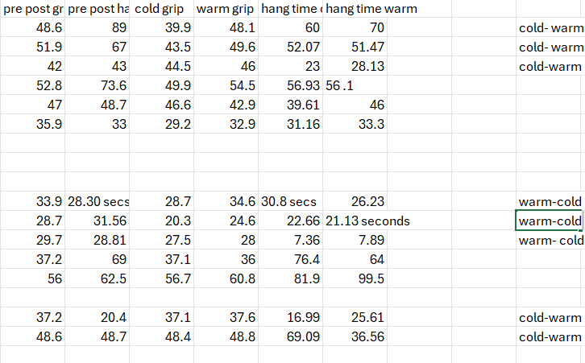

Appendix B: PAR-Q
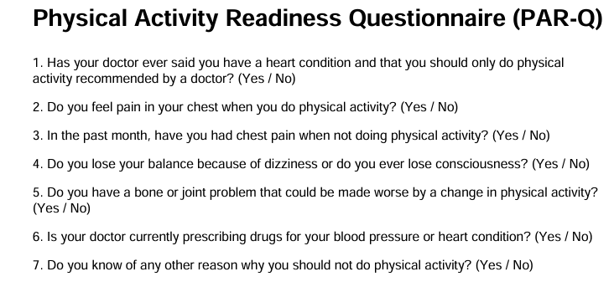

Appendix C: Participant consent forms
University of Wales Trinity Saint David
Programme: Exercise and Sport Science
Study Title: The Influence of Peripheral Temperature Modulation on Grip Strength and Hang-Time Endurance in Recreational Athletes
Principal Researcher: Kristopher John Llewellyn Jones
Student Number: 2317159
Supervisor: Geraint Forster
Please read each statement carefully and tick the box if you agree.
☐ I confirm that I have read and understood the Participant Information Sheet provided for this study.
☐ I understand the purpose of the study and what my participation involves.
☐ I understand that my participation is voluntary and that I am free to withdraw from the study at any time without giving a reason.
☐ I understand that I may stop the testing procedure at any point if I feel uncomfortable.
☐ I understand that the study involves forearm and hand immersion in water at different temperatures followed by grip strength and hang-time testing.
☐ I understand that any data collected will remain confidential and will be used only for academic research purposes.
☐ I understand that my personal data will be stored securely in accordance with GDPR and UWTSD Research Data Management Policy.
☐ I agree to take part in this research study.
Participant Details
Participant Name: __________________________________________
Age: _______________________________________________________
Signature: _________________________________________________
Date: ______________________________________________________

