DATE: 22.08.2024
Reflective report of Academic
Skills Through Learning
- Note-taking
- Information/research skills
- Summarising skills

Module Name: ACADEMIC SKILLS
Module Code: LCLM 4001
Student’s Name: VECIUNCA IONELA
Student’s ID: 2321294
Group: 1

Lecturer’s Name: TIM HOPKINS

University of Wales Trinity Saint David (London Campus)

Contents
INTRODUCTION. 2
REFLECTION TOPICS. 2
Note-taking 2
Information/research skills 2
Summarising skills. 2
CONCLUSION. 4
References. 5
APPENDICES. 6
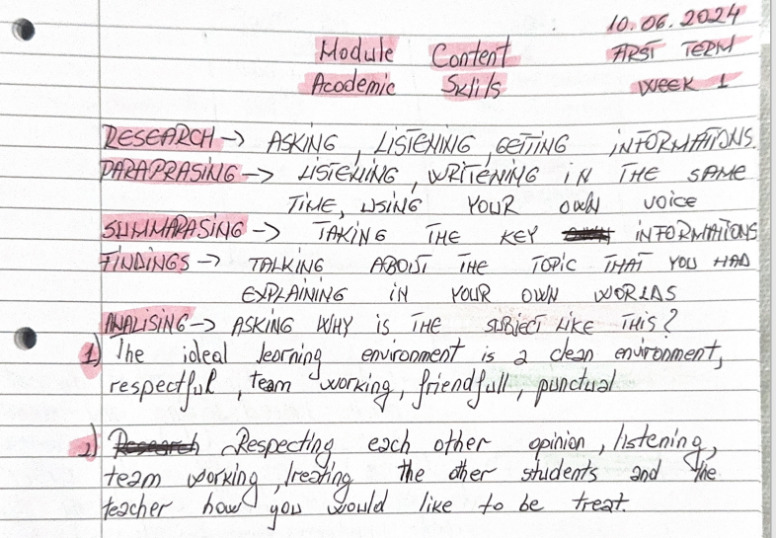 7

INTRODUCTION
Reflective practice is a key part of personal and professional growth, allowing individuals to learn from their experiences and apply that learning in future situations. This report uses Gibb’s Reflective Cycle (1988) to evaluate how this learning module helped me develop three essential academic skills: notetaking, information/research skills, and summarising skills. Gibb’s Reflective Cycle provides a structured way to reflect by guiding through the stages of description, feelings, evaluation, analysis, conclusion, and action plan.

REFLECTION TOPICS

Note-taking

Information/research skills

Summarising skills.

- Note-taking:
One of the most significant skills I worked on was note-taking. Initially, I followed the traditional method of writing down everything I thought was important during lectures and readings. However, this approach left me with overwhelming and disorganised notes that were difficult to use for revision. I felt anxious about missing key points and frustrated when my detailed notes wasted time.
Through this module, I adopted structured methods like the Cornell Note-Taking System, which helped me focus on the key points and organise my notes effectively (University of Leeds, 2020). This change made my notes easier to review and improved my confidence. I now use my notes more efficiently during study sessions and for revision, though I sometimes still fall back into the habit of overloading them with information.

- Information/Research Skills:
Before this course, my research skills were limited. I often relied on quick online searches through Google and Wikipedia, which, while useful for general information, were not reliable academic sources. At first, I felt confident in my ability to find information, but I soon realised that my approach was inadequate. This made me feel discouraged and pushed me to adopt better research strategies.
The module introduced me to academic databases like JSTOR, PubMed, and Google Scholar, where I learned to use Boolean operators and filters to narrow down my search results (Pears & Shields, 2019). I also learned how to evaluate the credibility and relevance of sources. These new skills greatly improved the quality of my research and strengthened my ability to support my arguments with reliable evidence.
- Summarising Skills:
Summarising was another challenging area for me. Initially, I struggled to condense large amounts of information into concise summaries. My early attempts often included too many unnecessary details or paraphrased content without fully understanding the material. This led to frustration and feelings of inadequacy.
Through practice, I learned to identify the main ideas and key points of a text. This not only improved my ability to summarise effectively but also enhanced my note-taking and overall comprehension during lectures. While I still face challenges with particularly complex materials, my summarising skills have improved significantly, helping me in academic writing and research.
Evaluation:
The development of these skills was both challenging and rewarding. For notetaking, learning a structured method made my study process more effective and saved time. Improved research skills allowed me to access better-quality sources and strengthened my academic work. Summarising skills helped me focus on key ideas, improving both my writing and my understanding of material.
Despite these improvements, there are areas where I still struggle. I occasionally revert to my old habits of taking overly detailed notes, and I need to refine my ability to locate the best academic sources. Additionally, I still find it difficult to summarise particularly complex materials, which shows that there is room for growth.

CONCLUSION.

Reflecting on the development of this academic skills, the learning from this module has had a big impact on my approach to studying and research. The structured note-taking methods have made my study sessions more efficient, while the researching skills improved the credibility and helped me to make easiest my academic work. The ability to summarise efficiently has not only improved my writing, but also made me understand better the materials presented. However, there is still room for improvement. While my notetaking has become more efficiently, I occasionally coming back to my old way, overloading my notes with a lot of information. The same situation it is with my research skills, while they improved, I need to continue finding my ability to search sources. Summarising, became improved, but still I’m getting challenges when I must discuss with some particularly complex materials. Moving forward, I am planning to continue developing these skills by setting specific aims and asking further for feedback. For notetaking, I will aim to review and research my notes shortly after each lecture, to make sure that they remain focused on key points. I will also try to experiment with digital note-taking tools like OneNote to see if they will help me to improve my note-taking skills. In terms of academic skills, I am planning to engage myself with the academic community by reading more journals regularly and attending workshops on advanced research techniques. This engagement will help me to in touch with the latest news and developments in research methodologies and improve my ability to identify the credible sources.
For summarising skills, I will continue practicing by summarise books, chapters outside of the assignment sessions. This practice will help me to identify the most important elements, and to recognize the key points of the ideas.

References

Cottrell, S., 2019. The Study Skills Handbook. 5th ed. Bloomsbury: Red Globe Press.
G, G., 1988. Learning by Doing, oxford: further education unit.
Gibbs, G., 1988. Learniung by Doing: A Guide to Teaching and Learning Methods. Oxford: Further Education Unit.
Pears, R. & Shields, G., 2019. Cite Them Right the essential referencing guide. 11 ed. Bloomsbury: Macmilan Study Skills.
University of Leeds, 2020. Effective Note-Making. Leeds, https://library.leeds.ac.uk/info/14011/writing/110/essay_and_disseration_planning/3.

APPENDICES.


