5/4/2021
A research report on Data Centre Virtualization -Task B Module code ACUA6001_DCV
BSc (Hons)Cloud Computing
Aleksandar Ivanov Andonov
UWTSD Student number 1813107
Table of contents
I. Scenario 1……………………………………………………………………..………….…2
Abstract………………………………………………………………………………………….2
1.Introduction………………………………………………………………………………...3
2.Virtualization…………………………………………………………………………….…3
3. How dose Virtualization work?.....................................................4
4.Hypervisor…………………………………………………………………………………..5
5.Types of Hypervisor………………………………………………………………….….6
- Type 1 hypervisor………………………………………………………………………..6
- Type 2 hypervisor………………………………………………………………………..7
6.Types of Virtualization…………………………………….…………………………..8
- Desktop virtualization………………………………………………………………..…8
- Network virtualization………………………………………………………………….8
- Storage virtualization…………………………………………………………………...8
- Data virtualization………………………………………………………………………..8
- Application virtualization……………………………………………………………..9
- Data centre virtualization………………………………………………………..……9
7.Implementation of Data Centre Virtualization………………………..…...9
8. Results/Benefits of Virtualization…………………………………………...…10
9. Disadvantages of Virtualization……………………………………….……..….11
10. Challenge to build Data Centre…………………………………………………12
11.Amazon Web Server (AWS)…………………………………………………..….13
12.Why Amazon Web Server is a good solution?.............................14
II. Scenario 2………………………………………………………………………….……..14
1. Data centre security…………………………………………………………….…...14
1.1Physical security……………………………………………………..…………………. 15
1.2 Software security………………………………………………………………………. 15
2.Storage Area Network……………………………………………………...………..16
3. Disaster Recovery……………………………………………………………………...17
3.1 Recovery Point Objective………………………………….………………………..17
3.2 Recovery Time Objective………………………….………………………………..17
4.Disaster Recovery as a service (DRaaS)………….……………………….….17
5.Disaster recovery sites…………………………………………………………….…17
III. Conclusion………………………………………………………………………….……18
References……………………………………………………………….19

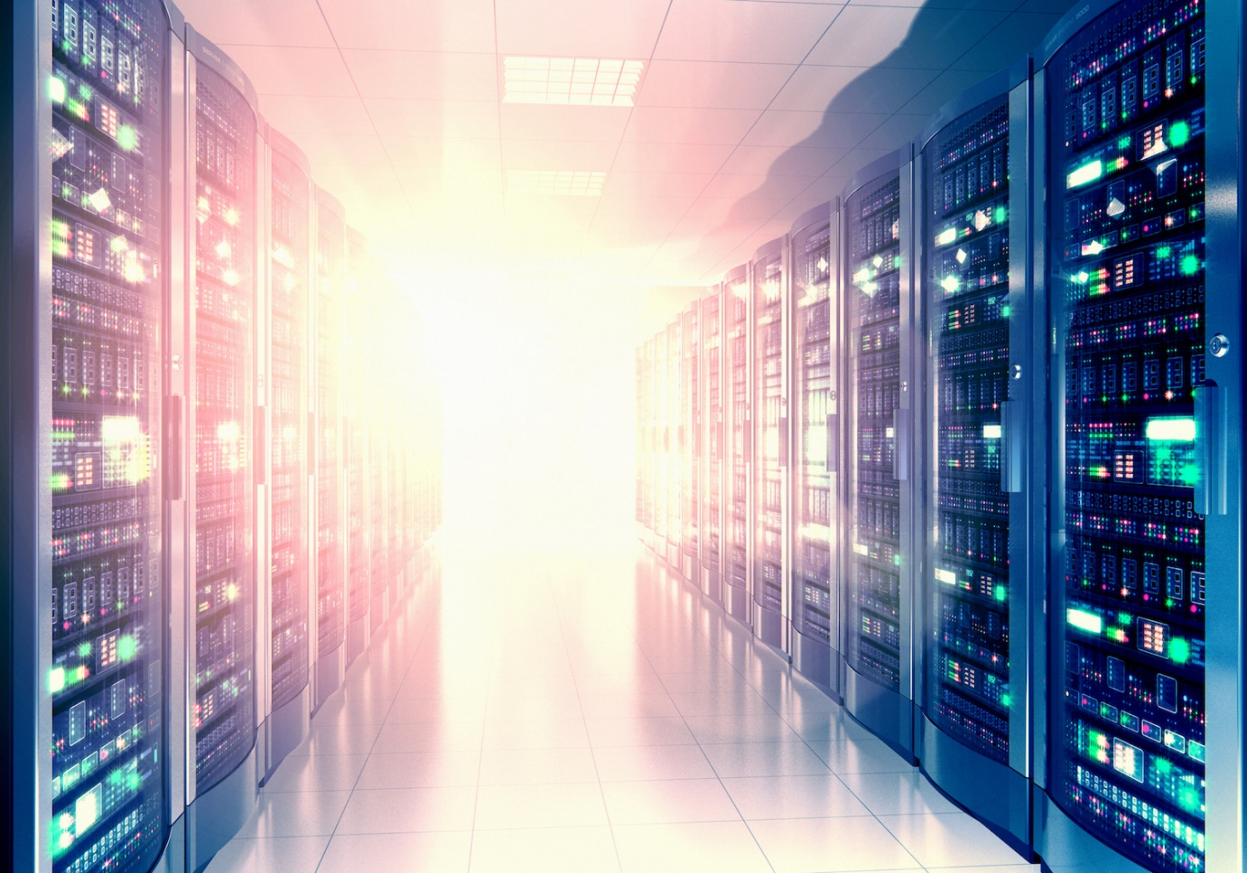
Data centre virtualization [1]

I. Scenario 1
Abstract
The problems which the business has today require near-real-time data access. Traditional data architecture, particularly when it comes to big data, does not meet modern business needs. Fortunately, data virtualization has developed to assist in the resolution of complex data centre performance, cost, and access issues. Companies are searching for ways to simplify and get the most out of data as it becomes one of the most valuable assets in industry. The task is difficult, and companies must handle an ever-increasing amount of data. The solution for this problem is Virtualization.[1]

1. Introduction
Virtualization has a long history, dating back to IBM's research and development in the 1960s and 1970s. It has developed from an inaccessible technology to a building block for modern IT infrastructure over nearly 50 years. With the building of data centres, a solution to the emerging issue of organisations needing a place to store a large amount of data is found.

In recent years, virtualization has become a vital subject of the IT world. Hundreds of thousands of businesses use virtualization technology to consolidate workloads and make their IT environments more scalable and efficient.[2]
2. Virtualization
Virtualization is a software technique for dividing a physical resource, such as a server, into virtual resources known as virtual machines (VMs). Users may use virtualization to consolidate physical resources, simplify deployment and maintenance, and save money on heating and cooling.[3]
Virtualization is one of the most rapidly evolving IT phenomena. This is a phase in which actual hardware, operating systems, platforms, and servers are replaced with virtual ones, allowing you to make better use of the available resources. [4],[31]
It is a technique that uses software to construct an abstraction layer over computer hardware that enables a single computer's hardware elements—processors, memory, storage, and other components—to be separated into several virtual computers, or virtual machines (VMs). We can see the concept of virtualization on fig.1. Even though it is only running on a portion of the actual underlying computer hardware, each VM runs its own operating system (OS) and acts like an individual computer.[5]

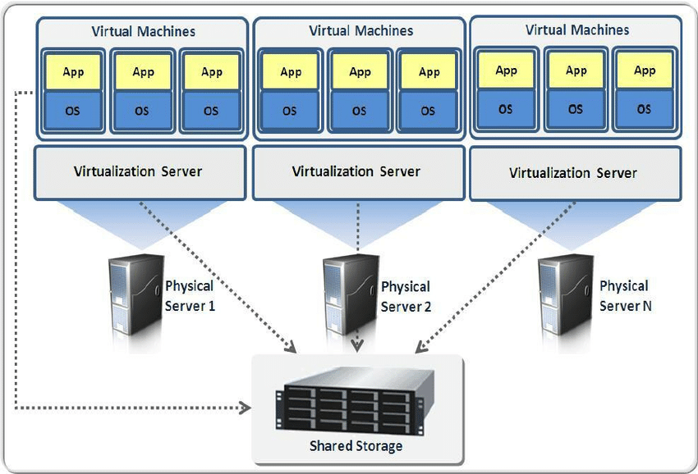

Figure 1. Concept of Virtualization [6]

3. How dose Virtualization work?

Virtualization is a technology that abstracts an application, guest operating system (guest OS), or data storage from the underlying hardware or software. Server virtualization, which uses a software layer called a hypervisor to simulate the underlying hardware, is a popular application of virtualization technology. Memory, input/output (I/O), and network traffic are often included. [7]
Virtualization separates an application, a guest operating system, or data storage from the underlying software or hardware. A hypervisor is a thin software layer that replicates the functions and actions of the underlying hardware for the abstracted hardware or software, resulting in multiple virtual machines (VM) on a single physical system. While the performance of these virtual machines may not be on par with that of true hardware-based operating systems, it is more than adequate for most systems and applications.[8]
In a virtual world, the virtual machine exists in on the host machine. It functions as if it were a single piece of hardware, like a server or device. All is routed into a hypervisor, which is in charge of managing requests to the physical computer. The hypervisor receives data from the hardware and relays it to the VM.
The VM will be housed on the host computer. It provides the computing power needed for virtual machines to operate by running virtualization software, which includes CPU, RAM, storage, and networking.[9]

4. Hypervisor

Hypervisor software separates physical resources from virtual worlds, or the items that need such resources. Hypervisors can run on top of an operating system (as on a laptop) or be fitted directly on hardware (as on a server), as most businesses do. Hypervisors break up the physical resources so that virtual environments can access them. From the physical world to the many virtual worlds, resources are partitioned as required. Inside the virtual world, users communicate with it and run computations (typically called a guest machine or virtual machine). The virtual machine is a single data file that runs. And, like any other digital file, it can be transferred from one device to another, opened in each, and expected to work correctly. [10]

Application

Operating System
Application
Operating System

hypervisor

Figure 2. Virtualization insertion hypervisor

The hypervisor is the application that ties everything together. Inside the host computer, it builds and manages virtual worlds. The hypervisor manages and allocates the resources that each operating system should have so that each VM can run smoothly without interfering with other processes.[9] Simple example on fig.2.
The hypervisor, also known as a virtual machine monitor (VMM), is in charge of managing these virtual machines as they coexist. It logically divides VMs by allocating each one its own slice of the underlying computing capacity, memory, and storage. This prevents the VMs from interfering with one another, because if one OS crashes or has a security breach, the others are unaffected. [11]

5. Types of Hypervisor

There are two main categories hypervisors: Type 1 and Type 2
- Type 1 hypervisor(fig.3) - A Type 1 hypervisor operates on the physical hardware of the underlying machine, communicating directly with the CPU, memory, and physical storage. As a result, Type 1 hypervisors are also known as bare-metal hypervisors. The host operating system is replaced by a Type 1 hypervisor.
- Since they have direct access to physical hardware, Type 1 hypervisors are very powerful. This also improves their reliability since there is little in the way of a hacker gaining access to the CPU.
- To administer various VMs and control the host hardware, a Type 1 hypervisor often requires a separate management computer.[11]

Examples for Type 1 Hypervisor software options are: VMware vSphere/ESXi , Microsoft Hyper-V , Citrix XenServer , Oracle VM , Red Hat Enterprise Virtualization(RHEV), Open source hypervisor KVM(Kernel-Based Virtual Machine).
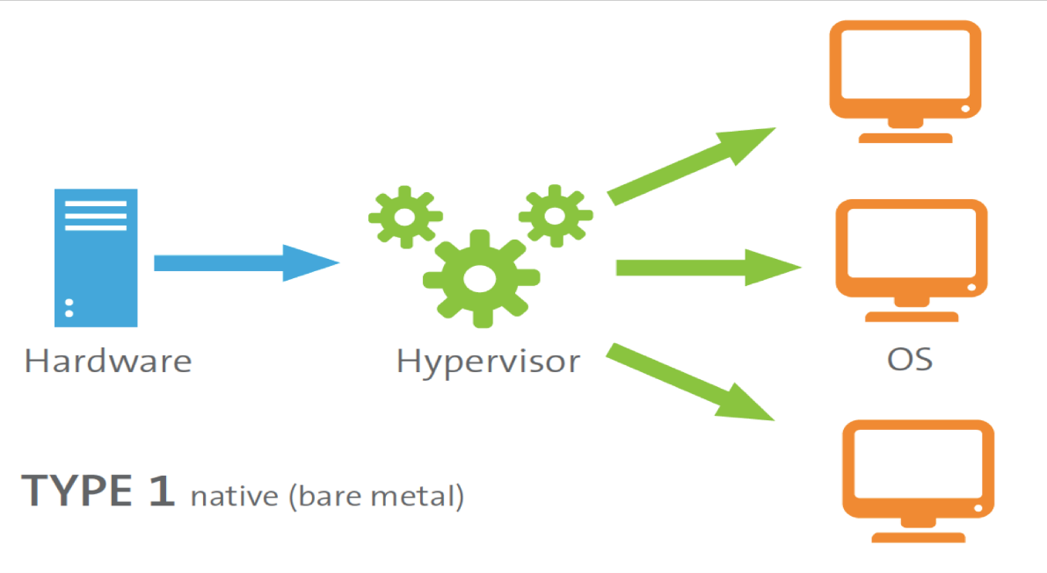
Figure 3. Type 1 hypervisor [12]

- Type 2 hypervisor(fig.4) - A Type 2 hypervisor does not run on the physical hardware. Instead, it runs like a programme on a computer's operating system. In server-based environments, Type 2 hypervisors are uncommon. Rather, they're designed for single-user PCs that need to run multiple operating systems. Type 2 is used by Engineers, security professionals analysing malware, and business users that need access to applications that are only accessible on other software platforms.
- In addition to the primary guest OS running on the host machine, a Type 2 hypervisor allows fast and easy access to an alternate guest OS. It's perfect for end-user productivity because of this.
- A Type 2 hypervisor must access computing, memory, and network resources via the host OS, which has primary access to the physical machine. This introduces latency issues, affecting performance. It also introduces potential security risks if an attacker compromises the host OS because they could then manipulate any guest OS running in the Type 2 hypervisor. [11]

Examples for Type 2 Hypervisor software options are: VMware Fusion, VMware Workstation, VMware Server, Microsoft Virtual PC , Oracle VM VirtualBox and Red Hat Enterprise Virtualization(RHEV) - it has abilities of both a hosted and a bare-metal virtualization hypervisor.
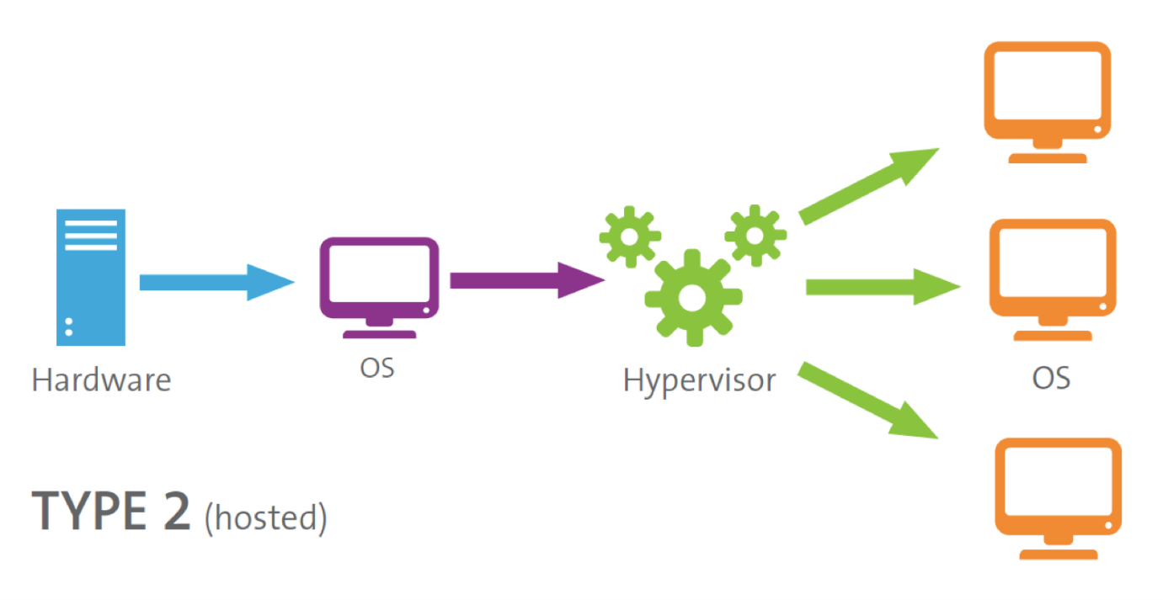

Figure 4. Type 2 hypervisor [12]

6. Types of Virtualization
Virtualization was originally intended mainly for server virtualization. However, the method's popularity has aided its expansion and growth to include networks, software, data, desktops, and storage. In this context there are many different types of virtualization.
- Desktop virtualization
There are two types of desktop virtualization:
- Virtual desktop infrastructure (VDI) runs multiple desktops in virtual machines (VMs) on a central server and streams them to thin client computers. In this way, VDI enables an enterprise to provide its users with access to a range of operating systems from any computer, without the need to instal operating systems on such devices.
- Local desktop virtualization instals a hypervisor on a local computer, allowing the user to run one or more additional operating systems on that computer and switch between them as required without affecting the primary OS.
- Network virtualization
Network virtualization employs software to build a “view” of the network that allows an administrator to access the network from a single console. It abstracts hardware elements and functions (for example, links, switches, and routers) into software that runs on a hypervisor. The network administrator can change and monitor these elements without having to touch the underlying physical components, making network management much easier.
- Storage virtualization
Storage virtualization allows all storage devices on a network to be accessed and operated as a single storage device, regardless of whether they're placed on individual servers or stand-alone storage units. Storage virtualization, in particular, consolidates all storage blocks into a single shared pool from which they can be allocated to any VM on the network as required.
- Data virtualization
Data from various applications is stored in multiple locations, ranging from the cloud to on-premises hardware and software systems, using multiple file formats. Any application can access all of the data-thanks to-data virtualization, regardless of its source, format, or location.
- Application virtualization
Application virtualization allows users to run applications without having to instal it on their operating system. Only the programme operates in a virtual environment; the operating system on the end user's computer continues to function normally.
- Data centre virtualization
Virtualization of data centres abstracts the majority of a data centre’s hardware into software, allowing an administrator to split a single physical data centre into several virtual data centres for various clients.[13]

7. Implementation of Data Centre Virtualization
We need a lot of software to handle the overall infrastructure of an enterprise like an IT corporation, whose assets are spread around the country and abroad, and we'll also need IT management, manpower, and energy to manage them.
These standards would usually increase costs and take a long time to enforce, affecting company turnover. Virtualization is being implemented to reduce business costs and allow the best use of time and resources. The cost of investing in the operations and maintenance of the workforce would be reduced by replacing physical servers with virtual machines. Furthermore, the most significant benefit is that it is very simple and fast to instal virtual machines to meet other business requirements, saving time and energy in the process, as well as in the management and cooling of these servers.
When we order and pay for a product, all payment and delivery information is saved in a format that the programme understands, and it is presented to the end user in a format that the consumer understands. The database Virtualization method accomplishes this. [14]
The data centre is most often used to refer to the interconnection of computing devices (servers) within data centres, or between servers and client devices (outside data centres and in user workstations or handhelds).
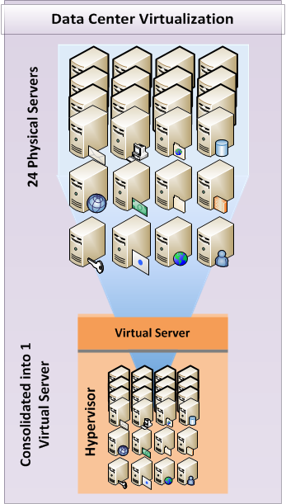

Figure 5. Data centre virtualization [15]

8. Results/Benefits of Virtualization

- Reduces the number of physical servers needed on the company's sites - It is always a good idea to conserve space, regardless of the size of the business.[16]
- Data Security - In the case of a data loss or other significant device failure, the virtualization process makes it simple to restore virtual machines by transferring them to another cloud system that is identical.
- Electricity - Since there are fewer physical servers to consume electricity, energy usage is reduced.[16]
- We are able to do more with less - If one of the servers becomes overloaded when the network is running, we can easily generate a virtual machine of the server and build a new server that will function in the same way as the original one.[16]
- Support for guest operating systems - Different operating systems behave in different ways and have a variety of hardware specifications. Both of the specifications will be integrated and fulfilled by the virtualization programme on the same platform. Virtual machines can operate on both 32-bit and 64-bit processors.[16]
- Reduce IT costs by using less hardware and requiring less administration.[16]
- Improving business continuity - The goal of business continuity is to have no or as few business interruptions as possible. Given that the most common cause of failure is in the server hardware, the functionality of server virtualization known as "live migration" can be said to be capable of maintaining business continuity by eliminating system inactivity. Administrators can use live migration to move virtual machines between physical servers without having to shut them down. The procedure involves synchronising the disc and memory status of two physical servers. The first virtual machine then stops and the target one starts at the same time.[17]
- Testing security updates and patches - Virtualization makes it easy to test new software updates or security patches before installing them on running systems. [17]
9. Disadvantages of Virtualization
High cost - Despite the fact that virtualization is extremely cost-effective, it also needs more investment when it comes to implementation. This is because, in certain cases, hardware and software are needed, which necessitates the purchasing of devices to allow virtualization. This will mostly affect virtual environment providers. However, it is a one-time investment that will pay off in the long run. [18],[19]
- Limitation - Virtualization has a number of drawbacks. Any server and application on the market is incompatible with virtualization. As a result, certain organisations' IT infrastructure would be unable to support virtualized solutions.
Availability - The data must be linked for an extended period of time. If this does not happen, the company will lose ground in the market. The virtualization servers may be to blame for the lack of availability. The virtualization servers have a proclivity to go down. As a result, the websites that are hosted will also malfunction. There is nothing the consumer can do about this because it is entirely under the regulation of third-party providers. [18],[19]
- Security - Server protection is always a problem, but protecting virtual servers makes it much more difficult. The complexity is primarily due to the large number of virtual servers in an environment and the short lifespans of these servers, which can be quickly spun up and destroyed.
- Single point of failure - One of virtualization's most tangible advantages is the ability to run multiple servers on a single piece of hardware, but it also provides a single point of failure. If the physical server that hosts the virtual servers fails, a significant portion of the data centre’s operations will be lost. The storage infrastructure that supports the virtual servers is also a single point of failure; if many VMs use the same RAID array and it fails, data can be lost in addition to service interruption. Virtual and physical server clustering could be sufficient to resolve a hardware failure.
[18],[19]
10. Challenge to build Data Centre
When it comes to providing additional power, IT infrastructure, or operations, the key question arises. Is it better to create a new data centre or to buy one?
Control, including access, maintenance, and potential upgrades, is the key advantage of owning a data centre.
Building your own facility, which, clearly, cannot be modified without incurring significant costs, and which would be difficult to relocate for any purpose. When you delegate to a data centre provider, they almost always have several data centres, allowing you much more flexibility to transfer your deployment to a different location – either physically or remotely.
Data centre providers invest heavily in research and development to ensure that their facilities are designed to the highest standards of quality, as well as in trained and certified personnel. Customers profit from this, allowing them to retain a competitive advantage over their rivals. This is a benefit for companies who want to purchase outsourced data centre space because they can be confident that the space and power, they're getting now will be future proofed in terms of infrastructure and reliability for many years.[20]
Knowing the benefits, disadvantages, and resources required to build a data centre, Amazon Web Server would be a good solution for UWTSD.
11. Amazon Web Server (AWS)
AWS is a cloud computing platform that includes a variety of products and services. Servers, storage, networking, remote computing, email, mobile production, and security are all available via Amazon's lucrative department. EC2 - Amazon's virtual machine service, Glacier-a low-cost cloud computing service and S3 - Amazon’s storage system, are the three primary items offered by AWS. [21]. AWS is now one of the market's most used platforms as presented in Figure 6.

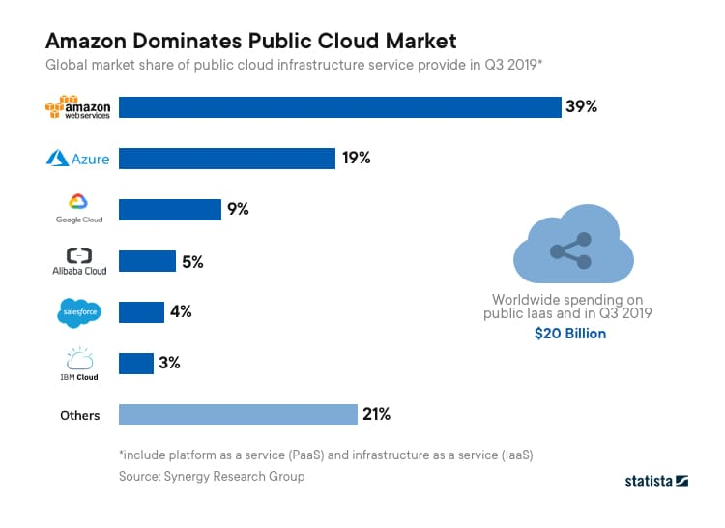
Figure 6. Amazon Public Market [22]
AWS provides seven different storage options, including backup, archiving, and data recovery. My selection and recommendation for UWTSD is Amazon FXs for Window File Server.
- Amazon S3
- Amazon Elastic Block Store
- Amazon Elastic File System
- Amazon FSx for Lustre
- Amazon FSx for Window File Server - Amazon FSx for Windows File Server is a completely managed, highly secure, and scalable file storage solution that uses the industry-standard Server Message Block (SMB) protocol for access. It includes deployment options, completely controlled backups, and data encryption both in transit and at rest. It's based on Windows Server and includes administrative features including user quotas, end-user file restoration, and Microsoft Active Directory (AD) integration. With SSD and HDD storage options, you can optimise cost and efficiency for your workload needs, and you can scale storage and adjust the throughput performance of your file system at any time. Amazon FSx file storage can be accessed from AWS or on-premises Windows, Linux, and MacOS compute instances and computers.[23]
- Amazon S3 Glacier
- AWS Storage Gateway

12. Why Amazon Web Server is a good solution?
The Agility, flexibility, low-cost and security of its servers are the things that made AWS preferred. Here are some benefits like Easy to use, No Capacity Limits, provides speed and agility, Secure and Scalable, Cost-effective and on the other hand the disadvantages are extra cost for support packages, AWS may have some common cloud computing issues when the enterprises move to a cloud, AWS sets default limits on resources that differ from region to region.[24]

II. Scenario 2
1. Data centre security
Safety is an essential part of the virtualized IT data centre. Security is essential in various areas of the data centre. Another area in which security is essential in the data centre is remote access. For maintaining or new service activations, operators frequently require remote access to the data centre. This remote connection should be secured and monitored to provide access only to authorised users.
The protection provided between VMs in a virtualized IT data centre is known as software application security. In the data centre, there is a lot of inter-VM contact, and managing it is a critical security issue. A virtual security appliance should be designed to restrict communication between those resources to only those protocols that are required for operation if a server is expected to access a database on another server or on a storage array. Limiting resource contact avoids data centre security breaches and may be needed depending on the regulatory requirements of the hosted applications. Protection in a virtual network, or between virtual machines, varies from security on a physical network. A hardware firewall can link to various subnets, protection zones, or servers in a physical network and provide security between those devices. The actual firewall in the virtual network is unable to see traffic between the virtual machines. To allow protection between VMs in these cases, a virtual hypervisor security appliance should be enabled.
When it comes to virtualization security, you need a solution that includes complete introspection hypervisor security, a high-performance, hypervisor-based stateful firewall, an integrated intrusion detection system (IDS), virtualization-specific antivirus defence, and unrivalled scalability for managing multitenant cloud data centre security. [25]
The data centre’s security can be divided into two categories: Physical and software protection.
1.1 Physical security - Access controls, such as cards, badges, or biometric systems, must be used to protect data centres, especially systems containing highly sensitive or controlled data. Server cages that are locked may also be needed. There should also be video and other surveillance systems in operation. In many cases is necessary and physical security guards. [26]
1.2 Software security - Some data centre networking software comes with protection built in or is built to work with other virtual security tools like firewalls and intrusion prevention and detection systems. This programme could be used by IT managers to create policies that classify users and decide who has access to the data centre. One trusted tool that IT departments can use to ensure that only approved users have access to a network linked to the data centre is two-factor authentication, which confirms a user's identity by asking for a password and username. [27]
A data centre is a location where data is stored. It does, however, act as a data centre for both incoming and outgoing data. As a result, conventional network and data protection tools play a crucial role in overall data centre security. Firewalls, anti-virus scanners, endpoint security monitors, application security scanners, and a variety of other software, modules, and services should all be considered—and most likely included. [28]
In this context, many companies provide security services and tools as VMware, IBM, Cisco, McAfee, FireEye, Fortinet, Symantec, HashiCorp, Juniper Networks, Trend Micro.
2. Storage Area Network
Through the advancement of technology, computing power was once centralised in a single physical location (data centres), but now it is spread across an organization's divisions and branches, bringing computing power closer to consumers (employees). SAN allows businesses to share access to the "data warehouse." As a result, in terms of data stored in the SAN, individual servers become less critical (peripheral) computers.
A SAN (Storage Area Network) is a collection of computers and storage devices linked by a high-speed (usually optical) network and configured for the purpose of storing and protecting data.
To pass data over the network and store it in block format on disc drives, SAN uses SCSI and Fiber Channel protocols. Creating a shared collection of storage devices and sharing data between it and the company's servers allows for archiving, restoring, and processing data in a high-speed environment.
For example, if computer “2” has to connect with computer “1's” data in this situation, it will need a copy of the data from server “1”. The transfer of data between the two computers in this situation is based on three common techniques: file transfer, inter-process communication, and backup, which is a criterion. Assume that data transfer from computer “1” to computer “2” has been completed. However, machine “2” would be forced to deal with data that is out of date simply because the copied data was not done in a timely manner. Due to the additional operational complexity that occurs between the two servers, data copying can often cause costly errors.
A SAN architecture framework would have a great solution for this whole scenario at this time. Both servers in a Storage Area Framework are physically connected to all storage devices. If server “2” requires data from server “1”, it may access the data directly from the computers on which server “1” has stored it, rather than requesting a copy of the data from server “1”.
ABC Data Ltd will benefit from SAN implementation in a number of ways, including the elimination of distance limits, maximum disc space availability, multi-way disc access, real-time recovery, new disaster recovery capabilities, and reduce the number of servers. [17],[29]
3. Disaster Recovery
Disaster recovery (DR) is a form of security preparation that seeks to protect a company from the consequences of major disasters. Following a disruption, having a disaster recovery plan in place allows an organisation to retain or rapidly restore mission-critical functions. Organizations and industries have different disaster recovery strategies, with different compliance criteria and standards. There is, however, a general outline that plans should adhere to.
Disaster Recovery plan use two main differ objective namely – Recovery Point Objective (RPO) and Recovery Time Objective (RTO).[30]
3.1 Recovery Point Objective is the maximum age of files that an entity must recover from backup storage in order to restore normal operations after a disaster. The minimum frequency of backups is determined by the recovery point goal. When an organization's RPO is three hours, for example, the device must be backed up every three hours.[30]
3.2 Recovery Time Objective - following a catastrophe, the RTO is the amount of time it takes an organisation to retrieve files from off-site and local backup storage and restore regular operations. In other words, the maximum amount of downtime an enterprise can tolerate is the recovery time goal. File recovery cannot take longer than five hours if an organization's RTO is five hours.[30]
4. Disaster Recovery as a service (DRaaS) - involves third-party cloud-based replication and hosting in the event of a catastrophe to enable complete environmental recovery.
Lower costs, faster implementation, and the opportunity to test plans on a regular basis are all advantages of DRaaS. Since they operate on a shared platform, cloud computing services save money for businesses. They are more adaptable because businesses can sign up for only the services they need.[30]
5. Disaster recovery sites
The organization can recover and restore its technology infrastructure and processes with external sites. They can be Hot, Warm and Cold.[30]
- Hot site is a fully operating data centre with hardware and software, employees, and customer data, usually staffed 24 hours a day, 7 days a week: disaster ready.
- Warm site is an equipped data centre with no customer data; in the event of a catastrophe, a company will instal additional equipment and incorporate customer data.
- Cold site - has the infrastructure to support IT systems and data, but no technology until a company activates its disaster recovery plans and instals the necessary equipment.[30]
Making of an effective, efficient and intelligent disaster recovery plan helps organisations, in the face of an unexpected disaster, minimise the real threat of economic loss, operational disruption and reduced brand credibility. It enables organised and controlled recovery, ensures safety and proper service repatriation with minimal problems. [30]

III. Conclusion
From the above introduction, I can say building a data centre is a technology that has a lot of potential. This technology eliminates the need to buy new equipment on a regular basis, which has a number of drawbacks: the search for a place, storage, cooling, and power.
Virtualization systems are one of the technologies that can help a company minimize the amount of equipment it needs by maximizing the use of existing hardware. Allows for simple repair and management of existing IT infrastructure, lowering the organization's associated IT equipment maintenance costs. Provides security, quick, easy, and constant access to information.
Furthermore, data centre protection and the implementation of a disaster recovery plan are top priorities for businesses. One of the most important things nowadays is to protect information. It is possible to replace a server; however, the loss of data could result in the company being shut down.

References
[1]"Why companies need data centre virtualization right now", New Horizons Worldwide, 2021. [Online]. Available: https://www.newhorizons.com/article/why-companies-need-data-center-virtualization-right-now#:~:text=Data%20center%20virtualization%20is%20the,high%20storage%20and%20processing%20demands.
[2]"Understanding Paravirtualization and Full virtualization - Introduction to Virtualization Technologies Course", Cloud Academy, 2021. [Online]. Available: https://cloudacademy.com/course/introduction-to-virtualization-technologies/paravirtualization-full-virtualization-1/.
[3]"Виртуализация на сървъри I Инсталиране на клъстери I от ЕВРИСТА", ЕВРИСТА, 2021. [Online]. Available: https://evrista-bg.com/virtualizatsia-na-sarvari/.
[4]"Виртуално - Бизнес ИТ услуги, Изграждане и поддръжка на компютърни мрежи", Virtualno.eu, 2021. [Online]. Available: http://www.virtualno.eu/it-services.php?id=itverts-virtualisation.
[5]"virtualization-a-complete-guide", Ibm.com, 2021. [Online]. Available: https://www.ibm.com/cloud/learn/virtualization-a-complete-guide.
[6]"Figure 1: illustration of the concept of Virtualization [7]", ResearchGate, 2021. [Online]. Available: https://www.researchgate.net/figure/illustration-of-the-concept-of-Virtualization-7_fig1_269636339.
[7]"What is Virtualization and How Does it Work?", SearchServerVirtualization, 2021. [Online]. Available: https://searchservervirtualization.techtarget.com/definition/virtualization.
[8] C. Wright, "What is Virtualization and How Does it Work | ResellerClub Blog", ResellerClub Blog, 2021. [Online]. Available: https://blog.resellerclub.com/what-is-virtualization-and-how-does-it-work/.
[9] J. Edwards, "Everything You Ever Wanted to Know about Virtualization - WhatsUp Gold", 2021. [Online]. Available: https://www.whatsupgold.com/blog/everything-you-ever-wanted-to-know-about-virtualization.
[10]"Virtualization", www.redhat.com, 2018. [Online]. Available: https://www.redhat.com/en/topics/virtualization/what-is-virtualization#:~:text=Virtualization%20is%20technology%20that%20lets,among%20many%20users%20or%20environments.&text=It's%20the%20same%20hardware%2C%20you,more%20of%20it%20more%20efficiently.
[11]"hypervisors", Ibm.com, 2021. [Online]. Available: https://www.ibm.com/cloud/learn/hypervisors.
[12]"What Does a Hypervisor Do? | Flexiant", Cloud Management Software and Cloud Orchestration Software | Flexiant, 2021. [Online]. Available: https://www.flexiant.com/2014/02/05/what-does-a-hypervisor-do/.
[13]"virtualization-a-complete-guide", Ibm.com, 2021. [Online]. Available: https://www.ibm.com/cloud/learn/virtualization-a-complete-guide.
[14]"Какво е виртуализация: Научете виртуализация на мрежа, данни, приложения и съхранение - Други", 2021. [Online]. Available: https://bg.myservername.com/what-is-virtualization#5_Data_Virtualization.
[15]Study.com, 2021. [Online]. Available: https://study.com/academy/lesson/what-is-data-center-virtualization.html.
[16]"Какво е виртуализация: Научете виртуализация на мрежа, данни, приложения и съхранение - Други", 2021. [Online]. Available: https://bg.myservername.com/what-is-virtualization.
[17]"6 ползи от виртуализацията в малкия бизнес", cio.bg, 2021. [Online]. Available: https://cio.bg/management/2012/02/20/3445502_6_polzi_ot_virtualizaciiata_v_malkiia_biznes/.
[18]"Top 10 disadvantages of server virtualization", SearchServerVirtualization, 2021. [Online]. Available: https://searchservervirtualization.techtarget.com/feature/Top-10-disadvantages-of-server-virtualization.
[19] M. Roomi and M. Roomi, "5 Advantages and Disadvantages of Virtualization | Drawbacks & Benefits of Virtualization", HitechWhizz - The Ultimate Tech Experience, 2021. [Online]. Available: https://www.hitechwhizz.com/2020/05/advantages-and-disadvantages-drawbacks-and-benefits-of-virtualization.html.
[20]"Data Center Build vs Buy | Data Center POST", Datacenterpost.com, 2021. [Online]. Available: https://datacenterpost.com/data-center-build-vs-buy/.
[21]"What Is Amazon Web Services and Why Is It so Successful?", Investopedia, 2021. [Online]. Available: https://www.investopedia.com/articles/investing/011316/what-amazon-web-services-and-why-it-so-successful.asp#:~:text=Scalable%20and%20Adaptable&text=In%20fact%2C%20AWS%20is%20great,seamlessly%20moved%20over%20to%20AWS.
[22]"What is Amazon Web Services & Why Should You Consider it?", Insights - Web and Mobile Development Services and Solutions, 2021. [Online]. Available: https://www.netsolutions.com/insights/what-is-amazon-cloud-its-advantages-and-why-should-you-consider-it/.
[23]"Amazon FSx for Windows File Server | Cloud File Storage | Amazon Web Services", Amazon Web Services, Inc., 2021. [Online]. Available: https://aws.amazon.com/fsx/windows/.
[24]"AWS Advantages & Disadvantages | Advantages of Cloud Computing - DataFlair", DataFlair, 2021. [Online]. Available: https://data-flair.training/blogs/aws-advantages/.
[25]"Understanding Security in the Virtualized IT Data Center - Technical Documentation - Support - Juniper Networks", Juniper.net, 2021. [Online]. Available: https://www.juniper.net/documentation/en_US/release-independent/solutions/topics/concept/security-virtual-it-dc-overview.html.
[26]"Top Data Center Security Software 2021 | Datamation", Datamation, 2021. [Online]. Available: https://www.datamation.com/data-center/data-center-security-software/.
[27]"Data Center Security", VMware, 2021. [Online]. Available: https://www.vmware.com/topics/glossary/content/data-center-security#:~:text=Aspects%20of%20data%20center%20security,malware%20programs%20to%20prevent%20breaches.
[28]"Top Data Center Security Software 2021 | Datamation", Datamation, 2021. [Online]. Available: https://www.datamation.com/data-center/data-center-security-software/.
[29]"What Is A Storage Area Network (SAN)? Working And Benefits", StoneFly, 2021. [Online]. Available: https://stonefly.com/resources/storage-area-network.
[30]"What is disaster recovery? Everything you need to know about DR", SearchDisasterRecovery, 2021. [Online]. Available: https://searchdisasterrecovery.techtarget.com/definition/disaster-recovery.
[31] G. Santana, Data Center Virtualization Fundamentals. [Place of publication not identified]: Cisco Press, 2013.

