Venetia marguerita bembridge francis
Uwtsd Birmingham
2108963 teacher A.rahman

: What is the Data, Information, Knowledge, Wisdom (DIKW) Pyramid?
• Gergana Petkova
4 years ago
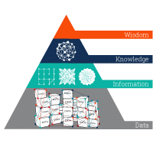
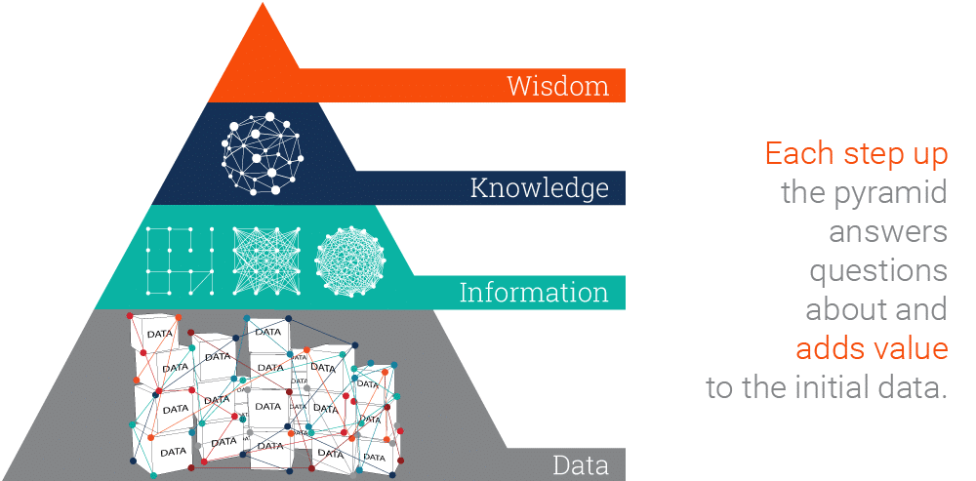
Knowledge Pyramid, Wisdom Hierarchy and Information Hierarchy are some of the names referring to the popular representation of the relationships between data, information, knowledge and wisdom in the Data, Information, Knowledge, Wisdom (DIKW)Pyramid.
Like other hierarchy models, the Knowledge Pyramid has rigidly set building blocks – data comes first, information is next, then knowledge follows and finally wisdom is on the top.
Each step up the pyramid answers questions about the initial data and adds value to it. The more questions we answer, the higher we move up the pyramid. In other words, the more we enrich our data with meaning and context, the more knowledge and insights we get out of it. At the top of the pyramid, we have turned the knowledge and insights into a learning experience that guides our actions.
Climb up the DIKW pyramid with the help of Ontotext!

How to Scale Data Up the Knowledge Pyramid
So, let’s have a look at the individual components of the Knowledge Pyramid and how we move from one to the next.

Data
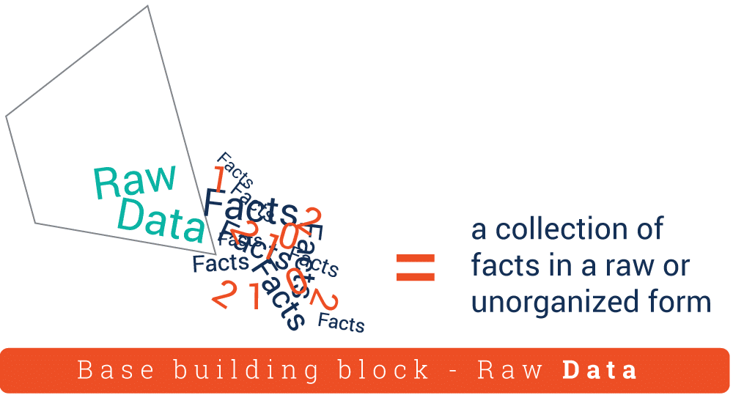
Data is a collection of facts in a raw or unorganized form such as numbers or characters.
However, without context, data can mean little. For example, 12012012 is just a sequence of numbers without apparent importance. But if we view it in the context of ‘this is a date’, we can easily recognize 12th of January, 2012. By adding context and value to the numbers, they now have more meaning.
In this way, we have transformed the raw sequence of numbers into

Information
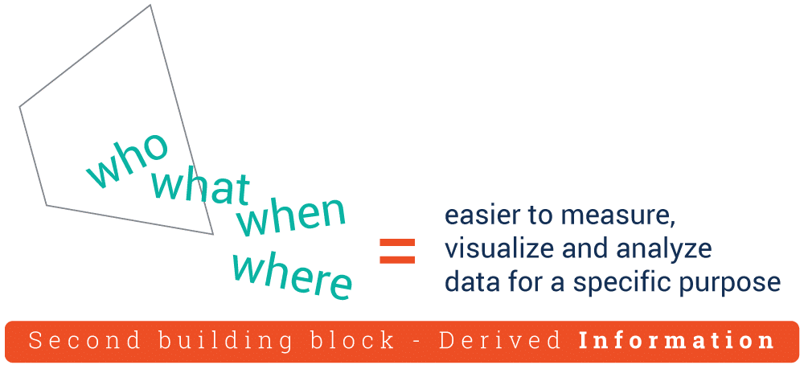
Information is the next building block of the DIKW Pyramid. This is data that has been “cleaned” of errors and further processed in a way that makes it easier to measure, visualize and analyze for a specific purpose.
Depending on this purpose, data processing can involve different operations such as combining different sets of data (aggregation), ensuring that the collected data is relevant and accurate (validation), etc. For example, we can organize our data in a way that exposes relationships between various seemingly disparate and disconnected data points. More specifically, we can analyze the Dow Jones index performance by creating a graph of data points for a particular period of time, based on the data at each day’s closing.
By asking relevant questions about ‘who’, ‘what’, ‘when’, ‘where’, etc., we can derive valuable information from the data and make it more useful for us.
But when we get to the question of ‘how’, this is what makes the leap from information to

Knowledge

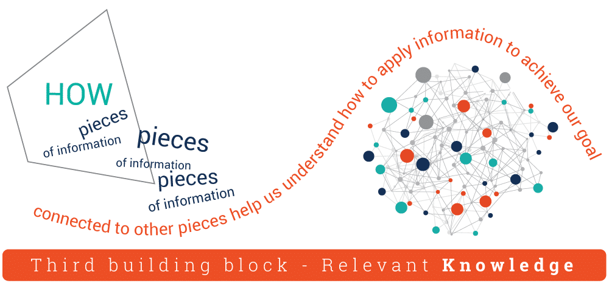
“How” is the information, derived from the collected data, relevant to our goals? “How” are the pieces of this information connected to other pieces to add more meaning and value? And, maybe most importantly, “how” can we apply the information to achieve our goal?
When we don’t just view information as a description of collected facts, but also understand how to apply it to achieve our goals, we turn it into knowledge. This knowledge is often the edge that enterprises have over their competitors. As we uncover relationships that are not explicitly stated as information, we get deeper insights that take us higher up the DIKW pyramid.
But only when we use the knowledge and insights gained from the information to take proactive decisions, we can say that we have reached the final – ‘wisdom’ – step of the Knowledge Pyramid.

Wisdom
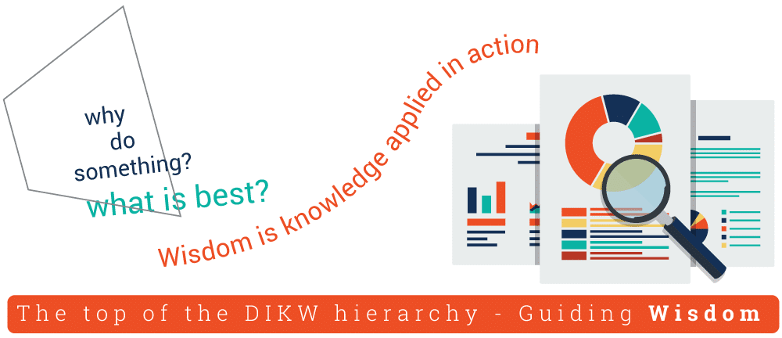
Wisdom is the top of the DIKW hierarchy and to get there, we must answer questions such as ‘why do something’ and ‘what is best’. In other words, wisdom is knowledge applied in action.
We can also say that, if data and information are like a look back to the past, knowledge and wisdom are associated with what we do now and what we want to achieve in the future.

Table 1

Central Michigan university

CRAAP Test
It can be tempting to use any source in your paper that seems to agree with your thesis, but remember that not all information is good information, especially in an online environment. Developed by librarians at California State University-Chico (see below for the link), the CRAAP Test is a handy checklist to use when evaluating a web resource (or ANY resource). The test provides a list of questions to ask yourself when deciding whether or not a source is reliable and credible enough to use in your academic research paper. CRAAP stands for Currency, Relevance, Authority, Accuracy, and Purpose. For more information, please see below.
Something to keep in mind: the CRAAP test is only one method for evaluating content. There are other methods out there that may be more appropriate such as RADAR (Relevance, Authority, Date, Appearance, Reason for writing). However, since it was one of the first evaluations for online content, we'll be focusing on CRAAP for this page.

CURRENCY
The timeliness of the information

- When was the information published or posted?
- Has the information been revised or updated?
- Does your topic require current information, or will older sources work as well?
- Are the links functional?
Another thing to consider - does the website's copyright date match the content's currency? Or is it just a standard range?

ACCURACY
The reliability, truthfulness and 
correctness of the content
- Where does the information come from?
- Is the information supported by evidence?
- Has the information been reviewed or refereed?
- Can you verify any of the information in another source or from personal knowledge?
- Does the language or tone seem unbiased and free of emotion?
- Are there spelling, grammar or typographical errors?

RELEVANCE
The importance of the information
for your needs
- Does the information relate to your topic or answer your question?
- Who is the intended audience?
- Is the information at an appropriate level (i.e. not too elementary or advanced for your needs)?
- Have you looked at a variety of sources before determining this is one you will use?

PURPOSE
The reason the information exists
- What is the purpose of the information? Is it to inform, teach, sell, entertain or persuade?
- Do the authors/sponsors make their intentions or purpose clear?
- Is the information fact, opinion or propaganda?
- Does the point of view appear objective and impartial?
- Are there political, ideological, cultural, religious, institutional or personal biases?
Note - to help answer Authority and Purpose questions, check out a website's About page.

AUTHORITY
The source of the information
- Who is the author/publisher/source/sponsor?
- What are the author's credentials or organizational affiliations?
- Is the author qualified to write on the topic?
- Is there contact information, such as a publisher or email address?
- Does the URL reveal anything about the author or source?
Note - to help answer Authority and Purpose questions, check out a website's About page.

