Cyber Security Report
1. Introduction
Cyber security threats have dramatically increased in scale and sophistication in recent years. Financial services organisations are especially exposed due to the high-value financial assets and sensitive customer information they possess. Vigilant Trust & Asset Management (VTAM) is a mid-sized financial services firm that has recently suffered several cybersecurity incidents, including a sophisticated phishing campaign that bypassed traditional email filtering systems, and an attempted ransomware infection. These events expose shortcomings in the organisation’s current security framework and underscore the critical importance of a more modern and robust cybersecurity infrastructure.
The rise of hybrid work environments, cloud computing and Software-as-a-Service (SaaS) platforms have all contributed to an exponentially larger attack surface for cybercriminals. According to NIST, modern security strategies should be based on the assumption that “there is no implicit trust granted to assets or user accounts based solely on their physical or network location” [1]. This is the basis of the Zero Trust security model, which is based on the continuous verification of users, devices and network activity.
This report offers a comprehensive cybersecurity framework for VTAM based on Zero Trust. The solution defines modern cyber threats, recommends the revision of security policies based on NIST Cybersecurity Framework (CSF) and ISO 27001 standards and suggests technical counter measures like Security Information and Event Management (SIEM), Security Orchestration Automation and Response (SOAR) and Cloud Security Posture Management (CSPM). The report also includes a proactive monitoring approach and a continuous cybersecurity awareness training program to enhance the organisation’s resilience to evolving cyber threats.

2. Identification of Modern Cyber Threats
Financial institutions face a wide range of cyber threats originating from both external attackers and internal actors. These threats continue to progress as attackers create advanced technologies and exploit weaknesses in cloud environments and human behaviour.
Ransomware-as-a-Service (RaaS)
Ransomware has become one of the most damaging forms of cybercrime to organisations around the globe. In recent years attackers have adopted a commercialised model known as Ransomware-as-a-Service (RaaS), where ransomware developers lease malicious software to affiliates who execute attacks.
According to the Cybersecurity and Infrastructure Security Agency (CISA), ransomware has become “one of the most prevalent and damaging cyber threats facing organisations today” [2]. Such attacks generally include the encryption of key systems and the demand for payment in cryptocurrency in return for decryption keys. Additionally, many ransomware groups employ double extortion tactics, threatening to release stolen data if the ransom is not paid.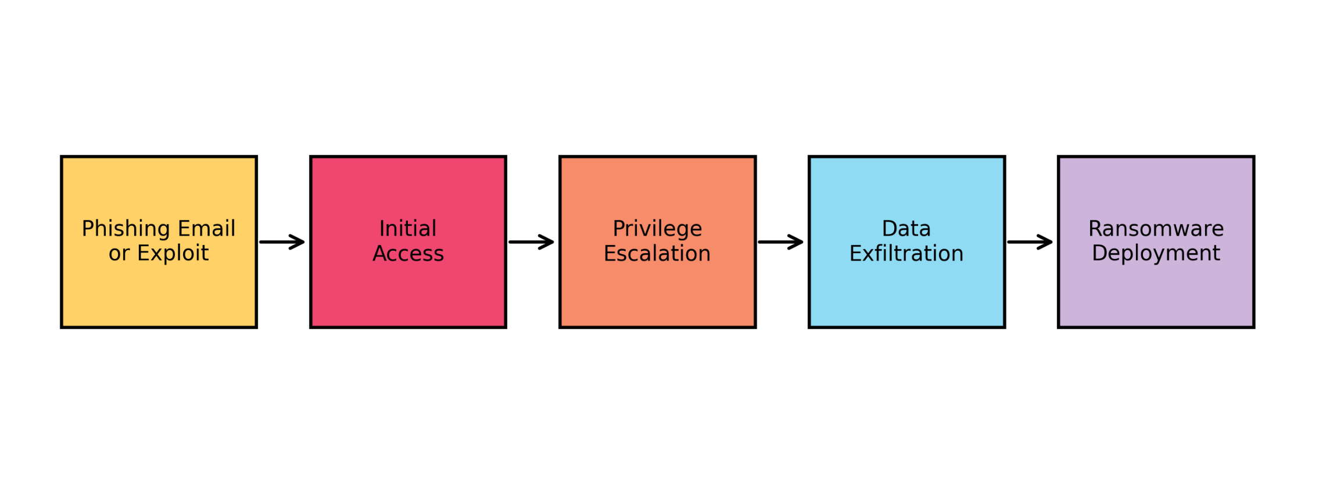
This diagram illustrates the typical stages of a ransomware attack, including phishing-based initial access, privilege escalation, data exfiltration, and final ransomware deployment.
For VTAM, a successful ransomware attack could disturb trading operations, expose sensitive financial data, and cause severe reputational damage.

AI-Powered Social Engineering and Vishing
Social engineering is still one of the most successful methods for cybercriminals to gain unauthorised access to systems. Today’s attackers are using artificial intelligence tools to craft highly convincing phishing emails, voice impersonations (vishing), and deepfake communications.
The European Union Agency for Cybersecurity (ENISA) states that “social engineering remains one of the most effective attack techniques because it exploits human trust rather than technical vulnerabilities” [3]. Attackers can impersonate executives, clients or IT staff to fool employees into releasing login credentials or authorising fraudulent financial transactions.

Supply Chain Attacks
Supply chain attacks happen when cybercriminals compromise trusted third-party software or service providers, allowing them to infiltrate multiple organisations at once. A recent example was the MOVEit file transfer vulnerability exploited in 2023, which affected thousands of organisations across the globe including financial institutions.
ENISA acknowledges that software vendors are increasingly targeted by attackers, as supply chain compromises enable attackers to “compromise multiple organisations simultaneously through trusted vendors” [4].

Cloud Misconfiguration Risks
Cloud adoption brings with it some major security challenges if environments are not configured correctly. Sensitive financial data can be exposed through misconfigured storage buckets, overly permissive access policies, and insecure APIs.
According to the Cloud Security Alliance, “misconfiguration remains the leading cause of cloud security incidents” [5]. This means that financial firms that are heavily reliant on cloud platforms, need to put in place strong cloud monitoring and governance controls.

Insider Threats
Security risks can also come from internal employees and contractors. Insider threats, whether intentional or not, are a possibility due to either malicious intent or human error, such as clicking on phishing links or mishandling sensitive data.
Strong identity management, monitoring, and access control policies are essential for VTAM to mitigate insider risk.

3. Modern Security Policies Based on Zero Trust
VTAM needs to implement a Zero Trust security architecture to counter these threats, built around the core functions of the NIST Cybersecurity Framework (CSF): Identify, Protect, Detect, Respond, and Recover.
Zero Trust is founded on three basic principles:
- 1. Always verify all users and devices
- 2. Use least privilege access
- 3. Assume breach, monitor all activity
NIST defines Zero Trust as “a cybersecurity paradigm focused on resource protection and the premise that trust is never granted implicitly” [1].
Identity and Access Management Policy
Require all users to have multi-factor authentication (MFA) enabled before granting access to company systems. Access should be based on Role Based Access Control (RBAC), so that employees have only the permissions they need to do their role.
Device Security Policy
Corporate network access should be limited to authorised, compliant devices. Use Endpoint Detection and Response (EDR) tools and Mobile Device Management (MDM) solutions to monitor the device health and security status.
Data Protection Policy
Sensitive financial data must be protected with encryption at rest and in transit. Data classification policies should ensure that confidential client information is stored securely and is only accessible to authorised personnel.
Vulnerability and Patch Management
To reduce exposure to active exploitation of security vulnerabilities, VTAM should perform automated vulnerability scanning and prioritise remediation based on the CISA Known Exploited Vulnerabilities (KEV) catalogue.
Together these policies support the CIA Triad, ensuring confidentiality, integrity, and availability of critical financial systems.

4. Technical Mitigation Measures
To implement the Zero Trust framework effectively, VTAM should put in place several modern cybersecurity technologies.
Multi-Factor Authentication (MFA)
MFA significantly reduces the likelihood of a credential compromise, demanding users to present multiple authentication factors like passwords and biometric verification.
Security Information and Event Management (SIEM)
SIEM systems ingest logs from endpoints, servers and cloud environments to alert on suspicious behaviour. These systems enable security teams to detect threats in real time and investigate incidents more effectively.
Security Orchestration, Automation, and Response (SOAR)
Pre-defined playbooks are run on SOAR platforms to automate incident response actions. For example, if SIEM detects suspicious log-in activity, SOAR can automatically disable the compromised account and isolate affected devices.
Cloud Security Posture Management (CSPM)
CSPM tools provide continuous monitoring of cloud environments to identify configuration errors, compliance violations and unauthorised changes.
Immutable Backups
Immutable backups protect your critical data from being overwritten or deleted by ransomware, allowing you to restore your system quickly after an attack.

5. Proactive Monitoring and Incident Response
To identify cyber threats before they cause major damage, a holistic approach to monitoring is needed. NIST recommends that "organisations implement continuous monitoring capabilities to identify and respond to cybersecurity events quickly" [6].
VTAM must put in place a Security Operations Center (SOC) that will be responsible for monitoring network activity on a 24/7 basis. SIEM platforms collect logs from across the organisation, and SOAR systems automate the initial responses to potential threats.
Figure 1 illustrates the Zero Trust architecture implemented across identity management, applications, and monitoring systems.
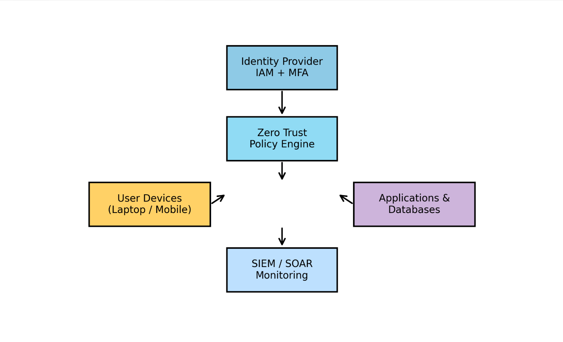
Figure 2 shows the SIEM and SOAR incident response workflow used to detect, analyse, and respond to security events.
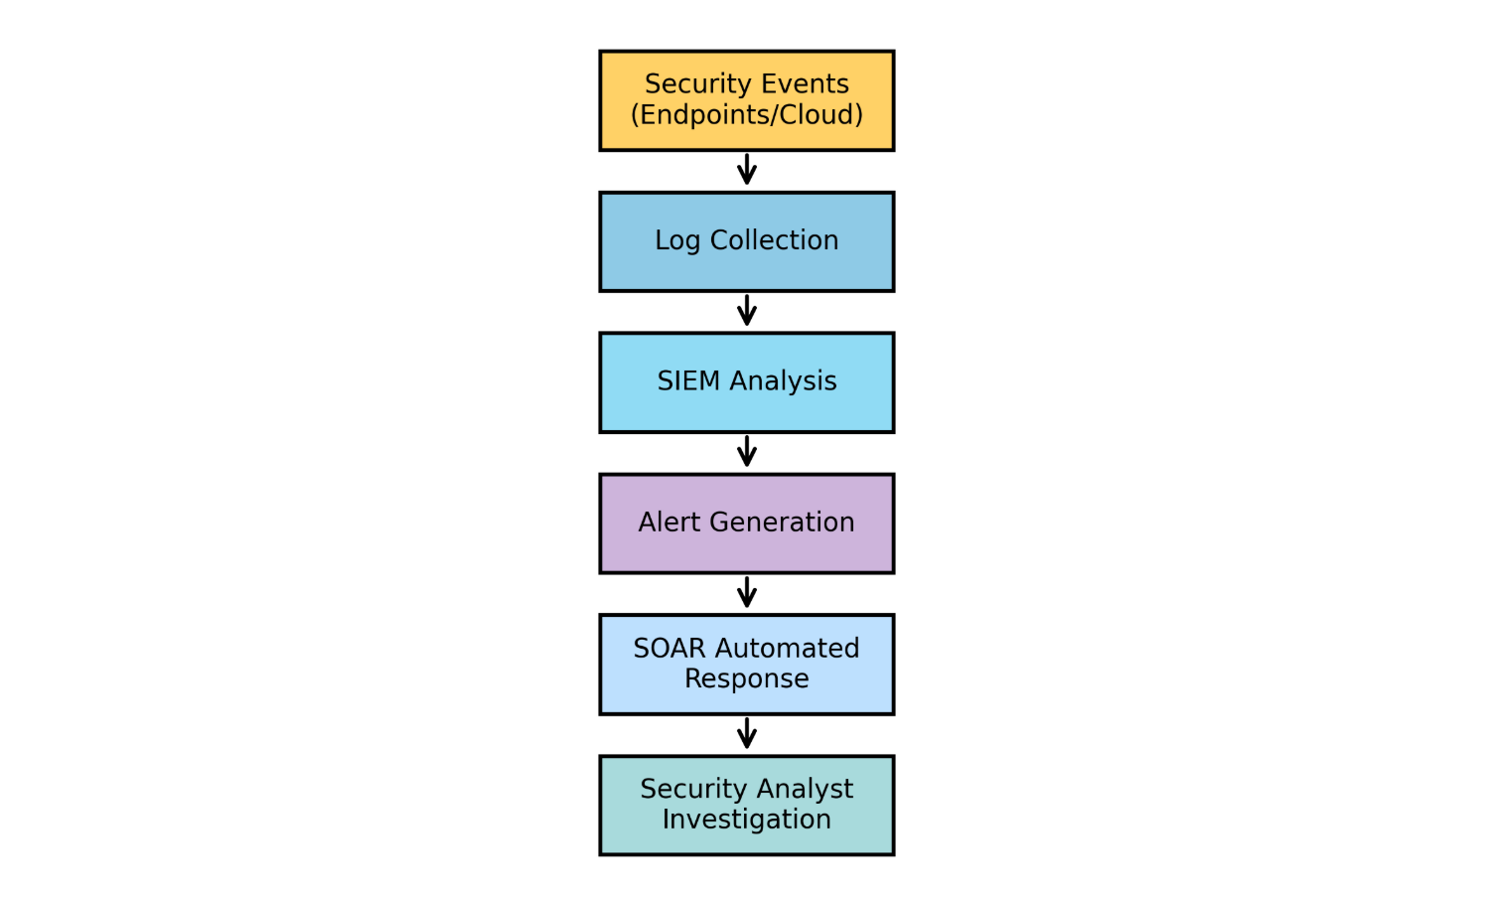
These technologies enable rapid detection of malicious activity, allowing security analysts to contain attacks before they escalate into major breaches.

6. Continuous Security Training and Awareness
Technology alone cannot prevent cyber incidents; employee awareness is also critical. Human error is still one of the biggest causes of security breaches.
According to ENISA, "security awareness programs are essential because employees represent the first line of defence against social engineering attacks" [3].
VTAM should implement a continuous training program that includes:
Phishing Simulation Exercises
Regular phishing simulations help employees to identify suspicious emails and improve their ability to identify malicious links or attachments.
Vishing and Social Engineering Training
Employees should take part in mock voice-based attacks to raise awareness of impersonation scams targeting financial staff.
Role-Based Security Training
Different departments should be trained in their relevant specialities depending on their roles. For example, finance teams should be trained to identify payment fraud attempts; IT personnel should be given advanced incident response training.
Security Culture Initiatives
Internal newsletters, monthly security briefings and reward programs for employees who report suspicious activity can help to build a culture of cybersecurity awareness.

7. Conclusion
Cybersecurity threats targeting financial institutions continue to evolve as cybercriminals leverage ransomware-as-a-service operations, AI-powered social engineering attacks, supply chain compromises, and cloud misconfigurations. Recent VTAM incidents have demonstrated that traditional perimeter-based security models are no longer sufficient to protect modern organisations.
A strong way to counter these risks is through the Zero Trust cybersecurity framework. VTAM can significantly reduce the risk of successful cyberattacks through strong identity verification, continuous monitoring, and least-privilege access controls.
The implementation of MFA, SIEM, SOAR, CSPM, and immutable backups enhances the organisation’s capacity to identify, address, and recover from security incidents. Continuous staff training also keeps employees alert to phishing, vishing and other social engineering methods.
Ultimately, cybersecurity needs to be seen as a strategic investment in organisational resilience, not merely an operational necessity. Implementing the recommendations in this report will help Vigilant Trust & Asset Management strengthen its security posture, protect client assets, and maintain trust in an increasingly complex cyber threat environment.

References
[1] National Institute of Standards and Technology, Zero Trust Architecture, NIST Special Publication 800-207, 2020.
[2] Cybersecurity and Infrastructure Security Agency, Ransomware Guide, 2023.
[3] European Union Agency for Cybersecurity, ENISA Threat Landscape 2023.
[4] European Union Agency for Cybersecurity, Threat Landscape for Supply Chain Attacks, 2023.
[5] Cloud Security Alliance, Top Threats to Cloud Computing, 2022.
[6] National Institute of Standards and Technology, Framework for Improving Critical Infrastructure Cybersecurity, 2018.

