I acknowledge the use of Co-Pilot to support in the research process only.
I used the prompt(s):
1. Studies to support this statement………..
I confirm that I have not presented any AI generated text as my own work
I confirm I have copies of my drafts, notes, and other resources I used before, and after the use of AI tools which I may be asked to provide in evidence

SLIDE 1 Identify a group that is at risk of exclusion; Critically reflect upon 2 barriers to full participation in society and consider possible solutions.

My role as Family Worker for Wellbeing comes under the umbrella of Early Intervention, and as a part of this I often support families in their fight with systems such as education for what their child needs. With this in mind, I came across a 2025 report developed by Cerebra alongside Leeds University which explores ‘Systems Generated Trauma’ which got me thinking of the systemic barriers that are in place and how these can be overcome to provide a child with neurodevelopmental needs what they require to be able to fully participate on an equitable level in their educational journey. SLIDE 2
The Equality Act (2010) is the main legislation that provides protection from discrimination, victimisation, harassment or unfair treatment for nine protected characteristics which include disability, age and race, for example. In Wales, there are two key pieces of legislation that support children with neurodevelopmental or possible neurodevelopmental concerns. The Social Service and Wellbeing (Wales) Act 2014 “brings together local authorities’ duties and functions in relation to improving the well-being of people who need care and support and carers who need support.” (Welsh Government, 2013). The Additional Learning Needs and Education Tribunal (Wales) Act 2018 and subsequent Additional Learning Needs (Wales) Regulations, 2021 and the Additional Learning Needs Code, 2021 also support children. In 2011, Wales indoctrinated the United Nations Convention on the Rights of the Child (UNCRC) into legislation and regulations that affect children to ensure that their rights are continually protected. However, even with legislation in place, it does not mean that discrimination does not take place, it simply allows people with the rights to fight when it does happen. SLIDE 3
Ableism is the underpinning assumption that there is a ‘normal’ and in terms of childhood neurodiversity, favours the neurotypical child. SLIDE 4 This, as a barrier to education has a root in the medical model of disability which states the person is the issue that needs fixing. Zaks (2023) argues that the medical model should be progressing into the normalisation model whereby societal ideals of what is ‘normal’ are just as harmful as the medical model of the past. SLIDE 5 Felder (2025) argues that the role of school is to provide educational achievements as well as develop societal norms due to the systemic underpinning of normative ideals. In neurodevelopmental educational terms this thinking can be a barrier to a child’s learning through lack of understanding rather than outward discrimination or prejudice. For example, bright lights, colourful wall displays and group tables rather than individual desks or pods can have a negative effect on the sensory system of a child who is still trying to learn how to recognise and regulate their physical responses to their emotions often resulting in inattention, distraction or disruption (Stern-Ellran et al., 2016). Having an understanding and teaching about equity and belonging from an early age can support in the changing of what the normative ideals are in society with everyone experiencing belonging (Erwin, Valentine and Toumazou, 2022). However, Johansson, et. al., 2024 found that belonging as an experienced concept has been neglected in both curricula and teaching over the years and suggest that belonging is a right that all must have.
Systems generated trauma can be a barrier in itself with parents often citing the fact that they have to fight for their child’s basic support or even a diagnosis in an educational setting. This can be due to lack of training, understanding or resources, however these often penalise children who are seemingly following the expected developmental pathway as well as their families. The current neurodevelopmental pathway will often rely on a child being in school and them providing evidence to support a referral and possible diagnosis. If a child does not display typically known neurodevelopmental traits, then schools are often unable to make a referral with them asking parents to attend their General Practitioner who are also reluctant to refer due to them not knowing the child in a personal capacity, thus leaving the parents fighting for support for a child they see struggling at home. Cerebra (2021) have found that parental blame for difficult behaviours is often alleged where lack of understanding and compassion for their often-exhausting fight can result in family breakdown, mental health difficulties and families becoming disillusioned with systems that are in place to support. Slide 6
Following the 2020 Covid Pandemic and according to the West Wales News Desk (2025) there has been an increased number of pupils who experience emotional based school avoidance (EBSA). SLIDE 7 Overwhelm has become a reality with many children and their families experiencing extreme emotions and emotional outbursts when faced with attending school. These can include anxiety, sensory triggers or fear of the classroom which can also trigger physical responses including nausea, headaches or stomach aches. SLIDE 8 Section 444 of the Education Act 1996 makes it a criminal offence for a parent to not send their child to their registered school or to ensure regular attendance. In Wales, each local authority has developed their Children and Young People Missing Education Policies. These set out the guidance which schools and Educational Welfare Officers must follow to support attendance and in turn attainment for children of compulsory school age not accessing alternative provision such as Specialist Resource Bases (SRB’s) or Home Education, for example. For a child who may be experiencing EBSA, penalising the parent via fixed penalty notices for a child’s dysregulation without reasonable adjustments being sought or made should also be seen as unlawful. Welsh Governments guidance on penalty notices for regular non-attendance at school (2013) states that schools and local authorities have an obligation to make ‘appropriate provision for the pupil’s needs.’
The new curriculum in Wales has embraced the concept of individualised learning and ensuring that a child is able to learn in the best way for them. In practice this can be difficult as all children are individuals and working out how a child learns best is often through trial and error with Thorndikes theory supporting this view (Shaoying, 2024). Equally if a child has not been in a setting environment previously, how can the parent let setting staff know if they are unaware of difficulties or learning styles themselves due to them not necessarily displaying difficult behaviours at home or the parent understanding differing styles of learning for a child. This could be due to the child feeling comfortable and accepted at home and being in a new or changing environment which can disrupt a child’s wellbeing in a classroom setting. SLIDE 9 Patilma (2025) goes on to support finding that inclusive classrooms with individualised learning in early childhood education has a positive effect on a child’s educational and social-developmental outcomes.
The term inclusive classroom can be a subjective concept, with Sahani and Patel (2023) arguing that for these classrooms to be beneficial they need to take into account the educational needs of all children regardless of if a disability or additional learning need is present. SLIDE 10 As stated, this can be problematic in practice with some children’s needs directly in opposition to others. For example, some children need quiet to concentrate while others such as those with possible attention deficit hyperactivity disorder (ADHD) may need distraction to concentrate on a task. Sun, Norton and Nancekivell (2023) look further into learning styles and if they have an impact on academic attainment. They concluded ‘that providing information about learning styles leads to (unwarranted) inferences about children’s intelligence and aptitude’ with kinaesthetic or hands on learners being categorised as non-academic and traditionally seen as apprenticeship students for subjects such as hairdressing or plumbing. SLIDE 11 Kubat (2017) further suggests that that to effectively establish a child’s ability, they also need to understand and take on board other characteristics such as perception, intelligence, gender and ability with reinforcing activities and being facilitated to ensure that all learning styles and aptitudes are considered to ensure understanding and participation. Thus, it can be surmised that for a classroom to be inclusive, individuality must be considered and differing environments should be offered to allow a child to choose their preferred way of learning.

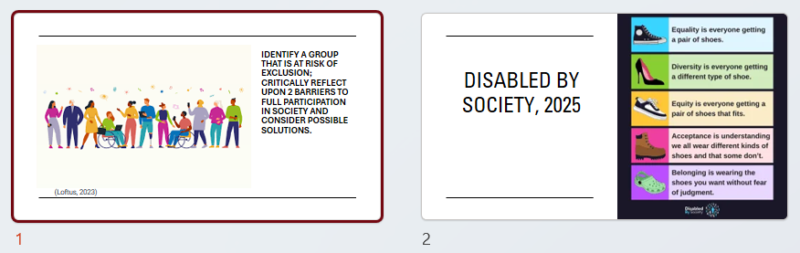
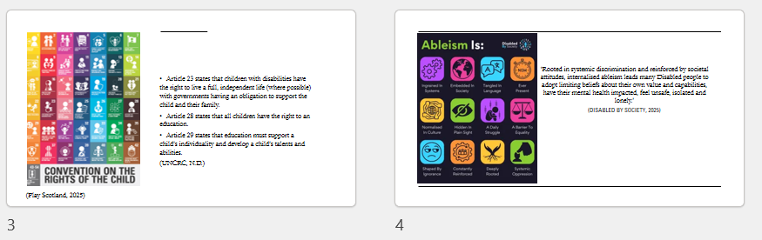
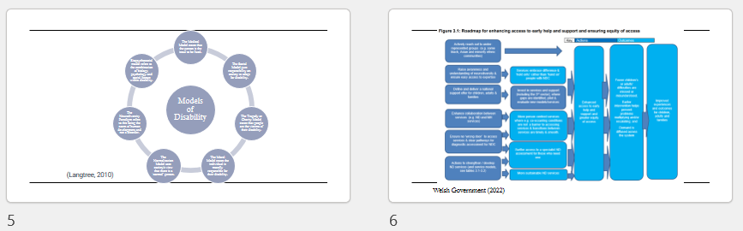
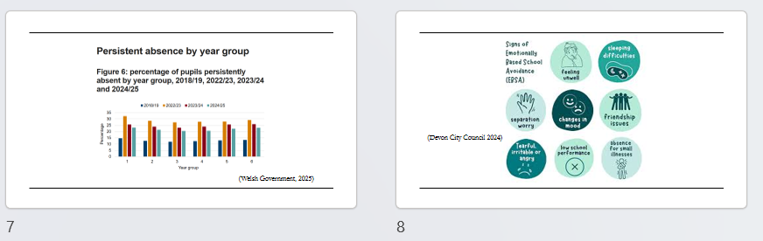
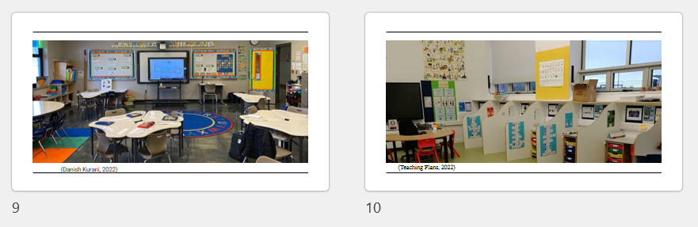
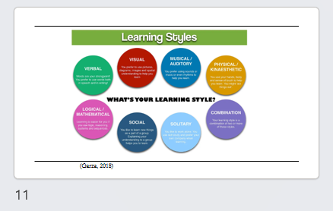

Referencing
Brown, N. and Ramlackhan, K. (2021). Exploring experiences of ableism in academia: a constructivist inquiry. Higher Education, 83(6). doi: https://doi.org/10.1007/s10734-021-00739-y.7
Church, P.T., Banihani, R., Rule, A., Frumberg, D., Maypole, J., Volion, A., Msall, M. and Rosenbaum, P. (2026). Impaired expectations: the challenge of ableism in paediatrics. The Lancet Child & Adolescent Health, 10(1), pp.62–70. doi: https://doi.org/10.1016/s2352-4642(25)00222-6.
crlt.umich.edu. (n.d.). Overview of Equity-focused Teaching at Michigan | CRLT. [online] Available at: https://crlt.umich.edu/overview-equity-focused-teaching-michigan.
Danish Kurani. (2022). I’ve designed learning spaces for over 10,000 students. I keep seeing the same 4 classroom design mistakes. [online] Available at: https://kurani.us/most-common-classroom-design-mistakes/.
Devon City Council (2024). What are the signs of EBSA? - Children, families and education. [online] Available at: https://www.devon.gov.uk/children-families-education/education/attendance-and-inclusion/ebsa/understanding-ebsa/what-are-the-signs-of-ebsa/.
Disabled By Society (2025). Internalised Ableism Policy Paper Data and Results. Disabled By Society – Disability Pride. Available at: https://disabledbysociety.com/disabled-by-society-resources/
Disabled By Society. (2025). Graphics - Disabled By Society. [online] Available at: https://disabledbysociety.com/disabled-by-society-graphics/ [Accessed 7 Feb. 2026].
Erwin, E.J., Valentine, M. and Toumazou, M. (2022). The study of belonging in early childhood education: complexities and possibilities. International Journal of Early Years Education, 32(1), pp.1–15. doi: https://doi.org/10.1080/09669760.2022.2128307.
Felder, F. (2025). Unveiling Ableism in Education: A Critical Examination of its Normativity and Implications for Learning in Schools. Educational Theory. doi: https://doi.org/10.1111/edth.70044.
Garza, R. (2018). Individual Learning Styles and Learning to Code. [online] Medium. Available at: https://medium.com/@rgarza7/individual-learning-styles-and-learning-to-code-41eb8054453a.
Gerlach, A., Newbury, J. and Berggren, T. (2024). Experiences of Unbelonging and Ableism in the Early Learning and Childcare Sector in British Columbia. Journal of Childhood Studies, pp.46–65. doi: https://doi.org/10.18357/jcs202421765 .
Gong Shaoying (2024). Trial and Error. pp.1553–1553. doi: https://doi.org/10.1007/978-981-97-7874-4_1159.
Jardinez, M.J. and Natividad, L.R. (2024). The Advantages and Challenges of Inclusive Education: Striving for Equity in the Classroom. Shanlax International Journal of Education , [online] 12(2), pp.57–65. doi: https://doi.org/10.34293/education.v12i2.7182.
Johansson, E., Emilson, A., Einarsdottir, J., Anna-Maija Puroila and Piskur, B. (2024). The politics of belonging in early childhood contexts: A comprehensive picture, critical factors and policy recommendations. Global Studies of Childhood, [online] 15(2). Doi: https://doi.org/10.1177/20436106241260079.
Kreitman, R. and Elasic, V. (2022). How Inclusive Practices in the Classroom Affect Children’s Social and Emotional Development: A Review of the Literature. [online] Available at: https://files.eric.ed.gov/fulltext/ED621833.pdf.
Kubat, U. (2018). Identifying the Individual Differences Among Students During Learning and Teaching Process by Science Teachers. International Journal of Research in Educational and Science, (IJRES), 4(1), 30-38. DOI:10.21890/ijres.369746
Langtree, I.C. (2010). Definitions of the Models of Disability. [online] Disabled World. Available at: https://www.disabled-world.com/definitions/disability-models.php.
Loftus, J. (2023). UK National Inclusion Week - PAM Wellness. [online] PAM Wellness. Available at: https://pamwellbeing.co.uk/resources/mental-health-blog/national-inclusion-week/.
Norwich, B. (2022). Research about inclusive education: Are the scope, reach and limits empirical and methodological and/or conceptual and evaluative? Frontiers in Education, 7. doi: https://doi.org/10.3389/feduc.2022.937929.
Patilima, H. (2025). Neurodiversity and trauma in early childhood: Implications for inclusive learning. South African Journal of Childhood Education, 15(1). doi: https://doi.org/10.4102/sajce.v15i1.1704.
Play Scotland (2025). Child-friendly UNCRC Poster leaflet. [online] Play Scotland. Available at: https://www.playscotland.org/resources/crc_poster_leaflet_final-indd_/
Reindal, S.M. (2015). Discussing inclusive education: an inquiry into different interpretations and a search for ethical aspects of inclusion using the capabilities approach. European Journal of Special Needs Education, 31(1), pp.1–12. doi: https://doi.org/10.1080/08856257.2015.1087123.
Ruba, K. (n.d.). Educational psychology Unit 3 Learning Theories Trial and Error-E L Throndike. [online] Available at: https://jjacademy.org.in/wp-content/uploads/2023/07/Educational-psychology-EL-Throndike.pdf [Accessed 6 Feb. 2026].
Sahani, R.S. and Patel, H.B. (2023) Inclusive Education: Meaning, Concept & Objectives. Journal of Emerging Technologies and Innovative Research (JETIR), Volume 10, Issue 4. Available at: www.jetir.org.
Sharma, S. (2025). Reimagining Inclusion: Addressing Ableism in Early Childhood Education. In: Peters, M.A., Heraud, R. (eds) Encyclopedia of Educational Innovation. Springer, Singapore. https://doi.org/10.1007/978-981-13-2262-4_342-1
Sharma, S. and Hamilton, C. (2019). Understanding ableism: A teaching and learning tool for early childhood education practitioners. Early Childhood Folio, 24(1), pp.9–13. doi: https://doi.org/10.18296/ecf.0069.
Shyman, E. (2016). The Reinforcement of Ableism: Normality, the Medical Model of Disability, and Humanism in Applied Behavior Analysis and ASD. Intellectual and Developmental Disabilities, 54(5), pp.366–376. doi: https://doi.org/10.1352/1934-9556-54.5.366.
Social Care Wales (2017). Overview of the Social services and well-being (Wales) Act 2014. [online] Social Care Wales. Available at: https://socialcare.wales/resources-guidance/information-and-learning-hub/sswbact/overview.
South Wales Reporting Team (2025). Emotional Based School Avoidance could explain why more than a quarter of children are persistently absent from school, expert warns Available at: https://westwalesnewsdesk.co.uk/2025/09/12/emotional-based-school-avoidance-could-explain-why-more-than-a-quarter-of-children-are-persistently-absent-from-school-expert-warns/ [Accessed Feb. 2026].
Stern-Ellran, K., Zilcha-Mano, S., Sebba, R. and Levit Binnun, N. (2016). Disruptive Effects of Colorful vs. Non-colorful Play Area on Structured Play—A Pilot Study with Preschoolers. Frontiers in Psychology, [online] 7. doi: https://doi.org/10.3389/fpsyg.2016.01661.
Sun, X., Norton, O. and Nancekivell, S.E. (2023). Beware the myth: learning styles affect parents’, children’s, and teachers’ thinking about children’s academic potential. npj Science of Learning, [online] 8(1), pp.1–11. doi: https://doi.org/10.1038/s41539-023-00190-x.
Teaching Plans (2022). How to Set Up an ASD Class. [online] Teaching Plans Ireland. Available at: https://teachingplans.ie/10856-2/.
The National Archives (2010). Equality Act 2010. [online] Legislation.gov.uk. Available at: https://www.legislation.gov.uk/ukpga/2010/15/contents.
UNICEF (n.d.). UN convention on the rights of the child (UNCRC). [online] unicef. Available at: https://www.unicef.org.uk/what-we-do/un-convention-child-rights/.
Welsh Government (2013) Guidance on penalty notices for regular non-attendance at school, Available at Caerphilly - Caerphilly County Borough.
Welsh Government (2013). SOCIAL SERVICES AND WELL-BEING (WALES) BILL Explanatory Memorandum. Department for Health, Social Services and Children, Wales. Available at: https://senedd.wales/media/q1mdoj2s/pri-ld9181-em-e-english.pdf. [Accessed Feb. 2026].
Welsh Government (2022) Review of the Demand, Capacity and Design of Neurodevelopmental Services: Summary Report. Available at: https://www.gov.wales/sites/default/files/statistics-and-research/2022-07/review-of-the-demand-capacity-and-design-of-neurodevelopmental-services-summary-report.pdf.
Welsh Government (2023). Early childhood play, learning and care in Wales - Hwb. [online] hwb.gov.wales. Available at: https://hwb.gov.wales/curriculum-for-wales/early-childhood-play-learning-and-care-in-wales.
Welsh Government (2025). Attendance of pupils in maintained schools: 2 September 2024 to 25 July 2025 | GOV.WALES. [online] Available at: https://www.gov.wales/attendance-pupils-maintained-schools-2-september-2024-25-july-2025 [Accessed Feb. 2026].
Welsh Government (2026). Announcements | GOV.WALES. [online] Available at: https://www.gov.wales/announcements/search?keywords=&announcement_type%5B4%5D=4&%20All%20=All&%20All%20=All&published_after=&published_before= [Accessed Feb. 2026].
Zosia Zaks (2024) Changing the medical model of disability to the normalization model of disability: clarifying the past to create a new future direction, Disability & Society, 39:12, 3233-3260, DOI: 10.1080/09687599.2023.2255926

