

Development of a Network Security Application
Cerberus

by
Paul Weaver

Supervisor: Nitheesh Kaliyamurthy
Second Marker: Dr Carlene Campbell

Project submitted as part of the requirements for the award of

BSc (Hons) Computing (Computer Networks and Cyber Security)

July 2021

DECLARATION

I, Paul Alan William Weaver declare that I am the sole author of this Project; that all references cited have been consulted; that I have conducted all work of which this is a record, and that the finished work lies within the prescribed word limits.

This work has not previously been accepted as part of any other degree submission.

Date: 13/07/2021

FORM OF CONSENT

I Paul Alan William Weaver hereby consent that my Project, submitted in candidature for the B.Sc. (Hons) Computing (stream) degree, if successful, may be made available for inter-library loan or photocopying (subject to the law of copyright), and that the title and abstract may be made available to outside organisations.

Date:13/07/2021

Abstract

Developed with the average local home networks security in mind Cerberus is a network security tool with defence and counterattack measures implemented. Cerberus aim is to defend a local home network without interfering with other connected devices whilst providing an easy-to-use GUI (Graphical User Interface) to the user for easy use. Considering the most common security threats Cerberus consists of a built in Antivirus and USB detector which informs the user of infections and possible unauthorised intrusions. With a built in Network scanner Cerberus can see all the devices which are connected to the local network. Using an access database Cerberus has a secure login which prevents unauthorized people from gaining access to its features. Due to more IoT devices being released without development of security measures in place are in return providing potential gateways into networks through their vulnerabilities which puts the users’ devices and data at risk, with the implementation of a VPN (Virtual Private Network) to change the users Ip Address and File encryptor to encrypt users’ files with 256-bit encryption it can make the difference between a successful attack to a failed one. With the implementation of a port scanner and DDOSS attack tool the user can launch a successful counterattack on any device on the network which poses a threat and in return reducing the threat of cybercrime. Developed in C# in Visual studio 2019 using the Waterfall development method Cerberus is a well-rounded network security tool. With use TAP (Task-based Asynchronous Pattern) Cerberus closes the efficiency gap between CLI (Command Line Interface) and GUI (Graphical User Interface) applications. Capable of expansion in all parts Cerberus has the potential to become fully automated with the implementation of an IDS (Intrusion Detection System) whilst remaining capable of defending against new threats as they are discovered.

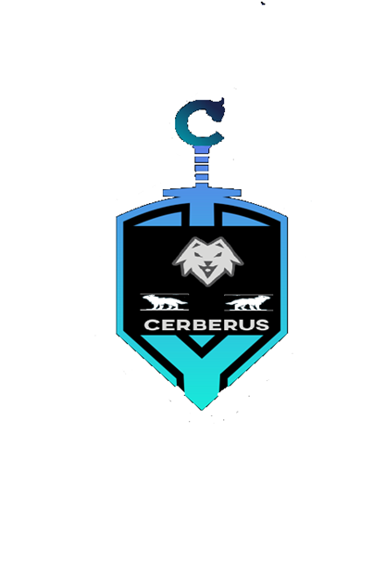
Table of Contents
1.0 Introduction 6
1.1 Aims and objective 6
1.1.1 Aims 6
1.1.2 Objectives 6
1.2 Summary 7
2.0 Literature review 9
2.1 Introduction 9
2.1.1 Similar Solutions 9
2.1.2 Physical security in Networks and Cyber Security 10
2.1.3 Home networks 10
2.1.4 Future of home networks 11
2.1.5 Third party solutions 12
2.1.6 Cybercrime Investigation Obstacles 12
2.1.7 Types of cyber weapons 13
2.1.8 How security tools are developed 13
2.0.9 Using C# for Network programming 14
2.1 Conclusion 15
3.0 Research and Development Methodology 16
3.1 Research Methodology 16
3.2 Development Methodology 16
3.2.1 Gantt Chart 18
3.2.2 Tools to be used 19
3.2.3 Risks 19
3.3 Contingency Plan 19
4.0 Design 20
4.1 Cerberus Storyboard 20
4.1.1 Home screen 20
4.1.2 Login error message 20
4.1.3 User access logged in 21
4.1.4 Admin access logged in 21
4.1.5 File Management system 22
4.1.6 Network Sniffing and IDS 22
4.1.7 Port scanner 23
4.1.8 DDOS Tool 23
5.0 Implementation 24
5.1 Project requirement 24
5.2 Tools Used 24
5.3 Database 25
5.4 Cerberus Solution 25
5.4.1 Login 25
5.4.3 Navigation and USB Detector 28
5.4.4 File Encryptor 30
5.4.5 Anti-Virus 33
5.4.6 Network Scanner 35
5.4.7 Port Scanner 38
5.4.8 DDOSS tool 40
5.4.9 VPN 42
5.6 Conclusion 44
5.7 Test documentation 44
6.0 Evaluation 45
7.0 Conclusion 46
7.1 Suggestions for further work 46
8.0 Reflection 48
9.0 Bibliography 50
10.0 Appendices 56

Page is purposely blank.

Introduction

Cyber Security has become an important part of people’s everyday lives due to the advances of technology. Technology is now used in almost every part of a person’s daily routine thus making it a prime target for cyber criminals from peoples private communications to an individual’s privacy in the comfort of their own home and peoples means of travel whether it be their own private vehicle or public transport, this is because everything a person does is online from ordering transportation such as public transport bookings using such applications as Uber to controlling the smart devices in their home from their smartphone. Companies have been known to spend thousands of pounds on their IT infrastructure and still manage to succumb to successful cyber-attacks, this is down to many different scenarios from not updating their software to human error by the employees within the organisations. Zero-day exploitations are the biggest threat to everybody using technology as nobody are aware of the vulnerabilities until it is usually too late, and the damage has already occurred. It is predicted by Kaspersky labs that cybercrime is going to rise in the coming years (11).
Due to the Covid 19 Pandemic more people are working from home than ever before and have not got the security infrastructure in place to defend against a cyber-attack. By implementing a network cyber security solution with a GUI (Graphical user interface) it will provide its users from all walks of life with a fighting chance against cyber criminals.

Aims and objective

The following are the aim and objectives for the project which needs to meet for Cerberus to be successful at protecting home networks and reducing cybercrime over time.

Aims

- Device sensor on USB ports for unknown connections thus protecting device from physical attacks.
- Show information of local network infrastructure for abnormalities.
- Secure login database which automatically allows only authorised users to access Cerberus’s functions by implementing an access database alongside Visual Studio 2019 C#.
- 256-bit File Encryption to protect files from attackers.
- Port scanner to scan an alleged attacker’s device for open ports to launch a successful counterattack.
- IDS (Intrusion Detection System) to make Cerberus smart to work automatically on its own without user and gather evidence for prosecution.
.

Objectives

- To work efficiently across all types of networks without causing performance issues to network users or systems.
- Be cross platform compatible.
- Be user friendly by implementing a GUI thus allowing people to use without having to attend any lessons on how to use Cerberus.
- Work in an ethical manner in respect to all international laws in relation to the use of Cerberus.
- Bring cybercrime levels down by gathering evidence on all attempts.
- Be capable of expansion and adapt to future attacks such as new Virus’s and new forms of potential attacks.
- Capability of launching successful counter attacks when and if ever needed.
- Successfully defend and protect users and their data on their respected home networks.
- Cerberus is to be a self-sufficient Cyber defence tool capable of defending small home network infrastructure.
- Reduce cybercrime.

Summary

The following report will help the reader understand the importance of cyber security in the average home network and will provide detail of some methods and techniques used by cyber criminals and common mistakes used by the average home user and how to protect against them. The report will clearly describe the reason why and how the chosen solution was chosen including the techniques and tools used to develop it. The report will also provide the reader with an in-depth view of the design methods used and instructions on how to operate the chosen solution.

By implementing a Network security solution which can monitor the network infrastructure and scan connected devices within in the network for open ports, while being to connect to its own VPN (Virtual Private Network) will help to see threats and gain information about any potential threat before they even attack. Once threats have been found it is then paramount that any threats are isolated to stop the spread of any infection to any nodes thus protecting files and sensitive data. As stated previously just protecting files with encryption is not going to put a stop to the attacker so another part of Cerberus is to launch an attack on the attacker once all the two previous steps has been implemented to gather the evidence needed for a conviction in a court of law, the attack which Cerberus will make will be a DDOSS attack potentially slowing the attackers attack to the extent freezing the attackers’ systems.

For Cerberus to work as intended it needs to be broken down into three main steps which are:

• Network Monitoring
• identification and resolution of any Infection
• Attack the attacker

However, there is one main implementation Cerberus will need which it needs to be doing constantly once implemented into a network and that is monitoring of all devices connected to the network for suspicious activity using the IDS. The main point of this part is that Cerberus on its own will have a capability of working as a standalone protection system for the average home network to provide users with peace of mind within the ever-changing world of Cyber Security and IoT devices.

For Cerberus to be successful in its objectives it needs to have the capability of monitoring all systems on the network and keep a record of logging of end users so it will help determine how any intrusions into the network was made being physical or packet sent. An example of this is Impero which is widely used in the education sector (8). By creating log files, it will show patterns of attacks allowing for easier spotting of repeat attackers such as time, ip addresses used and mac addresses of systems used. By keeping records this will also allow users to pinpoint any weak points within their network infrastructure and with further development Cerberus would be able to advise users of the vulnerabilities if the vulnerabilities have been overlooked due to being zero-days.

Zero-day exploits are the biggest threat to any device due to them being unknown exploits because either they have not been discovered yet or they have been discovered but not documented for personal gain by the person who discovered them.

Literature review

2.1 Introduction

Cyber-attacks are now more common than they were in the past with the high-profile attackers being caught and prosecuted but the lower profile attackers not being caught and prosecuted, this is due to high profile attacks being performed on large companies while the lower profile attacks are performed on individuals (1). There are many cyber-attacks which do not get reported this includes both companies and individuals this is due to the negative impact that the victims believe will harm their reputation and the prosecutors will not take the case seriously (2). Due to rapid evolution of technology on a daily basis more exploits are being found and new forms of cyber threats are being developed which is a major problem taking into consideration that technology is being more commonly used in a person’s daily life to the extent that a person’s main privacy is now commonly stored on smart devices (3); an individual’s privacy can now also be compromised through their own vehicle as vehicles are becoming more smart with technological advances to the extent they are being manufactured with storage systems such as hard disk drives being installed along with its very own Wi-Fi hotspot running off a 4g network and storing the vehicle users driving location history on to the onboard system (4).

When a person uses their personal smart devices, which is commonly a smart phone, most do not realise the possible risks that can occur when they install third party applications or when they download a file/image which they have received through an email, it is possible that any downloaded files or images can carry malware which infects the user’s device. People are led to believe that if they purchase an iPhone rather than an Android device that they cannot be infiltrated by black hat hackers which unfortunately is not the case, a perfect example of a zero-day exploit on an iPhone is the zero-day clicker vulnerability. The real reason why iPhones are less likely to be exploited is due to the OS language as not many people know how to code in Swift whereas Java and SQLite are more commonly practised today, and Android devices can be bought at a cheaper price (26-29).

The majority of cyber-attacks are performed without the attacker having any physical contact with the victim’s device and the attack is performed over a network due to the wireless networks upgrades making them faster and better thus being implemented in more technology (5), such as motor vehicles which now allow for multiple devices to be connected to them wirelessly simultaneously this a major security threat as the devices being connected to the vehicle may already be infected and thus spread the infection to the vehicle (6). With the ever-growing evolution of technology and the way it is used in people’s lives cyber security is without a doubt is needed more than it has ever been needed in the past this is because a successful cyber-attack can cost companies and individuals a lot of money and can also be used for political gain or to cause catastrophic events whether it be causing car accidents to causing explosions in nuclear reactor plants (7).

2.1.1 Similar Solutions

Created by ex-Israel Defence force Cybereason is practically almost everything and the closest solution to what Cerberus is aiming to be minus the counterattack measures and being self-sufficient due to needing 24/7 monitoring by humans. Other solutions similar Cerberus include Norton 360, Kaspersky total security and McAfee. When looking into the reviews left by the mentioned solutions customers and users it is evident that after installation on their systems users see performance issues with their systems to the extent it can render their systems incapable of operation, this seems to be especially true when virus scanning is implemented, and live protection is operational (100-107).

It is also evident that all similar solutions to Cerberus are all compatible with different types of devices whereas that will need to be something researched for Cerberus in the future.

2.1.2 Physical security in Networks and Cyber Security

It is commonly mis interpreted that cybersecurity only relates to the security of the network traffic within the network, the user accounts on the nodes and security of the applications but the physical security of systems are just as if not more important. Stuxnet is an excellent example to show how important physical security of systems really is, Stuxnet was an attack launched by an unauthorised person gaining physical access to the system which enabled them to plug in a USB device with malicious code which is known as a USB attack, after the attacker had inserted the device into the system it would then run the malicious code. The malicious code which was released into the system was a multi part worm which was designed to search PCs connected to the infected system individually for Siemens Step 7 software which was being used for automating and monitoring electromechanical equipment. Once the malware had found what it was looking for the malware would update itself by connecting to the internet and would begin to attack the electromechanical system connected to the infected computer by sending instructions to damage the components. It would damage the components while making false feedback be sent to the engineers making everything look normal thus showing everything was normal when in fact it was about to explode (61).

2.1.3 Home networks

Home routers which are provided by ISP’s (Internet Service Providers) are WPA2 encryption secured which is not as secure as the latest WPA3. When customers are provided with the ISP routers, they are not informed of the security risks of leaving some of the routers functions operational such as WEP pin which is a four-digit pin to connect to the router, this can be easily cracked by using a dictionary attack. Dictionary attacks are reliant on having access to the login interface of the targeted device this is the reason why it is good practice to turn off the router when it is not being used.

The most common home Networks have a router of which some come with the same username and password required to log in to the router which can easily be found upon a quick internet search thus giving anyone on the home network Administration privileges an example of this would be the sky HUB SR-102 WIRELESS router to which both the username and password is Admin. Another common problem with a home router is the firmware updates as most routers requires manual updates of the firmware at standard set up and unfortunately the normal user is not usually aware of this which causes a higher security risk to a home network especially if one of the user devices is infected. Due to the technical advances over the years, it has become more common for home networks to be fully wireless thus creating more exploitable access points within a home network and as technology advances even furthermore IoT devices are being implemented into home networks thus creating a higher security risk especially if they have not been developed properly these can be anything from smart tv’s to baby monitors (13-20).

As stated previously personal devices in the form smart phones are being used to control almost every part of a person’s life however, due to technological advancement and the amount of IoT being implemented on a home network they are also being used to control an individual’s everyday items from heating appliances to electricity appliances such as smart bulbs. If a person’s smart device were to get infected an attacker could essentially have control over almost every aspect of a person’s life this includes an individual’s private life as well with such devices having visual and audio capabilities through the built-in cameras and microphones (21-22}.

Taking into consideration the evolution of security cameras it is now common for people to install IP security cameras to both the interior and exterior of their properties; this causes another security issue due to the cost as people would rather buy a cheap system that does the same as a more expensive system, but which does not have the added protection of the expensive system thus causing another gateway into a person’s home network. If a cybercriminal can gain access to a victims security camera system it would enable them to gain an in depth picture of the home owners daily routine which can then turn a cybercrime into a possible physical threat crime due to them knowing when the victim isn’t going to be home and depending on how secure the security system or how deeply infiltrated the attacker is on the victims home network is it is also possible for the attacker to delete any evidence of any crime being committed, this can also be said for any other smart home security systems such as door locks, alarms etc (23).

Although not being part of the security system as a whole but there are now homes which are being implemented with smart sprinkler systems inside of the home which once again is connected to a home network thus if an attacker was to find a vulnerability within this type of system, they could easily cause catastrophic damage to the home internally including any valuable items and unfortunately not all home insurance policies cover an individual for such events (24-25).

2.1.4 Future of home networks

WPA3 and 6ghz networks are currently the latest technology slowly being implemented in home networks, an example of this would be the latest ASUS ROG Rapture GT-AX11000 router which is upgrade from the GT-AC5300 (48).

As stated previously motor vehicles are becoming smarter but they are also quickly becoming electric, the UK alone has promised to ban all new sales of fossil fuel vehicles in 2030 to battle climate change. Although some electric vehicles come with built in solar panels to make them self-charging the majority require an electricity outlet to charge the batteries this alone poses its own cybersecurity risk. Juice Jacking is an MitM attack which enables an electrical outlet to be used as a data connection and is found mainly in public USB charging points which is used to exploit mobile phones however as technology advances and as vehicles become smarter it is possible this form of attack can mutate to electric vehicles which are able to share files with all the users IoT. With the current sale of electric cars there is now an option for the owner to buy their own fast electric chargers which is a box that will usually be fitted to the exterior of said owner’s property and if security is not implemented potential attackers could gain physical access to the charge points to implement a Juice Jacking technique. There is also an application available which allows electric vehicle users to connect their smart phones or other smart devices to the charge point itself. (30=34).
Home network routers provided by the ISP do come with built in Firewalls which are made for stopping packets which have been noted as dangerous from entering the network as well as providing filters to prevent certain types of attacks such as DDOSS attacks (49).
Privately bought routers such as the ROG Rapture routers come with built in Firewalls but also built in IDS (Intrusion detection systems). IDS’s work by protecting the whole network by analysing both inbound and outbound traffic. As technology has evolved devices on a home network such as mobile phones and tablets have become less dependent on having one internet access route like the home router due to having their own built-in networks through cellular connection such as 4g and 5g, this allows for attacks to come from an attacker from outside the network to come from any infected device with its own cellular network connection thus bypassing the routers firewall (50).

2.1.5 Third party solutions

Even the best trained professionals in the networking and cyber security field can succumb to a successful cyber-attack even though they have own devices secured to the highest standard and this is down to third party applications not being updated by the developer, an example of this would be the solar winds exploit. The solar winds exploit was achieved by the attackers exploiting two vulnerabilities within the application which could have been prevented due to Fire Eye announcing the exploit months before the attack. The attack itself resulted in a snowball effect affecting all networks with the software being installed which included big name companies in the networking and cybersecurity field including Cisco and other victims include federal agencies to which the American government are holding Russia responsible (58-63).

It is not only software that is sometimes reliant on third party solutions, Web based solutions are also reliant on third party hardware such as servers. When choosing to host a website consideration needs to be taken into the security of the server itself as an unsecure site which allows access to anybody, and an unmaintained server can easily cause an exploitable vulnerability to the website’s owners data (64).

2.1.6 Cybercrime Investigation Obstacles

There are some problems which cause an issue for convicting cyber criminals. The main obstacle is the fact that cyber criminals can pay for specific hardware and software which keeps them Anonymous which allows them to engage without alerting the victim or authorities and allow their identity to be hidden, examples of such software and hardware are the following:

Software:
- Proxies
- Tor
- Vpn’s such as NordVPN
- Virtual Machines such as VMWare
Hardware:
- Live bootable USB sticks with operating systems such as Tails, Kali Linux, Anonymous OS Live etc.
- Raspberry Pi working as a wireless point which the user connects to instead of the router which then filters the network traffic through the Tor network.
Due to anonymity making for smoother free flow of the attacker’s data they rarely concern themselves with thoughts of repercussion which is why cybercrime is on the rise. The attackers are also protected by the data protection act, Maras 2016, the human rights act, and Cybercrime Legal frameworks. Concerns have recently been raised by most of the Cybersecurity professionals stating that the computer misuse act is outdated and unfortunately putting white hats in the firing line of repercussions when their work purely ethical (35-47).

Known as a spoofing attack, criminals can mask their identity and masking their devices it is possible for attackers to make it look like an attack has come from a different part of the world which can arguably turn a cybercrime into a cyberwar between countries dependent on the attack type and what goal was obtained during the attack (51-53).

2.1.7 Types of cyber weapons

Like all technological solutions cyber weapons come in many different forms whether it be applications installed on a personal device, a web application hosted from a web server or bespoke built hardware with bespoke code to make an exploit within a secure infrastructure. Although there are Cyberweapons that are classified and unless in the profession the average person will probably never hear of them and launching Cyber-attacks in the UK is illegal, it is possible to successfully download the tools which can easily be found with an internet search, and it is very rare to find a tool which is not open source. There are many different tools to choose from tools built by hobbyists on GitHub and tools used to teach the next generation of Cyber Security professionals, but for the purpose of this report here are the best known and used (73):

- Kali Linux
- LOIC
- Parrot Security
- Metasploit
- Pony Express
GCHQ (Government Communications Headquarters) have recently released their own open-source Cyber tool which they call the Swiss army knife of cyber security called Cyber Chef however this tool is centred around encryption, networks, and forensics (54-58).

2.1.8 How security tools are developed

Security tools are developed when a particular vulnerability is found, this can be in form of hardware or software and can be to protect the vulnerability or exploit it. The most common Security tools are developed in C/C++ dependant on what they are developed to do the majority are CLI (Command Line Interface). Hobbyists are developing their own tools in Python also neither language is better than the other however, the language is important when developing tools due to compatibility issues and one language can be better suited for a certain solution than the other (65-66).

As technology has advanced over the years the methods of developing security tools have had to adapt and will continue to in the future. New languages are being released which allows for faster application problem solving thus making current cyber tools obsolete with time due to the likelihood of new languages using less CPU or RAM on the systems which it is being run on which can have an adverse effect on the user using that device at the time.
CLI and GUI

When developing tools it needs to be decided how the user is going to interact with the tool in security it is common for CLI (command Line Interface) software to be implemented due to commands being need to be learnt by the user to use the tool thus can be argued it adds an extra layer of security whereas, GUI (Graphical User Interface) software arguably makes it easier for the user to use especially when labels are appropriately displayed thus removing the need to learn complex commands before using the tool. There is no doubt if an extra layer of security such as a secure login is not added to a security tool and if it falls into the wrong hands, it will more likely be used for malicious intent than a tool with CLI (Command Line Interface) would be.

GUIs (Graphical User Interfaces) use more memory to work than CLI (Command Line Interface) because of its graphical components thus making it slower however, GUI allows for customizable appearances and is flexible where as CLI (Command Line Interface) lacks in these areas (67).

2.0.9 Using C# for Network programming

Some of the advantages of using C# for Cerberus are that its cross platform compatible meaning that the future updates are limitless as well as being an easier programming language to program with when compared to others especially when reusable code is its primary feature. C# is also easy to read and even non-programmers can sometimes understand what the code does. Being a OOP (Object oriented Programming) Language it makes very efficient, scalable, flexible and easy to maintain. C# is a great language to create windows solutions in and taking into consideration that Windows is the most used Operating system in the home it seems logical that it is the language of choice to be used to develop Cerberus especially when there are over 1.3 billion devices all over the world running Windows as well. C# is an excellent slanguage for socket programming due to simplifying the namespaces like sytems.net and systems.net.sockets (78-83).

It can be argued that using the C# TAP (Task Asynchronous Programming) model can drastically increase the efficiency of complex programming tasks which is obviously going to be needed when programming a solution like Cerberus especially if it is to be self-sufficient. The TAP model will be implemented by using the async and await keywords when the tasks tend to take a long time to complete, taking into consideration that Cerberus is being developed as an GUI application implementing TAP in theory should compensate for it being slower than CLI (Command Line Interface). (84-86).

By implementing third party software packages into the solution to speed up the processes can prove vital in reducing time as the source code from the third-party solutions are already programmed for complex tasks in the program which can take a very long time to develop as a developer on their own and more than likely the code from the developer will not be as efficient as the third-party software. Three third party solutions have been identified and used by other developers which are Networkminer, WinPcap and SharpPcap. As stated previously there are obvious risks to using third party applications however, reviews from other developers have proven these third-party solutions are okay for use with C# .Net (87-89).
Cybercriminals

Cybercriminals are on the rise in number and there are many reasons why they do what they do just like any other crime. Types of Cybercriminals are as follows (68-70):
- Identity Thieves
- Internet Stalkers
- Phishing Scammers
- Cyber Terrorists
- State Sponsored Hackers
- Crackers
See Appendices 1.A. for more literature review details

2.1 Conclusion

As can be seen there are many different threats to every home network from human error to third party applications and they are just the threats that is known at the present time, there is no doubt more threats that have not yet been discovered and as stated previously as technology advances so will more vulnerabilities come to light. Unless the laws on cybercrime are updated White Hat hackers who help stop the black hat hackers from initiating their malicious deeds is likely to continue because the white hat hackers do not want to be on the wrong side of the law (75-76).

When developing security tools, a CLI (Command Line Interface) is usually the best way to go in terms of development however, user disabilities need to be taken into consideration and some users will struggle to learn and remember the commands and in these scenarios GUI (Graphical User Interface) is the best development option (77).

3.0 Research and Development Methodology

The following is the research and development Methodology used to help design, develop, and test Cerberus throughout the project. Both parts have been separated to give the reader a better in-depth view.

3.1 Research Methodology

See Appendices 2.A.

3.2 Development Methodology

Due to using the waterfall methodology, once the research Methodology had concluded it allowed for the route of the development methodology to begin. Once the Design had concluded Cerberus was then broken down into Parts in terms of functionality and was researched, designed, implemented, verified, and maintained during each inclusion of new features. The development will be sone using the waterfall methodology due having experience using it on past projects which were successful.

1. | Design Database
  Does the fields in the tables meet the requirements to gain aims and objectives?
2. | Design Login Form
3. | Design Navigation Form
4. | Design all other Forms
  Are the designs sensible and do they include all the necessary interfaces for user use?
5. | Begin development
6. | Develop Database
7. | Develop Login Form
8. | Connect Database to Login Form
  Is the database connection to the Login Form successful (can a user login)?
9. | Develop Navigation Form
10. | Connect Navigation Form to Login Form
  When logged in does the user with the correct credentials get transferred to the Navigation form from the login form?
11. | Add navigation buttons to Navigation Form
12. | Develop File Encryptor
  Have any problems arisen during development? If so research.
13. | Test File Encryptor
  Any errors during testing? If so research and fix.
14. | Connect File encryptor to Navigation Form
  Does File Encryptor open from Navigation Form?
15. | Develop Port Scanner
  Have any problems arisen during development? IF so research.
16. | Test Port Scanner
17. | Connect Port Scanner to Navigation Form
  Does Port Scanner open from Navigation Form?
18. | Develop Network Scanner
  Have any problems arisen during development? IF so research.
19. | Test Network Scanner
20. | Connect Network Scanner to Navigation Form
  Does the Network Scanner open from the Navigation Form?
21. | Develop DDOSS tool
  Have any problems arisen during development? IF so research.
22. | Test DDOSS tool
23. | Connect DDOSS tool to Navigation Form
  Does the DDOSS tool open from Navigation Form?
24. | Test Cerberus full functionality
  Is Cerberus working as intended and is user functionality okay or can adjustments be made?
25. | Add Exit buttons to all forms and a logout button on Navigation
26. | Test new buttons
  Do the new buttons work as intended?
27. | Begin further development on existing features
  Can any improvements be made?
28. | Research further enhancements on Port Scanner
  Can any improvements be made?
29. | Research IDS development
  How will it work?
30. | Research further enhancements on Network Scanner
  Can efficiency be improved?
31. | Begin development of IDS (Intrusion Detection System)
32. | Test IDS
  How can the IDS be Tested, and does it work?
33. | Begin enhancements on Port Scanner
34. | Test Cerberus full functionality
  Does everything work as intended?

3.2.1 Gantt Chart

The following are the steps that were taken to develop Cerberus throughout the project.

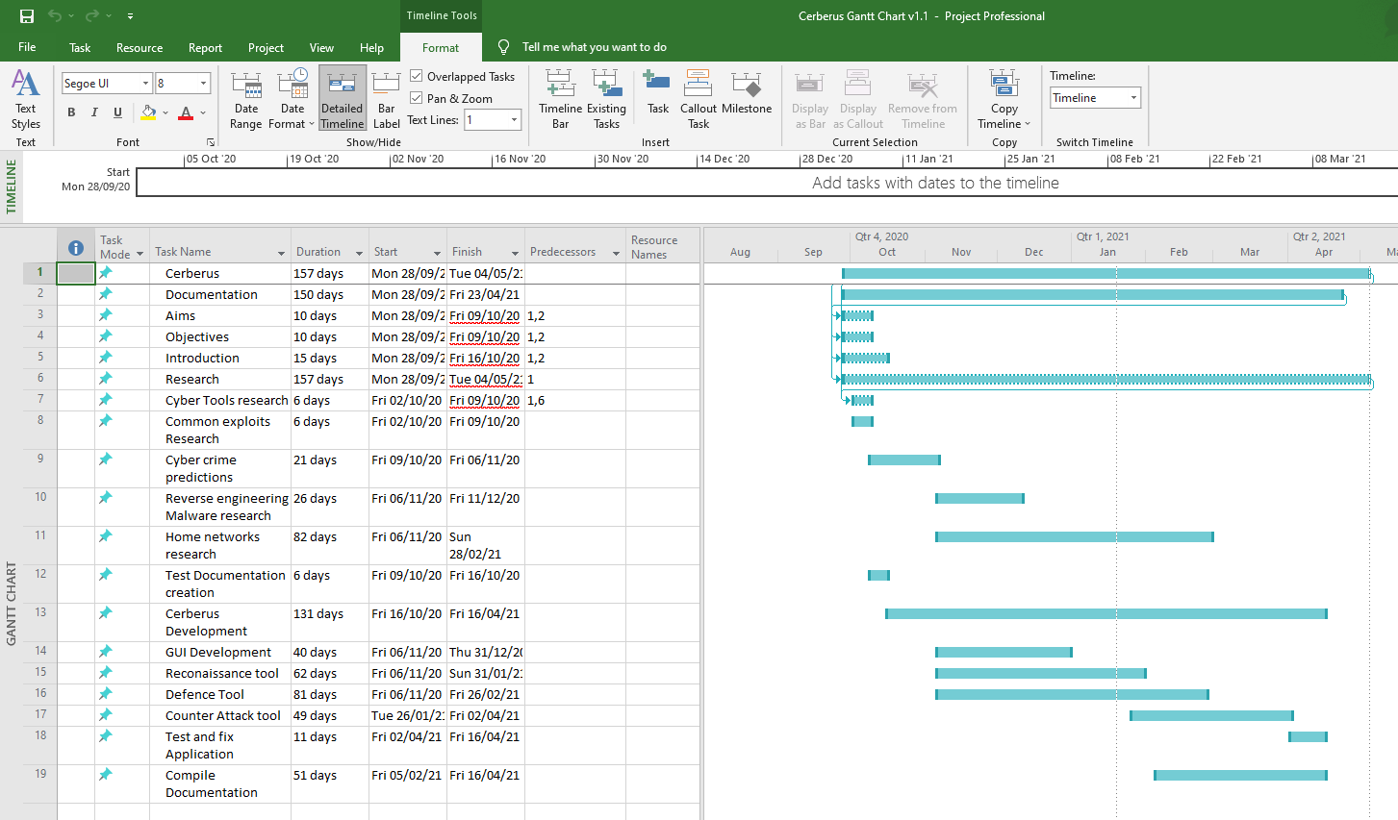
(Fig 1. Cerberus Gantt Chart V1.0)

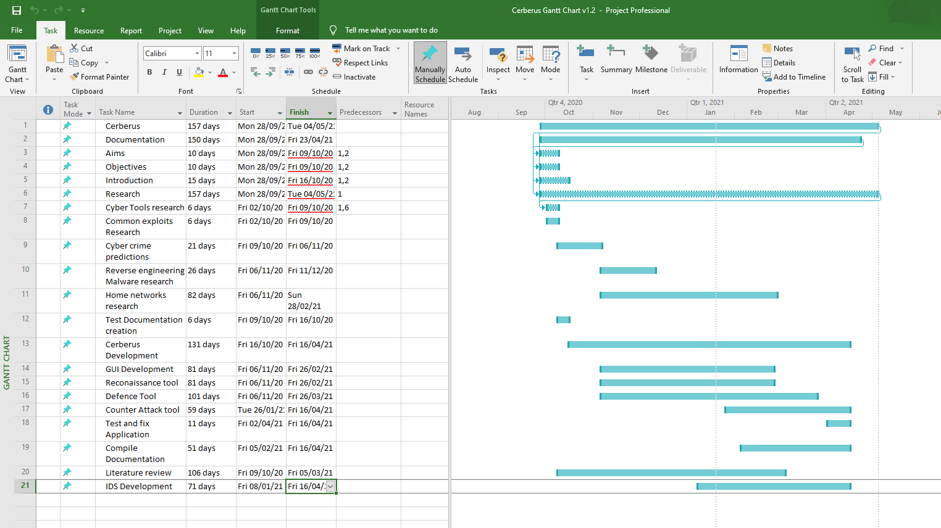
(Fig 2. Cerberus Gantt Chart V1.1)

3.2.2 Tools to be used

C# and visual studio 2019 and development in the .net 4.7 framework due to easy third-party installations being possible to change the style and add custom items to the project throughout the development is the reason why these have been chosen, another reason for choosing these is that having previous experience it will save time in the development meaning more can be done in shorter periods of time and problems will be less likely. Due to Cerberus being GUI Visual studio is the ideal IDE to be using for the development due to simplicity use of drag and drop when designing the forms.

WAMP server and MySQL will be used to develop the database.

3.2.3 Risks

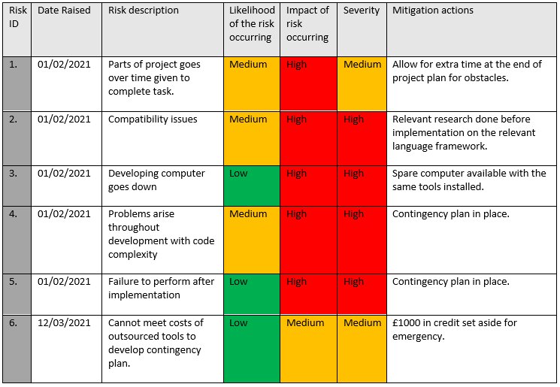

3.3 Contingency Plan

See Appendices 2.B.

4.0 Design

Considering Cerberus is a GUI (Graphical User Interface) solution the design phase is a very important piece of this report as it shows the user how Cerberus is supposed to look and operate while providing the end user with a smooth experience when in use.

4.1 Cerberus Storyboard

4.1.1 Home screen

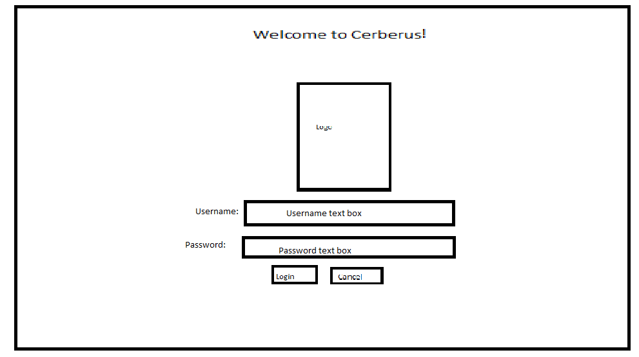

4.1.2 Login error message

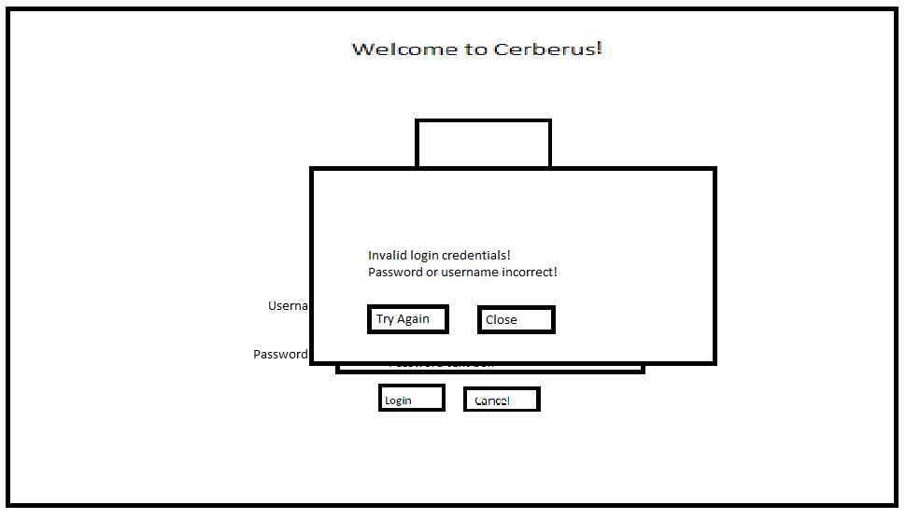

4.1.3 User access logged in

Close button closes whole program. Log out logs user out of session and returns them to home/log in screen.
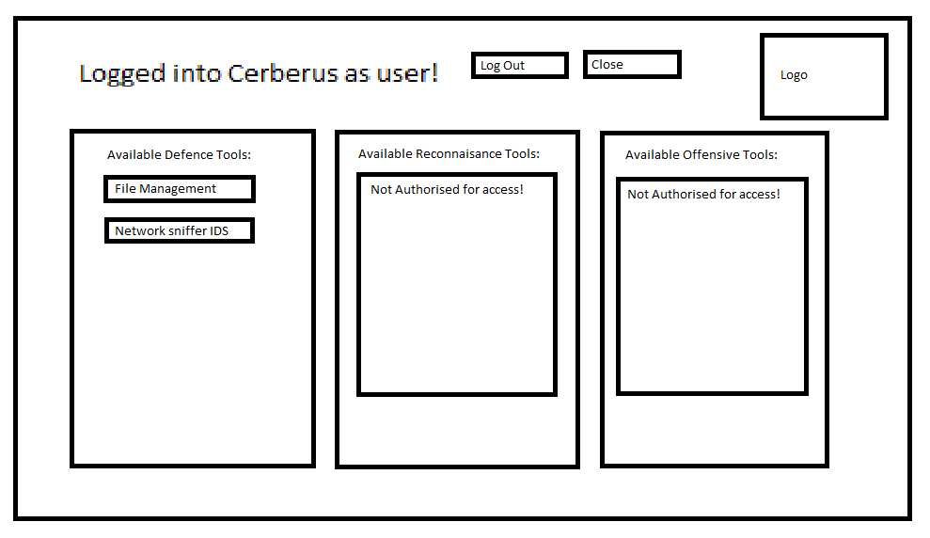

4.1.4 Admin access logged in

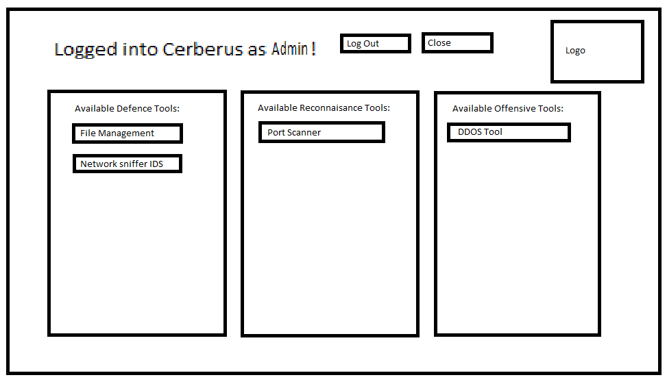

4.1.5 File Management system

Dependent on admin or user log in different permissions will be permitted, users only have access to view isolated files whereas Admin can make changes to all available files.

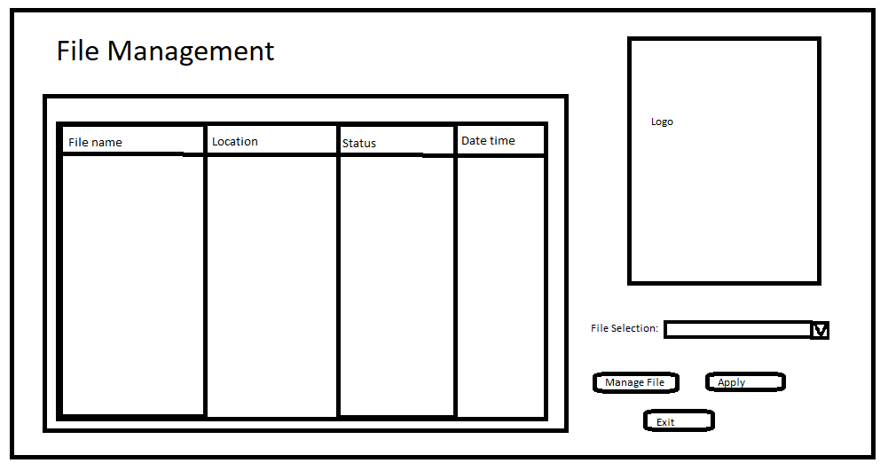

4.1.6 Network Sniffing and IDS

Dependent on live packets being viewed logo will change colour, red means packets matching a forbidden form has been identified, purple meaning abnormalities have been identified and awaiting user decision and blue means ids is running whereas Gray ids is not functional. User can select protocol from DataGrid view box and upon pressing inspect button will be able to manage the packets however only admin will have these control functions and other users will only be able to view.
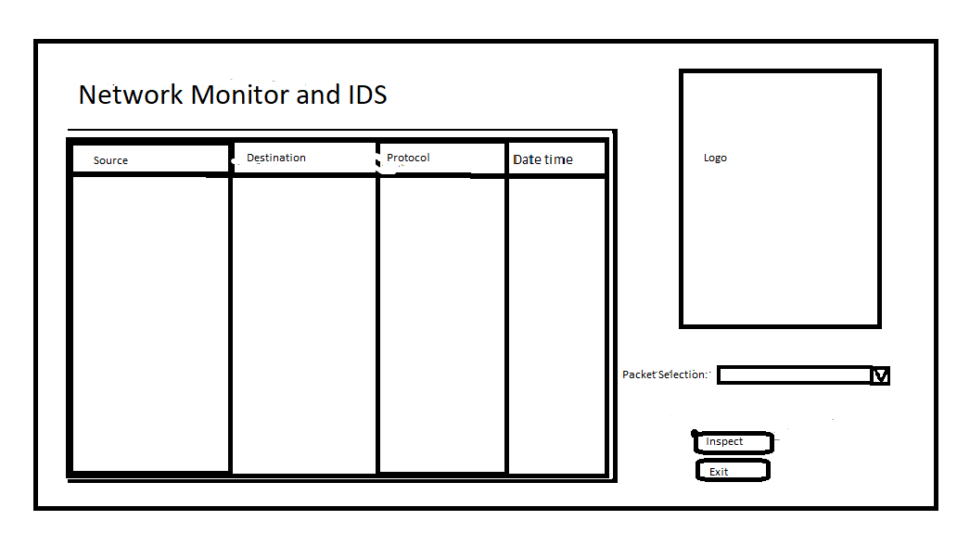

4.1.7 Port scanner

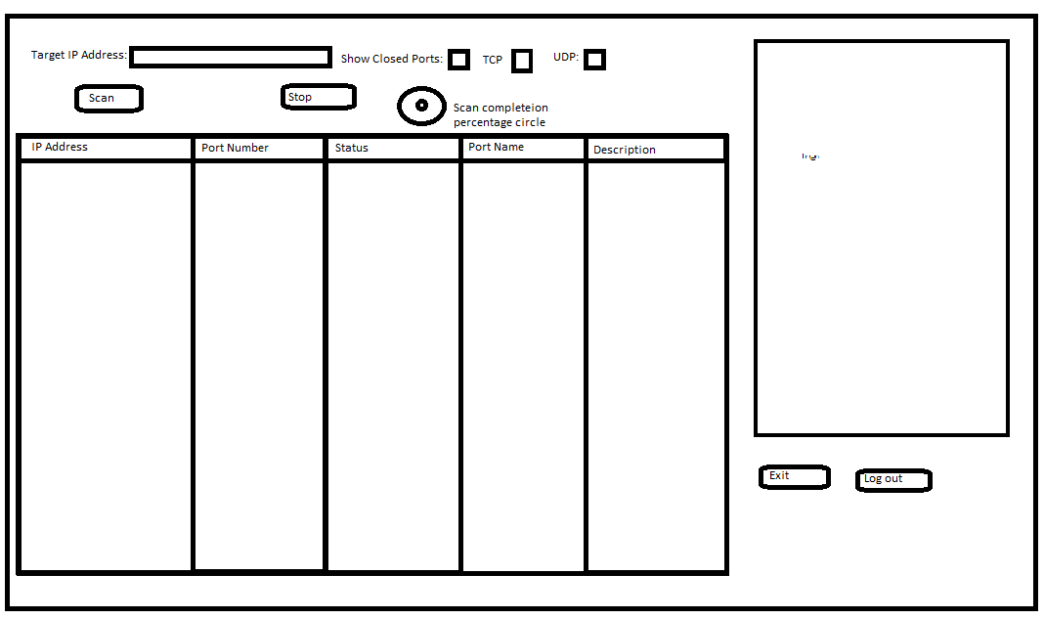

4.1.8 DDOS Tool

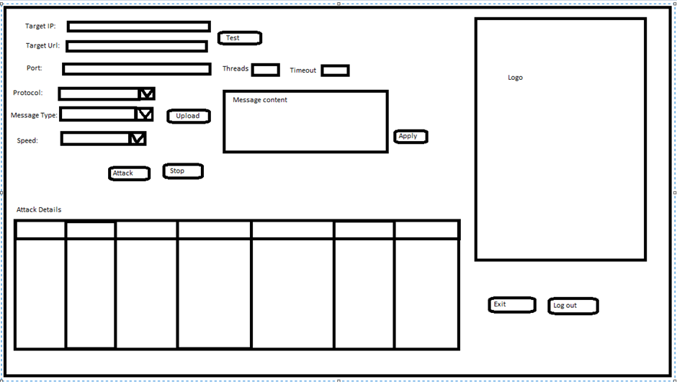

5.0 Implementation

The following is going into detail about how Cerberus has been implemented and the tools that was used to help with the development (90-95).

5.1 Project requirement

The requirement of Cerberus is to be a solution to ever growing cyber threat that is cybercriminals and zero-day exploits. Through research it was evident that zero-day exploits are on the rise as well as cybercrime due more IoT (Internet of Things) devices being released with no real security measures in place but had a lot of capability in terms of Wi-Fi connection and connections to unprotected web servers. When more IoT are being bought by people and taken into their homes it opens a new gateway into that person’s network in return providing a back door in so to say. By implementing a network security solution which can detect abnormalities it provides greater protection to people in their private homes especially with capabilities of being able to disrupt an attack by attacking the attack. Attacking the attack has been used for centuries by a Kung Fu system called Wing Chun and has been documented throughout history because of its effectiveness and is still used today by military special forces from all over the world. By implementing Cerberus with a GUI other than a CLI and developing Cerberus with techniques to close the gap between differences it serves as a great opportunity to educate the average person in cyber security without them having to learn complex syntax to operate the solution another way to look at would be a burglar would not want to break into a house if they knew there was a considerably large nasty dog inside it (128).

5.2 Tools Used

IDE – Visual Studio 2019

Language – C#

Framework - .Net Framework 4.7

Database – Microsoft Access

Hardware – One Gaming Laptop: ACER Predator, CPU 4.2 GHZ turbo boosted, 128gb NVMe SSD, 1GB SSD and 16GB RAM. Windows 10 Professional.

One ACER Laptop 2.3GHZ 512GB SSD 8GB RAM. Windows 10 Professional.

Other tools used for implementation are:
- FileZilla
- OpenVPN
- Ubuntu Server
- Digital ocean account
- Putty

5.3 Database

Consisting of four field the database was created in Microsoft access; the purpose of the database is connected to Cerberus Login Form to enable secure log in so only authorised users can use Cerberus. The four fields of the database are as follows:

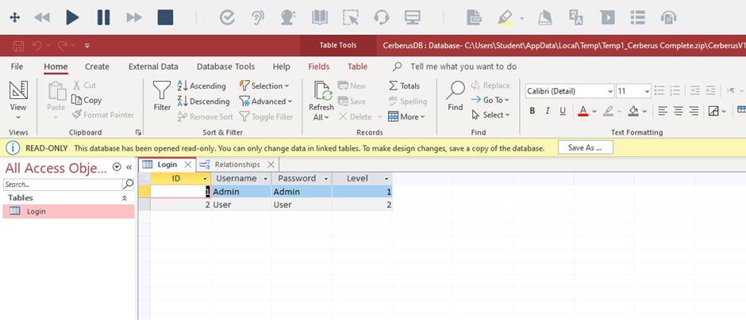

5.4 Cerberus Solution

5.4.1 Login

Using System.data.oledb after installation of the Microsoft Access Database Engine 2010 which is need to implement Access database alongside C# in Visual Studio allows for connection of the access database to the login form. When username and password data is entered in the textbox and is does not meet the data in the database table a message box appears stating wrong credentials have been inserted. When the password is entered in the password textbox the text is masked by the character * providing a layer of security in case someone is overlooking the user’s shoulder. Exit button closes the program and the login button verifies user credentials and grant user access to rest of Cerberus features. Cerberus V1.0 was developed to run from a My SQL connection using WAMP however, when the Predator laptop which it was being developed on failed because of corrupted net core and Cerberus was transferred over to the ASUS laptop WAMP and XAMPP would not work so Access database was used in its place. Originally to get the database to work using MySQL a download of MySQL for visual studio and MySQL connector net was needed then instead of using System.data.oledb MySql.Data.MySqlClient to add the package to the solution. Keeping in mind that the following implementation has been designed for each feature to work in conjunction with the IDS by orviding information from one feature to operate the other there are parts missing from the individual tools as compared to similar solutions of them developed by other developers such as the DDOSS tool has no port choice available to the user (also added safety feature at present) due to the future implementation of the IDS choosing the targeted ports from the results of the IP scanner etc. (108-112).

See Appendices 5.A for Cerberus solution.
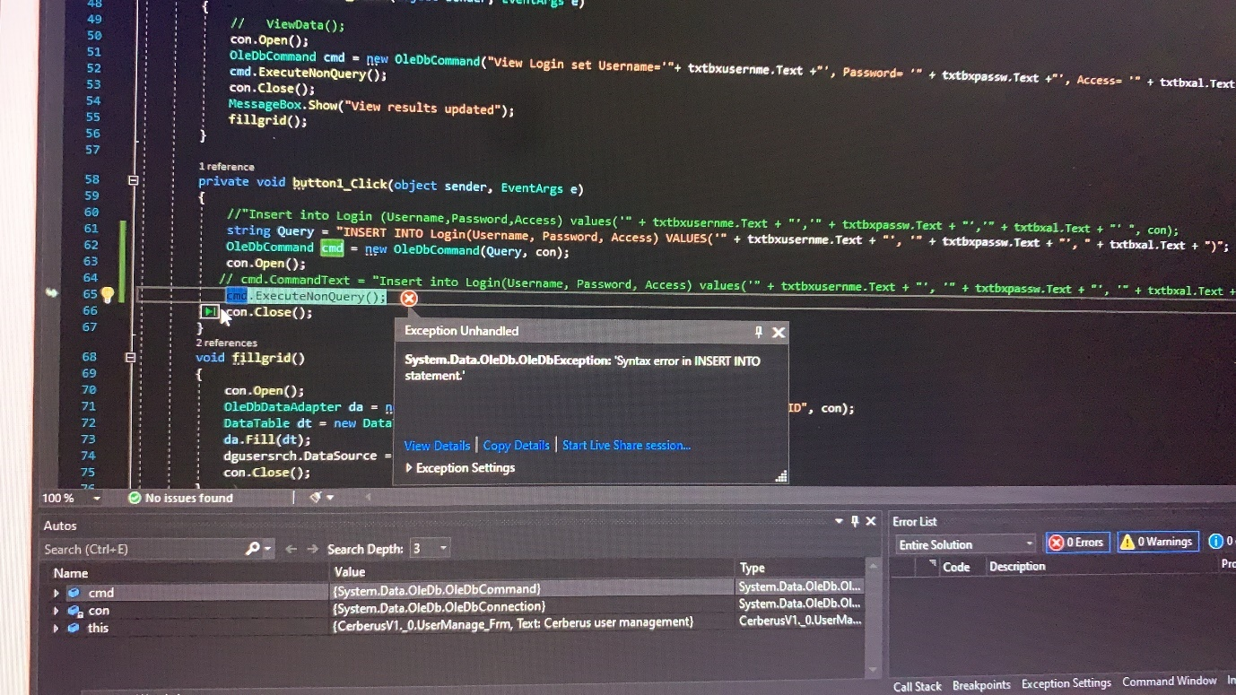
(Fig 3. Evidence of Database problem using WAMP)

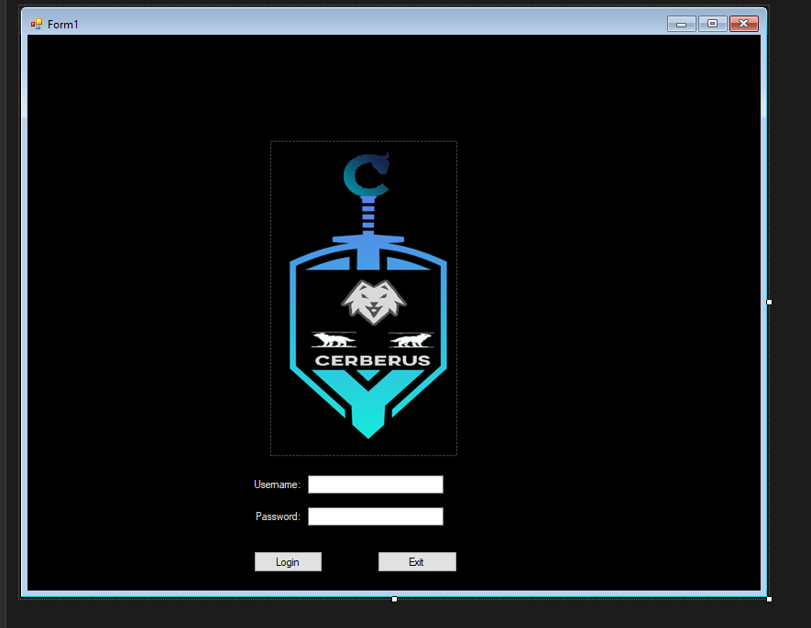
(Fig 4. Cerberus Login Screen)

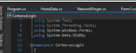
(Fig 5. Cerberus OleDB connection)

(Fig 6. Cerberus database connection file path)

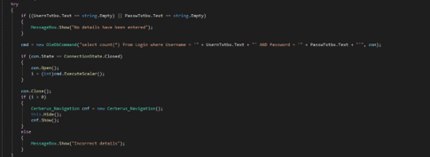
(Fig 7. Cerberus checking field values to username and password textbox)

5.4.3 Navigation and USB Detector

Providing the connection to all of Cerberus features the navigation form comprises of navigation buttons which when clicked opens the forms to the other features, the Navigation form also contains a USB detector in the form of a text box which will display when a USB device has been connected to the system which Cerberus is running on. Dependent on if the user wants to close the Cerberus or return to the Login Screen to change user by using this.close() and .show() commands. From research prior to development, it was evident that payloads from infected USB devices are a problem and by including a USB device detector it will log all USB device connections and disconnections which will allow the user to see any abnormalities and then using Cerberus other application the built-in antivirus the user can scan any unrecognised files for known viruses. When all features combined into Cerberus the navigation buttons did seem problematic at first due to the way the other features had to be referenced then programmed to be opened when buttons were clicked on but after a few internet searches it soon began to work (126-127).

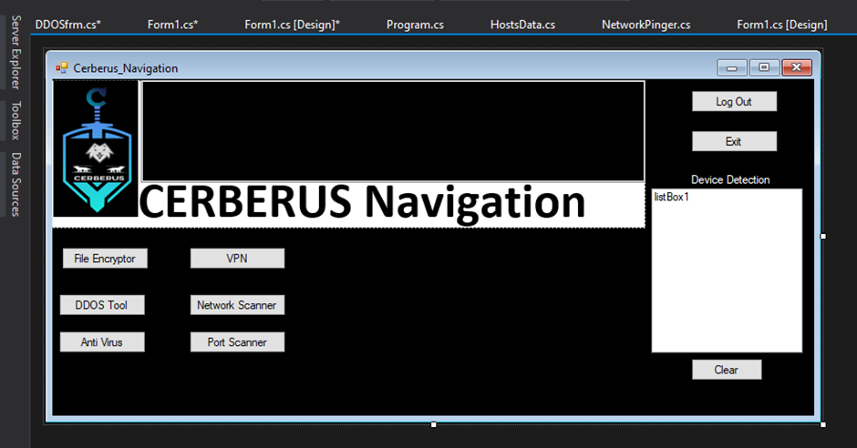
(Fig 8. Cerberus Navigation user interface and USB device detection)

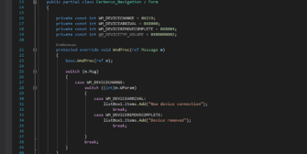
(Fig 9. Cerberus USB detection source code)

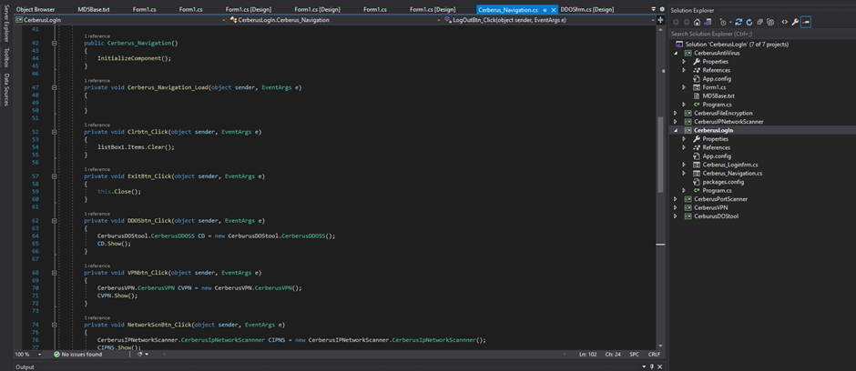
(Fig 10. Navigation form buttons to other features Part 1 of 2)

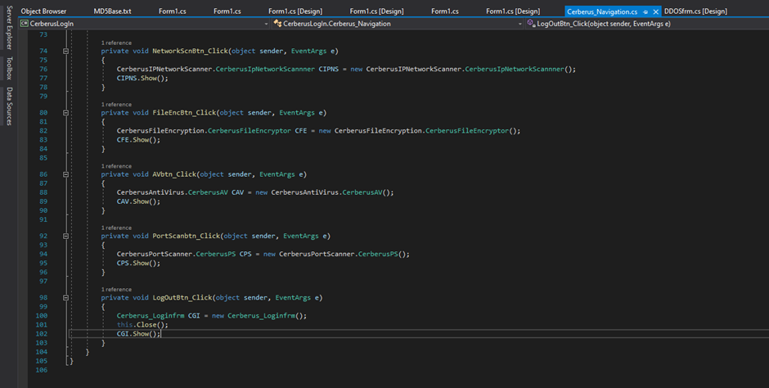
(Fig 11. Navigation form buttons to other features Part 2 of 2)

5.4.4 File Encryptor

File encryption is a great way of protecting files on a system as should the system that the files be breached by unauthorised users, they still will not be able to read any sensitive information on any encrypted files. The File Encryptor has been developed by using System.IO…… Using a browse button which allows the user to browse through files on the system and then choose the file they wish to encrypt or decrypt which the user needs to select by using one of the radio buttons. Before the user can encrypt or decrypt, they are required to enter a password, if there is no password entered a message box will appear telling the user that a password much be entered before encryption or decryption can be utilised. Although doing the job it is intended to do after much reading into stack overflow solutions it became evident that making the file encryptor work the way it was supposed to wasn’t going to happen, ideally the file encryptor would encrypt and decrypt a file without having to save it but due to the time remaining it had to be left the way it is (113).

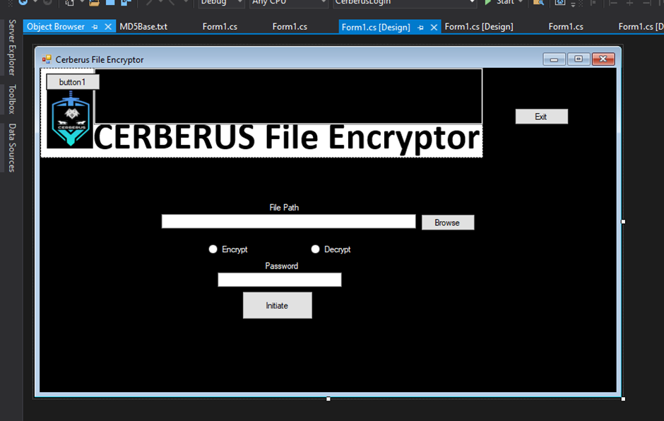
(Fig 12. User Interface for File Encryptor)

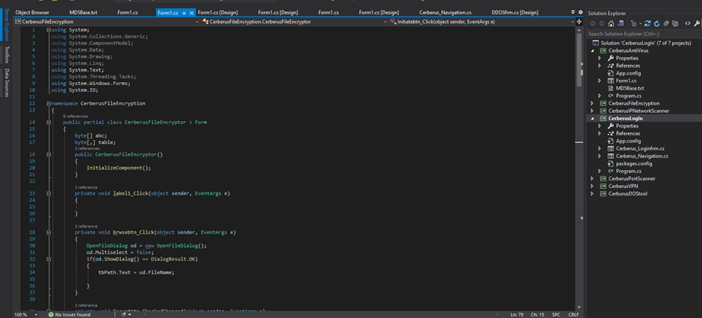
(Fig 13. Source code for file encryptor part 1 of 5)

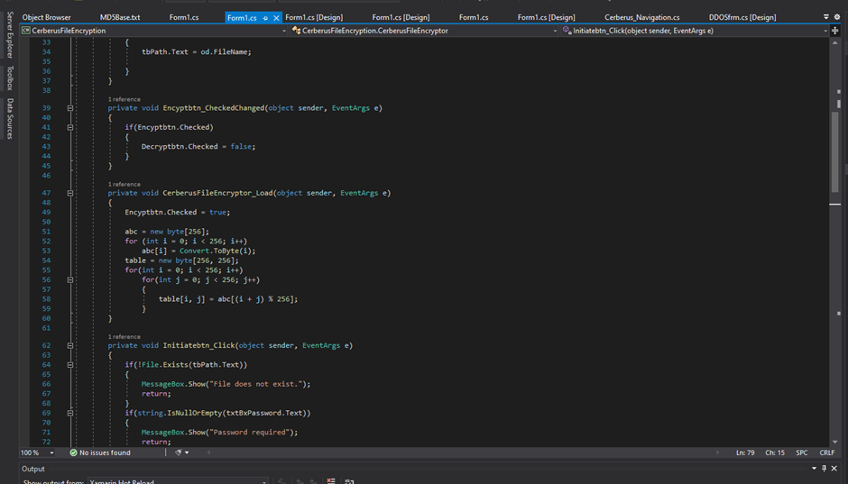
(Fig 14. Source code for file encryptor part 2 of 5)

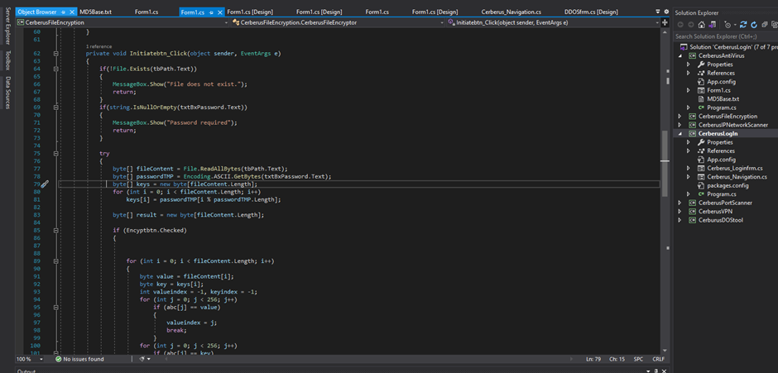
(Fig 15. Source code for file encryptor part 3 of 5)

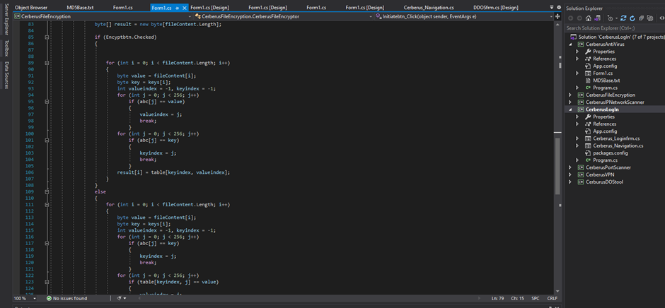
(Fig 16. Source code for file encryptor part 4 of 5)

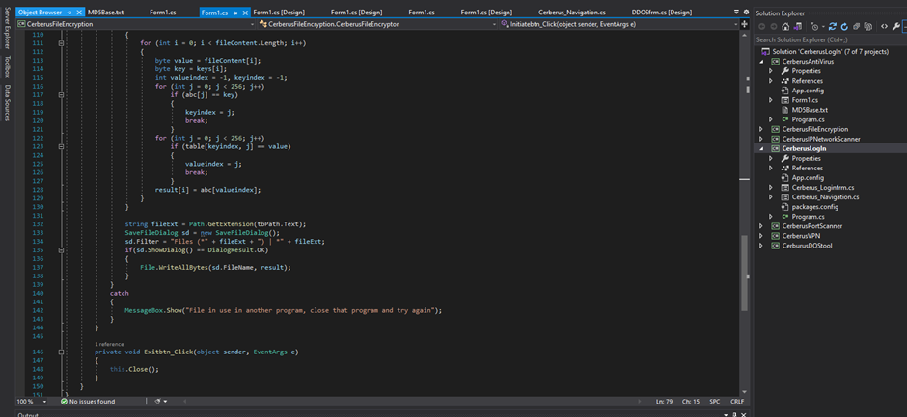
(Fig 17. Source code for file encryptor part 5 of 5)

5.4.5 Anti-Virus

The Anti-Virus has been developed in a way so it does not slow the system like similar solution to Cerberus users have been complaining about that it is running on by scanning files spontaneously, Cerberus puts the user in control and will only scan selected files when wanted or needed to by the user. Using a text file with a list of known viruses MD5 hashes, when a virus hash in a scanned file is the same as a virus hash in the MD5 text file the user will be notified by the red label stating infected, or green stating clear. The user will have a choice to delete the file or keep it if it is found to be infected. The virus hashes in the MD5 text file have been sourced from https://virusshare.com/. By using system.security.cryptography allows the antivirus program to use cryptographic services. The anti-virus feature is one features which unfortunately works better as a standalone project due to it became buggy after implementing it with all the other features of Cerberus however, it is still fully functional (114-115).

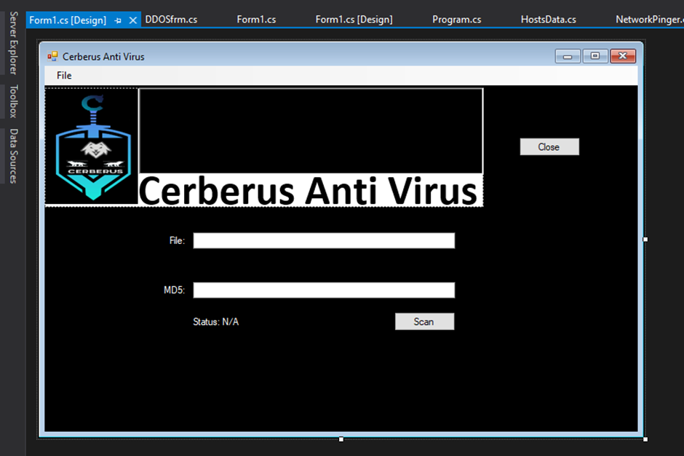
(Fig 18. User interface for Anti-Virus)

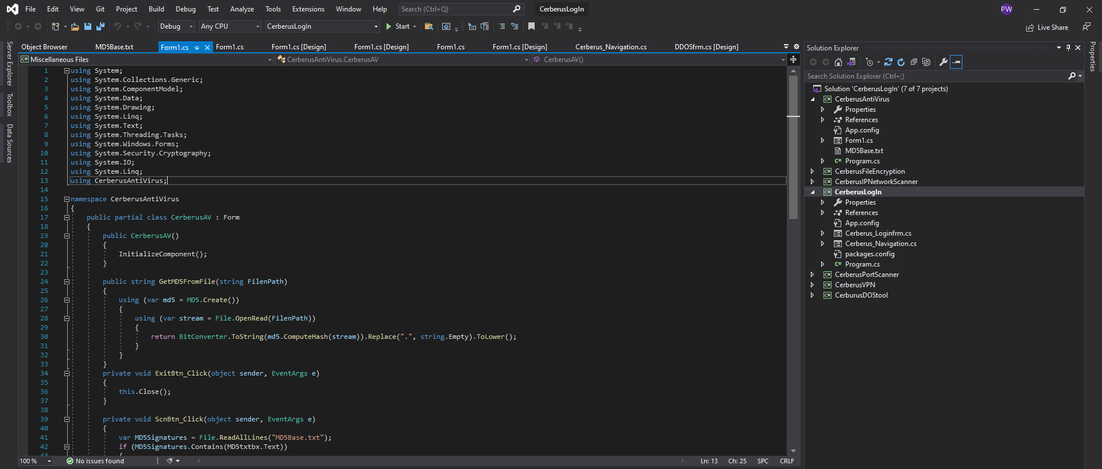
(Fig 19. Source code for Anti-Virus part 1 of 2)

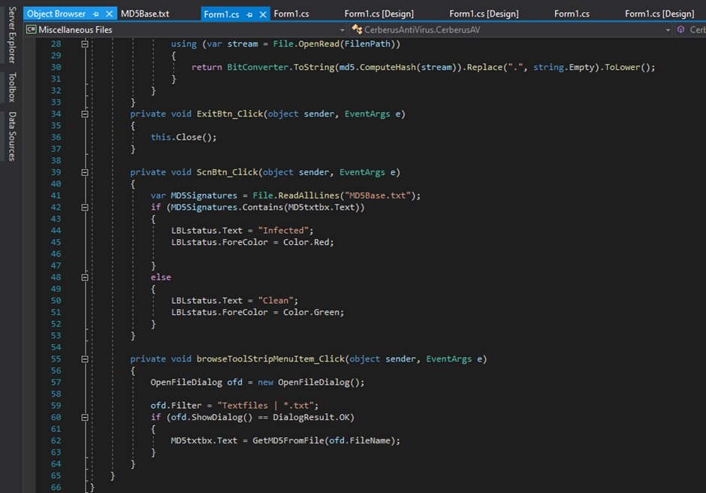
(Fig 20. Source code for Anti-Virus part 2 of 2)

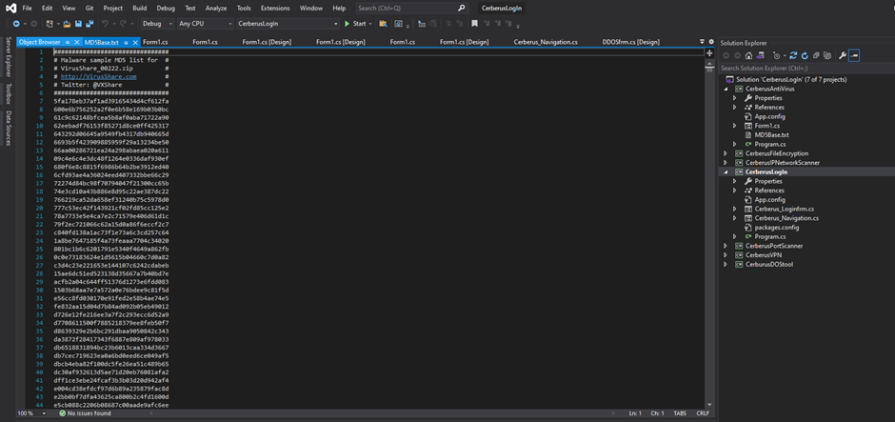
(Fig 21. Virus MD5 text file)

5.4.6 Network Scanner

As stated previously in the literature review GUIs are slower than CLI applications and a solution found during research to rectify this was using async and await which has been implemented into this Network scanner. Using two classes one of which called Network Pinger is the main engine of the network scanner without it the network scanner would not be able to operate and the other class being Host Data which stores the name and IP address of each successful ping that the Net Pinger does. The form which is the user interface compromises of a large multiline textbox which is implemented to display the scanners findings of devices which includes their device name and IP Address. As can be seen from the below image there is not anything for the user to type all the user needs to do is click scan and the network scanner will begin to ping 255 IP addresses on the local network of which the system it is running on is connected to. The pinging of the 255 IP Addresses is where the implementation of acronym and await function has been implemented to speed up the pinging process. The Net Pinger classes uses system.net.networkinformation to implement the IP pinging and the syste.diagnostics to evaluate the time it takes to successfully ping all scanned ip addresses. By far the most successful feature of Cerberus although development was lengthy the Network Scanner has really made the time and effort put into its development worthwhile especially when it is closing the efficiency gap between Graphical user interface command line interface solutions, admittedly it take a lot of research to learn how to implement the async and await functions to the extent it was thought to have been to complex (116-117).

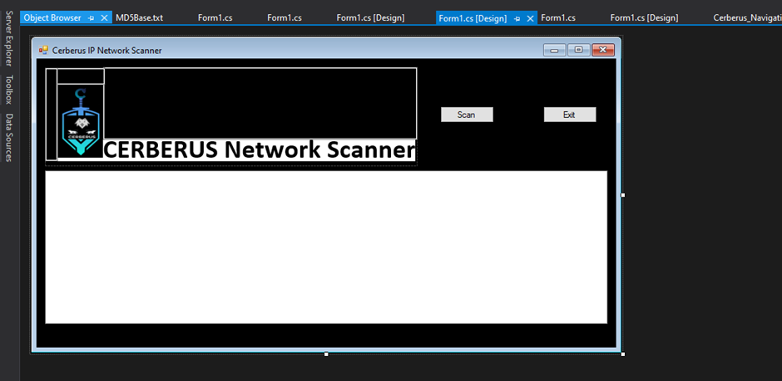
(Fig 22. User interface for Cerberus Network Scanner)

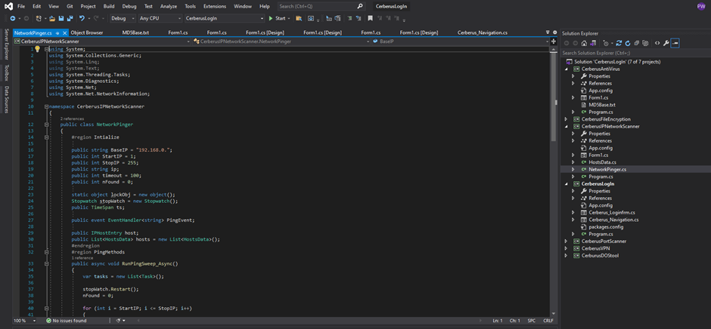
(Fig 23. Source code for Network Pinger class part 1 of 3)

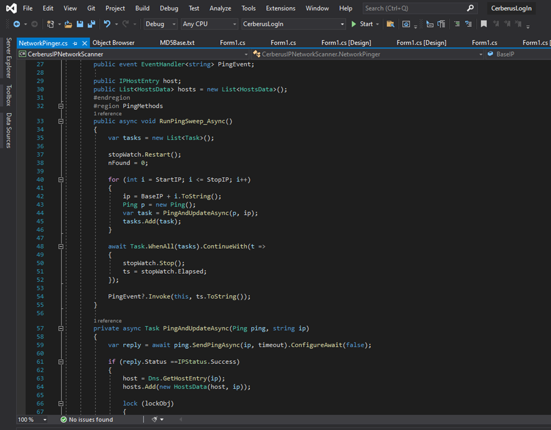
(Fig 24. Source code for Network Pinger class part 2 of 3)

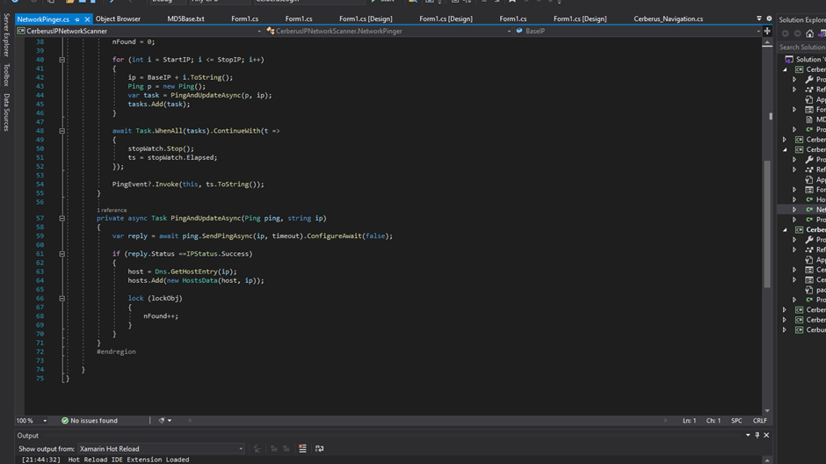
(Fig 25. Source code for Network Pinger class part 3 of 3)

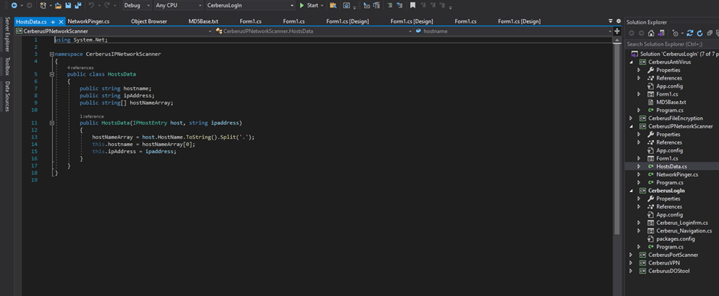
(Fig 26. Source code for host data class)

5.4.7 Port Scanner

Allowing the user to pick the target by typing in the targets IP Address and to choose which ports to scan from the below Port scanner displays to the user whether the targeted ports of the targeted system are open or closed, along with a progress bar underneath the designated port selection text boxes to show the progress of the port scan. As can be seen from the second image below the port scanner was developed using the system.net.sockets which was also discussed in the literature review (118-120). The Port Scanner was by far the most frustrating feature to develop especially when taking into consideration it partially being the reason for causing obstacles through trying to implement third party solutions to give it more complexity. Although loading the progress bar still does not function the way it was intended to.
.
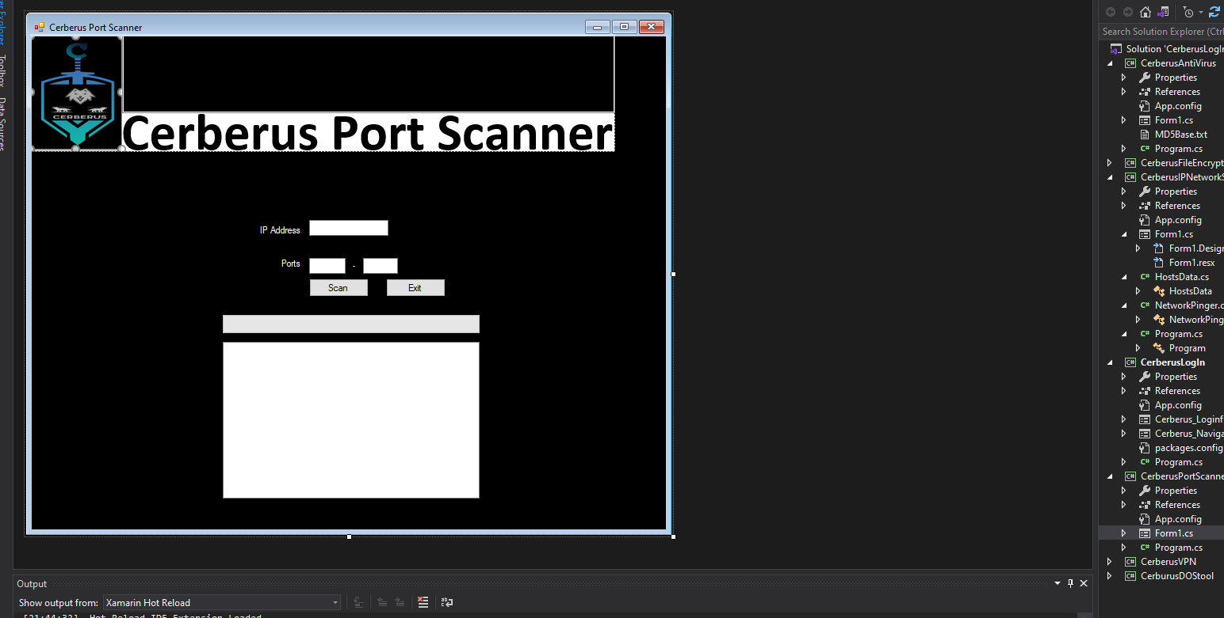
(Fig 27. User Interface for Cerberus Port Scanner)

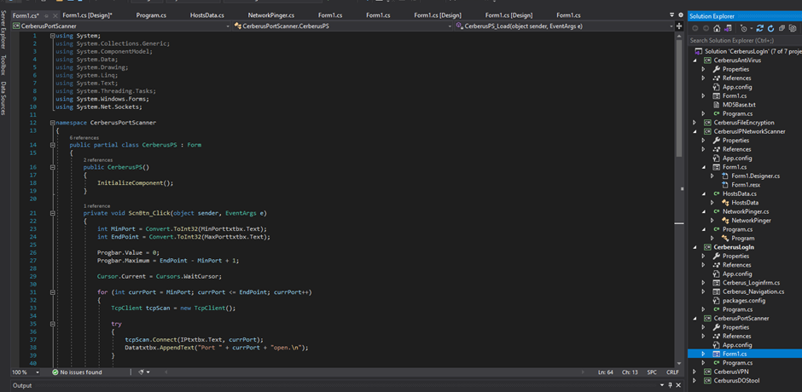
(Fig 28. Source code for Port Scanner Part 1 of 2)

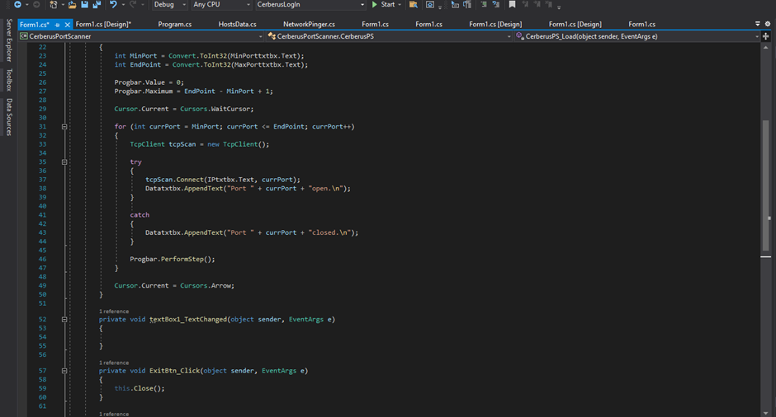
(Fig 29. Source code for Port Scanner Part 2 of 2)

5.4.8 DDOSS tool

This DDOSS tool has been made with user safety restrictions in mind by purposely leaving out the choice of port which the user could choose to attack (the port targeted is set at 80). The user has a text box of which they enter the targets IP address they wish to attack or test then by clicking the start button the attack will unleash a wave of UDP packets at the targeted IP address port, the attack needs to be stopped manually by clicking the stop button. When an attack is initiated, data relating to the attack is displayed in the multiline text box for the user to see the attack live as it unfolds. The most problematic part about coding the DDOSS tool was about how to go about implementing the targeted port without adding in designated ports to choose from to save time.

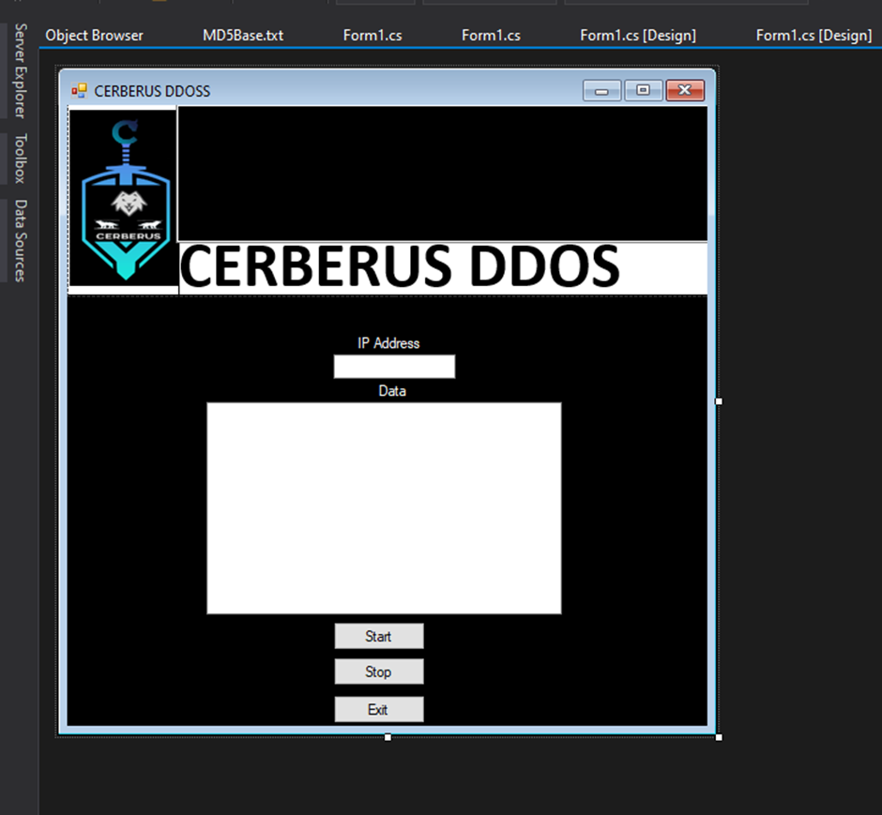
(Fig 29. User interface for Cerberus DDOSS tool)

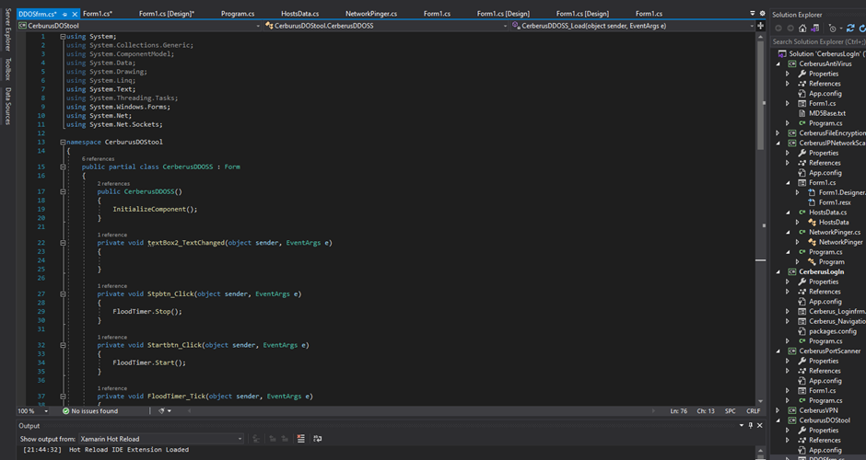
(Fig 30. Source code DDOSS tool part 1 of 2)

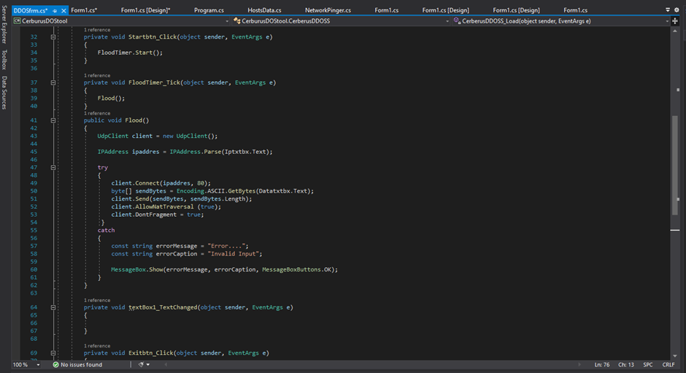
(Fig 31. Source code DDOSS tool part 2 of 2)

5.4.9 VPN

Providing the user with the choice between UDP or TCP connection Cerberus built in VPN has been developed with user choice in mind this also includes a dropdown textbox allowing the user to choose from a list of servers. The VPN server is Open VPN hosted on a ubuntu server in New York City which is provided by Ocean Digital as a test server for the project. When developing FileZilla needed to be implemented to allow for file transfer from the ubuntu server to the development computer to allow for changes to be made to server configuration files then be re uploaded to the server hosting the VPN connection. The VPN works by using the UDP and TCP radio buttons to select which connection type the user wishes to connect to where the connection link is separated in to two individual sever configuration .txt files. Before a connection can be made using a different connection type the user will need to disconnect from the other connection using the disconnect button first before establishing a new connection. When a connection has successfully established a message will appear to the user stating connection succeeded or should a connection fail, a different message will appear telling the user that connection had failed. The exit button allows the user to return to the navigation form when they have finished with the VPN.

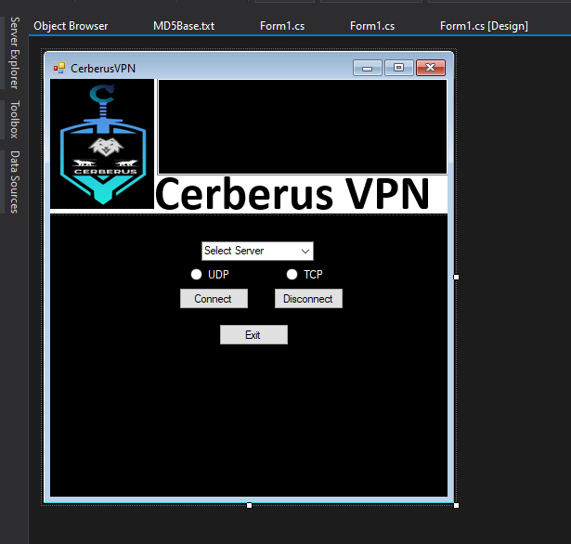
(Fig 32. User Interface for Cerberus VPN)

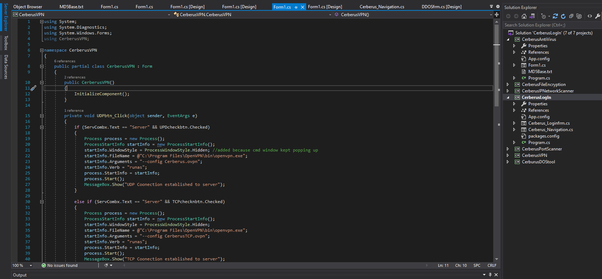
(Fig 33. Source code for Cerberus VPN part 1 of 2)

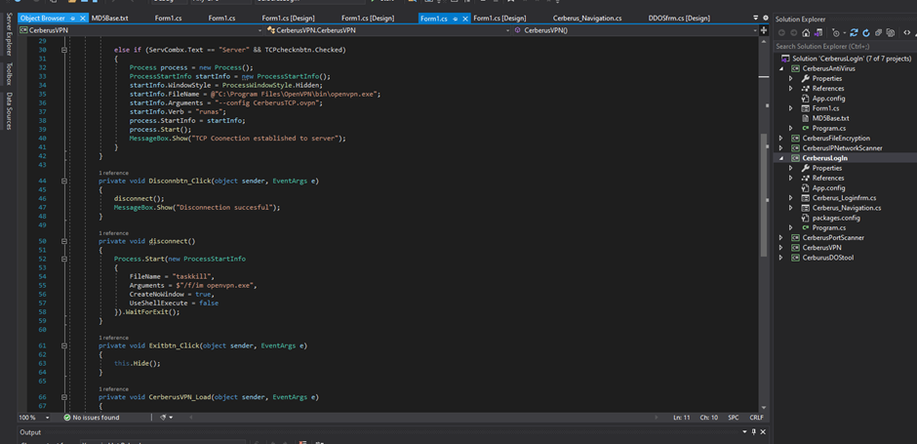
(Fig 34. Source code for Cerberus VPN part 2 of 2)

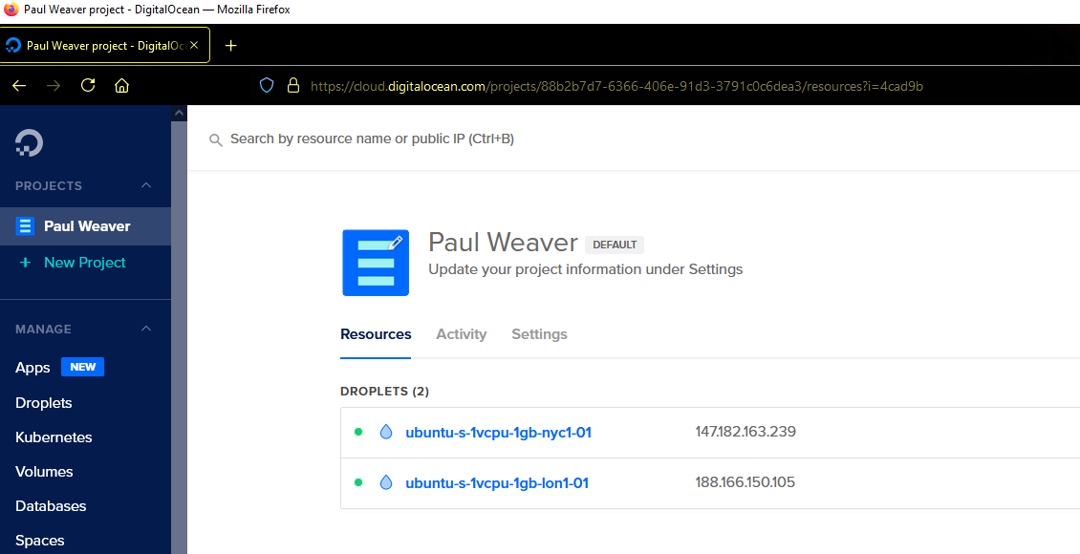
(Fig 35. Cerberus VPN Servers)

5.6 Conclusion

Individually all features of Cerberus when tested worked as intended however, when putting the pieces together it became very challenging due to having to reference different parts of the features into one and having to move the correct the correct files into the correct folders for the referencing to work. Although fully operational Cerberus when combined can be a bit buggy and slow in places especially with the message boxes as the user will sometimes need to hover over the program square at the bottom of the screen to see what parts of the program are running then click off the message boxes before continuing whereas when the parts of the program doing this are run separately from their own folders there are no problems like it. Also, due to adding future improvements to the features which have already been put together when checking the original folders, they have not updated along with their referenced versions, yet the folders are required to be in the same folder to function (125).

Testing of Cerberus was done by using Wireshark for network capture regarding the DDOSS tool which showed the UDP being sent from the Wi-Fi interface. The Port scanner was tested by scanning the ports 50 to 80 of another laptop on the local network. The file encryptor was tested by encrypting text files, photos, and folders. The user interface of all features was tested by 4 family members from the same household.

When the IDS is implemented, there is no doubt Cerberus will work ass originally intended.

5.7 Test documentation

Test documentation has been used throughout the development of the project and can be found in Appendices 3.A

6.0 Evaluation

Although not being able to complete the IDS (Intrusion Detection System) to the extent Cerberus would be self-sufficient the foundation is now certainly there and it providing it is accepted by the university Cerberus development could be carried to post graduate as the masters project as with further research and development there is no doubt that Cerberus can become one of the leaders of Next generation security solutions especially as home networks become hybrid networks where there is cellular connection through a sim carded dongle as well as the traditional router and modem connection which BT are claiming to be a unbreakable network due to the two connections which will means that the counter attack on Cerberus would need to be re-engineered or accompanied by more counter attack measures due to DDOSS attacks not being effective on dynamic IP (internet protocol) addresses (122).
Also, what has been evident as the project came to close whilst looking at what could have been implemented in terms for graphical interfaces like graphs and diagnostic monitors if the project had been created after installation of third-party solutions such as the metro framework (121).

Ideally this type of project would be best on a standalone system like its own router with the hardware components to run it with an interface which the user can log into using their personal device with a light login application being the gateway to access the login by doing this it will prevent any unnecessary performance issues which may affect the users’ machines as it currently stands like its similar solutions as previously discussed.
Overall Cerberus has been a success as it clearly shows the user their network, has defensive capabilities from the VPN, Antivirus, and file encryptor and has reconnaissance features by scanning ports of a targeted system on top of having an attack feature for counterattack. Although there is still a gap between a CLI application speed as compared to Cerberus it is evident that through using programming techniques the gap between them can and has been closed. As a whole Cerberus can detect infection, deploy counter measures to stop and prevent an attack and launch a successful counterattack. Unless implemented in a real-life scenario it can be told if Cerberus will reduce cybercrime however, Cerberus is capable defending a small home network without adversely affecting the performance of the network.
Total cost of project development is £10 for the cost of the Ubuntu server hosting due to implementation of the VPN and testing.

7.0 Conclusion

As a network security tool Cerberus does not affect any connected devices to the network unless the user targets a device themselves and launches an attack using the DDOSS tool after using the network scanner and port scanner. The DDOSS tool allows for a successful counterattack to be launched as of when needed by the user’s command. Cerberus DDOSS attack would benefit from implementation of a botnet army where a smaller version of Cerberus could be installed on other devices connected to the network and launches their own DDOSS attack on the targeted device as this would make the attack more effective.
Cerberus does not need any complex syntax for a user to operate due to the easy navigation of the use of the buttons and allows for easy operation of features through buttons and each feature compliments the other such as if the user suspects that there is a device connected to the network which should not be connected the network scanner will display the ip address of the device which the user can then input the shown IP address in to the DDOSS tool textbox then launch an attack. When a user makes an error the necessary message box will appear telling the user what has gone wrong or what needs to be done. If the IDS could have been implemented, it would have taken away the need for user operation.

Due to the way Cerberus has been developed it is very unlikely that Cerberus breaks any international laws due to the features being restricted to local home networks due to lack of facility throughout the development of a larger lab environment.

The way the antivirus has been implemented allows for new viruses to be added to the MD5 hash file as they are discovered thus keeping Cerberus antivirus up to date against new threats without affecting the performance of the user’s system which Cerberus is being run on. Thanks to the VPN and File Encryptor working in conjunction with the antivirus Cerberus can successfully defend and protect users and their data on their respected home networks and devices from cybercriminals should any attack attempts happen.

Without the IDS implemented the evidence gathering tool could not be implemented and as it currently stands the evidence gathering will need to be down to the user to screenshot and gather evidence using other means to successfully prosecute any attacks on their networks.
Cerberus is capable of being cross platform compatible due to being developed in C# which when implanted using Razor allows for Cerberus to be used a web application which can be used on any device with an internet connection due to it being hosted from a web server however this could not be implemented due to time and will be implemented in the future.

7.1 Suggestions for further work

The project from start to finish has been an enjoyable experience even though it has been really challenging, stressful and frustrating at times due to time and other problems mentioned in the report. As Cerberus stands now it allows for future improvements to be made and the IDS to be implemented in the near feature which will then allow for the evidence collecting of attacks to be implemented also which will most certainly bring cybercrime down due to the likelihood of a successful conviction. Due to personal care commitments during these already hard times, I have had to work to a very tight schedule throughout the project which alone created its own problems regarding time without the other obstacles which were unexpected.

Cerberus is certainly capable of adapting to ever changing situations and I will be implementing more features in terms of new counterattack features and isolation for infected files instead of having the user need to delete them. Throughout the research it was clear that ransomware is now the biggest threat to all technological users next to zero-day exploits, if a ransomware counterattack instead of a DDOSS attack the likelihood of prosecution would be raised due to the ransomware being able to encrypt the attackers’ systems and a decryption key can be provided to the authorities for the gathering evidence purpose.

It is suggested that the web-based application of Cerberus using Razor be implemented using access level control which has been implemented into Cerberus database but was out of scope and could not be implemented due to time, by doing this it will allow for restrictions of controls by certain users so they can only operate certain features of Cerberus whereas admin can access everything (129-130).

Once the IDS has been implemented new attack algorithms can be added to the database which will allow Cerberus to detect new forms of attacks on the user’s system and working in conjunction with other features could even possibly scan connected devices on the network for vulnerabilities which in return provides its own extra layer of security for other devices without being installed on them.

Due to the time that was remaining after losing the original work the port scanner development had to be rushed and in return it is slow and async and await functions or any third-party installations which could speed up its process has not been implemented into it so ideally it would be best to rebuild from scratch and further be concluded before redevelopment of the feature.

It is also recommended that further research is investigated about implementing the USB detector in conjunction the Antivirus so that the Antivirus will scan the connected USB device for infected files which may be stored in it and then warn the user whilst disabling the connection to the port which device is connected to by doing this risk of infection will be drastically reduced.

There is a rough draft of source code which I was originally trying to implement until the test method which I intended to use was not available on visual studio 2019 and the original developing laptop stopped working connected in the appendices which the reader can view if they want to have a sneak peek at how the IDS will be implemented in the future during the development of Cerberus V.2.0 however, it is a prototype of the prototype and in theory only detects DDOSS attacks by implementation of three but has not been implemented or tested in any way.

Due to the way Cerberus has been developed the possibilities for future features are endless and once the function of the IDS for home network security has been implemented it is possible that it could be further enhanced to include a full home security system also with the use of C#, Razor and the use of Arduino to create sensors and alerts on home doors and windows which will be able to alert the user if any are open or broken and can be alerted through to their personal devices.

8.0 Reflection

Looking over what has been developed over the course of the year it has been a great learning lesson as it has taught me that although something may seem to lack in efficiency compared to using another solution if properly planned and researched it is possible to close the efficiency gap by using better programming methods thus if it had to be done all over again more research would be done prior to beginning development in terms of programming algorithms and techniques to speed up efficiency.

Professionally the project has made me respect and take time management a lot more serious and has taught me that it is also important to balance personal life alongside the professional whilst maintaining a healthy lifestyle by looking after oneself, so it does not impact on the professional work.

The project has provided me with great confidence in everyday life and has taught me valuable problem-solving skills along with transferable skills that can be used in any work sector should a career change ever be needed. The project has also allowed prepared me and gave me the necessary skills needed to help me through with my post graduate study with the University when I do the masters Network and cybersecurity in September providing the degree grade of the bachelors is sufficient.

The project has really given me the chance to test the programming skills that I was taught during my foundation degree with UWTSD through Gower College Swansea and the skills which I was taught had certainly helped hone them and update them to a modern standard whilst developing a solution regarding the subject I most enjoy and in return it will without a doubt play a vital role in obtaining the exact job role I have been working towards for the past 8 years.

It is obvious that the Intrusion Detection System of Cerberus is the main feature of Cerberus to make it work, taking this into consideration more time should have been spent developing that rather than adding more features however, it can also be argued that the IDS would have been completed if the computer it was being developed on net.core did not become corrupt.

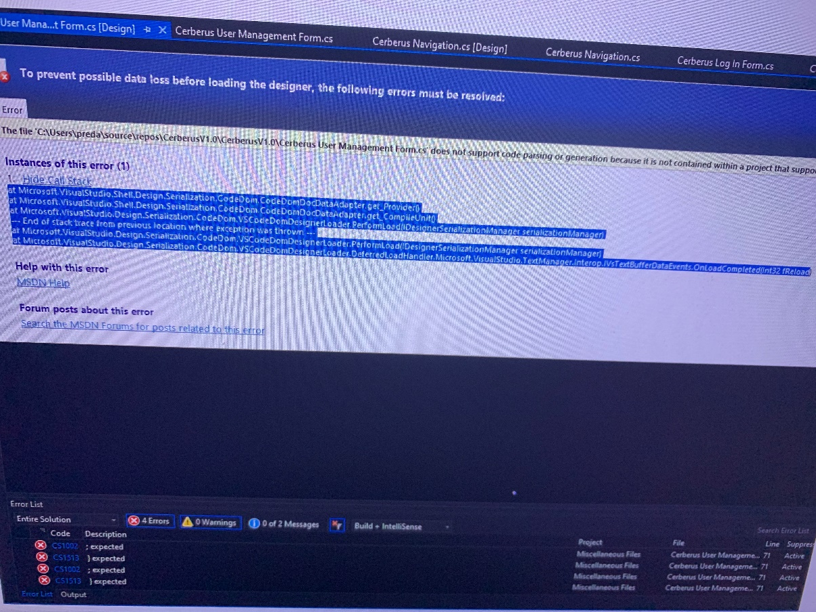

(Fig 36. Evidence of why contingency plan had to be implemented part 1 of 2)

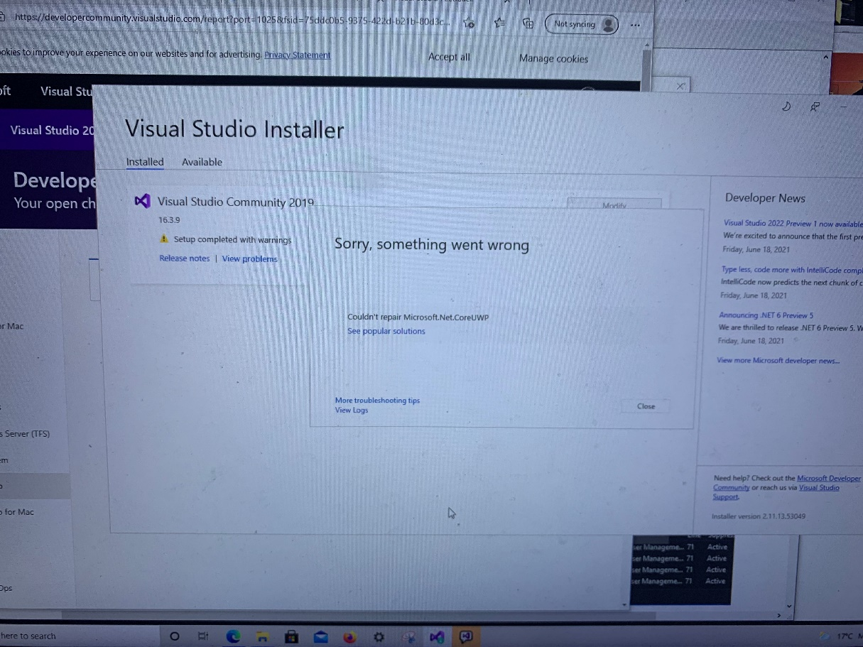
(Fig 37. Evidence of why contingency plan had to be implemented part 1 of 2)

See Appendices 4.A. for evidence showing why contingency plan had to be implemented.

9.0 Bibliography

[1] Garg, R., 2021. How to protect your technology and business information from cyber attacks - iPleaders. [online] iPleaders. Available at: <https://blog.ipleaders.in/protect-technology-business-information-cyber-attacks/> [Accessed 13 July 2021].
[2] Cybercrimejournal.com. 2021. [online] Available at: <http://cybercrimejournal.com/Brown2015vol9issue1.pdf> [Accessed 13 July 2021].
[3] Koyuncu, M. and Pusatli, T., 2021. Security Awareness Level of Smartphone Users: An Exploratory Case Study. [online] Available at: 3. <https://www.hindawi.com/journals/misy/2019/2786913/> [Accessed 13 July 2021].
[4] https://www.ncbi.nlm.nih.gov/pmc/articles/PMC6509749/ [Accessed 13 July 2021].
[5] Jang-Jaccard, J., &amp; Nepal, S. (2014, February 10). A survey of emerging threats in cybersecurity. Journal of Computer and System Sciences. https://www.sciencedirect.com/science/article/pii/S0022000014000178. [Accessed 13 July 2021].
[6] ExtremeTech. 2021. Extreme Archives - Page 495 of 1402 - ExtremeTech. [online] Available at: <https://www.extremetech.com/category/extreme/page/495> [Accessed 13 July 2021].
[7] https://www.ncbi.nlm.nih.gov/pmc/articles/PMC5370589/[Accessed 13 July 2021].
[8] https://www.imperosoftware.com/zh-cn/products/education-pro/classroom-management-2/ [Accessed 13 July 2021].
[9] https://www.wireshark.org/ [Accessed 13 July 2021].
[10] https://sysnetgs.com/ [Accessed 13 July 2021].
[11] https://securelist.com/apt-predictions-for-2021/99387 /[Accessed 13 July 2021].
[12] https://github.com/DedSecInside/TorBot [Accessed 13 July 2021].
[13] (PDF) Wireless Network Security: Vulnerabilities, T. and Network Security -Common Threats, a., 2021. Best job options for Common Wireless Network Vulnerabilities - 07/2021. [online] Linktoworks.com. Available at: <https://www.linktoworks.com/common-wireless-network-vulnerabilities> [Accessed 13 July 2021].
[14] Homenet Howto. 2021. IP addresses, Subnet Masks and IP networks - Homenet Howto. [online] Available at: <https://www.homenethowto.com/basics/ip-addresses/> [Accessed 13 July 2021].
[15] Documents.trendmicro.com. 2021. [online] Available at: <https://documents.trendmicro.com/assets/white_papers/wp-cybersecurity-risks-in-complex-iot-environments.pdf> [Accessed 13 July 2021].
[16] https://modemly.com/Sky-SR102-router-setup [Accessed 13 July 2021].
[17] teiss. 2021. Baby monitors & smart cameras "easily" hacked by criminals - teiss. [online] Available at: <https://www.teiss.co.uk/baby-monitors-smart-cameras-easily-hacked-by-criminals/> [Accessed 13 July 2021].
[18] https://www.samsung.com/in/support/tv-audio-video/how-to-protect-your-samsung-smart-tv-from-hacking-and-malicious-code/ [Accessed 13 July 2021].
[19] https://www.kaspersky.co.uk/resource-center/threats/secure-iot-devices-on-your-home-network [Accessed 13 July 2021].
[20] Taylor & Francis. 2021. Security and privacy in the internet of things. [online] Available at: <https://www.tandfonline.com/doi/full/10.1080/23738871.2017.1366536> [Accessed 13 July 2021].
[21] https://www.mcafee.com/blogs/consumer/how-do-hackers-hack-phones-and-how-can-i-prevent-it/ [Accessed 13 July 2021].
[22] Stern, J., 2021. What I Learned From the Hacker Who Spied on Me. [online] WSJ. Available at: <https://www.wsj.com/articles/what-i-learned-from-the-hacker-who-spied-on-me-11549559728> [Accessed 13 July 2021].
[23] https://www.verkada.com/blog/3-ways-to-hack-a-cctv-camera/[Accessed 13 July 2021].
[24] https://www.cover4insurance.com/insurance-products/personal/cyber-insurance[Accessed 13 July 2021].
[25] Dfw.cbslocal.com. 2021. Study: Burglars Could Hack Smart Sprinkler Systems To Disable Alarm. [online] Available at: <https://dfw.cbslocal.com/2018/12/12/study-burglars-hack-smart-sprinkler-systems-disable-alarm/> [Accessed 13 July 2021].
[26] profile, V., 2021. Project Zero: An iOS zero-click radio proximity exploit odyssey. [online] Sps1.blogspot.com. Available at: <https://sps1.blogspot.com/2020/12/project-zero-ios-zero-click-radio.html> [Accessed 13 July 2021].
[27] https://uk.norton.com/internetsecurity-mobile-android-vs-ios-which-is-more-secure.html [Accessed 13 July 2021].
[28] Hodge, R., 2021. iOS 13 vs. Android 10: Which is more secure? [online] CNET. Available at: <https://www.cnet.com/tech/mobile/ios-13-vs-android-10-which-os-is-more-secure/> [Accessed 13 July 2021].
[29] Protsenko, M. and Müller, T., 2021. Android Malware Detection Based on Software Complexity Metrics. https://link.springer.com/chapter/10.1007/978-3-319-09770-1_14 [Accessed 13 July 2021].
[30] https://searchsecurity.techtarget.com/definition/juice-jacking [Accessed 13 July 2021].
[31] https://www.bbc.co.uk/news/science-environment-54981425 [Accessed 13 July 2021].
[32] https://andersen-ev.com/products/andersen-a2/?gclid=EAIaIQobChMIkL2DuvLV7QIVB57tCh388gmfEAQYAiABEgJNRfD_BwE [Accessed 13 July 2021].
[33] https://www.amazon.co.uk/Electric-EV-Charging-commercial-manufactured/dp/B01N12OVZI/ref=asc_df_B01N12OVZI/?tag=googshopuk-21&linkCode=df0&hvadid=310668964056&hvpos=&hvnetw=g&hvrand=7353339342573280909&hvpone=&hvptwo=&hvqmt=&hvdev=c&hvdvcmdl=&hvlocint=&hvlocphy=1007454&hvtargid=pla-302013905418&psc=1 [Accessed 13 July 2021].
[34] https://www.myev.com/research/buyers-sellers-advice/best-smartphone-apps-for-ev-owners [Accessed 13 July 2021].
[35] Unodc.org. 2021. Cybercrime Module 5 Key Issues: Obstacles to Cybercrime Investigations. [online] Available at: <https://www.unodc.org/e4j/en/cybercrime/module-5/key-issues/obstacles-to-cybercrime-investigations.html> [Accessed 13 July 2021].
[36] https://www.legislation.gov.uk/ukpga/1998/42/contents [Accessed 13 July 2021].
[37] https://www.gov.uk/data-protection [Accessed 13 July 2021].
[38] https://www.legislation.gov.uk/ukpga/1990/18/contents [Accessed 13 July 2021].
[39] https://portswigger.net/daily-swig/computer-misuse-act-most-uk-cybersecurity-pros-fear- breaking-the-law-by-simply-doing-their-jobs [Accessed 13 July 2021].
[40] https://www.zdnet.com/article/anonymous-releases-an-os/ [Accessed 13 July 2021].
[41] https://pimylifeup.com/raspberry-pi-tor-access-point/ [Accessed 13 July 2021].
[42] https://tails.boum.org/ [Accessed 13 July 2021].
[43] https://www.kali.org/ [Accessed 13 July 2021].
[44] https://us.norton.com/internetsecurity-privacy-what-is-a-vpn.html [Accessed 13 July 2021].
[45] https://www.kali.org/docs/usb/kali-linux-live-usb-install/ [Accessed 13 July 2021].
[46] https://www.virtualbox.org/ [Accessed 13 July 2021].
[47] https://www.varonis.com/blog/what-is-a-proxy-server/ [Accessed 13 July 2021].
[48] https://www.asus.com/uk/networking-iot-servers/wifi-routers/rog-republic-of-gamers/filter?Series=ROG-Republic-of-Gamers [Accessed 13 July 2021].
[49] https://www.n-able.com/blog/how-do-firewalls-work [Accessed 13 July 2021].
[50] https://www.imperva.com/learn/application-security/intrusion-detection-prevention/ [Accessed 13 July 2021].
[51] https://www.malwarebytes.com/spoofing [Accessed 13 July 2021].
[52] https://us.norton.com/internetsecurity-malware-ip-spoofing-what-is-it-and-how-does-it-work.html [Accessed 13 July 2021].
[53] https://www.google.com/url?sa=t&rct=j&q=&esrc=s&source=web&cd=&ved=2ahUKEwi6-tvGs9PxAhVE6aQKHQEDAYAQFjAAegQIBRAD&url=https%3A%2F%2Fnordvpn.com%2F&usg=AOvVaw0NXOpR2zVRT8zX0g3f1fq [Accessed 13 July 2021].
[54] https://gchq.github.io/CyberChef/ [Accessed 13 July 2021].
[55] https://www.google.com/url?sa=t&rct=j&q=&esrc=s&source=web&cd=&cad=rja&uact=8&ved=2ahUKEwiXyI6htNPxAhUHHOwKHQImDEQQFjAAegQIDxAD&url=https%3A%2F%2Fwww.kali.org%2F&usg=AOvVaw3j7AL-f4E1FDyRP_ygi8cR [Accessed 13 July 2021].
[56] https://www.google.com/url?sa=t&rct=j&q=&esrc=s&source=web&cd=&cad=rja&uact=8&ved=2ahUKEwix-Y-utNPxAhWJHewKHczFA4AQFjAAegQIBBAD&url=https%3A%2F%2Fwww.metasploit.com%2F&usg=AOvVaw3oeQluU2zEZCt8Qt65PPag [Accessed 13 July 2021].
[57] https://www.google.com/url?sa=t&rct=j&q=&esrc=s&source=web&cd=&cad=rja&uact=8&ved=2ahUKEwi6mNm8tNPxAhVOnaQKHQ2zDWUQFjAAegQIAhAD&url=https%3A%2F%2Fsourceforge.net%2Fprojects%2Floic%2F&usg=AOvVaw2b-eDcmZxiCECO8BtXBGOP [Accessed 13 July 2021].
[58] https://www.google.com/url?sa=t&rct=j&q=&esrc=s&source=web&cd=&cad=rja&uact=8&ved=2ahUKEwjDma7ItNPxAhWKs6QKHaEfDuYQFjAAegQIAhAD&url=https%3A%2F%2Fwww.parrotsec.org%2F&usg=AOvVaw3ZEmvbSwHojIfTpaE0V9Sc [Accessed 13 July 2021].
[59] https://www.trentonsystems.com/blog/solarwinds-hack-overview-prevention [Accessed 13 July 2021].
[60] https://www.npr.org/2021/04/16/985439655/a-worst-nightmare-cyberattack-the-untold-story-of-the-solarwinds-hack [Accessed 13 July 2021].
[61] https://www.mcafee.com/enterprise/en-gb/security-awareness/ransomware/what-is-stuxnet.html [Accessed 13 July 2021].
[62] https://www.crn.com/news/security/cisco-hacked-through-solarwinds-as-tech-casualties-mount [Accessed 13 July 2021].
[63] https://www.securitymagazine.com/gdpr-policy?url=https%3A%2F%2Fwww.securitymagazine.com%2Farticles%2F93608-hidden-risks-with-third-party-software-and-how-to-mitigate-those-risks [Accessed 13 July 2021].
[64] https://searchsecurity.techtarget.com/definition/web-server-security [Accessed 13 July 2021].
[65] https://www.csoonline.com/article/3398485/28-devsecops-tools-for-baking-security-into-the-development-process.html [Accessed 13 July 2021].
[66] https://www.csoonline.com/article/3315700/what-is-application-security-a-process-and-tools-for-securing-software.html [Accessed 13 July 2021].
[67] https://pediaa.com/difference-between-gui-and-cli/[Accessed 13 July 2021].
[68] https://online.norwich.edu/academic-programs/resources/who-are-cyber-criminals [Accessed 13 July 2021].
[69] https://blog.f-secure.com/what-are-state-sponsored-cyberattacks/ [Accessed 13 July 2021].
[70] https://securitytrails.com/blog/hacker-vs-cracker [Accessed 13 July 2021].
[71] https://csis-website-prod.s3.amazonaws.com/s3fs-public/legacy_files/files/media/csis/pubs/021101_risks_of_cyberterror.pdf [Accessed 13 July 2021].
[72] https://www.kaspersky.com/resource-center/threats/deep-web [Accessed 13 July 2021].
[73] https://www.complex.com/pop-culture/2016/09/pwn-phone-mr-robot-real [Accessed 13 July 2021].
[74] https://www.informit.com/articles/article.aspx?p=30048 [Accessed 13 July 2021].
[75] https://www.washingtonpost.com/news/powerpost/paloma/the-cybersecurity-202/2018/08/03/the-cybersecurity-202-the-law-doesn-t-protect-ethical-hackers-this-new-project-could-help-close-that-gap/5b6330421b326b0207955ecb/ [Accessed 13 July 2021].
[76] https://portswigger.net/daily-swig/computer-misuse-act-most-uk-cybersecurity-pros-fear-breaking-the-law-by-simply-doing-their-jobs [Accessed 13 July 2021].
[77] https://edu.gcfglobal.org/en/computerbasics/using-accessibility-features/1/ [Accessed 13 July 2021].
[78] https://www.codeguru.com/csharp/csharp/benefits-of-c.html [Accessed 13 July 2021].
[79] https://agilites.com/pros-and-cons-of-using-c-as-your-backend-programming-language.html [Accessed 13 July 2021].
[80] https://docs.microsoft.com/en-us/dotnet/framework/network-programming/ [Accessed 13 July 2021].
[81] https://docs.microsoft.com/en-us/dotnet/framework/network-programming/ [Accessed 13 July 2021].
[82] https://news.microsoft.com/bythenumbers/en/windowsdevices [Accessed 13 July 2021].
[83] http://csharp.net-informations.com/communications/csharp-socket-programming.htm [Accessed 13 July 2021].
[84] https://docs.microsoft.com/en-us/dotnet/csharp/programming-guide/concepts/async/ [Accessed 13 July 2021].
[85] https://docs.microsoft.com/en-us/dotnet/csharp/async [Accessed 13 July 2021].
[86] https://www.c-sharpcorner.com/article/async-and-await-in-c-sharp/ [Accessed 13 July 2021].
[87] https://www.netresec.com/?page=networkminer [Accessed 13 July 2021].
[88] https://www.winpcap.org/ [Accessed 13 July 2021].
[89] https://github.com/chmorgan/sharppcap [Accessed 13 July 2021].
[90] https://www.digitalocean.com/community/tutorials/how-to-set-up-an-openvpn-server-on-ubuntu-16-04 [Accessed 13 July 2021].
[91] https://filezilla-project.org/ [Accessed 13 July 2021].
[92] https://ubuntu.com/download/server [Accessed 13 July 2021].
[93] https://openvpn.net/ [Accessed 13 July 2021].
[94] https://visualstudio.microsoft.com/ [Accessed 13 July 2021].
[95] https://dotnet.microsoft.com/download/dotnet-framework/net47 [Accessed 13 July 2021].
[96] https://www.microsoft.com/en-ww/microsoft-365/access [Accessed 13 July 2021].
[97] https://www.wampserver.com/en/ [Accessed 13 July 2021].
[98] https://www.apachefriends.org/index.html [Accessed 13 July 2021].
[99] https://codebuns.com/wordpress/fix-port-80-conflict-wamp/ [Accessed 13 July 2021].
[100] https://www.cybereason.com/ [Accessed 13 July 2021].
[101] https://www.gartner.com/reviews/market/endpoint-detection-and-response-solutions/vendor/cybereason/product/cybereason-defense-platform [Accessed 13 July 2021].
[102] https://www.mcafee.com/en-gb/index.html [Accessed 13 July 2021].
[103] https://uk.trustpilot.com/review/www.mcafee.com [Accessed 13 July 2021].
[104] https://www.kaspersky.co.uk/ [Accessed 13 July 2021].
[105] https://uk.trustpilot.com/review/www.kaspersky.co.uk [Accessed 13 July 2021].
[106] https://uk.norton.com/ [Accessed 13 July 2021].
[107] https://uk.trustpilot.com/review/www.norton.com [Accessed 13 July 2021].
[108] http://csharp.net-informations.com/data-providers/csharp-oledb-connection.htm [Accessed 13 July 2021].
[109] https://www.microsoft.com/en-us/download/details.aspx?id=13255 [Accessed 13 July 2021].
[110] https://www.codeproject.com/Tips/666932/Using-Masked-TextBox-in-NET [Accessed 13 July 2021].
[111] https://dev.mysql.com/downloads/windows/visualstudio/ [Accessed 13 July 2021].
[112] https://ozanecare.com/connect-mysql-with-visual-studio-2019/ [Accessed 13 July 2021].
[113] https://docs.microsoft.com/en-us/windows/win32/devio/wm-devicechange [Accessed 13 July 2021].
[114] https://virusshare.com/ [Accessed 13 July 2021].
[115] https://docs.microsoft.com/en-us/dotnet/api/system.security.cryptography?view=net-5.0 [Accessed 13 July 2021].
[116] https://foxlearn.com/windows-forms/how-to-scan-ip-address-in-a-network-using-csharp-507.html [Accessed 13 July 2021].
[117] https://www.codeproject.com/Articles/10190/Implement-a-basic-IP-Scanner-for-a-local-LAN-in-C [Accessed 13 July 2021].
[118] https://jonlabelle.com/snippets/view/csharp/simple-c-open-port-network-scanner [Accessed 13 July 2021].
[119] https://stackoverflow.com/questions/52569696/c-sharp-port-scanner [Accessed 13 July 2021].
[120] https://www.programmersought.com/article/82117636948/ [Accessed 13 July 2021].
[121] https://thielj.github.io/MetroFramework/ [Accessed 13 July 2021].
[122] https://www.bt.com/exp/halo?s_intcid=con_redirect_halo [Accessed 13 July 2021].
[123] https://www.nationalcrimeagency.gov.uk/?view=article&id=243:ddos-attacks-are-illegal&catid=2 [Accessed 13 July 2021].
[124] https://www.security.org/vpn/ddos/ [Accessed 13 July 2021].
[125] https://stackoverflow.com/questions/37397568/how-to-add-a-project-as-a-reference-of-another-project [Accessed 13 July 2021].
[126] https://stackoverflow.com/questions/23700587/c-sharp-calling-a-form-from-another-project [Accessed 13 July 2021].
[127] https://stackoverflow.com/questions/6003822/how-to-detect-a-usb-drive-has-been-plugged-in [Accessed 13 July 2021].
[128] https://www.iaw-tonbridge.com/principles--mottoes-of-wingchun.html [Accessed 13 July 2021].
[129] https://docs.microsoft.com/en-us/aspnet/web-pages/overview/getting-started/introducing-razor-syntax-c [Accessed 13 July 2021].
[130] https://www.w3schools.com/asp/razor_syntax.asp [Accessed 13 July 2021].

10.0 Appendices

1.A. Literature review continued

2.A. Research Methodology

2.B. Contingency Plan

3.A. Testing Sheet

4.A. IDS Prototype

5.A. Cerberus Solution

