Source: Architectural Digest (2024)
Source: LX Collection (No Date)
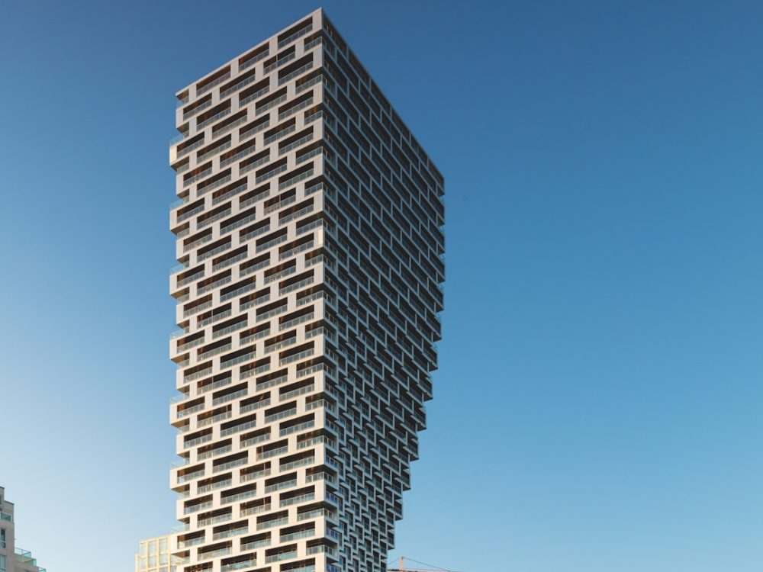  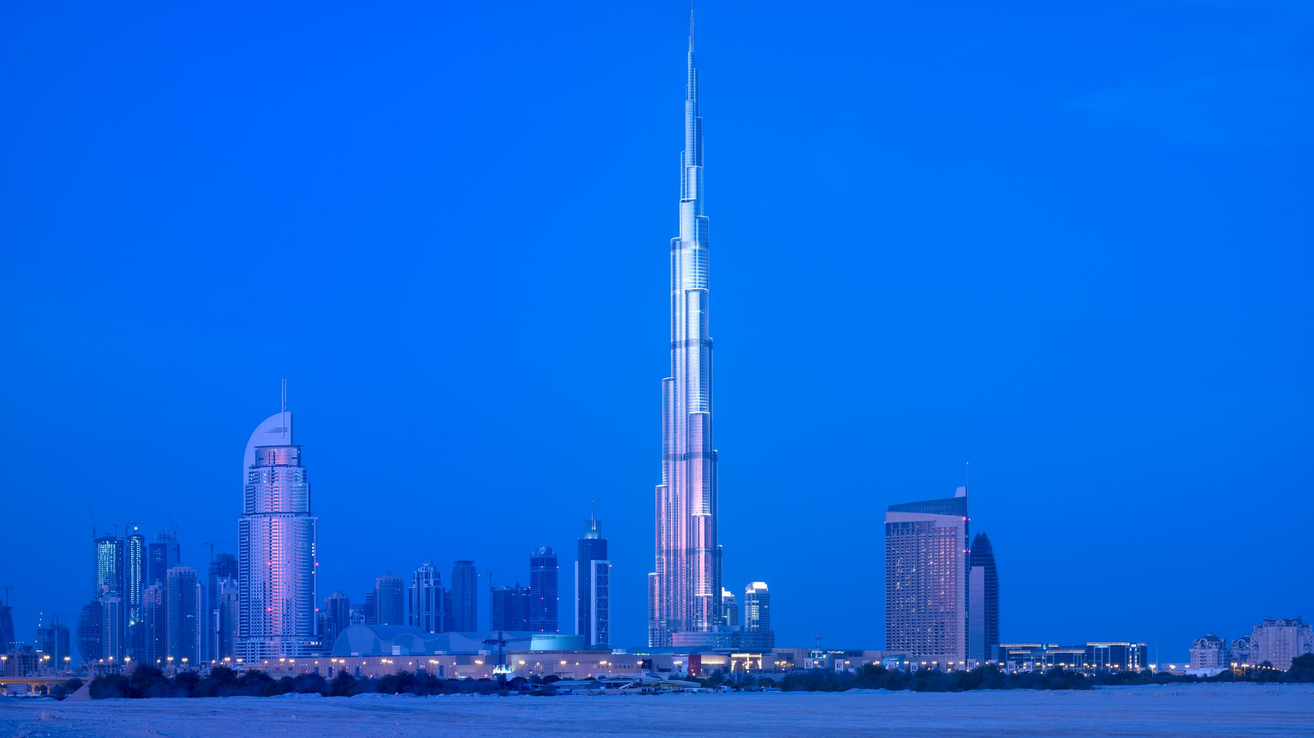  Steel vs concrete framing  Comparison and insight of habitable steel and concrete framings in different climates | Luke MacDonald (2100654)  Construction Materials (ACBA4016)

Contents
Structure Choices Overview 2
Framing Material Choice 3
Summary and Comparison 6
References 7

Structure Choices Overview
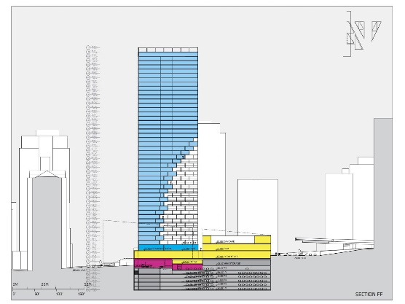
Concrete Frame Building
For the concrete structure I have chosen the Vancouver House in Vancouver Canada for various reasons, the main reason being is it a primarily concrete structure but its also located in a cold climate. In terms of the architectural design of the building, it really is unique. Starting at the bottom it rises in uniform before beginning to protrude on one side until it reaches its peak, giving the building a unique look and understandably cause all types of issues to arise in the planning to make the construction
Source: Danish Architecture Centre (No Date)
a difficult task. The design team faced challenges in this design on the Vancouver House project, as proven by StructureMag (no date). The structure makes use of reinforced concrete slabs on each floor as well as concrete columns.
A large reason for the use of concrete for this structure is proven by StructureMag (no date) again who mention that the structure uses a reinforced concrete core that was both flexible and torsion robust. This was necessary due to the shape of the building and the forces because of the seismic and gravity affects, which is common along the west coast of North America. Another use for concrete was that it is good insulator which is helpful to keep the interior at a warm temperature by releasing the heat slowly, as well as being able to withstand the freezing temperatures that are common in Canada along with being fire resistant.
Steel Frame Building

For the steel structure I have chosen the Burj Khalifa in Dubai, for the primary reason that it is a steel structure in an extremely hot climate. For the architectural design of the building, it is formally the tallest building in the world, so the design must be perfect to handle the altitude and the extreme heat. The design has a triangle like centre with multiple protruding but large areas in only three directions that get larger the closer they are to the centre, while the centre remains uniform until all points begin to thin out as the tower rises in height. The Arch Daily (2017) implies the towers design was inspired by a regional desert flower and its geometries along with the patterning systems in Islamic culture. Although the Burj Khalifa uses a concrete core, steel plays a massive role in ensuring the Burj Khalifa can handle the extreme loads of the structure. As mentioned by Dubai BM (no date), the skeletal frame is primarily high-strength steel which provides rigidity and strength which is necessary for such a towering building. The skyscraper took 6 years to be built, and the use of steel beams was used due to it speeding up the construction process as steel beams can be constructed away from the building site and then simply assembled on site. As well as this, the skyscraper needed resistance and flexibility due to the high wind speeds at that altitude and steel is perfect for both resistance and flexibility.
Source: Entri Blog (2024)

Framing Material Choice
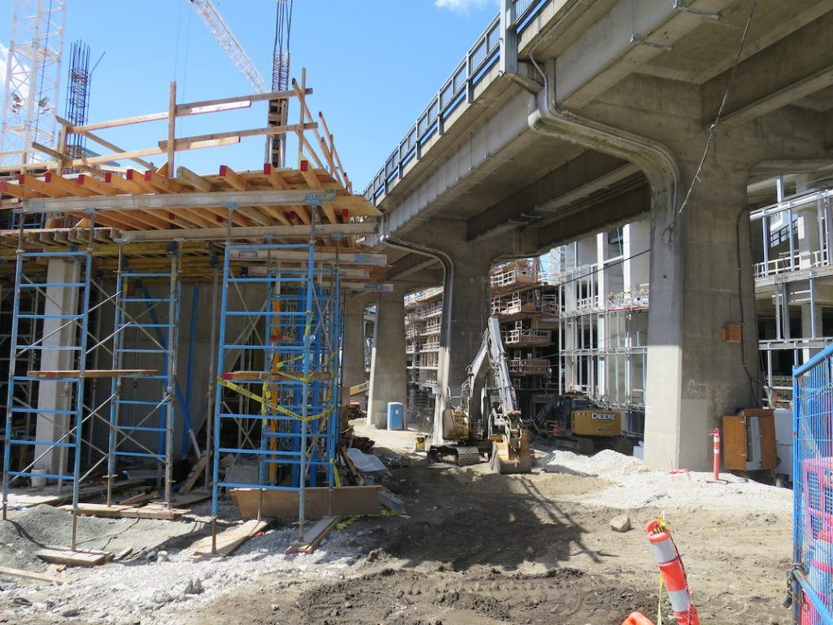
Concrete Frame (Vancouver House)
Concrete is an extremely useful and versatile material for construction, it’s simple to produce and can be moulded into almost any desirable shape. A massive factor of concrete is its incredible strength and durable especially in relevance to large compressive forces, and its ability in cold climates. For the Vancouver House, concrete is extremely important as given the shape of the structure a very strong material needed to be used to bare the weight of the increasingly overhanging side of the structure. Revisiting Structure Mag (no date) they imply that the structure used post-tensioned reinforced concrete slabs on each of the floors, along with concrete columns to support the structure and its shape. Not only this, but concrete has a very long lifespan, as top-quality concrete can last up to 100 years without maintenance. As proven by Concrete Supply (no date), there are a wide range of factors that influence concretes lifespan including the mix design, weather conditions, and the curing. As touched upon previously, concrete is a very good insulator that contains a high thermal mass, which can store heat easily and slowly release the heat. It also has high durability in freezing conditions as it is resistant to the expansion that occurs in freezing making it less likely to deteriorate or crack, making it perfect for the environmental conditions exposed to on the site.
Source: Daily Hive (2018)
The production of concrete can have impacts on both the community and environment in several areas, as for the community it can arise concerns in the aesthetics of landscapes as extracting the necessary materials for concrete can cause issues such as the loss of green spaces causing impacts in the local community regarding cultural values among others. Furthermore, carbon emissions and energy consumptions can affect the environment as the concrete process involves heating limestones at extremely high temperatures, releasing a lot of carbon dioxide into the atmosphere. Also, it involves a lot of energy, mostly from fossil fuels, to meet these energy demands, as proven by Science Direct (2022) who state that making concrete relies on fossil fuels to meet the temperature required which accounts for around 7-8% of carbon emissions.
Additionally, concrete is not a very recyclable material once it has hardened as it is very hard to breakdown due to its strength. Once destroyed, it cannot be easily reused without going through a similar process to revert it back to cement, this also results in the burning of fossil fuels again before it is able to be reused. As well as this, the resulting concrete after the recycling process would not be as strong as the original piece, as the containing aggregates would be crushed down into smaller pieces, resulting in the properties being lessened during the process. Furthermore, the concrete can also be contaminated as a result of any outside elements used on it such as paint or the internal metal bars. A result of this would be a deeper cleaning of the material to ensure no outside elements are present in the cement that could otherwise effect it.

Concrete can also be assembled very easily; with a quick curing time, structures can be built swiftly and can be pre-cast off site and transported to the build site. To expand, in harmony with the ease of assembly it is also extremely adaptable and can take almost any mould the concrete is placed into, because of the cement being liquid-like before it is cured. This means that any slight changes within the design can be altered with ease, as all it would take is the mould to be changed prior to the cement being poured in. on the negative side, if concrete needed to be adapted post construction the concrete would not be very adaptable as once the mixture sets it cannot be easily reshaped or adjusted, the material is so strong that large amounts of effort would be needed to fix the issue. Additionally, concrete is not a flexible material and is very stiff, meaning it would encounter difficulties when used on structures that often move in high winds, or in structures that are prone to seismic activities such as earthquakes.
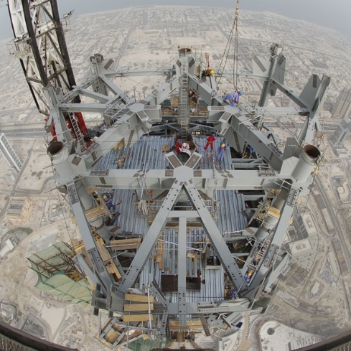
Steel Frame (Burj Khalifa)
Steel is also an extremely important material for construction, steel is also an extremely strong support for high rise buildings and excels at its resistance in terms of tension and compression, due to its ductility, which makes it almost essential to use when constructing high rise structures. Steel is incredibly tough that it can stretch while under tension, as well as handle compressive forces without cracking or buckling. As mentioned by Unity Manufacturer (2023) who state that steel possesses many important properties such as ductility, toughness, corrosion resistance and machinability. In terms of the lifespan of steel, high quality and well-constructed steel can last up to 50 years with good maintenance and low exposure. Steel can be subject to rusting if not maintained and protected with galvanise which can slow the rusting process. The type and quality of materials used are huge when making steel that can last, as proven by Ameribuilds (no date) who say that quality of materials, construction standards, environmental conditions and maintenance practises are huge factors in the steel durability.
Source: New Civil Engineer (2007)
Furthermore, steel is very resistant to extreme weather, especially extreme heat hence its use in the Burj Khalifa. Steel is effectively heat resistant because of its extremely high melting point, also the expansion of the steel in hot climates is relatively predictable allowing for easy compromising to counteract these expanding effects. Steel also retains its strength at high temperatures and is relatively low maintenance despite the conditions. This is proven by Specialty Metals (no date) who state that chromium oxide layer protects against corrosion but also resist staining that’s easily cleaned, resulting in the materials low maintenance. Steel is also a very good conductor, meaning it is very efficient at transferring heat which is imperative in hot climates. This can also be helped with specific designs within the architecture.

In terms of environmental and community impacts, the production of steel can have a variety of impacts on both the community and environment. A large impact to the environment is its air pollution during production, steel requires very high temperatures to extract the iron from iron ore resulting in the burning of fossil fuels and a large excess of carbon dioxide into the atmosphere, contributing to global warming. As mentioned by Science (2024) who state that temperatures of up to 1600°C to melt the raw iron, the burning of fossil fuels accounts to around 7% of human greenhouse gasses emissions. Furthermore, the production of steel required a large amount of steel ore which results in huge mining queries to obtain these amounts. This can have detrimental impacts on both the environment and the community. As for the environment, large-scale deforestation along with potential habitat destruction would be necessary to obtain the iron needed and would also generate large amounts of noise pollution and dust, affecting any local communities and wildlife.
In addition, the production of steel can result in serious health issues for workers and possible habitants in the surrounding area. Steel creation produces harmful airborne pollution that if inhaled, can lead to serious issues down the line. As mentioned by The CoolDown (2024) who state that because of nitrogen oxides and sulphur dioxide produced in the process it creates around 250,000 asthma cases per year, and can also cause neurological issues, heart diseases and strokes. Furthermore, steel produces a large amount of waste after production when extracting iron for the ore, this includes slag which can easily contaminate water and soil. Any mismanagement during the disposal can have large environmental consequences.
Steel is very easily assembled onto structures; it is usually pre-cut within factories and then transported to the site for placement, saving time on site. In addition to this, the steel can also be tested at the factory to ensure high quality control and precision saving huge amounts of time on site. Furthermore, it is relatively light weight in comparison to its strength and has a high versatility in terms of its connection methods, where it can be welded, bolted or even clipped on. Steel can also be altered to suit any building altercations; they can be easily re-engineered to meet any new requirements without reducing its strength.

Summary and Comparison
Below is a table summarising the different factors between concrete frames and steel Frames.
Factor | Concrete Frame | Steel Frame
Strength | Very durable, withstand compressive strengths | High compressive and tension strengths
Durability | Longer lifespan, weather resistant, low maintenance | Chance of corrosion/rusting, needs protective layer
Climate Resistance | Resistant to extreme temperatures, hot and cold | Requires protective coating to prevent corrosion/rusting
Environmental Impact | Requires high energy levels, not easily recyclable | Required large mines, ability to be recycled
Production Process | High carbon emissions, requires many resources | Requires high temperatures, high emissions
Assembly | High labour required, can be slow in curing process | Can be prepared offsite, fast, higher flexibility
Adaptability | Can be difficult to adapt to changes, hard to modify | Can easily adapt, suitable for structures with later changes
Cost | Cheaper but higher labour cost | More expensive, but faster installation

To summarise, from the above table both framings have their pros and cons when it comes to construction. Both materials are very strong, but concrete has a longer lifespan in comparison to steel as well as concrete framing is more resistant without the need of any protection, whereas steel needs a protective layer to prevent corrosion and rusting. In terms of environmental impacts, both contribute negatively to the environment with both requiring high energy levels which produce high carbon dioxide emissions; however, steel can be recycled with a lot more ease than concrete, due to concretes immense strength. As for the assembling process, concrete can require more labour than steel due to its need for moulds and has a longer curing time. In comparison to steel, it can be moulded and produced off site for rapid installation on site. Additionally, steel is a lot easier to adapt to modifications, whereas concrete is a lot harder to remove and modify if any future altercations were made post construction. Finally, the cost of the two is similar, with concrete framing being cheaper but requiring a higher labour cost due to the installation, and steel being more expensive due to the materials needed but resulting in less labour cost and a significantly faster installation time.
Both materials are extremely important for construction, but the decision on what material is used entirely relies on the climate and extreme weather conditions. Although both are very good in extreme weather conditions, concrete framing may be a cheaper method of construction in comparison to steel framings, however concrete can be seen as a less aesthetically pleasing material to use in comparison to steel. Furthermore, a combination of both materials can create a massively strong structure, although it would result in high construction costs, especially for skyscrapers. Additionally, both materials have a vastly different lifespan, with concretes lifespan doubling that of steels. This is an extremely important factor to consider when planning a structure as steel would require heavy maintenance and even replacement after 50 years, whereas concrete can last up to 100 years

References
Ameribuilds (No Date) Durability of Steel Buildings: A Lifespan Guide. Available at: Durability of Steel Buildings: A Lifespan Guide (Accessed on: 27th March 2025)
Arch Daily (2017) Burj Khalifa. Available at: Burj Khalifa / SOM | ArchDaily (Accessed on: 25th March 2025)
Architectural Digest (2024) Burj Khalifa: Everything You Need to Know About the Tallest Building in the World. Available at: Burj Khalifa: Unpacking the World’s Tallest Building | Architectural Digest (Accessed on: 25th March 2025) (Photo 2)
Concrete Supply (No Date) How Long Does Concrete Last? Available at: How Long Does Concrete Last? | Concrete Supply (Accessed on: 26th March 2025)
Daily Hive (2018) Vancouver House Construction has Topped Out at its Ultimate Height of 497ft. Available at: Vancouver House construction has topped out at its ultimate height of 497 ft (PHOTOS) | Urbanized (Accessed on 26th March 2025) (Photo 5)
Danish Architecture Centre (No Date) Vancouver House. Available at: Vancouver House - Danish Architecture Center - DAC. (Accessed on: 25th March 2025) (Photo 3)
Dubai BM (No Date) What Are The Materials Used To Build Burj Khalifa? Available at: What Are The Materials Used To Build Burj Khalifa? (Accessed on: 25th March 2025)
Entri Blog (2024) The Structural System of Burj Khalifa. Available at: The Structural System of Burj Khalifa (Accessed on: 26th March 2025) (Photo 4)
LX Collection (No Date) Vancouver House. Available at: Vancouver House | Luxury Condominium Residences | Vancouver (Accessed on: 25th March 2025) (Photo 1)
New Civil Engineer (2007) Burj Dubai: Big Burj. Available at: Burj Dubai: Big Burj | New Civil Engineer (Accessed on 27th March 2025) (Photo 6)
Science Direct (2022) Global Carbon Recoverability Experiences from the Cement Industry. Available at: Global carbon recoverability experiences from the cement industry - ScienceDirect (Accessed on 26th March 2025)
Science (2024) Steel Industry Emissions are a Big Contributor to Climate Change. Can it go Green? Available at: Steel industry emissions are a big contributor to climate change. Can it go green? | Science | AAAS (Accessed on: 27th March 2025)
Specialty Metals (No Date) Stainless vs Galvanised Steel: Longevity and Maintenance. Available at: Stainless vs Galvanised Steel: Longevity and Maintenance - Speciality Metals (Accessed on: 27th March 2025)
StructureMag (No Date) Vancouver House. Available at: Vancouver House (Accessed on: 25th March 2025)
The Cool Down (2024) New report uncovers surprising health impact of US coal-based steel production: 'Outcomes you've never even thought of before'. Available at: New report uncovers surprising health impact of US coal-based steel production: 'Outcomes you've never even thought of before' (Accessed on: 27th March 2025)

Unity Manufacturers (2023) Steel Properties: Strength, Hardness, And More. Available at: Steel Properties: Strength, Hardness, And More - Unity Manufacture (Accessed on: 26th March 2025)

