Learning in the Digital Era
Assessment 01 – E-Portfolio
Portfolio Link: https://sway.office.com/DPVGx1Nlv1PyMghT?ref=Link&loc=play
Ahmed Tufayal
Student ID:2225675
UWTSD Quay Place Campus

Table of Contents
Task 01 1
A)Summary 1
References: 2
B)Similarity Score 3
Task 02 – E-Portfolio 4
Microsoft Sway 4
References: 4
Task 03 – Referencing Tool 6
Mendeley 6
References: 8
Task 04 – Poster 9
Life is a Team Sport 9
Introduction 9
Why is teamwork important for academic and career success? 9
What are the similarities between teamwork and sports? 10
The benefits of effective teamwork in academic and professional settings 10
How to become an effective team member? 10
Conclusion 10
References: 12

Task 01

Summary
As a student, developing essential skills for study and employment is crucial for success in academic and professional endeavours. Unit 1 covered several skills: time management, communication, critical thinking, and teamwork. Time management skills involve prioritising tasks and managing time effectively (Putwain, Sander and Larkin, 2018). These skills are important for meeting deadlines, staying organized, and maximizing productivity. Good time management skills are highly valued by employers and will benefit students in any career path. Effective communication is another essential skill for success (Cottrell, 2021). This includes communicating ideas clearly and concisely, both verbally and in writing. Communication skills are essential in the workplace, as effective communication is necessary for collaboration and teamwork, which must be considered academically and professionally (García-Pérez et al., 2021).
Critical thinking skills are also essential for success, which involve the ability to analyze information, evaluate evidence, and make sound decisions. Critical thinking skills are highly valued by employers, as they are necessary for problem-solving and decision-making. In academic work, critical thinking can allow students to think outside the box and bring the best solution based on detailed analysis (Indrašienė et al., 2021). Finally, teamwork skills are collaborating, sharing ideas and resources, and resolving conflicts. Employers highly value teamwork skills, as teamwork is necessary for achieving common goals and maximizing productivity (Cottrell, 2021). Moreover, teamwork skills are the best opportunity for individuals to learn more skills and work with others to get to know others, which is also essential to perform well in professional life. By developing these skills, students will be better prepared to succeed in the workplace and achieve their career goals.

References:
Cottrell, S., 2021. Skills for success: Personal development and employability. Bloomsbury Publishing.
García-Pérez, L., García-Garnica, M. and Olmedo-Moreno, E.M., 2021. Skills for a working future: How to bring about professional success from the educational setting. Education sciences, 11(1), p.27.
Indrašienė, V., Jegelevičienė, V., Merfeldaitė, O., Penkauskienė, D., Pivorienė, J., Railienė, A., Sadauskas, J. and Valavičienė, N., 2021. Critical thinking in higher education and labour market (p. 524). Peter Lang International Academic Publishers.
Putwain, D., Sander, P. and Larkin, D., 2018. Academic self‐efficacy in study‐related skills and behaviours: Relations with learning‐related emotions and academic success. British Journal of Educational Psychology, 83(4), pp.633-650.

Similarity Score
I'm glad that the similarity score for my work is only 6%. To further improve this score, I can use my own words to paraphrase and summarize information from sources instead of directly quoting them. Additionally, I can review my references to ensure that all sources are properly cited using the Harvard referencing standard. I can also check my work against a plagiarism checker tool to identify any potential issues with similarity. By taking these steps, I can further reduce the similarity score of my work and ensure that it is original and accurately represents my ideas and understanding of the topic.
Based on the generic assessment criteria, I would award myself a high mark for the summary as it effectively summarizes the key points discussed in Unit 1 on essential skills for study and employment in the digital era. The summary provides a clear and concise overview of these skills and highlights their importance in the modern workplace. Using references from credible sources also demonstrates research skills and adds credibility to the summary. Overall, I would award myself a mark of 90% for this summary.

Task 02 – E-Portfolio

Microsoft Sway
Microsoft Sway has been used as an online E-portfolio management tool to complete the current task. Microsoft Sway is an excellent tool for creating digital presentations and e-portfolios. It offers an interactive and engaging way to showcase your work, achievements, and skills to potential employers and academic institutions (Nissa and Dheanti, 2021). Sway allows users to create a visually appealing and professional-looking portfolio with its simple and intuitive interface.
One of the key advantages of using Microsoft Sway for e-portfolio is that it allows users to showcase their work in a multimedia format, including text, images, videos, and audio recordings (Usman and Baihaqi, 2020). This makes it a powerful tool for demonstrating graphic design, multimedia production, and presentation skills, which are highly valued in many disciplines.
Additionally, Sway allows users to collaborate and share their portfolios with others, making it easy to get feedback and suggestions for improvement. This can be particularly beneficial for students and professionals seeking to improve their work and enhance their skills (Harefa et al., 2019).

References:
Harefa, N., Silalahi, N.F.D., Sormin, E., Purba, L.S.L. and Sumiyati, S., 2019. The difference of students’ learning outcomes with project based learning using handout and sway Microsoft 365. Jurnal Pendidikan Kimia, 11(2), pp.24-30.
Usman, R.K. and Baihaqi, A., 2020. The Use of Microsoft Sway 365 in teaching reading descriptive text: A response to pandemic situation. Journal of English Language Teaching and Cultural Studies, 3(2), pp.82-88.
Nissa, P.K. and Dheanti, B.L., 2021. The E-Learning Design for Problem Based Learning in Dynamic Fluid Topic using Microsoft Sway. Jurnal Penelitian & Pengembangan Pendidikan Fisika, 7(2), pp.115-122.

Task 03 – Referencing Tool

Mendeley
Mendeley is a free reference management tool that has been widely used as an automatic referencing tool by students and researchers. Mendeley allows users to easily organize, manage, and cite references in their academic work (Patak and Tahir, 2019). Its automatic referencing feature allows users to generate citations and bibliographies in various citation styles, including the Harvard referencing style.
Mendeley has been used by students and researchers worldwide due to its user-friendly interface and efficient citation management features (Castillo et al., 2022). Some of the experiences of using Mendeley as an automatic referencing tool include saving time and effort in managing references, reducing the risk of errors in citation and bibliography formatting, and facilitating collaboration and sharing of references with peers (Fernand, 2020).
Below are some screenshots of references used in Mendeley, demonstrating its capability as an automatic referencing tool:
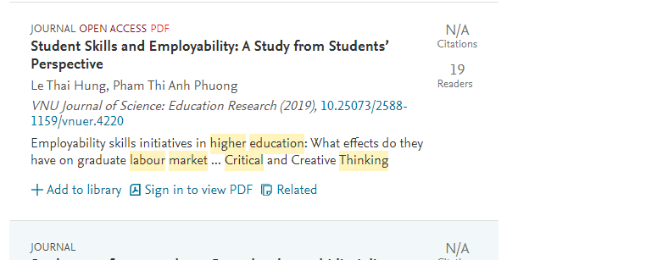
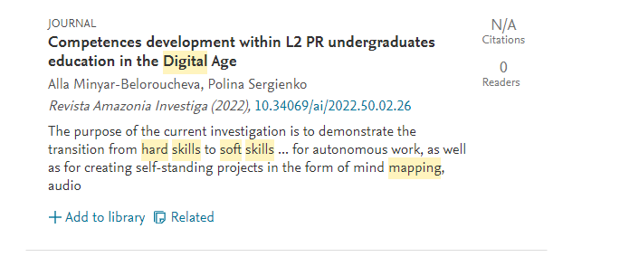
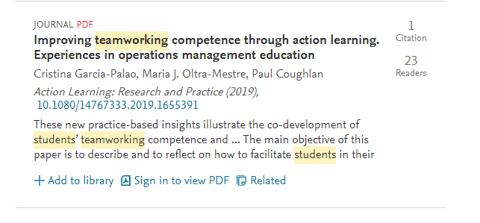
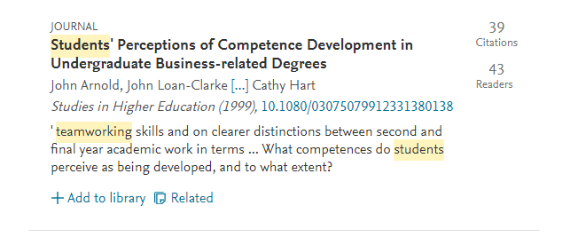

References:
Castillo, A.G.R., Paricahua, E.W.P., Paricahua, A.K.P., Lopez, H.R.P., Huayta-Meza, F.T., León, C.R.R., Mohamed, M.M.H., Cabala, J.L.B., Pérez, L.A.C., Mansilla, E.B.R. and Lipa, J.P.T., 2022. Bibliographic Reference management: The Role of Technological Appropriation in Students. Eurasian Journal of Educational Research, 100(100), pp.133-157.
Fernand, 2020. Library guides: Mendeley: Use Mendeley with ms word, Use Mendeley with MS Word - Mendeley - Library Guides at AUT University. Available at: https://aut.ac.nz.libguides.com/mendeley/word.
Patak, A.A. and Tahir, M., 2019. Avoiding Plagiarism Using Mendeley in Indonesian Higher Education Setting. International Journal of Evaluation and Research in Education, 8(4), pp.686-692.

Task 04 – Poster

Life is a Team Sport
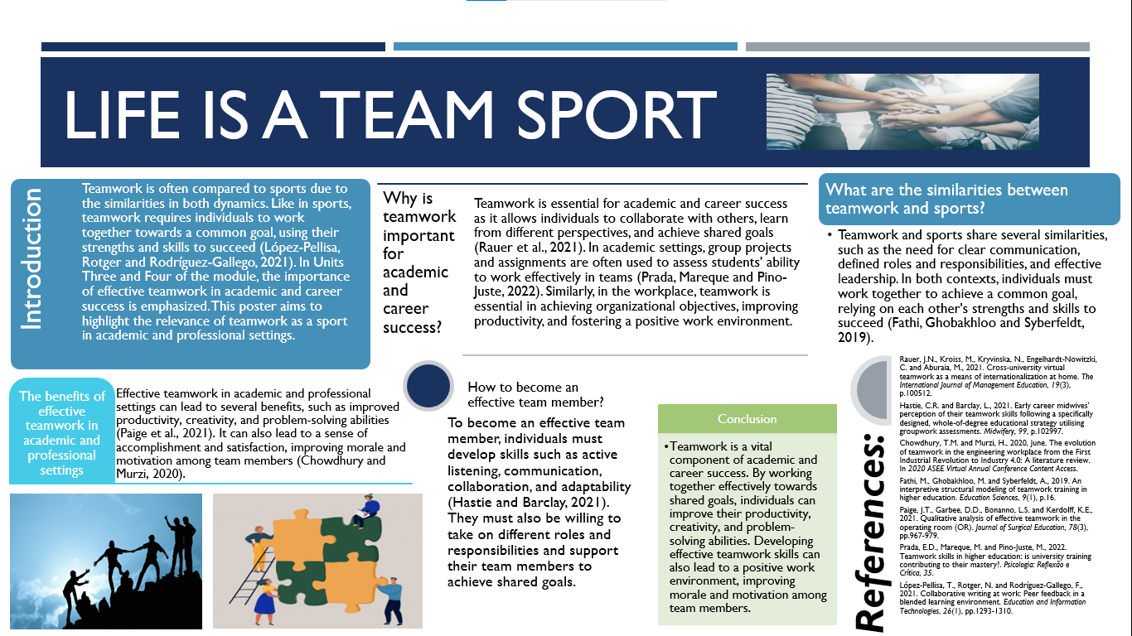

Introduction
Teamwork is often compared to sports due to the similarities in both dynamics. Like in sports, teamwork requires individuals to work together towards a common goal, using their strengths and skills to succeed (López-Pellisa, Rotger and Rodríguez-Gallego, 2021). In Units Three and Four of the module, the importance of effective teamwork in academic and career success is emphasized. This poster aims to highlight the relevance of teamwork as a sport in academic and professional settings.

Why is teamwork important for academic and career success?
Teamwork is essential for academic and career success as it allows individuals to collaborate with others, learn from different perspectives, and achieve shared goals (Rauer et al., 2021). In academic settings, group projects and assignments are often used to assess students' ability to work effectively in teams (Prada, Mareque and Pino-Juste, 2022). Similarly, in the workplace, teamwork is essential in achieving organizational objectives, improving productivity, and fostering a positive work environment.

What are the similarities between teamwork and sports?
Teamwork and sports share several similarities, such as the need for clear communication, defined roles and responsibilities, and effective leadership. In both contexts, individuals must work together to achieve a common goal, relying on each other's strengths and skills to succeed (Fathi, Ghobakhloo and Syberfeldt, 2019).

The benefits of effective teamwork in academic and professional settings
Effective teamwork in academic and professional settings can lead to several benefits, such as improved productivity, creativity, and problem-solving abilities (Paige et al., 2021). It can also lead to a sense of accomplishment and satisfaction, improving morale and motivation among team members (Chowdhury and Murzi, 2020).

How to become an effective team member?
To become an effective team member, individuals must develop skills such as active listening, communication, collaboration, and adaptability (Hastie and Barclay, 2021). They must also be willing to take on different roles and responsibilities and support their team members to achieve shared goals.

Conclusion
Teamwork is a vital component of academic and career success. By working together effectively towards shared goals, individuals can improve their productivity, creativity, and problem-solving abilities. Developing effective teamwork skills can also lead to a positive work environment, improving morale and motivation among team members.

References:
Rauer, J.N., Kroiss, M., Kryvinska, N., Engelhardt-Nowitzki, C. and Aburaia, M., 2021. Cross-university virtual teamwork as a means of internationalization at home. The International Journal of Management Education, 19(3), p.100512.
Hastie, C.R. and Barclay, L., 2021. Early career midwives’ perception of their teamwork skills following a specifically designed, whole-of-degree educational strategy utilising groupwork assessments. Midwifery, 99, p.102997.
Chowdhury, T.M. and Murzi, H., 2020, June. The evolution of teamwork in the engineering workplace from the First Industrial Revolution to Industry 4.0: A literature review. In 2020 ASEE Virtual Annual Conference Content Access.
Fathi, M., Ghobakhloo, M. and Syberfeldt, A., 2019. An interpretive structural modeling of teamwork training in higher education. Education Sciences, 9(1), p.16.
Paige, J.T., Garbee, D.D., Bonanno, L.S. and Kerdolff, K.E., 2021. Qualitative analysis of effective teamwork in the operating room (OR). Journal of Surgical Education, 78(3), pp.967-979.
Prada, E.D., Mareque, M. and Pino-Juste, M., 2022. Teamwork skills in higher education: is university training contributing to their mastery?. Psicologia: Reflexão e Crítica, 35.
López-Pellisa, T., Rotger, N. and Rodríguez-Gallego, F., 2021. Collaborative writing at work: Peer feedback in a blended learning environment. Education and Information Technologies, 26(1), pp.1293-1310.

