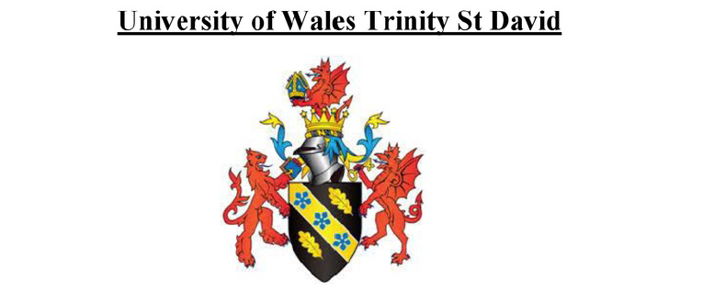

Analyze the current and future external and internal environment of Marriott Hotel
Yuheng Luo
18 March 2022
Course name：Strategic Marketing
Module code： BMBM6016
Lecturer： Lisa Knight
Student ID：2100106

A report submitted in fulfillment of the requirements for Course BMBM6016, Strategic Marketing, University of Wales Trinity Saint David

Executive Summary
With the globalisation of the economy and the constant growth of COVID-19, market rivalry is getting more fierce. Because of the size and severity of the business environment, it is essential to strengthen the company's competitiveness. To better understand Marriott Hotels and the challenges it is now experiencing, this article examines both external and internal causes that have contributed to its tremendous growth in recent years. SWOT and PESTEL models are used to analyse current market conditions, competition, and Marriott Hotels' own issues, and then countermeasures are devised to address these issues in order to improve Marriott Hotels' long-term viability.

Content
Executive Summary 1
1.0 Introduction 3
2.0 Main Findings 3
2.1 SWOT and Marriott hotel 3
2.1.1 Threat 4
2.1.1.1 Competitive Lodging Industry 4
2.1.1.2 Coronavirus (COVID-19) Outbreak 5
2.2 PESTEL and Marriott hotel 7
2.2.1 Political Factors 8
2.2.2 Technological Factors 10
2.3 Porter's five forces model 10
2.3.1 Threat of New Entrants 11
2.4 McKinsey’s 7S Framework 12
2.4.1 Shared values 12
3.0 Conclusion and Recommendation 13
Reference 14

1.0 Introduction
Internal audits are designed to educate management and employees on how to enhance corporate operations and efficiency. The major goal of external audits is to provide shareholders confidence in their financial reporting. An audit report may help evaluate a company's performance and manage risk. Any kind of business may utilise it. It may also help firms find prospective growth areas and collect data to achieve their objectives (Anthony, 2022). COVID-19 is a brand-new coronavirus strain that has never been seen in humans before (Coronavirus, 2022).In this report, the audit is designed to assess the micro and macro environment of the post-pandemic world. The impact of the ongoing development of COVID-19 on the hotel industry will be analysed, such as changes in hotel performance, staff transfers within the business, etc. Marriott International Inc. It operates approximately 8,000 hotels in 139 countries and territories. The company began as a nine-seat A&W root beer stand in Washington, D.C. in 1927 and has evolved into the world's largest hotel chain. Marriott Hotels offers hotel and car rental reservations across North America, Europe, the Middle East, Africa, and Asia Pacific. Marriott has properties throughout the Caribbean and Latin America. Marriott Hotels' corporate offices are in Bethesda, Maryland (Marriott,2022).

2.0 Main Findings

2.1 SWOT and Marriott hotel
SWOT is an acronym for Strengths, Weaknesses, Opportunities, and Threats. A SWOT analysis may help an organisation determine its strengths, weaknesses, opportunities, and threats (Leigh, 2009). Firms may use SWOT analysis to better identify their strengths and development possibilities. Growth may be achieved through identifying and exploiting a company's flaws. Get an early glimpse at what's coming up. Firms may design crucial growth strategies based on their strengths and weaknesses. Methods like these might help firms analyse risks and make necessary modifications to their structures or expansion plans (Kearns, 1992). It also encourages the construction of backup and contingency plans. By combining strengths and opportunities, organisations may convert weaknesses and threats into strengths and opportunities. To continue the organization's marketing strategy, the SWOT analysis approach provided provides crucial incentive (GURL, 2017).

Tab.1: SWOT analysis in Marriott

Strength  The Network of Operations  Portfolio of Brands  The North American market is seeing an increase in revenue  Full-Service | Weakness  Financial Leverage  Cost Efficiency
Opportunity  Strategic Initiatives  Growing Global Travel and Tourism Industry  Business Expansion | Threat  Competitive Lodging Industry  Coronavirus (COVID-19) Outbreak

Source: Marriott International, Inc(2020)

Franchised hotels and lodging facilities are managed and operated by Marriott, as can be seen from Table 1. Strong brand portfolio, revenue growth from its North American full-service business, and operational network are important strengths, but cost efficiency and limited financial leverage remain areas of concern. Growth will be aided by company expansions, smart planning, and an expanding global travel and tourist sector. Covid-19, a competitive lodging market in the United States might cause problems for the company's operations (Marriott International, Inc, 2020).

2.1.1 Threat

2.1.1.1 Competitive Lodging Industry
Marriott hotels confront a lot of competition since they are both a hotel operator and a franchisor. More than 1,400 accommodation management businesses operate in the United States's lodging sector. Private management businesses make up the majority of these operators, but there are also some huge national chains that own and run their own hotels and also franchise their own brands. Rivalry between Marriott's hotel brands, home and flat-sharing services, national and international centres, independent firms and big hotel chains is fierce (Ulrich, 1991).Key competitive variables include the product or service's quality or value, the efficiency of the service, and consumer-facing technology. AccorHotels, Best Western International, International Select Hotels, Hilton Worldwide Holdings, and InterContinental Hotels Group are all fierce competitors for Marriott International in most areas. Real estate prices have risen as a consequence of this severe rivalry, which has led to a large demand for real estate space. Large sums of money were needed to purchase these hotels, which are well-known for their lavish accommodations and expansive grounds (Datamonitor Plc, 2020). As a consequence, Marriott's premium brand has become uncompetitive, resulting in less market penetration chances for the corporation as a result of fierce rivalry and price wars.

2.1.1.2 Coronavirus (COVID-19) Outbreak
Since its discovery, COVID-19 has caused havoc on the world economy. Hoteliers face two challenges from COVID-19 (Monika, 2021). Following the corporate lockout, initial demand and sales fell, lowering earnings. Allowing businesses to continue operating during a pandemic would result in lower sales revenues due to reduced demand for hotel services and other constraints. Between lock-in and operational activity, the company must pay fixed expenditures a second time. These expenditures are crucial in the hotel industry due to the high cost of property and labour. The additional limits may make operations more expensive than planned. Mandatory precautions may also result in additional expenditures for sterilisation or worker safety (Bloomberg, 2021). This reduces operational profit and hence profitability. The loss is the difference between the expected and actual operational profits. It is possible that real-world fluctuations are significantly bigger.

In terms of customer service, Marriott is noted for its employees' strong sense of belonging and pride in the company. The company's general managers have an average tenure of 17 years, demonstrating their feeling of security and conviction in their ability to contribute to its success. The hospitality industry has a low turnover rate of 28% (David, 2008). Marriott International is rewarding hotel employees who get the new crown vaccination with cash. Employees at the company's hotels in the US and Canada would get four hours' pay for completing the immunisation. The vaccine's mass distribution will help both travellers and hotel staff, Marriott says. Marriott lost $1 billion when the 2020 epidemic interrupted global travel. Marriott encourages but does not force its employees to be vaccinations (Bloomberg, 2021).

Fig. 1: World Economic Outlook April 2020
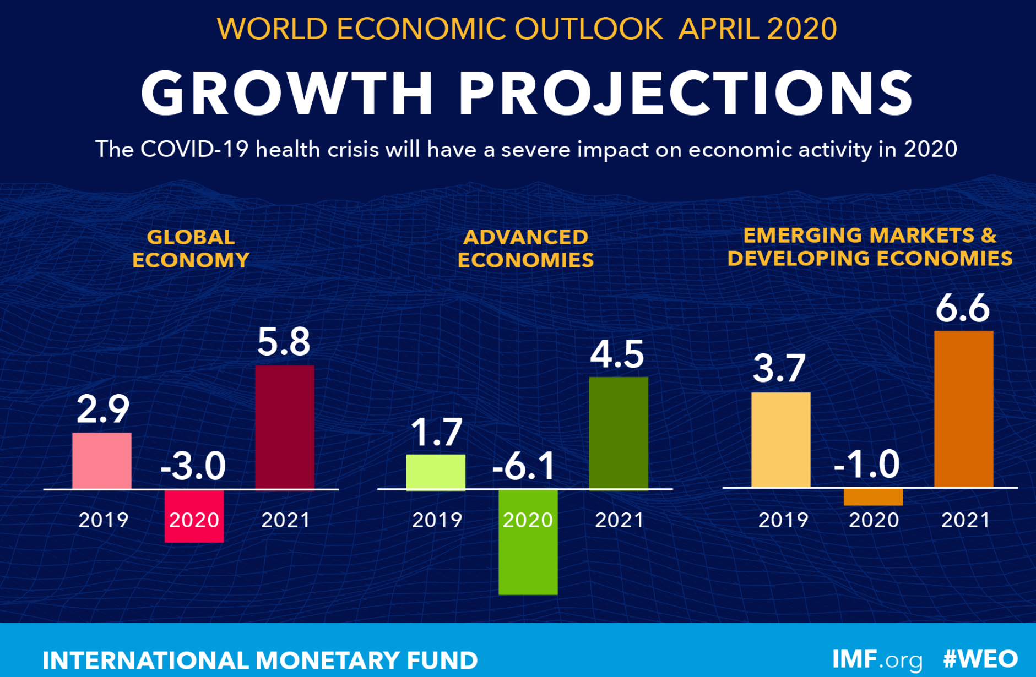

Source: International Monetary Fund (2020)

Compared to the 2.9% growth rate recorded in 2019, the April 2020 World Economic Outlook Report anticipated that global economic growth after the outbreak of the pandemic will be -3 percent. It is possible that the world economy might see an 8 percent decline if the epidemic persists beyond 2021, if it continues to spread. According to the World Bank, developed and rising economies and developing economies are predicted to expand at an annual rate of -6.1 percent and 0.1%, respectively, in 2020. Around the globe, the epidemic has resulted in the closure of several pubs, clubs, and restaurants. Business and financial prospects may be adversely affected for Marriott, which operates in the hotel industry.

Fig. 2: World Economic Outlook January 2022
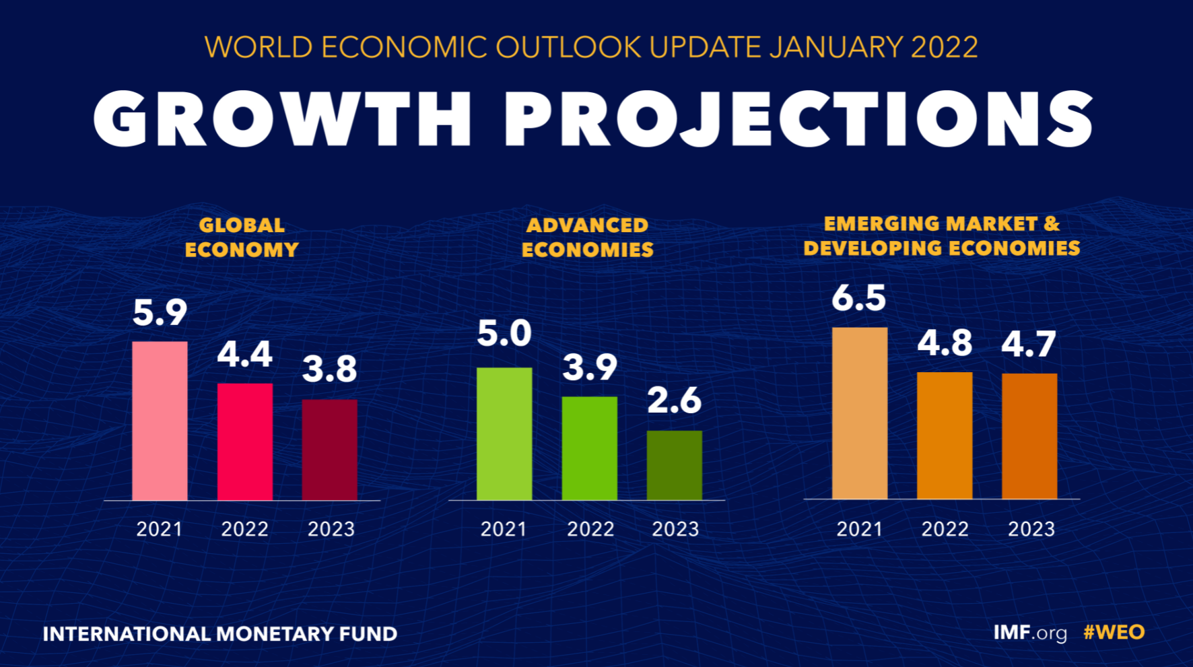
Source: International Monetary Fund (2022)

Almost two years after the epidemic began, the virus has undergone a mutation. Global economic growth is expected to be 4.4% in 2020, down from 5.9% in 2021, according to the January World Economic Outlook Report for 2022. If the epidemic persists through 2023, the world economy is anticipated to shrink by 4.4 percent in 2022, and by 10 percent in 2023. Comparing 2019 growth rates with 2020 projections, developed and emerging market economies are predicted to increase by 3.9% and 4.8%, respectively, up from 5.0% and 6.5% in 2019. inflicting fresh damage on the world's nightclubs and bars It is expected that Marriott, which has a foothold in the hotel industry, would be harmed by the epidemic once again.

2.2 PESTEL and Marriott hotel
The PESTEL framework or tool helps marketers understand and manage their organization's macro-environment (external marketing environment). Environmental, economic, social, technological, and legal considerations are assessed (Libby, 2021). A PESTEL analysis may help any business owner, whether they are just starting out or already have a successful firm. It may help firms develop long-term growth plans. Because more people can sell, customer service, sales, and marketing departments may all be handled internally. It's easy to understand how many factors affect the business environment. Producing new things requires strategic thinking and a better understanding of the components.

Fig. 3: PESTEL Analysis: Factors
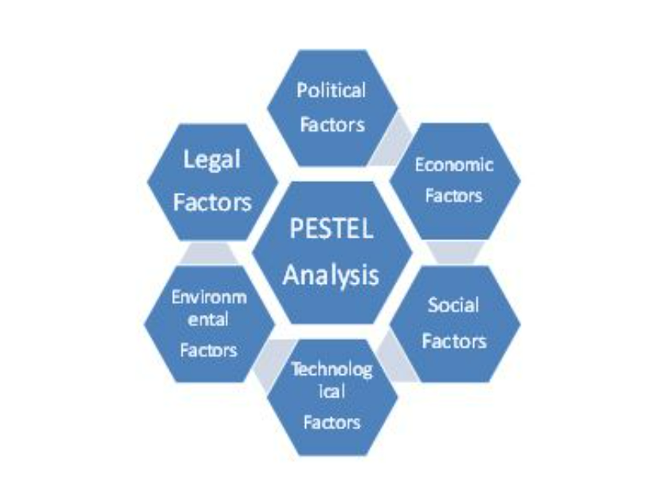

Source: StudiosGuy.com

2.2.1 Political Factors
Trade and the business climate are influenced by political considerations, such as government laws and legal concerns. Political stability, tax standards, trade regulations, security regulations, and employment laws are among the elements that are taken into consideration (Shatskaya, Samarina& Nekhorosheva, 2016).

The minimum wage has been raised in 26 states in the United States as of January 1, 2022..The minimum hourly wage in Maryland, where Marriott International is located, has been increased to $12.50 (Charles, 2021). Government-mandated hikes in the minimum wage and an increase in the percentage of full-time workers have all contributed to the rise in labour expenditures. Operating expenses might rise as a result of rising labour costs, which can have a negative impact on profitability (Hamermesh, 2021). When labour expenses grow, salaries and incomes rise for everyone, which in effect functions as a sensible allocation of wealth, thereby boosting everyone's quality of living and employee happiness. To some extent, though, increasing labour expenses might have unintended consequences (Meer and West, 2016). Marriott International's profit margins and the number of job openings they can provide have shrunk, which may have a bigger effect on people looking for entry-level work.

Fig. 4: Table of minimum wage changes in Maryland in 2022
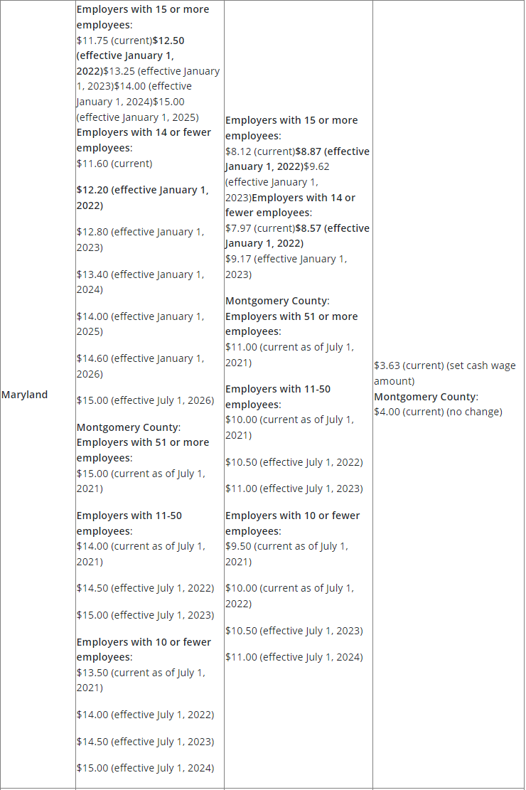

Source: Mondaq.com(Charles, 2021)

2.2.2 Technological Factors
These variables have a positive or negative impact on the efficiency of technological marketplaces and sectors. To add to the list of possible effects, it may affect the choice of certain industries to enter new markets or to outsource some of their production to other nations. Companies may avoid spending money on technologies that will become outdated in the near future owing to shifting technology trends if they are aware of the most current ones (Shatskaya, Samarina& Nekhorosheva, 2016).

Marriott International has established a multi-pronged platform based on the creation of Covid-19 to enhance cleaning standards and hotel norms and behaviours to address the new health and safety issues presented by the contemporary pandemic environment, which primarily relies on sophisticated technology. Disinfect surfaces throughout the hotel using electrostatic sprayers and hospital-grade disinfectants. As recommended by the CDC and WHO to treat recognised infections, electromagnetic spray technology utilises a disinfectant with the greatest level of efficacy. In the hotel setting, the sprayer cleans and disinfects guest rooms, lobbies, gyms, and other public spaces fast and efficiently. Additional to that, Marriott is experimenting with UV disinfection of hotel key fobs. For this reason, a new Marriott Global Cleaning Committee has been formed in response to the reality of the COVID-19 epidemic in hotel rooms worldwide. Next generation hotel cleaning standards, norms and behaviours are being developed to minimise risk while increasing the safety of Marriott guests as well as its own workers (HTN Staff, 2020). On the other hand, Marriott hotels can develop a partnership with Airbnb to achieve a win-win situation.

2.3 Porter's five forces model
Porter's Five Forces Model examines and analyses the five competitive variables that drive each sector, revealing defects and strengths of that sector. The five forces analysis is often used to determine a company's market strategy. Any sector of the economy may apply Porter's model to assess industrial competition and long-term profitability (Grundy, 2006). The Five Forces Model may be used to analyse an industry's profitability and strategy. The data may also be used to decide whether to enter a new industry or grow an existing one, what competitive strategies to utilise, and what challenges to expect (StudiosGuy, 2022).

Fig. 4: Porter’s Five Forces of competitive position analysis

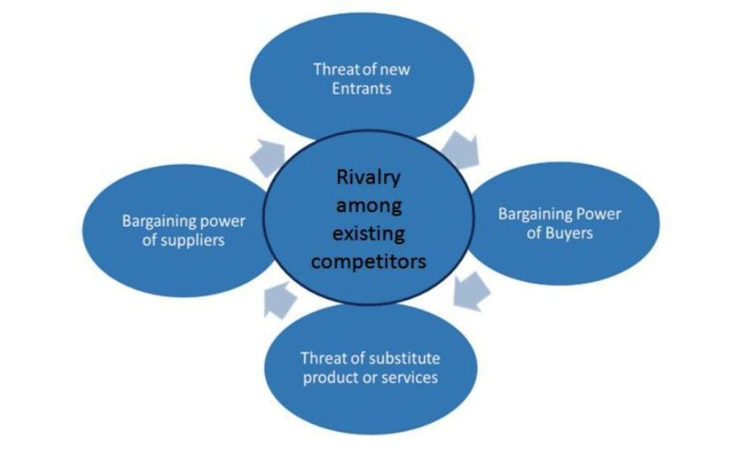
Source: StudiosGuy.com

2.3.1 Threat of New Entrants
Porter's Five Forces concept includes a force called the Threat of New Entrants, which describes the danger that new participants in an industry offer to the existing players. An industry's competitive environment is shaped by this factor, and it has a significant impact on the industry's desirability (Grundy, 2006)。

Increased competitiveness has resulted from technological advancements and globalisation. Innovation and cost-cutting are a constant battle for businesses of all sizes and across all sectors. These firms, according to Porter, are the only ones that will be able to maintain a long-term competitive edge (Porter, 1996). Businesses and academics on the other hand believe new products do not provide enough of a competitive edge in these troubled times (McGrath, 2011). As a result, rivals could easily copy and technological advancements reduced product life cycles, the justification for this decision was stated. Therefore, corporations consider business model innovation as a source of long-term competitive advantage as well as a replacement for product and process innovation (Teece, 2010; Amit & Zott, 2012; Bashir, Yousaf, Verma, 2015).

Before establishing a hotel chain's infrastructure, it is essential to look about and evaluate the competitors in the area. As a result, they build a distinct perspective and strive for a distinct set of qualities that separate their product from the competitors. Instead of being a hotel chain, Airbnb calls itself "a social networking platform that links individuals who have room with others who are searching for housing." Using a marketplace concept, the business serves as a go-between for hotels and tourists (Choudary, 2013).

The hotel industry is in the midst of a boom, with six consecutive years of strong growth, and the state of affairs prior to the epidemic was such that demand had outstripped supply. Airbnb is a newcomer to the hotel industry that has quickly established itself as a viable option. As a result of this economic strategy, the firm has been able to rapidly expand supply and reduce rents (Bashir & Verma, 2016). As a new player in the hotel market, Marriott International may lose some consumers as a result of the rapid growth of Aribnb. Because of the ease with which rivals might join the market by offering distinct services, the business's existence is in jeopardy. In the long run, sectors with more obstacles to entry result in a lower level of competitiveness (Jeroen and Albert ,2016).

2.4 McKinsey’s 7S Framework

Using the McKinsey 7S model, a company's organisational design may be examined to see whether it is aligned with the firm's goals in terms of its seven essential internal elements: strategy, structure, systems, shared values, style, personnel, and skills (Singh, 2013). Using the model, a merger or acquisition's departments and processes may be coordinated to improve a company's performance, and the best strategy to executing it can be determined (Singh, 2013).

2.4.1 Shared values
A company's essential ideas and ambitions are encapsulated in its values, which serve as the foundation for its corporate culture (Singh, 2013).

Since its founding in 1927, Marriott has been committed to fostering a diverse and inclusive workplace. An organization's health and happiness are its most important assets, and Marriott, as the world's biggest hotel chain with a rapidly expanding worldwide portfolio, cannot thrive without their support. As part of Marriott's core principles and strategic goals, diversity and inclusion are essential. Employees are Marriott's most significant asset, and the company's culture of caring for them is reflected in every aspect of its business. Marriott has forged long-term relationships with more than 30 organisations. And collaborates with the local community to generate possibilities that promote well-being and are essential to the development of the company (Marriott, 2022).

3.0 Conclusion and Recommendation
As the economy grows more global, people are seeking a better quality of life, according to this report's analysis and subsequent discussion. Similarly, the hotel business is growing fast. This trend has led to a huge growth in hotel sector firms, making competition a problem that all companies in the industry must confront and handle. Personal safety, preventative measures in all parts of the hotel, and active participation in government regulations are all things Marriott should undertake to cope with the COVID-19 environment. As a result of competition, Marriott can better manage its internal environment, establish a branding plan, sustain the industry, improve efforts to produce marketing for Marriott hotels, and construct a solid market. Marriott can use the decrease in labour costs to improve the company's technology or upgrade its industry, and it can also improve its human capital by developing education and training and investing more in the employees themselves, which is a fundamental response to the situation, and replacing the quantity of labour with the quality of the employee workforce.

Word Count: 2701

Reference
- Anthony Jones (2022). How Do Internal Audits Work? [Online] Available at: How Do Internal Audits Work & What Do They Cover? (ispartnersllc.com) [Access12th March, 2022]
- Bashir, M., & Verma, R. (2016). Airbnb disruptive business model innovation: Assessing the impact on hotel industry. International Journal of Applied Business and Economic Research, 14(4), 2595-2604.
- Bloomberg (2021) ‘Marriott to Pay Hotel Employees for Getting Covid-19 Vaccines’, Wealth Management [Preprint].
- Chaoudary, S. P. (2013), The airbnb advantage: how to avoid competition and become a multi-billion dollar startup. Retrieved from http://thenextweb.com/insider/2013/03/10/the-airbnbadvantage-how-to-avoid-competition-and-become-a-multi-billion-dollar-startup.
- Charles E. McDonald, III (2021). United States: Minimum Wage Increases In 2022: A Chart Of Upcoming Changes And Interactive Map [Online] Available at: Minimum Wage Increases In 2022: A Chart Of Upcoming Changes And Interactive Map - Employment and HR - United States (mondaq.com) [Access13th March, 2022]
- Coronavirus (2022). What Is COVID-19? [Online] Available at: What Is COVID-19? | coronavirus (dc.gov) [Access18th March, 2022]
- Grundy, T., 2006. Rethinking and reinventing Michael Porter's five forces model. Strategic Change, 15(5), pp.213-229.
- GURL, E. (2017). SWOT analysis: A theoretical review.
- Hamermesh, D. S. (2021). Do labor costs affect companies’ demand for labor?. IZA World of Labor.
- HTN Staff (2020). Marriott International Utilizes Advanced Technologies to Elevate Its Cleanliness Standards in the Age of COVID-19 [Online] Available at: Marriott International Utilizes Advanced Technologies to Elevate Its Cleanliness Standards in the Age of COVID-19 | (hoteltechnologynews.com) [Access12th March, 2022]
- Jeroen Oskam and Albert Boswijk (2016) ‘Airbnb: the future of networked hospitality businesses’, Journal of tourism futures, 2(1), pp. 22–42. doi:10.1108/JTF-11-2015-0048.
- Kearns, K. P. (1992). From comparative advantage to damage control: Clarifying strategic issues using SWOT analysis. Nonprofit Management and Leadership, 3(1), 3-22.
- Leigh, D. (2009). SWOT analysis. Handbook of Improving Performance in the Workplace: Volumes 1‐3, 115-140.
- Libby Knapik. (2021). PESTEL Analysis [Online] Available at: What is a PESTEL Analysis - PESTEL Analysis - Research Guides at Sacred Heart University [Access13th March, 2022]
- Marriott (2022). Diversity & Inclusion [Online] Available at: Diversity and Inclusion Programs & Initiatives | Marriott [Access11th March, 2022]
- Marriott International, Inc. SWOT Analysis (2020). Datamonitor Plc.
- Matović, I. M. (2020). PESTEL Analysis of External Environment as a Success Factor of Startup Business. In ConScienS Conference Proceedings (pp. 96-102). Scientia Moralitas Research Institute.
- McGrath, R. G., S. Cliffe. (2011), When your business model is in trouble. Harvard Business Review. 89 (January–February) 96–98.
- Meer, J., West, J. "Effects of the minimum wage on employment dynamics." Journal of Human Resources 51:2 (2016): 501–522.
- POLLITT, D., 2008. Marriott Hotels stresses the Spirit to Serve: Firm among best big companies to work for in UK. Human Resource Management International Digest, 16(5), pp. 26-28.
- Porter, M. (1996), What is strategy? Harvard Business Review, November-December, pp. 61- 78.
- Shatskaya, E., Samarina, M., & Nekhorosheva, K. (2016). PESTEL analysis as a tool of strategic analysis in international markets. SCOPE ACADEMIC HOUSE B&M PUBLISHING, 47.
- SINGH, A., 2013. A Study of Role of McKinsey's 7S Framework in Achieving Organizational Excellence. Organization Development Journal, 31(3), pp. 39-50.
- StudiosGuy (2022). PESTEL Analysis: Definition, Examples, Importance & Advantages [Online] Available at: PESTEL Analysis: Definition, Examples, Importance & Advantages – StudiousGuy [Access13th March, 2022]
- StudiosGuy (2022). Porter’s Five Forces Model: Analysis, Template, Examples [Online] Available at: Porter’s Five Forces Model: Analysis, Template, Examples – StudiousGuy [Access13th March, 2022]
- Teece, D. J. (2010), Business models, business strategy and innovation. Long range Planning, 43(2), 172-194.
- Ulrich, D., & Lake, D. (1991). Organizational capability: Creating competitive advantage. Academy of Management Perspectives, 5(1), 77-92.
- Wieczorek-Kosmala, M. (2021) ‘COVID-19 impact on the hospitality industry: Exploratory study of financial-slack-driven risk preparedness’, International journal of hospitality management, 94, pp. 102799–102799. doi:10.1016/j.ijhm.2020.102799.

