
Skills for the Workplace
Module Assignment Submission
Student Name: | Kirsty Thomas
Student Number: | 1911073
Module No: | BMSK4001
Module Title: | Academic and Employability Skills

Statement of Confirmation of Authenticity
By the act of making this submission, the student declares that this is the work of the student named above. The work has not, in whole or in part, been knowingly presented elsewhere for assessment, or where assessment has been built on a previous assessment, this has been identified. Where materials have been used from other sources it has been properly acknowledged. If this statement is untrue, the student acknowledges that an assessment offence has been committed.
Attention is drawn to the plagiarism and unfair practice policies of both the University and of ILM.

Table of Contents
Part 1 Employability 3
1.0 Explore ‘Leadership Employability Skills’ in general 3
1.2.1 Current Employability skills 6
Gap Analysis to identify ‘gaps’ in knowledge/skills 6
2.0 Reflection on Academic Skills required for University Level Study 8
2.1 Evaluate own Academic Skills 9
2.1.1 Current Academic Skills 10
Gap Analysis to identify ‘gaps’ in knowledge/skills 10
2.1.2 Action Plan for Improvement 10
Conclusion 10

Introduction

Throughout the entire module, "Building Your Personal Brand for Sustainable Employment," I will be reflecting on what I have learned. I'll use the Kolb model of reflection to pinpoint the most important lessons I've learnt and how doing so has helped me build my own brand. Brand You, It's a Small World, Opportunity Knocks, and the Pursuit of Happiness are the topics I'll discuss. learning how to build a Zander letter and its advantages, a PDP (personal development plan), and an insightful CV.

Section one – Brand You

Throughout this unit, I have gained valuable insights into various aspects of personal and professional growth. One thing I can take away from this is the critical role that ambition plays in achieving success. I will feel more confident to set ambitious goals, work hard, and persist in the face of challenges.
Another important aspect that I have explored is understanding what truly drives me. Identifying what motivates me is crucial as it helps me align my goals and aspirations with my core values and passions.
This section has assisted me in finishing my personal development plan (PDP) by providing realistic goal suggestions for the areas I need to develop in and indicating when I should revisit these goals.

Section Two – It's a Small World

Throughout this unit, I have gained valuable insights that have broadened my understanding in various areas.
The first lesson that stands out is the notion that no one is an island. This phrase emphasises the importance of human connection and collaboration. Learning about this concept has taught me the significance of fostering positive relationships, both personally and professionally, and the value in seeking support and guidance from others.
I have learned to appreciate and respect the uniqueness of individuals, recognising that everyone has something valuable to contribute.
Exploring the concept of a network society has shed light on the impact of technology and connectivity in today's world. I have come to understand that we are living in an interconnected world where information and communication flow freely.

Section Three – Opportunities Knock
The Cynefin Framework has been a truly enlightening concept for me, teaching me invaluable lessons about decision-making and problem-solving in complex systems. One of the key takeaways from this framework is the understanding that different situations require different approaches. The framework categorises problems into four domains: Simple, Complicated, Complex, and Chaotic.
It has made me aware that in complex systems, there is no one-size-fits-all solution. Instead, it has taught me to be flexible and adaptable in my approach, to experiment, learn from failures, and continuously iterate. It has given me the confidence to embrace uncertainty and navigate through complex and ambiguous situations with a sense of purpose and resilience.
This unit has also taught me the importance of taking initiative and being proactive in shaping my own destiny. It has emphasised the significance of being prepared, seizing opportunities, and cultivating a positive mindset to attract luck and success. It has taught me to consider not only traditional career paths but also emerging industries and alternative options that may be a better fit for my aspirations.

Section Four – The Pursuit of Happiness

Firstly, this unit has encouraged me to envision my ideal self and set meaningful goals to work towards. By visualising the person I aspire to become, I have gained clarity and direction in my life. Additionally, it has taught me the significance of staying dedicated and resilient in the pursuit of my dreams. Understanding that success often requires hard work, determination, and the ability to overcome obstacles has motivated me to keep pushing forward, even when faced with challenges.
The section on "Plan, prepare, perform" has emphasised the importance of effective planning and preparation in achieving desired outcomes. Learning how to organise my tasks, set priorities, and develop a structured approach to my work will significantly enhanced my productivity and time management skills
Lastly, studying "Career role models" has exposed me to the experiences and journeys of successful individuals in various fields. Their stories have served as a source of inspiration and guidance, allowing me to learn from their achievements and strive to emulate their qualities. Overall, this unit has provided me with valuable knowledge and skills that will undoubtedly contribute to my personal and professional growth in the future.

Conclusion

In conclusion, this unit has provided me with a comprehensive understanding of various aspects related to personal growth and career development. From creating my own luck to identifying career opportunities, opening doors, and building a personal brand, how to create a CV and the use of a Zander letter, I have acquired practical skills and knowledge that will undoubtedly contribute to my future success. I now feel equipped to navigate the professional world with confidence, continuously seeking new opportunities and maximizing my potential.

References
Blaxell, R. & Moore, C. (2012). Connecting academic and employability skills and attributes. In Developing student skills for the next decade. Proceedings of the 21st Annual Teaching Learning Forum, 2-3 February 2012. Perth: Murdoch University. Available at: http://otl.curtin.edu.au/tlf/tlf2012/refereed/blaxell.html Accessed 07.03.20
FutureLearn. 2020. What Is Employability And Why Is It Important?. [online] Available at: <https://www.futurelearn.com/courses/career-success/0/steps/21285> [Accessed 23 February 2020].
Virtanen, A. (2023, July 20). What is Kolb’s experiential learning theory? Growth Engineering. https://www.growthengineering.co.uk/kolb-experiential-learning-theory/

Ian. (2019, June 5). We’re
all “A” grade. orchestra conductor Benjamin Zander’s secret for unlocking greatness. Challenging Coaching. https://challengingcoaching.co.uk/were-all-a-grade-orchestra-conductor-benjamin-zanders-secret-for-unlocking-greatness/

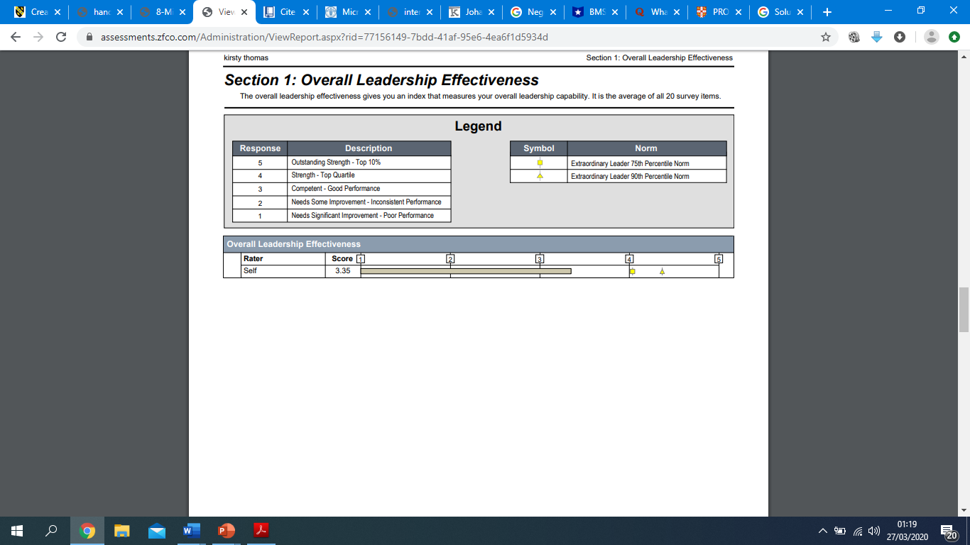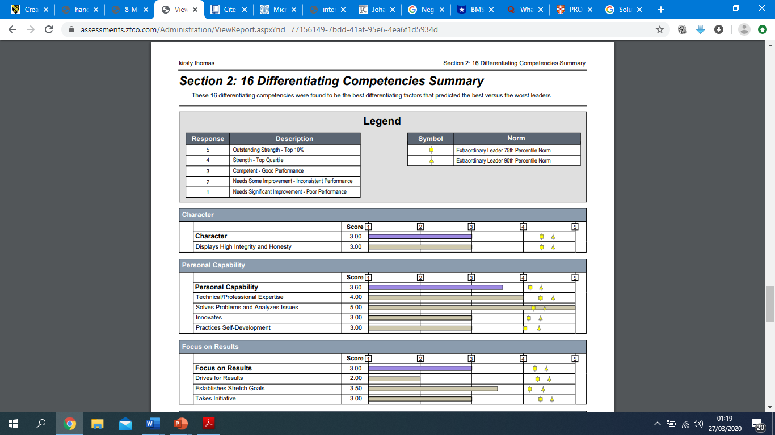

Appendix F



