
Module Code: LCMB7035
Module Name: Dissertation

Title: Impact of Social Media Marketing on Purchase Intention Among Generation Z Consumers

Student Name: Taranjot Randev
Student ID: 2436053
Submission Date: 17th July , 2026
Word Count: 2217
Table of Content
1. Introduction 3
1.1 Background 3
1.2 Problem Statement 4
1.3 Rationale 4
1.4 Research Aim 4
1.5 Research Objectives 5
1.6 Research Questions 5
2. Literature Review 5
2.1 Introduction 5
2.2 Concept of Social Media Marketing 6
2.3 Generation Z Consumers 6
2.4 Purchase Intention 7
2.5 Theoretical Framework 8
2.5.1 Theory of Planned Behaviour (TPB) 8
2.5.2 Stimulus–Organism–Response (SOR) Model 8
2.6 Social Media Marketing Dimensions 9
2.7 Purchase Intention among Generation Z 10
2.8 Research Gap 10
2.9 Conceptual Framework 10
3. Research Methodology 11
3.1 Research Philosophy 11
3.2 Research Approach 11
3.3 Research Design 12
3.4 Research Strategy 12
3.5 Population and Sampling 12
3.6 Data Collection 12
3.7 Data Analysis 13
3.8 Ethical Considerations 13
3.9 Reliability and Validity 13
4. Expected Findings 13
5. Limitations 14
6. Timeframe 14
7. Conclusion 15
References 16

1. Introduction

1.1 Background
Marketing on social media is one of the most rapidly evolving marketing strategies in the digital world, influencing purchasing decisions and creating a change in the way organisations communicate with their customers. In 2025, global social media users reached 5.3 billion (or around 65% of the world population), and digital advertising spend reached more than US$790 billion, with more than a third of all digital advertising spending going into social media (Dixon, 2025) (Refer to Figure 1). All these advancements have pulled businesses away from typical promotional techniques and toward more interactive and data-oriented marketing. Thus, influencer marketing, personalised ads and user-generated content are becoming more and more popular as ways for businesses to boost consumer engagement and drive sales.
Figure 1. Most Popular Social Networks Worldwide as of October 2025
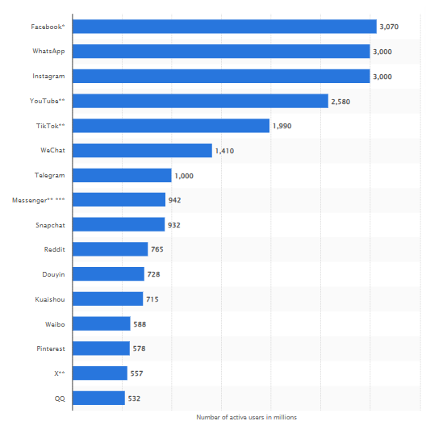
Source: Adapted from: Dixon, 2025

1.2 Problem Statement
Organisations heavily invest in social media marketing, but still do not ensure that they know how much they really impact the purchase intention of Generation Z. Some researchers found that friends' positive influence was substantially higher than bloggers' or YouTube influencers' entertainment media and eWOM, while others found that neither propaganda's influence nor eWOM was significantly stronger than friends' influence (Vu et al., 2024). Such inconsistent factors provide theoretical uncertainty and problems for marketers aiming at the optimisation of digital marketing investments.

1.3 Rationale
The academic significance of this study arises from a growing body of consumer behaviour literature as well as digital marketing literature that focuses on various determinants affecting the purchase intention of Gen-Z (Guerra-Tamez et al., 2024). In real terms, the results will help businesses make better decisions about their marketing investments by targeting more valuable strategies or campaigns that result in higher engagement and conversions. Generation Z makes up almost 30% of the worldwide workforce by 2030, and is expected to have over US$450 billion in annual direct spending globally, making it a strategic target for sustainable competitive advantage for businesses (EMARKETER Editors, 2026).

1.4 Research Aim
The study aims to examine the mediating role of Brand Trust in the relationship between Social Media Marketing Dimensions and Purchase Intention.

1.5 Research Objectives
- To examine the influence of entertainment content on Generation Z purchase intention.
- To evaluate the role of electronic word-of-mouth (eWOM) in shaping purchase intention.
- To investigate the relationship between social media engagement and purchase intention.
- To provide evidence-based recommendations for marketers to improve social media marketing effectiveness.

1.6 Research Questions
RQ1: What is the relationship between Social Media Marketing Dimensions (SMMD) and Brand Trust among Generation Z consumers?
RQ2: What is the relationship between Brand Trust and Purchase Intention among Generation Z consumers?
RQ3: Does Brand Trust mediate the relationship between Social Media Marketing Dimensions and Purchase Intention among Generation Z consumers?

2. Literature Review

2.1 Introduction
Social media marketing has grown from a watermarking method to a method of influencing customers' behaviour and will be an issue for global social media users by more than 5.3 billion in 2025 (Vyas and Vishwakarma, 2026). The evidence of influencer marketing and eWOM as the main drivers of purchase is sometimes contradicted by other accounts, which highlight engagement and entertainment as the drivers. Thus, this chapter critically compares the relevant theories, empirical findings and research gaps for the purchase intention of Generation Z.

2.2 Concept of Social Media Marketing
The seven building blocks of social media marketing describe aspects of social media that facilitate the interactions of the consumers and improve the engagement with the consumer (Dubbelink et al., 2021). Although Dubbelink et al. (2021) focus on maintenance of the relationship, Laradi et al. (2023) state that organisations' responsiveness, content quality and communication strategy are more important to the building of sustained brand equity than simply enabling online interactions.
Figure 2. Functional Building Blocks of Social Media Marketing
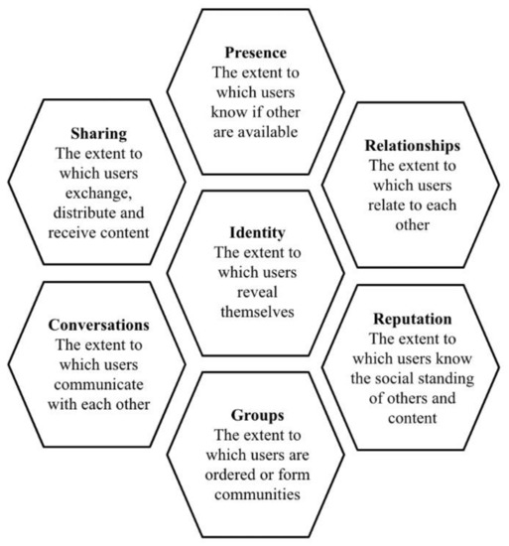
Source: Adapted from: Dubbelink et al. (2021)

2.3 Generation Z Consumers
As highly engaged consumers of digital platforms, Generation Z have different purchase drivers that don't all stack up to easy-to-reach preferences. Assumptions of homogeneous consumption are questioned by Hosany and Serdiuk (2025) as differences in sustainability attitudes are found among individuals. In contrast, the researchers D. Y. and Moodbidri (2026) suggest that the trust in the brand is a more salient factor that makes consumers willing to pay more in the face of differences in preferences for sustainable products.

2.4 Purchase Intention
Figure 3 shows that various value dimensions influence consumers' purchase intention, but the relative importance of those value dimensions is a topic of debate. Adopting a functional and emotional perspective, Chi et al. (2021) claim that these two factors have the most significant power in affecting consumers' buying decisions on environmental products. Conversely, Yu (2023) argues that external elements such as product quality, price, brand trust and marketing communication are also significant determinants. These comparisons indicate that purchase intention is not just a function of perceived value, but it is a function of both the internal evaluations and external market stimuli.
Figure 3. Factors Influencing Purchase Intention towards Recycled Polyester Athleisure Apparel
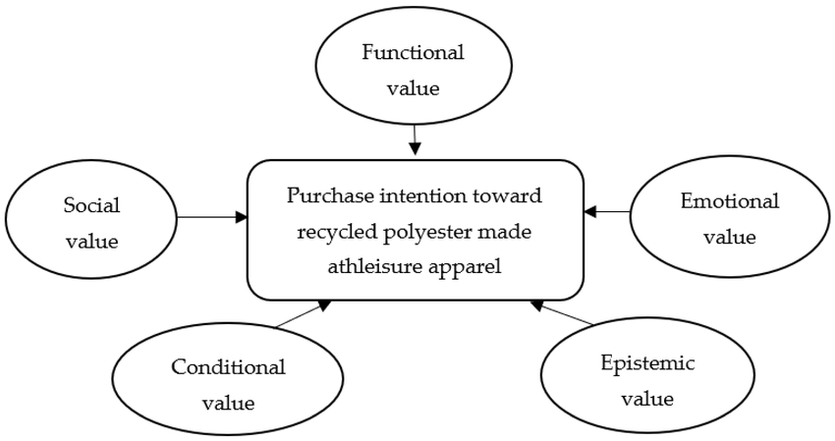
Source: Adapted from: Chi et al. (2021)

2.5 Theoretical Framework

2.5.1 Theory of Planned Behaviour (TPB)
As depicted in Figure 4, the Theory of Planned Behaviour (Ajzen) is a theory that addresses not only attitudinal beliefs and subjective norms, but also perceived behavioural control, to explain behaviour in terms of the intention to engage in a behaviour. While Si et al. (2019) affirm its predictive capacity, Chen and Yaacob (2024) suggest that TPB fails to adequately reflect emotional and digital factors, which puts it at risk of being used in current social media marketing contexts.
Figure 4. Theory of Planned Behaviour (TPB)
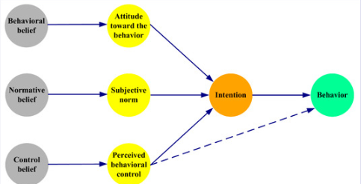
Source: Adapted from: Si et al. (2019)

2.5.2 Stimulus–Organism–Response (SOR) Model
In the SOR model, emotional responses are identified as a major factor that influences behaviour, as shown in Figure 5. However, Chen and Yaacob (2024) have contended that positive emotions also enhance purchase intentions, whereas Si et al. (2019) have stated that the cognitive evaluation and social influences are still important, indicating that the positive emotions and rational thoughts have an equal influence on shaping consumer behaviour.
Figure 5. Stimulus–Organism–Response (SOR) Model
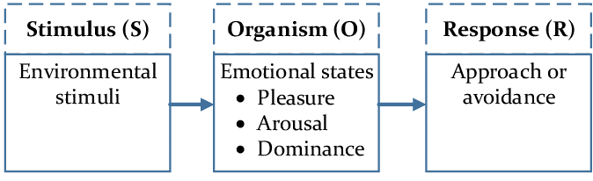
Source: Adapted from: Chen and Yaacob (2024)

2.6 Social Media Marketing Dimensions
The efficiency of social media marketing is related to strategic planning and customer engagement, as shown in Figure 6. According to Li et al. (2020), long-term value creation needs to have an integrated marketing strategy that goes with consumer behaviour. On the contrary, from a standpoint of purchase intentions, there are specific dimensions that can have more immediate effects, such as aspects of entertainment, interaction, trendiness and electronic word of mouth, is maintained by Jamil et al. (2022).
Figure 6. Conceptual Framework of Social Media Marketing Strategy
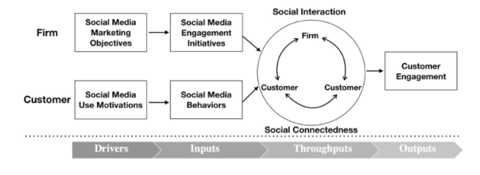
Source: Adapted from: Li et al. (2020)

2.7 Purchase Intention among Generation Z
There are many variables involved with Gen Z purchase intent, not just digital marketing. Nguyen et al. (2026) indicate that the purchase of trendy fashion comes down to two factors: first, affordability, and second, trend appeal. On the other hand, Vidya and Karthic (2024) highlight the importance of the community's engagement with the social media platform and the trust they have in the brand as positive factors, indicating that both economic and relational aspects affect consumer behaviour.

2.8 Research Gap
The results of previous studies are mixed with respect to relatively important social media marketing strategies to influence the purchase intention of Generation Z, with findings from studies indicating that either influencer marketing or eWOM is relatively more important, or the relative importance of engagement and entertainment (Vidya and Karthic, 2024; Nguyen et al., 2026). In addition, little research has examined these factors concurrently under the same umbrella, which are of considerable interest for contemporary digital marketing in light of studies on Generation Z consumers' purchase intentions.

2.9 Conceptual Framework
The conceptual framework is based on the hypothesis that the variables to be investigated, such as entertainment, interaction, trendiness, customisation, and electronic word-of-mouth (eWOM), while influencing the purchase intention of Generation Z consumers independently, together contribute to the final determining variable. The study combines these salient elements of social media marketing under one umbrella, thereby eliminating the inconsistencies identified from the previous studies and offers an in-depth analysis for an empirical study of the relative effect on purchase intention.
Figure 7. Conceptual Framework
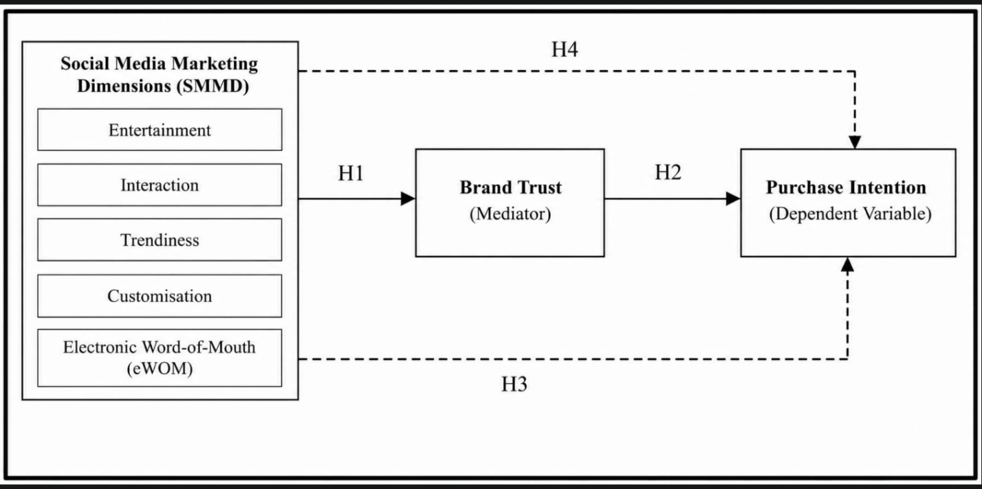
Source: Self-Created
Hypothesis
H1: Social Media Marketing Dimensions have a positive and significant effect on Brand Trust.
H2: Brand Trust has a positive and significant effect on Purchase Intention.
H3: Social Media Marketing Dimensions have a positive and significant effect on Purchase Intention.
H4: Brand Trust mediates the relationship between Social Media Marketing Dimensions and Purchase Intention.

3. Research Methodology

3.1 Research Philosophy
In this study, the researcher applies the positivism approach to the research methodology, whose approach is to assume that social phenomena can be measured by observable and measurable evidence. Positivism is commonly used in marketing research because it helps researchers test their hypotheses and analyse the data using statistics (Park, Konge and Artino, 2020).

3.2 Research Approach
The deductive research approach is used to test hypotheses based on theories or models: the Theory of Planned Behaviour and the Stimulus – Organism – Response model. Deduction aims at empirical verification and can be used to analyse social media marketing dimensions and the causal relationship between them and purchase intention, which makes it suitable for this study as an alternative to theory development based on inductive approaches.

3.3 Research Design
The study is quantitative, with a cross-sectional survey design, which is used to obtain raw data that are all numerical for consumers in Generation Z at a single time. Consumer behaviour researchers are known to utilise the cross-sectional type of survey because of its efficiency and cost-effectiveness (Maier et al., 2023).

3.4 Research Strategy
A structured questionnaire survey is the main research method, which can help to collect the data from a specified number of respondents in standardized mode. The advantages of using questionnaires over qualitative interviews are that researcher bias is reduced and that questionnaires are easier to analyse statistically.

3.5 Population and Sampling
The target audience is Generation Z consumers, with active social media usage, and prior online shopping experience aged ~18-28 years. The convenience sampling technique will be used because it is the most convenient and saves time and money in accessing the respondents. Around 100-150 participants are to be selected via the internet.

3.6 Data Collection
Data will be gathered from primary sources through an online self-administered questionnaire that was previously created using Google Forms. The results will be assessed on a 5-point Likert Scale from "strongly disagree" to "strongly agree. Online questionnaires offer speedy and cost-efficient data collection, and widen geographical reach.

3.7 Data Analysis
Data collected will be analysed with IBM SPSS Statistics. Demographic characteristics and distribution of variables will be summarised using descriptive statistics. Cronbach's alpha will be used for the assessment of internal consistency reliability, and values over 0.70 are considered acceptable (Taber, 2018). Relationships between variables will be analysed using correlation analysis, and the influence of entertainment, interaction, trendiness, customisation, influencer credibility and electronic word-of-mouth effects on the purchase intention of Generation Z will be determined by multiple regression analysis.

3.8 Ethical Considerations
As far as possible, informed consent, voluntary participation, anonymity and confidentiality will be respected during the research. Volunteers may opt out at any time, for no penalty (Hiratsuka, 2025). Collected data will be properly and securely kept and used in compliance with institutional ethical guidelines and the data protection laws to protect the privacy of data participants.

3.9 Reliability and Validity
The questionnaire will undergo a pilot study with around 10 – 15 respondents to assess the clarity and consistency of the questionnaire. Reliability will be evaluated by Cronbach's Alpha (0.70 or more), and content validation will be validated from the point of view of experts and compared to validation that has been carried out in previous studies.

4. Expected Findings
This study will likely reveal a positive correlation between social media marketing dimensions and Generation Z consumers' purchase intention. It is expected that influence credibility and electronic word of mouth (eWOM) have the greatest positive influence, and entertainment and social media engagement have a notable influence on consumer behaviour.

5. Limitations
There are a number of limitations in this study. The small number of respondents in each study (100–150) and the short period in which the studies took place might limit the generalisability of findings. Additionally, because of the study's geographical constraints, the study findings may not be generalizable to other generations of young people and other cultures.

6. Timeframe

Activities | W1 | W2 | W3 | W4 | W5 | W6 | W7 | W8 | W9 | W10 | W11 | W12
Proposal Approval
Literature Review
Questionnaire Design
Pilot Testing
Data Collection
Data Analysis (SPSS)
Results Interpretation
Dissertation Writing
Proofreading & Revision
Final Submission

7. Conclusion
This idea aimed at social media marketing effects on finding purchase intention among Generation Z consumers. The literature is used to build a theoretical basis and a quantitative method is proposed to test the literature BASED research objectives in a systematic way. The results will have implications for marketing theory and can provide practical guidance for crafting a more successful and evidence-backed social media marketing campaigns for Generation Z consumers.

References
Chen, D. and Yaacob, H.B. (2024). Conceptualizing the Influence of Souvenir Image and Place Identity on Souvenir Repurchasing Intentions. South Asian Journal of Social Sciences and Humanities, 5(4), pp.112–135. doi:https://doi.org/10.48165/sajssh.2024.5406.
Chi, T., Ganak, J., Summers, L., Adesanya, O., McCoy, L., Liu, H. and Tai, Y. (2021). Understanding Perceived Value and Purchase Intention toward Eco-Friendly Athleisure Apparel: Insights from U.S. Millennials. Sustainability, [online] 13(14), p.7946. Available at: https://www.researchgate.net/publication/353330857_Understanding_Perceived_Value_and_Purchase_Intention_toward_Eco-Friendly_Athleisure_Apparel_Insights_from_US_Millennials.
D. Y., A. and Moodbidri, S. (2026). Trust-enabled drivers of Gen Z consumers’ willingness to pay for sustainable packaging: an extended TRUST-PACT model. Frontiers in Sustainability, 7. doi:https://doi.org/10.3389/frsus.2026.1762826.
Dixon, S.J. (2025). Most Popular Social Networks Worldwide as of February 2025, by Number of Monthly Active Users. [online] Statista. Available at: https://www.statista.com/statistics/272014/global-social-networks-ranked-by-number-of-users/ [Accessed 4 Jul. 2026].
Dubbelink, S.I., Soria, C.H. and Constantinides, E. (2021). Social Media Marketing as a Branding Strategy in Extraordinary Times: Lessons from the COVID-19 Pandemic. Sustainability, [online] 13(18), p.10310. doi:https://doi.org/10.3390/su131810310.
EMARKETER Editors (2026). FAQ on Gen Z: How marketers can reach this generation in 2026. [online] EMARKETER. Available at: https://www.emarketer.com/content/faq-on-gen-z--how-marketers-reach-this-generation-2026 [Accessed 4 Jul. 2026].
Guerra-Tamez, C.R., Keila Kraul Flores, Gabriela Mariah Serna-Mendiburu, David Chavelas Robles and Jorge Ibarra Cortés (2024). Decoding Gen Z: AI’s influence on brand trust and purchasing behavior. Frontiers in artificial intelligence, [online] 7. doi:https://doi.org/10.3389/frai.2024.1323512.
Hiratsuka, T. (2025). The volunteer participation paradox: Ethical tensions between self-selection and targeted sampling. Research Methods in Applied Linguistics, [online] 4(2), pp.100206–100206. doi:https://doi.org/10.1016/j.rmal.2025.100206.
Hosany, A.R.S. and Serdiuk, K. (2025). Understanding Gen Z Consumers: A Typology of (Un)sustainable Purchases. Psychology & Marketing. doi:https://doi.org/10.1002/mar.70013.
Jamil, K., Dunnan, L., Gul, R.F., Shehzad, M.U., Gillani, S.H.M. and Awan, F.H. (2022). Role of Social Media Marketing Activities in Influencing Customer intentions: a Perspective of a New Emerging Era. Frontiers in Psychology, [online] 12(1), pp.1–12. doi:https://doi.org/10.3389/fpsyg.2021.808525.
Laradi, S., Berber, N., Rehman, H.M., Hossain, M.B., Hiew, L.-C. and Illés, C.B. (2023). Unlocking the Power of Social Media marketing: Investigating the Role of posting, interaction, and Monitoring Capabilities in Building Brand Equity. Cogent Business & Management, 10(3). doi:https://doi.org/10.1080/23311975.2023.2273601.
Li, F., Larimo, J. and Leonidou, L.C. (2020). Social Media Marketing strategy: definition, conceptualization, taxonomy, validation, and Future Agenda. Journal of the Academy of Marketing Science, [online] 49(1), pp.51–70. doi:https://doi.org/10.1007/s11747-020-00733-3.
Maier, C., Thatcher, J.B., Grover, V. and Dwivedi, Y.K. (2023). Cross-sectional research: a Critical perspective, Use cases, and Recommendations for IS Research. International Journal of Information Management, [online] 70(70), p.102625. Available at: https://www.sciencedirect.com/science/article/abs/pii/S0268401223000063.
Nguyen, L.T.T., Nguyen, T.T. and Pham, N.T.A. (2026). Exploring generation Z’s unsustainable purchase intention towards ultra-fast fashion products. Discover Psychology. doi:https://doi.org/10.1007/s44202-026-00594-x.
Park, Y.S., Konge, L. and Artino, A.R. (2020). The Positivism Paradigm of Research. Academic Medicine, [online] 95(5), pp.690–694. doi:https://doi.org/10.1097/ACM.0000000000003093.
Si, H., Shi, J., Tang, D., Wen, S., Miao, W. and Duan, K. (2019). Application of the Theory of Planned Behavior in Environmental Science: A Comprehensive Bibliometric Analysis. International Journal of Environmental Research and Public Health, [online] 16(15), p.2788. doi:https://doi.org/10.3390/ijerph16152788.
Taber, K.S. (2018). The Use of Cronbach’s Alpha When Developing and Reporting Research Instruments in Science Education. Research in Science Education, [online] 48(6), pp.1273–1296. Available at: https://link.springer.com/article/10.1007/s11165-016-9602-2.
Vidya, M. and Karthic, M.U. (2024). Issue 3 Consumer Purchase Intentions of Generation Z. Frontiers in Health Informatics, [online] 13(3), pp.11080–11095. Available at: https://www.researchgate.net/publication/387226383_Issue_3_Consumer_Purchase_Intentions_of_Generation_Z.
Vu, V.C., Wang, S., Keating, B.W. and Chen, E.Y. (2024). Increasing Social Media Stickiness Through Parasocial Interaction and Influencer Source Credibility. Australasian Marketing Journal. doi:https://doi.org/10.1177/14413582241306130.
Vyas, Y. and Vishwakarma, P. (2026). Artificial Intelligence in Brand Communication: A Comprehensive Literature Review and Research Outlook. International Journal of Consumer Studies, 50(1). doi:https://doi.org/10.1111/ijcs.70170.
Yu, Q. (2023). Research on Factors Affecting Consumers’ Purchase Intention. Advances in Economics Management and Political Sciences, [online] 37(1), pp.61–66. doi:https://doi.org/10.54254/2754-1169/37/20231835.

