Hugh Owens, p146761, BSc Web Development

Responsive web design and development
Assignment 1

Contents
Introduction 2
Implementation 3
Description of the website 3
Responsive Design 3
Breakpoints 3
Displaying content for different viewports 3
Responsive Navigation 3
Frameworks and libraries used 4
Screenshots of the pages 5
index.html 5
sights.html 9
eat.html 11
shopping.html 12
stay.html 13
cityAreas.html 14
Evaluation 15
Errors or challenges encountered when implementing the website 15
Evaluation of the website 15
Future Improvements 15
References 16

Introduction
The following report contains the implementation of a responsive web site describing its purpose as well as the design, responsive navigation, any frameworks or libraries used, screenshots of each page in different views, errors that may have been encountered, an evaluation of the website and any future improvements that could be made.

Implementation

Description of the website
The website that has been chosen to be implemented is based off the “Visit Copenhagen” website. [1]
The purpose of this website is to give the target audience, who are potential tourists to Copenhagen, an insight of the city’s qualities before they decide to visit. When the user first visits the site, they see information about Copenhagen including a brief paragraph on the city’s history. The second page they see is a page with information on some of the attractions of Copenhagen. Various places to eat and drink around the city is on the next page. Next is a page containing information on different places to shop in the city. The final two pages contain information on places a potential tourist could stay and some of the different areas of the city.

Responsive Design

Breakpoints
The website has a minimum width of 320px and a max width of 1200px.
The website’s breakpoints are based off Bootstrap 4’s standard breakpoints. [2]
Bootstrap 4 was chosen as a reference due to its popularity as it is a widely used framework for styling websites. Bootstrap 4 is the latest version of Bootstrap, it was decided that these standard breakpoints templates would be used, as these templates are tried and tested by other developers. Thus, reducing the risk of faults occurring.
The breakpoints they decided to go with are:
575px for mobile devices
768px for tablet devices
991px for laptops/ PCs

Displaying content for different viewports
For the text, the developer used letter spacing of 0.5em and used a line height of 1.4em to improve the readability of the content.
The images are responsive. They use a max width of 100%, height of auto. As the max width is set to 100% it allows for it to scale down but never scale up larger than its original size. [3]

Responsive Navigation
The responsive navigation used is a hamburger menu:
At anything below 480px in width the hamburger menu shows. When the hamburger class is clicked the slide down class is toggled. The list items then slide down. When the hamburger has been clicked again it toggles the slide down class and removes it which in turn makes the menu slide back up.

Frameworks and libraries used
No frameworks were when implementing this website although the breakpoints are based off the Bootstrap framework. [4]
The Developer has implemented a hamburger menu using a pen by Sarah Holden from the website www.codepen.io as a reference. [5]
The developer implemented the hamburger menu to work so that when the screen is anything up to a maximum width of 480px the hamburger icon shows instead of the normal navigation links that show on a screen with a maximum width higher than 480px. When the user clicks the hamburger icon it toggles a class called “slide-down”. When this class has been toggled the menu shows the navigation links that had previously been hidden. When the user clicks the hamburger again the “slide-down” class is then toggled once more which then hides the navigation links again.

The developer used Lightbox 2 to overlay a larger image of the one that already exists on the web page. [6]
Lightbox allows for a grouped image gallery to be implemented to a site by showing an overlay on the screen. The developer implemented Lightbox to allow the user to view images grouped as a gallery. When the user clicks an image on the page, Lightbox then shows the image as an overlay. The user can then hover their mouse over the left or right of their screen on desktop view to user the arrows to see the next images in the gallery. To see the next images in the gallery in mobile or desktop view the user can tap the left or right side of their screen.
The developer implemented a jQuery smooth page scrolling using a pen by Chris Coyier as a reference. [7]
The smooth page scrolling feature works when the user clicks on a “scroll to …” link. Once the user has done this the link clicked then focuses on the element with the same id, which brings the user to that section of the page. The “scroll back to the top” link finds the element with the id “top” and focuses on that.

Screenshots of the pages

index.html

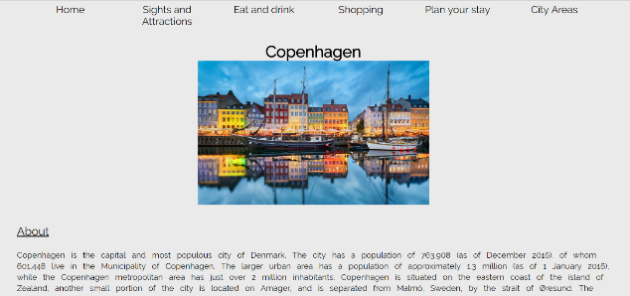
Below is a screen shot of the index page in desktop view


Below is a screen show of the bottom of the index page in desktop view. Using the responsive-grid layout on has allowed for two images to be viewed next to each other on larger devices. The images use lightbox to display an overlay of the image.

Here is a screenshot of the lightbox overlay on an index page image. The screenshot shows the overlaid image over the two images on the web page.

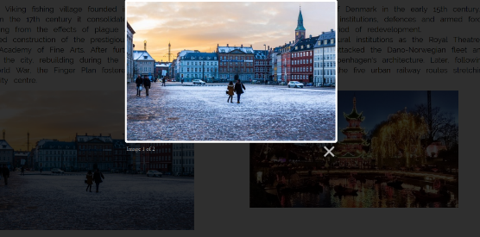
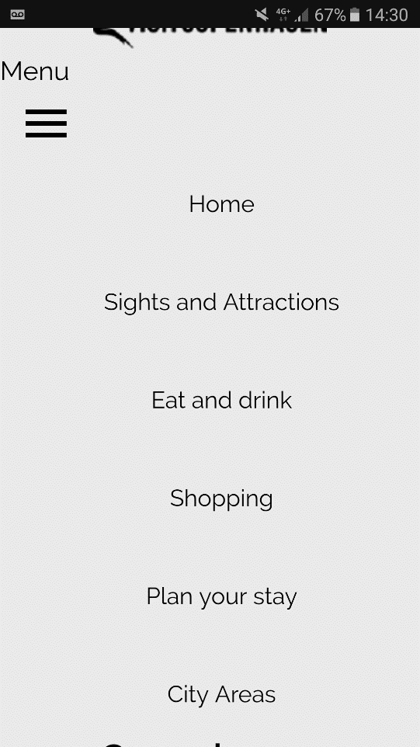
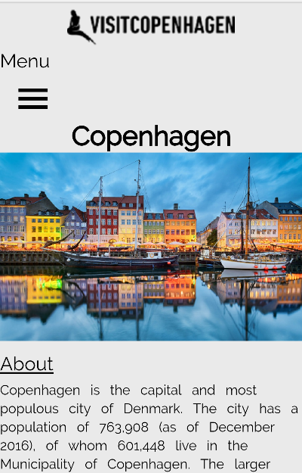
Here is a screenshot of the index page viewed from a mobile phone. This screenshot shows the menu has changed to a hamburger menu using a media query that detects the max-width of the screen.

The screenshot on the right shows the hamburger menu when it has been pressed and the navigation links have been shown as the slide-down class has been toggled.
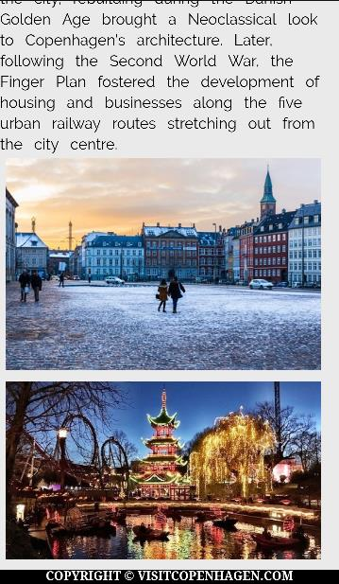
Here is a screenshot of the images in on the index page in mobile view. A responsive grid is used to allow for images in a mobile view to be shown taking up 12 columns per row. This is illustrated by the two images being one below the other as seen in the screenshot. This is different from the same images on the desktop view which were next to each other as they took up 6 columns each opposed to the 12 that they take for each row in mobile view.

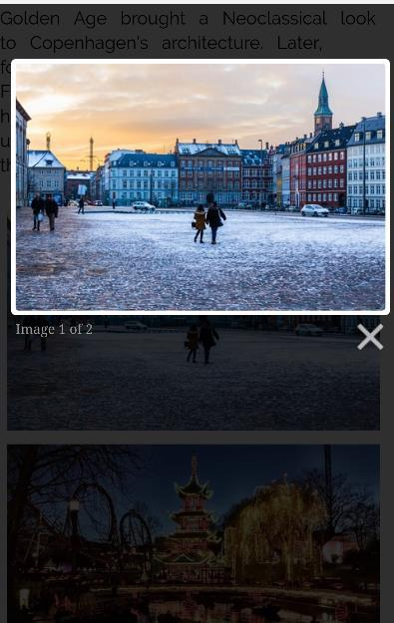
The screenshot on the right shows the image overlaid over two images on the web page using Lightbox.

sights.html

The screenshot below shows the top section of the sights.html page. When the user clicks on the Scroll to Christiana link it moves the focus of the page to the Christiana section of the site.
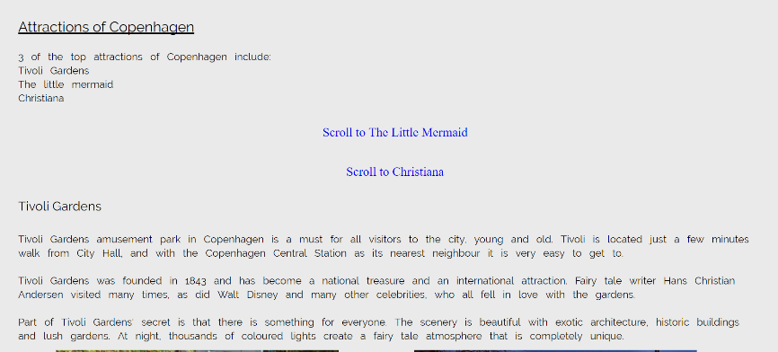

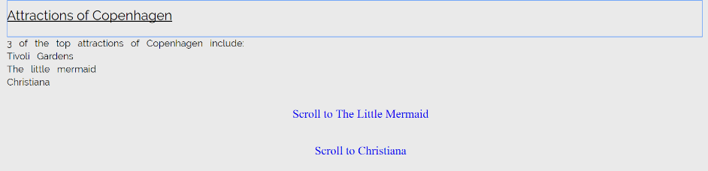
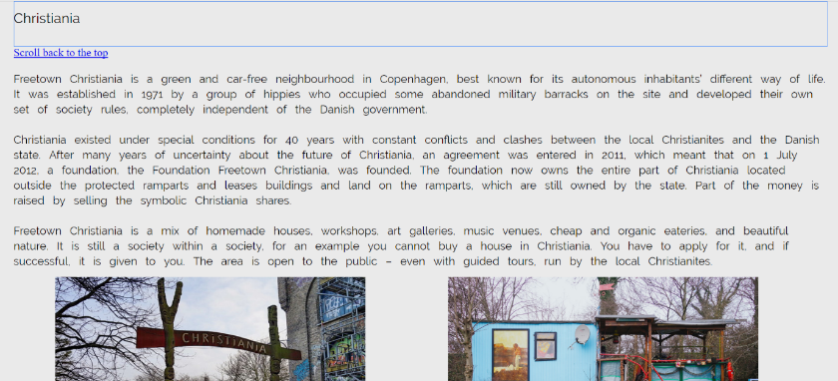
The following two screenshots show when the page has focused on the Christiana section of the page and when the “scroll back to the top” link has been pressed
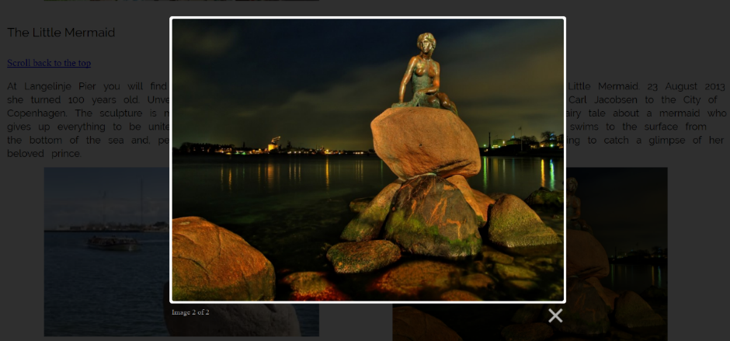
The following screenshot is of the Lightbox working on the page

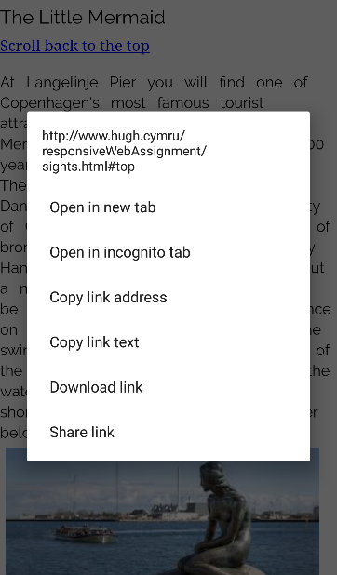
The screenshot on the left is of the page before it focuses back to the top of the page.

eat.html
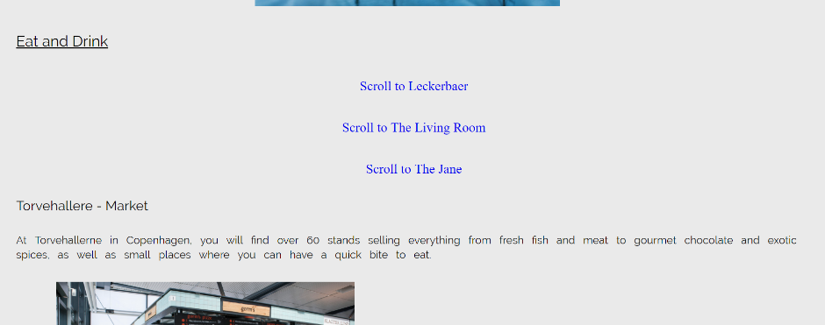
The following screenshot is of the eat and drink page in desktop view

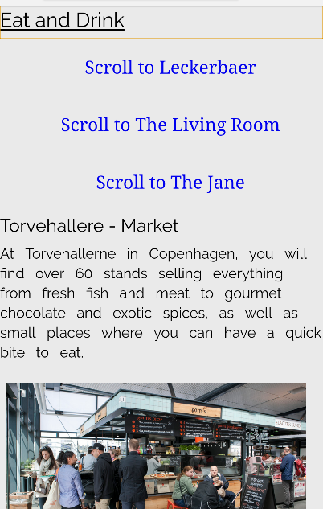
The screenshot on the right is of the eat and drink page in mobile view

shopping.html
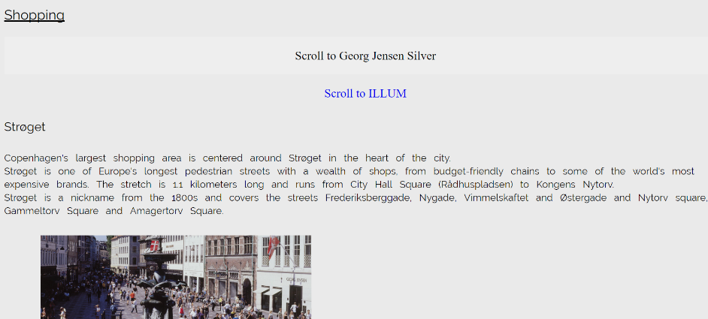
This is a screenshot of the shopping page in desktop view

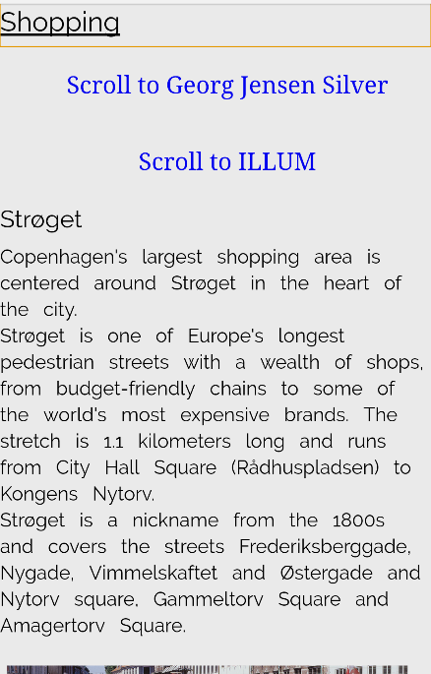

The screenshot on the right is of the shopping page in mobile view.

stay.html
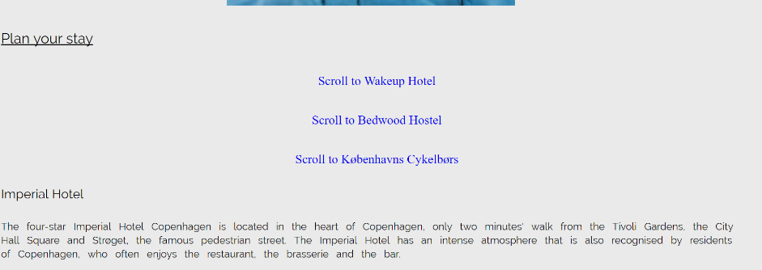
This screenshot is of the plan your stay page in desktop view

This screenshot is of the plan your stay page in mobile view
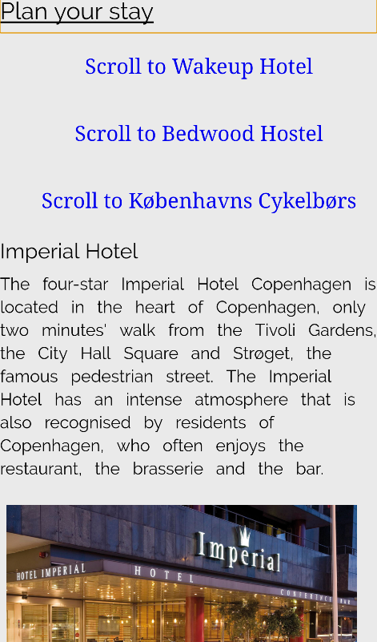

cityAreas.html
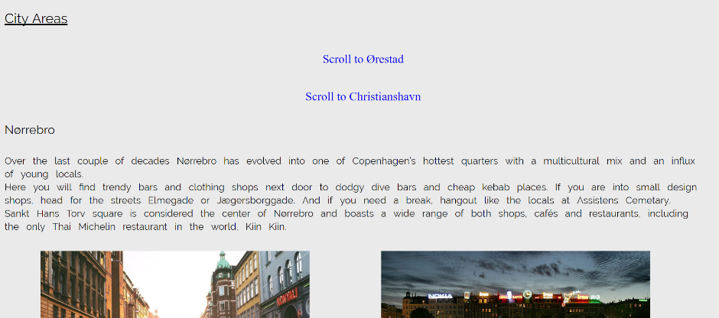
The following screenshot is of the city areas page in desktop view

The following screenshot is of the city areas page in mobile view
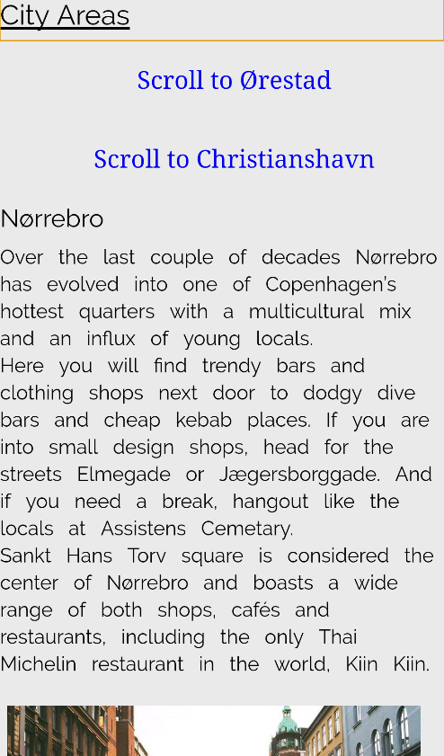

Evaluation

Errors or challenges encountered when implementing the website
On a couple of occasions, there was a problem with the positioning if the developer had used the float attribute in the CSS. To fix this they used the “clear: both” attribute to help fix the problem.

Evaluation of the website
The website fits its purpose as an informative site for potential tourists to Copenhagen, as mentioned in the description of the website. The site’s background colour is neutral and is not too bright that it reduces the site’s readability. The word spacing makes the site easier to read as otherwise the text would be closer together making it potentially harder for some people.
The site’s navigation is simple and easy to follow. The developer used a heading which is underlined on each page to indicate which page the user is currently on.

Future Improvements
In the future, the website could be improved by adding more media to it; such as more images to the Lightbox gallery, and a video gallery of some of the points of interest in Copenhagen. The content of the “sights and attractions”, “eat and drink”, “shopping”, “plan your stay” and “city areas” pages could be improved to show more than three or four items.
Doing this would improve the site’s information to give to potential tourists. The image at the top of the page that appears on each page could be replaced with a dynamic gallery of different images relating to Copenhagen, which change every couple of seconds.

References

[1] | visit copenhagen, “visit copenhagen,” [Online]. Available: http://www.visitcopenhagen.com/ . [Accessed 22 November 2017].
[2] | Medium Corporation, “The Most Used Responsive Breakpoints in 2017 Of Mine,” 22 April 2017. [Online]. Available: https://medium.com/@uiuxlab/the-most-used-responsive-breakpoints-in-2017-of-mine-9588e9bd3a8a . [Accessed 1 December 2017].
[3] | w3School, “Responsive Web Design - Images,” [Online]. Available: https://www.w3schools.com/css/css_rwd_images.asp. [Accessed 29 November 2017].
[4] | Bootstrap, “Documentation - layout,” [Online]. Available: https://v4-alpha.getbootstrap.com/layout/overview/#responsive-breakpoints. [Accessed 29 November 2017].
[5] | S. Holden, “Hamburger menu,” [Online]. Available: https://codepen.io/sarahholden/pen/cfa2589812da7490cb25dde7a80a816a . [Accessed 29 November 2017].
[6] | L. Dhakar, “Lightbox 2,” [Online]. Available: http://lokeshdhakar.com/projects/lightbox2/. [Accessed 2 December 2017].
[7] | C. Coyier, “Smooth page scrolling,” [Online]. Available: https://codepen.io/chriscoyier/pen/dpBMVP . [Accessed 5 December 2017].

marking criteria and Student FEEDBACK

This section details the assessment criteria. The extent to which these are demonstrated by you determines your mark. The marks available for each criterion are shown. Lecturers will use the space provided to comment on the achievement of the task(s), including those areas in which you have performed well and areas that would benefit from development/improvement.

Common Assessment Criteria Applied (Assignment 1) | Marks available | Marks  awarded
1. Research-informed Literature
Extent of research and/or own reading, selection of credible sources, application of appropriate referencing conventions.
References consulted are appropriate and have been cited appropriately and in a consistent manner, but there is still room for improvement in the range of references consulted. Expanding the scope will also help you to further enhance your overall implementation. (Grade mark: 60.00%) | 5 | 3
2. Knowledge and Understanding of Subject
Extent of knowledge and understanding of concepts and underlying principles associated with the discipline.
Demonstrates a good understanding of responsive web design (RWD), but the overall implementation is a bit on the simple side to fully demonstrate an enhanced understanding of RWD concepts. The main area for improvement is to apply the grid classes, specifically the column classes, properly. You were generally applying the classes to only images. The classes need to be applied to all the content and if your website had more content beyond the mostly text content, you would definitely have noticed the problems. See your report for additional comments. (Grade mark: 60.00%) | 15 | 9
3. Analysis
Analysis, evaluation and synthesis; logic, argument and judgement; analytical reflection; organisation of ideas and evidence
Overall, you have provide a fair evaluation of the website, but I would have liked to see a more critical review. A good and relevant list of suggested improvements has been provided. (Grade mark: 53.33%) | 15 | 8
4. Practical Application and Deployment
Deployment of methods, materials, tools and techniques; application of concepts; formulation of innovative and creative solutions to solve problems.
Demonstrates very good engagement with the class tutorial exercise. A bit more CSS styling is required for additional improvements. For example, setting the background image size to cover the entire page and using either positioning or flexbox to get the footer menu to display properly. The footer links should also ideally be enclosed in a <nav> element to add meaning to your content as they are a set of navigational links.  Overall, this is a good attempt and the implemented website is responsive. The use of the back to top link, especially on the mobile version when the page becomes quite long, is very good. There is, however, room for improvement. The website is on the simplistic side and could be enhanced to provide an overall, better user experience and further demonstrate your skills and understanding of RWD. Please refer to comments above under knowledge and understanding about correctly applying the grid classes and further suggestions in your report. A very good attempt, well done. (Grade mark: 62.50%) | 60 | 37.5
5. Skills for Professional Practice
Attributes in professional practice: individual and collaborative working; deployment of appropriate media; presentation and organisation.
The report is of a good standard. It is well-written and presented, but take note of when to use apostrophes to indicate possession and remember to add page numbers to your report too. (Grade mark: 70.00%) | 5 | 3.5

Assignment Mark (Assessment marks are subject to ratification at the Exam Board. These comments and marks are to give feedback on module work and are for guidance only until they are confirmed. ) | Late Submission Penalties (tick if appropriate) |  | 61%
 | Up to one week late |  | 61%
 | 1st/2nd/3rd attempt? |  | 61%

