
An Aerial Investigation and Mapping Project in Southern Holderness:
An Evolving Wetland Landscape
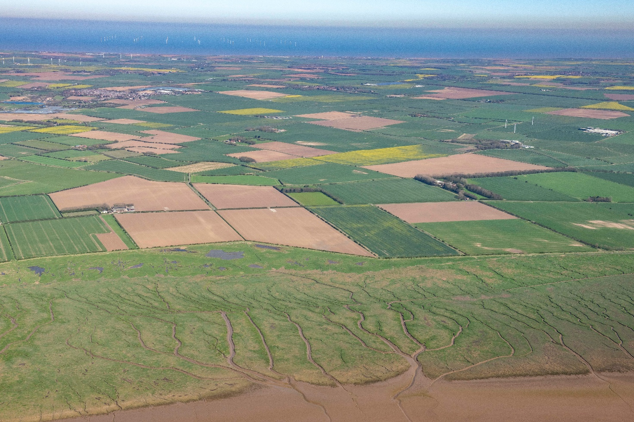Robyn Andrews
Student Number: 2309525
Year: 2026
Wordcount: 16333

Cover image: Southern Holderness from the Humber Estuary looking across to the Study Area. TEMP_SRT0287 07-MAR-2026 © Historic England Archive


Master’s Degrees by Examination and Dissertation - Declaration Form
1. This work has not previously been accepted in substance for any degree and is not being concurrently submitted in candidature for any degree.
Name: Robyn Andrews
Date: 21/04/2026
2. This dissertation is being submitted in partial fulfilment of the requirements for the degree of MA Apprenticeship Archaeological Practice - Distance (MA18-PTPA7MA-APR)
Name: Robyn Andrews
Date: 21/0/2026
3. This dissertation is the result of my own independent work/investigation, except where otherwise stated.
Other sources are acknowledged by footnotes giving explicit references.
A bibliography is appended.
Name: Robyn Andrews
Date: 21/04/2026
4. I hereby give consent for my dissertation, if accepted, to be available for photocopying, inter- library loan, and for deposit in the University’s digital repository
Name: Robyn Andrews
Date: 21/04/2026
Supervisor’s Declaration.
I am satisfied that this work is the result of the student’s own efforts.
Signed: …………………………………………………………………………...
Date: …………………………………………………………………………..
University of Wales Trinity Saint David - E-Thesis Deposit Agreement

Contents
Contents ii
Illustrations iv
Tables vii
Abstract 1
1. Project Context 2
1.1 Introduction 2
1.2 The Southern Holderness Study Area 3
1.3 Aim and Objectives 6
2. Project Research Context 7
2.1 Previous Aerial Mapping Projects in Holderness 7
2.2 Excavations within the study area 10
3. Evolution of the Wetlands 12
3.1. Southern Holderness before the 18th century 12
3.2 Drainage and Land Reclamation in the 18th century 14
3.3 Modelling the Wetlands in the Iron Age period 17
4. Methodology 20
4.1 Area selection methodology 20
4.2 Aerial Mapping methodology 23
4.3 Methodological Approach and Project Adjustments 25
5. Mapping Results 27
5.1 Cropmarks 28
5.2 Earthwork Survival 32
6. Discussion 35
6.1 Neolithic 35
6.3 Bronze Age 39
6.4 Iron Age/Roman 39
6.5 Early Medieval 45
6.6 Medieval and Post-medieval 46
Ridge and Furrow 47
Moated sites 48
Settlement Earthworks 53
Post-medieval Parkland 56
6.8 20th Century 56
Heavy Anti-Aircraft Battery 56
BBC Broadcasting Station 59
Military camp 60
Aircraft Obstruction Earthworks 60
Bombing Range Marker 61
Gun Emplacement 63
Royal Observer Corps Post 63
6.9 Conclusion 64
7. Recommendations 66
References 68

Illustrations
Figure 1: Map showing the location of the Study Area - [Includes OS data © Crown copyright and database right 2026 Open Government Licence]. 3
Figure 2: Map depicting the coverage of Aerial Investigation Mapping projects in and around the study area (including past NMP projects) [Includes OS data © Crown copyright and database right 2026 Open Government Licence]. 9
Figure 3: Historic maps showing the position of the study area (red square) and the changing Humber Estuary position [Maps reproduced with the permission of the National Library of Scotland]. 15
Figure 4: Historic maps showing the position of the study area (red square) and the changing Humber Estuary position [Maps reproduced with the permission of the National Library of Scotland]. 16
Figure 5: Models of water table height above sea level (ASL) created using QuickterrainModeller - Study area outlined in black square. 18
Figure 6: Map showing distribution of sites photographed in 2025 aerial reconnaissance - Top map - Heat map of sites - Lower map - Distribution of sites with NRHE records (Green) and without any records (Orange)- [Includes OS data © Crown copyright and database right 2025 Open Government Licence] 22
Figure 7: Map showing the completed mapping in the study area and the surrounding buffer area [Includes OS data © Crown copyright and database right 2025 Open Government Licence] 27
Figure 8: Comparison of the same cropmark site in 2011(Right)and 2025(Left) – Left photo TEMP_SRT6541 – 11-JUL-2025/ Right Photo – 28196_048 12-JUL-2011 © Historic England Archive 29
Figure 9: Distribution of sites mapped as cropmarks in the study area overlying superficial geology soil data [Contains - Geological Map Data BGS © UKRI 2026 – Background mapping - OS data © Crown copyright and database right 2025 Open Government Licence]. 30
Figure 10: Distribution of Cropmark sites identified in the 2025 reconnaissance overlying the superficial geology soil data [Geological Map Data BGS © UKRI 2026 – Background mapping - OS data © Crown copyright and database right 2025 Open Government Licence]. 31
Figure 11: Figure 11: Map showing ridge and furrow survival around Winestead - areas in blue with dashed outline indicate total mapped ridge and furrow areas now mostly levelled [Archaeological mapping © Historic England. Includes data © Historic England; source Environment Agency and data © Environment Agency copyright and/or database right 2022. 33
Figure 12: Comparison of the same field from 1947 (lower) to 2025 (top) - Ridge and furrow earthworks shown in the 1947 photograph have been ploughed, but are still showing as faint cropmarks in 2025 along with a new Iron Age enclosure in the top image –[Top photo TEMP_SRT6713 11-JUL-2025 / Lower photo RAF/CPE/UK/2396_RP_17-NOV-1947 © Historic England Archive] 34
Figure 13: Imagery of the cursus monument, seen in 2003 and with possibly extended ditches in 2022 [Google Earth Imagery captured 2003 © 2025 Infoterra Ltd & Bluesky] 36
Figure 14: Cursus monument surrounded by wetlands - using the 6m ASL water table model 38
Figure 15: Six examples of Iron Age/Roman Enclosures photographed in 2025 by the author [All photographs © Historic England Archive] 41
Figure 16: Map showing distribution of Iron Age/Roman period features in relation to the underlying topography - Green indicates the lowest elevation and white indicates the higher elevation (up to 28m above sea level) 42
Figure 17: Map of digitised Iron Age/Roman period features positioned close to the maximum wetland extent, shown using the 6m above sea level water table model 44
Figure 18: Map of the early medieval triple-ditched site north of Halsham digitised as part of the ASLF mapping project alongside the 4.5m ASL water table model - (Deegan and van den Toorn,2008). 46
Figure 19: Historic map depicting two phases of moat construction - OS Six Inch 1st edition map (1855) [Reproduced with the permission of the National Library of Scotland] 50
Figure 20: Aerial Photograph showing cropmark evidence of levelled moat earthworks at Halsham Old Hall still showing as cropmarks [NMR_12909_017 00-JUN-1996] 51
Figure 21: North Winestead moat in its landscape context [top left – Parkland context (contains OS Six Inch 1st edition map, 1855, Reproduced with the permission of the National Library of Scotland), top right – Lidar reveals earthwork survival (Lidar © Historic England, source Environment Agency), lower Left – Moat showing as a soil mark (APGB Imagery 03-NOV-2022 © Bluesky International Limited and Maxar Technologies), Lower right – Digitised moat feature (background mapping contains OS data © Crown copyright and database right 2025, Open Government Licence) 52
Figure 22: Digitisations of Rimswell settlement earthworks (Top) and Winestead settlement earthworks (lower). Background map includes OS data © Crown copyright and database right 2025 Open Government Licence. 55
Figure 23: The Heavy Anti-Aircraft site in Halsham (RAF/CPE/UK/1911_RS_4010_27-DEC-1946) (Background mapping includes OS data © Crown copyright and database right 2025, Open Government Licence). 58
Figure 24: Digitisation of BBC Broadcasting Station alongside the RAF photograph of the site (Ridge and Furrow digitisation not included in this figure to make the mapping clearer) (Contains extract of RAF photograph - RAF/CPE/UK/2396_RS_4018_17-Nov-1947. Background map includes OS data © Crown copyright and database right 2025 Open Government Licence) 59
Figure 25: Newly recorded searchlight battery site digitisation alongside RAF photograph of the site (contains extract of RAF aerial photograph RAF/CPE/UK/2396_RP_3023_17-NOV-1947 © Historic England Archive. Background map includes OS data © Crown copyright and database right 2025 Open Government Licence) 62

Tables
Table 1: Number of Historic England digital oblique photographs taken between 2009 and 2024 in Holderness (figures taken from Aerial Photo Explorer, published by Historic England) 4
Table 2: The number of features vs. the number of sites recorded in the study area 28
Table 3: The total number of cropmark features attributed to each period 29
Table 4: Table showing the survival of ridge and furrow attributed to different periods 32
Table 5: Iron Age/Roman Period Enclosure Characteristics – data derived from mapped features in ArcGIS Pro 40
Table 6: List of Iron Age/Roman period enclosures showing a preference for slightly elevated locations - data retrieved from elevation profiles of each site in ArcGIS Pro – Enclosure numbers link to the elevation profiles in appendix item 2 43

Abstract
In 2025, over 100 new archaeological sites were identified through targeted aerial reconnaissance in Holderness, East Yorkshire. The aerial reconnaissance flights were conducted by the author of this project, who works in the Aerial Survey team at Historic England. The new archaeological sites were identified as cropmarks, with many previously recorded sites also revealing additional features. The Holderness region is predominantly underlain by heavy boulder clay, a soil type generally unfavourable for cropmark formation due to poor drainage. Consequently, the region has attracted limited systematic cropmark reconnaissance in previous years due to limited returns. The unexpectedly high number of discoveries made in 2025 has highlighted the need for a dedicated aerial mapping project to assess the significance of these sites within their broader archaeological and topographical landscape context.
For this project, a 25km² area, incorporating a 1km buffer, was defined in southern Holderness for a programme of aerial investigation and mapping. The extent of the study area was selected to encompass a notably dense concentration of archaeological sites, newly recorded during the 2025 aerial reconnaissance season. This project employed the Historic England Aerial Investigation and Mapping Standards developed and used by the Aerial Survey team at Historic England, which enables spatial and characteristic analysis of archaeological features at a landscape scale.
The landscape of Holderness has been shaped by substantial changes, driven by both natural processes and human activity, since it was first inhabited. Much of the landscape was once covered by wetlands, influenced by the tidal patterns of the River Humber. It is essential to understand how the wetland landscape has evolved over time to understand how it was experienced and exploited throughout history. The project aimed to improve the understanding of human activity in an evolving wetland environment from the Neolithic period up to the 20th century.

1. Project Context

1.1 Introduction
During the summer of 2025, over 100 new archaeological sites were identified through targeted aerial reconnaissance across Holderness, East Yorkshire. The aerial reconnaissance flights were conducted by the author of this paper, who works in the Aerial Survey team at Historic England. Historic England’s aerial reconnaissance programme focuses on the discovery and monitoring of archaeological sites during the summer months, when cropmark formation is at its most favourable. The Holderness region is predominantly underlain by heavy boulder clay, which is generally unfavourable for cropmark formation due to poor drainage. Consequently, the region has not attracted targeted systematic cropmark reconnaissance in previous years due to limited and sporadic returns. The spring of 2025 was the warmest on record and the driest in over 100 years (Met Office, 2025). This explains why there has been a particular boom in cropmarks in an area that doesn’t usually produce cropmarks on such a scale. Not only were new cropmark sites showing, but the quality of cropmarks was also much stronger than previously recorded, also revealing new details for previously known sites. The substantial number of discoveries highlighted the need for a dedicated Aerial Investigation and Mapping project (AI&M) to assess the significance of these sites within their broader archaeological and topographical context.
Although the reconnaissance flights in 2025 discovered new sites throughout Holderness, for this project, a 25km² area, incorporating a 1km buffer, was defined in southern Holderness for a detailed programme of aerial mapping to be completed in time. The extent was selected to encompass a notably dense concentration of newly identified cropmark sites. This project has employed the Historic England Aerial Investigation and Mapping Standards developed and used by the Aerial Survey team at Historic England (Historic England, 2025), which enables spatial and characteristic analysis of archaeological features at a landscape scale. This project assesses how mapped archaeological features relate to a historic landscape that, before the 18th century, was dominated by wetlands.

1.2 The Southern Holderness Study Area
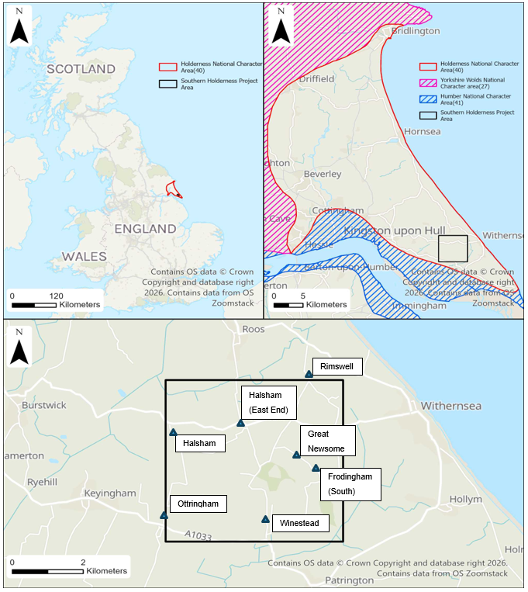
Figure 1: Map showing the location of the Study Area - [Includes OS data © Crown copyright and database right 2026 Open Government Licence].

The study area is located in the county of East Yorkshire, centred on the parishes of Halsham and Winestead. Holderness is characterised as a rural region, with small towns and villages surrounded by large open fields used mainly for arable farming. The fields are bounded with drainage ditches and low hedges, which makes the landscape feel open. The Holderness region is surrounded by water on two sides, with the sea to the east, the Humber estuary to the south, and the more elevated Yorkshire Wolds in the north and west. Holderness sits at a very low elevation, averaging 5-30m above sea level. Areas of elevated land created by glacial till have been exploited throughout Holderness as locations for contemporary settlements.
The geology of Holderness consists of a chalk bedrock covered by a substantial layer of boulder clay, deposited by glacial movement (Natural England, 2013, p.11). Unlike typical clay soils, boulder clay includes gravel and stones of varying sizes, which can enhance cropmark formation by improving drainage. The varied nature of gravel and stone inclusions within the soil results in non-uniform drainage characteristics. This causes cropmark expression to vary across the landscape, with pockets of denser gravel often enhancing cropmark clarity due to improved drainage (Wilson, 2000, pp. 69-70). Holderness has a few productive aggregate sites as identified in the AI&M project funded by the Aggregate Levy Sustainability fund (Deegan and Van Den Toorn, 2008), highlighting sand and gravel pockets that sit within the boulder clay; the closest aggregate site to the study area is at Keyingham. Holderness is not an area traditionally targeted for aerial reconnaissance, as clay soils do not usually produce strong cropmarks, if any (Wilson, 2000, pp. 69-70). The conditions for cropmark production in heavier soils rely on longer periods of drought, for the heavier, water-retaining soils to begin to dry out and cause crop stress (Wilson, 2000, pp.69-70).
Table 1: Number of Historic England digital oblique photographs taken between 2009 and 2024 in Holderness (figures taken from Aerial Photo Explorer, published by Historic England)
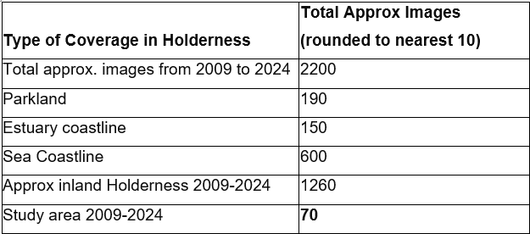
Since 2009, Holderness has had only approximately 2200 oblique aerial photographs taken, with a high proportion of those concentrated on the coast, urban areas, and parklands; only 70 were taken within the study area (Table 1The reconnaissance undertaken in 2025, demonstrates that the identification of cropmark sites in Holderness is achievable, and if timed right with the optimum conditions, it can hold the potential for new archaeological sites to be discovered.
The landscape of Holderness has been shaped by substantial changes arising from both natural processes and human activity since its earliest occupation. After the last glacial retreat, the area was left littered with numerous moraines and meres, although only Hornsea Mere now survives in the north of the region (Natural England, 2013, p.11). The position of the North Sea coastline has progressively migrated landward, while the Humber shoreline has advanced outward, producing significant geomorphological impacts across the study area. These contrasting coastal and estuary shoreline movements have created a landscape markedly different from that experienced in the Neolithic period through to the 18th century. Much of the region would once have supported extensive wetland environments, shaped by tidal influence from the Humber estuary.
From the 18th century onwards, extensive drainage and land reclamation schemes further reshaped the Holderness landscape, facilitating the expansion of arable agriculture, a process accelerated in the 20th century, particularly during and after the Second World War. Due to shifts in farming practices and land use over the last 100 years, many earthworks in the region have been ploughed out, and field boundaries have been reduced to create larger, more open field patterns to suit modern arable farming. Studying historic aerial photographs enables many earthworks that have since been ploughed away to be mapped, helping to understand archaeological features that are no longer extant.

1.3 Aim and Objectives

Aim
To improve what is known about the archaeological character of Holderness, within a broader archaeological and topographical landscape context.

Objectives
- Use all available sources (lidar, modern and historical aerial photographs, satellite imagery and historic maps) to digitise all archaeological features from the Neolithic up to the 21st century within a 25km² area in Holderness
- Look for patterns in cropmark site location using soil data and lidar, to understand whether soil type or elevation creates bias in the discoverability of cropmarks or reveals a preference for site position and its function
- To explore how changes in land use have impacted earthwork survival in Holderness by studying historical aerial photographs from the Historic England Archive

2. Project Research Context
This chapter explores previous research and excavations in and around the Southern Holderness study area.

2.1 Previous Aerial Mapping Projects in Holderness
In Holderness, three projects have studied the archaeological character at a landscape scale using aerial mapping research methods. The projects were undertaken in 2007 (Deegan and Van Den Toorn), 2008 (Deegan, Bacilieri, and Adams), and 2019 (Fleming and Royall). All three projects used a variant of the National Mapping Programme (NMP) methodology (Historic England, 2013), which has evolved into the Aerial Investigation & Mapping (AI&M) standards currently used for aerial mapping projects (Historic England, 2025).
Two of the AI&M projects were conducted as part of the Rapid Coastal Zone Assessment Survey (RCZAS) projects, which included the coastal zone (Deegan, Bacilieri & Adams, 2007) and the inner Humber Estuary (Fleming and Royall, 2019). Both of the project’s scopes were evidently limited to the coastal and estuarine zones, where archaeological sites are most at risk from erosion, in order to support improved management of the coastline, estuary, and associated heritage assets (Deegan, Bacilieri & Adams, 2007). In the earlier RCZAS project, which focused on the coast, Second World War military sites were the most prolifically recorded site type. Features showing as cropmarks from the later prehistoric and Roman periods were notably sparser in the southern extent of Holderness, mostly visible as small, isolated sites (Deegan, Bacilieri & Adams, 2007). Only nine prehistoric, nine Bronze Age, and 33 Iron Age and Roman features were recorded in the earlier RCZAS project; however, it is important to consider the limits of a project bound to the coastal zone, as there are likely to be fewer cropmark sites visible in the small section of land between the low water table, coastline, and inland buffer. The numbers are therefore not likely to represent the wider picture of later prehistoric, Iron Age, and Roman activity throughout Holderness. The latter RCZAS project, conducted in 2019 (Fleming and Royall), was focused on the inner Humber Estuary. The project identified only a single later prehistoric site within Holderness, and the majority of features again belonged to the Second World War period (Fleming and Royall, 2019). This poses the same scoping issues as previously mentioned and should also be treated with caution when applying to the rest of Holderness.
The other mapping project in Holderness was funded by the Aggregate Levy Sustainability fund (ALSF) (Deegan & van den Toorn, 2008). The ALSF project was split into six areas within Holderness to assess the impact of past and ongoing aggregate extraction on the historic landscape and inform future planning and management (Deegan & van den Toorn, 2008). The study areas were selected for aggregate context rather than archaeological potential, yet they offer broad coverage across Holderness. The medieval period had the highest number of sites recorded, with 154, but the Iron Age and Roman periods had the second highest number of sites recorded, with 43 sites (Deegan & Toorn, 2008). The Second World War period also had 38 sites recorded, highlighting their presence inland as well as on the coast, but perhaps not as prolifically (Deegan & van den Toorn, 2008).
All three projects, although located within Holderness, have large gaps in landscape coverage (Figure 2). The earlier projects also did not incorporate lidar, as national coverage was incomplete when the data first became available, and resolution varied considerably. Consequently, Lidar was not included within the NMP methodology at the time the 2007 and 2008 projects were undertaken. As previously mentioned, Holderness had not been targeted heavily for cropmark reconnaissance before 2025; consequently, no aerial mapping projects have yet been undertaken in the region that utilise modern digital aerial photographs to analyse patterns in cropmark sites. This project aims to be the first AI&M study in Holderness to integrate all available sources and apply the most up-to-date mapping methodology to enhance understanding of the area’s archaeological character.

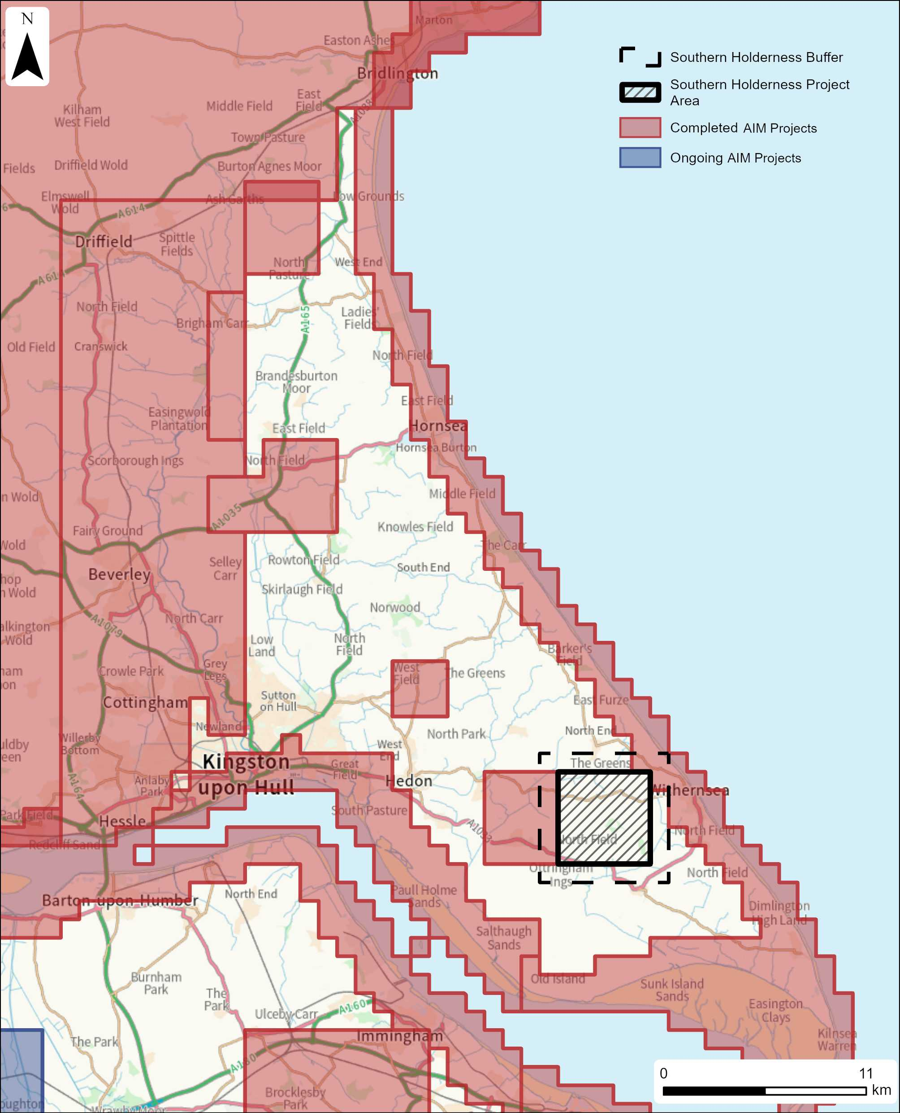
Figure 2: Map depicting the coverage of Aerial Investigation Mapping projects in and around the study area (including past NMP projects) [Includes OS data © Crown copyright and database right 2026 Open Government Licence].

2.2 Excavations within the study area
A large National Grid pipeline was constructed in Holderness in 2008, with twenty areas excavated along the route before installation (Glover, Moore, and Flintoft, 2016). Although the investigations were necessarily limited to the pipeline corridor, which naturally avoided towns and villages and aimed to avoid significant archaeological sites where possible, the excavation results provide insight into the types of archaeology spread across Holderness. Of particular interest are the two excavations conducted within this project’s study area, named Winestead and Churchlands, named after their respective locations.
The Winestead excavation identified a series of ditched enclosures tentatively dated to the early medieval period based on radiocarbon evidence from a single charred grain (Glover, Moore and Flintoft, 2016, pp. 53–54). Although Iron Age and Roman pottery sherds were also recovered, these were discounted due to their size and poor condition (Glover, Moore and Flintoft, 2016, pp. 53–54). Given the weakness of the dating evidence, the features should be interpreted with caution, and the site is more plausibly understood as an area of repeated use, with evidence for both earlier and later activity.
The Churchlands excavation sits just under one mile from the Winestead excavation to the northwest. The Churchlands excavation included a wide range of features, dating from the Iron Age up to the post-medieval period (Glover, Moore and Flintoft, 2016, pp. 50-53). The Churchlands excavation also recovered a few finds from earlier periods, including Mesolithic worked flint and an assemblage of Bronze Age Biconical Urn sherds, which may indicate a disturbed Bronze Age funerary site (Glover, Moore and Flintoft, 2016, p. 51). The Churchlands excavation was dominated by the presence of Iron Age features, including a ring gulley and variously shaped ditches and pits with Iron Age pottery sherds found within them (Glover, Moore, and Flintoft, 2016, pp. 52). Among the various irregular ditches and pits were two double-ditched enclosures, one presenting as a curvilinear enclosure, which was replaced and overcut by a rectilinear enclosure (Glover, Moore and Flintoft, 2016, pp. 52). The curvilinear double-ditched enclosure had no finds recovered within the concentric ditches, but multiple handmade pottery sherds dated to the Late Iron Age period were recovered from the parallel ditches of the rectilinear enclosure (Glover, Moore, and Flintoft, 2016, pp. 52). The Churchlands site only revealed the south-western extents of both double-ditched enclosures, which were ploughed out beyond the site, indicating other sites in Holderness have likely also faced similar survival issues from plough damage (Glover, Moore and Flintoft, 2016, p. 52). This paper provided a useful group of comparative sites that aided in the interpretation of similar sites in this project.
The most recent excavations conducted within the study area came as a result of a water pipeline renewal project (Speed, 2024). Approximately half of the pipeline falls within the northern half of the study area, running between Rimswell and Halsham. The pipeline renewal resulted in geophysical surveys, archaeological monitoring, and archaeological excavations, conducted from 2016 to 2017 (Speed, 2024, p. 1). Notable sites identified from the archaeological works within and on the periphery of the study area include evidence of an Iron Age square barrow burial site close to Halsham Church, where three graves were identified (Speed, 2024, p.38). Also discovered was an area of ring gullies, one of which has been tentatively interpreted as an early Bronze Age barrow, although there were no human remains or datable finds from the inner ditch, only the outer ditch (Speed, 2024, pp.47-48). Also in the same area were two other ring gullies interpreted as early Iron Age round houses with associated postholes (Speed, 2024, pp.48-49). The excavation of datable features has produced a valuable set of comparative sites for this project. The identification of two functionally different circular features from the Bronze and Iron Ages also underscores the challenges of interpreting similar sites in the area solely from cropmark evidence.
The East Riding Archaeological Society (ERAS) recorded their findings from multiple seasons of excavations between 1984 and 1990 on a site within the survey area, called Ring of Bright Water (Smith, 1988, pp.3-4; Smith, 1989a, pp.6-7; Smith, 1989b, pp.9-10; Smith, 1990, p.7). The site is located at the south-eastern extent of the study area. A variety of datable finds and archaeological features were recovered, revealing an Iron Age occupation site (Smith, 1990, p.7). Interpretation of the site suggests it was flooded, with a layer of blue estuarine clay covering the excavated ditches in 100 cal BC. (Smith, 1989a, pp.6-7). An environmental specialist analysed the estuarine clay and identified pondweed within the soil, indicating that the area was covered by a wetland environment, long enough for pondweed to be established (Smith, 1989, p.6-7). Also found on the site was the preserved hoof print of a cow close to one of the Iron Age ditches, which indicates the presence of cattle farming in the Iron Age period, if contemporary with the archaeological features (Smith, 1990, p.7). The presence of a preserved hoof print in puddled mud suggests that wetland grazing was practised in the immediate environment. The Ring of Bright Water site sits between 2m and 5m above sea level, indicating other sites at this elevation in the area may also have been vulnerable to flooding events.

3. Evolution of the Wetlands
This chapter explores the former extent of the estuary and the development of wetlands within the study area, assessing how these conditions impacted archaeological sites predating the 18th century, before large-scale drainage and land reclamation schemes were implemented.

3.1. Southern Holderness before the 18th century
It is impossible to fully understand how the Holderness landscape was experienced before the 18th century if we rely only on its modern landscape setting. The landscape in Holderness has undergone huge changes over the last 10,000 years, both from natural processes and human alteration; the various archaeological features mapped in this project before the 18th century would have sat in a landscape quite different from today, surrounded by vast areas of wetland.
Two major research studies into regional sea levels during the Holocene in Holderness have produced different models. The latter model (Shennan, Bradley and Edwards, 2018) produced a curve showing the rapid sea level rise during the early Holocene, which became more gradual in the later Holocene, never going above the sea level we see today, reaching -4m OD by 2000 cal BC. However, an older model (Gaunt and Tooley, 1974) proposes that sea levels may have reached today's levels in 3800 cal BC and exceeded today’s levels briefly after 1500 cal BC, with further periods of sea level fall and rise until reaching today's levels (Van der Noort, 2004, p. 22). According to the Humber wetland project, the archaeological evidence corresponds more closely with the earlier regional sea-level model, with some excavated sites showing evidence for flooding (Van der Noort, 2004, p. 23).
In addition to sea-level change from the Neolithic through to the Roman period, the estuary shoreline would have been situated considerably further inland, potentially by as much as 6km. The estuary position would have had a substantial impact on the extent to which estuarine tidal influences affected the study area (Batty, 1997, p.12; Dinnin, 1995, p.42). Coring data interpreted by Metcalfe et al. indicate that the study area lay largely above the estuarine range, but was surrounded by an assortment of subtidal, intertidal, and eutrophic wetland environments (Metcalfe et al., 2000, p. 112). Coring data indicate that eutrophic wetlands encompassed a diverse range of environments, including fresh and brackish marsh, salt marsh, alder carr, sedge fen, and oak and hazel fen woodland (Metcalfe et al., 2000, p. 113). Throughout the late Neolithic to early Iron Age, the wetlands in the study area would have gradually reached further inland with the gradual rise in sea levels, expanding up the valley systems (Metcalfe et al., 2000, p.113).
Holderness during the Roman period likely experienced drier and more stable conditions as sea levels fell slightly (Van der Noort, 2004, p.23). This may have enabled areas at lower elevations to be exploited for farming and settlement purposes (Hyland, 2009, p.193). There is evidence from Roman sites in the Humber Basin area that experienced flooding events at different times, covering sites by around a meter of estuarine alluvium in the 3rd century AD and in the late or post Roman period, suggesting multiple episodes of marine transgression perhaps affecting sites in the Humber basin differently dependant on their location (Van der Noort, 2004, p. 109) (Hyland, 2009, p.193). This suggests that sites below 5m OD may be buried beneath alluvial deposits and therefore less visible as cropmarks, skewing the archaeological record and biasing current interpretations of Iron Age/Roman Holderness toward higher-elevation sites. Earlier periods, such as the earlier Neolithic, are also likely to be missed from the record due to overlying sediment and alluvium from later sea level rise. The evidence from archaeological site excavations both within the study area and in the locality points to episodes of sea level fall and rise, conforming to the sea-level curve modelled in earlier research (Gaunt and Tooley, 1974; Van Der Noort, 2004, p.22).
Medieval sources record that northern Europe, including England, experienced an increased frequency of severe storms during the 13th to 15th centuries (Sheppard, 1956, p. 7). Such conditions likely intensified the need for drainage improvements in Holderness, where drainage schemes are known to have begun in the 14th century (Sheppard, 1956, p. 7; Dinnin and Lillie, 1995, p. 118). Tidal heights in the River Humber are highly variable and, during the spring tides when they are at their highest, can range from 1-8m above sea level on an average day (National Tidal and Sea Level Facility, n.d.). When combined with storm events, these tides can exceed typical limits, with the highest recorded level reaching 8.68m in 1983 (National Tidal and Sea Level Facility, n.d.). The combined effects of tidal variation and changes in the estuary’s extent would have had a direct impact on wetlands within the study area, creating a dynamic environment subject to both short-term seasonal variation and long-term environmental change.

3.2 Drainage and Land Reclamation in the 18th century
In the 18th century, extensive drainage and large-scale land reclamation schemes were established in Southern Holderness, which caused the estuary coastline to shift, reducing the extent of wetland environments inland (Dinnin and Lillie, 1995, p.118; Metcalfe et al., 2000, p.114).
These changes are well documented in early cartographic sources, which illustrate the dramatic impact of drainage and land reclamation between the eighteenth and nineteenth centuries. The first reference to Sunk Island appears on a 1771 map (Figure 3, Lower map), while later mapping from 1826 shows it attached to the mainland, alongside the construction of embankments and additional drainage channels (Figure 4, top map). Collectively, these early maps demonstrate how land reclamation caused the significant displacement of the estuary from its earlier position, fundamentally reshaping the landscape.
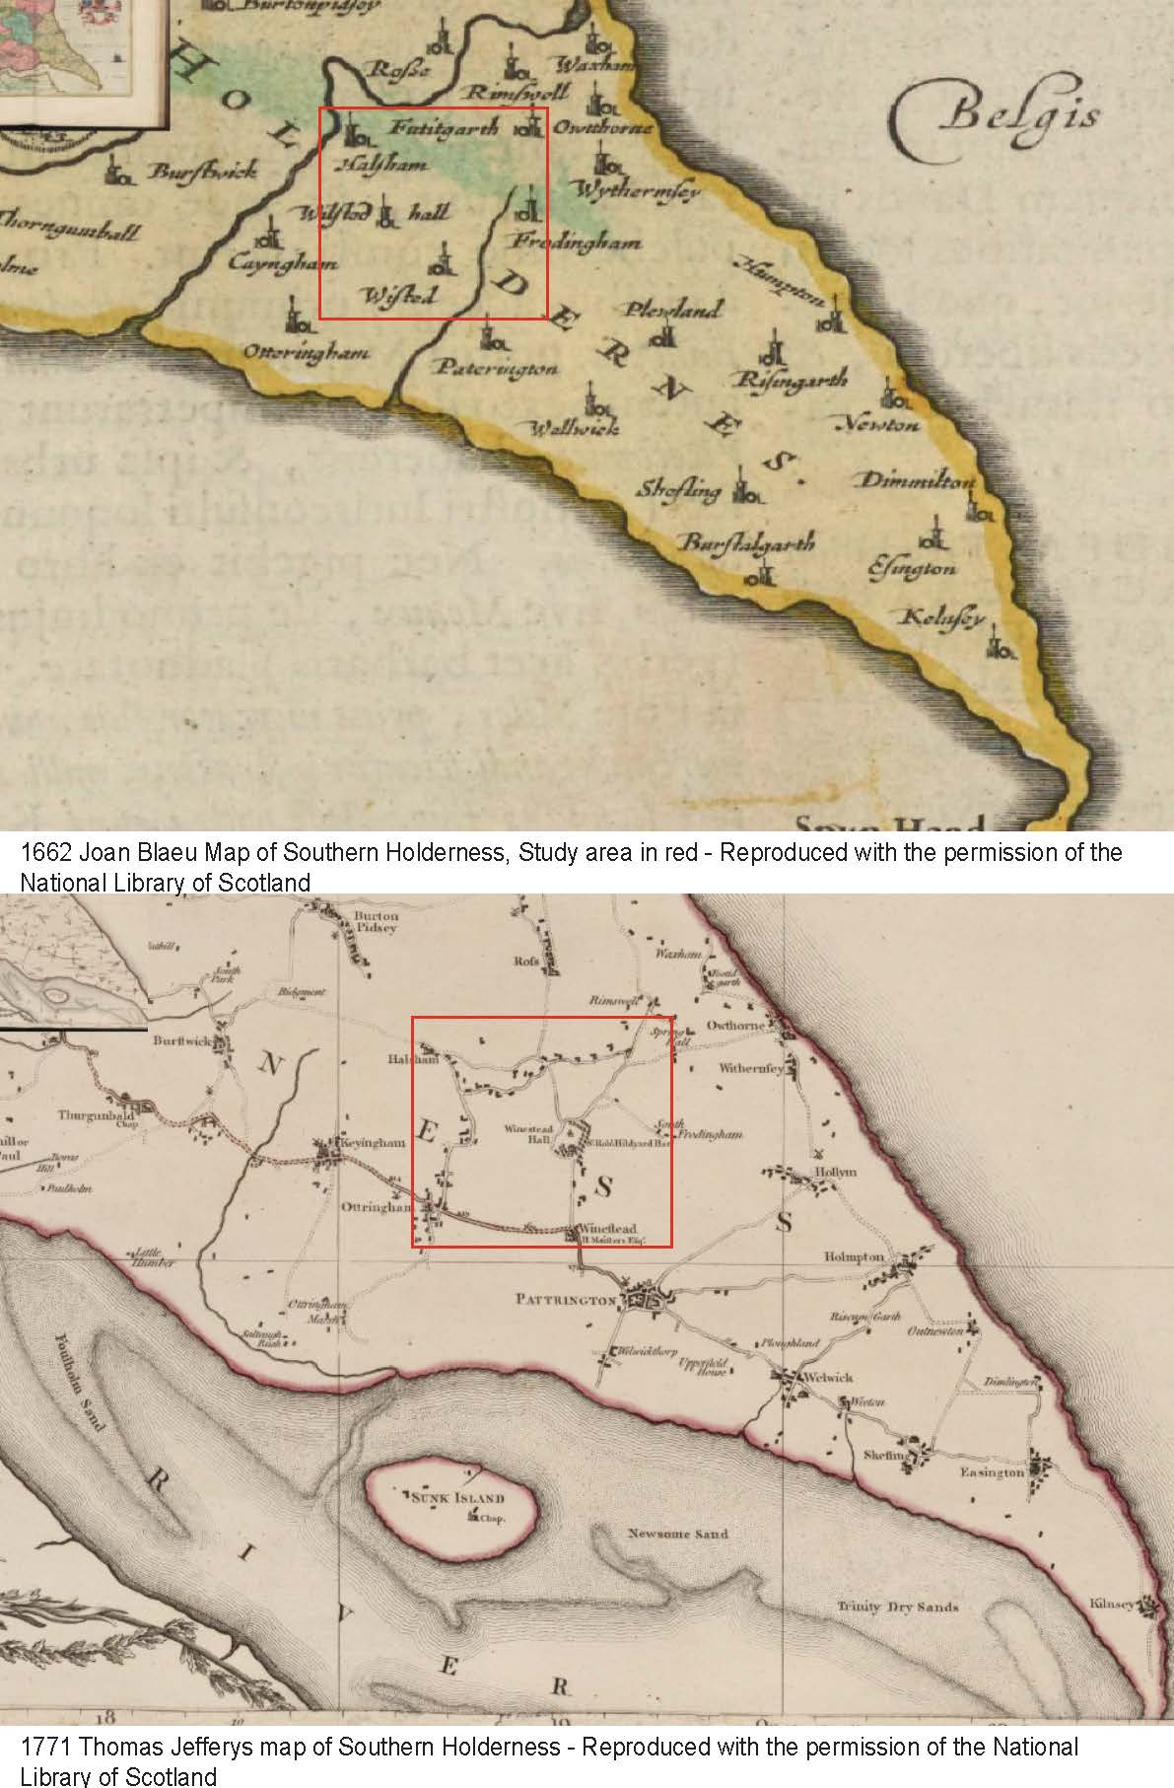
Figure 3: Historic maps showing the position of the study area (red square) and the changing Humber Estuary position [Maps reproduced with the permission of the National Library of Scotland].
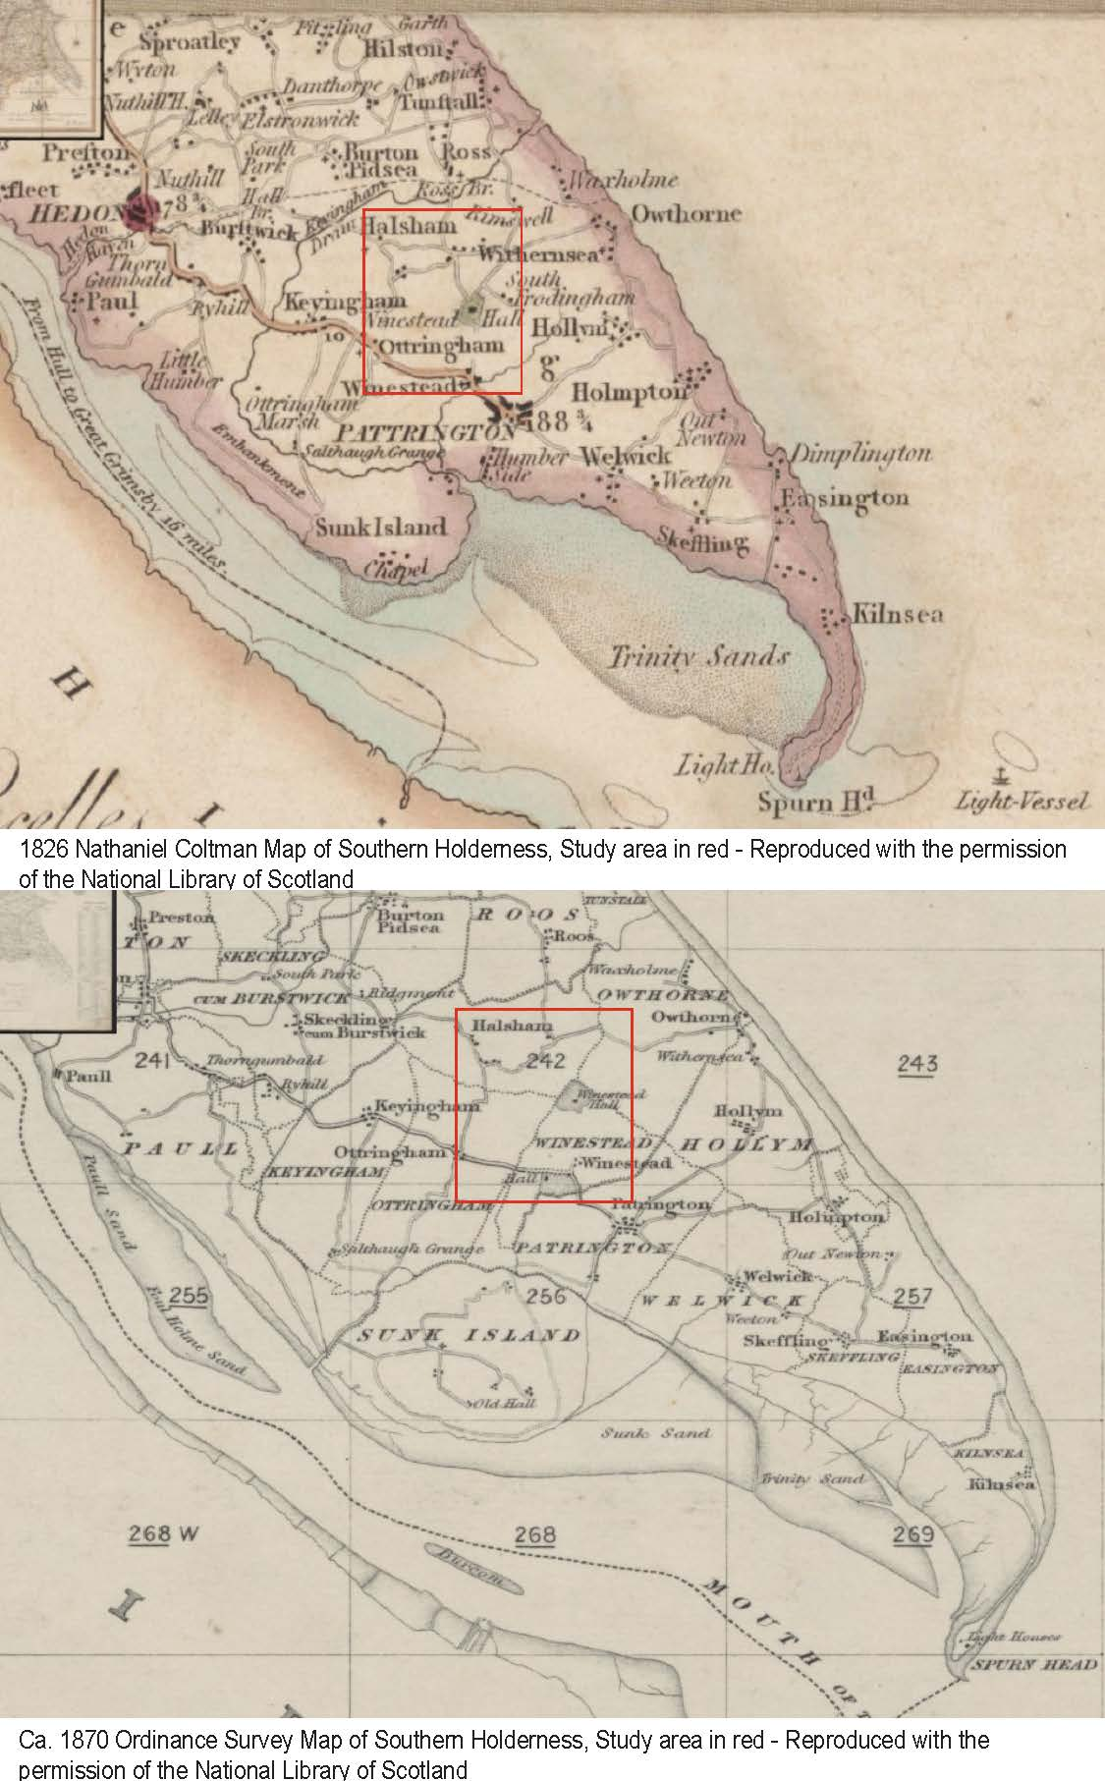
Figure 4: Historic maps showing the position of the study area (red square) and the changing Humber Estuary position [Maps reproduced with the permission of the National Library of Scotland].

3.3 Modelling the Wetlands in the Iron Age period
Four models representing different water-table levels (2m, 2.5m, 4.5m, and 6m) have been rapidly reconstructed (Figure 5) to illustrate the likely extent of the estuary in the Late Iron Age, how far tidal waters may have penetrated inland, and how far the wetlands may have penetrated inland. The models were created using QuickTerrain Modeler, which has a water table function that uses height data to model the amount of water across the study area when the water table is raised. The models were created using the modern coastline and elevation data to inform the water table. The position of a known storm beach deposit dated to the Iron Age (1260–1210 cal BC) running between Keyingham and Patrington Haven was used as a reference point for the models, as well as the known flooding of the Iron Age settlement site, Ring of Bright Water (Smith, 1990). Water levels were raised in the models to explore where water would inundate first and visualise the predicted maximum extent of the wetlands. The author was unable to utilise the necessary paid-for GIS tools required for more accurate modelling, and as a result, the simplified models in Figure 5 function primarily as visual aids to understand how the mapped features may have been situated within their historical wetland landscape context.
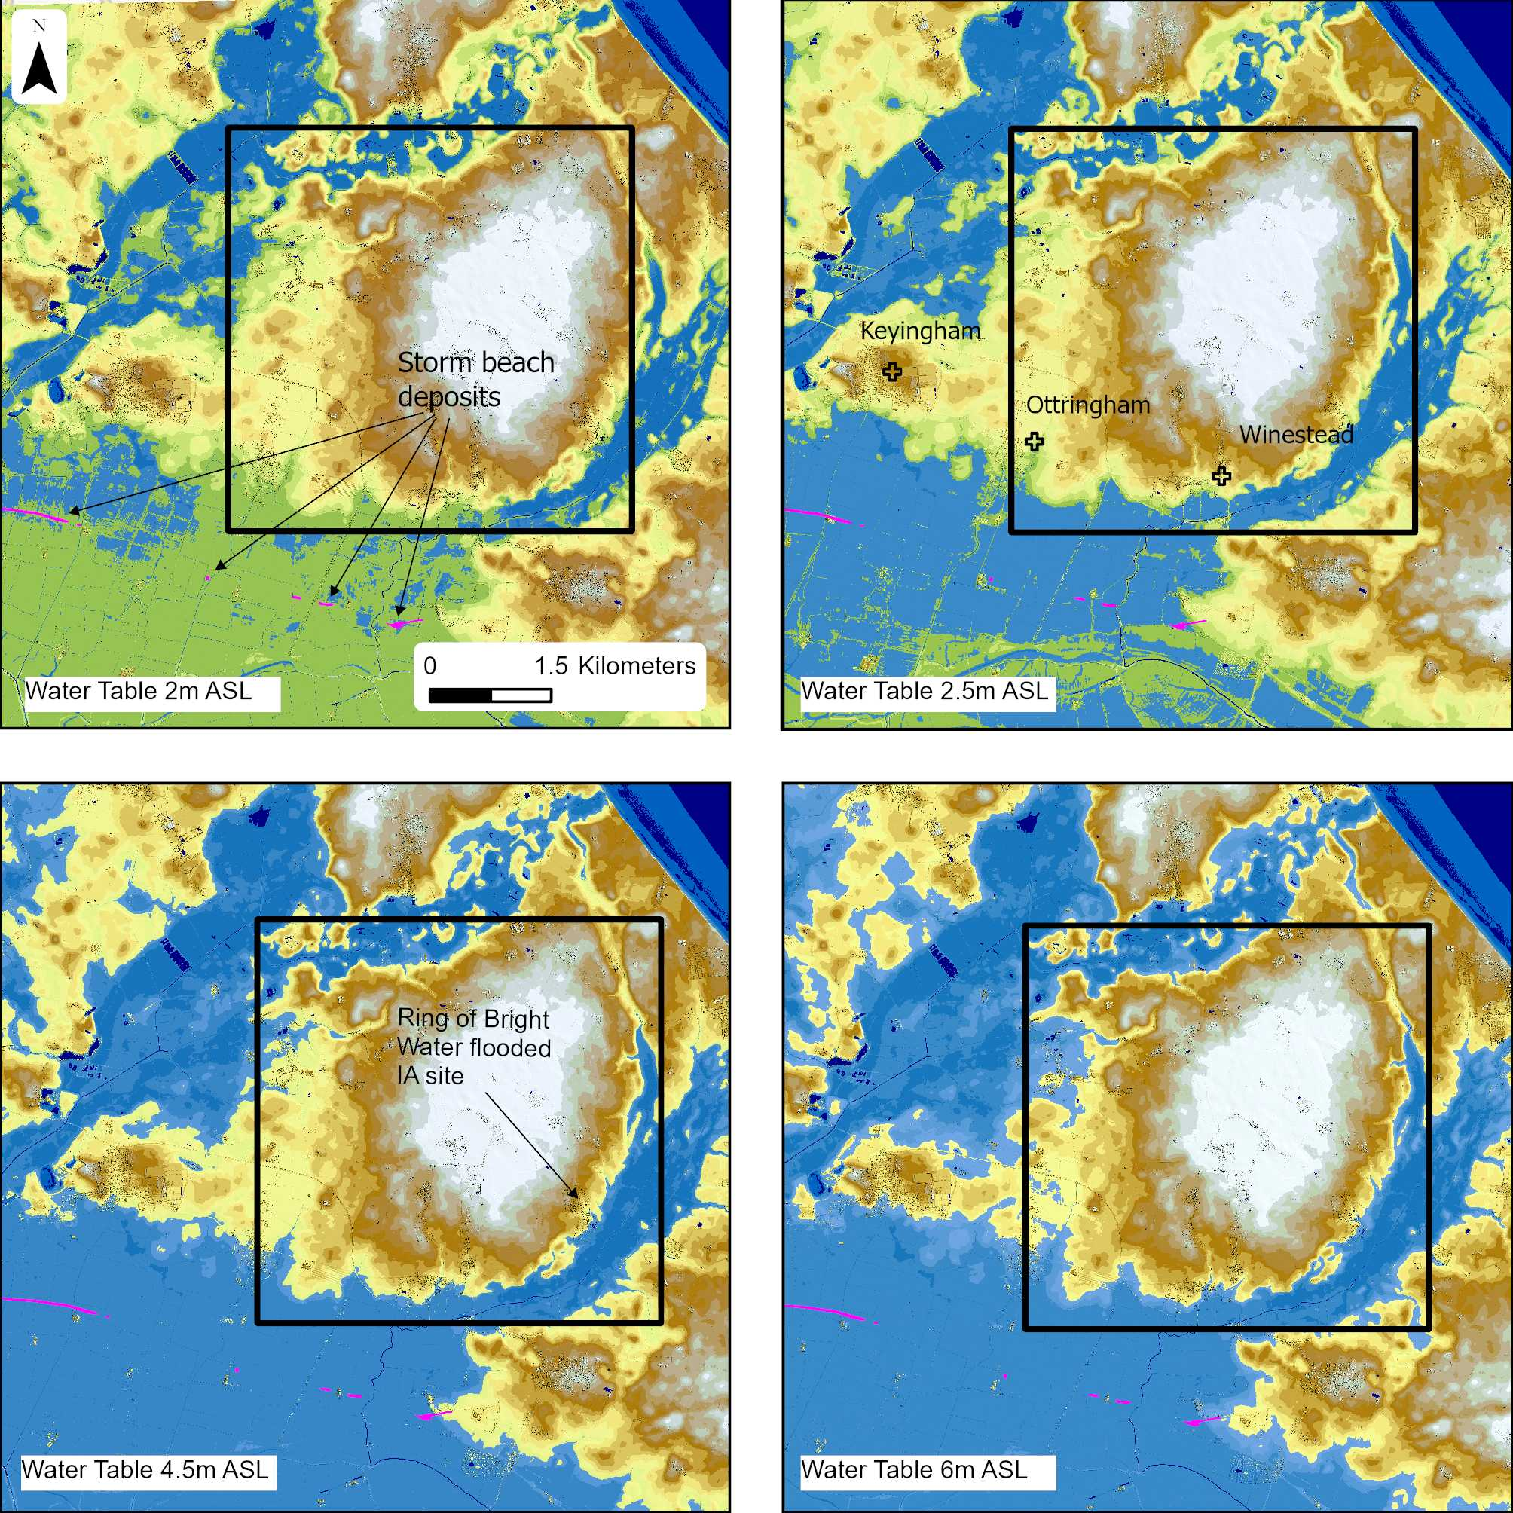
Figure 5: Models of water table height above sea level (ASL) created using QuickterrainModeller - Study area outlined in black square.

In Figure 5, the first model (top left) shows how water fills the ancient meres around the study area first when the water levels are increased to 2m above sea level. Between 2m and 2.5m, the greatest changes occur, flooding the area south of Keyingham, Ottringham, and Winestead (top right). The area south of Keyingham, Ottringham, and Winestead would have been close to the extent of the Humber Estuary, which is represented by storm beach deposits found from coring samples (shown in pink) and would likely have been permanently wet, forming a variety of wetland environments. In Figure 5, the excavated Ring of Bright Water Iron Age site becomes flooded at water table 4.5m (lower left), which perhaps indicates extreme tides may have reached this far inland, further than the storm beach deposits suggest, highlighted in pink. Finally, in Figure 5, lower right, the water table is at 6m ASL; this visualisation was created to explore the extent of the wetlands, not the extent of the River Humber. The Humber spring tides can reach a maximum of just over 8m above sea level, so it is expected that the areas shown in blue in Figure 5, lower right, would have at least been seasonally inundated with water, forming a variety of wetlands depending on the amount and type of water inundation (freshwater or saltwater) and water retention rates (National Tidal and Sea Level Facility, n.d). Looking at the extremes of wetland expansion predicted in the Iron Age period helps to understand how different archaeological features mapped in this project would have sat in a drastically different landscape context; the 6m ASL model was used for analysing the historical landscape context of the later prehistoric sites digitised in this project (Neolithic and Iron Age/Roman period).

4. Methodology
This chapter explores the method used to choose the study area, as well as a brief overview of the mapping methodology used to digitise, interpret, and record the archaeological features identified in aerial sources. Although the methods for aerial mapping will be described below, this will only be brief, as the methods employed in this project follow the Aerial Investigation and Mapping (AI&M) best standards, stipulated in greater detail in the standards and guidance (Historic England, 2025; Evans, 2019). The author works within the Aerial Reconnaissance portion of the Aerial Survey team at Historic England and was responsible for capturing the summer 2025 aerial photographs, which form one of the key data sources in this project. The methodology of aerial reconnaissance will not be covered in this paper.

4.1 Area selection methodology
As the dissertation research subject was prompted by the discovery of over 100 new sites in Holderness, through aerial reconnaissance conducted by Historic England in summer 2025, it was logical to choose an area that took advantage of as many of the new aerial photographs as possible. The author, who conducted the aerial surveys and had access to the photographs and flight traces, plotted all the sites into ArcGIS Pro manually. This process required the GPS tracks from the summer 2025 flights over Holderness, which record where the plane flies over the ground, recording points every 0.3km travelled. The GPS time is synced to the time on the cameras, which allows each photograph's timestamp to be matched to the nearest point recorded by the GPS. All photographed site locations were identified on an OS map layer within ArcGIS Pro, and points were created to plot these. The ArcGIS Pro template that the Aerial Survey team uses for mapping projects contains the National Monument of the Historic Environment (NRHE) data, which enabled any previously unrecorded sites to be identified, as these would not have corresponding NRHE records in the map. All sites with NRHE data were also analysed to identify if new features that were not included in the record were also visible. The sites without any records were separated from those that already had records but didn’t show new features, and these were then colour-coded to help visually identify where the densest cluster of newly identified sites was, to aid in choosing a project area (Figure 6).
A quick analysis of the topographic relationship between the sites identified was also conducted by consulting the lidar data provided by the Environment Agency Open Data Hub. The lidar was processed to create a 16-direction hillshade visualisation using a low tolerance of 5 degrees height to emphasise the microtopography of Holderness, which is notoriously flat. The project area was ultimately chosen as it included the densest cluster of sites, which also sit on an area of higher ground. As Holderness is a relatively flat region, with elevations averaging between 0 and 30m above sea level, even minor variations in topography are likely to have been advantageous for more permanent settlement and land use. By selecting an area of higher ground for the study area, which would have offered relatively drier conditions throughout the year, it was intended to increase the likelihood of identifying additional archaeological sites. Increasing the potential for site discovery provides more opportunities to enhance understanding of the archaeological character of Holderness throughout time.
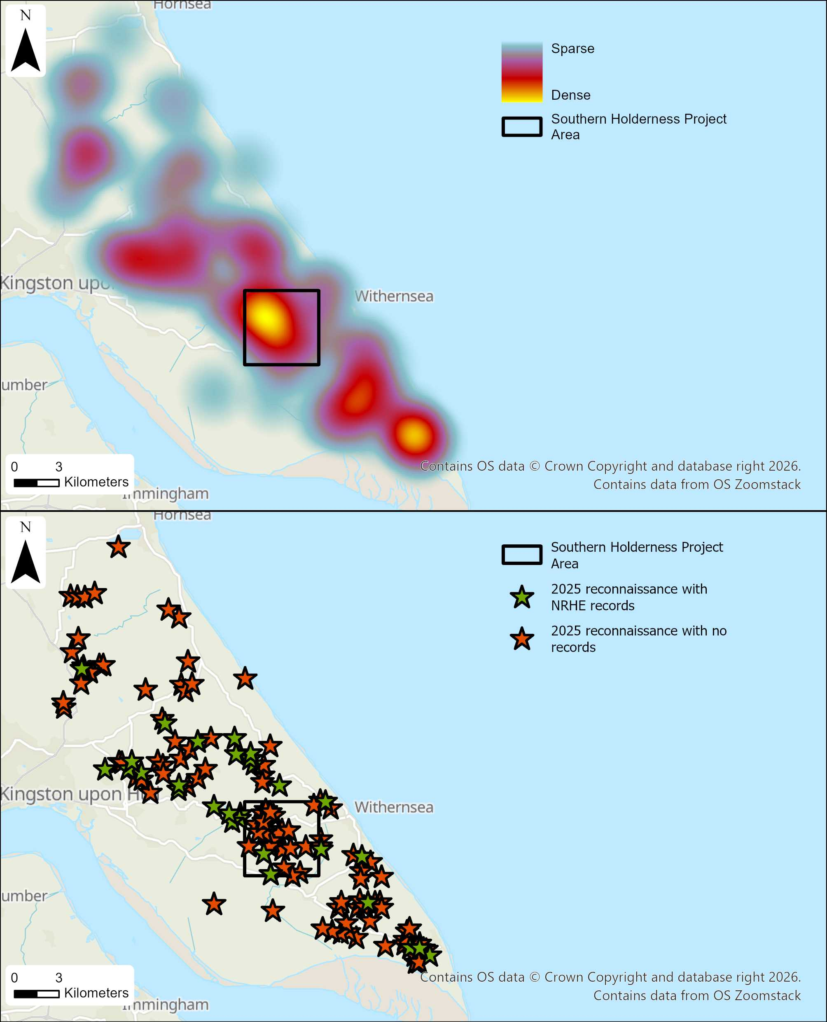
Figure 6: Map showing distribution of sites photographed in 2025 aerial reconnaissance - Top map - Heat map of sites - Lower map - Distribution of sites with NRHE records (Green) and without any records (Orange)- [Includes OS data © Crown copyright and database right 2025 Open Government Licence]

4.2 Aerial Mapping methodology
The methodology employed for the mapping stage of this project is derived from the Aerial Investigation and Mapping (AI&M) standards (Historic England, 2025), developed by and used at Historic England. The author was trained to map archaeological features using the AI&M standards by staff from the Aerial Survey team at Historic England, ensuring the project methodology aligns with the current AI&M methodology.
The current AI&M methodology is detailed in the Aerial Investigation and Mapping Standards guidance document (Historic England, 2025). A brief outline of the method used is provided in this document; for a more in-depth understanding of the process, refer to the guidance (Evans, 2019). The main sources consulted for the mapping process included Historic England specialist aerial photographs, archive aerial photographs, both digital and print, including RAF vertical photographs from the 1940s and 1950s, and OS vertical photographs taken in the 1970s and 1980s. Along with these aerial sources, the project has also utilised Aerial Photography for Great Britain imagery (APGB), Google Earth Imagery, and 1m resolution Lidar DTM and DSM data obtained from the Government Environment Agency data hub.
All source material was evaluated by the author to identify archaeological features, including earthworks, cropmarks, soilmarks, and structures. The scope of archaeology included in the project incorporates all features dated between the Neolithic period and the Cold War period. Photographs in print form were viewed using a hand-held stereoscope at 2x magnification, and where possible, stereo pairs of vertical photographs were viewed together (Evans, 2019, p.39). Viewing photographs using a stereoscope enhances archaeological features using magnification, and viewing vertical stereopairs creates a 3D effect, which helps earthwork features to be identified more easily as it exaggerates height differences (Evans, 2019, p.39). While viewing the photographs, complimentary notes were made as a layer in ArcGIS Pro to describe any features identified and to cite the corresponding photograph for later use in digitising. Once all photographic sources were viewed, the area was split into 1km square sections, using the corresponding notes to identify which individual photographs show archaeological features. These photographs were then scanned and saved in TIF format to retain high resolution (Evans, 2019, p.40). When selecting photographs for mapping, it’s also often useful to process them in Adobe Photoshop before using them for mapping, to enhance faintly visible cropmarks or improve the clarity of an overexposed photograph.
All photographs viewed, both oblique and vertical, digital and print, are distorted in some way, whether it be the angle at which they are taken or the type of camera lens used. A software called Aerial was created specifically to remove these distortions and enable the user to rectify the photographs to the ground surface using Environment Agency digital terrain model (DTM) 5m height data. In order to successfully rectify a photograph, accurate control points within a 2m tolerance must be identified both within the photograph that is being used and either a 1:2500 scale OS map or APGB imagery (Evans, 2019, pp.41-42). Care was taken when rectifying historical photographs, as quite a lot of the field boundaries have been removed since the original photographs were taken. Historical maps, which are included as a layer in the ArcGIS Pro mapping template, can be referenced while choosing control points to find field boundaries, roads, or buildings that have not been changed, as the layer overlies the modern OS map and helps visualise change and continuity.
Once the photographs have been rectified, the archaeological features can be spatially digitised in ArcGIS Pro, using the GIS mapping template used by the Aerial Survey team at Historic England. The template contains various data layers required to digitise the features and provide useful reference material, including OS map layers at various scales, Historic maps from different years, APGB imagery, and NRHE data. ArcGIS Pro also allows the input of lidar data, which can be processed to create different visualisations using the Relief Visualisation Toolbox (RVT) software (Evans, 2019, pp. 57-58). There is no single standard visualisation recommended in the AI&M standards and guidance, as the appropriate visualisation depends on the topography of the study area (Evans, 2019, p.57). The study area topography varies in height from -5m below sea level to +30m above sea level, which means small variations in height will not be clearly visible in all visualisations. A 16-direction hillshade visualisation was chosen with a sun elevation angle of 5 degrees to exaggerate any differences in height and enable small earthwork features to be identified more easily. This is useful when mapping, as some features identified as cropmarks and soilmarks can also have surviving earthwork elements, which need to be mapped as banks. Both ditch and banks are digitised using different symbology. The symbology for different feature forms, whether ditches, banks, structures, or ridge and furrow, is stipulated in the AI&M standards and guidance and has been set up as different mapping layers in the ArcGIS Pro mapping template to ensure consistency between different projects (Evans, 2019, pp.75-78). A level of interpretation also begins at this stage, as each feature digitised must be given attribute data stipulating Period, Narrow Type, and Broad Type, for the individual features. For each attribute, a pick list is provided within the GIS template to inhibit spelling errors, long text, and alternative descriptions, again ensuring consistency between projects and ensuring that searching for specific features is easier later in the project. For the Narrow Type and Broad Type pick lists, the FISH terminology is used, ensuring the project is fully compliant with the Forum on Information Standards in Heritage (FISH) thesaurus terms (Evans, 2019, pp.80-81). Also included in the attribute data is the source the feature was mapped from, which requires citing the photograph, APGB imagery, or lidar, as well as the form the feature was identified as, such as earthwork, cropmark, soilmark, etc. Projects such as the Burton Pidsea to Rimswell Renewal project (Speed, 2024) and the Easington to Ganstead gas pipeline excavations (Glover, Moore, and Flintoft, 2016) are valuable comparative examples for sites found within and to the study area, specifically from the Iron Age/Roman period.
Once mapping was complete, all digitised features could be examined within their wider landscape context in ArcGIS Pro. This enabled analysis of patterns in feature morphology and topographic positioning, as well as an improved understanding of the spatial relationships between different features. GIS allows multiple datasets to be viewed simultaneously, facilitating detailed spatial analysis by integrating digitised features with additional data sources such as Lidar and soil data. This was also useful for viewing digitised site position and the water tables produced in Quick Terrain Modeller (Figure 5).

4.3 Methodological Approach and Project Adjustments
As the author started the project while undertaking training in the mapping process, the methodology was modified to support a more structured and accessible progression through each stage. The main part of the methodology that was altered was the order in which different aerial sources were consulted. While AI&M projects typically start with the earliest available sources first, this project instead commenced with the most recent 2025 aerial photographs first. These photographs were taken by the author of this project and provided a useful degree of familiarity with the study area, especially useful in the rectification stages. The 2025 aerial photographs also show modern field boundaries, which correspond with the latest Ordnance Survey maps and APGB imagery from 2024, making the rectification process easier. Often starting with early photography can be disorientating as many field boundaries have since been removed and the landscape can look very different. In addition, due to a backlog of archive loans, there was a two-month delay in receiving the required Historic England Archive material. To ensure the project commenced on schedule and that training could begin, the most recent aerial photographs taken by the author in summer 2025 were used for the initial mapping stages, as these were already available.
Another minor difference was the rationale behind selecting the study area, which was chosen specifically due to the archaeological discoveries made during the 2025 reconnaissance flights. Usually, Historic England's large-area aerial mapping projects are selected because of their direct contribution to internal organisational strategies and agendas, or external factors, including understanding archaeological landscapes at risk from land-use change, development, and agricultural intensification.
In standard AI&M practice, once a study area has been defined, mapping is ordinarily confined strictly within its boundaries. For this project, however, a more flexible approach was adopted, incorporating archaeological features visible within a 1km buffer around the study area, coming to a natural stop when the features ended. This ensured that fields containing archaeological features on the periphery, such as medieval ridge and furrow, were included in their entirety. In addition, three sites photographed during the 2025 reconnaissance and located within this buffer were deliberately incorporated to maximise the use of new aerial photographic material and to enhance the completeness of the archaeological record.

5. Mapping Results
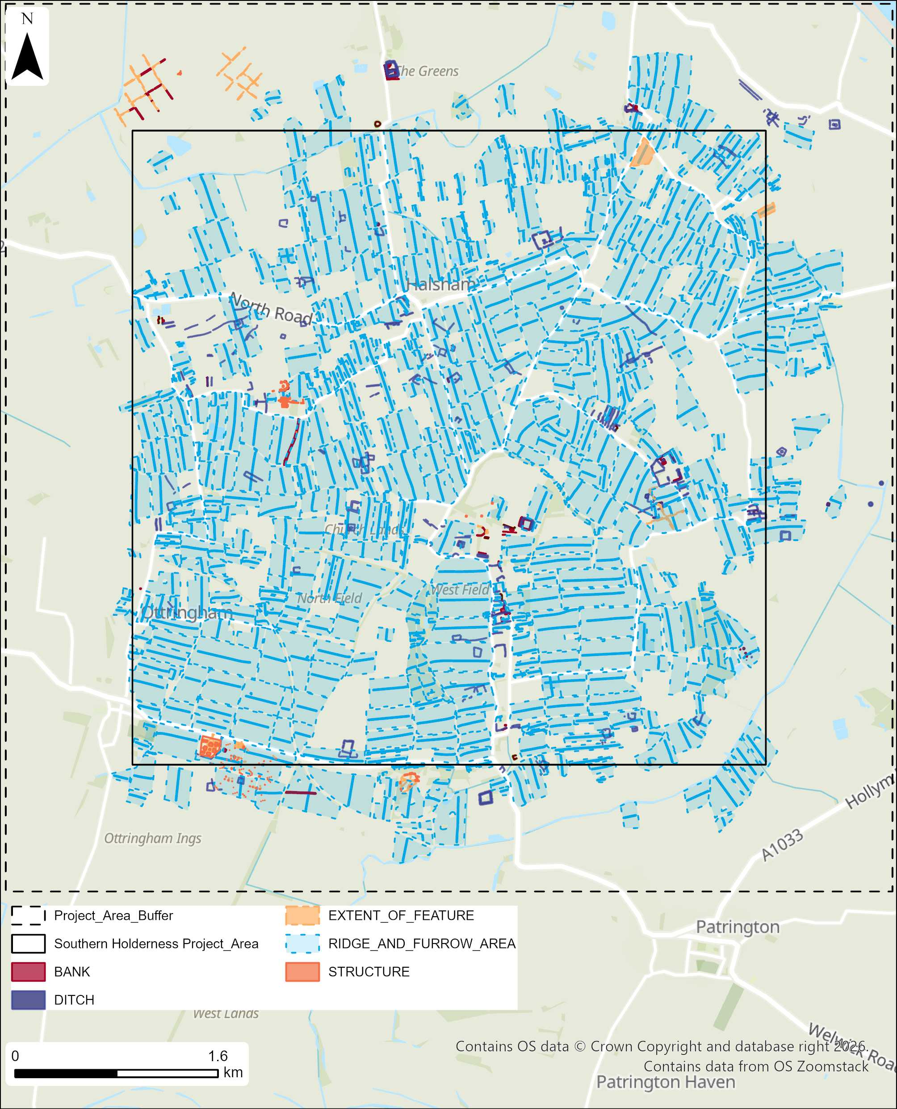
Figure 7: Map showing the completed mapping in the study area and the surrounding buffer area [Includes OS data © Crown copyright and database right 2025 Open Government Licence]
The project mapped a total of 1,257 features shown in Figure 7; this figure is not representative of the number of sites collectively mapped, as multiple features can constitute a single monument, such as the Second World War Broadcasting station, which has 159 individual features digitised (Figure 23). When quantified by the number of individual recorded monuments, the Iron Age/Roman period represents the second most frequently attributed phase.
Table 2: The number of features vs. the number of sites recorded in the study area
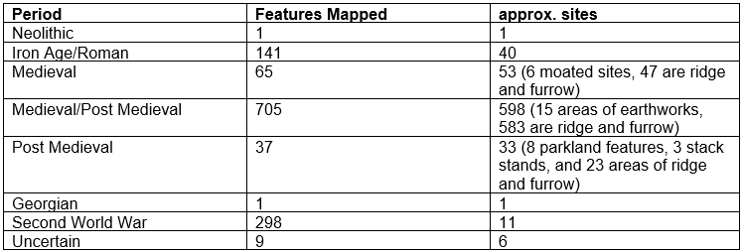
The mapping stages recorded features ranging from the Neolithic up to the Second World War (Table 2). The project did not record any Bronze Age or early medieval sites, but these periods are represented in the wider area. Ridge and furrow is the most frequently digitised site type, spread extensively across the study area, attributed mostly to the medieval/post-medieval period.
Across the study area and within the buffer area, only 18 of the recorded monuments have NRHE records, highlighting the value of this project in improving the archaeological record across multiple periods.

5.1 Cropmarks
The majority of sites identified as cropmarks and digitised in this project primarily used the photographs taken in the 2025 reconnaissance, with 30 new site discoveries from this source alone. The majority of cropmarks digitised were attributed to the Iron Age/Roman period, with some areas of medieval/post-medieval ridge and furrow identified as cropmarks, and the parching of the Georgian Red Hall country house foundations (previously Winestead Hall).
Table 3: The total number of cropmark features attributed to each period
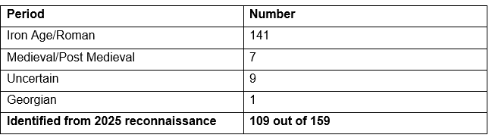
The quality of the cropmarks recorded in 2025 was visibly stronger compared to older aerial sources, as evidenced in Figure 8, where the photographs were taken almost exactly 14 years apart, highlighting the faster progression of crop growth in 2025 compared to 2011, resulting in clearer cropmarks. The crop growth was likely sped up due to the hot and dry conditions experienced from March into July 2025 (Met Office, 2025). Various previously recorded sites, such as the one illustrated in Figure 8, displayed newly identified features in 2025, leading to a substantially higher density of recorded cropmark features throughout the study area. Only eight cropmark sites in the study area have NRHE records, and four of these revealed additional detail in the 2025 reconnaissance. Although most historic vertical aerial photographs were not taken at optimal times of year for cropmark formation, several of the cropmarks identified in 2025 were also visible in archive sources. Notably, an Ordnance Survey sortie flown in June 1970, one of the few summer flights, captured six of the cropmark sites photographed in 2025, albeit only partially.
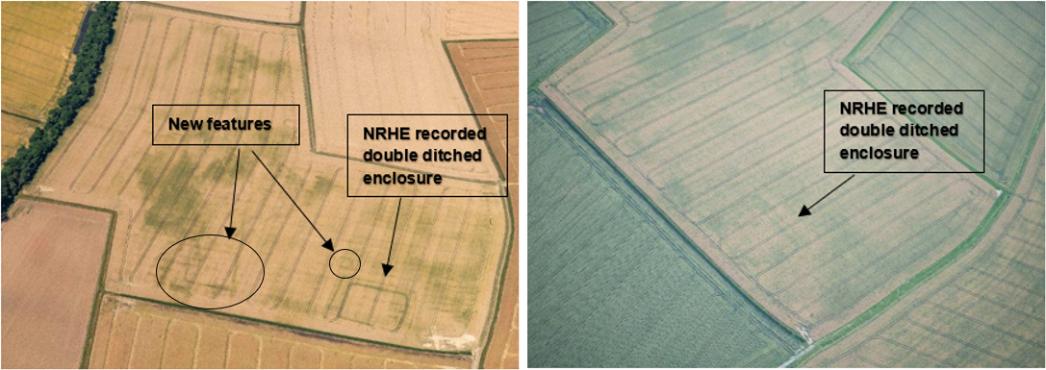
Figure 8: Comparison of the same cropmark site in 2011(Right)and 2025(Left) – Left photo TEMP_SRT6541 – 11-JUL-2025/ Right Photo – 28196_048 12-JUL-2011 © Historic England Archive

Most cropmark sites were recorded on Glacial Till soils, with only a small number located on an area of sand and gravel west of Halsham (Figure 9). Glacial Till covers the study area widely, which does not reveal a strong pattern in cropmark position until looking more at the sites recorded more widely in southern Holderness through the 2025 reconnaissance, suggesting there is a strong association between cropmarks and Glacial Till (Figure 10).
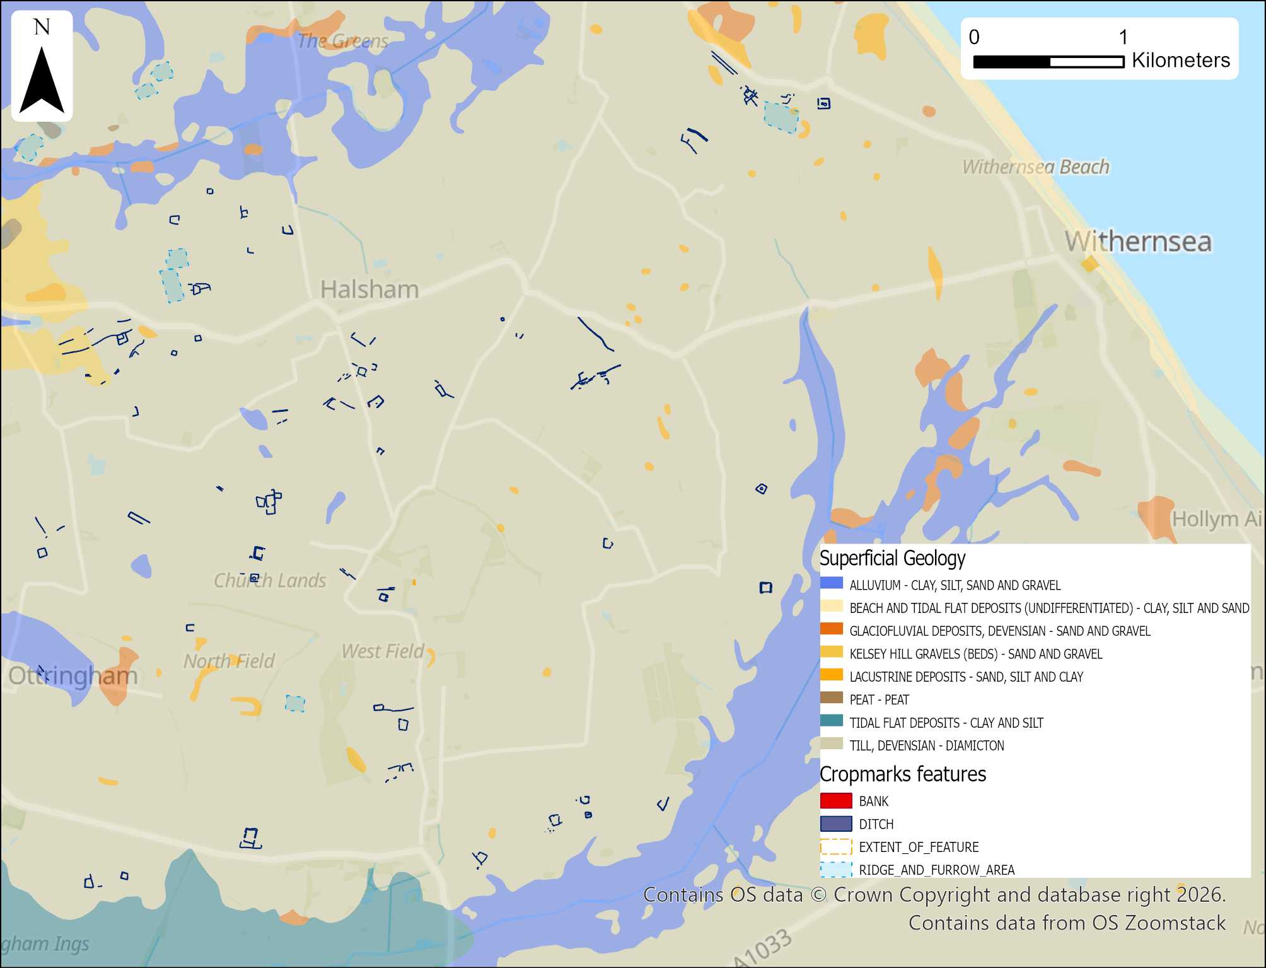
Figure 9: Distribution of sites mapped as cropmarks in the study area overlying superficial geology soil data [Contains - Geological Map Data BGS © UKRI 2026 – Background mapping - OS data © Crown copyright and database right 2025 Open Government Licence].

There are two outliers shown in Figure 10, located in the alluvium to the south of the study area; these likely represent post-medieval features, established following drainage and land reclamation in the 18th century. It is difficult to discern whether the pattern in cropmark locations reveals a preference for those soils or a preference for exploiting locations at higher altitudes, as Glacial Till also represents areas of higher elevation. As discussed in earlier chapters, there are also large areas overlain with alluvium, which could mask archaeological sites from periods when sea levels were lower. Extensive alluvial deposits may conceal entire phases of human activity, particularly site types associated with low-lying landscapes.
Although elevated ground was probably favoured for permanent settlement and farming in the later prehistoric periods, lower elevations within and at the margins of wetlands were likely used for wetland-associated activities or occupied before sea level rise and during periods of sea level regression. These ‘blank’ areas should be treated with caution as alluvium soils are likely to be masking earlier sites and may even be protecting organic materials such as the Roos Carr figures, which were found in an area of bog overlain with alluvium (Van De Noort, 2004, pp. 97-98).

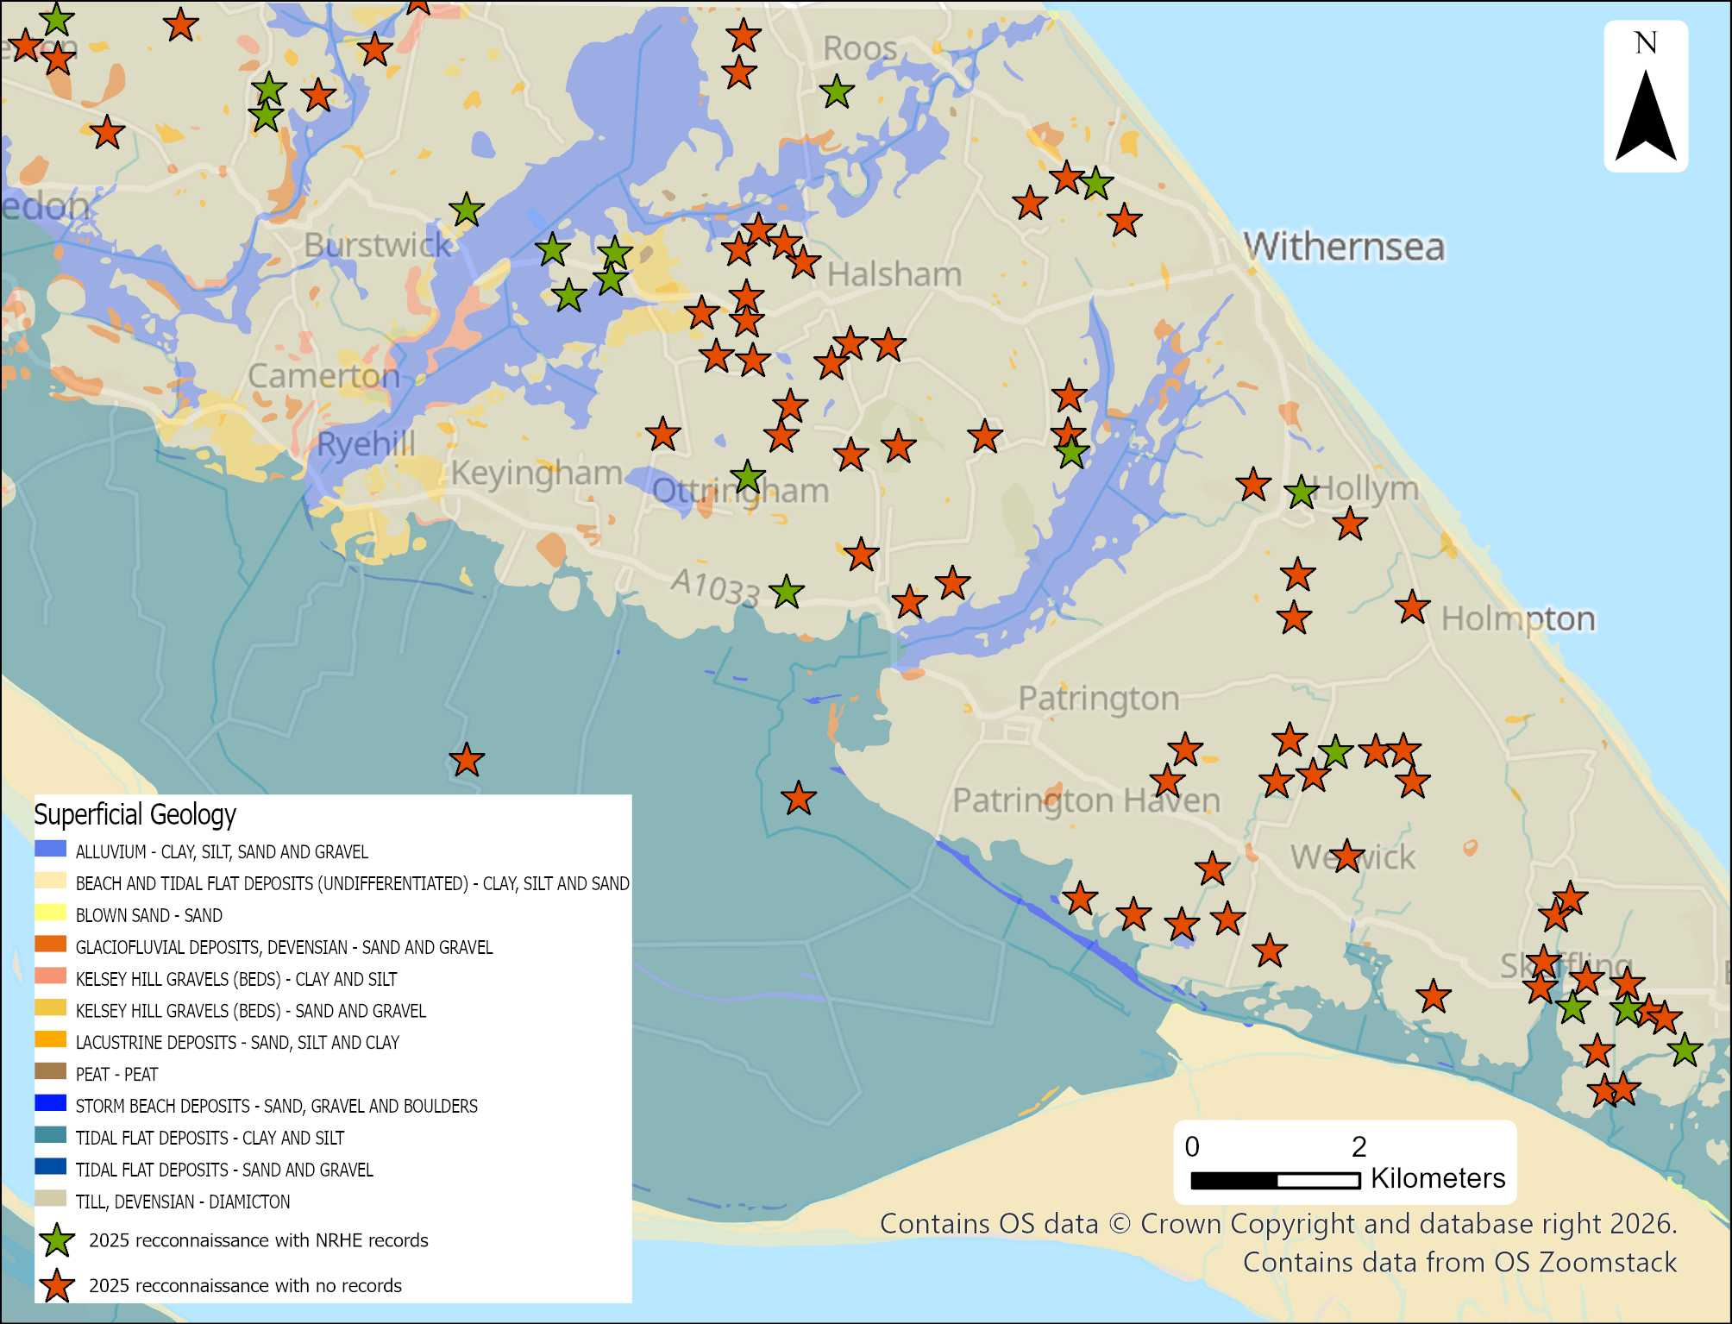
Figure 10: Distribution of Cropmark sites identified in the 2025 reconnaissance overlying the superficial geology soil data [Geological Map Data BGS © UKRI 2026 – Background mapping - OS data © Crown copyright and database right 2025 Open Government Licence].

5.2 Earthwork Survival
Analysis of historic aerial imagery has been valuable for identifying earthwork features such as ridge and furrow, but it also highlights their substantial loss across the study area. In Holderness, arable land increased from 30% to 60% between 1939 and 1946, alongside a 30% decline in sheep farming (Borchert, 1948, p. 58). The Second World War and the immediate post-war drive for increased agricultural production closely correlate with the widespread removal of ridge and furrow, with the majority of these earthworks disappearing after the 1946–47 RAF aerial surveys. Further loss resulted from the removal of post-medieval field boundaries to accommodate mechanised farming, contributing to the transformation of Holderness into the open, largely flat landscape seen today.
Table 4: Table showing the survival of ridge and furrow attributed to different periods

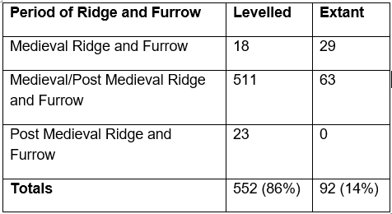
Ridge and furrow was the most common feature type but also had the lowest survival rate, at only 14%, with the more discreet post-medieval ridge and furrow not surviving at all (Table 4). Surviving evidence of extant ridge-and-furrow earthworks is mostly found within and on the edges of villages, within woodlands, and in the White Hall parkland, as identified in the lidar (Figure 11).

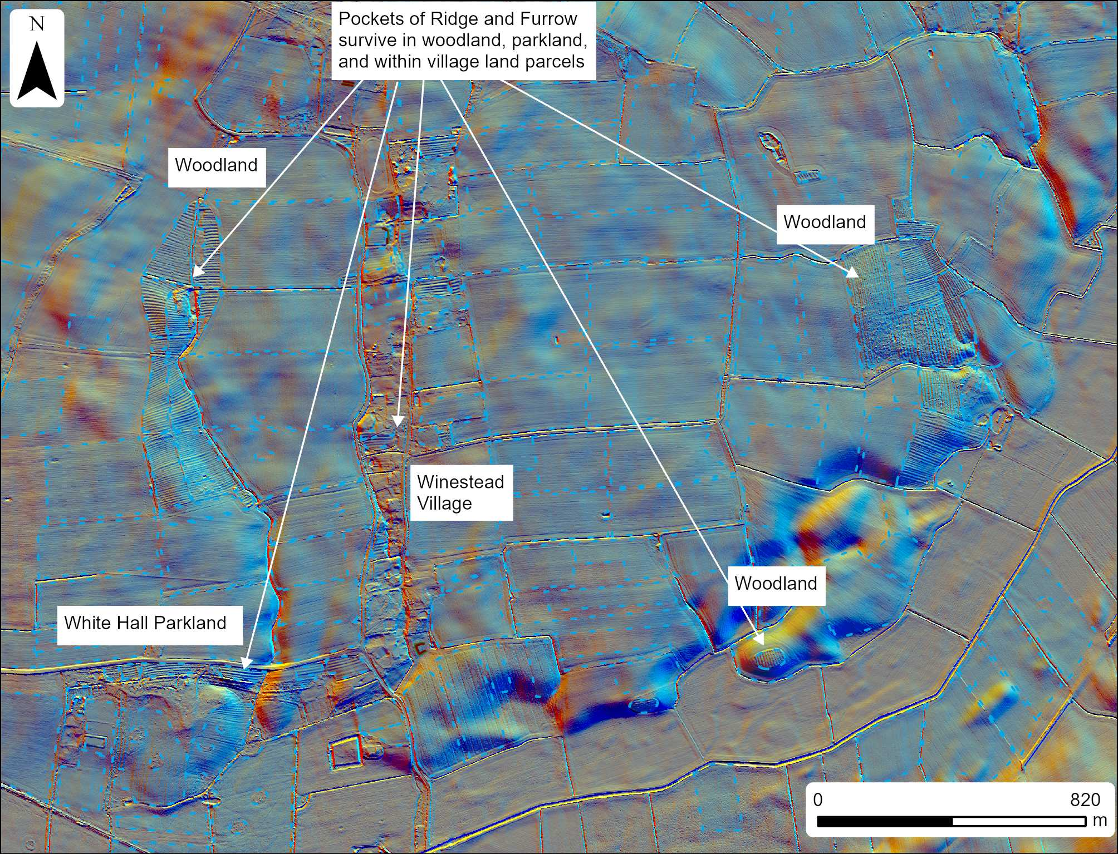
Figure 11: Figure 12: Map showing ridge and furrow survival around Winestead - areas in blue with dashed outline indicate total mapped ridge and furrow areas now mostly levelled [Archaeological mapping © Historic England. Includes data © Historic England; source Environment Agency and data © Environment Agency copyright and/or database right 2022.

Although the widespread loss of earthwork features has altered the landscape character, it has in many areas also revealed previously obscured archaeological remains through the emergence of new cropmarks such as the site shown in Figure 12. Approximately 90% of recorded cropmark sites occur in fields where ridge and furrow earthworks have been levelled. Further archaeological discoveries through cropmark reconnaissance remain likely in Holderness, driven by continued agricultural activity and enhanced cropmark formation during increasingly frequent drought conditions.

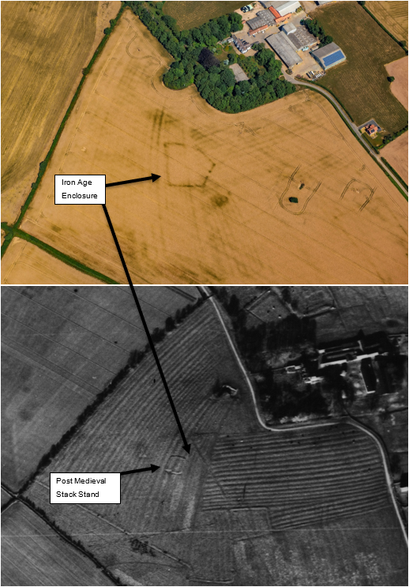
Figure 13: Comparison of the same field from 1947 (lower) to 2025 (top) - Ridge and furrow earthworks shown in the 1947 photograph have been ploughed, but are still showing as faint cropmarks in 2025 along with a new Iron Age enclosure in the top image –[Top photo TEMP_SRT6713 11-JUL-2025 / Lower photo RAF/CPE/UK/2396_RP_17-NOV-1947 © Historic England Archive]

6. Discussion
This section will explore how the results from the study fit into their wider landscape and thematic contexts.

6.1 Neolithic
The Neolithic period is represented in the study area by a single feature type, interpreted as a cursus monument. Cursus monuments are typically defined by two parallel ditches, usually straight and terminating in either convex or squared ends (Loveday, 2019, p. 1). This example lies at approximately 10 m above sea level, is aligned north-west to south-east, and measures around 36 m in width. The longest visible section of ditch extends for approximately 150 m, with a complete terminal preserved at the north-western end. It is unclear whether this feature extends further at the southern extent; the area to the south of the feature appears to be obscured by drainage ditches, which will likely hide any archaeology or disrupt the continuation of the ditches. The cursus feature was identified in this project using Google Earth Historical Imagery from 2003, taken in late summer (exact date not displayed). Assessment of the archive material revealed it was faintly visible in OS vertical photographs taken in 1970 and also faintly in Google Earth imagery taken in 2022, where the length of the ditches was identified extending further, but still with no visible southeastern terminal (Figure 13).

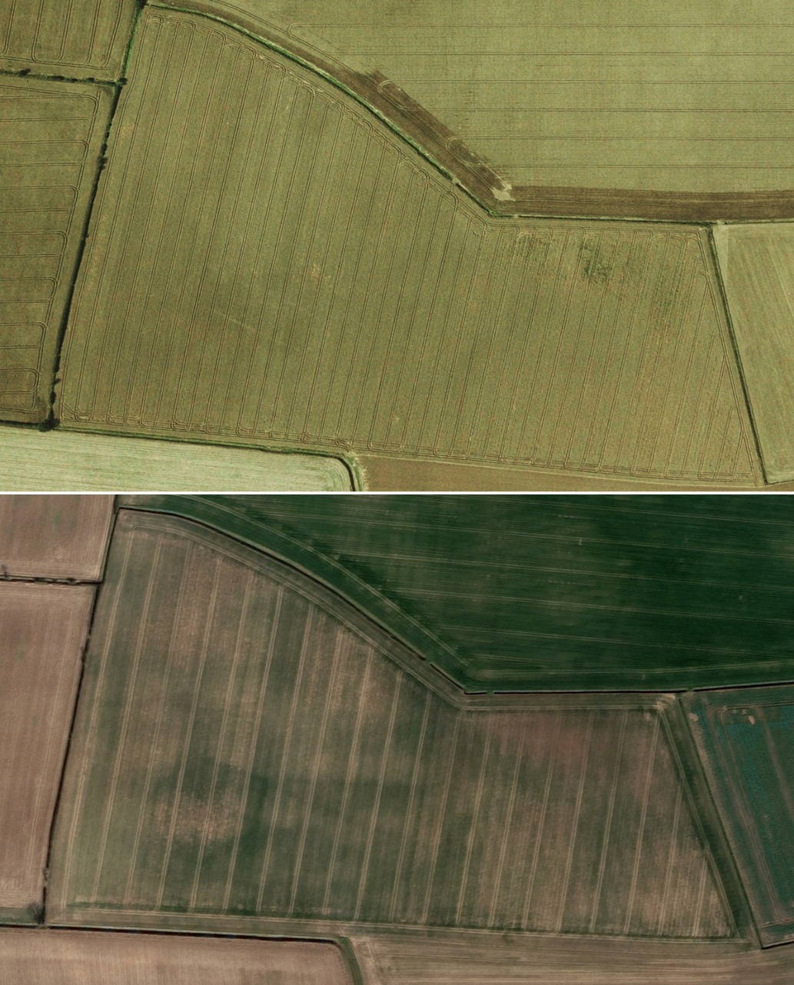
Figure 14: Imagery of the cursus monument, seen in 2003 and with possibly extended ditches in 2022 [Google Earth Imagery captured 2003 © 2025 Infoterra Ltd & Bluesky]
Interpreting this feature as a cursus is not without difficulty. While its overall form falls within the broad size range of cursus monuments, which can vary from approximately 100m to several kilometres in length, it also shares similarities with larger mortuary enclosures (Historic England, 2018a, p. 2). Without further investigation, the feature could plausibly belong to either monument type; however, its size places it at the upper limit of long mortuary enclosures and aligns more closely with cursus monuments in both width and length (Loveday, 1985, pp. 35–42). Its pronounced linearity, squared terminal, and consistent width along the length of the visible ditches further support a cursus interpretation, as mortuary enclosures typically display greater curvature and less regular terminals (Loveday, 1985, p. 48). This feature would benefit from further investigation, especially a geophysical survey to verify its form and perhaps locate the other terminal, if present at the south-eastern extent.
No evidence of Neolithic settlement was identified during this project, reflecting the wider scarcity of such evidence nationally. In Holderness, only a single Neolithic structure has been excavated, near Easington, suggesting some degree of more permanent occupation in the area (Van de Noort, p. 60).
Although this feature represents the first of its kind identified in Holderness, other significant Neolithic monuments are known from the wider region. Notably, four cursus monuments are located at Rudston, approximately 40km to the north. While relatively nearby, the Rudston cursus monuments are not directly comparable due to their much larger scale, exceeding 2km in length, as well as differences in alignment and landscape setting. These monuments occupy the edge of the Yorkshire Wolds, a landscape markedly different from the flatter, low-lying terrain of Holderness. Despite their contrasting settings, both the Rudston cursus and the southern Holderness cursus share a key similarity in their placement within transitional landscapes, positioned at the margins between distinct landscape zones.
Another notable Neolithic monument is the henge situated north of Hornsea Mere, around 24km from the southern Holderness cursus (Historic England, 2015). Although Neolithic monuments are rare in Holderness, the presence of the Hornsea henge demonstrates that a range of monumental forms did exist in the region, with its proximity to Hornsea Mere likely a significant factor in its placement.

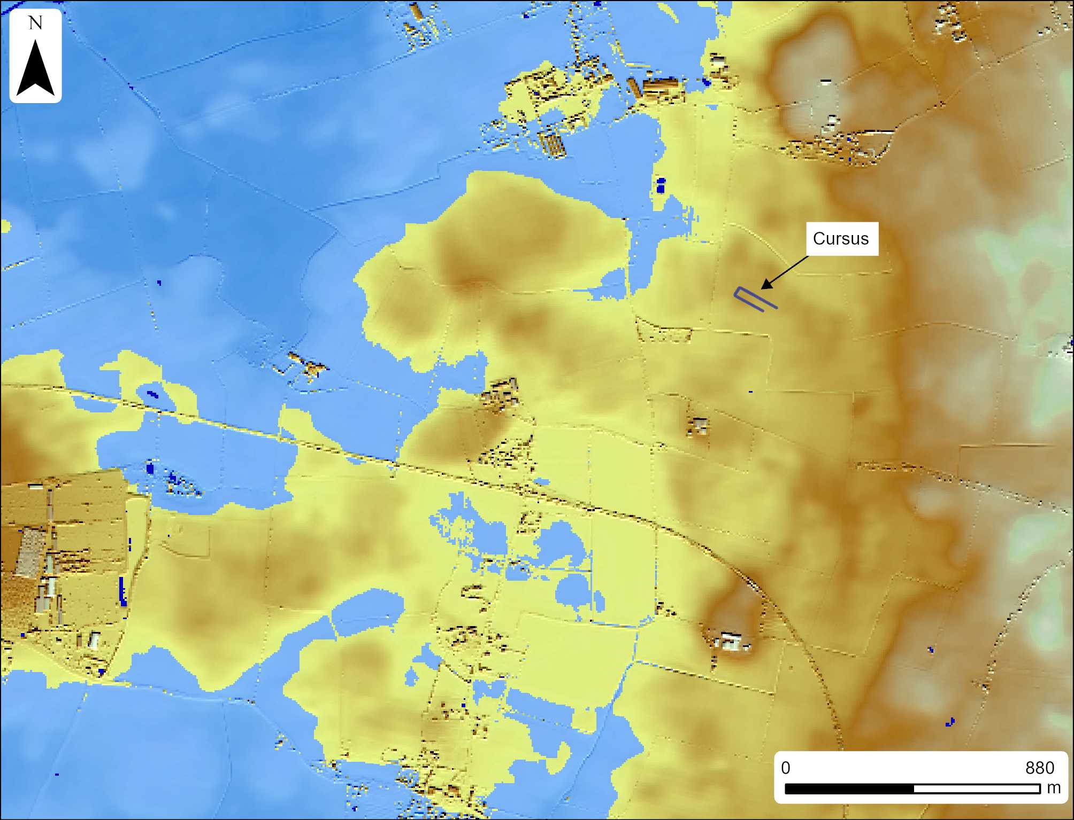
Figure 15: Cursus monument surrounded by wetlands - using the 6m ASL water table model

The position of the cursus in the study area would have sat a lot closer to the river Humber (within 2km) and in proximity to the wetlands, as shown in Figure 14, suggesting the cursus may have served a significant role in the wetland landscape, whether for ritual or practical purposes or perhaps both (Leary & Kador, 2016, p.6). Loveday proposes that cursus monuments were deliberately positioned near rivers to exert a degree of processional control over the movement of resources passing through the landscape from key routeways such as rivers or the sea. Such resource movement might have included livestock driven as part of transhumant grazing practices (Loveday, 2016, p. 99), the distribution of handaxes that may have been transported along waterways (Loveday, 2016, pp. 91–92), or, in the Holderness wetland environment, the circulation of organic materials which would have played a significant role in broader trade networks (Loveday, 2016, p. 91). The surrounding wetlands, whether seasonally inundated or persistently waterlogged, would have provided suitable conditions for wetland pasture, which may support the interpretation that the site was connected to transhumant grazing activities (Saunders, 2019, p. 345).

6.3 Bronze Age
The only features mapped in the project that could be attributed to the Bronze Age are ring ditches. Ring ditches are particularly difficult to assign to a specific period, as they can represent both roundhouses or ploughed-out barrows, as identified in the sites excavated as part of the pipeline renewal project (Speed, 2024). In this area, most of the ring ditches sit within an enclosure context and likely represent roundhouses or ring gullies associated with Iron Age/Roman settlement activity. Excavations within the study area have revealed ring ditches dating to both the Bronze Age and the Iron Age/Roman periods, so those placed outside of the Iron Age/Roman enclosure could be dated earlier (Speed, 2024, pp. 47–51). The isolated ring ditches not found within enclosures are more likely candidates to be interpreted as ploughed-out barrows, which are also more likely to be dated to the Bronze Age, but without archaeological intervention, this is difficult to interpret from aerial photographs alone. Excavation evidence indicates occupation of this landscape from at least the Bronze Age through to the Iron Age/Roman period, making it plausible that some of the ring ditches mapped in the study area represent earlier Bronze Age activity, whether funerary or domestic in nature. This can only be confirmed through excavation.

6.4 Iron Age/Roman
Distinguishing between the Iron Age and the Roman periods is difficult when interpreting sites from aerial sources, as many forms of enclosures from both periods can appear morphologically similar. The enclosures and associated trackway features have been assigned a broad Iron Age/Roman date and are recorded solely as cropmarks, with no corresponding earthworks visible on lidar. Where earthworks are present in the archive, these are more likely to relate to medieval or post-medieval activity, as ridge and furrow earthworks are frequently observed overlying most of the cropmark sites in the study area (75%). Most of the Iron Age/Roman period is represented by enclosures, trackways, and linear ditches. The fragmentary linear ditches may reflect an earlier pattern of land-division contemporary with some Iron Age/Roman enclosures; they don’t correspond with any post-medieval or modern field boundaries.

Table 5: Iron Age/Roman Period Enclosure Characteristics – data derived from mapped features in ArcGIS Pro
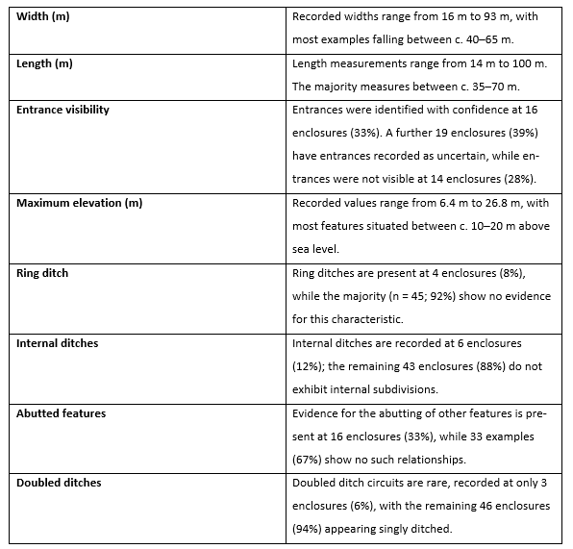
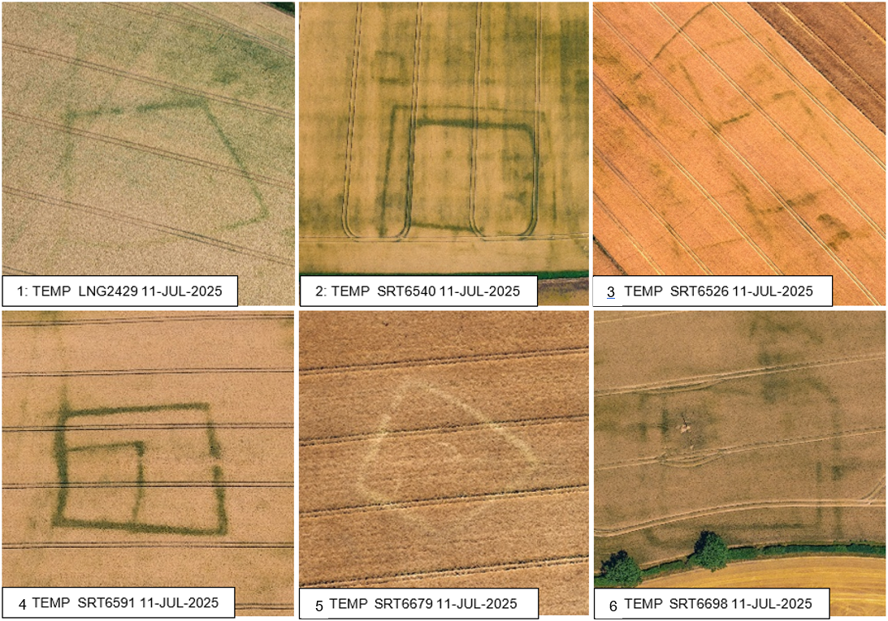 Figure 16: Six examples of Iron Age/Roman Enclosures photographed in 2025 by the author [All photographs © Historic England Archive]

Table 5 shows the characteristics of all 49 individual Iron Age/Roman enclosures digitised in the project (there were 40 Iron Age/Roman sites in total, as some enclosures, trackways and field boundaries are positioned directly alongside each other and were classed as a single monument). There is a wide variety of enclosure forms in the study area, as shown in Figure 15. Identifying entrances was difficult at some sites, as although gaps were seen in the enclosure circuits, these did not always appear as entrances, with some enclosures appearing quite fragmentary. More confident entrances were recorded where the ditches appeared to have slightly wider and rounded termini, such as sites 1 and 4 in Figure 15. Multiple enclosures also had direct relationships with linear ditches interpreted as field boundaries, suggesting these features to be contemporary to the enclosures (sites 1 and 4 in Figure 15). The variety in size and shape of the enclosures indicates a variety of purposes, serving both as settlement enclosures and stock enclosures for animals. While 92% of enclosures lacked identifiable roundhouse remains (Table 5), this should not be taken to indicate that they were not used for settlement. Many of the ring ditches identified in the enclosures were very faint, and most were only identified when processing the photographs after they were taken. Site 5 in Figure 15 contains the most clearly defined ring ditch, while others may be present within enclosures but remain too slight to form cropmarks.
Dating sites from aerial imagery are reliant on comparative dated examples; limited excavation and geophysical survey in the study area have revealed enclosures of similar form to be dated to the Iron Age and Roman period, with some examples revealing settlement evidence and others without (Speed, 2024, pp.50-51; Glover, Moore and Flintoft, 2016, pp.51-52).

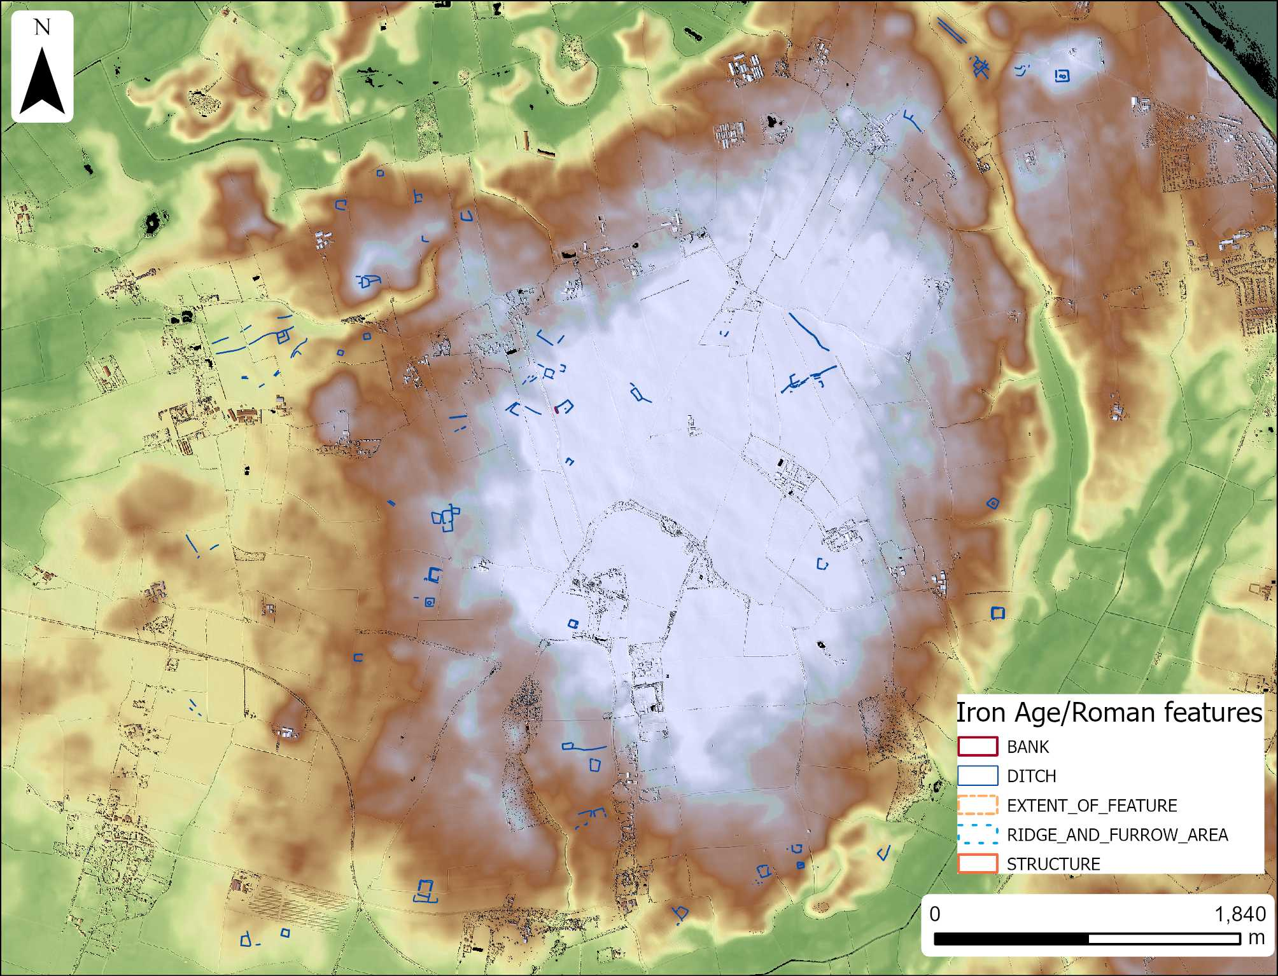
Figure 17: Map showing distribution of Iron Age/Roman period features in relation to the underlying topography - Green indicates the lowest elevation and white indicates the higher elevation (up to 28m above sea level)
Table 6: List of Iron Age/Roman period enclosures showing a preference for slightly elevated locations - data retrieved from elevation profiles of each site in ArcGIS Pro – Enclosure numbers link to the elevation profiles in appendix item 2
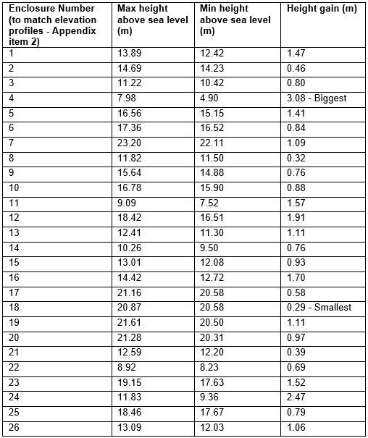
Approximately half of the enclosures within the study area demonstrated a clear preference for land with slight elevation compared with the immediate surrounding land. Enclosures excluded from the table were either situated on slopes that distorted the elevation profile or were not positioned at the highest point relative to the immediately surrounding terrain. Among the enclosures that did meet the criteria, a subtle pattern was evident: those located at lower elevations tended to exhibit greater height gains relative to their surroundings, while enclosures at higher elevations were placed in more discreet positions with smaller variations in elevation. The importance of micro-topography within the study area is a recurrent theme and shows how people exploited the natural topography, no matter how slight, to their benefit.
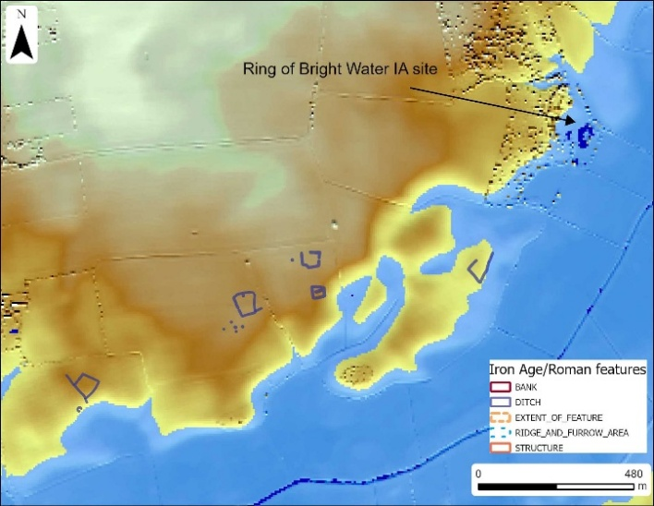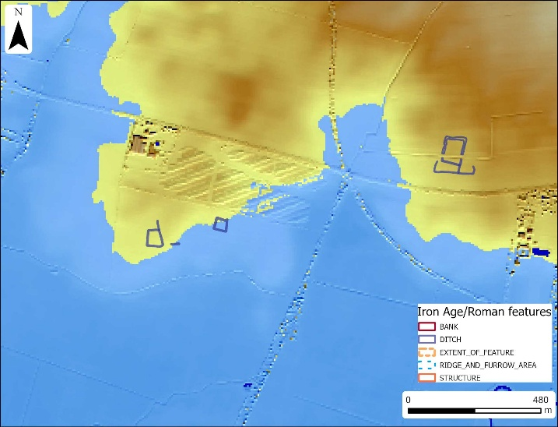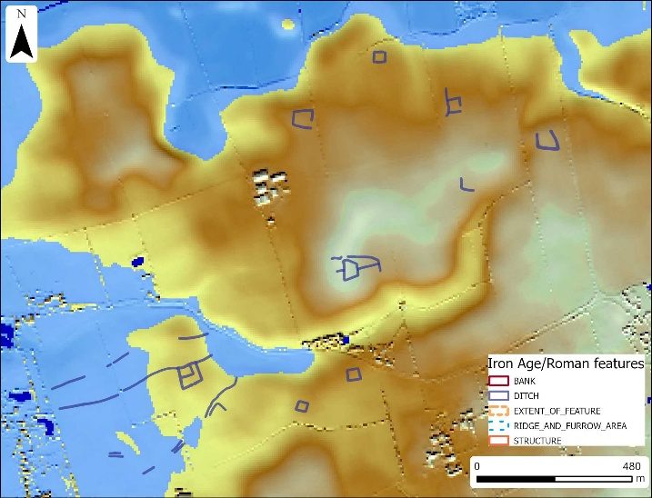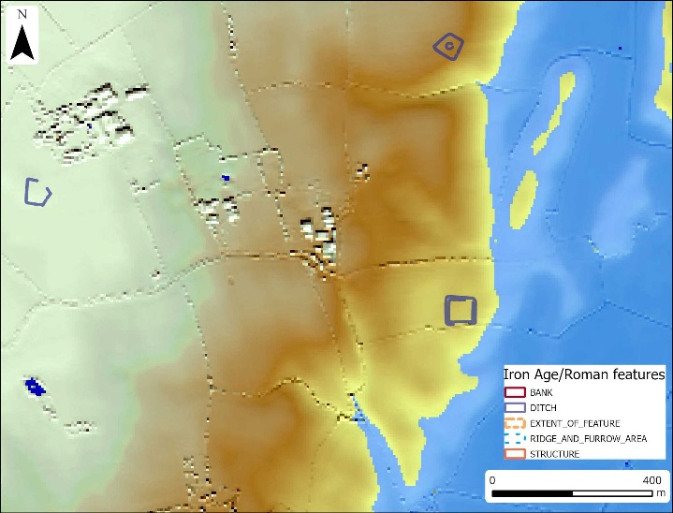
Figure 18: Map of digitised Iron Age/Roman period features positioned close to the maximum wetland extent, shown using the 6m above sea level water table model

Many of the Iron Age/Roman period enclosure sites are located well above the wetlands (Figure 16; however, there are four areas where some enclosures, field boundaries and trackways may have sat right on the edge of the wetlands and some within its margins (Figure 17). This may indicate that these sites were constructed in drier periods when the wetlands did not reach so far inland, perhaps favouring an earlier Iron Age date before the Ring of Bright Water site was flooded (Smith, 1990, p.7). After the 4th century AD, it is thought that sites occupying lower ground were abandoned due to a period of unstable climate and rising sea levels, which would have re-watered previously dry areas (Lenney, 2021, pp. 68-69) (Hyland, 2009, p.193). Alternatively, this may suggest that some enclosures were intentionally positioned within, or directly adjacent to, the wetlands to serve a particular function based on the environment at that time; perhaps as stock enclosures strategically placed next to the wetlands for animals grazing such as those in Figure 17 top right, or as field boundaries used for the movement of animals in and out of areas used for wetland grazing shown in Figure 17 lower left. The enclosures positioned higher and further inland are more likely to have been used for permanent settlement, favouring reliably dry locations.

6.5 Early Medieval
There were no newly recorded features attributed to the early medieval period in the study area. This period is likely hidden by later activity, as many of the modern villages overlie medieval activity, which could have even earlier origins in the early medieval period. Located north-west of the modern core of Halsham village is an extensive triple-ditched boundary feature, which lies to the west of, and partially encloses, a group of medieval house platforms and a moated manor site (Figure 18)(Historic England Research Records, 2008; Historic England Research Records 2011). The features shown in Figure 18 were mapped as part of the ALSF project (Deegan & van den Toorn, 2008), which sits on the western edge of the study area. Although not mapped as part of this project, when placing the site alongside the 4.5m water table model, the strategic position is exemplified, revealing how the site exploits its topographic location (Figure 18). The 4.5m water table model was used as it is predicted that the extent of the wetlands would have retreated slightly in the early medieval period compared to in the Iron Age, when sea levels were at their highest (Van der Noort, 2004, p. 22). As shown in Figure 18, the triple-ditched feature was likely constructed in an area of wetland, or an area with a high water table, where skilfully channelling water into the ditches would have enhanced the defensive nature of the site, no doubt also continued when the medieval moat was constructed. The complexity of the triple ditched site reveals an elite place, perhaps uniquely positioned to control the surrounding wetlands, which would have provided a wealth of resources. The presence of this elite site could indicate that settlements for the ‘everyday’ people in society were also present in the area, just not visible as cropmarks, or hidden by later modern settlement, which occupies the most elevated, favourable positions in the study area. The site illustrates how topography and the natural environment continued to be deliberately exploited in the early medieval period.
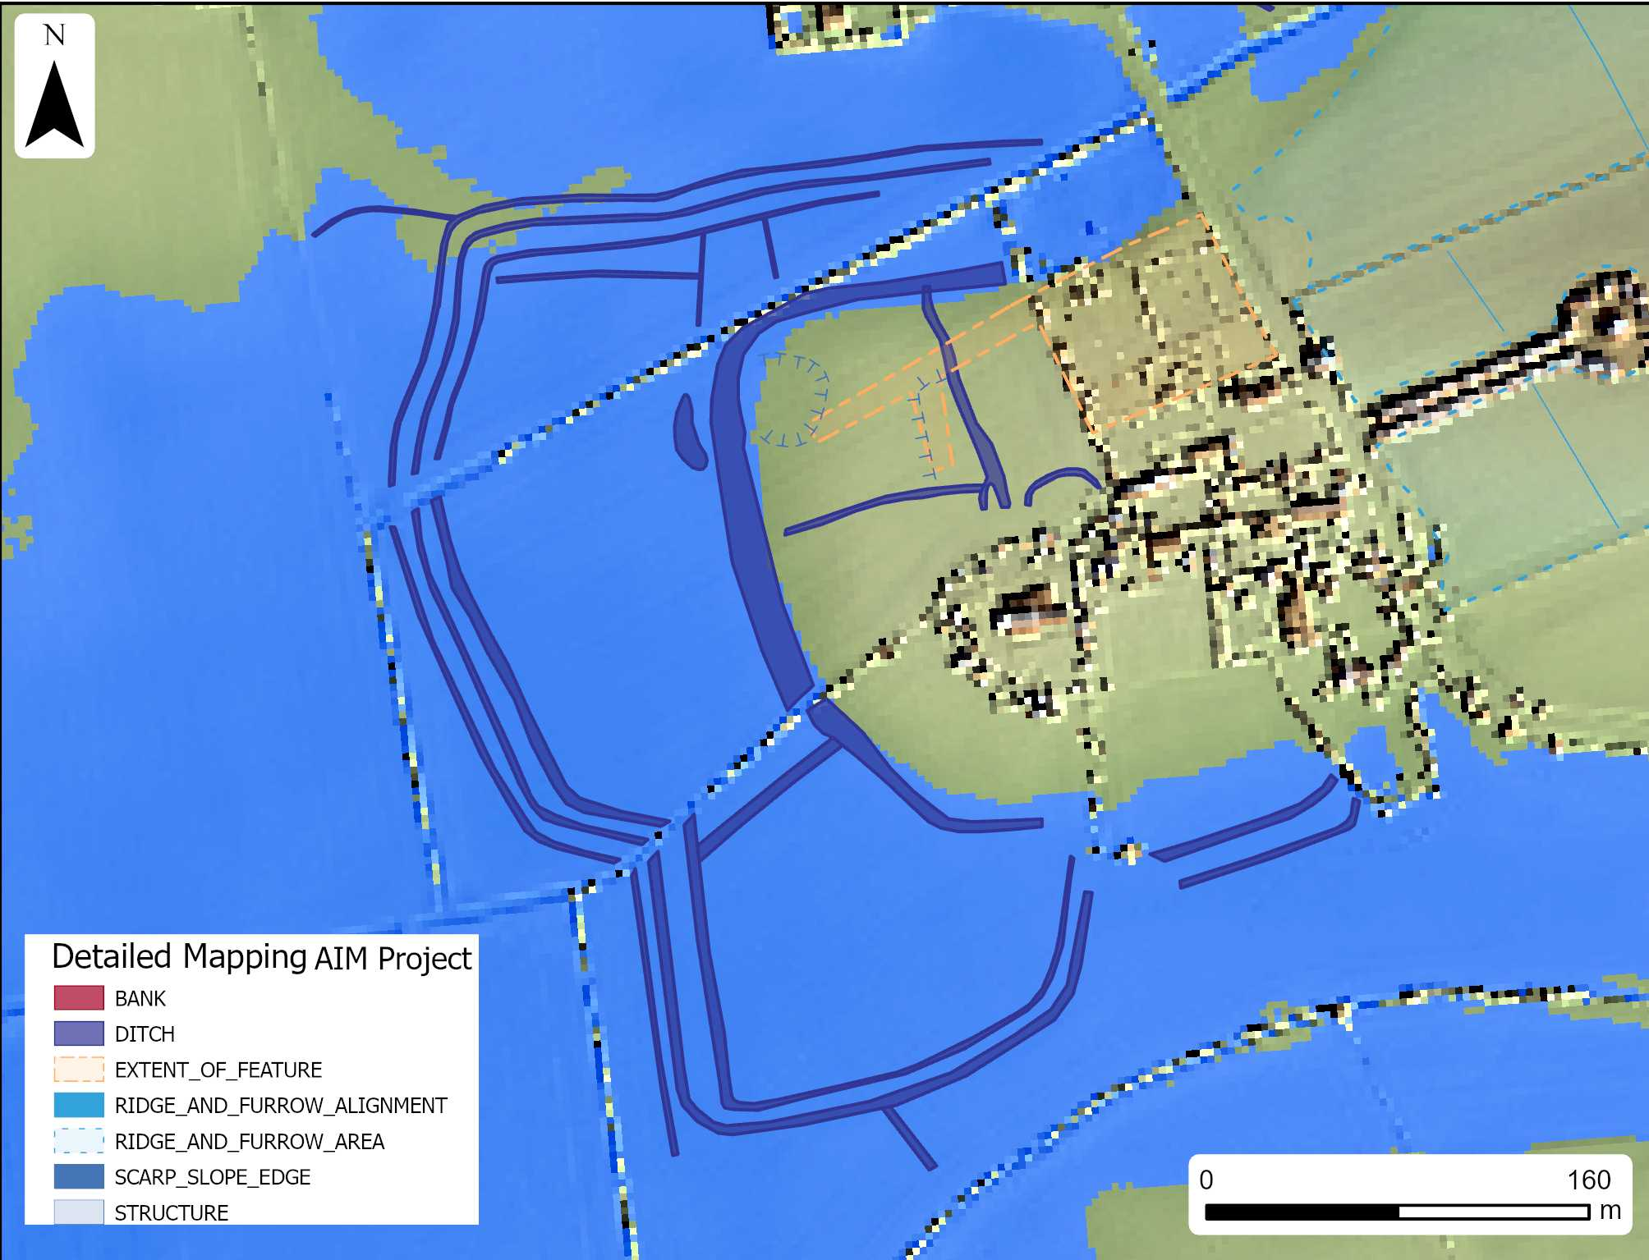
Figure 19: Map of the early medieval triple-ditched site north of Halsham digitised as part of the ASLF mapping project alongside the 4.5m ASL water table model - (Deegan and van den Toorn,2008).

6.6 Medieval and Post-medieval
The medieval and joint medieval/post-medieval periods have the most features attributed to them, including evidence of extensive ridge and furrow, moated sites, fishponds, and small remnants of settlement earthworks located on the edges of Rimswell and within Winestead.

Ridge and Furrow
Extensive evidence of ridge and furrow was identified densely across the study area with 644 features. Ridge and furrow earthworks are the remnants of medieval farming practices, which continued into the post-medieval period. Ridge and furrow earthworks are formed from ploughing the land in open field systems. Areas of ridge and furrow are usually arranged into blocks of aligned ridges and furrows separated by shallow ditches or headlands, which are banks formed by soil accumulation where the plough was turned at the end of each strip. The design of ridge and furrow improved field drainage, which was particularly advantageous in low-lying areas with naturally high water tables, such as southern Holderness; this probably explains why it was recorded so widely throughout the study area. Medieval ridge and furrow can be recognised by a characteristic form, often as reversed S-shaped or shallow C-shaped curves produced by the use of heavy, ox-drawn ploughs, both examples of which are found across the study area (Historic England, 2018b, pp.7-8). Many of the fields containing ridge and furrow were given a joint medieval/post-medieval period due to difficulties in determining which period they fell into. In some places, the furlongs were extremely long, measuring over one kilometre, with the curvier ends of the ridges and furrows often missing and the straightest parts remaining. The fields containing wide S-shaped ridges and furrows were attributed more confidently to the medieval period, but those which looked straighter and in places narrower were attributed a joint medieval/post-medieval date, as they likely were medieval in origin but showed alterations made in the post-medieval period. During the post-medieval period, many of the broad medieval ridge and furrow systems were straightened and subdivided to create fields better suited to more efficient cultivation. A few fields showed evidence of narrow ridge and furrow, created using steam-powered ploughs introduced after 1850, leaving behind ridges and furrows measuring below 4.5m in diameter; these were confidently attributed to the post-Medieval period (Forestry Commission, 2026).
The north-western and south-eastern parts of the study area, characterised by land below 3 m above sea level and close to major drainage channels, show a reduced density of ridge and furrow earthworks. These low-lying areas would have been particularly susceptible to flooding and were therefore poorly suited to arable cultivation prior to the large-scale drainage works of the 18th century. Notably, over half of the narrow ridge and furrow features attributed to the post-medieval period occur within these zones, suggesting that cultivation became viable only after drainage reduced flood risk and improved land reliability. The areas with less ridge and furrow at lower elevation are likely to have been used for alternative purposes, including grazing, with intertidal salt and freshwater marshes providing valuable grazing land; this was no doubt something exploited in earlier periods too (Lenney, 2021, p. 266).

Moated sites
With the exception of ridge and furrow as the most common site type found throughout the study area, moated sites also have quite a high density, with seven moated sites located within the study area and its buffer zone. This project mapped six of the seven moated sites located within the study area and its buffer zone; the remaining site, Halsham Manor Moat (Figure 18), had already been recorded as part of the ALSF aerial mapping project and so was not mapped in this project (Deegan, 2008). Within the study area buffer, two of the moats are protected scheduled monuments: Winestead Manor Moat and Roos Castle moated site. Both Winestead Manor Moat and Roos Castle Moat are the best preserved in the study area, with extant earthwork remains that were able to be mapped from Lidar data.

Winestead Manor Moated Site
Winestead Manor Moat survives as a complete ditch surrounding a platform where Winestead Manor sat (Historic England, 1994). The moat is thought to have been constructed in the 12th century, coinciding with the earliest phases of St Germain church, which sits adjacent to the moat (Historic England, 1966b). Winestead Manor was abandoned in 1579, when the family relocated north of Winestead village to establish a new residence, Winestead Hall, within a newly created area of parkland. Although Winestead Hall no longer survives, elements of the surrounding designed landscape remain visible (Neave and Waterson, 1988, p. 67). The continuity between the medieval moated manor and the post-medieval estate north of Winestead, linked through the Hildyard family, highlights the enduring patterns of landownership and landscape influence in the area (Camden, 1610).

Roos Castle Moated Site
Roos Castle moated site is also a scheduled monument, linked to the Roos family who built Helmsley Castle in North Yorkshire (Historic England,1951). Roos Castle moated site contains a large, ditched area interpreted as a fishpond and two small, banked enclosures, which are interpreted to be the remnants of buildings. The moat has been altered since its first construction, evidenced by the northern arm of the moat, which has been widened and blocked from the rest of the moat ditch to create a fishpond still retaining water, whilst the rest of the moat is dry. The south-western corner of the moat also appears to have been altered with two curving banks overlying the ditch; it is unknown what the date and function of these banks were. The mapped features correspond with the interpretation in the scheduling, with some extra details unpicked from the use of lidar, including two small areas of possible building remnants interpreted as remnants of Roos Castle (Historic England, 1951).

South Frodingham Moat
South Frodingham Moat is one of the more complicated moated sites within the study area. The 1855 OS map (Figure 19) shows multiple water-filled moat ditches, with those on the eastern side of the site depicted as broader than those to the west. The eastern ditches are comparable in width to those at the moated site of Winestead Manor, which is dated to the medieval period, suggesting South Frodingham moat had an earlier phase to the east, which was then modified and extended to the west. The western side appears to have a more elaborate layout with two entry points and an extra arm that extends into the inner area where an orchard appears to be planted. The western moated sections are likely to have been features of a designed garden, most likely established when the 16th-century Hall was built (Bulmer, 1892, pp.466-467). The Frodingham placename is linked by name to the landowners first recorded in the mid-13th century, which bolsters the interpretation of an earlier phase of the moated site dating to the medieval period (Bulmer, 1892, p.466).
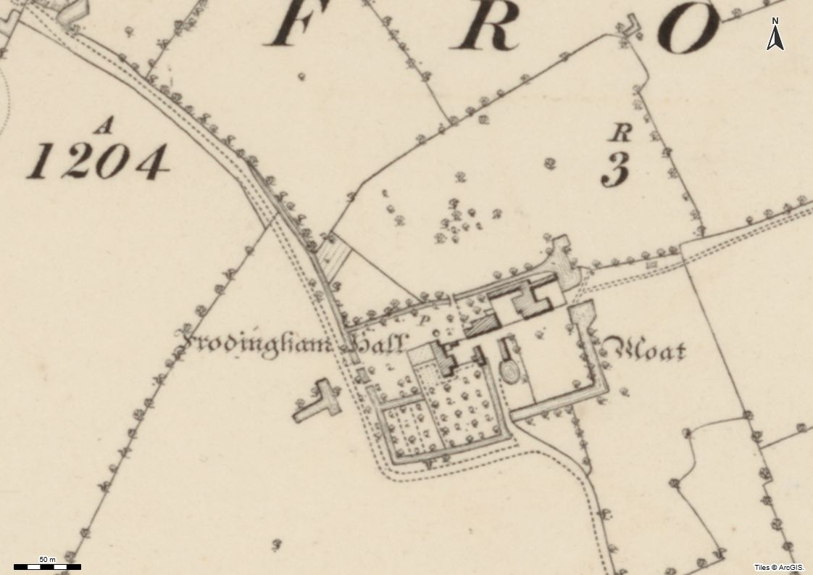
Figure 20: Historic map depicting two phases of moat construction - OS Six Inch 1st edition map (1855) [Reproduced with the permission of the National Library of Scotland]

Halsham East End Moat
Less is known about the other two moated sites in the study area. Very little remains of the moat located at East End in Halsham. Only the north section and a small section of the west side of the moat survive, with the rest now built over by modern development. The remaining sections of the moat appear to be widened, possibly to function as a pond.

Halsham Old Hall Moat
Another moated site, located further east on the site of Halsham Old Hall, has been mostly levelled and is only visible in historic aerial photographs and as depicted on the earliest OS maps dated to the late 19th century. A section of one of the moat arms on the eastern side can be seen in an undeveloped part of the site as a cropmark (Figure 20). All that hints at the location of the original moat is a section of hedges and the drain boundaries which follow the western and part of the southern extents of the moat; the rest of the site has been developed with farm buildings and hardstanding overlying much of the moated site.
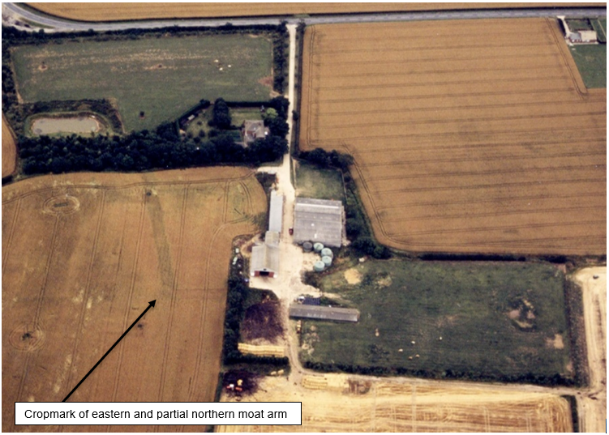
Figure 21: Aerial Photograph showing cropmark evidence of levelled moat earthworks at Halsham Old Hall still showing as cropmarks [NMR_12909_017 00-JUN-1996]

Winestead Hall Parkland Moat
An entirely new moated site was discovered in the study area, having never previously been recorded; the rest of the moats in the area all have NRHE records and depictions in early OS maps. The newly recorded moated site sits within the bounds of the Winestead/Red Hall parkland, which now houses Winestead Hall Hospital north of Winestead Village. It has some earthwork survival visible in lidar (Figure 21, top right), but it has been mostly levelled by ploughing, identified as both a soil mark in APGB imagery (Figure 21, lower left) and a cropmark in the 2025 aerial photographs. The size and shape of the feature appear very similar to the Winestead Manor moated site, but the condition of both is starkly different. The 1855 OS six-inch map depicts the northern Winestead moat as wooded (Figure 21, top left), suggesting it may have been favoured for plantation rather than pasture, likely because of the underlying earthworks. This site requires further investigation to confirm the date and interpretation as a moat; earthwork survival makes it more likely that the feature dates to the medieval period, but the lack of documentation or historical reference could indicate that this site may be earlier in origin. Both excavation and geophysical survey would benefit the understanding of this site.
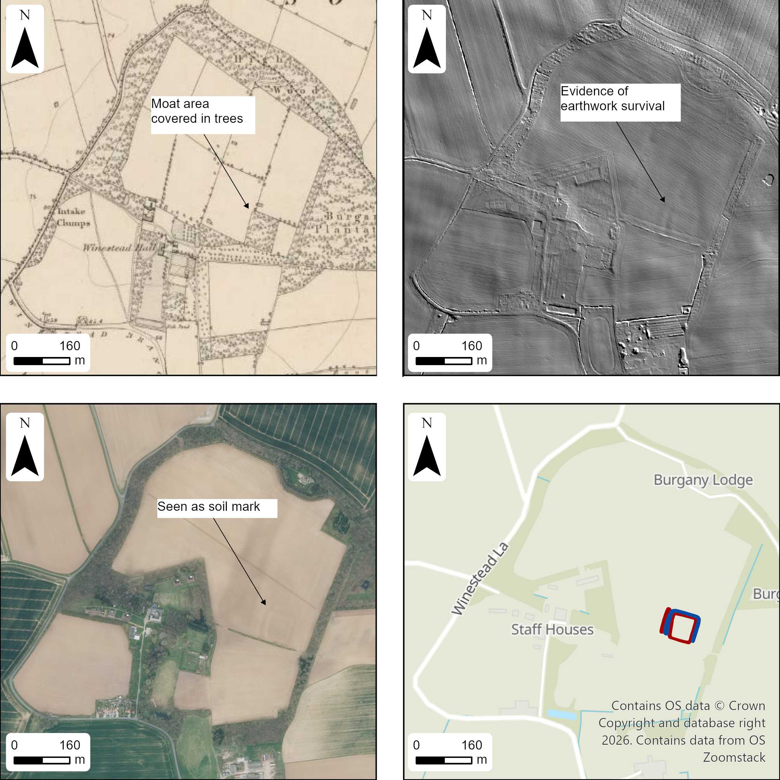
Figure 22: North Winestead moat in its landscape context [top left – Parkland context (contains OS Six Inch 1st edition map, 1855, Reproduced with the permission of the National Library of Scotland), top right – Lidar reveals earthwork survival (Lidar © Historic England, source Environment Agency), lower Left – Moat showing as a soil mark (APGB Imagery 03-NOV-2022 © Bluesky International Limited and Maxar Technologies), Lower right – Digitised moat feature (background mapping contains OS data © Crown copyright and database right 2025, Open Government Licence)

The study area contains a high concentration of moats, which fits within the wider regional pattern of increased moated site density located close to the river Humber compared with the rest of Yorkshire (Coveney, 2015, p. 63). It is likely that, although moats represented a growing trend for the elite, they also held practical functions providing drainage and protection from flooding in Southern Holderness (Lenney, 2021, p.196). Most moats in the vicinity of the River Humber are believed to date between 1250 and 1350, linked to either religious centres or nobility, coinciding with early drainage schemes implemented in the 14th century, organised and funded by Meux Abbey (Van de Noort, 2004, p. 149) (Siddle, J, 1962, pp.17-21). The density of elite sites emphasises the value of Southern Holderness in the medieval period, as a desirable place to live and control resources. Holderness was described as “the most prosperous part of the East Riding in the 11th Century” (Siddle, 1967, p.40), although where the value is derived from is not entirely clear, as although heavily covered with ridge and furrow hinting at widespread crop production, it is also documented by the chronicler of the Cistercian monastery of Meaux that Holderness produced only oats, shortly after the Norman Conquest (Lenney, 2022, p.109). These contrasting views could suggest that value in the area was not simply provided by crops but by a range of resources provided by the wetlands, such as fishing and fouling and the organic materials provided by different wetland environments.

Settlement Earthworks
There are two areas with evidence for possible medieval or post-medieval settlement earthworks recorded in this project, on the edge of Rimswell and within Winestead (Figure 22). Both areas of earthworks include building banks, ditched hollow ways, and former field boundaries, which were identified through lidar. The building earthworks are positioned along the edges of the hollow way ditches at both sites, as shown in Figure 22. Although these two sites survive as extant banks and ditches, there is very little settlement evidence surviving elsewhere in the study area. Many modern settlements in the study area are strung out along roads in a linear form, such as those at Halsham and Winestead. Halsham is recorded to have been a linear village in the early 13th century, split into western and eastern sides following the extent of where the modern village runs (Lenney, 2021, p. 269). Many modern settlements and dispersed farmsteads are likely situated directly over earlier medieval occupation, obscuring much of the evidence for everyday rural settlement while indicating long-term continuity in village locations. While elite occupation is well represented through moated sites, evidence for non-elite rural communities is largely absent or has been masked by later activity. Nevertheless, the widespread distribution of medieval and medieval/post-medieval ridge and furrow across the study area implies a substantial and sustained agricultural population. Although much of this earthwork evidence has now been levelled, in contrast, settlement extents appear to have remained remarkably stable, with most villages in the study area recorded in the Domesday Book, including Halsham, Winestead, Great and Little Newsome, Patrington, Ottringham, and Rimswell.
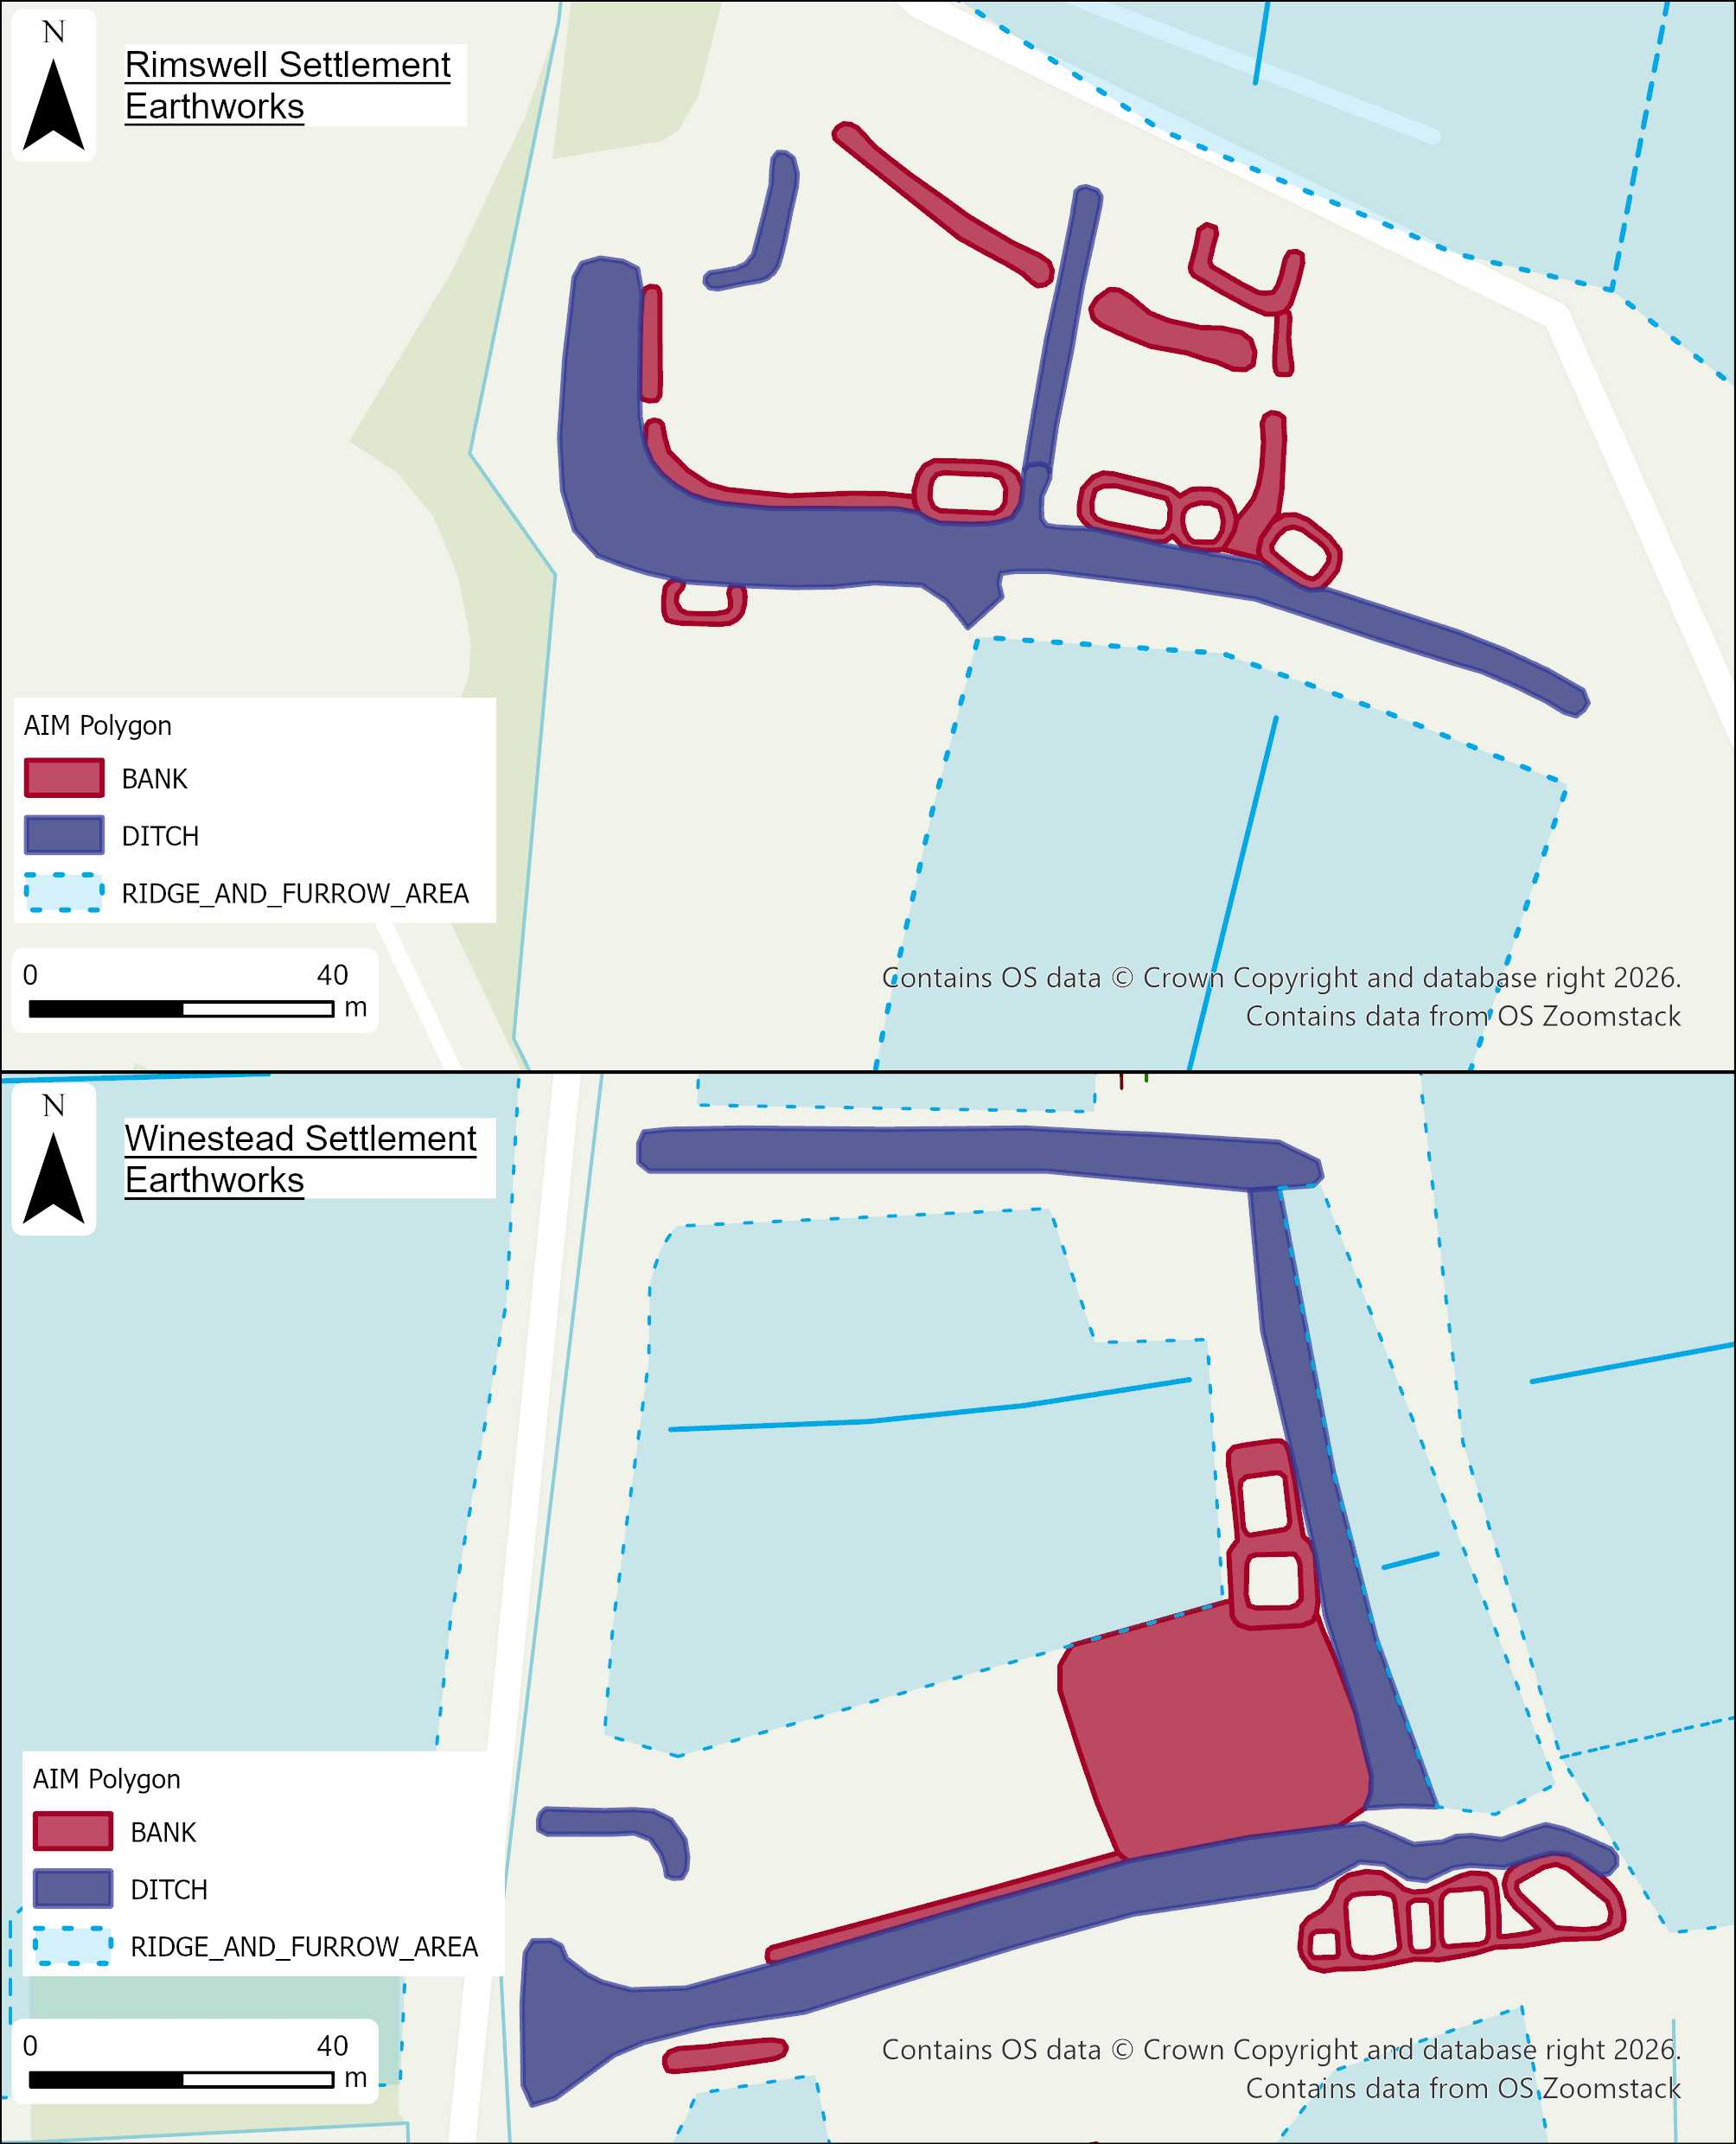
Figure 23: Digitisations of Rimswell settlement earthworks (Top) and Winestead settlement earthworks (lower). Background map includes OS data © Crown copyright and database right 2025 Open Government Licence.

Post-medieval Parkland
Two areas of designed parkland are present within the study area, associated with White Hall at the southern extent and Red Hall (formerly Winestead Hall) near its centre. The original Winestead Hall, established in the late 16th or early 17th century, was demolished and replaced by Red Hall in the 1720s (Neave and Waterson, 1988, p.67). Red Hall itself was demolished in 1936 (Neave and Waterson, 1988, p.67). Almost the entire footprint was digitised from parchmarks visible on vertical OS aerial photographs taken in June 1970, which match almost the floor plan of the ground floor (Neave and Waterson, 1988, p.69). The driveway to the western entrance of Red Hall is also still visible in lidar as an extant earthwork. These earthworks are covered with woodland, which has preserved their condition. Within the parkland, tree enclosure rings have also been mapped as earthworks visible in the RAF 1946 aerial photographs. The tree enclosure rings would have formed a part of the wider designed landscape surrounding the Hall. Interestingly, one of the tree enclosure rings sits within an earlier Iron Age enclosure, identified as a cropmark in the 2025 aerial photographs. The Iron Age enclosure is positioned on an area of slightly elevated ground, later identified as a desirable location for a tree ring enclosure within the designed landscape. This continuity in the use of microtopography demonstrates the enduring importance of subtle variations in relief as a determining factor in the placement and construction of features across multiple periods.

6.8 20th Century
Within the study area and the 1km buffer area, a variety of Second World War features were digitised, most of which were only visible in the 1940’s RAF aerial photographs. Only the BBC broadcasting station survived into the late 1990’s, and a small remnant of the Heavy Anti-Aircraft battery site survives today.

Heavy Anti-Aircraft Battery
The Heavy Anti-Aircraft (HAA) battery site was clearly identifiable as a military structure due to its recognisable layout. The HAA follows the usual pattern of a central command post surrounded by four circular gun emplacements. This site also has two extra square structures, one of which likely functioned as a magazine, and the other appears to be a square-shaped gun emplacement (Historic England Research records, 1992). The buildings to the south of the site were also associated with the HAA site as accommodation huts and offices (Figure 22) (Lowry et al., 1995, p.49). Some of the circular gun emplacements and the magazine structure can be visible as parch marks in extreme dry conditions, seen most clearly in the 2019 APGB imagery; the only upstanding structure are the remnants of the magazine. Similar examples of HAA’s have been recorded in the surrounding areas, including the Hull Valley, where one site clearly shows guns still positioned in the emplacements when photographed in 1945 (Evans et al., 2012, p. 35).
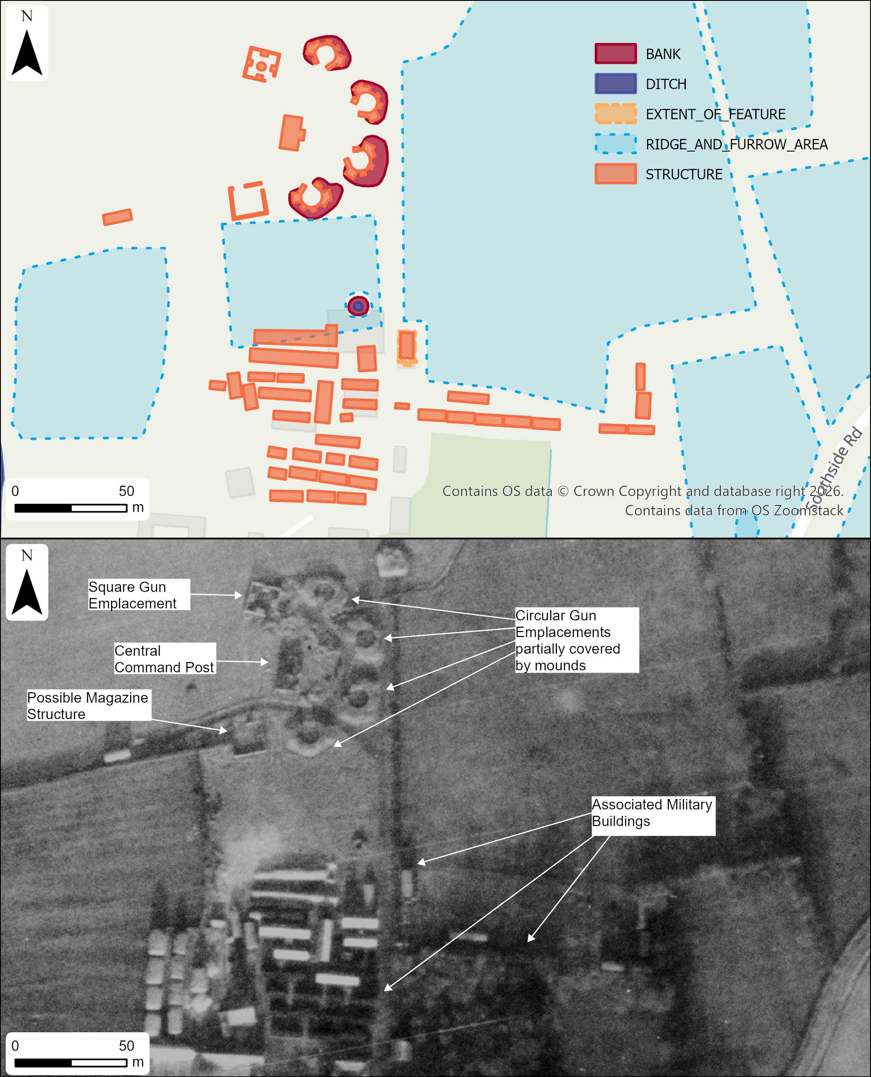
Figure 24: The Heavy Anti-Aircraft site in Halsham (RAF/CPE/UK/1911_RS_4010_27-DEC-1946) (Background mapping includes OS data © Crown copyright and database right 2025, Open Government Licence).

BBC Broadcasting Station
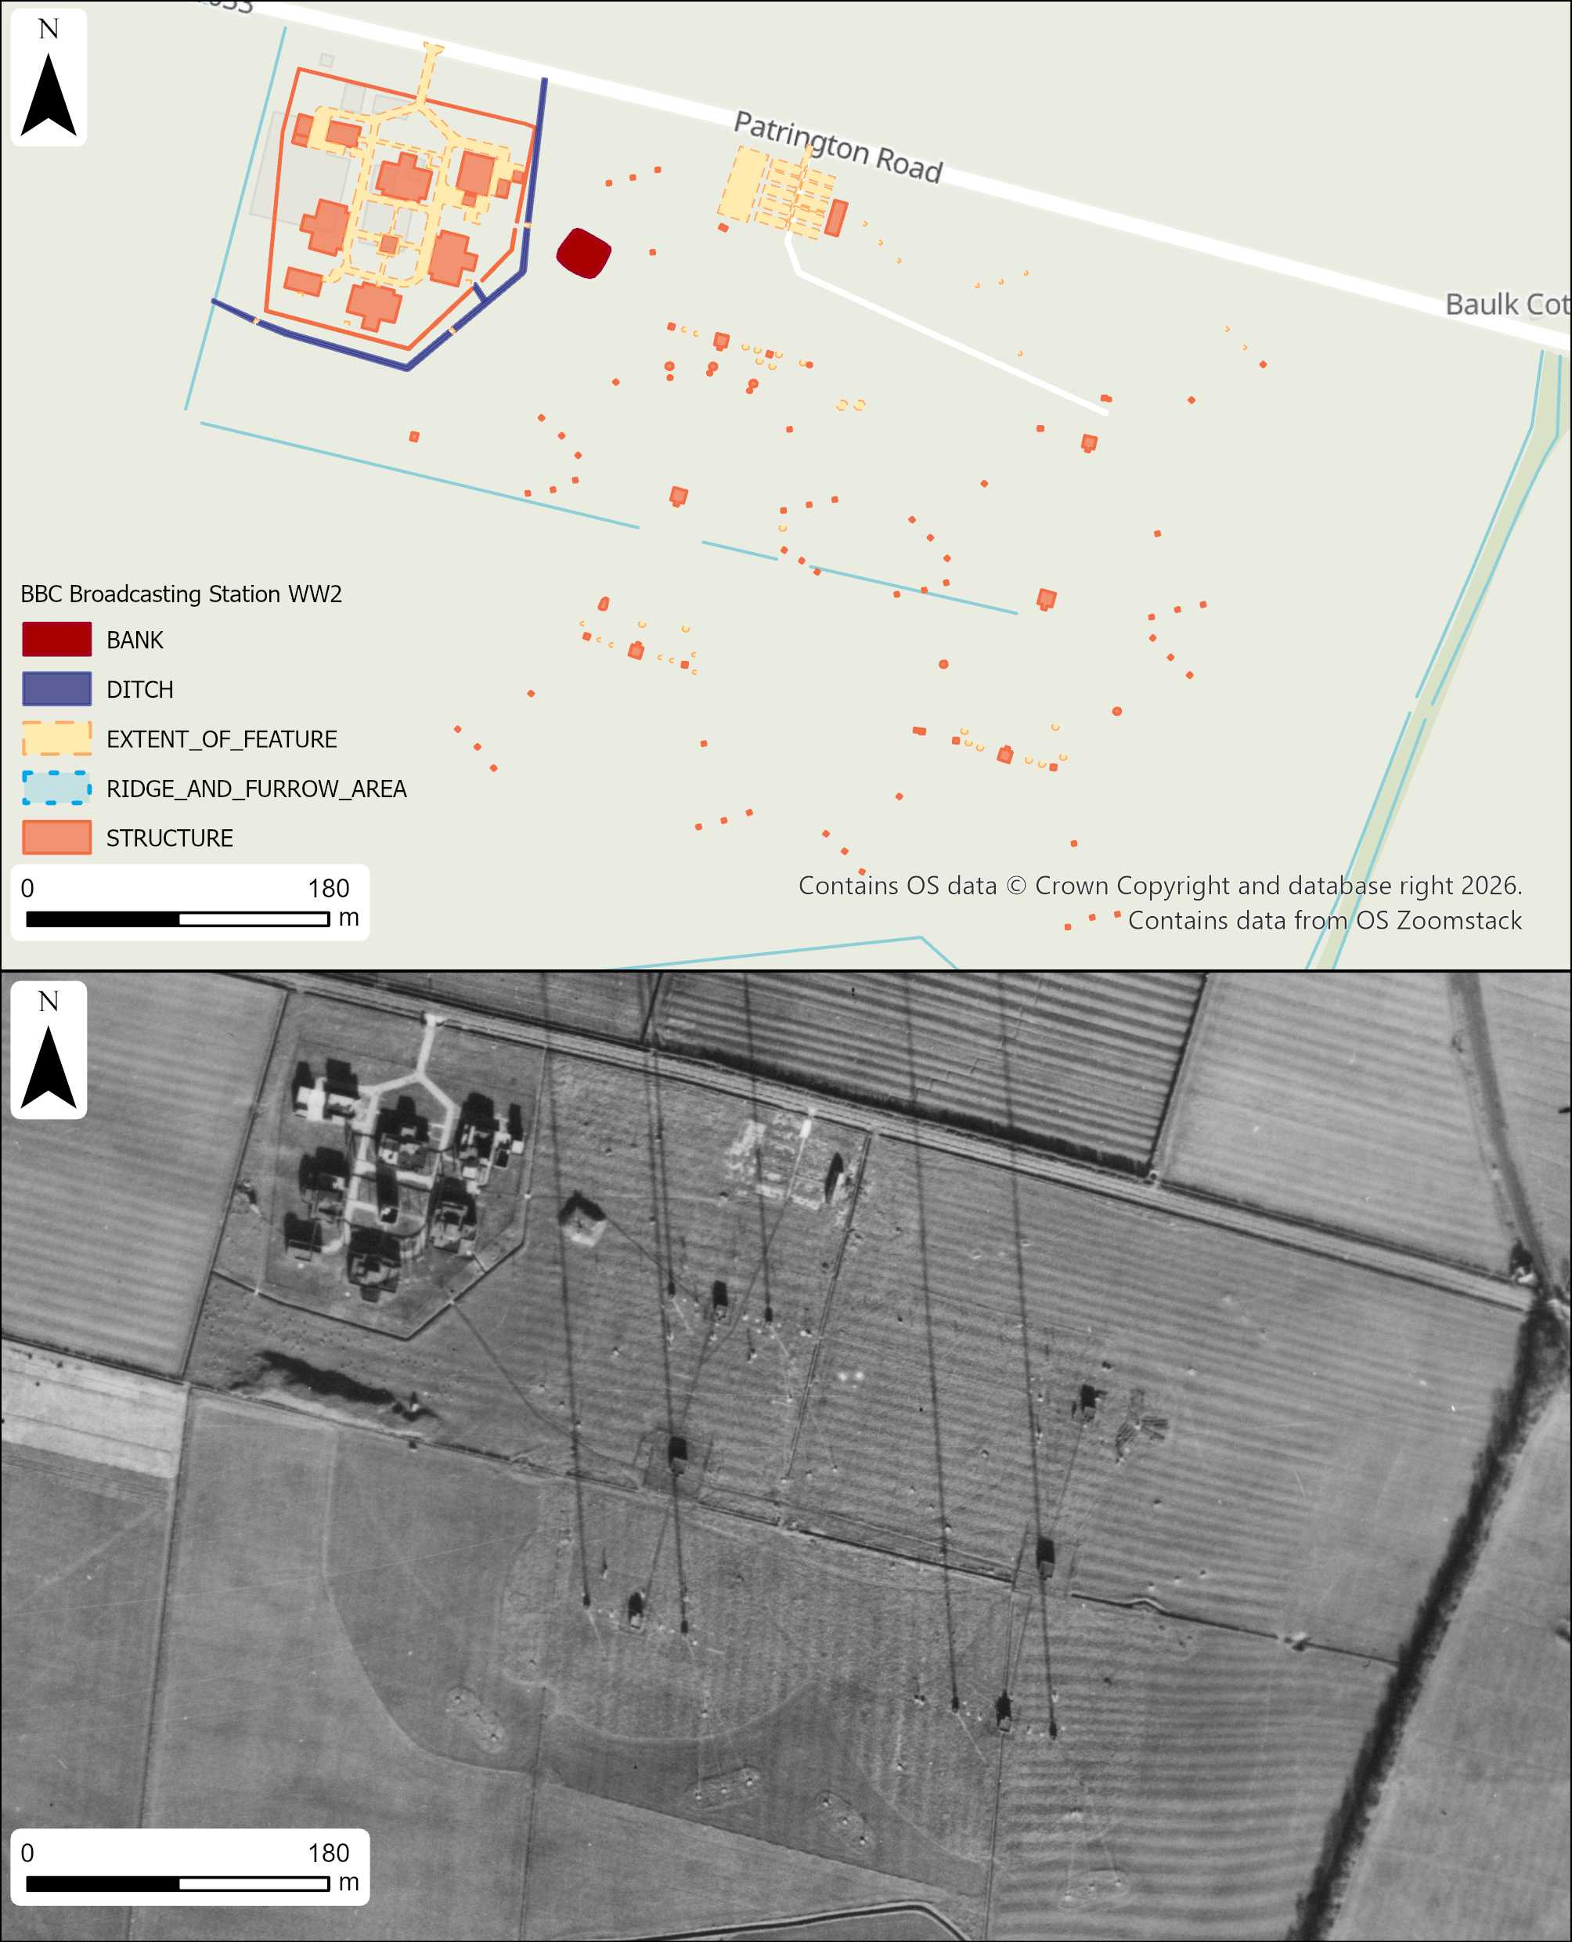
Figure 25: Digitisation of BBC Broadcasting Station alongside the RAF photograph of the site (Ridge and Furrow digitisation not included in this figure to make the mapping clearer) (Contains extract of RAF photograph - RAF/CPE/UK/2396_RS_4018_17-Nov-1947. Background map includes OS data © Crown copyright and database right 2025 Open Government Licence)
Also recorded in the study area was a large broadcasting radio station at the south-western extent of the study area. The broadcasting station was protected by the BBC and built during World War Two (Historic England Research records, 1995). The site consists of an arrangement of tall radio telegraphy masts, which are held in place with wires that sit in concrete bases, most of which were still erect in 1947 (Figure 23). Each group of masts also has accompanying small buildings spread over two large fields. In proximity to both the masts and the adjoining buildings, a large sub-rectangular mound has been interpreted as an air raid shelter. The broadcasting radio station also has a complex of buildings in a well-protected area, surrounded by a drainage ditch to the west and north, positioned between the buildings and the road, as well as a ditch cut around the extent of the buildings. Barbed wire can also be seen surrounding the buildings inside the ditch, visible very faintly (Figure 23). There also appear to be the remnants of concrete platforms adjacent to the group of buildings, which probably held temporary huts used for accommodation for those working on site. The site was last visited in 1992 by the Fortress Studies Group, where the group of buildings associated with the broadcasting equipment was still seen to be in good condition (Historic England Research records, 1995). The site has since been redeveloped, with all original buildings levelled. The masts and associated structures in the adjacent field have also been dismantled, and the area is now occupied by a solar farm. The southern field has not been redeveloped, instead used for arable farming, and small cropmarks where the concrete bases sat can still be seen in APGB imagery from 2019.

Military camp
To the east of the broadcasting station, within the grounds of the White Hall parkland, a military camp was identified in 1946 RAF vertical photographs. The site appears very discreetly, with many of the associated buildings tucked into the treeline. Across the site, many paths can be seen cutting between the buildings. The use of the site cannot be interpreted from the aerial photographs, but there is a reference to the site being used possibly for anti-aircraft guns (Rands, 2005).

Aircraft Obstruction Earthworks
Two areas of aircraft obstruction earthworks were identified within the study area and its buffer zone. The aircraft obstruction earthworks in the study area functioned as anti-glider ditches, usually placed in potential landing grounds within 8km of vulnerable ports (Hegarty and Newsome, 2007, p.58). The aircraft obstruction sites in the study area sit just over 6km from the coast, which fits well with this pattern. Just outside of the study area, within the buffer zone at the northwest extent, are two fields with aircraft obstruction earthworks visible in 1946 RAF aerial photographs. The aircraft obstruction earthworks consist of a series of straight ditches in a grid pattern; some of the ditches appear to be flanked by a small amount of spoil material visible as small banks. Another area of aircraft-obstruction earthworks was also identified to the south of Great Newsome, although these features are less extensive than those recorded in the north, they share a similar layout.

Bombing Range Marker
Located between the two fields containing aircraft obstruction earthworks at the northwest of the study area is a small bombing range marker and observation post. The bombing range marker is shown as an arrow pointing roughly north-north-east. Neither of these features were visible in photographs taken after 1947.

Searchlight Battery
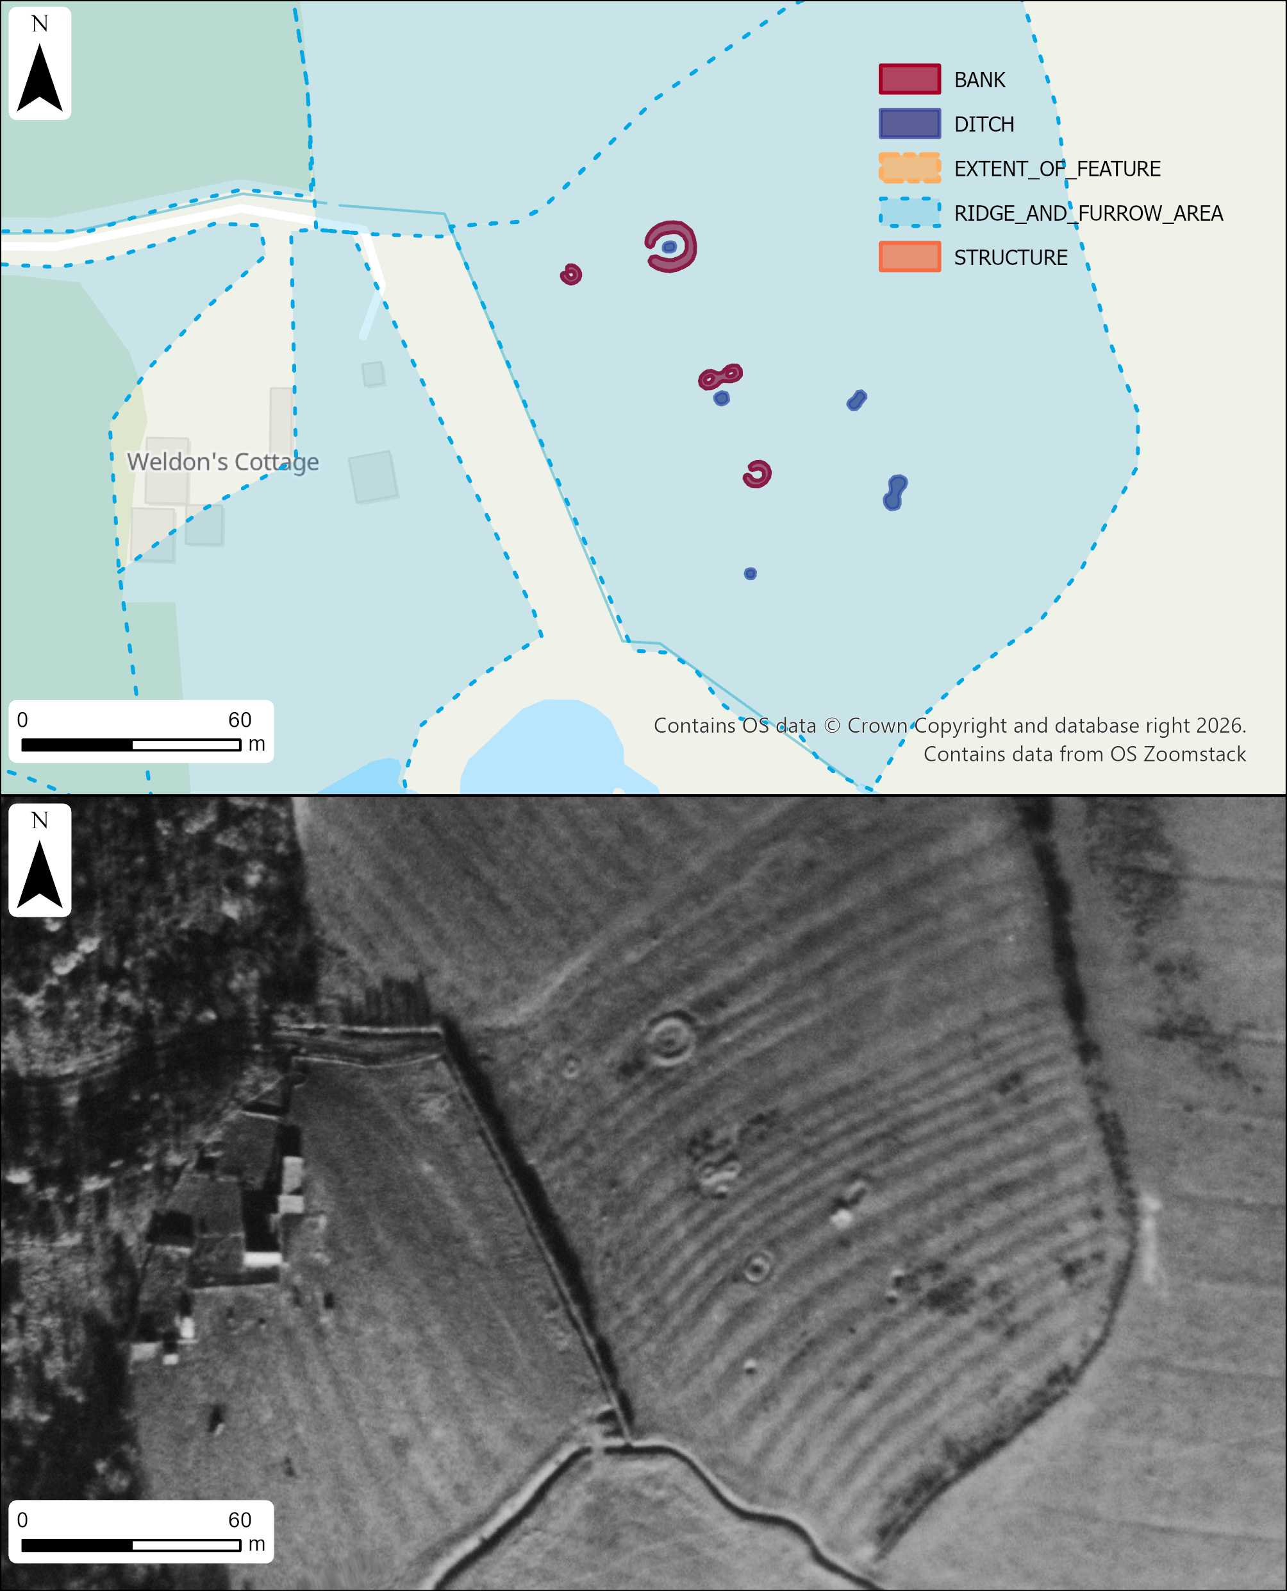
Figure 26: Newly recorded searchlight battery site digitisation alongside RAF photograph of the site (contains extract of RAF aerial photograph RAF/CPE/UK/2396_RP_3023_17-NOV-1947 © Historic England Archive. Background map includes OS data © Crown copyright and database right 2025 Open Government Licence)
The searchlight battery located at the southeastern extent of the study area is a newly recorded site with no previous NRHE records. The site was identified in 1947 RAF aerial photographs, showing numerous pits and circular banked features with internal pits (Figure 24). Searchlight batteries usually comprise a larger circular earthwork which would have housed the searchlight, a predictor emplacement earthwork feature, and at least one weapons pit (Lowry et al., 1995, pp. 62- 63). The searchlight battery in the study area has a larger circular earthwork which measures approximately 13.4m, whilst the inner area within the circular bank measures just over 9.4m, which is the precise size needed to house a 90cm searchlight, bolstering the interpretation of the site (Lowry et al., 1995, p.63). The other circular banks are smaller in diameter; these may have held smaller searchlights or functioned as gun emplacements. It is likely, a rangefinder would also have been positioned on site. There are also five small pits, which may have been weapon pits. The site, like the other Second World War sites in the study area, was removed from the landscape very quickly and was only visible in the 1947 RAF aerial photographs.

Gun Emplacement
The gun emplacement feature located North of Halsham East End was also newly identified. The gun emplacement was isolated and consisted of a circular bank enclosing an inner circular ditch. The earthwork feature identified from 1946 RAF aerial photographs was quite substantial in size, measuring approximately 25m with an inner ditch measuring approximately 10m across, placing it within a similar range to the HAA gun emplacements located in Halsham.

Royal Observer Corps Post
An isolated structure was also identified in the 1946 RAF aerial photographs, which has been tentatively interpreted as a Royal Observer Corps (ROC) post. The function of the ROC post was to inform of incoming enemy aircraft, providing essential information to warn of air raids and alert other parts of the defence system, including HAA and searchlight batteries (Air Ministry, 1941). The ROC post appears as a small square structure placed on an area of hardstanding or a possible small mound. The post and mound sit on top of a post-medieval field boundary bank, which would have provided the ROC post with additional elevation, enabling a better view of incoming aircraft.

6.9 Conclusion
Overall, the project proved highly effective, greatly increasing the number of recorded archaeological sites across the study area. Although no features were attributed to the Bronze Age or early medieval periods, the project significantly enhanced records for the Neolithic, Iron Age/Roman, medieval, medieval/post-medieval, and Second World War periods.
Only a single Neolithic site was identified; however, this is significant given that only one other Neolithic site has been recorded in Southern Holderness and only one other monumental site has been recorded in the wider region (Van de Noort, 2005, p. 60)(Historic England, 2015). The construction of the cursus monument within a wetland setting may reflect its significant role, whether functional or ritual, or both, within the surrounding landscape. Its presence within southern Holderness also suggests that the area held significance during the Neolithic, increasing the likelihood that further sites from this period may be present.
The discovery of approximately 30 previously unrecorded Iron Age sites during the 2025 reconnaissance significantly expands the known archaeological record for Holderness. These findings indicate a far denser distribution of Iron Age/Roman activity than previously recognised and, through the diversity of site forms identified, provide an important foundation for future interpretations of settlement and land use in the region. While a general preference for locations above 6 m above sea level can be observed among Iron Age/Roman period sites, closer examination of individual enclosure positions suggests a more deliberate engagement with micro-topography. Over half of the enclosures appear to have been sited to take advantage of subtle elevation changes relative to the surrounding landscape, implying that slight height differences were actively valued rather than incidental. Such positioning may reflect concerns with drainage, visibility, or symbolic distinction within a predominantly low-lying environment, and offers a potentially useful indicator for predicting the location of further sites. By applying water-table modelling to situate Iron Age/Roman enclosures within their reconstructed historic landscapes, this approach seeks to emphasise the dynamic relationship between settlement and wetland environments, and to highlight the central role wetlands likely played in shaping patterns of occupation and land use during these periods, particularly in southern Holderness.
The widespread documentation of now-levelled medieval and medieval/post-medieval ridge-and-furrow earthworks highlights a broader problem concerning the loss of earthwork archaeology. While the removal of ridge and furrow has exposed a new layer of archaeology presenting as cropmark sites, it is likely that other feature types traditionally preserved as earthworks, such as prehistoric barrows, have been lost through the same processes of landscape alteration. This loss of earthworks generally across the study area may skew the archaeological record, with certain types of sites omitted due to lack of survival.
The variety of features recorded in the study area highlights the important role that Holderness played during the Second World War. Not only are features located on the coastline, as highlighted in the Rapid Coastal Zone assessments (Fleming and Royall, 2019; Deegan, Bacilieri and Adams, 2007), but they are also positioned further inland for a variety of different functions. The limited longevity of Second World War earthwork sites, established within the last century, highlights the vulnerability of earthwork preservation more widely and suggests that the archaeological record may significantly underrepresent certain site types, particularly for sites that traditionally survive only as earthworks.

7. Recommendations
As this project progressed, it became evident that to enable a deeper understanding of the archaeological features, the topographical and environmental context was essential to understand their purpose in the landscape.
- The topography of Holderness at face value appears flat and homogenous, but this is far removed from the reality of how the land was exploited. Small changes in land height are widely exploited for Iron Age/Roman period enclosures, which could be a useful consideration when thinking about landscape sensitivity models, helping to predict where further sites may be positioned (Kidd and Last, 2024).
- In Southern Holderness, future archaeological research must address the evolving estuary coastline and its impact on human occupation throughout all periods. Significant coastal change, sea-level rise, and episodic flooding have altered both the environmental context and the visibility of archaeological sites, particularly at lower elevations. As a result, the apparent absence of evidence for certain periods may reflect burial beneath alluvial deposits rather than genuine gaps in occupation. Future work should therefore integrate detailed soil mapping, paleoenvironmental data, and reconstructions of historic estuary extents in order to assess sites within their original landscape settings and mitigate interpretative bias within the archaeological record.
- Combining archaeological and environmental research will ensure that the historical evolution of wetlands in Southern Holderness is better understood. Archaeological sites often hold key environmental deposits which help build a more complete picture of the environment at the time of site construction/use. For much of Southern Holderness, the development of the wetlands through the later prehistoric period is still relatively patchy and would benefit from further research, especially when excavating future sites. It has been shown from archaeological excavations around the Humber that episodes of marine transgression occurred in both the Iron Age and Roman periods, highlighting just how valuable archaeological research can be in the development of localised environmental models.
- Future models created to explore the wetland extents in the Iron Age/Roman periods would be better informed using a more robust reconstruction, incorporating a predicted Iron Age estuary extent and using a distance-weighted tidal decay model, allowing simulation of how tidal water would have travelled inland along valleys and channels well before the wider floodplains became inundated. It would be useful to explore other periods, to examine how the wetlands were affected by rising and lowering sea levels.
- Although much of the landscape has been heavily drained, the layer of alluvium could potentially protect early sites containing finds made from organic materials, such as the Roos Carr Figures (Van De Noort, 2004, pp.97-98). Drainage schemes have likely already destroyed many of these sites through dewatering, but it is a consideration for potentially ‘blank’ areas that sit on alluvium.
- Throughout this project, it has become evident that extensive earthwork features within the study area have been levelled. Many cropmark sites that were absent from the earliest aerial photographs have gradually emerged as successive layers of soil have been ploughed away, a process that will continue under modern agricultural practices. Holderness is likely to yield further cropmark discoveries and should remain a priority for aerial reconnaissance when conditions are optimal. As noted earlier, the increasing frequency of extreme weather associated with climate change may further enhance cropmark formation, particularly in areas where only severe drought allows buried features to become visible. Consequently, even regions with traditionally difficult soils may still hold significant potential for new discoveries.
- As this project only focused on a 25km² area, it did not encompass all of the new sites discovered in 2025. A comprehensive programme of aerial mapping across the rest of the Holderness would greatly benefit the archaeological record, as much of the area has yet to be studied from a landscape approach in a formal capacity. It would be useful to compare northern Holderness to Southern Holderness to reveal regional variances in different periods, likely linked to the topography and environment.

References

- Air Ministry (1941) Air Defence of Great Britain: Instructions for Observer Posts. Available at: http://www.roc-heritage.co.uk/uploads/7/6/8/9/7689271/__oc_posts_1941.pdf
- Batty, L. (1997) ‘Predicting the effects of habitat loss and change on estuarine birds: are we asking the right questions?’, Effect of Habitat Loss and Change on Waterbirds. Available at: 62510-libre.pdf
- Borchert, J.R. (1948) ‘The Agriculture of England and Wales, 1939-1946’, Agricultural History, 22(1). Available at: https://www.jstor.org/stable/3739744
- Bulmer, T (Firm). (1892). History, Topography, and Directory of East Yorkshire (with Hull). Preston. Available at: https://hdl.handle.net/2027/uc1.a0010007433
- Camden, W. (1610) Britain, or, a Chorographicall Description of the Most Flourishing Kingdomes, England, Scotland, and Ireland. Transcribed by P Holland. London: George Bishop and John Norton. Transcribed by D.F. Sutton (2004). Available at: Vision of Britain | William Camden | Yorkshire: East and North Ridings (Accessed: 30 March 2026)
- Coveney, N. (2015) Moated Sites in Medieval England: A Reassessment. Doctoral Dissertation, University of Leicester. Available at: Item - Moated Sites in Medieval England: A Reassessment - University of Leicester - Figshare
- Deegan, A., and Toorn, D. (2008) Desk-Based Resource Assessment and Research and Management Framework of Aggregate-Producing Landscapes in the East Riding of Yorkshire. Available at: Desk-Based Resource Assessment and Research and Management Framework of Aggregate-Producing Landscapes in the East Riding of Yorkshire
- Deegan, A., Bacilieri, C., and Adams, H. (2007) The Yorkshire Coast and Humber Estuary Rapid Coastal Zone Assessment Project (3729). Available at: The Yorkshire Coast and Humber Estuary Rapid Coastal Zone Assessment Project
- Dinnin, M. (1995) ‘Introduction to the paleoenvironmental survey’. In Van de Noort, R. and Ellis, S. (eds.) Wetland heritage of Holderness: an archaeological survey. School of Geography and Earth Resources, University of Hull.
- Dinnin, M., and Lillie, M. (1995) ‘The paleoenvironmental survey of southern Holderness and evidence for sea level change’. In Van de Noort, R. and Ellis, S. (eds.) Wetland Heritage of Holderness: An Archaeological Survey. School of Geography and Earth Resources, University of Hull.
- Evans, S. (2019) Historic England Aerial Investigation and Mapping (formerly National Mapping Programme) Standards Technical Review. Historic England. Available at: https://historicengland.org.uk/research/results/reports/9037/HistoricEnglandAerialInvestigationandamp%3bMapping(formerlyNationalMappingProgramme)StandardsTechnicalReview
- Evans, S., Boutwood, Y., Knight, D., and Oakey, M. (2012) East Riding of Yorkshire, Chalk Lowland and the Hull Valley NMP: Aerial Investigation and Mapping Report. Research Report 39/2012. Historic England. Available at: EastridingofYorkshireChalkLowlandandtheHullValleyNMPAerialInvestigationandMappingReport
- Fleming, F., and Royall, C. (2019) The Inner Humber Estuary Rapid Coastal Zone Assessment: Aerial Investigation and Mapping Project. Historic England. Available at: TheInnerHumberEstuaryRapidCoastalZoneAssessment_AerialInvestigationandMappingProject
- Forestry Commission (2026) Ridge and Furrow Guidance for Forestry in England. GOV.UK. Available at: Ridge and furrow guidance for forestry in England - GOV.UK (Accessed: 31/03/2026)
- Glover, G., Moore, R., and Flintoft, P. (2016) " A Mersshy Contree Called Holdernesse": Excavations on the Route of a National Grid Pipeline in Holderness, East Yorkshire: Rural Life in the Claylands to the East of the Yorkshire Wolds, from the Mesolithic to the Iron Age and Roman Periods, and beyond. Archaeopress Publishing Ltd. Available at: https://play.google.com/store/books/details?id=hxteEAAAQBAJ&rdid=book-hxteEAAAQBAJ&rdot=1&source=gbs_vpt_read&pcampaignid=books_booksearch_viewport&pli=1
- Hegarty, C. and Newsome, S. (2007) Suffolk's Defended Shore: Coastal Fortifications from the Air. English Heritage.
- Historic England Research Records. (1992) Monument Number 914269. Site of World War II Heavy Anti-Aircraft Battery, Halsham. Historic England. Available at: Heritage Gateway - Results. (Accessed: 30/03/2026)
- Historic England Research Records. (1995) Monument Number 915133. BBC Protected Transmitting Station at Ottringham. Historic England. Available at: Heritage Gateway - Results. (Accessed: 30/03/2026)
- Historic England Research Records. (2008) Monument Number 81682. The Site of Halsham Manor, with the Remains of the Moat and Associated Anglian Settlement. Historic England. Available at: Heritage Gateway - Results. (Accessed: 30/03/2026)
- Historic England Research Records. (2011) Monument Number 81679. A Triple-Ditched Settlement Boundary, Possibly Early Medieval in Date, is Visible as Cropmarks and Earthworks on Air Photographs. Historic England. Available at: Heritage Gateway - Results. (Accessed: 30/03/2026)
- Historic England (1951) Roos Castle Moated Site and Associated Fishponds. 1008046. Available at: Roos Castle moated site and associated fishponds, Roos - 1008046 | Historic England (Accessed: 30/03/2026)
- Historic England (1966a) The White Hall, 1310373. Available at: The White Hall, Patrington - 1310373 | Historic England (Accessed: 30/03/2026)
- Historic England (1966b) Church of St Germain, 1161091. Available at Church of St Germain, Patrington - 1161091 | Historic England
- Historic England (1994) Winestead Moated Manor Site, 1009778. Available at: Winestead Manor moated site, Patrington - 1009778 | Historic England (Accessed: 30/03/2026)
- Historic England (2013) National Mapping Programme. York: Archaeology Data Service. Available at: https://doi.org/10.5284/1106882 (Accessed: 30/03/2026)
- Historic England (2015) East Field Crop Mark Site Centred 300m SSE of Northorpe, Interpreted as a Neolithic Henge Later Reused as a Bronze Age Ringwork, 1423379. Available at: East Field crop mark site centred 300m SSE of Northorpe, interpreted as a Neolithic henge later reused as a Bronze Age ringwork, Hornsea - 1423379 | Historic England (Accessed: 30/03/2026)
- Historic England (2025) Aerial Investigation and Mapping Standards. Internal document.
- Historic England (2018a) Prehistoric Avenues and Alignments: Introductions to Heritage Assets. Historic England. Swindon. Available at: Prehistoric Avenues and Alignments – Introductions to Heritage Assets
- Historic England (2018b) Field Systems: Introductions to Heritage Assets. Historic England. Swindon. Available at: Field Systems: Introductions to Heritage Assets
- Hyland, L. (2009) ‘The Roman Archaeological Evidence of Holderness’, Yorkshire Archaeological Journal, 81. The Yorkshire Archaeological Society. pp 179-197.
- Kid, S. and Last, J. (2024) Archaeological Sensitivity Pilot Projects. Research Report 34/2024. Historic England. Available at: ArchaeologicalSensitivityPilotProjects
- Leary, J. and Kador, T. (2016) ‘Movement and mobility in the Neolithic’. In Leary, J. and Kador, T. (eds.) Moving on in Neolithic Studies: Understanding Mobile Lives, Neolithic Studies Group Seminar Papers, 14. pp.1-13.
- Lenney, J. (2021) Holderness: Human/Environment Interaction in a Dynamic Landscape: A Regional Study from the Norman Conquest to the Dissolution of the Monasteries. Available at: THESIS_DOCTOR_OF_PHILOSOPHY_LENNEY_Jessica_Alexandra_2022.pdf
- Loveday, R. (1985) Cursuses and Related Monuments of the British Neolithic. Doctoral dissertation, University of Leicester. Available at: Item - Cursuses and Related Monuments of the British Neolithic - University of Leicester - Figshare
- Loveday, R. (2016) ‘Monuments to mobility? Investigating cursus patterning in southern Britain’. In Leary, J. and Kador, T. (eds.) Moving on in Neolithic Studies: Understanding Mobile Lives, Neolithic Studies Group Seminar Papers, 14. pp.67-109.
- Loveday, R. (2019) Introduction to Prehistory: Neolithic Factsheet 8 Neolithic Cursus Monuments. The Prehistoric Society. Available at: Microsoft Word - PS Intros Neo 8-Cursus monuments_amended.docx
- Met Office (2025) Double Record Breaker: Spring 2025 is Warmest and Sunniest on UK Record. Available at: Double record breaker: Spring 2025 is warmest and sunniest on UK record - Met Office. (Accessed on: 09 March 2026).
- Metcalfe, S.E., Ellis, S., Horton, B.P., Innes, J.B., McArthur, J., Mitlehner, A., Parkes, A., Pethick, J.S., Rees, J., Ridgway, J. and Rutherford, M.M. (2000) ‘The Holocene evolution of the Humber Estuary: reconstructing change in a dynamic environment’. In Shennan, I. and Andrews, J.E. (eds.) Holocene Land–Ocean Interaction and Environmental Change around the North Sea. Geological Society of London. Available at: https://doi.org/10.1144/GSL.SP.2000.166.01.07
- National Tidal and Sea Level Facility (n.d) Highest Recorded Levels for Immingham. The National Oceanography Centre. University of Liverpool. Available at: Highest recorded levels | National Tidal and Sea Level Facility (Accessed on: 09 March 2026).
- Neave, D., and Waterson, E.F. (1988) Lost Houses of East Yorkshire. Bridlington, Clifford Ward & Co. Ltd.
- Rands, R. (2005) Wartime Reminiscences of Holderness by Mr. Ray Rands. Part three. BBC WW2 People’s War. Hull. Available at: BBC - WW2 People's War - Wartime Reminiscences of Holderness by Mr. Ray Rands (Accessed on: 09 March 2026).
- Saunders, D.J. (2019) An Investigation into Potential Correlations Between the Placement of Neolithic Cursus Monuments and Large Herbivore Movement. Doctoral dissertation, University of Buckingham. Available at: An investigation into potential correlations between the placement of Neolithic Cursus Monuments and Large Herbivore Movement - Buckingham E-Archive of Research
- Shennan, I., Bradley, S.L. and Edwards, R. (2018) ‘Relative sea-level changes and crustal movements in Britain and Ireland since the Last Glacial Maximum’. Quaternary Science Reviews, 188, pp.143-159. Available at: Relative sea-level changes and crustal movements in Britain and Ireland since the Last Glacial Maximum
- Sheppard, J.A. (1956) The Draining of the Marshlands of East Yorkshire. Doctoral dissertation, Queen Mary University of London. Available at: THE DRAINING OF THE MARSHLANDS OF EAST YORKSHIRE
- Siddle, D. J. (1962) Holderness: Land Drainage and the Evolution of a Landscape. Masters Thesis, Durham University. Available at: https://etheses.durham.ac.uk/id/eprint/9983/
- Siddle, D. J. (1967) ‘The rural economy of medieval Holderness’. The Agricultural History Review, 15(1), pp.40-45. Available at: 15_02_079.tif
- Smith, A. (1988) ERAS News No. 27. East Riding Archaeological Society. Available at: erasnews27.pdf
- Smith, A. (1989a) ERAS News No. 30. East Riding Archaeological Society. Available at: erasnews30.pdf
- Smith, A. (1989b) ERAS News No. 31. East Riding Archaeological Society. Available at: erasnews31.pdf
- Smith, A. (1990) ERAS News No. 34. East Riding Archaeological Society. Available at: erasnews34.pdf
- Speed, G. P. (2024) Burstwick to Rimswell Renewal: Archive Report Volume 1. Sheffield, ECUS Ltd. Available at: https://doi.org/10.5284/1133842
- Van De Noort, R. (2004) The Humber Wetlands: The Archaeology of a Dynamic Landscape. Windgather Press.
- Wilson, D.R. (2000) Air photo interpretation for archaeologists. London: Batsford.

