

Student Name: Marcela Elena Oprea
Student Number: 2322804
Module Title: Changemakers: Building your Personal Brand for Sustainable Employment
Module Code: BMHP5015
Assignment Title: Component 1: Online Portfolio of Set Exercises

Table Of Contents

Contents
Task 1 – Personal Brand 3
Task 2 - Network Map and Rationale 4
Task 3- Blog 5
Task 4- NHS Equality, Diversity and Inclusion 6
Task 5- A Letter to Yourself 8
Task 6- GANTT Chart (200 words equivalent) 9
Task 7- Making Changes- Report 11
Task 8- Self-Reflection 12
Reference List 13

Task 1 – Personal Brand
Write about your own person brand and how you could develop this to enable you to reach your employment goals (200 words- 2 referenced sources)

Although my personal brand is still growing and occasionally I do not communicate it to employers properly, I envision myself as a future health and social care worker who is trustworthy and caring. My personal brand is how I show my abilities, principles, and conduct to potential employers so they can understand what type of team player I will be in actual work settings (Barclays LifeSkills, n.d.). I need a brand that demonstrates empathy, safe practices, and respect for service users and families in order to achieve my aim of working in a health or social care setting in the United Kingdom.
I intend to align my brand more closely with the values that employers seek in order to create this. In order to choose individuals whose personal values align with their service, in addition to their technical abilities, many social care businesses in the UK employ values-based recruitment (abilities for Care, 2021). I'll go over my resume, LinkedIn profile, and interview samples to make sure they showcase genuine instances where I worked effectively in interdisciplinary teams, listened intently to those in need and maintained composure under duress. In order to determine whether my online and offline behaviour conveys the same message, I also want to get input from classmates and placement supervisors. My personal brand can help me achieve my long-term career goals in this way.

Task 2 - Network Map and Rationale
Create a map of your own network considering career, support, social and community dimensions. Additionally you should provide a supporting rationale explaining and critically assessing this (200 words- 2 referenced sources).

Four major components make up my network. First, the careers service, placement supervisors and my university instructors are all part of the career side. These individuals can provide references, application guidance and details regarding positions in the health and social care sectors in the United Kingdom. Second, when study or placement becomes tough, I may turn to my close family and a few reliable friends for emotional support. Third, folks I encounter at my part-time job and my classmates from the course make up my social network. Finally, interactions from neighbourhood volunteer organisations and health promotion and wellness-related organisations are included in the community dimension.
According to UK career studies, networking facilitates students' transition from school to the workforce, particularly when they form both strong and weak professional relationships (CIPD, 2022). In my situation, my network's career section is still rather limited and overly concentrated on academia. I require additional connections with employers, including independent care providers and NHS trusts. Some students have less professional relationships than others, and social capital is frequently unequal, which might restrict access to mentorship and job information (Bathmaker et al., 2016). As a result, rather than limiting myself to talking to people I already know well, I intend to strategically grow my network.
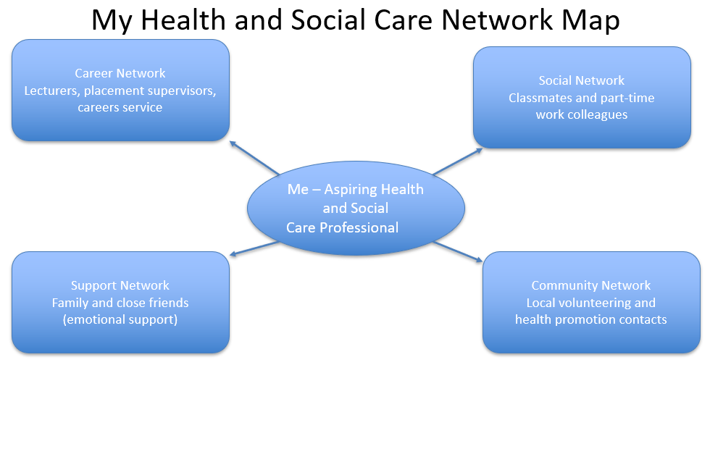

Task 3- Blog
Write a blog exploring a current topic or issue of your choice within the health and social care sector in the UK. The purpose of this is to inform a specific target audience of your choosing (300 words)

I'm writing mostly for family carers who assist an elderly relative at home or in a care facility, and I want to discuss the lack of workers in UK social care. Even if they do not use the phrase "workforce crisis," many families experience the effects of this problem on a daily basis.
Insufficient care workers might cause minor issues to escalate into major dangers. Missing a personal care appointment is more than just a hassle. It may indicate that meals are skipped, medication is delayed, or a fall is not promptly observed. This causes ongoing stress for a son or daughter who already worries about their parent. Because they don't completely trust that support will arrive on time, people begin to believe that they need to keep an eye on everything.
For the employees themselves, the situation is challenging as well. Although many carers desire to provide safe and compassionate care, understaffing results in hurried visits and little opportunity for meaningful conversations with clients or their families. This may harm relationships. Families may believe that staff members don't care, but in actuality, they are under a lot of stress and feel bad about not being able to do more.
It can be beneficial to have calm, open communication with the care provider as a family carer. It may be simpler to communicate your worries if you keep a brief log of any missing visits or modifications to your relative's health. Asking to talk to the manager or care coordinator instead of just the individual employee may also increase the likelihood of changes. Small, coordinated activities can preserve the safety and dignity of the person you love, even in the face of major issues with the larger system. It is not an easy situation, and at times it feels unfair.

Task 4- NHS Equality, Diversity and Inclusion
Quiz (250 words equivalent)
- What is the primary goal of the NHS Equality, Diversity, and Inclusion Improvement Plan?
(Answer in one or two sentences.)

Enhancing equality, diversity, and inclusion for all NHS employees as well as strengthening their sense of belonging are the main objectives in order to ensure that each employee is treated equally and has the opportunity to succeed.

- How does the NHS EDI Improvement Plan propose to tackle the gender pay gap?
(Answer in one to two sentences.)

By routinely examining pay data, exposing disparities, and taking focused action on hiring, advancement, and compensation decisions when unjust discrepancies arise, the initiative seeks to eliminate the gender pay gap.

- What is meant by the term ‘intersectionality’ as used in the NHS EDI Improvement Plan?
(Answer in one to two sentences.)

Intersectionality means recognising that people have several linked identities, and that disadvantages like racism, sexism or ableism can overlap, so they cannot be fixed if each characteristic is viewed alone.

- Why is it important for the NHS to create a psychologically safe work environment?
(Answer in one to two sentences.)
Employee welfare and safer patient care are supported by a psychologically safe workplace, where employees must feel free to voice concerns about errors, hazards and prejudice.

- How does the NHS EDI Improvement Plan suggest improving the experience of internationally recruited staff?
(Answer in one to two sentences.

The plan calls for improved, organised onboarding and induction for foreign-hired employees, as well as continuous pastoral support, equitable access to training, advancement and anti-exploitation measures.

- What role does leadership play in advancing EDI objectives according to the NHS Improvement Plan?
(Answer in one to two sentences.)

Leaders are expected to set clear EDI priorities, hold specific measurable objectives, model inclusive behaviour in daily decisions, and make sure teams are accountable for progress rather than treating EDI as optional.

- Identify one way the NHS EDI Improvement Plan aims to reduce health inequalities within the workforce.
(Answer in one to two sentences.)

Requiring each organisation to develop and implement a workforce health inequalities improvement strategy that focusses on employee groups with worse health, wellness, or sick leave outcomes is one approach.

- Why does the NHS EDI Improvement Plan emphasise the importance of collecting and analysing data on protected characteristics?
(Answer in one to two sentences.)

By gathering and evaluating information on protected characteristics, the NHS may identify areas of inequality, monitor the effectiveness of initiatives, fulfil its legal obligations and create interventions that reflect the actual experiences of its employees.

- Explain how flexible working policies can contribute to equality and inclusion in the NHS workforce.
(Answer in one to two sentences.)
Because they make it simpler for employees with long-term ailments, disabilities, or caregiving duties to continue working, advance in their careers, and feel appreciated, flexible working policies promote equality.

- What is one strategy mentioned in the NHS EDI Improvement Plan to combat bullying and harassment in the workplace?
(Answer in one to two sentences.)
One key strategy is to strengthen prevention and response to bullying and harassment through clear zero-tolerance standards, accessible reporting systems and consistent follow-up so staff see that complaints are acted on.

Task 5- A Letter to Yourself
Think of a time in the past when you may have been experiencing issues or difficulties, and after considering what you have learned in this module about emotional intelligence and resilience write a letter to your younger self explaining how these attributes were important at that time and perhaps how developing these areas could have been useful (250 words)

Dear younger me,

I remember you arriving in the UK from Romania, feeling like everything was too loud, too fast, and strange. You worried about every sentence in English, afraid people would laugh at your accent. You tried to copy local traditions and customs, but inside you felt very lost and sometimes a bit invisible.
Emotional intelligence would have helped you see your feelings as signals, not as weakness. Instead of pushing down your frustration and shame when you did not find the right word, you could name it and say to yourself, “I feel anxious now, but it is normal in this situation.” If you had paid more attention to the emotions of people around you, you would notice that many classmates were also insecure, just in different ways. This might make you feel less alone.
When you started university and worked at the same time, you were very hard on yourself. You thought tiredness meant you were lazy. Resilience here means not only continuing, but also adjusting. It is the ability to recover after a difficult shift, to ask for support from tutors, and to accept that progress can be slow. Every small success, like passing one assignment, was proof that you were already stronger than you believed.
I want you to know that these difficult years are shaping you into someone who can listen carefully to others in pain, especially in health and social care. Your struggle is not wasted; it becomes part of the help you will offer.

Task 6- GANTT Chart (200 words equivalent)
Compile a Gantt chart which illustrates the tasks you have to complete to achieve your future employment goals

Activity | Now – End of degree | Summer after graduation | Months 1–6 in job | Months 7–12 in job
Complete remaining university modules | ████████████████
Part-time work in health / social care | ████████████████ | █████
Improve professional English (spoken and written) | ████████████████ | █████ | ███ | ███
Update CV, LinkedIn and personal statement | █████ | ████ | ██
Gain mandatory training (Care Certificate, BLS, safeguarding) |  | █████████████ | ██
Job search and applications (NHS, local authority, charities) | ███ | █████████████ | ██
Interview practice and mock interviews | ███ | █████
Induction and probation in first full-time role |  |  | █████████████
Ongoing CPD courses and e-learning |  |  | █████████ | █████████
Supervision, reflective practice and feedback |  |  | █████████ | █████████

Task 7- Making Changes- Report
You are the manager of a care home and want to make changes your workplace. Identify one specific change that you want to implement and write a brief report on how this is going to be achieved considering the necessary skills needed and addressing possible barriers to success. Relevant change models can be highlighted (250 words- 2 referenced sources).

One major adjustment I suggest making to the care facility is requiring all employees including care assistants, nurses, and domestic helpers who interact with residents on a daily basis to complete an organised dementia training program. The prevalence of dementia in UK care facilities is significant, and national guidelines emphasise the importance of providing staff with high-quality, graded training to enable them to offer person-centred care and lessen residents' and families' distress (NICE, 2018). The Care Quality Commission's requirements that employees get role-appropriate training and supervision in order to provide safe care and enhance services over time are also connected to this transformation (CQC, 2024).
Lewin's change model will be used for implementation. In order to demonstrate the discrepancy between current abilities and suggested standards, I would first "unfreeze" current practice through staff meetings, oversight, and the use of incident data or complaints. After the course, I would use practice-based reflection sessions, protected learning time, and an accredited dementia framework to offer the new training. Lastly, by implementing explicit policies, incorporating dementia skills into evaluations, and doing frequent refreshers, I would "refreeze" the new method of working.
Communication, negotiation and data literacy are essential for success since they allow me to arrange rotas with personnel, set reasonable training dates, and track results like falls, complaints, or distressed behaviour. Time constraints, employee churn, and some opposition from long-term employees who believe they already "know dementia" are likely obstacles. Flexible session hours, acknowledging past experience and providing proof that homes with robust training and development retain employees longer and provide better care are how I would answer (CQC, 2023).

Task 8- Self-Reflection
Using one of the highlighted models of reflection, reflect on what you have learned about yourself during this module ,as well as the knowledge you have gained, and explain how this has developed your skills and informed your future practice (250 words- you must reference the model you use)

Because it provides a clear framework for considering experience and what should change next, I am adopting Gibbs' reflective cycle for this reflection (Gibbs, 1988). When I first started this program, I thought that being employable was mostly about having a strong resume, some experience, and high grades. My personal brand, my feelings, and my connections with other health and social care professionals are also essential components of my future practice, I recognised while working on the various tasks.
I recall feeling both proud and uneasy when I reflect on how I felt during the module. As a Romanian student in the UK, writing about my network and personal narrative exposed me, but it also demonstrated that I had previously honed my communication and resilience abilities without naming them. I can tell that several things went well during the evaluation phase. Using the Gantt chart and networking exercises, for instance, I started to plan my career moves more actively. Additionally, I can see that I continue to steer clear of some challenging discussions, particularly when I'm uncertain about my professional identity or my English.
My future steps depend on the analysis and action-planning phases. I discovered that self-awareness, emotional intelligence, and introspection are not just "soft skills"; they have an impact on teamwork and patient safety in actual services. Using Gibbs' questions as a guide, I intend to maintain a straightforward reflective record during placements and early employment in my future practice. I should be better able to handle stress, react to criticism, and gradually develop into a self-assured health and social care worker as a result.

Reference List

Barclays LifeSkills (n.d.) ‘Build your personal brand’. Barclays LifeSkills. Available at: https://barclayslifeskills.com/working-life/skills-for-the-workplace/build-your-personal-brand/ (Accessed: 08 November 2025).

Skills for Care (2021) ‘What is values-based recruitment?’ Skills for Care Blog, 13 September. Available at: https://www.skillsforcare.org.uk/Home.aspx?utm_source=google&utm_medium=cpc&utm_campaign=skills_for_care&utm_content=supporting_the_adult_social_care_sector&gad_source=1&gad_campaignid=22951391967&gbraid=0AAAAADiSFW3dXFBkd6aY8nOVSiLfh33GH&gclid=CjwKCAiAw9vIBhBBEiwAraSATuceFEO-lVpI-q6km4e7ocsQDddgjvn7I1YM4T0-1xkkfH_NSWLhHRoC0egQAvD_BwE (Accessed: 08 November 2025).

Bathmaker, A.-M., Ingram, N. and Waller, R. (2016) Higher education, social class and social mobility: the degree generation. Basingstoke: Palgrave Macmillan.

Chartered Institute of Personnel and Development (CIPD) (2022) Student career support: effective employability provision in UK higher education. London: CIPD.

Care Quality Commission (CQC) (2023) The state of health care and adult social care in England 2022/23. Newcastle upon Tyne: CQC. Available at: https://www.cqc.org.uk/sites/default/files/2023-10/20231020_stateofcare2223_print.pdf (Accessed: 13/11/2025

Care Quality Commission (CQC) (2024) ‘Safe and effective staffing – assessment framework’. CQC. Available at: https://www.cqc.org.uk/guidance-regulation/providers/assessment/single-assessment-framework/safe/safe-effective-staffing (Accessed: 14 November 2025).

National Institute for Health and Care Excellence (NICE) (2018) Dementia: assessment, management and support for people living with dementia and their carers (NG97). London: NICE.

Gibbs, G. (1988) Learning by doing: A guide to teaching and learning methods. Oxford: Oxford Polytechnic.

